
15-09-2025
Statement of Work & Proposal
For
Company name
For
{{ client_logo }}

Company name

Contents
[[CONTENTS]]

INTRODUCTION

CyberSmithSECURE is incorporated under the Indian Company act 1956 is a privately held corporation that is CERT-In empanelled & also an ISO 9001:2015 Certified Organisation promoted by Industry Recognised Entrepreneurs.
CyberSmithSECURE is a consulting organisation which aims to strength the maturity model of organisation’s information security policies thorough continuous monitoring, inspired by the passionate & experienced IT Leader that CyberSmithSECURE owns, integrating them with wider range of service outline comprising of red teaming, blue teaming & infrastructure penetration testing assessments over multilayer environment such as Cloud & Docker.

CyberSmithSECURE also provides vendor management & trainings programs for various IT organisation. Through enhance modelling of the virtual infrastructure of their cyber range labs.

The Key focus of CyberSmithSECURE realises on network, cloud, and web & mobile application penetration testing services. As a Security organisation, we uncover vulnerabilities which may put your organization at risk, and provide assistance to mitigate & remediate them. We collaborate the security research, proprietary technologies, and industry-leading security professionals to deliver the best consulting services that we own on our Platform comprising of external network, complex web applications in the AWS cloud, or Insider Threat Drills, we provide the specialists to fit your unique needs.

CyberSmithSECURE helps customers in Commercial, Government and Enterprises to identify, protect, detect, respond & recover on the basis of key frameworks like the NIST, CREAST ISO27001:2013, 2022 are the best practises that we follow during our consultation with clients.

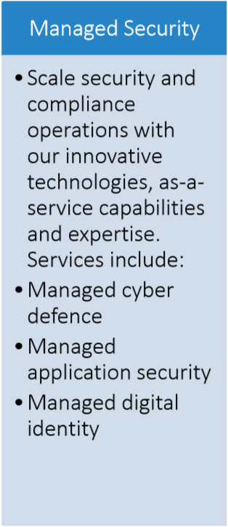
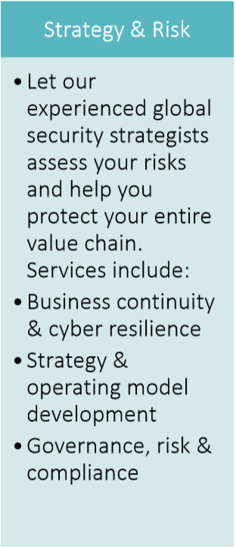
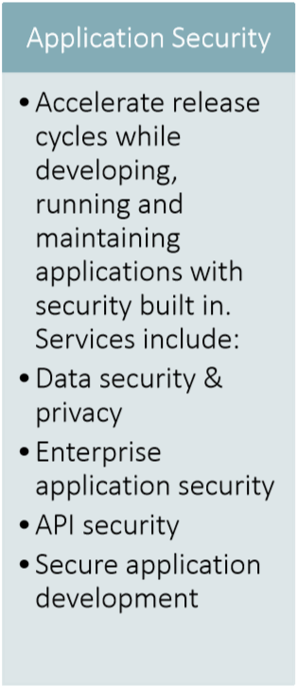
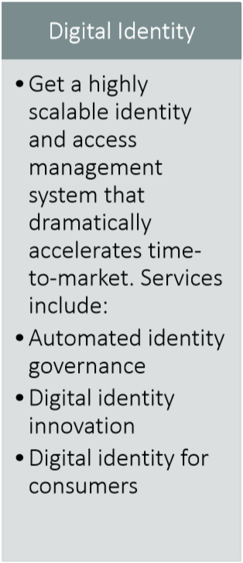
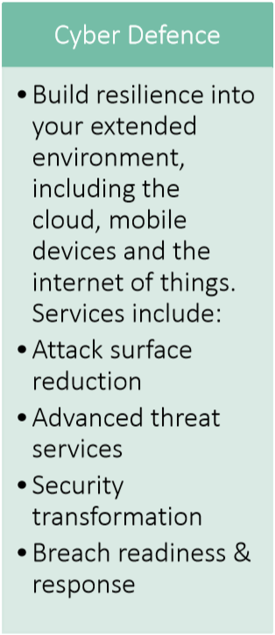

OUR UNDERSTANDING OF YOUR REQUIREMENT

The company highly depends on Information Technology for its business operations and therefore wishes to protect it from malicious attacks from within the organization as well as from external threat agents. In order to build strong defences, it wishes to conduct a thorough vulnerability assessment & penetration testing for its critical data continuously mitigate the risks by deploying adequate mitigating controls within the shortest possible time.
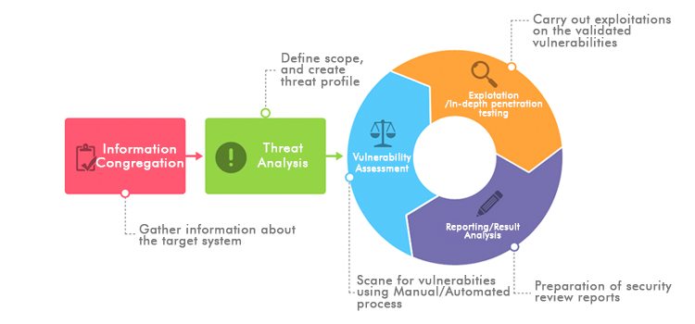

TEAM OVERVIEW
Sr No. | Level | Profile | Experience | Role
1. | CyberSmithSECURE L3 | Senior Consultant | 7 years | Senior Penetration Tester
2. | CyberSmithSECURE L2 | Consultant | 3 years | Configuration Analyst
3. | CyberSmithSECURE L1 | Senior Analyst | 2 Years | Security Analyst

METHODOLOGY OVERVIEW

CyberSmithSECURE penetration testing methodology is a repeatable and documented security assessment methodology. A methodology that is kept up-to-date according to changes in the threat environment and industry best practices provides consistency and structure to security testing. CyberSmithSECURE keeps its VAPT methodology updated with new tools, processes, techniques, or as trend develops. Our methodology is a comprehensive blend of the following methodologies and IT Security industry best practices:
- Open-Source Security Testing Methodology Manual (OSSTMM) from the Institute for Security and Open Methodologies (ISECOM).
- NIST Technical Guide to Information Security Testing and Assessment.
- OWASP Mobile Top 10 Most Critical Web Application & Mobile Security Risks.
- SANS Top 25 Most Dangerous Software Errors.
- CWE/Public Exploit checks.
- White Box/Grey Box/Black Box Assessment.
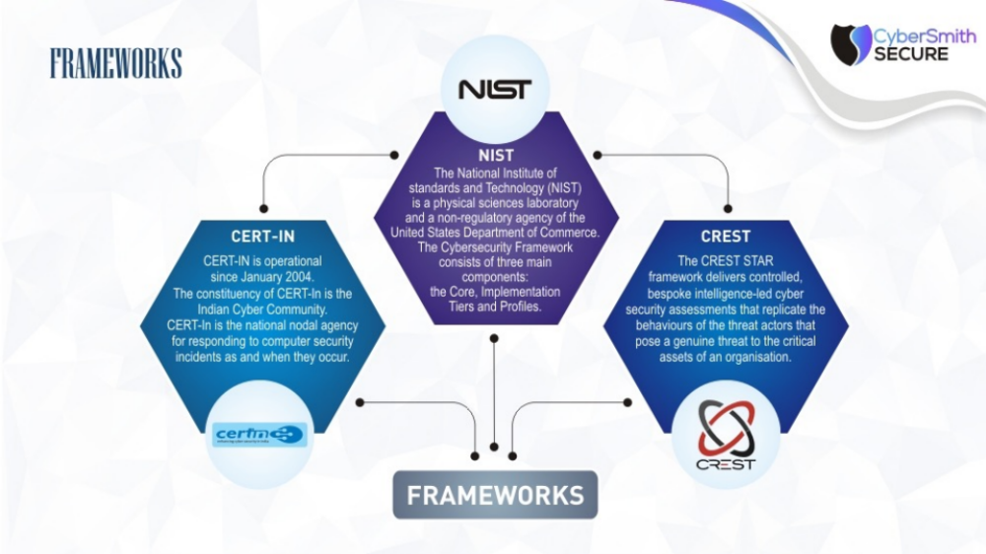

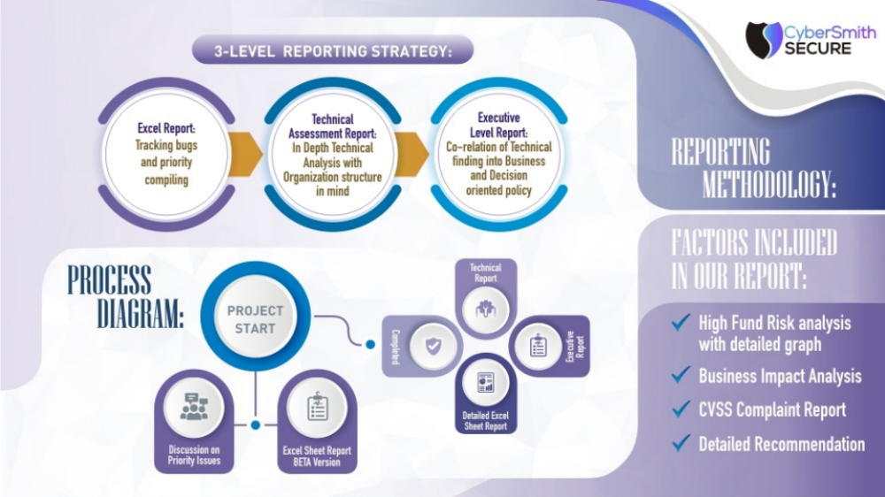

VULNERABILITY ASSESSMENT METHODOLOGY

A vulnerability assessment is a security auditing technique, used to identify and analyse general security flaws that might exist within a computer network or specific host. This process involves a thorough active analysis of all the Security related features of the systems in question, followed by an attempt to break into the system by breaching these security features if requested.

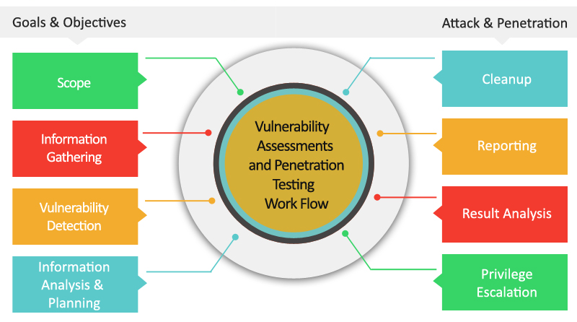

A vulnerability assessment is a security auditing technique, used to identify and analyze general security flaws that might exist within a computer specific host. Penetration testing is a step further from vulnerability assessment and this activity actually exploits the vulnerability identified and tries to gain access into the target system and not just report vulnerabilities. The purpose of penetration testing exercise is to identify methods of gaining access to a system by using common tools and techniques used by attackers. This process involves a thorough active analysis of all the security related features of the systems in question, followed by an attempt to break into the system by breaching these security features.

CyberSmithSECURE’s Penetration Testing methodology involves the following phases as identified below:
- PLANNING PHASE

In the planning phase, assessment rules are identified, management approval is finalized and documented, and testing goals are set. The planning phase sets the groundwork for a successful penetration test. The penetration testing team prepares a definite strategy for the assignment. Existing security policies, industry standards, best practices, etc. will be some of the inputs towards defining the scope for the test. This phase usually consists of all the activities that are needed to be performed prior to assessment/penetration test. No actual testing occurs in this phase.

- DISCOVERY

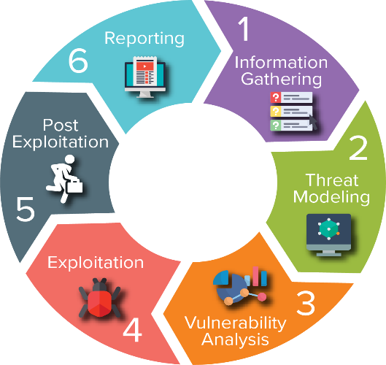
The discovery phase includes two parts. The first part is the start of actual testing, and covers information Gathering and scanning. Network port and service identification is conducted to identify potential targets. In addition to port and service identification, other techniques to identify vulnerabilities in the network are employed. The second part of the discovery phase is vulnerability analysis, which involves comparing the services, applications, and operating systems of scanned hosts against vulnerability databases, using auto vulnerability scanner and through manual process leveraging the testers’ own knowledge of vulnerabilities.

Discovery phase is categorized as follows:
- Foot printing phase
- Scanning and Enumeration phase
- Vulnerability Analysis phase

- ATTACK

Executing an attack is critical activity of the penetration test. It is the process of verifying previously identified potential vulnerabilities by attempting to exploit them. If an attack is successful, the vulnerability is verified, and safeguards are identified to mitigate the associated security exposure. Exploit testing may result in the testing team learning more about the targeted network and its potential vulnerabilities.

- REPORTING

The reporting phase occurs simultaneously with the phases of the penetration test. In the discovery and attack phases, written logs are usually kept, and periodic reports are made to system administrators and/or management. At the conclusion of the test, a report is generally developed to describe identified vulnerabilities, present a risk rating, and give guidance on how to mitigate the discovered weaknesses.
The vulnerability assessment/penetration testing report consist of:
- Executive Summary
- Detailed Findings
- Risk level of the Vulnerabilities found
- Business Impact
- Recommendations

Typical tools that may be used in a vulnerability assessment and penetration test include the following:


- Nmap
- Nessus
- Burp suite
- Metasploit framework
- Nikto

- Netcat
- Acunetix
- NetSparker
- Manual Intelligence & Approach






Annexure 1: Network Penetration Testing Assessment

Sub-Activity:
Network Penetration Testing

Tools which will be used during Assessment:
- Nmap
- Nessus
- Metasploit
- Hashcat
- Netcat
- Xfreerdp
- Smbclient
- Impacket
- Enum4linux
- Rpcclient
- Nslookup
- Hping3
- Whois
- Traceroute
- Hydra
- Wireshark
- Ettercap
- Nikto

Methodologies:
- White box / Grey box /Black box Assessment
- MITRE ATT&ACK Framework
- CWE (Common Weakness Enumeration) / Public exploit checks
- NIST (National Institute of standards and Technology) Technical guide to Information security testing and assessment
- Cert-In Cyber Security Framework
- CIS Benchmarks
- CVE Details & Exploit DB

Vulnerability Assessment:
A vulnerability assessment is a security auditing technique, used to identify and analyse.
general security flaws that might exist within a computer network or specific host. This process involves a thorough active analysis of all the Security related features of the systems in question, followed by an attempt to break into the system by breaching these security features if requested.
- Vulnerability Identification
- Analysis
- Risk Assessment
- Remediation

Frequency: One time with Revalidation

Count:

Deliverables:
• Scan Reports
- Scheduling Network Vulnerability Scans
- Cloud Infrastructure Audit & Review Scans
- Internal PCI Network Scans
- Network Penetration Testing
- Vulnerability Analysis
- CIS Benchmark Review
- Port Scanning
- Web Applications, Networks, DNS VA Scans
- Project planning
- Report discussion and analysis
- Re-Validation testing is secondary confirmation to mitigate identified threats in the
- Assessment activity after the successful submission of final report.

• Summary Report about Overall Findings
- List of IP’s Scanned
- High & Critical Risks
- Observations
- Artefacts of the Assessment
- Mitigation
- Proof of Concepts & Reproducing High & Critical Vulnerabilities
- Certain vulnerabilities which the developers aren’t able to understand because of the complexity shall be tested manually and detailed PoC (Proof of Concept) of specifics shall be provided.
- Even vulnerabilities which are found to be having adverse effect shall be separately documented and highlighted.
- Brief Analysis of Vulnerabilities & Explanations for DevSecOps Culture.
- Regular Weekly & Bi Weekly Meetings with Specific teams to discuss about various vulnerabilities.
- Weekly Meetings with Developer Heads, & CISO depending upon the urgency. Monthly Meeting with the CISO about the on-going security laps and status.
- Working with developers to create a repository for vulnerability mitigation & fixation

• Re-Validation Checks & Analysis
- Re-validating Security issues identified and closing the necessary on excel
- Providing Clarity of Vulnerabilities Patched/Un-patched in the Overall Summary

Expectation:
- To conduct Vulnerability Analysis on the nodes of the organization & Penetration Testing with ensuring that there is no business downtime.
- To support the organizations different departments for enforcing cyber security practice particularly to Development Team & IT Team.
- To ensure that all the Critical, High Vulnerabilities causing intrusions are reported
- To ensure that relevant stakeholders are updated on the proper timings about various activities that are carried.
- To regularly update the management about the status of pending Re-Validation of security issues.
- Providing Intelligence about blind spots exposed on the network infrastructure.

Objectives:
- To make organization infrastructure cyber resilient
- To report critical vulnerabilities causing intrusions
- To support organization on detection side of the NIST Framework and CSI benchmarks
- To provide with recommendation and mitigation on the basis of Industry best practices
- To help organization align and fix security issues on the basis of technology, strategy & business.

Requirements for Starting the assessment:
1) Network Security Assessment Requirements P1
- Internal VPN Connectivity access around 5
- We would require a Network process Architecture diagram
- Asset Inventory Sheet for the IPs which needs to be tested for specific quarter (already information is shared it shall be mapped will be shared with organization management to provide an approval on the same)
- Providing information of stakeholders including mail address, phone number to report details and findings with respective of different departments.
- Setting up a mail ID of organization for processing information.
- If required providing a dedicated instance to Plug-in Infrastructure Security Tools -System Requirement (GCP win 10 OS, 4 Core, 16gb RAM, 20 to 50GB storage)

Comments:
- IPs which aren’t responsive will be updated to the necessary stakeholder to provide us with proper connectivity.
- Going forward it will be very important that IT Team also creates a repository of security fixation issues that are suggested by us.
- A separate plan will be shared separately during the start of Network Vulnerability assessment and Penetration Testing

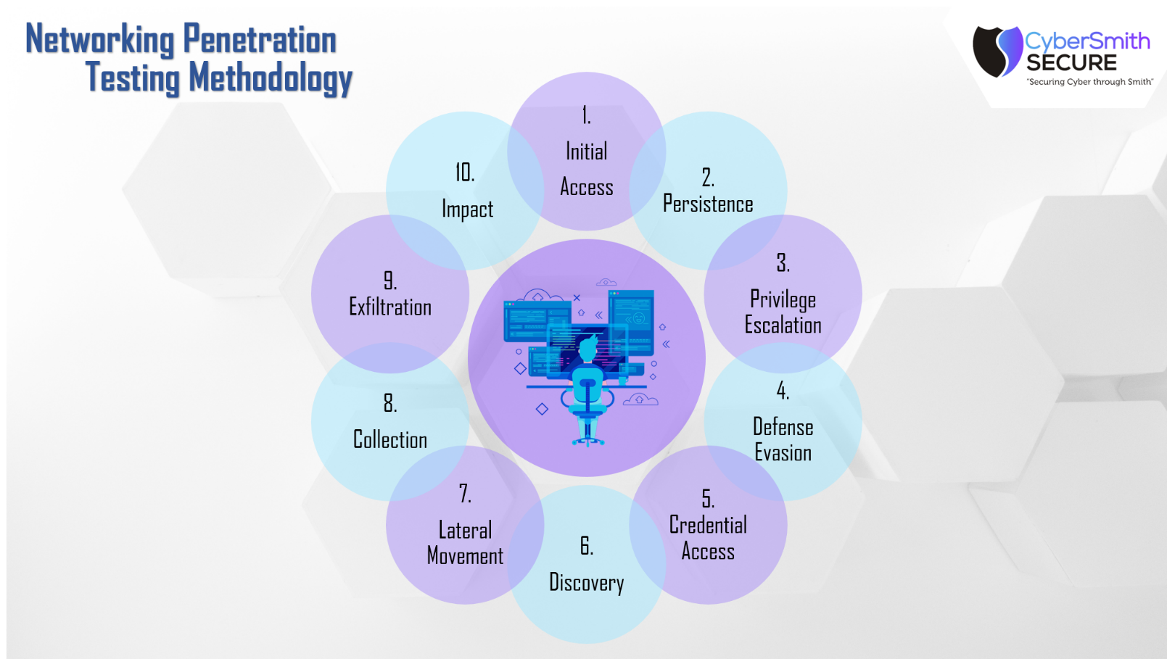

Annexure 2: Web Application Penetration Testing Assessment

Sub-Activity:
- Testing of Public Facing & Internal Web Applications

Methodologies:
- White box / Grey box / Black box Assessment
- CWE (Common Weakness Enumeration) / Public exploit checks
- SANS Top 25 most dangerous software errors
- NIST (National Institute of standards and Technology) Technical guide to Information security testing and assessment
- OWASP Top 10 Mobile Application & Web Application
- SANS Top 25 Web Attacks
- Cert-In Cyber Security Framework

Vulnerability Assessment:
A vulnerability assessment is a security auditing technique, used to identify and analyze
general security flaws that might exist within a computer network or specific host. This process involves a thorough active analysis of all the Security related features of the systems in question, followed by an attempt to break into the system by breaching these security features if requested.
- Vulnerability Identification
- Analysis
- Risk Assessment
- Remediation

Frequency: One Time with Revalidation

Count:
- Web Applications - Small:
- Web Applications - Medium:
- Web Applications - Large:

Deliverables:
Manual Application Security Assessment Grey Box
- Technical assessment report Web applications estimated Excel & PDF report
- Executive Assessment Report of Web Applications
- Project Planner of the Activity
- Excel Tracker Vulnerability Management
- Re-Validation Testing & Updating Information of Closures
- Web Application Report Sharing with Regulators about Issues resolved
- Report Discussion on the security issues identified.

• Executive Report should have this information about Findings
- List of Web Apps Scanned
- List of Web Apps Not Responsive
- List of Pending Re-Validation Web Apps
- High & Critical Risks
- Executive Summary
- Objectives
- Observations
- Artefacts of the Assessment
- Mitigation & Recommendations

• Technical Assessment Report
- Graph of Vulnerabilities Identified based on CVSS Ratings
- Vulnerability Name
- Vulnerability Description
- Vulnerability Impact
- Recommendation
- Proof of Concept & Step to Reproduce
- Even vulnerabilities which are found to be having adverse effect shall be updated to the management on priority and escalated to the security heads.
- Brief Analysis of Vulnerabilities & Explanations for DevSecOps Culture
- Regular Weekly & Bi Weekly Meetings with Specific teams to discuss about various vulnerabilities
- Weekly Meetings with Developer Heads & CISO depending upon the urgency. Monthly Meeting with the CISO about the on-going security laps and status
- Working with developers to create a repository for vulnerability mitigation & fixation.
- The Vulnerabilities identified should be mapped in the Threat Modelling sheet for avoidance of future occurrence.

• Re-Validation Checks & Analysis
- Re-validating Security issues identified and closing the necessary on excel
- Providing Clarity of Vulnerabilities Patched/Un-patched in the Monthly Summary & Quarterly Report
- Intensity of Attack & Down Time Concerns
- If application testing is provided to be done on production system the testing speed will be decreased to subject of application might go down. Therefore, the organization during the time of allotment should make clear which application are having UAT instance or a production instance.
- Subject to production instance the testing shall be performed with a lower intensity taking the necessary care of avoid business downtimes.

Expectation:
- To identify security issues in public facing infrastructure as first priority
- To conduct Vulnerability Assessment & Penetration Testing for the Web Application involving internal & external to avoid business continuity loss.
- To support the organizations different departments for enforcing cyber security practice particularly to Development Team & IT Team.
- To ensure that all the Critical, High Vulnerabilities causing intrusions are reported
- To ensure that relevant stakeholders are updated on the proper timings about various activities that are carried.
- To regularly update management about the status of pending Re-Validation of security issues.
- Providing Intelligence about blind spots exposed on the infrastructure.

Objectives:
- To make organization Application Infrastructure Cyber Resilient.
- To report critical vulnerabilities causing intrusions.
- To support organization on detection side of the NIST Framework and OWASP top 10 framework
- To provide with recommendation and mitigation on the basis of Industry best practices.
- To help organization align and fix security issues on the basis of technology, strategy & business.

Requirements for Starting the assessment:
1) Web Application Security Assessment and penetration Testing Requirements P1
- Providing with the details of application that needed to be tested in every specific time period.
- Conducting a walkthrough meeting to ensure that process mapping expectation from every application working point is resolved.
- Clarification of Methodologies Scheduled for every application is made clear in the Walkthrough meetings.
- For New Application UAT instance shall be provided for kick starting the testing wherever applicable.
- During the configurational review check of Web Applications policies, it is required to share read only access to specific user created account.
- Providing Special Hours for Scheduling Stress Testing on the Applications Subjected to affect downtime status.
- Application hosted on UAT instance backup should be kept separately on other instance as well to avoid data catches and integrity violation that can happen during the testing side of grey box.
- Miscellaneous scripts which leave logs and traces shall be avoided to ensure that application stability is not affected in the black box test.
- Relevant credentials should be shared with the consulting team for scheduling Grey Box Testing.

Comments:
- Applications which aren’t responsive will be updated to the necessary stakeholder to provide us with proper connectivity.
- Going forward it will be very important that Developer Team also creates a repository of security fixation issues that are suggested by us.
- A separate plan will be shared separately during the start of Network Vulnerability assessment and Penetration Testing

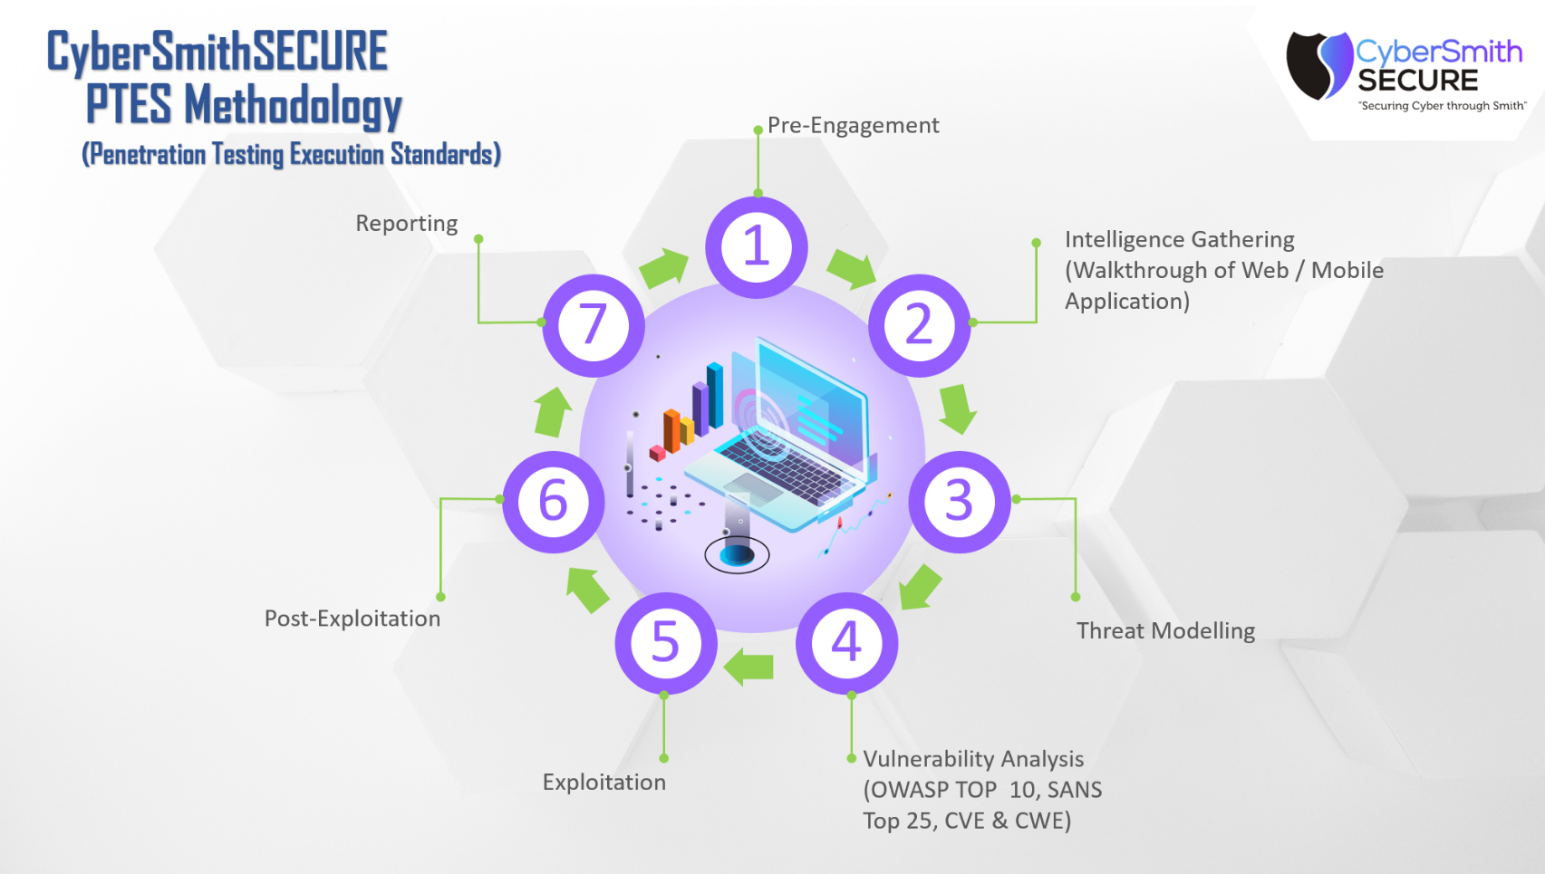

Annexure 3: Network Configuration Review Assessment

Sub-Activity:
Network Configuration Review Assessment
A Secure Configuration review is a detailed review and verification of configuration settings of IT infrastructure components including systems, network devices & applications to measure the security effectiveness of the IT environment. Typically, when deploying, maintaining or enhancing computing systems/network/network security devices, the expected secure configuration settings may not be implemented or maybe missed. Any poorly configured component of the IT environment then becomes a weak link that may allow adversaries to gain unauthorized access, leading to possible outages and security breaches.

Methodologies
- CIS benchmarks
- NIST standards
- Data Gathering (Current Configuration and Deployment Settings using authenticated scans or manual data gathering)
- Data Analysis (Reviewing Configuration Settings)
- Identification and rating of configuration weaknesses
- Reporting

Frequency: One time and Revalidation

Count:
- Routers: 11
- Firewall: 10
- IOS Applications:
- Switches (Manageable): 235
- Domain Controller: 8
- Backup Servers: 3
- Virtualizer: 12
- Servers: 11
- Desktops:

Deliverables:
• Scan Reports
- Cloud Infrastructure Audit & Review Scans
- MDM Config Reviews
- Offline Config Audits
- Policy Compliance Auditing
- CIS Benchmark Review
- Port Scanning
- Project planning
- Report discussion and analysis
- Re-Validation testing is secondary confirmation to mitigate identified threats in the
- Assessment activity after the successful submission of final report.

• Summary Report About Overall Findings
- List of IP’s Scanned
- High & Critical Risks
- Observations
- Artifacts of the Assessment
- Mitigation
• Proof of Concepts of Compliant and Non- compliant Vulnerabilities
- Certain vulnerabilities which the developers aren’t able to understand because of the complexity shall be tested manually and detailed poc of specifics shall be provided.
- Even vulnerabilities which are found to be having adverse effect shall be separately documented and highlighted.
- Regular Weekly & Bi Weekly Meetings with Specific teams to discuss about various vulnerabilities
- Weekly Meetings with Developer Heads, & CISO depending upon the urgency. Monthly Meeting with the CISO about the on-going security laps and status
- Working with developers to create a repositories for vulnerability mitigation & fixation
• Re-Validation Checks & Analysis
- Re-validating Security issues identified and closing the necessary on excel
- Providing Clarity of Vulnerabilities Patched/Un-patched in the Overall Summary

Objectives:
- Analysing & Reconnaissance
- Identification of Potential Threat
- Employee Awareness & Social Engineering Campaigns
- Critical Attacks for Data Loss & Data Theft
- To report critical vulnerabilities causing intrusions.
- To support organization on detection side of the NIST Framework & CIS Benchmark.
- To provide with recommendation and mitigation on the basis of Industry best practices.
- To help organization align and fix security issues on the basis of technology, strategy & business.

Annexure 4: Insider Threat Assessment for Data Infiltration & Exfiltration

Sub-activity:
Insider Threat Assessment

Frequency: One Time with Revalidation

Deliverables:
- Detect Weak Policies and Policy Changes
- Vulnerabilities and Misconfiguration
- Providing insights on Suspicious User and Account Activity
- Visibility and Controls – to enhance visibility and detection of malicious events on AD
- Harden privileged user access and privileged access management
- Evaluate the architecture – on premise and cloud environments
- Identify Common Attack Vectors
- Provide Action Plan - Detailed recommendations to improve your security posture to help prevent, detect, and rapidly recover from attacks.
- Review of Configurations and Network based Vulnerabilities
- Weak Password

• The Threat detection Assessment focuses on several key pillars, including:
- Review of operational processes
- Review of the privileged accounts/groups membership as well as regular account hygiene
- Review operating system configuration, security patch, and update levels
- Review of domain and domain controller configuration compared to Microsoft recommended guidance
- Review of key object permission delegation

• Summary Report about Overall Findings
- High & Critical Risks
- Observations
- Artefacts of the Assessment
- Mitigation

Expectation:
- Brief Overview of The Process of Exploitation & Persistence Gaining
  - Gaining persistence has been a key factor in targeted Cyber Ops, for the necessary a deployment has to go through various stages of runtime based presence with various evading factors, exploits & social engineering technique in order to have a better C&C established. The Training aims to deliver a core overview of how a C&C can be deployed & what factors are required to undergo.
- Understanding of Getting Admin Privileges & Compromising Third Party C&C’s for Exfiltration of Data
  - When a vulnerability is known the next step is to exploit the loophole & get the access or privilege to the domain or the targeted machine. For the specific this training aims to demonstrate the various techniques to compromise a server & gain access to critical data.
- The Defensive Structure & Safeguarding an Organisation Using Defensive Controls
  - The key factor of an organisation is to secure itself from malicious threats which can be in any forum, after the risk assessment is carried of an critical infrastructure an organisation. The role of patch management & having brief overview of Configuration Review Check is being assisted in this training.
- Understanding Brief overview of Different Advance Persistent Threat Groups & Activities.

Objectives:
- One of the key security Standards, Policies & Advisories by NCIIPC (National Critical Information Infrastructure Protection Centre) & Cert-IN (Computer Emergency Response Team of India).
- To make organization infrastructure cyber resilient
- To report critical vulnerabilities causing intrusions
- To support organization on detection side of the Industry Specifics Standards
- To provide with recommendation and mitigation on the basis of Industry best practices
- To help organization align and fix security issues on the basis of technology, strategy & business.

Requirements for Starting the Assessment:
  - Internal VPN Connectivity access around 5
  - We would require a Network process Architecture diagram
  - Asset Inventory Sheet for the IP’s which needs to be tested for specific quarter (already information is shared it shall be mapped will be shared with organization management to provide a approval on the same)
  - Providing information of stakeholders including mail address, phone number to report details and findings with respective of different departments.
  - Setting up a mail ID of organization for processing information.
  - If required providing a dedicated instance to Plug-in Infrastructure Security Tools - System Requirement (GCP win 10 OS, 4 Core, 16gb RAM, 20 to 50GB storage)

Annexure 5: Mobile Application Penetration Testing

Sub-activity:
Mobile Application Vulnerability Assessment and Penetration Testing
• Testing of Android Application & IOS Application.
• Grey Box Testing of Mobile Application (iOS and Android) Security Assessment

Methodologies
- White box / Grey box /Black box Assessment
- CWE (Common Weakness Enumeration) / Public exploit checks
- SANS Top 25 most dangerous software errors
- NIST (National Institute of standards and Technology) Technical guide to Information security testing and assessment
- OWASP Top 10 Mobile Application
- SANS Top 25 Mobile Application Attacks
- Cert-In Cyber Security Framework

Vulnerability Assessment
A vulnerability assessment is a security auditing technique, used to identify and analyse general security flaws that might exist within a computer network or specific host. This process involves a thorough active analysis of all the Security related features of the systems in question, followed by an attempt to break into the system by breaching these security features if requested.

- Vulnerability Identification
- Analysis
- Risk Assessment
- Remediation

Mobile Application Security Assessment and Penetration Testing
A vulnerability assessment is a security auditing technique, used to identify and analyse general security flaws that might exist within a computer. Penetration testing is a step further from vulnerability assessment and this activity actually exploits the vulnerability identified and tries to gain access into the target system and not just report vulnerabilities. The purpose of penetration testing exercise is to identify methods of gaining access to a system by using common tools and techniques used by attackers. This process involves a thorough active analysis of all the security related features of the systems in question, followed by an attempt to break into the system by breaching these security features.

Phase of Penetration Testing
- Planning Phase
- Discovery
- Attack
- Reporting

Deliverables:
Manual Application Security Assessment Grey Box
- Technical assessment report Mobile (iOS & Android) applications estimated Excel & PDF report
- Executive Assessment Report of Mobile (iOS & Android) Applications
- Project Planner of the Activity
- Excel Tracker Vulnerability Management
- Re-Validation Testing & Updating Information of Closures
- Web Application Report Sharing with Regulators about Issues resolved
- Report Discussion on the security issues identified.

• Executive Report Should have this information About Findings
- List of Mobile Apps Scanned
- High & Critical Risks
- Executive Summary
- Objectives
- Observations
- Artefacts of the Assessment
- Mitigation & Recommendations
• Technical Assessment Report
- Graph of Vulnerabilities Identified based on CVSS Ratings
- Vulnerability Name
- Vulnerability Description
- Vulnerability Impact
- Recommendation
- Proof of Concept & Step To Reproduce
- Even vulnerabilities which are found to be having adverse effect shall be updated to the management on priority and escalated to the security heads.
• Brief Analysis of Vulnerabilities & Explanations for Devops Culture
- Regular Weekly & Bi Weekly Meetings with Specific teams to discuss about various vulnerabilities
- Weekly Meetings with Developer Heads & CISO depending upon the urgency. Monthly Meeting with the CISO about the on-going security laps and status
- Working with developers to create a repository for vulnerability mitigation & fixation.
- The Vulnerabilities identified should be mapped in the Threat Modelling sheet for avoidance of future occurrence.
• Re-Validation Checks & Analysis
- Re-validating Security issues identified and closing the necessary on excel
- Providing Clarity of Vulnerabilities Patched/Un-patched in the Summary Report
• Intensity of Attack & Down Time Concerns
- If application testing is provided to be done on production system the testing speed will be decreased to subject of application might go down. Therefore, the organization during the time of allotment should make clear which application are having UAT instance or a production instance.
- Subject to production instance the testing shall be performed with a lower intensity taking the necessary care of avoid business downtimes.

Expectation:

- To identify security issues in public facing infrastructure as first priority
- To conduct Vulnerability Assessment & Penetration Testing for the Mobile Application involving internal & external to avoid business continuity loss.
- To support the organizations different departments for enforcing cyber security practice particularly to Development Team & IT Team.
- To ensure that all the Critical, High Vulnerabilities causing intrusions are reported
- To ensure that relevant stakeholders are updated on the proper timings about various activities that are carried.
- To regularly update management about the status of pending Re-Validation of security issues.
- Providing Intelligence about blind spots exposed on the infrastructure.

Objectives:
- One of the key security Standards, Policies & Advisories by NCIIPC (National Critical Information Infrastructure Protection Centre) & Cert-IN (Computer Emergency Response Team of India).
- To make organization Application Infrastructure Cyber Resilient.
- To report critical vulnerabilities causing intrusions.
- To support organization on detection side of the NIST Framework.
- To provide with recommendation and mitigation on the basis of Industry best practices.
- To help organization align and fix security issues on the basis of technology, strategy & business.

Requirements for Starting the Assessment:
1) Mobile Application Security Assessment and penetration Testing Requirements P1
- Providing with the details of application that needed to be tested in every specific time period.
- Conducting a walkthrough meeting to ensure that process mapping expectation from every application working point is resolved.
- Clarification of Methodologies Scheduled for every application is made clear in the Walkthrough meetings.
- While Testing Mobile Application on both Android & iOS we would require .apk & .ipa files with disabling the ssl pining and root detection
- Providing Special Hours for Scheduling Stress Testing on the Applications Subjected to affect downtime status.
- Application hosted on UAT instance backup should be kept separately on other instance as well to avoid data catches and integrity violation that can happen during the testing side of grey box.
- Miscellaneous scripts which leave logs and traces shall be avoided to ensure that application stability is not affected in the black box test.
- Relevant credentials should be shared with the consulting team for scheduling Grey Testing.

Comments:
- Applications which aren’t responsive will be updated to the necessary stakeholder to provide us with proper connectivity.
- Going forward it will be very important that Developer Team also creates a repository of security fixation issues that are suggested by us.
- A separate plan will be shared separately during the start of Mobile Application Vulnerability assessment and Penetration Testing.

Annexure 6: Active Directory Security Assessment

Sub-activity:
An Active Directory Security Assessment is a simple methodical assessment that your organization can conduct to assess the security of your foundational Active Directory. It assists your organization in identifying, quantifying, and reducing the risks affecting your AD.
- Provide a snapshot of the Active Directory security configuration.
- Identifies the most common and effective attack vectors and explains how best to detect, mitigate, and prevent.
- Offers tailored recommendations for leveraging existing technology investments to improve your organization’s overall security posture (expert guidance and advice).
- Identifies top security issues and provides guidance on the best methods to mitigate and resolve them.
- Provides a detailed report of the issues discovered and their impact along with recommended remediation—expert advice and recommendation.

Methodology of testing
- Enumeration
- Exploitation
- Persistence
- Privilege Escalation

Frequency: One time With Revalidation

Count: 1

Deliverables:
- Detect Weak Policies and Policy Changes
- Vulnerabilities and Misconfiguration
- Providing insights on Suspicious User and Account Activity
- Visibility and Controls – to enhance visibility and detection of malicious events on AD
- Harden privileged user access and privileged access management
- Evaluate the architecture – on premise and cloud environments
- Identify Common Attack Vectors
- Provide Action Plan - Detailed recommendations to improve your security posture to help prevent, detect, and rapidly recover from attacks.
- Review of AD Configurations and Network based Vulnerabilities

• Scan Reports
- Active Directory Audit & Review Scans
- Internal PCI Network Scans
- Active Directory Config Reviews
- Offline Config Audits
- Policy Compliance Auditing
- Testing Active Directory for Any Ransomware attack scenarios/ Zero day attacks
- Vulnerability Analysis
- CIS Benchmark Review
- Port Scanning
- Project planning
- Report discussion and analysis
- Re-Validation testing is secondary confirmation to mitigate identified threats in the
- Assessment activity after the successful submission of final report.

• The Active Directory Security Assessment focuses on several key pillars, including:
- Review of operational processes
- Review of the privileged accounts/groups membership as well as regular account hygiene
- Review of the forest a nd domain trusts
- Review operating system configuration, security patch, and update levels
- Review of domain and domain controller configuration compared to Microsoft recommended guidance
- Review of key Active Directory object permission delegation

• Summary Report about Overall Findings
- High & Critical Risks
- Observations
- Artefacts of the Assessment
- Mitigation
• Proof of Concepts & Reproducing High & Critical Vulnerabilities
- Certain vulnerabilities which the developers aren’t able to understand because of the complexity shall be tested manually and detailed PoC (Proof of Concept) of specifics shall be provided.
- Even vulnerabilities which are found to be having adverse effect shall be separately documented and highlighted.
• Brief Analysis of Vulnerabilities & Explanations for DevSecOps Culture
- Regular Weekly & Bi Weekly Meetings with Specific teams to discuss about various vulnerabilities
- Weekly Meetings with Developer Heads, & CISO depending upon the urgency. Monthly Meeting with the CISO about the on-going security laps and status
- Working with developers to create a repository for vulnerability mitigation & fixation
• Re-Validation Checks & Analysis
- Re-validating Security issues identified and closing the necessary on excel
- Providing Clarity of Vulnerabilities Patched/Un-patched in the Overall Summary

• Detailed Focus of the Assessment:
- Stale objects
- Privileged accounts
- Trusts
- Anomalies
- Forest architecture
- Operational processes
- Monitoring and response
- Group policy controls and enforcement
- Permission delegation
- Remote access controls and hardening
- Endpoint configuration and hardening
- Review of AD configurations
- Review of GPO Settings
- Automated benchmarking
- Manual review
- Comparison against best-practices
- Review of OUs, groups, users, computers
- Classification of severity of findings

Expectation:
- To identify security issues in Internal as well as External facing infrastructure as first priority
- To conduct Security Assessment & Penetration Testing For the Zero day Attack scenarios involving internal & external to avoid business continuity loss.
- To support the organizations different departments for enforcing cyber security practice particularly to Development Team & IT Team.
- To ensure that all the Critical, High Vulnerabilities causing intrusions are reported
- To ensure that relevant stakeholders are updated on the proper timings about various activities that are carried.
- To regularly update management about the status of pending Re-Validation of security issues.
- Providing Intelligence about blind spots exposed on the infrastructure.

Objectives:
- To make organization Application Infrastructure Cyber Resilient.
- To report critical vulnerabilities causing intrusions.
- To support organization on securing the Active Directory controls.
- To provide with recommendation and mitigation on the basis of Industry best practices.
- To help organization align and fix security issues on the basis of technology, strategy & business.

Requirements for Starting the Assessment:

1) Infrastructure Requirements P1
- Internal VPN Connectivity access around 5
- Providing information of stakeholders including mail address, phone number to report details and findings with respective of different departments.
- Setting up a mail ID of organization for processing information.
- If required providing a dedicated instance to Plug-in Infrastructure Security tools System requirement (GCP win 10 OS, 4 Core, 16gb RAM, 20 to 50GB storage)

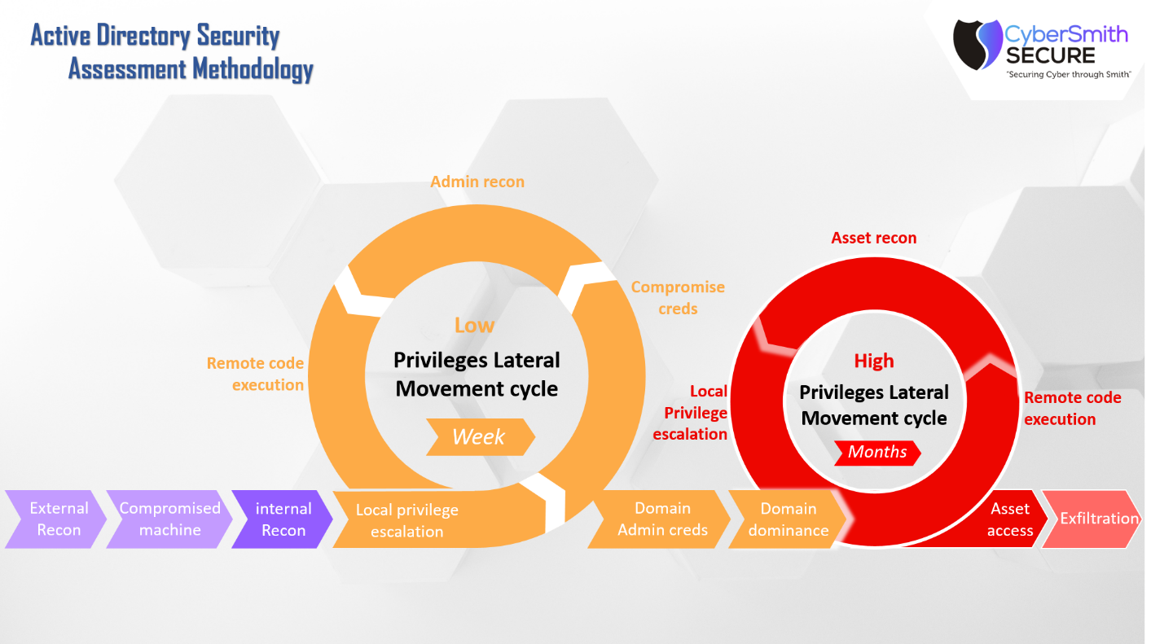

Annexure 7: SOC Simulation Exercise

Sub-activity:
Security Operation Centres (SOCs) are the front line for incident detection, response, and escalation for organizations. Few security teams evaluate their SOC's tools, techniques and procedures (TTPs) are working the way they are supposed to for expected SOC response. This Assessment will cover how Blue and Red teams can build and execute live fire security incidents to target your SOC's TTP abilities to detect, respond, and escalate. Techniques will be discussed in how to develop basic SOC exercise scenarios, determine expected outcomes, measure actual results, and report lessons learned to improve your SOC's ability for TTP execution.
- Defines terminology based on doctrine and practical implementation
- Defines objectives for executing threat scenarios to asses cyberspace operations capabilities
- Outlines threats, ranges, and best practices for operating a Cyber Exercise
- Reports on the effectiveness of cyber injects and scenarios
- Provides the necessary information to execute and assess cyber threat scenarios within an exercise
- Exercise structures
- Creating scenarios
- Incident response plan
- Observation and incident reporting formats
- Network architecture
- Tools that could facilitate various scenarios

Frequency: One time With Revalidation

Count: 1

Deliverables:
• Summary Report about Overall Findings
- High & Critical Risks
- Observations
- Artefacts of the Assessment
- Mitigation
• Proof of Concepts & Reproducing High & Critical Vulnerabilities
- Certain vulnerabilities which the developers aren’t able to understand because of the complexity shall be tested manually and detailed PoC (Proof of Concepts) of specifics shall be provided.
- Even vulnerabilities which are found to be having adverse effect shall be separately documented and highlighted.

• Brief Analysis of Vulnerabilities which are compliant and non-compliant
- Regular Weekly & Bi Weekly Meetings with Specific teams to discuss about various vulnerabilities
- Weekly Meetings with Developer Heads, & CISO depending upon the urgency. Monthly Meeting with the CISO about the on-going security laps and status
- Working with developers to create a repository for vulnerability mitigation & fixation
• Re-Validation Checks & Analysis
- Re-validating Security issues identified and closing the necessary on excel
- Providing Clarity of Entire SOC management of CAPITA in the Overall Summary

Expectation:
- To identify security issues and to assessment proper implementation and Monitoring of SOC against malicious attacks on Internal as well as External facing infrastructure as first priority
- To conduct Security Assessment & Penetration Testing for the Zero day Attack scenarios involving internal & external to avoid business continuity loss.
- To support the organizations different departments for enforcing cyber security practice particularly to Development Team & IT Team.
- To ensure that all the Critical, High Vulnerabilities causing intrusions are reported
- To ensure that relevant stakeholders are updated on the proper timings about various activities that are carried.
- To regularly update management about the status of pending Re-Validation of security issues.
- Providing Intelligence about blind spots exposed on the infrastructure.

Objectives:
- To make organization's Infrastructure Cyber Resilient.
- To report critical vulnerabilities causing intrusions.
- To support organization on Assessing SOC simulation is properly implement.
- To provide with recommendation and mitigation on the basis of Industry best practices.
- To help organization align and fix security issues on the basis of technology, strategy & business.

Annexure 8: Cloud Penetration Testing

Sub-activity:
The type of penetration tests take place in the cloud environment, during this process the penetration tester will review cloud security configurations as well as systems, web apps and another component associated with the cloud environment.

Vulnerability discovery is the process of testing and probing system entry points for flaws that can be used to generate an error condition, raise an invalid response, monitor traffic or data, or control a key system process. Examples of these vulnerabilities include:

- Pre-Engagement – Defining Scope and Approach
- Reconnaissance and Information Gathering – Based on Cloud Platform such AWS, Azure, GCP etc
- Identity and Access Management – includes MFA, password policies, IAM policies
- Review Authentication Architecture – issues with authentication and authorization
- Network Security – controls such as ingress and egress rulesets. Traffic limits, flow logging etc
- Logging API Call and Events
- Monitoring – reviewing ACLs. Security policy/groups, routing tables etc
- Vulnerability Analysis
- Reporting and Explanation of Vulnerabilities found and finding Solution for mitigating security flaws

Frequency: One time With Revalidation

Count: Cloud Azure & AWS 2

Deliverables:
- Pre-Engagement – Confirming test scope, Ips, URLs, Compliance Requirements, Cloud Provider agreements etc
- Identity and Access Management – includes MFA, password policies, IAM policies
- Review Authentication Architecture – issues with authentication and authorization
- Network Security – controls such as ingress and egress rulesets. Traffic limits, flow logging etc
- Logging API Call and Events
- Monitoring – reviewing ACLs. Security policy/groups, routing tables etc
- Vulnerability Analysis
- Reports
- Patch Management
- Extended Support

• Summary Report About Overall Findings
- High & Critical Risks
- Observations
- Artefacts of the Assessment
- Mitigation
• Proof of Concepts & Reproducing High & Critical Vulnerabilities
- Certain vulnerabilities which the developers aren’t able to understand because of the complexity shall be tested manually and detailed PoC (Proof of Concept) of specifics shall be provided.
- Even vulnerabilities which are found to be having adverse effect shall be separately documented and highlighted.
• Brief Analysis of Vulnerabilities which are Compliant and Non-Compliant
- Regular Weekly & Bi Weekly Meetings with Specific teams to discuss about various vulnerabilities
- Weekly Meetings with Developer Heads, & CISO depending upon the urgency. Monthly Meeting with the CISO about the on-going security laps and status
- Working with developers to create a repository for vulnerability mitigation & fixation
• Re-Validation Checks & Analysis
- o Re-validating Security issues identified and closing the necessary on excel
- o Providing Clarity of Vulnerabilities Patched/Un-patched in the Overall Summary

Expectation:
- To identify security issues in Cloud infrastructure as first priority
- To conduct Security Assessment & Penetration Testing for the Zero-day Attack scenarios involving internal & external to avoid business continuity loss.
- To support the organizations different departments for enforcing cyber security practice particularly to Development Team & IT Team.
- To ensure that all the Critical, High Vulnerabilities causing intrusions are reported
- To ensure that relevant stakeholders are updated on the proper timings about various activities that are carried.
- To regularly update management about the status of pending Re-Validation of security issues.
- Providing Intelligence about blind spots exposed on the infrastructure.

Objectives:
- To make organization's Cloud Infrastructure Cyber Resilient.
- To report critical vulnerabilities causing intrusions.
- To support organization on Assessing SOC simulation is properly implement.
- To provide with recommendation and mitigation on the basis of Industry best practices.
- To help organization align and fix security issues on the basis of technology, strategy & business.

Annexure 9: API Penetration Testing Assessment

Sub-activity:
API Vulnerability Assessment and Penetration Testing
- Testing of Public facing and Internal Facing API.
- Grey Box Testing of API

Vulnerability Assessment

A vulnerability assessment is a security auditing technique, used to identify and analyze general security flaws that might exist within a computer network or specific host. This process involves a thorough active analysis of all the Security related features of the systems in question, followed by an attempt to break into the system by breaching these security features if requested.

- Vulnerability Identification
- Analysis
- Risk Assessment
- Remediation

Phase of Penetration Testing
- Planning Phase
- Discovery
- Attack
- Reporting

Methodologies:
- White box / Grey box /Black box Assessment
- CWE (Common Weakness Enumeration) / Public exploit checks
- SANS Top 25 most dangerous software errors
- NIST (National Institute of standards and Technology) Technical guide to Information security testing and assessment
- OWASP Top 10 API testing Framework
- SANS Top 25 Web Attacks
- Cert-In Cyber Security Framework

Frequency: One time With Revalidation

Count: API = 2350

Deliverables:
- Pre- Engagement
- Mapping the API and Threat Modelling
- API Static Analysis
- API Dynamic Analysis
- Testing Business Logic Flaw
- Reporting

Manual Application Security Assessment Grey Box
- Technical assessment report API’s Tested, estimated in Excel & PDF report
- Executive Assessment Report of API Vulnerability Assessment and Penetration Testing
- Project Planner of the Activity
- Excel Tracker Vulnerability Management
- Re-Validation Testing & Updating Information of Closures
- API VAPT Report Sharing with Regulators about Issues resolved
- Report Discussion on the security issues identified.

• Executive Report should have this information About Findings
- List of API’s Scanned
- List of API’s Not Responsive
- List of Pending Re-Validation for API VAPT
- High & Critical Risks
- Executive Summary
- Objectives
- Observations
- Artefacts of the Assessment
- Mitigation & Recommendations

• Technical Assessment Report
- Graph of Vulnerabilities Identified based on CVSS Ratings
- Vulnerability Name
- Vulnerability Description
- Vulnerability Impact
- Recommendation
- Proof of Concept & Step to Reproduce
- Even vulnerabilities which are found to be having adverse effect shall be updated to the management on priority and escalated to the security heads.
• Brief Analysis of Vulnerabilities & Explanations for DevSecOps Culture
- Regular Weekly & Bi Weekly Meetings with Specific teams to discuss about various vulnerabilities
- Weekly Meetings with Developer Heads & CISO depending upon the urgency. Monthly Meeting with the CISO about the on-going security laps and status
- Working with developers to create a repository for vulnerability mitigation & fixation.
- The Vulnerabilities identified should be mapped in the Threat Modelling sheet for avoidance of future occurrence.

• Re-Validation Checks & Analysis
- Re-validating Security issues identified and closing the necessary on excel
- Providing Clarity of Vulnerabilities Patched/Un-patched in the Monthly Summary & Quarterly Report
• Intensity of Attack & Down Time Concerns
- If application testing is provided to be done on production system the testing speed will be decreased to subject of application might go down. Therefore, the organization during the time of allotment should make clear which application are having UAT instance or a production instance.
- Subject to production instance the testing shall be performed with a lower intensity taking the necessary care of avoid business downtimes.

Expectation:
- To identify security issues in public facing API’s as first priority
- To conduct Vulnerability Assessment & Penetration Testing For the API involving internal & external to avoid business continuity loss.
- To support the organizations different departments for enforcing cyber security practice particularly to Development Team & IT Team.
- To ensure that all the Critical, High Vulnerabilities causing intrusions are reported
- To ensure that relevant stakeholders are updated on the proper timings about various activities that are carried.
- To regularly update management about the status of pending Re-Validation of security issues.
- Providing Intelligence about blind spots exposed on the infrastructure.

Objectives:
- To make organization Application Infrastructure Cyber Resilient.
- To report critical vulnerabilities causing intrusions.
- To support organization on detection side of the NIST Framework & OWASP top 10 API testing Benchmark.
- To provide with recommendation and mitigation on the basis of Industry best practices.
- To help organization align and fix security issues on the basis of technology, strategy & business.

Annexure 10: Offensive & Defensive Security Training

Sub-activity:
Training 1: Application Patch Management & Vulnerability Fixation
Training 2: DevSecOps Deployment & Usability to Fix Security Issues Using Automation
Training 3: Offensive & Defensive Security for DevSecOps

Methodologies:
- White box / Grey box /Black box Assessment
- CWE (Common Weakness Enumeration) / Public exploit checks
- SANS Top 25 most dangerous software errors
- NIST (National Institute of standards and Technology) Technical guide to Information security testing and assessment
- OWASP Top 10 API testing Framework
- SANS Top 25 Web Attacks
- Cert-In Cyber Security Framework

Frequency: One time With Revalidation

Count:

Deliverables:
Day I: Cyber Operations – Offensive Approach: (8 - Hours)
- Session 1: Identifying different Cyber Operations Approach Different Types of Cyber Operations. Analyzing Different types of Cyber Operations.
- Session 2: Identifying Different VAPT Process. Analysing Different VAPT Process.
- Analysing Process of Different VAPT Process.
- Session 3: Scanning: External & Internal Information Gathering. Importance of Scanning. Analysing Different Scanning Process. Different Approaches of Finding Information of an Organization.
- Session 4: Exploitation Overview Exploitation? Usages and Causes.
- Identifying Different Types of Exploitation Techniques, Small Overview of Mitigation.
- Session 5: Identifying OWASP TOP 10 & SANS 25 modules Analysing OWASP TOP 10 Vulnerabilities. Analyzing SANS 25 Vulnerabilities. Analyzing the Difference between Several Vulnerability Categorization.
- Session 6: Analysing Client Application Misconfiguration Identifying the Client Application Mechanism. Identifying Different Types of Vulnerabilities Found in Client Application.
- Session 7: Over-viewing Security Architecture Misconfiguration Overview of a Security Architecture Loop Holes that can be Found In Security Architecture
- Session 8: Data Ex-filtration & Infiltration Identifying Data In-Filtration Identifying Data Ex-Filtration
- Session 9: Host Machine Compromise via Misconfiguration Identifying Network Level Vulnerabilities. Identifying Network Packets of Exploits used in Compromise a Host Machine
- Session 10: Data Leakages Understanding the impact of Data Leakage. Identifying Different Source of Data Leakages in Applications/Organization/Third-Parties
- Session 11: Detailed Overview of Infrastructure Penetration Testing Requirement of Infrastructure Penetration Testing Infrastructure Pentesting – Scope, Methodology.

Day II: Cyber Operations – Defensive Approach: (18 - Hours)
- Session 1: Detailed Overview of Vulnerability & Impact Analysis Identifying Different Types of Vulnerability. Analyzing Vulnerability Impact on Organization.
- Session 2: Policy Checks & Recommendation Different Types of Policy Checks Methodology. After Policy Checks What? Identifying Recommendation.
- Session 3: Mitigation of Network & Client Application Vulnerability Identifying Client Application Code. Identifying Mistakes done by Programmers. Identifying the Mitigation of Different Vulnerability.
- Session 4: Port Filtration Why Port Filtration. What if there is no Port Filtration. Mitigating Different Network Level Vulnerability.
- Session 5: Attack Traffic Analysis Identifying How Network Attacks can be analysed. Identifying How a particular Network Based Vulnerability Work. Over-viewing the Sample Network Attack Traffic.
- Session 6: Security Updates & patch Management Solution Need of Patch Management Solution and Security Updates. Different Approach to Patch Management and Remediation.
- Session 7: Windows Configuration Checks Need of Configuration Review. Different Approach to Windows Configuration Review.
- Session 8: Antivirus & Anti Malware Solutions Need of Anti-Malware Solution in Organization. Difference between IDS/IPS & Anti-Malware Solutions.
- Session 9: Over-viewing different types of WAFs Requirement of WAFs. Different Types of WAFs and their usage.
- Session 10: Implementation of WAFs Implementing WAF. Traffic Analysis Before & After WAF Implementation.
- Session 11: Importance of IDPS - Intrusion Detection Prevention System What is IDPS? New Concept or Old One? Why we need IDPS?
- Session 12: Detailed Overview of CIS Benchmarks. Understanding CIS Benchmarks. Requirement of CIS Benchmarks while during Security Audits.
- Session 13: Identifying different types of Honeypots & Decoys. Why Honeypots & Decoys are made. Benefits behind the Idea of making Honeypots & Decoys.

Expectation:
Introduction to DevOps and DevSecOps
- Introduction to the Tools of the trade
- Secure SDLC and CI/CD pipeline
- Software Component Analysis (SCA)
- Static Analysis (SAST) in CI/CD pipeline.
- Dynamic Analysis (DAST) in CI/CD pipeline.
- Infrastructure as Code and its security.
- Compliance as code Vulnerability Management with custom tools
- Container security & Fundamentals
- Kubernetes Security Policies

Software Security and Risk Principles Overview
• Secure Coding Practices Checklist
- Input Validation
- Output Encoding
- Authentication and Password Management
- Session Management
- Access Control
- Cryptographic Practise
- Error Handling and Logging
- Data Protection
- Communication Security
- System Configuration
- Database Security
- File Management
- Memory Management
• Secure Coding Practices
- Design
- Security Design Principals
- Threat Modelling
- Develop an Encryption Strategy
- Standardize Identify and Access Management
- Establishing Log Requirements and Audit Practices
- Secure Coding Practises
- Establishing Code Standard and Convections
- Use Safe Functions Only
- Use Code Analysis Tools To Find Security Gaps
- Handle Data Safely
- Handle Errors
- Planning the Implementation and Deployment of secure Development
- Product Development Model and Lifecycle
- Scope of Initial Deployment
- Stakeholders Management and Communications
- Compliance Measurement
- SDL Process Health
- Value Proposition
• A1: SQL Injection
- Basics
- SQL Injection Mitigation
- SQL Injection Demo & Labs
• A2 Broken Authentication and Session Management
- Session Hijacking & Fixation
- Demo & Labs
- Protecting User Sessions and Tokens
• A3: Sensitive Data Exposure
- Basics
- Cryptography
- Password Best Practices & Labs
- Sensitive Data Labs
• A4: XML External Entities
- Basics
- Demo & Labs
• A5: Broken Access Control
- Basics
- Demo & Labs
- Directory Traversal Attack
- Insecure Direct Object Reference
• A6: Security Misconfigurations
- Basics
- Demo & Labs
• A7: Cross Site Scripting
- Basics
- Cross Site Scripting Mitigation
- Cross Site Scripting Demo & Labs
• A8: Insecure Deserialization
- Basics
- Demo & Labs
• A9: Using Components with Known Vulnerabilities
- Basics
- Best Practices
• A10: Insufficient Logging & Monitoring
- Basics
- Best Practices
• Cross Site Request Forgery
- Basics
- Demo & Labs

• API1: Broken Object Level Authorization (BOLA) basics
- Demo
- Labs
• API2: Broken Authentication basics
- Demo
- Labs
• API3: Excessive Data Exposure basics
- Demo
- Labs
• API4: Lack of Resources & Rate Limiting basics
- Demo
- Labs
• API5: Broken Function Level Authorization basics
- Demo
- Labs
• API6: Mass Assignment basics
- Demo
- Labs
• API7: Security Misconfiguration basics
- Demo
- Labs
• API8: Injection basics
- Demo
- Labs
• API9: Improper Assets Management
- Demo
- Labs
• API10: Insufficient Logging & Monitoring
- Demo
- Labs

Day I: Cyber Operations – Offensive Approach: (8 - Hours)
- Session 1: Identifying different Cyber Operations Approach Different Types of Cyber Operations. Analyzing Different types of Cyber Operations.
- Session 2: Identifying Different VAPT Process. Analysing Different VAPT Process.
- Analysing Process of Different VAPT Process.
- Session 3: Scanning: External & Internal Information Gathering. Importance of Scanning. Analysing Different Scanning Process. Different Approaches of Finding Information of an Organization.
- Session 4: Exploitation Overview Exploitation? Usages and Causes.
- Identifying Different Types of Exploitation Techniques, Small Overview of Mitigation.
- Session 5: Identifyi ng OWASP TOP 10 & SANS 25 modules Analysing OWASP TOP 10 Vulnerabilities. Analyzing SANS 25 Vulnerabilities. Analyzing the Different between Several Vulnerability Categorization.
- Session 6: Analysing Client Application Misconfiguration Identifying the Client Application Mechanism. Identifying Different Types of Vulnerabilities Found In Client Application.
- Session 7: Over-viewing Security Architecture Misconfiguration Overview of an Security Architecture Loop Holes that can be Found In Security Architecture
- Session 8: Data Ex-filtration & Infiltration Identifying Data In-Filtration Identifying Data Ex-Filtration
- Session 9: Host Machine Compromise via Misconfiguration Identifying Network Level Vulnerabilities. Identifying Network Packets of Exploits used in Compromise a Host Machine
- Session 10: Data Leakages Understanding the impact of Data Leakage. Identifying Different Source of Data Leakages in Applications/Organization/Third-Parties
- Session 11: Detailed Overview of Infrastructure Penetration Testing Requirement of Infrastructure Penetration Testing Infrastructure Pentesting – Scope, Methodology.

Day II: Cyber Operations – Defensive Approach: (18 - Hours)
- Session 1: Detailed Overview of Vulnerability & Impact Analysis Identifying Different Types of Vulnerability. Analyzing Vulnerability Impact on Organization.
- Session 2: Policy Checks & Recommendation Different Types of Policy Checks Methodology. After Policy Checks What? Identifying Recommendation.
- Session 3: Mitigation of Network & Client Application Vulnerability Identifying Client Application Code. Identifying Mistakes done by Programmers. Identifying the Mitigation of Different Vulnerability.
- Session 4: Port Filtration Why Port Filtration. What if there is no Port Filtration. Mitigating Different Network Level Vulnerability.
- Session 5: Attack Traffic Analysis Identifying How Network Attacks can be analysed. Identifying How a particular Network Based Vulnerability Work. Over-viewing the Sample Network Attack Traffic.
- Session 6: Security Updates & patch Management Solution Need of Patch Management Solution and Security Updates. Different Approach to Patch Management and Remediation.
- Session 7: Windows Configuration Checks Need of Configuration Review. Different Approach to Windows Configuration Review.
- Session 8: Antivirus & Anti Malware Solutions Need of Anti-Malware Solution in Organization. Difference between IDS/IPS & Anti-Malware Solutions.
- Session 9: Over-viewing different types of WAFs Requirement of WAFs. Different Types of WAFs and their usage.
- Session 10: Implementation of WAFs Implementing WAF. Traffic Analysis Before & After WAF Implementation.
- Session 11: Importance of IDPS - Intrusion Detection Prevention System What is IDPS? New Concept or Old One? Why we need IDPS?
- Session 12: Detailed Overview of CIS Benchmarks. Understanding CIS Benchmarks. Requirement of CIS Benchmarks while during Security Audits.
- Session 13: Identifying different types of Honeypots & Decoys. Why Honeypots & Decoys are made. Benefits behind the Idea of making Honeypots & Decoys.

Objectives:
- One of the key security Standards, Policies & Advisories by NCIIPC (National Critical Information Infrastructure Protection Centre) & Cert-IN (Computer Emergency Response Team of India).
- The objective of training is to generate understanding & make the Internal SOC (Security Operation Centre) Team as well as the internal employees aware about their duty towards their particular organisation from a Cyber Security point of view focussing about Insider Threat Scenarios in-terms of leaking sensitive data over social media without having the intend & the impacts towards the organisation.
- Also providing with various case studies we bring an enhanced optimised way which focuses on the Development & Enhancement of Skills through Interactive, “Practical & Hands” on demonstration with custom created training modules & Series of Labs comprising a delivery model primary focussing on Corporates & Government employees.
- The objective of starting Cyber Security Training is to make sure that an Individual can Identify, Protect, Detect, Respond & Recover Cyber Threats. Our aim is to provide a maximum mitigation approach policy to an organisation through making them understand the criticality of the threats & the proposed action plan based on Live demonstration of technical attack & then understanding the cause of the attack & the modus operendi along with the vulnerability impact

Requirements:
- The major part of the sessions includes Live Demos and Hands on Practical Experience.
- The Training shall include a demonstration of a temporary lab environment which has to be configured before starting the trainings.
- The Trainer may provide with various other course tools, videos & pdf which can help escalating the knowledge.
- The Training will be demonstrated by two Individuals who will be assisting in the Operational & Setting up the work.
- The Training shall broadly cover all the prime objectives focusing on Cyber Risk & Cyber Threat which are directly or Indirectly Related to National Security Perspective.
- The Details & Demonstration done during the training should remain confidential.
- The Objective of the Training is to generate Internal Capacity for Dealing with Cyber Warfare Situations.

Annexure 11: Source Code Review

Sub-activity:
Code review is a software quality assurance process in which software’s source code is analysed manually by a team or by using an automated code review tool. The motive is purely, to find bugs, resolve errors, and for most times, improving code quality. Reviewing the codebase makes sure that every software or new feature developed within the company is of high quality. Code review is an essential process that every software company must follow, so we researched the best practices for reviewing code.
  - Prepare and Threat Modelling
  - Code Mapping and Enumeration
  - Automated Code Analysis
  - Manual Code Analysis
  - Results and Reports

Frequency: One time With Revalidation

Count:

Deliverables:

Objectives:
- To make organization infrastructure cyber resilient
- To report critical vulnerabilities causing intrusions
- To support organization on detection side of the NIST Framework and CSI benchmarks
- To provide with recommendation and mitigation on the basis of Industry best practices
- To help organization align and fix security issues on the basis of technology, strategy & business.

Requirements:

1) Infrastructure Requirements P1
- Internal VPN Connectivity access around 5
- Providing information of stakeholders including mail address, phone number to report details and findings with respective of different departments.
- Setting up a mail ID of organization for processing information.
If required providing a dedicated instance to Plug-in Infrastructure Security Tools System Requirement (GCP win 10 OS, 4 Core, 16gb RAM, 20 to 50GB storage)

Annexure 12: Post Breach Scenario Assessment
Overall Engagement Summary:
This proposal is regarding Post Breach Scenario Testing and providing clarity/visibility to XYZ LLC on whether the implemented defenses, particularly antivirus and endpoint protection controls, are working as expected or if there are hidden gaps that allow attacker-style antivirus bypass techniques within the environment.
Scope of Work (High Level):
- Conduct a controlled, non-destructive Post Breach Scenario – Antivirus Bypass Assessment simulating realistic attacker techniques against XYZ LLC’s antivirus / endpoint defenses within agreed environments.
- Evaluate the effectiveness of antivirus / EDR / endpoint security controls in detecting and blocking malicious commands, scripts and payloads with malware-like properties across on-disk and in-memory vectors.
- Provide clear technical and executive-level reporting on antivirus bypass feasibility, detection gaps and recommended hardening actions to improve post breach resilience.
Sub-Activity:
- Post breach style Antivirus Bypass Analysis focused on assessing how attacker techniques can evade existing antivirus / EDR solutions within the agreed XYZ LLC environment.
- Analysis of antivirus and endpoint configurations for detecting and blocking on-disk payloads, scripts and fileless in-memory execution patterns.
- Execution of controlled, non-destructive antivirus bypass techniques aligned to real-world attacker tradecraft, with continuous coordination with XYZ LLC stakeholders.
- Documentation of gaps where malicious behaviour is not detected, partially detected or incorrectly handled by current defenses.
Methodologies:
- NIST SP 800-115 – Technical Guide to Information Security Testing & Assessment (adapted for antivirus / endpoint testing).
- MITRE ATT&CK Enterprise Matrix – focus on T1055 (Process Injection), T1055.012 (Process Hollowing), T1055.001 (DLL Injection), T1027 (Obfuscated/Encrypted Files or Information), T1055.004 (DLL Side-Loading) and related TTPs.
- OSSTMM – relevant sections for system and endpoint evaluation under controlled conditions.
- CIS Benchmarks and vendor baselines for endpoint / antivirus / EDR configurations (where applicable).
- CERT-In Cyber Security Framework & advisories (for reference of regional best practices where applicable).

Post Breach Antivirus Bypass Assessment:
The Post Breach Antivirus Bypass Assessment focuses specifically on analysing whether a realistic attacker, having already gained an initial foothold, can bypass XYZ LLC’s antivirus and endpoint security solutions through on-disk and in-memory techniques. The objective is to determine how effectively the current defenses detect, block and log malicious behaviour without causing any destructive impact on the environment.
- Review of current antivirus / EDR architecture, policies, update mechanisms and integration with central logging / SIEM.
- On-disk Antivirus Bypass Testing including:
- Obfuscation of payloads, scripts and binaries to test signature and heuristic detection.
- Packing techniques to compress and transform executables while maintaining functionality.
- Use of Protectors to hinder reverse engineering and debugging, and to observe AV/EDR reaction.
- Cryptor-based encryption/wrapping of payloads with in-memory decryption to test AV detection of unpacked code.
- In-memory Antivirus Bypass Testing including controlled use of:
  - Memory Process Injection using Windows APIs such as OpenProcess(), VirtualAllocEx(), WriteProcessMemory(), GetModuleHandle(), GetProcAddress(), CreateRemoteThread() (where approved and safe).
  - Hooking techniques to alter execution flow and trigger hidden malicious logic while normal functions continue.
  - Process Hollowing - replacing the memory image of a suspended legitimate process with controlled test payloads and observing detection.
  - DLL Injection (on disk and in memory) to evaluate how DLL-based execution is handled by AV/EDR.
  - Analysis of antivirus reaction across all tested techniques including alerts, blocking, quarantine, process termination and logging behaviour.
  - Identification of bypass scenarios where malicious behaviour is executed without adequate detection, blocking or logging.
  - Correlation of antivirus bypass opportunities with potential post breach attack paths (e.g., lateral movement, privilege escalation, data access) for prioritised remediation.

Frequency: One time Assessment with Revalidation

Count: Post Breach Antivirus Bypass Assessment Environment(s): 01 (within agreed XYZ LLC scope)
Deliverables:
Manual Post Breach Scenario - Antivirus Bypass Assessment
- Technical Assessment Report (Excel & PDF) detailing on-disk and in-memory antivirus bypass attempts, outcomes and mapped TTPs.
- Executive Assessment Report summarizing antivirus bypass readiness, key risks and recommended actions for management.
- Project Planner of the Activity outlining phases, responsibilities and key milestones.
- Excel Tracker for Antivirus Bypass Findings including test type, technique, tool, TTP mapping, severity, owner and status.
- Re-Validation Testing & Updating Information of Closures for critical antivirus bypass scenarios post remediation.
- Report Discussion sessions with XYZ LLC’s Security, SOC, Infrastructure and Endpoint Management teams.
- Mapping of key scenarios and findings to MITRE ATT&CK, NIST CSF and CIS Controls where applicable.
- No regulatory certification is provided; however, reports may be used by XYZ LLC for internal audit/compliance submissions.

Executive Report should have this information about Findings:
- List of environments, operating systems and antivirus / EDR solutions assessed.
- Summary of on-disk and in-memory techniques tested and their overall detection/blocking performance.
- List of Critical and High-risk antivirus bypass scenarios confirmed during testing.
- List of Pending Re-Validation scenarios and current remediation status.
- High & Critical Risks mapped to potential Business Impact (e.g., undetected malware execution, lateral movement, data theft).
- Executive Summary of antivirus / endpoint security posture in post breach situations.
- Objectives of the Assessment and linkage to tested scenarios.
- Key Observations on configuration gaps, missing visibility and control weaknesses.
- Artefacts of the Assessment (high-level diagrams, charts, sample screenshots).
- Blast Radius / Threat Map Summary showing how antivirus bypass supports broader attacker objectives.
- Mitigation & Roadmap Recommendations with prioritised actions.

Re-validation checks and analysis:
- Re-validating selected critical antivirus bypass scenarios after configuration and control changes have been applied.
- Tracking each scenario as Blocked / Partially Blocked / Not Blocked in the Excel Tracker.
- Ensuring updated antivirus / EDR policies, signatures and detection rules are effective and do not introduce new blind spots.
- Coordinating revalidation activities with SOC and Endpoint Management teams to avoid confusion with real incidents.
- Maintaining non-destructive testing approach throughout revalidation to prevent business disruption.

Expectation:
- To identify antivirus / endpoint specific security gaps and bypass scenarios as a high-priority activity for XYZ LLC.
- To support SOC, Endpoint, Infrastructure and Security teams in understanding true detection and blocking capabilities.
- To ensure all Critical and High-risk antivirus bypass related gaps are reported promptly for action.
- To keep stakeholders updated regularly on tested techniques, outcomes and remediation progress.
- To provide intelligence about blind spots that are not visible from traditional malware scanning or standard VAPT exercises.

Objectives:
- To make XYZ LLC’s antivirus and endpoint defense stack more resilient against real-world post breach techniques.
- To report critical misconfigurations and antivirus bypass paths that enable undetected malicious execution.
- To support detection & response capabilities in line with NIST CSF, MITRE ATT&CK and relevant best practices.
- To provide practical recommendations for policy, configuration and monitoring improvements that directly reduce risk.

Out of Scope/Exclusions:
To ensure safety, avoid service disruption, and maintain non-destructive testing standards, the following are explicitly out of scope:
- DoS / DDoS testing or any activity intended to cause system or service unavailability.
- Password cracking at scale against production user directories or offline password databases.
- Destructive payload execution such as ransomware encryption, wiping or deliberate data corruption.
- Physical security testing of offices, data centres or endpoints.
- Any modification or deletion of critical production data or configurations without explicit written approval.
- Full-scale data exfiltration from production; only controlled sampling as agreed is permissible.
- Any unapproved simulation that may materially impact operational continuity or breach legal/regulatory requirements.
Note: All testing will follow a strictly non-destructive approach. If any activity appears to pose risk, the assessment team will pause and seek written approval before proceeding.
Requirements for Starting the assessment:
- High-level environment documentation for endpoints, servers and security tools in scope for antivirus bypass testing.
- Details of antivirus / EDR solutions in use (products, versions, management consoles, policy structure).
- Access to management consoles (read-only or admin as approved) for reviewing policies and logs.
- Standard user access to representative endpoints and servers for conducting controlled tests (where agreed).
- Clarification of test environments – production vs UAT/lab – and any constraints on where techniques can be used.
- Approvals for specific tools and techniques to be used for on-disk and in-memory testing.
- Logging / SIEM / EDR integration details including where alerts are viewed and how incidents are tracked.
- Stakeholder identification for SOC, Endpoint, Infrastructure and Security functions with clear escalation paths.
- Agreement on maintenance windows or low-usage periods if tests may temporarily increase resource utilisation.
Comments:

Non-responsive systems, consoles or environments that prevent antivirus bypass testing will be highlighted to XYZ LLC stakeholders for follow-up.

XYZ LLC teams are expected to maintain repositories of fixes, policy changes and detection content updates derived from this assessment.

A separate, detailed Test Plan will be shared at the start of the engagement covering scenarios, tools, safeguards and communication plans.

Annexure 13: Active Directory Assessment
Sub-Activity:
- In-depth Security Assessment of On-Premises Active Directory & Hybrid Identity Components (where applicable)
- Identification of misconfigurations, privilege escalation paths, abuse of delegations, and AD bypass techniques
Methodologies:
- OSSTMM (Open-Source Security Testing Methodology Manual)
- NIST SP 800-115 (Technical Guide to Information Security Testing & Assessment)
- NIST SP 800-53 / NIST Cybersecurity Framework (Identify–Protect–Detect–Respond–Recover)
- MITRE ATT&CK Enterprise Matrix Mapping
- CIS Benchmarks for Windows Server & Active Directory
- CERT-In Cyber Security Framework
- SANS Critical Security Controls (CSC) for Identity & Access Management
- Microsoft Security Baselines for Active Directory, Domain Controllers & Windows Servers
Active Directory Assessment:
The Active Directory Security Assessment is a deep-dive audit and exploitation-driven review of the AD environment. It focuses on how design decisions, misconfigurations, and legacy controls can be abused by an attacker to escalate privileges from normal user to domain admin, persist in the environment, and compromise critical business systems. This process involves a thorough analysis of:
- Directory Design & Trust Relationships - Forests, domains, trusts, and administrative boundaries.
- Privilege & Group Structures - Domain Admins, Enterprise Admins, Schema Admins, custom privileged groups.
- GPO & Security Baselines - Hardening of domain controllers, member servers, and workstations through Group Policy.
- Authentication & Kerberos Configuration - Delegation, ticket lifetimes, encryption types, SPNs, and service accounts.
- ADCS (Certificate Services) Attack Surface - Template misconfigurations and certificate abuse possibilities.
- ACL / ACE Misconfigurations - Excessive permissions on objects, containers, and admin groups.
- Password & Account Hygiene - Password policies, lockout policies, stale accounts, and privileged service accounts.
- Logging, Monitoring & Alerting - Events, audit policies, and integration with SIEM / SOC.

Key Phases:
- Identification of Weaknesses
- Analysis & Attack Path Modelling
- Risk Assessment (Likelihood vs Impact)
- Remediation & Hardening Recommendations

Frequency: One time Assessment with Revalidation

Count: AD Environment: 01
Deliverables:
Manual Post Breach Scenario Assessment
- Technical Assessment Report (Excel & PDF) for AD Security & Exploitation Findings
- Executive Assessment Report of Active Directory Posture
- Project Planner of the AD Assessment Activity
- Excel Tracker – AD Misconfigurations, Privilege Path & Vulnerability Management
- Re-Validation Testing & Updating Information of Closures
- AD Report Sharing with Management/Regulators (where required)
- Report Discussion sessions with IAM, Infrastructure & Security Teams

• Executive Report should have this information about Findings
- List of AD Domains / Forests Assessed
- Summary of Domain Controllers & Critical AD Components Reviewed
- List of Critical AD Weaknesses & Privilege Escalation Paths
- List of Pending Re-Validation Items (High / Critical)
- High & Critical Risks mapped to Business Impact
- Executive Summary of AD Security Posture
- Objectives of the Assessment
- Key Observations (Design, Configuration, Operations)
- Artefacts of the Assessment (Attack path diagrams, graphs, screenshots)
- Ransomware / Lateral Movement Blast Radius Summary
- Mitigation & Roadmap Recommendations (Short / Medium / Long Term)

• Technical Assessment Report
- Graph of Misconfigurations & Weaknesses based on Severity (CVSS / Custom Risk Rating)
- Observation Title (e.g., Unconstrained Delegation on Critical Server, Weak ADCS Template, Shadow Admin Privileges)
- Technical Description of Observation
- Affected AD Objects (Users, Groups, OUs, Computers, GPOs, Trusts, Certificates, etc.)
- Business & Security Impact (Privilege escalation, credential theft, lateral movement, persistence, data access)
- Recommendation (Configuration changes, architectural changes, process controls, monitoring rules)
- Proof of Concept & Step-by-Step Reproduction (where safe and approved)
- Immediate Escalation of Findings having adverse impact to management & security heads
- Brief Analysis of Findings in the context of DevSecOps / IT Ops processes
- Regular Weekly & Bi-Weekly Meetings with IAM / Infrastructure / Security teams to discuss AD issues
- Weekly Meetings with CISO / Security Leadership depending upon urgency; Monthly Governance Meeting on overall AD posture
- Mapping of all key findings into Threat Modelling & Risk Register for future reference and continuous improvement

• Re-Validation Checks & Analysis
- Re-validating all identified issues (Credential, Privilege, Delegation, GPO, Hybrid Identity Gaps)
- Re-validating AD Security issues identified and closing the necessary on Excel Tracker
- Providing clarity of Issues Patched / Partially Patched / Un-patched in Monthly report
- Re-checking that privilege escalation paths (identified earlier) are fully broken post-fix
- Validating that new GPOs, hardening scripts, and configuration changes are correctly applied across DCs & member systems
- Ensuring that re-validation in production is executed carefully to avoid login failures or service outages
- Subject to production-only environments, testing intensity will be tuned to avoid impact on authentication / domain services
Expectation:
- To identify security issues and misconfigurations within the entire Active Directory as high priority
- To conduct a practical Security Assessment & Exploitation exercise for AD involving internal privilege escalation and lateral movement, without business continuity loss
- To support different departments (Infrastructure, IAM, SOC, Application, HR where relevant) in enforcing robust identity and access security practices
- To ensure that all Critical and High-risk weaknesses that can lead to domain compromise are reported and communicated on priority
- To ensure that relevant stakeholders (Infrastructure Lead, IAM Lead, CISO, SOC Manager) are updated at proper intervals about activities and key observations
- To regularly update management about the status of pending AD Re-Validation and residual risk
- To provide intelligence about blind spots in AD & Hybrid Identity which are not visible in traditional VAPT or compliance-only checks

Objectives:
- To make the organization’s Active Directory & Hybrid Identity Infrastructure Cyber Resilient
- To report critical misconfigurations and paths that can lead to full domain compromise
- To support the organization on Detection & Response side of NIST CSF and MITRE ATT&CK mapping for identity-based attacks
- To provide recommendations and mitigation steps based on Microsoft Security Baselines, CIS Benchmarks & Industry Best Practices
- To support the organization align and fix identity-related security issues based on technology, process & business impact on high level.

Out of Scope/Exclusions:
To ensure safety, avoid service disruption, and maintain non-destructive testing standards, the following are explicitly out of scope:
- DoS / DDoS Attacks on Domain Controllers, Member Servers, or any AD component
- Intentional service disruption affecting authentication, DNS, Group Policy, or domain replication
- Brute force attacks that may lock out user, service, or admin accounts
- Destructive payload execution, ransomware deployment, or malware detonation
- Any activity causing instability to production-critical systems
- Password cracking at scale using domain password hashes
- Modification of production GPOs unless done under client-controlled change windows
- Modification or deletion of AD objects, groups, users, certificates, or trust relationships
- Destructive ADCS exploitation involving actual certificate revocation or tampering
- Executing DCShadow/DCsync in production without a safe isolated environment
- Any non-approved simulation that may harm operational continuity
- Physical security testing of servers, racks, or data centers
Note: All testing will follow a strictly non-destructive approach. If any activity appears to pose risk, the assessment team will pause and seek written approval before proceeding.
Requirements for Starting the assessment:
- Active Directory P1
  - Providing detailed overview of AD Forest(s), Domain(s), Sites, and Trust Relationships in scope
  - Providing Network Architecture Diagram
  - Conducting a detailed walkthrough meeting with AD / IAM / Infrastructure team to understand current design, privileged groups, and critical business systems relying on AD
  - Clarification of Methodologies & Attack Scenarios (read-only vs controlled exploitation) to be used during assessment
  - Read-only access for assessment accounts to review AD objects, GPOs, Sites & Services, DNS, and ADCS configuration
  - Controlled credentials to test different privilege levels such as:
    - 2 Standard User Account(s) for privilege escalation simulation
    - 2 Privileged / Admin Account(s) (Domain / Enterprise Admin test ID) under strict monitoring
    - 2 Service Accounts used by critical applications, backup tools, and management platforms
  - Access (interactive / remote) to at least one domain-joined workstation and one member server to simulate realistic lateral movement
  - Permission to run standard AD security tools and scripts (e.g., BloodHound collector, PowerView, AD reconnaissance tools) in a controlled manner
  - Clarification whether any legacy systems or critical production services require special handling to avoid downtime during GPO / configuration review
  - Confirmation of logging & monitoring systems (SIEM / EDR / XDR) to ensure events are captured and do not trigger unnecessary incident escalations during planned tests
Comments:
- Applications which aren’t responsive will be updated to the necessary stakeholder to provide us with proper connectivity.
- Any Domain Controller, Site, or AD Component not reachable or out of sync will be updated to the relevant stakeholder for corrective action.
- It will be important that Infrastructure / IAM / Security teams create and maintain a central repository of AD security fixes, scripts, and configuration baselines recommended during this engagement.
- A separate, detailed test plan will be shared at the start of the Active Directory Security Assessment & Exploitation exercise, including list of tools, scripts, and safeguards to be followed.

Terms & Conditions

- CyberSmithSECURE will make sure that the report delivery of the project will be process after the analysis period of having not more than 5 days after the man-hours. If any serious vulnerabilities are inspected which have to brought under note will be done on the client premises itself making sure the integrity is owned.
- The project will be initiated only after:
  - Applicable advance payment is released.
  - Company name is ready with the entire scope & all the necessary requirements for conducting the tests.
- The assessment will comprise of experience professionals having understanding of industries best practices.
- During critical periods if required the team may extend the time & duration in the office premises to make sure the vulnerability is reported on prioritise basis.
- CyberSmithSECURE shall deploy 3 certified and experienced testers for conducting VAPT on the identified scope while utilizing industry best practices & standards
- CyberSmithSECURE shall send two resources to the client location, their charges should be paid actual depending upon travel, accommodation, & other logistics.
- In case of a White Box Penetration Testing Assessment, the domain and hosting credentials shall be required for conducting thorough testing.
- CyberSmithSECURE shall require internal admin/user login credentials for advanced testing.
- CyberSmithSECURE shall provide a one-time recommendation in the report about how to patch the discovered vulnerabilities. However, Company name shall be responsible for performing the actual patching of the said vulnerabilities.
- If additional help is required, Company name is requested to contact us for enabling our Patch Management Service that provides full-service patching of all vulnerabilities using Secure Code experts and professionals.
- In case of any deviation in the scope during the duration of the assessment, both parties must agree upon the same in writing. Also, Company name shall have to pay additional amount based on the hours required by CyberSmithSECURE resources to fulfil the deviation. The charges for the same are as follows:

Sr No. | Level | Deviation Charges
1. | CyberSmithSECURE L3 | ₹ 8,500 / hour
2. | CyberSmithSECURE L2 | ₹ 6,500 / hour
3. | CyberSmithSECURE L1 | ₹ 2,500 / hour

Conclusion & Pricing

Provided below are the consulting fees analysis for the above-mentioned work
requirements:
Our HSN/SAC code: - 998319

Sr. No | Assessment Type | Quantity | Frequency | Cost Per Annexure
1 | Web Application Penetration Testing | 5 Web Applications | One Time
2 | Mobile Application Penetration Testing | Android - 6, IoS - 3 | One Time
Total | ₹ /- * + 18% GST

PAYMENT TERMS
- 50% advance payment will be done along with the purchase order.
- Once the final report is submitted to the team of Company name the invoice shall be raised by CyberSmithSECURE.
- Company name will pay the remaining 50% of the amount within 5 days of the said invoice being raised.

CyberSmithSECURE thanks Company name for reposing its trust in us.
We request you to return a signed copy of the proposal as indication of acceptance of the scope and terms and conditions of service delivery indicated in this proposal.

In witness whereof, the parties have executed this SOW as of the date set forth below.

CyberSmithSECURE Pvt. Ltd. Company name Ltd.

By: _____________________ By: __________________________

Name: Smith Gonsalves Name:

Title: Chief Operating Officer Title:

