




{{report_date}}
{{document_id}}
{{company_logo}}
{{client_name}}
IP VAPT
{{document_id}}
© Copyright 2025 CyberSmithSECURE Private Limited

Disclaimer

All information contained in this document is confidential and proprietary to CyberSmithSECURE and Reproduction, disclosure or use of any information contained in this document by photographic, electronic or any other means, in whole or part, for any reason other than for the purpose of operations is strictly prohibited without written consent.

Limitations on Disclosure and Use

This document contains sensitive and confidential information concerning vulnerabilities of target applications. CyberSmithSECURE recommends that special precautions be taken to protect the confidentiality of the information contained in this report.

While the VAPT Team is confident that the major security vulnerabilities of the target applications have been identified, there can be no assurance that an assessment of this nature will identify all possible security exposures. Additionally, the findings and recommendations presented in this document are based on the technologies and known threats as of the date of this report. As technologies and risks change over time, the vulnerabilities and the recommendations associated with the target applications may also change.

{{document_id}}
Table of Content

Document Control 3
RISK LEVEL & DESCRIPTION 4
SCAN Type 5
List of Tools. 6
Overall Findings 7
{{client_name}} Risk Assessment Analysis of the Entire Framework 7
Test Case 8
Vulnerabilities Found 9
URL 10
1) https://{{client_name}}.com 10

{{document_id}}

Document Control

Document Name | {{client_name}} Web Application VAPT
Document ID | {{document_id}}
Security Classification | External

Authorization
Reviewed By | Authorized By
{{ reviewed_by }} | {{ authorized_by }}

Amendment Log
Version | Date | Reviewed By | Brief description of the change
{% for log in amendment_log %}
{{log.Version}} | {{log.Date}} | {{log['Reviewed By']}} | {{log['Brief description of the change']}}{% endfor %}

{{document_id}}

RISK LEVEL & DESCRIPTION
The below vulnerability ranging risk pattern indicates the ratings of the vulnerability according to their respective CVSS3.1 Score.
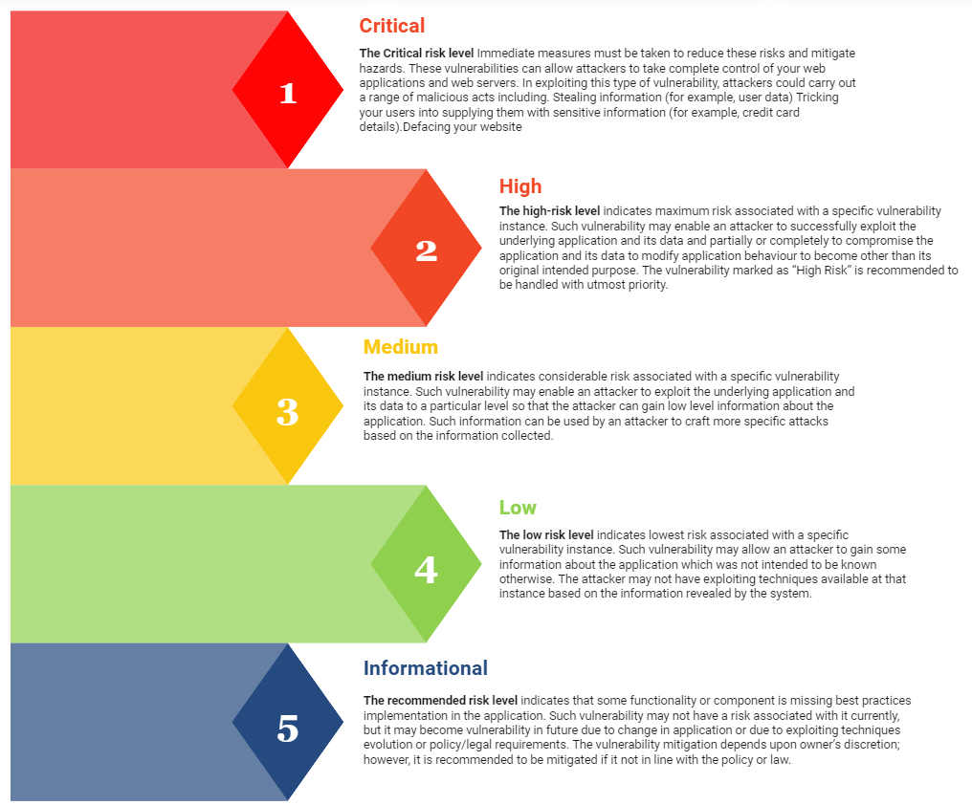

{{document_id}}

SCAN Type
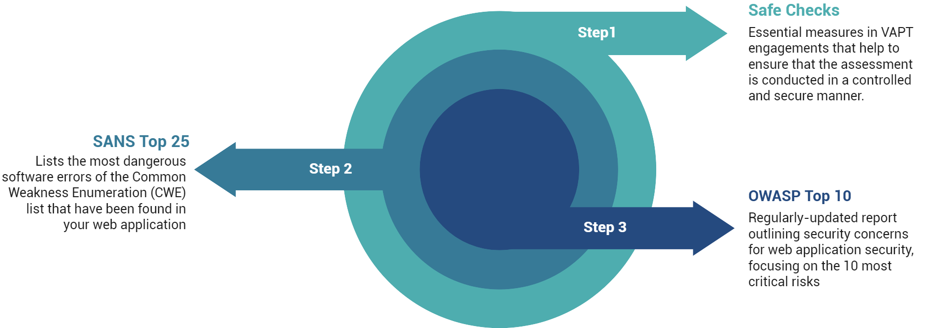

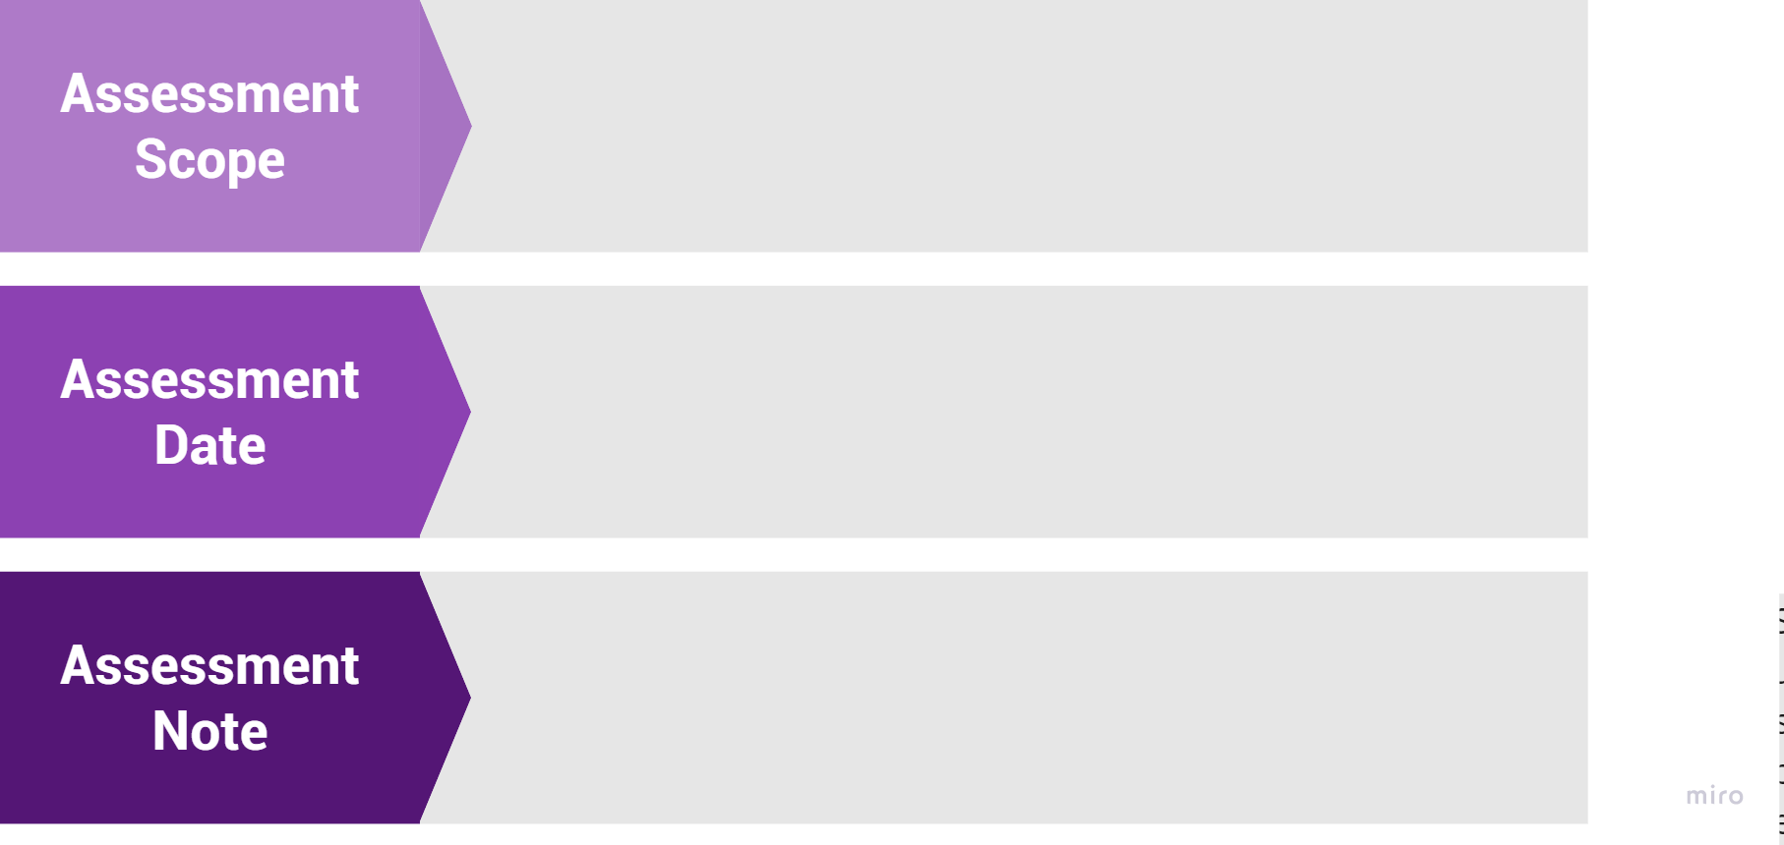
The application security assessment is done:
{{assessment_scope}}

The security vulnerabilities were reported for the following quarter on:
{{date_range}}

{{ assessment_note }}

List of Tools.
{{document_id}}

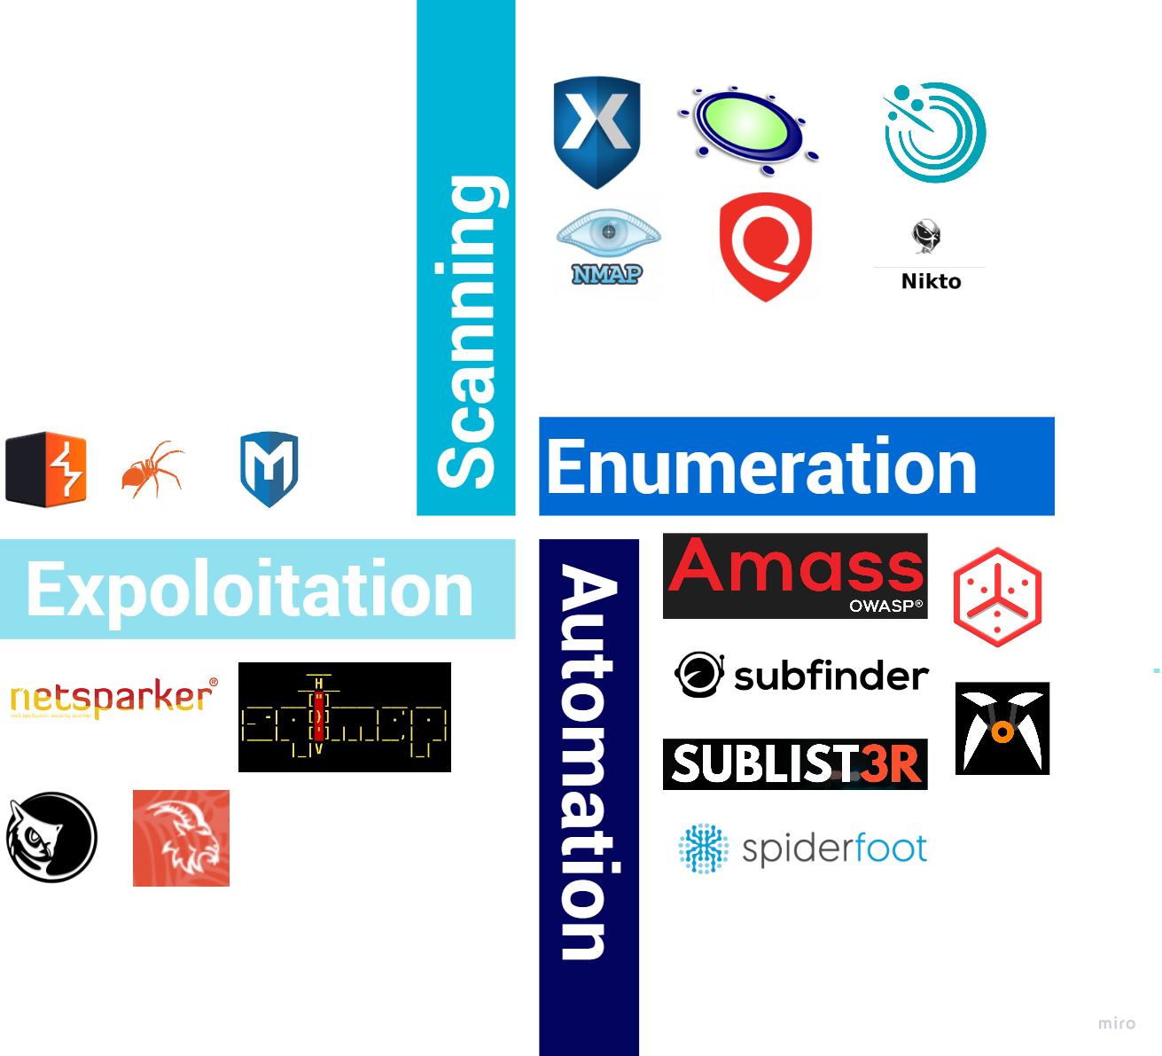

{{document_id}}

Overall Findings

Risk Assessment Analysis of the IPs
_RISK_ASSESSMENT_ANALYSIS_PLACEHOLDER_

Test Case
_TEST_CASE_TABLE_PLACEHOLDER_

Vulnerabilities Found
_VULNERABILITIES_FOUND_PLACEHOLDER_

URL
_VULNERABILITY_SUMMARY_TABLE_PLACEHOLDER_

{{document_id}}

{{document_id}}

{{document_id}}

