Contents

Introduction 4

Data Dictionary of dataset 4

Objective 4

Part A 4

Solution 4

Code 5

Code 5

Part B 6

Solution 6

Observation 6

Output 7

Observation 7

Explaining reasoning for solution 8

Implementing ways to treat missing values 8

Output 8

Output 9

Observation 9

Code 9

Output 9

Observation 9

“yob” column 9

Code 9

Output 10

Code 10

Output 10

“age” column 10

Code 10

Code 11

“gender” column 11

Output 11

Code 11

Output 11

Is there still any missing value? 12

Output 12

Observation 12

Interesting Observation 12

Part C 12

Solution 13

Treating Issue 1 13

Output 13

Output 13

“yob” column 13

Output 14

Output 14

Output 14

Treating Issue 2 14

Output 15

Output 15

Observation 15

Treating issue 3 15

Output 16

Output 16

Removing the missing valued records 16

Output 16

Output 17

Observation 17

Part D 17

Solution 17

Output 17

Output 18

Part E 18

Solution 18

Code 18

Graph 19

Observation 19

Creating another Visualization 19

Code 19

Graph 20

Observation 20

Code 20

Graph 20

Observation 21

Code 21

Graph 21

Observation 21

Code 21

Graph 22

Observation 22

Code 22

Graph 23

Observation 23

Interesting Insights 23

# Introduction

The given dataset is about the commuters’ journeys. The data is comprised of 670009 records. There are 10 different variable columns which were supposed to be analyzed to get several insights from the data.

# Data Dictionary of dataset

|  |  |
| --- | --- |
| **Variable** | **Description** |
| origin | Start location identifier |
| destination | End location identifier |
| start | Start time of commuter |
| end | End time of commuter |
| id | Device/Vehicle identifier |
| type | Commuter profile type |
| subscriber | Subscribing commuter (Yes/No) |
| yob | Commuter year of birth |
| age | Commuter Age |
| gender | Commuter Gender |

# Objective

The object of this GBA is to analyze the dataset, perform necessary cleaning, and get familiar with the process of data preparation.

# Part A

In the requirements, it is given that in the dataset, ‘-’, ‘--’, and ‘?’ are considered as missing values, and the variable columns of the dataset are noted as in the data dictionary in order. As part of data preparation, read the dataset in as a Pandas dataframe, with the above considerations.

# Solution

# Importing the necessory library

import pandas as pd

# Reading the dataset as Pandas dataframe

commuters = pd.read_csv('./GBA_data.csv')

commuters.head()

By using this code, we imported the required dataset in a variable and saw the top 5 rows of the data.

After that, we checked the basic information about the data. This was done by using the following code:

## Code

# Checking the basic information about the data

commuters.info()

Output:

## Code

# Using describe() to get some more information about the features

commuters.describe()

With the given considerations, the dataset was read.

# Part B

Identify the variable columns which have missing values. As part of data preparation, implement ways to treat them, and explain your rationale. State any interesting observation(s).

# Solution

# Checking the null values in the dataset.

commuters.isna().sum()

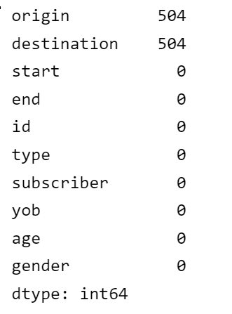

## Observation

There are two columns in the dataset which have blank values in the samples. Both columns are of float datatype.

To identify the variables which contained the missing values, following code was written:

# Making a userdefined function to check which feature columns have any of the missing values.

def check_missing_values(variable_column):

    '''

    Check any of the missing value in the variable column.

    '''

    missing_value_1 = "-" in variable_column

    missing_value_2 = "--" in variable_column

    missing_value_3 = "?" in variable_column

    to_return = [True]

    if missing_value_1:

        to_return.append("-")

    if missing_value_2:

        to_return.append("--")

    if missing_value_3:

        to_return.append("?")

    if missing_value_1 or missing_value_2 or missing_value_3:

        return to_return

    else:

        return False

# Storing the results in a dictionary by calling a function on all columns

result = {}

for column in commuters.columns:

    result[column] = check_missing_values(list(commuters[column].unique()))

result

## Output

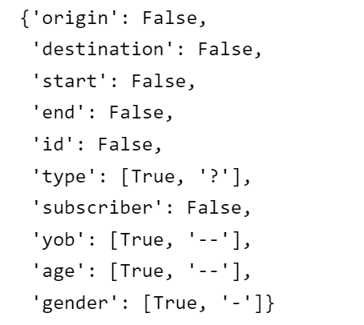

## Observation

We have identified that the feature columns `origin` and `destination` have the blank values in them by using `isna()`. Also, there are the columns `type`, `yob`, `age`, and `gender` which have the missing values. The function is returning the columns which have missing values along with the missing values which are present in those columns.

# Explaining reasoning for solution

When we are dealing with the missing values in a dataset, we can perform different operations on them. They could be:

1. Fill the missing values with some appropriate value (Also known as Imputation)
2. Remove the samples with the missing values altogether

In the case of excessively large number of samples present, we can skip the samples with the missing values. Otherwise, we prefer to fill them with some appropriate values.

The missing values can be filled with the maximum number of values that are present in the column. They can also be filled with the average of all the available values in the case of numeric column. In some cases, we can fill the missing values with the label "missing" to identify that these were the cells which are filled during Imputation.

# Implementing ways to treat missing values

# Removing the samples with missing values in the “origin” column

commuters.dropna(subset=['origin'], inplace=True)

commuters.isna().sum()

## Output

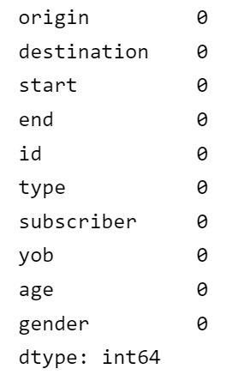

commuters.info()

Now from the output shown above, we can see that the `type` column has `?` missing value. As the `type` is of `object` datatype, we will be filling it with the maximum value that appears in the `type` column.

commuters['type'].value_counts()

## Output

## Observation

`type` column has a value: `Regular` which appeared most of the times. So, we are filling the missing value with `Regular`.

## Code

commuters['type'] = commuters['type'].replace({"?": "Regular"})

# Checking the "type" column for missing values

commuters['type'].value_counts()

## Output

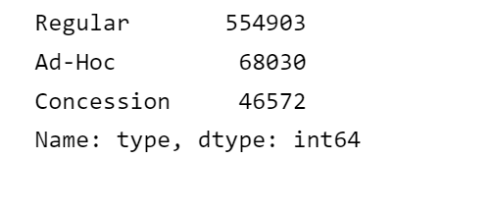

## Observation

Now we see that, the missing value does not exist anymore. Similar procedure will be applied for other columns with missing values.

## “yob” column

## Code

commuters['yob'].value_counts()

## Output

## Code

commuters['yob'] = commuters['yob'].replace({"--": 1988})

commuters['yob'].value_counts()

## Output

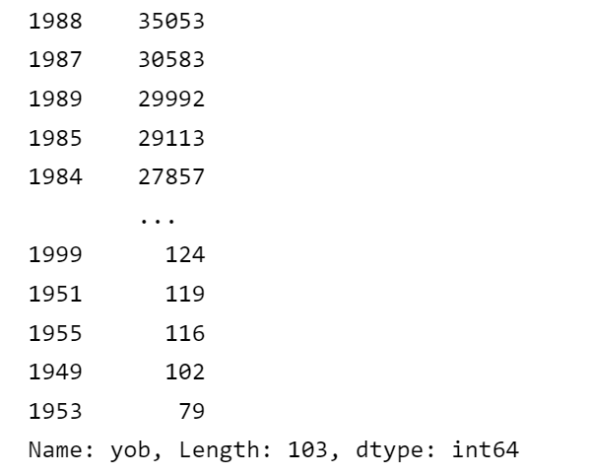

## “age” column

## Code

commuters['age'].value_counts()

## Code

commuters['age'] = commuters['age'].replace({"--": 32})

commuters['age'].value_counts()

## “gender” column

commuters['gender'].value_counts()

## Output

## Code

commuters['gender'] = commuters['gender'].replace({"-": "Male"})

commuters['gender'].value_counts()

## Output

## Is there still any missing value?

# Checking whether any of the column still contains some missing values or not

result = {}

for column in commuters.columns:

    result[column] = check_missing_values(list(commuters[column].unique()))

result

## Output

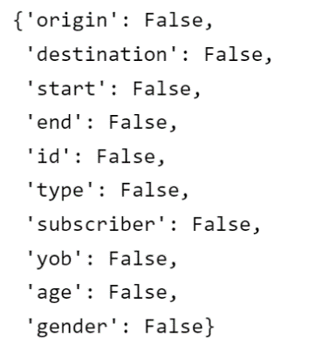

## Observation

All the missing values are now gone, and the dataset is now filled.

## Interesting Observation

Following are some interesting observations made during the process:

1. When performing the replacement in the data, we encountered the issue of `chained indexing`. While the process of chain indexing, we got `SettingWithCopy` warning. This occurred because in this case, it's hard to predict whether it will return a view or a copy. That's why we changed this method with the replacing method.
2. While finding the missing values, the blank values were not being compared as they had not any specific datatype. So, for getting rid of those missing data, we removed the samples with the missing values.
3. After handling with the missing values, our dataset is now filled and does not contain any missing values.

# Part C

As part of data preparation, identify ***three (3)*** other data quality issues in the data. Similarly, suggest and implement ways to treat them, and explain your rationale.

# Solution

The other quality issues encountered are following:

1. **Mixed Datatypes**: There is `type mismatch` in `age` and `yob` columns. Some of the values are in string format and some are in the numeric format. This causes the problem in dealing with the same kind of data. For example, if we want to sort the list, it would not possible because of the data type mixing.
2. **Create Dummy Variables**: There are some categorical variable columns which need to be reduced during data preparation. Keeping all our data in numeric format is one of the quality assurances about the data.
3. **Too much Data**: I think that there is too much data in the dataset which is causing some difficulty in getting information from some attributes of data. Due to the massive amount of data, some other data quality issues are becoming more severe. It sometimes become difficult to extract information of such type of columns which have too much unique values as we cannot compare them with some other independent variable columns. Sometimes these kinds of features need transformation to be properly scaled.

# Treating Issue 1

commuters['age'].unique()

## Output

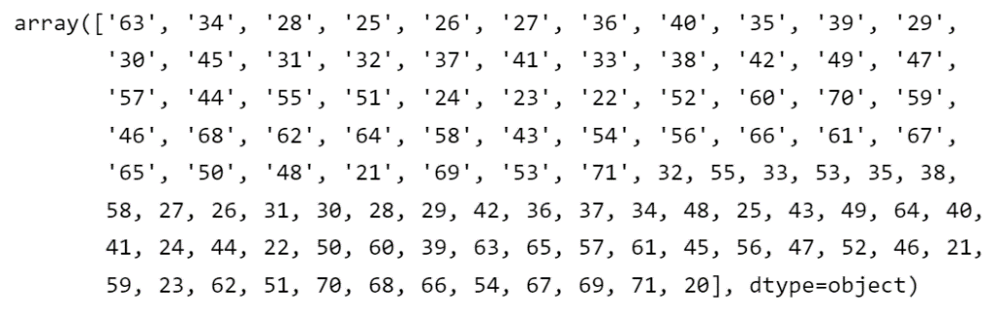

We will now resolve this issue:

commuters['age'] = commuters['age'].astype('int64')

commuters['age'].unique()

## Output

# “yob” column

commuters['yob'].unique()

## Output

commuters['yob'] = commuters['yob'].astype('int64')

commuters['yob'].unique()

## Output

commuters.info()

## Output

# Treating Issue 2

Now we will see how to convert categories into numbers

commuters.head()

dummies = pd.get_dummies(commuters[["type", "gender"]])

dummies.head()

## Output

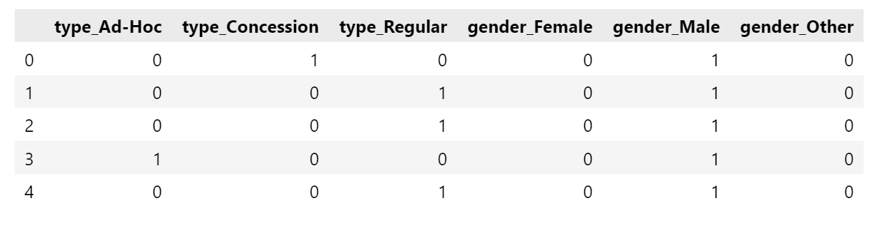

dummy_dataframe = commuters.drop(["type", "gender"], axis=1)

pd.concat([dummy_dataframe, dummies], axis=1).head()

## Output

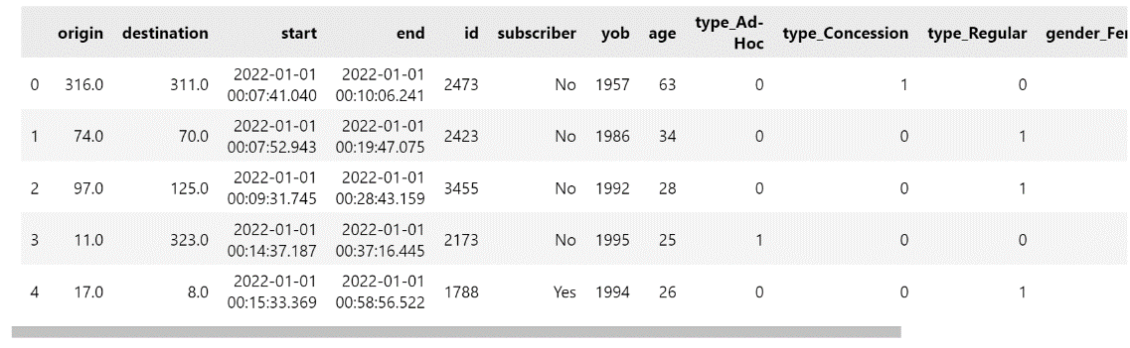

## Observation

Now we have the encoded the values of the columns and the nominal nature of variables is reduced to numbers. We can use it in our dataset and then use for further procedure. If we treat any numerical column as a category, we can use astype to change them to 'category', 'str' or 'object' before converting it to dummy.

# Treating issue 3

For treating this issue, we can transform our variables so that they can be matched with other variables in the dataset.

But for achieving some sort of precision, we can also remove all the data with missing or ambiguous value so that our dataset can get rid of the records with missing values and the massive nature of data can also be reduced along with that.

# Reading the dataset again

df = pd.read_csv('./GBA_data.csv')

df.head()

len(df)

## Output



# Checking whether any of the column contains some missing values or not

result = {}

for column in df.columns:

    result[column] = check_missing_values(list(df[column].unique()))

result

## Output

## Removing the missing valued records

# remove rows using the drop() function

df.drop(df.index[df['type'] == '?'], inplace=True)

df.drop(df.index[df['yob'] == '--'], inplace=True)

df.drop(df.index[df['age'] == '--'], inplace=True)

df.drop(df.index[df['gender'] == '-'], inplace=True)

len(df)

## Output

# Checking whether any of the column contains some missing values or not

result = {}

for column in df.columns:

    result[column] = check_missing_values(list(df[column].unique()))

result

## Output

## Observation

Here we can see that the input data now does not contain any assumed values. Also, some amount of data is reduced which is not affecting much as compared to our initial amount of data. So, sometimes we need to remove the ambiguous data to retain the precision.

# Part D

Develop a user-defined function that will print the hour, expressed in the 12-hour clock format (e.g., 12am, 1pm), whereby the highest number of commuters start their journey.

# Solution

commuters['start']

## Output

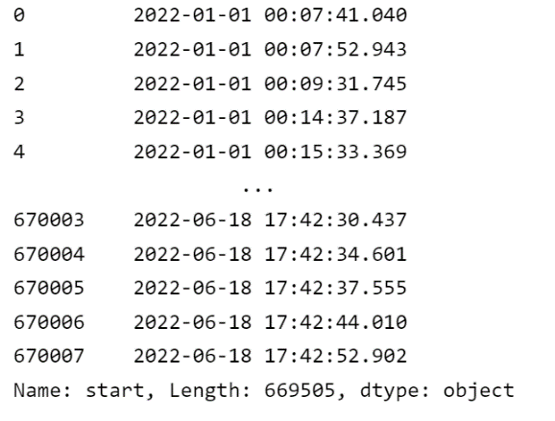

def get_highest_starting_hour():

    start_times = []

    for start_date_and_time in commuters['start']:

        start_date_and_time = start_date_and_time.split(' ')

        start_times.append(start_date_and_time[1])

    occurences = {}

    for start_time in start_times:

        start_time = start_time.split(':')[0]

        if start_time in occurences:

            occurences[start_time] += 1

        else:

            occurences[start_time] = 1

    highest_starting_hour = int(max(occurences, key=occurences.get))

    if highest_starting_hour > 12:

        return str(highest_starting_hour - 12) + "pm"

    elif highest_starting_hour == 0:

        return "12am"

    elif highest_starting_hour == 12:

        return "12pm"

    else:

        return highest_starting_hour + "am"

print(f"The highest number of commuters start there journey at: {get_highest_starting_hour()}")

## Output



# Part E

Write a Python code to create appropriate visualisations of the commuter data. Analyse the results and then discuss three (3) interesting insights.

# Solution

## Code

import matplotlib.pyplot as plt

import numpy as np

%matplotlib inline

commuters['type'].value_counts()

commuters['type'].value_counts().plot(kind="bar",

                                      color=['salmon', 'lightblue', 'lightgreen']);

plt.title('Frequency of Each Customer Profile Type')

plt.xlabel('Customer Profile Type')

plt.ylabel('Amount');

## Graph

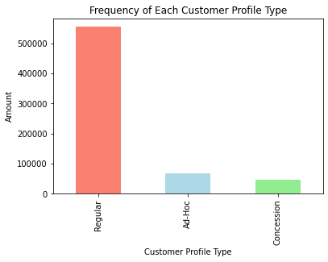

## Observation

We can see that a greater number of commuters are of `Regular` type rather than Concession of Ad-Hoc. It means that the ratio of regular customers is more than the others.

## Creating another Visualization

## Code

pd.crosstab(commuters.subscriber, commuters.type).plot(kind="bar", figsize=(10, 6), color=["salmon", "lightblue", "lightgreen"])

plt.title("Subscribers Values for each Customer Profile Type")

plt.xlabel("Subscriber")

plt.ylabel("Count");

## Graph

## Observation

We can see here that the more `Regular` commuters are `non-Subscribing` commuters. Whereas here we can see that `Ad-Hoc` type of commuters are less in amount but all of them are non-Subscribing. We cannot see any of `Ad-Hoc` commuter who is Subscribing as well.

## Code

pd.crosstab(commuters['age'], commuters['gender']).plot(kind="bar", figsize=(15, 8), color=['salmon', 'lightblue', 'lightgreen'])

plt.title("Age Frequency of each gender")

plt.xlabel("Age")

plt.ylabel("Count");

plt.yticks(np.arange(0, 30000, 1000));

## Graph

## Observation

Here we can infer that more of the commuters are Males. Also, the maximum number of commuters are of age `32`. This graph is clearly showing that we have very rare number of commuters who have `other` gender. Also, after age 60, there is a smaller number of Females. The range of age can be seen from 20 to 71.

## Code

# Create figure

plt.figure(figsize=(12,8))

# Scatter for subsctibing customer

plt.scatter(commuters.type[commuters.subscriber=="Yes"],

            commuters.id[commuters.subscriber=="Yes"],

            c="lightblue"); # axis always come as (x, y)

## Graph

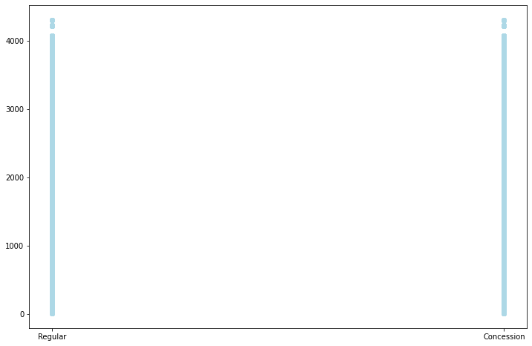

## Observation

From the given information we can infer that there are no `Ad-Hoc` type of commuters who are subscribers. But we can see the graph of those commuters who are non-subscriber. This will show us that the non-subscribers are of each type.

## Code

# Create figure

plt.figure(figsize=(12,8))

# Scatter for subsctibing customer

plt.scatter(commuters.type[commuters.subscriber=="Yes"],

            commuters.id[commuters.subscriber=="Yes"],

            c="lightblue") # axis always come as (x, y)

# Scatter for non-subscribing customer

plt.scatter(commuters.type[commuters.subscriber=="No"],

            commuters.id[commuters.subscriber=="No"],

            c="salmon") # define it as a scatter figure

# Add some helpful info

plt.title("Subscriber in function of Type and Id")

plt.xlabel("Type")

plt.legend(["Subscriber=No", "Subscriber=Yes"])

plt.ylabel("ID")

plt.yticks(np.arange(0, 4500, 250));

## Graph

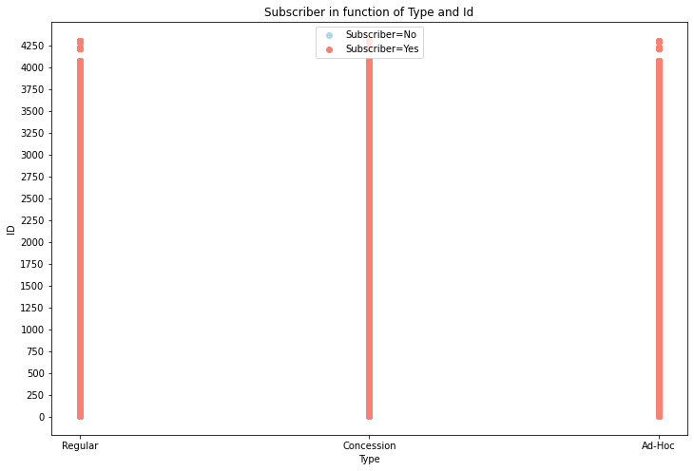

## Observation

Now we can see that all the `lightblue` dots are hidden below the `salmon` dots. This is because the `non-subscribing` commuters are in all type of commuters and in all genders (will be shown below).

## Code

pd.crosstab(commuters['subscriber'], commuters['gender']).plot(figsize=(10, 6), kind='bar', color=['salmon', 'lightblue', 'lightgreen']);

# Add some helpful info

plt.title("Subscriber Frequency of Each Gender")

plt.xlabel("Subscriber")

plt.legend(["Female", "Male", "Other"])

plt.ylabel("Count");

## Graph

## Observation

When we compare the subscribing and non-subscribing commuters, we can get to know that a greater number of Males and females are un-subscribing. Commuters with `other` as gender are only non-subscribing commuters.

Now as a whole we can infer that a greater number of consumers are `Un-Subscribing` altogether.

# Interesting Insights

After observing the whole dataset, we have got different interesting information about the data. Some interesting insights which we have got are:

1. More number of commuters are `Males`.
2. More number of commuters are `Un-Subscribing`.
3. We mostly have the `Regular` type of customers.
4. We can feel that the commuters of age range `25-40` are in greater amount. This means that we have more young commuters than the other aged ones.
5. Different commuters start their journey at different times but mostly the journey is started in evening time.