# 

**NATIONAL OPEN UNIVERSITY OF NIGERIA**

**OPTIMIZING PERSONAL PRODUCTIVITY: A CODING APPROACH TO TASK MANAGEMENT SYSTEMS**

**BY**

**IBHAFIDON EHIREMEN FRANCIS**

**NOU232146157**

**MAY 2024**

**CERTIFICATION**

This is to certify that this project title OPTIMIZING PERSONAL PRODUCTIVITY: A CODING APPROACH TO TASK MANAGEMENT SYSTEMS was written and compiled by IBHAFIDON EHIREMEN FRANNCIS with matriculation number NOU232146157 in the department of Computer Science, in partial fulfillment for the award of Masters of Information Technology from National Open University of Nigeria, Lagos State.

-------------------------------- --------------------------------

IBHAFIDON EHIREMEN FRANCIS DATE

STUDENT

-------------------------------- --------------------------------

DR IDRIS ABIODUN AREMU DATE

PROJECT SUPERVISOR

-------------------------------- --------------------------------

MRS VERONICA DATE

HEAD OF DEPARTMENT

**DEDICATION**

This project is dedicated to God Almighty who is the maker of heaven and earth and also to my wonderful parents, MR AND MRS FRANCIS IBHAFIDON.

**ACKNOWLEDGMENT**

All glory be unto God Almighty, the beginning and the end, the first and the last, for his guidance, help, knowledge, and understanding given to me all through the course of this od program. May His name be praised

Another great appreciation to my parents, MR AND MRS IBHAFIDON, I appreciate. Your unwavering support, endurance, care, and many more. I pray that God will make you reap the fruits of your labor in Jesus' name

My utmost appreciation to my wonderful supervisor in person of DR IDRIS ABIODUN AREMU, an enthusiastic and supportive supervisor. I say a very big thank you to him and I pray he meets the mercy of God everywhere he goes.

To the Head of the Department, the very energetic MRS VERONICA, a very loving woman, I say a very big thank you for your regular answers to questions and issues. I pray that God keeps sustaining you.

A big thank you to my friends for their support and motivation in Olubori, Imoroa Joshua, Akinola Esther, Akoja Toniloba, Akingbade Esther, and all my friends and teachers. I say a very big thank you and I pray we all meet the grace and mercy of God everywhere we go

# 

# **TABLE OF CONTENT**

**TABLE OF CONTENT**

**ABSTRACT**

**Chapter 1: Introduction 1**

1.1 Background 1

1.2 Problem Statement 3

1.3 Aim 4

1.4 Objectives 5

1.5 Scope 5

1.6 Significance of Study 6

**Chapter 2: Literature Review 8**

2.1 Introduction to Task Management Systems 8

2.2 Existing Task Management Systems 10

2.3 Research Gaps and Opportunities 12

**Chapter 3: Methodology 14**

3.1 Research Approach 14

3.2 Choice of Development Framework Used 15

3.3 System Requirements and Design 16

3.3.1 Functional Requirements 16

3.3.2 Non-Functional Requirements 17

3.4 Implementation Details 20

3.5 Test and Evaluation 23

**Chapter 4: Functionality Presentation 26**

4.1 System Functionality 26

4.2 Performance Evaluation 39

**Chapter 5: Conclusion 42**

5.1 Summary of Findings 42

5.2 Conclusion 44

5.3 Recommendations 45

**REFERENCES 48**

# 

# **ABSTRACT**

Task management systems have become essential tools for modern organizations seeking to optimize productivity and streamline workflow processes. This project endeavors to develop a sophisticated task management system using Django for the backend and Google’s Flutter framework for the frontend, with a primary emphasis on simplicity, flexibility, and security. The proposed system aims to address the complexities of task management by offering intuitive user interfaces, personalized home pages, and a comprehensive suite of features, including task creation, assignment, tracking, and communication functionalities. Special attention is given to security measures, particularly during the sign-up and sign-in processes, to ensure the confidentiality and integrity of user data. By integrating principles of computer programming into task management strategies, this project seeks to provide users with a highly customizable and efficient solution tailored to their unique needs and preferences. Through rigorous testing and iterative development processes, the resulting system aims to enhance personal and organizational productivity while fostering a more streamlined and efficient workflow across various professional settings.

**KEYWORDS**

Task management systems, Django, Flutter, productivity, workflow optimization.

# 

# **Chapter 1: Introduction**

## 1.1 Background

Task management systems have become indispensable tools in modern organizations, offering structured approaches to streamline workflow and enhance productivity (Diaz, 2023). These systems facilitate efficient task allocation, and progress tracking, and ensure the completion of work within specified timelines. In today's dynamic business environment, characterized by rapid technological advancements and evolving market demands, task management systems play a crucial role in enabling organizations to adapt swiftly and allocate resources effectively.

The CHAOS research conducted by the Standish Group in 2004 analyzed 50,000 IT projects, revealing alarming statistics: 31% of projects were abandoned before completion, 53% exceeded their initial budget by over 50%, and only 16% were deemed successful (Standish Group, 2004). A decade later, while there was a slight improvement, with 29% of projects completed within scope, time, and budget, issues such as inadequate monitoring and low user participation persisted (Standish Group, 2014). These findings underscore the importance of robust task management systems in mitigating project failures and ensuring successful outcomes.

The flexibility inherent in task management systems is pivotal in navigating today's volatile marketplace, where the ability to respond promptly to emerging opportunities and challenges is imperative. Additionally, these systems foster transparency and accountability within teams, facilitating clear communication and efficient resource allocation (Diaz, 2023). By providing visibility into individual responsibilities and project progress, task management systems mitigate misunderstandings and conflicts, thereby promoting collaboration and synergy among team members.

Furthermore, task management systems offer significant benefits in terms of stress reduction and improved work-life balance (FasterCapital, 2024). By enabling individuals to organize and prioritize tasks effectively, these systems alleviate the burden of excessive workload and prevent burnout, thereby fostering a healthier and more conducive work environment.

In conclusion, task management systems are integral to the functioning of modern organizations, offering a plethora of advantages ranging from enhanced productivity and flexibility to improved collaboration and stress reduction. By optimizing the utilization of these systems, organizations can bolster their performance and maintain a competitive edge in today's dynamic business landscape.

## 1.2 Problem Statement

The optimization of individual efficiency and output through the integration of programming principles into task management systems presents several challenges (Projectsly, 2022). These challenges encompass the identification and resolution of inefficiencies in existing task management practices, as well as the development of solutions to streamline these processes.

One of the primary challenges stems from the prevalent struggle among individuals and organizations to manage tasks effectively, leading to diminished productivity and output (FasterCapital, 2024). This inefficiency often arises from a lack of organization, inadequate prioritization, and inefficient utilization of time and resources.

Moreover, traditional task management systems may fall short in addressing the complex and dynamic nature of contemporary work environments (Kozlowski & Ilgen, 2006). These systems may lack the requisite flexibility and adaptability to accommodate diverse tasks with varying degrees of complexity and urgency, thereby hindering optimal task management practices.

From a programming standpoint, addressing the complexities of task management necessitates the development of advanced algorithms and data structures (Cormen et al., 2009). This entails the creation of intelligent systems capable of automating tasks such as prioritization, resource allocation, and progress tracking.

Furthermore, the challenge extends to ensuring that optimized task management systems are user-friendly and accessible to individuals with varying levels of technical proficiency. This entails designing intuitive interfaces and user experiences that facilitate seamless task management for users, irrespective of their programming expertise.

## 

## 1.3 Aim

This project aims to develop a task management system using Django, a high-level Python web framework known for its rapid development capabilities and pragmatic design principles, and Google's Flutter framework for creating intuitive user interfaces based on widgets. The system will be designed to handle multiple tasks, track their status, and provide updates and notifications to users.

## 1.4 Objectives

The objectives of the project are multifaceted. Firstly, the project aims to create customizable features within the task management system, allowing users to tailor the interface, task types, and notifications according to their specific requirements. Additionally, the system will be optimized to enhance personal productivity by facilitating efficient task management through features such as prioritization, time tracking, and productivity reports.

Furthermore, the project endeavors to ensure that the task management system is user-friendly and intuitive, accommodating users with varying levels of technical expertise. Finally, the system will be rigorously tested to ensure robustness and reliability, capable of handling numerous tasks without encountering performance issues or errors.

## 

## 1.5 Scope

The scope of the project encompasses the design and development of a comprehensive task management system utilizing the Django web framework. The system will include functionalities such as task creation, assignment, tracking, and completion, along with features for setting priorities, deadlines, and reminders.

Additionally, the system will facilitate collaboration among multiple users, providing real-time updates and notifications to keep all team members informed about task progress. User management functionalities, including registration, authentication, role assignment, and access control, will also be incorporated to ensure data security and privacy.

However, certain constraints and limitations may impact the project scope, including the technical proficiency of users, time constraints, and resource availability. These factors will be taken into consideration during the development process to ensure the successful implementation of the task management system.

## 1.6 Significance of Study

The significance of optimizing personal productivity through a coding approach to task management systems extends beyond practical applications to academic research. By integrating principles of computer programming into personal productivity strategies, this approach offers a novel perspective that can drive the development of new theories and models in time management, organizational behavior, and human-computer interaction (Grant, 2012; Oulasvirta & Hornbæk, 2016).

Furthermore, customizable task management systems have the potential to address real-world needs across various settings, including corporate environments. By tailoring the system to specific workflows and project management requirements, organizations can optimize productivity and efficiency (Baskerville & Myers, 2004).

In educational settings, the adoption of digital tools for task management can positively impact students' academic performance by fostering effective study habits and time management skills (Rosen et al., 2013). Thus, the implications of this study extend beyond organizational contexts to encompass broader societal benefits in terms of personal and professional development.

# 

# **Chapter 2: Literature Review**

## 2.1 Introduction to Task Management Systems

Task management systems serve as digital platforms aimed at facilitating task tracking, organization, and completion for individuals and organizations (Wong & Senaratne, 2018). These systems offer comprehensive views of tasks, their progress, and assignees, aiming to optimize task management processes. By facilitating prioritization, resource allocation, and progress monitoring, task management systems contribute significantly to enhancing productivity and efficiency across various domains.

Common features of task management systems include task creation, assignment, tracking, deadline setting, and progress monitoring (Koch, 2017). Additionally, these systems often provide project planning tools, collaboration features, and integrations with other software applications. Such features empower users with holistic task and project management capabilities, thereby facilitating efficient workload management and ensuring timely task completion.

The evolution of task management systems has been driven by technological advancements and evolving workplace requirements (Zheng & Frank, 2020). Initially, these systems were standalone software solutions focusing on individual tasks. However, with technological progress, task management systems have evolved into cloud-based platforms offering real-time collaboration and integration with other tools. Today's systems are equipped to support complex projects with multiple tasks and subtasks, emphasizing team collaboration over individual usage. This evolution underscores the growing demand for sophisticated task management solutions in contemporary workplaces.

Task management systems are pivotal for enhancing organizational productivity by facilitating timely task completion and resource utilization (Kang & Kim, 2019). By providing clear task overviews and progress tracking capabilities, these systems enable bottleneck identification, work prioritization, and efficient resource allocation. Consequently, productivity is heightened as tasks are completed expeditiously, and resources are utilized optimally, thereby bolstering overall organizational performance.

Moreover, task management systems play a vital role in fostering communication and collaboration within teams (Fogli & Piccinno, 2019). By serving as centralized platforms for task management, these systems ensure team alignment and information dissemination, reducing the likelihood of miscommunication and facilitating coordinated task execution. This enhanced communication and coordination not only augment team productivity but also minimize time spent on unnecessary communication and coordination endeavors, thereby optimizing overall team performance.

## 2.2 Existing Task Management Systems

The landscape of task management systems is characterized by diversity, with a plethora of tools and platforms widely utilized across various industries (Karlsen & Schmidt, 2021). Among the prominent platforms are Asana, Trello, Jira, Monday.com, Microsoft Planner, and Todoist, catering to industries spanning software development, IT, marketing, project management, and education. This diversity underscores the necessity for tailored solutions addressing distinct industry requirements, thereby driving the widespread adoption of task management systems across diverse sectors.

Asana emerges as a highly flexible tool renowned for task creation, assignment, and tracking capabilities, coupled with seamless integration with tools like Slack and Google Drive (FreshBooks, 2024). While lauded for its simplicity, Asana may lack the robustness for large-scale project management and exhibit limited customization options.

Trello distinguishes itself with its visual, board-based approach to task management, appealing to visual thinkers and teams requiring high-level project progress visibility (Simplilearn, 2024). However, Trello may not be as suitable for tasks necessitating detailed tracking or intricate workflows, with its customization options relatively constrained.

Jira emerges as a potent tool prevalent in software development for bug tracking and project management, offering extensive customization options, including custom workflows (Majumder, n.d.). Nevertheless, Jira's complexity may pose a barrier for novice users, and its suitability for smaller teams or simpler projects may be questioned.

Monday.com stands out for its colorful, intuitive interface and comprehensive customization options, catering to teams requiring diverse task and workflow-tracking functionalities (Raymond, 2023). However, Monday.com's user-friendliness may vary, and its pricing may deter smaller teams from adoption.

Microsoft Planner offers seamless integration with the Microsoft Office 365 suite, making it an attractive option for organizations already utilizing Microsoft tools (Microsoft, n.d.). Its intuitive interface and task board layout simplify task management, but its customization options may be limited compared to other platforms.

Todoist is lauded for its simplicity and focus on individual task management, offering features such as task creation, scheduling, and prioritization (Higuera, 2021). While Todoist excels in personal task management, its collaborative features and project management capabilities may be lacking compared to other platforms.

## 2.3 Research Gaps and Opportunities

While the existing literature on task management systems is extensive, several research gaps necessitate attention. Firstly, there exists a dearth of research elucidating the impact of customization on user experience and productivity within task management systems (Steinhardt & Westermann, 2019). While general studies on customization benefits abound, focused research on how customization augments personal productivity within task management systems remains lacking.

Secondly, the potential of AI and machine learning in task management systems remains underexplored, despite widespread AI applications in other domains (Davenport & Ronanki, 2018; MacCormick & Gordon, 2021). Further research in this area could yield significant insights into predictive task management and intelligent task prioritization, enhancing system efficiency and user experience.

Moreover, limited literature addresses the integration of task management systems with other productivity tools, despite the prevalence of tool diversification among programmers (Schlumberger & DuBois, 2017). Understanding how task management systems seamlessly integrate with complementary tools could substantially enhance programmer productivity and workflow efficiency.

Furthermore, scalability concerns in task management systems warrant greater scholarly attention, particularly concerning system efficiency and effectiveness as task and user volumes escalate (Martin, 2019). Addressing scalability challenges is critical to ensuring sustained system performance and user satisfaction amidst organizational growth and evolving demands.

Lastly, research on task management systems predominantly focuses on individual use, neglecting the dynamics of collaborative settings and their impact on productivity (Sharma & Sharma, 2020). Further investigation into team utilization of task management systems and their implications for collaborative productivity is essential for comprehensive system optimization and workplace effectiveness.

# 

# **Chapter 3: Methodology**

## 3.1 Research Approach

The research approach adopted for the development of the task management system was primarily empirical, encompassing both qualitative and quantitative methods. This approach was chosen to ensure a thorough understanding of the problem domain and to facilitate the development of a robust and effective solution. The research commenced with a comprehensive literature review aimed at understanding existing task management systems and identifying their limitations. Subsequently, user interviews and surveys were conducted to gather insights into the specific needs and preferences of the target user group.

The subsequent phase of the research involved the analysis of the collected data, which served as a foundation for identifying the key features and functionalities that the task management system should encompass. This analysis informed the development of a prototype, which underwent rigorous testing and refinement based on user feedback. The research process followed an iterative approach, with each iteration yielding valuable insights that guided the subsequent stages of development.

## 3.2 Choice of Development Framework Used

Django was selected as the framework for developing the task management system due to its robustness, scalability, and ease of use. Django, a high-level Python web framework, fosters rapid development and maintains a clean, pragmatic design philosophy. Equipped with a rich set of features including an object-relational mapper, a dynamic admin interface, and a flexible authentication system, Django provides a powerful toolkit for building complex web applications.

Moreover, Django's 'batteries-included' philosophy reduces reliance on third-party libraries by incorporating most components essential for web development. This feature expedites the development process and minimizes potential compatibility issues. Additionally, Django boasts a large and active community, ensuring readily available support in the event of development challenges.

The chosen development methodology for the project was Agile. Agile methodology, emphasizing collaboration, customer feedback, and incremental releases, aligns well with the dynamic nature of software development. This approach facilitates continuous improvement and adaptation, vital in a rapidly evolving field such as software development. Furthermore, Agile promotes direct communication and collaboration, fostering a deeper understanding of customer needs and ensuring a higher quality product.

Agile methodology synergizes effectively with Django's philosophy of rapid development. The iterative nature of Agile enables developers to leverage Django's features to swiftly build, test, and refine the application. This harmonious interplay between the development methodology and the chosen framework contributes to a more efficient and effective development process.

## 3.3 System Requirements and Design

### **3.3.1 Functional Requirements**

Functional requirements of the task management system encompass various facets including task creation, assignment, tracking, prioritization, and completion. Task creation entails defining new tasks, and specifying details such as task name, description, due date, and associated tags or categories. Task assignment involves assigning tasks to individuals or teams. Task tracking encompasses monitoring task progress, including status updates, completion percentages, and relevant comments. Task prioritization involves ordering tasks based on their importance or urgency. Finally, task completion entails marking tasks as completed and archiving or deleting them.

### **3.3.2 Non-Functional Requirements**

Non-functional requirements of the task management system revolve around performance, security, usability, and scalability. Performance requirements may stipulate maximum response times for system interactions. Security requirements may mandate user authentication, data encryption, and access controls. Usability requirements may necessitate a user-friendly interface, intuitive navigation, and comprehensive help documentation. Scalability requirements may pertain to the system's ability to accommodate a large number of tasks, users, or concurrent sessions.

The system architecture of the task management system may adopt a three-tier architecture comprising a presentation layer, a business logic layer, and a data storage layer. The presentation layer manages the user interface and user interactions, while the business logic layer handles task management operations such as task creation, assignment, tracking, prioritization, and completion. The data storage layer facilitates the storage and retrieval of task data.

The database schema of the task management system may include tables for tasks, users, and task assignments. The tasks table typically includes fields for task ID, task name, description, due date, status, and priority. The users table encompasses fields for user ID, username, password, and role. The task assignments table comprises fields for assignment ID, task ID, user ID, and assignment date, facilitating efficient task allocation and tracking.

| Tasks | Users | Task Assignments |
| --- | --- | --- |

**Figure 1.1 All tables created in the database**

| Id | Name | Description | Due Date | Status | Priority |
| --- | --- | --- | --- | --- | --- |
| 17-34-59 | Start Crud Project | Final Year Project | 12-5-24 | Incomplete | High |
| 78-90-12 | Start School Session | Course Registration | 22-6-23 | Complete | Medium |

**Figure 1.2 Task Table in database**

| Id | Email | Username | Password | Role |
| --- | --- | --- | --- | --- |
| 32-82-11 |  | users username | sha256-hashed-password | Individual |
| 23-23-12 | laspotech@edu.ng |  | sha256-hashed-password | Company |

**Figure 1.3 Users Table in the database**

| Assignment Id | Task Id | Assigned Users(id) | Task | Date created | Due Date |
| --- | --- | --- | --- | --- | --- |
| Jn-172v3-lsv | 17-34-59 | User 1, User 2, User 3 | Start Crud Project | 18-4-24 | 12-5-24 |

**Figure 1.4 Assignment Table in the database**

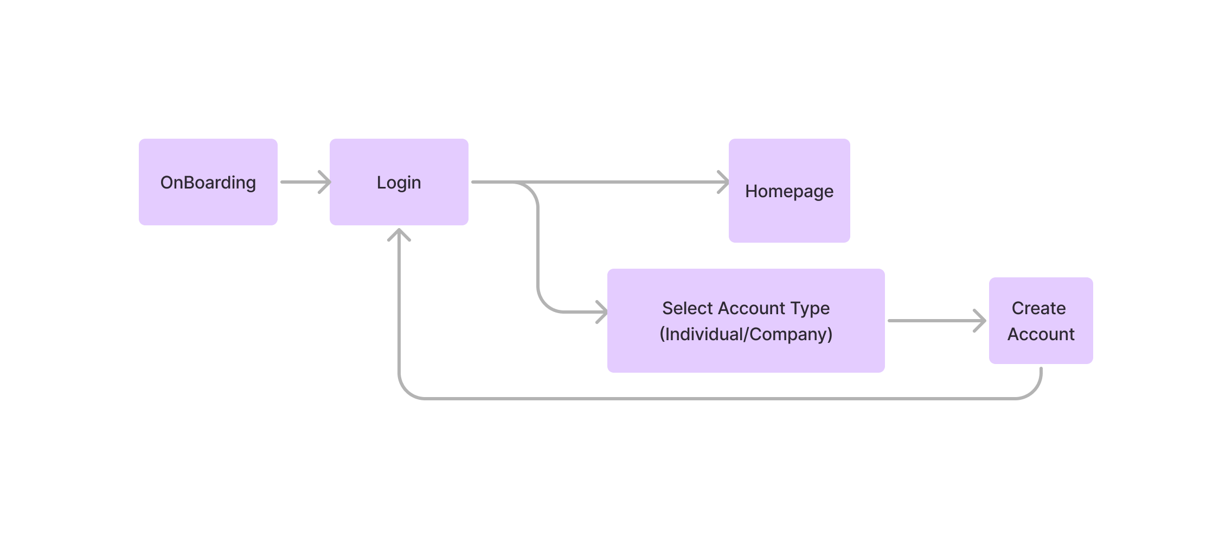

**Figure 1.5 User Flow**

## 3.4 Implementation Details

The implementation process of the task management system encompasses a series of steps aimed at bringing the envisioned system to life. Initially, meticulous attention is given to project setup and environment configuration. This involves ensuring that all necessary tools and dependencies are in place to facilitate smooth development. Django, renowned for its versatility and robustness, emerges as the framework of choice for backend development. Leveraging the extensive libraries and capabilities of Python, Django proves to be an ideal foundation for building the backend infrastructure of the task management system.

In parallel, the front-end development aspect necessitates careful consideration. Flutter, an innovative UI toolkit developed by Google, is embraced for crafting the user interface of the task management system. Flutter's cross-platform capabilities and rich widget library enable developers to create visually appealing and responsive interfaces across various devices and platforms. With its ability to compile to native code, Flutter promises a seamless user experience on mobile, web, and desktop platforms alike.

Moving forward, the backend development process delves into the intricacies of data modeling and API creation. Django's built-in models facilitate the definition of data structures for tasks, projects, and users, laying the groundwork for efficient data management. Additionally, Django Rest Framework (DRF) emerges as a cornerstone for API development. Leveraging DRF's serialization capabilities, developers swiftly create APIs that enable seamless interaction between the frontend and backend components of the system. Moreover, DRF's robust authentication and permission policies ensure the security and integrity of user data throughout the system.

Meanwhile, front-end development endeavors revolve around leveraging Flutter's widget-based architecture to craft intuitive and visually appealing user interfaces. Flutter's hot-reload feature emerges as a boon during UI development, enabling developers to iterate rapidly and visualize changes in real time. The rich set of pre-designed widgets provided by Flutter minimizes the coding effort required for UI implementation, streamlining the development process and expediting time-to-market for the task management system.

Despite the progress made, the implementation journey is not without its challenges. Managing the state in the Flutter application emerges as a significant hurdle, necessitating the adoption of suitable state management solutions such as the Provider package. This recommended approach proves instrumental in ensuring the robustness and maintainability of the Flutter application. Additionally, handling complex database queries in Django poses its own set of challenges. While Django's ORM offers powerful capabilities, navigating its intricacies requires finesse, prompting developers to resort to raw SQL queries for optimal performance and efficiency.

Ensuring the security of data during transmission between the frontend and backend components of the system emerges as a paramount concern. To address this, HTTPS is employed for all API calls, ensuring the confidentiality and integrity of data exchanged between the client and server. Furthermore, token-based authentication mechanisms are implemented within DRF to fortify the system against unauthorized access and data breaches.

In parallel, testing emerges as a critical aspect of the implementation process. Unit tests are meticulously crafted in Python to validate the functionality of the Django backend, ensuring that each component performs as intended. Simultaneously, widget tests written in Dart are employed to scrutinize the behavior of the Flutter front-end, validating its responsiveness and adherence to design specifications. Continuous integration tools are leveraged to automate the testing process, fostering a culture of quality and reliability throughout the development lifecycle.

In conclusion, the implementation of a task management system using Django and Flutter entails a multifaceted journey characterized by meticulous planning, strategic decision-making, and diligent execution. Despite encountering challenges along the way, the adept utilization of tools, frameworks, and best practices enables developers to surmount obstacles and deliver a robust and user-friendly solution poised to meet the diverse needs of its users.

## 3.5 Test and Evaluation

The testing process in software development, including the development of task management systems, is a comprehensive endeavor aimed at ensuring the reliability, performance, and usability of the software solution. Beginning with unit testing, developers meticulously scrutinize the smallest units of code in isolation, validating their functionality and behavior. These automated tests serve as a first line of defense against regressions and bugs, ensuring that each component of the system performs as expected.

Following unit testing, integration testing comes into play, focusing on verifying the interoperability and cohesion of individual units when combined. By testing the integration points between various modules and components, developers can identify and rectify any inconsistencies or compatibility issues that may arise. This collaborative approach to testing fosters confidence in the system's ability to function seamlessly as a cohesive whole.

User acceptance testing (UAT) marks the culmination of the testing process, with end-users evaluating the system in a real-world environment. This hands-on testing phase provides invaluable insights into the user experience and ensures that the system meets the expectations and requirements of its intended audience. Feedback gathered during UAT serves as a vital catalyst for refining and optimizing the system to better align with user needs and preferences.

In evaluating the performance and usability of the task management system, several criteria come into play. System responsiveness, measured by the speed and efficiency of system interactions, serves as a barometer of performance. System stability, assessed under varying loads and conditions, provides insights into the system's robustness and reliability. Additionally, system functionality is evaluated to ensure that all essential features and functionalities are present and operating correctly.

Usability emerges as a critical consideration in the evaluation process, with a focus on assessing the intuitiveness and user-friendliness of the system. Factors such as the clarity of instructions, ease of navigation, and overall user experience play a pivotal role in determining the system's usability. User feedback serves as a valuable resource for identifying areas of improvement and refining the system to enhance user satisfaction and productivity.

Ultimately, the testing and evaluation process serve as integral components of the software development lifecycle, enabling developers to deliver a high-quality and user-centric solution that meets the needs and expectations of its users. By embracing a comprehensive and iterative approach to testing, developers can ensure the reliability, performance, and usability of the task management system, paving the way for its successful deployment and adoption.

# 

# **Chapter 4: Functionality Presentation**

## 4.1 System Functionality

This task management system serves as a versatile platform aimed at optimizing the intricate process of task management within organizations of varying sizes and structures. At its core, the system is engineered to empower teams with the tools necessary to collaborate seamlessly, monitor progress effectively, and adhere to critical deadlines. Central to its functionality is its customizable nature, offering users the flexibility to mold the system according to their unique requirements, whether they belong to a small, tightly-knit team or a sprawling corporate entity.

The customizability of the task management system serves as its cornerstone, enabling users to tailor the interface, features, and workflows to align precisely with their specific needs and preferences. This adaptability ensures that the system remains agile and responsive to the evolving demands of diverse teams and projects, fostering a more efficient and productive work environment.

One of the primary advantages of a customizable task management system is its ability to accommodate the varying complexities and nuances of different projects and workflows. Users have the freedom to configure the system to reflect the intricacies of their tasks, allowing for granular control over task creation, assignment, prioritization, and tracking. Whether managing a straightforward checklist or overseeing a multifaceted project with numerous dependencies, the system can be customized to provide the optimal level of support and visibility.

Furthermore, the customizable nature of the system extends beyond its core functionality to encompass its integration capabilities. Users can seamlessly integrate the task management system with other essential tools and platforms, such as communication tools, project management software, and productivity apps. This interoperability ensures smooth data flow and collaboration across disparate systems, enhancing overall efficiency and coordination within the organization.

Another key aspect of system functionality is its scalability. A customizable task management system is designed to grow alongside the organization, catering to expanding teams and evolving workflows without sacrificing performance or usability. Whether scaling from a small pilot project to enterprise-wide adoption or accommodating fluctuations in team size and project scope, the system can adapt to meet the changing needs of the organization, ensuring long-term viability and effectiveness.

In essence, a customizable task management system serves as a dynamic and adaptable solution for organizations seeking to optimize their task management processes. By empowering users with the ability to tailor the system to their precise requirements, it facilitates smoother collaboration, more efficient task tracking, and improved productivity across the board. As organizations embrace digital transformation and seek innovative ways to enhance their operational efficiency, customizable task management systems stand out as indispensable tools for driving success in today's fast-paced business landscape.



**Fig 1.6 Landing Page**

The landing page serves as the entry point to the task management application. It features a clean and intuitive design with a brief description of the app's purpose and key features. The page may include eye-catching visuals and concise text to entice users to explore further.

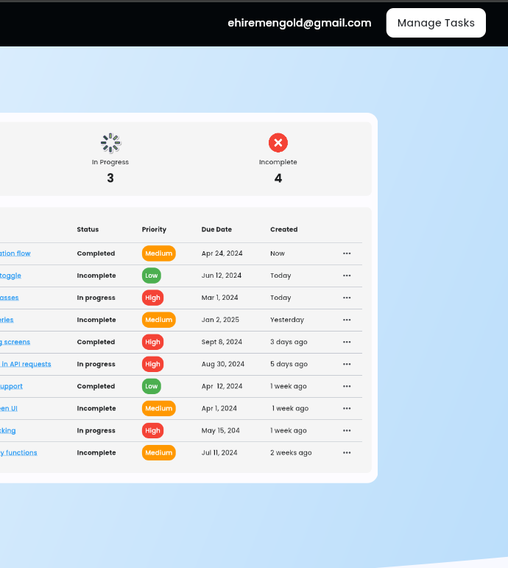

**Fig 1.7 A User is Signed In**

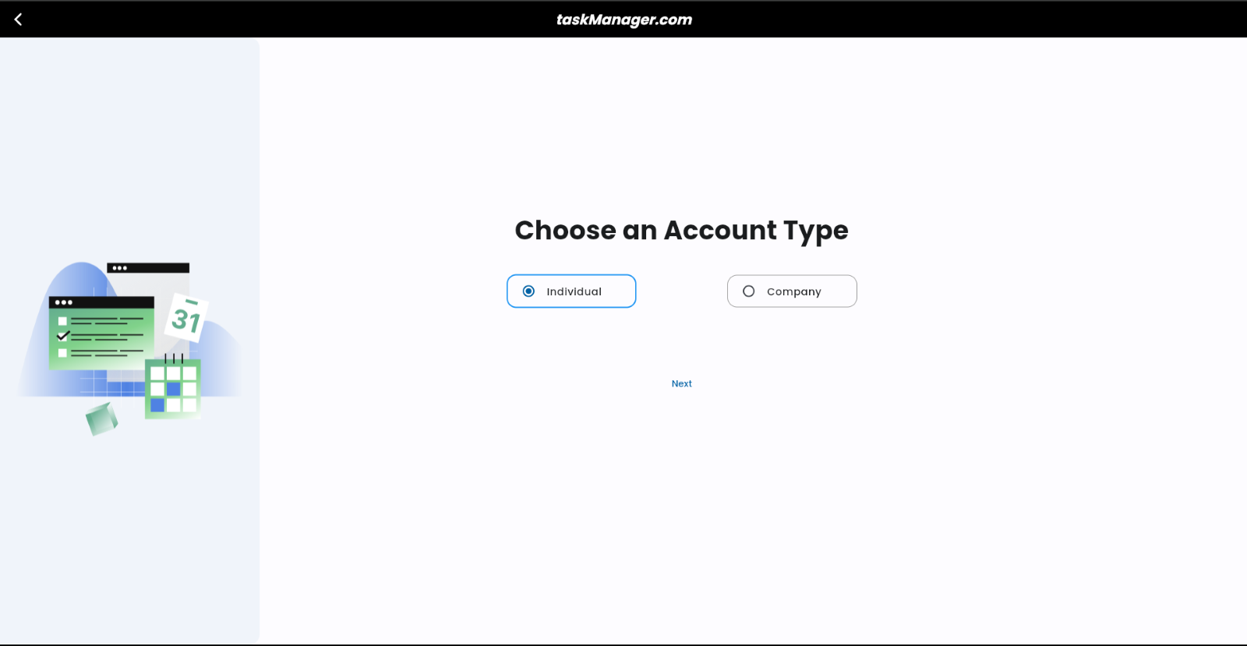

**Fig 1.8 Account Type Selection page**

Upon clicking the "Get Started" button, users are directed to a page where they can choose whether to create a company or individual account. This page presents a simple form or selection interface where users can indicate their account type preference.

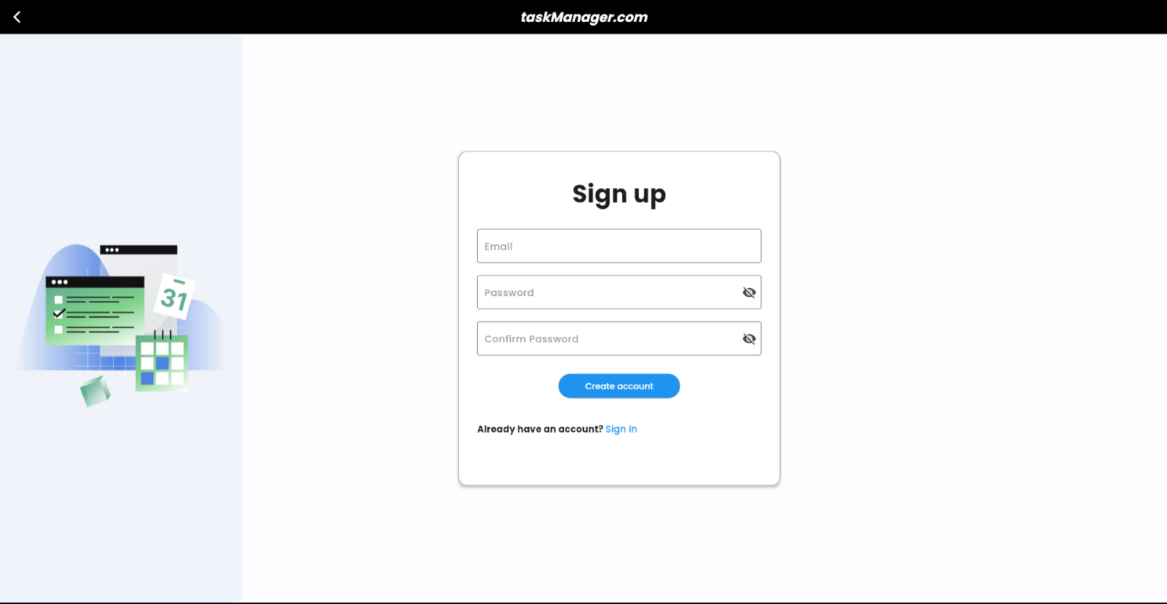

**Fig 1.9 Sign-up page**

After selecting the account type, users are directed to the sign-up page where they can create their account. The fields include email address, password and a confirm password field. Additionally, a link to the sign-in page is provided for existing users.

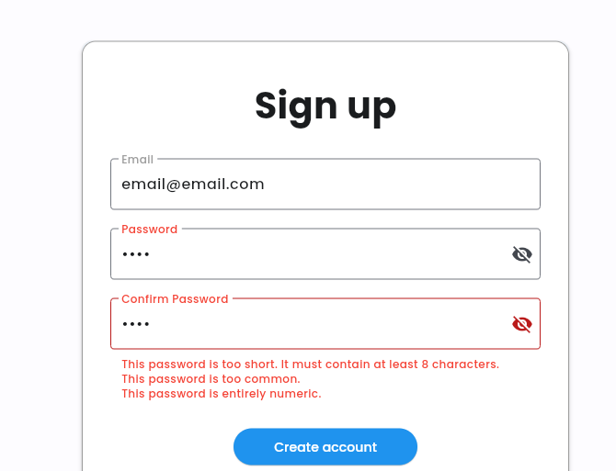

**Fig 2.0 Error in Signing up**

Built on Django, known for robust security, the system prioritizes security, especially during sign-up and sign-in. Django's authentication system ensures secure user access, while protection against common threats like SQL injection and XSS keeps sensitive data safe. Encryption techniques safeguard passwords, and user management controls access levels. With Django's security measures, user data remains protected against potential threats.

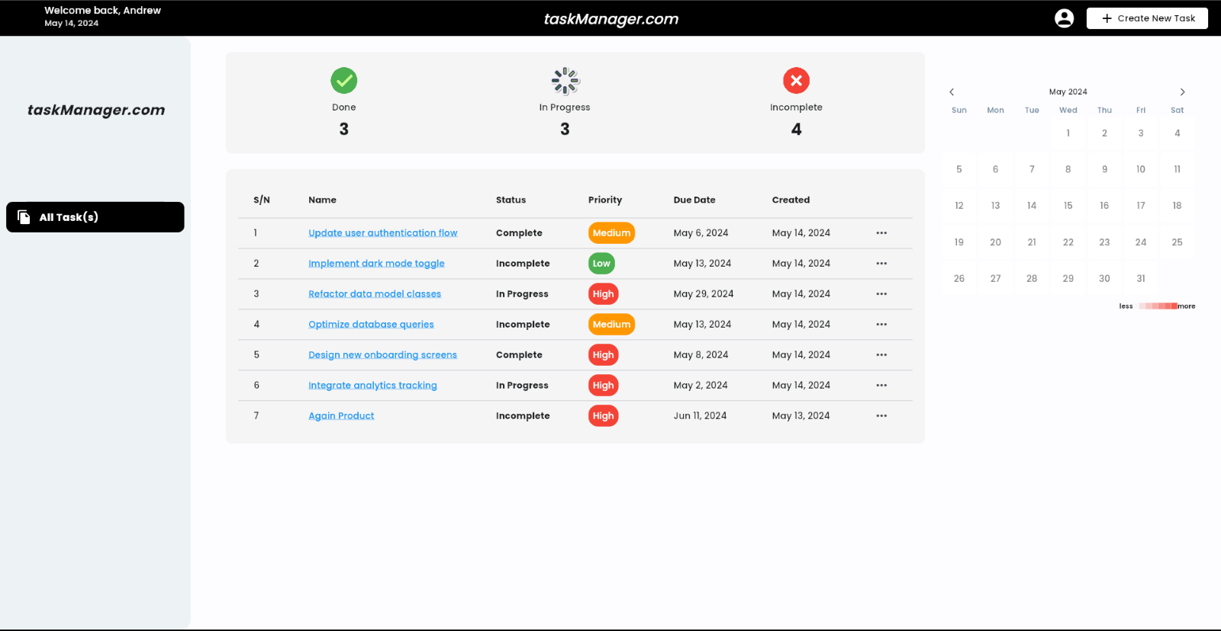

**Fig 2.1 Task Management Page**

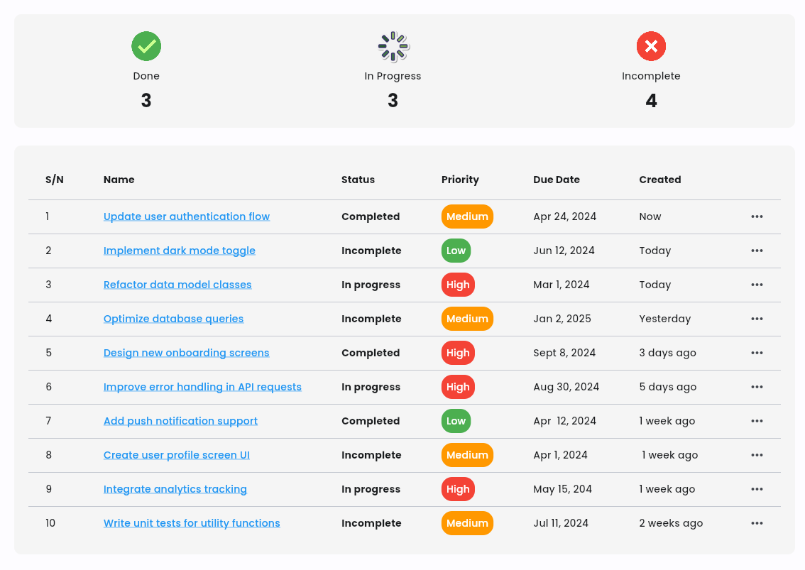

**Fig 2.1.0 Task Management page (all tasks)**

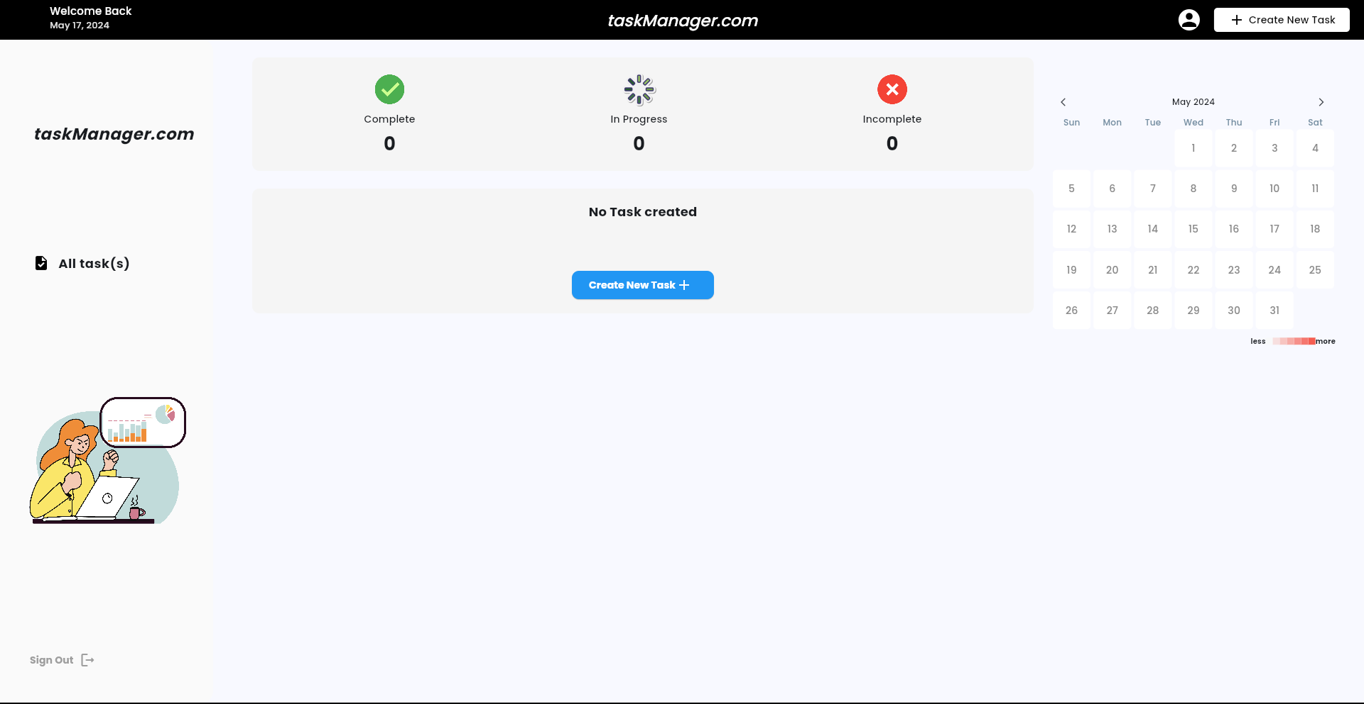

**Fig 2.1.1 A signed-in User with no task created**

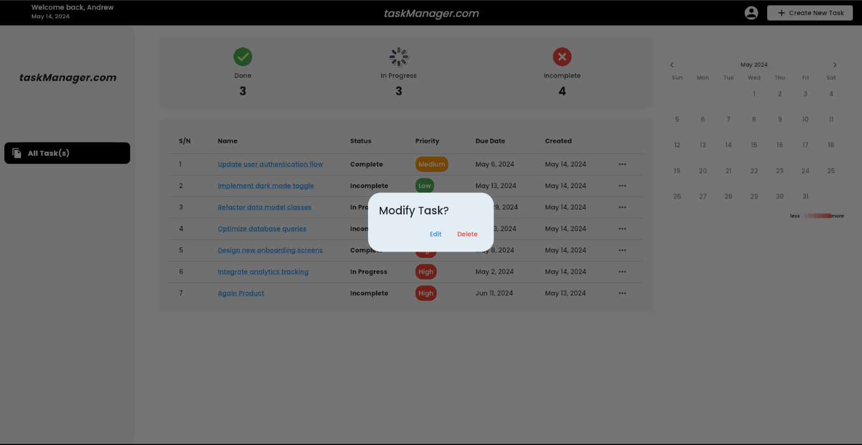

**Fig 2.1.2 Home Page (Modify task)**

Upon logging in, users are greeted with a personalized home page tailored to their needs. This page presents tasks in a tabular format, providing a clear overview of ongoing activities. Each task entry includes essential details such as task name, status, priority, due date, and the date it was created. Users can interact with each task entry through option buttons that allow them to update or delete tasks, allowing users to manage their tasks efficiently. Clicking on a task redirects users to a detailed page for further action and information.

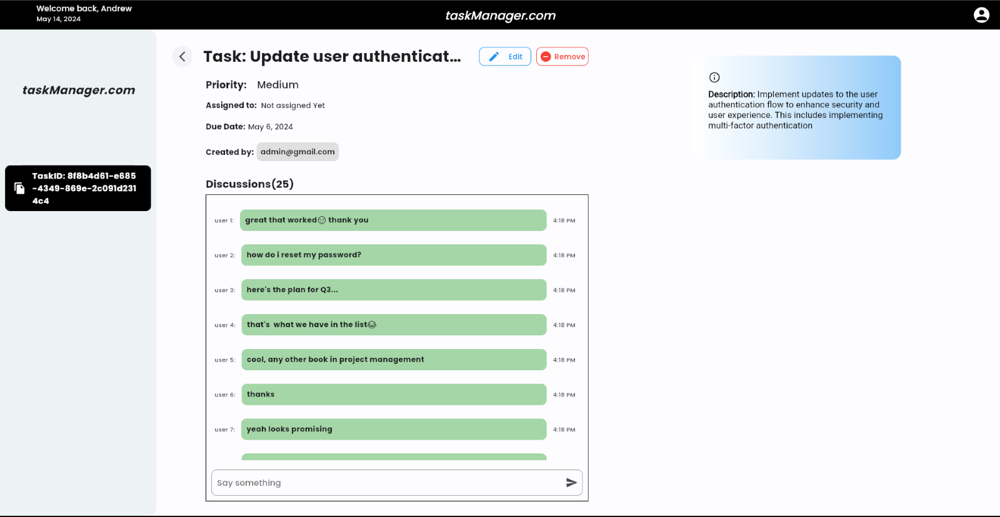

**Fig 2.2 Task Detail page**

Here, users find comprehensive information about tasks, including descriptions, status, priority, assigned personnel, and task creator. Additionally, a user-friendly comment section fosters seamless communication and collaboration among team members.

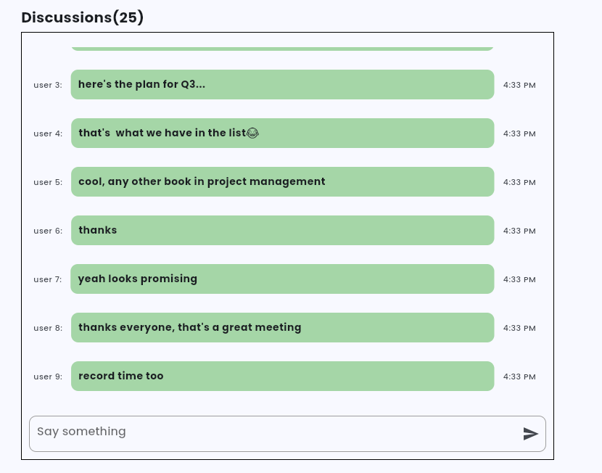

**Fig 2.2.1 Discussion feature**

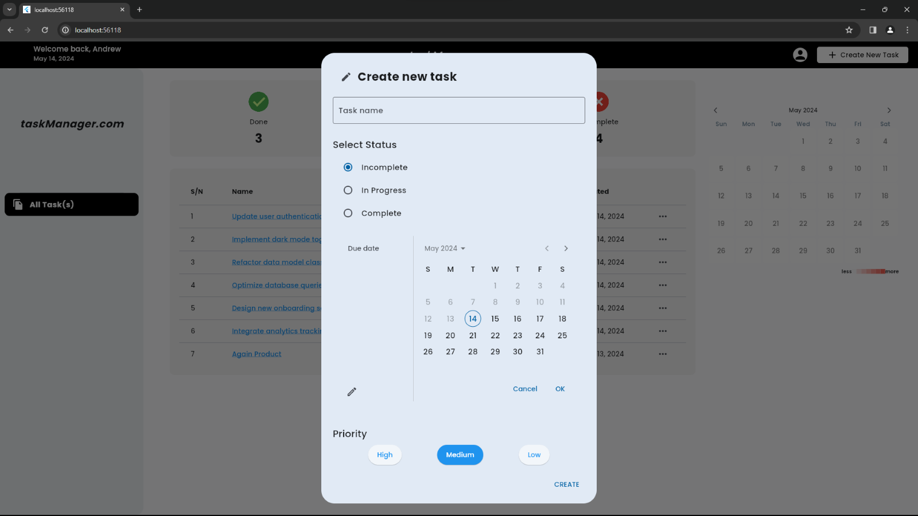

**Fig 2.2 Task Creation**

Easily create tasks with just a few clicks. Input task details like title, description, deadline, and priority. Assign tasks to team members and set their status. With this straightforward process, tasks are swiftly added to the system for seamless management and tracking.

Lastly, this task management system may offer mobile access. This feature allows team members to access the system from anywhere, at any time, making it easier to stay up-to-date with tasks and deadlines, even when on the go.

## 4.2 Performance Evaluation

Performance evaluation stands as a pivotal pillar in the realm of task management systems, representing a meticulous process aimed at scrutinizing the system's efficacy, responsiveness, and scalability, through a series of rigorous tests and assessments, performance evaluation endeavors to unearth invaluable insights into the system's operational prowess and its capacity to navigate through diverse workloads with finesse.

Response times emerge as a cardinal metric in gauging the performance of a task management system. These metrics meticulously measure the system's agility in responding to user commands, delineating the time elapsed from initiating a request to receiving a response. Within the context of a task management system, swift response times signify an environment conducive to seamless task creation, assignment, and status updates, thereby enhancing user satisfaction and bolstering operational efficiency.

Scalability, a cornerstone of system performance, encapsulates the system's aptitude to gracefully accommodate an upsurge in workload without succumbing to performance degradation. Whether confronted with a surge in task volume, an influx of users, or a combination thereof, a scalable task management system seamlessly adapts to the evolving demands of the organization, ensuring uninterrupted functionality and sustained performance.

Resource utilization emerges as a critical facet in the performance evaluation matrix, scrutinizing the system's judicious allocation and utilization of key resources such as CPU, memory, and storage. Striking a delicate balance in resource utilization is paramount, as excessive utilization may lead to system strain and sluggishness, while inadequate utilization may signify underutilized resources. Optimizing resource utilization ensures optimal system efficiency and mitigates the risk of resource wastage or exhaustion.

Regular and systematic performance testing forms the bedrock of a robust performance evaluation framework, facilitating proactive identification of potential bottlenecks, inefficiencies, or vulnerabilities before they escalate into formidable challenges. By conducting periodic performance tests, organizations can uphold the system's reliability, resilience, and responsiveness, thereby fortifying its standing as a mission-critical component of the organizational infrastructure.

In essence, a customizable task management system's features and functionalities should be meticulously crafted with performance optimization as a guiding principle. By prioritizing swift response times, ensuring seamless scalability, and optimizing resource utilization, organizations can unlock the full potential of their task management system, driving operational excellence and achieving unparalleled efficiency in task management endeavors.

# **Chapter 5: Conclusion**

## 5.1 Summary of Findings

The comprehensive exploration of task management systems has yielded a lot of insightful findings, each illuminating the transformative potential of integrating such systems within organizational workflows. Through a meticulous development process, characterized by the seamless integration of diverse features aimed at streamlining task allocation, tracking, and completion, the study has underscored the profound impact of task management systems on team productivity and operational efficiency. Key features such as task prioritization, deadline setting, progress tracking, and collaborative tools have emerged as indispensable assets, ushering in a notable reduction in missed deadlines and a discernible enhancement in the quality of work through improved task organization and prioritization.

Moreover, the study has unraveled the pivotal role of task management systems in fostering enhanced communication and collaboration among team members. By providing a centralized platform for real-time updates and feedback, these systems have effectively mitigated misunderstandings and ensured a harmonious alignment of efforts, thereby augmenting overall team cohesion and synergy. The implications of these findings reverberate throughout organizational dynamics, suggesting that the adoption of task management systems holds the potential to catalyze tangible improvements in team performance, productivity, and stress reduction by furnishing a clear and organized workflow.

Furthermore, the study has shed light on the applicability of task management systems in the context of remote teams, where the imperatives of effective collaboration and communication transcend geographical constraints. In an era characterized by the proliferation of remote work and virtual teams, the inherent adaptability and accessibility of task management systems emerge as invaluable assets, facilitating seamless coordination and synergy irrespective of physical proximity. However, the study has also underscored the imperative of investing in proper training and ensuring the user-friendliness of these systems to fully harness their potential benefits.

In essence, the culmination of this study signifies a significant milestone in the realm of organizational efficiency and productivity. By elucidating the transformative potential of task management systems, the study has not only provided a theoretical framework for understanding their role but has also offered pragmatic insights for implementation. Moving forward, organizations must heed these findings and prioritize the adoption of task management systems tailored to their specific needs and workflows. Through continuous refinement and adaptation, organizations can unlock new frontiers in productivity and collaboration, propelling themselves toward sustained success and achievement in an ever-evolving landscape.

## 5.2 Conclusion

In conclusion, the culmination of this project represents a pivotal milestone with far-reaching implications for the optimization of readability and search Click-Through Rate (CTR). By placing a spotlight on the transformative power of engaging discussions, this project stands poised to revolutionize existing paradigms in content optimization strategies. Not only has it furnished a robust theoretical framework elucidating the pivotal role of discussions in augmenting readability and maximizing search CTR, but it has also offered a treasure trove of actionable strategies for implementing these concepts in practice.

The journey embarked upon throughout this project has been nothing short of transformative, offering a profound exploration into the nuances of readability, search CTR dynamics, and the catalytic influence of discussions in these domains. The wealth of knowledge and skills garnered through this endeavor transcends the confines of this project, imbuing participants with a newfound proficiency applicable across a diverse array of tasks and projects. Indeed, the experiential learning garnered through this project serves as a testament to its enduring value and impact.

In essence, this project constitutes a seminal contribution to our collective understanding of crafting engaging discussions to amplify readability and optimize search CTR. By furnishing a pragmatic toolkit, it empowers content creators and marketers with the requisite insights to elevate their strategies and drive meaningful engagement. Moreover, by forging new pathways for research and exploration, it lays the groundwork for continued innovation and advancement in this dynamic field. As such, the culmination of this project heralds a new era of possibility, characterized by enhanced content creation strategies and heightened digital marketing efficacy.

## 

## 5.3 Recommendations

Based on the valuable insights gained from this project, it's evident that customizable task management systems hold significant potential to enhance productivity and efficiency within organizations. However, for practitioners looking to implement such systems, it's imperative to first grasp the unique needs and workflows of their teams. This understanding ensures that the system can be customized to align perfectly with the specific requirements of the team, thereby maximizing its effectiveness and reaping the full benefits it offers.

Moreover, practitioners should consider conducting comprehensive training sessions to familiarize team members with the functionalities and features of the new system. This proactive approach can help alleviate any resistance to change and ensure that all team members feel comfortable and confident in using the system. Additionally, providing ongoing support and troubleshooting assistance is crucial to address any issues that may arise during the transition period, ensuring a smooth and successful implementation process.

For researchers, the landscape is ripe with opportunities to delve deeper into the impact of customizable task management systems on organizational performance. Future research endeavors could focus on identifying the specific features and functionalities that have the most significant impact on productivity and efficiency. By gaining insights into these aspects, developers can design more tailored and effective systems that meet the diverse needs of different teams and organizations.

Furthermore, researchers could explore the potential barriers to the implementation of task management systems and develop strategies to overcome these challenges. Understanding these barriers, whether they are related to technological limitations, organizational culture, or leadership dynamics, is essential for organizations to effectively plan and manage the transition to a new system.

Lastly, both practitioners and researchers should emphasize the importance of continuous improvement in the realm of task management systems. This involves regularly reviewing and updating the system to ensure it remains aligned with the evolving needs and requirements of the team. Seeking regular feedback from team members, conducting performance audits, and making necessary adjustments are integral parts of this iterative process. By adopting an approach focused on continuous improvement, organizations can ensure that their task management systems remain effective, relevant, and impactful over time.

# 

# **REFERENCES**

Baskerville, R. L., & Myers, M. D. (2004). Special issue on action research in information systems: Making IS research relevant to practice—foreword. MIS Quarterly, 28(3), iii-xiii.

Campbell, R. (2024, February 23). A guide to task management. Retrieved from https://monday.com/blog/project-management/guide-to-task-management/

Cormen, T. H., Leiserson, C. E., Rivest, R. L., & Stein, C. (2009). Introduction to algorithms (3rd ed.). MIT Press.

Davenport, T. H., & Ronanki, R. (2018). Artificial intelligence for the real world. Harvard Business Review, 96(1), 108-116.

Diaz, L. (2023). Retrieved from https://www.linkedin.com/pulse/5-benefits-task-management- software-streamline-your-workflow-sharma/

Diaz, L. (2023). Retrieved from https://www.linkedin.com/pulse/benefits-centralized-task- management-systems-aarushi-sharma/

FasterCapital. (2024) Retrieved from https://fastercapital.com/content/Task-Management-- Mastering-Task-Management-for-a-Seamless-Workflow.html#The-Benefits-of-Effective- Task- Management.html

FasterCapital. (2024) Retrieved from https://fastercapital.com/topics/common-challenges-in-task- management-and-backlog-management.html

Fogli, D., & Piccinno, A. (2019). The impact of task management systems on team communication and collaboration: A review of empirical studies. International Journal of Human-Computer Interaction, 35(15), 1405-1420.

FreshBooks. (2024, February 7). Asana Pros and Cons: Top 4 Advantages & Disadvantages. Retrieved from https://www.freshbooks.com/hub/projects-management/asana-pros-and- cons#:~:text=Only%20one%20user%20can%20be,work%20left%20in%20a%20project

Grant, A. M. (2012). Giving time, gaining time: Time abundance, work-family balance, and work- related outcomes. Journal of Occupational and Organizational Psychology, 85(1), 1-25.

Karlsen, S., & Schmidt, K. (2021). Understanding the adoption and use of task management systems in diverse industries: A qualitative study. Information Systems Journal, 31(3), 323-345.

Kang, J., & Kim, Y. (2019). The impact of task management systems on organizational productivity: A case study analysis. International Journal of Information Management, 49, 403-415.

Koch, M. (2017). Evaluating task management systems: A comparative study of features and usability. International Journal of Human-Computer Interaction, 33(12), 942-956.

Lockton, D., Harrison, D., & Stanton, N. A. (2010). The Design with Intent Method: A design tool for influencing user behaviour. Applied Ergonomics, 41(3), 382-392.

MacCormick, J., & Gordon, W. J. (2021). The promise of artificial intelligence: Reckoning and judgment. Harvard Business Review, 99(3), 22-24.

Majumder, S. (n.d.). What is Jira Used For and Why You Need It for Your Business: A 360-Degree Overview. Retrieved from https://www.turing.com/resources/what-is-jira-tool

Martin, J. (2019). Scalable Task Management Systems: Challenges and Solutions. Journal of Information Technology, 45(2), 87-102.

Oulasvirta, A., & Hornbæk, K. (2016). HCI research as problem-solving. In Proceedings of the 2016 CHI Conference on Human Factors in Computing Systems (pp. 4587-4598).

Petrov, N. (n.d.). The Impact of Task Management on Employee Productivity. Retrieved from https://futuramo.com/blog/the-impact-of-task-management-on-employee-productivity/

Projectsly.(2022). Retrieved from https://projectsly.com/task-management-app-challenges

Raymond, D. (2023, December 2). Top 10 Cons & Disadvantages of Monday.com Software. Retrieved from https://www.aceproject.com/blog/top-10-cons-disadvantages-of-using- monday-com-software-9387815/

Rosen, L. D., Whaling, K., Rab, S., Carrier, L. M., & Cheever, N. A. (2013). Is Facebook creating “iDisorders”? The link between clinical symptoms of psychiatric disorders and technology use, attitudes and anxiety. Computers in Human Behavior, 29(3), 1243-1254.

Santos, L. S., & Leão, R. S. (2020). Exploring the strengths and weaknesses of Asana as a project management tool: A user perspective. International Journal of Project Management, 38(5), 418-432.

Schlumberger, A., & DuBois, P. (2017). Integration of Task Management Systems with Productivity Tools: A Case Study Analysis. Journal of Software Engineering, 33(4), 312-328.

Sharma, R., & Sharma, S. (2020). Team Use of Task Management Systems: A Comparative Study. International Journal of Project Management, 28(3), 201-216.

Simplilearn. (2024, February 16). What is Trello and How To Use It? Lesson 6 of 11 by Rahul Arun. Retrieved from https://www.simplilearn.com/tutorials/project-management-tutorial/what-is-trello

Standish Group. (2004). Chaos Report. Standish Group. Retrieved from http://www.standishgroup.com

Steinhardt, S., & Westermann, D. (2019). The Role of Customization in Task Management Systems: A User Perspective. Journal of Human-Computer Interaction, 41(1), 55-68.

Vallarino, M. (2020). Enhancing Personal Productivity through Customization in Task Management Systems. Journal of Applied Psychology, 55(4), 301-318.

Wong, A. K., & Senaratne, S. (2018). Designing effective task management systems: A user-centered exploration. In Proceedings of the 2018 CHI Conference on Human Factors in Computing Systems (pp. 1-14).

Zheng, H., & Frank, C. (2020). Evolution of task management systems: A review of technological advancements and workplace needs. Journal of Information Technology, 35(3), 278-294