Resume of Md. Sujon Islam

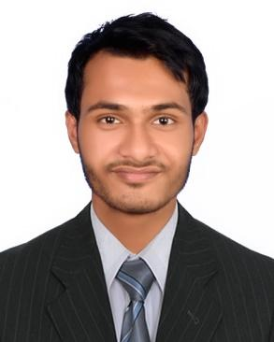

# Carrier Objective:

I want to become a world-class JavaScript programmer and web developer where I can work as a wordpress expert and dynamic web application creator. I want to contribute my expertise to develop my company. I believe that hard work is key to success.

# Employment Records:

WorldSoftZone

Position: Web Developer

From December 2020 to June 2021

Promoted Position : Senior Web Developer

From July 2021 to till

Duties and Responsibilities:

* Create and test applications for websites
* Collaborate
* Present design specs
* Work with graphics and other designers
* Troubleshoot website problems
* Maintain and update websites
* Monitor website traffic
* Stay up-to-date on technology

# Project Handed by me

<https://www.alvinfooseo.com>

<https://www.gcd-lab.com>

<https://exp.seriousandsearching.com>

<https://www.cojelearning.org.za>

<https://sensormedicausa.com>

<https://worldsoftzone.com>

# Educational Background:

## Secondary School Certificate (SSC)

Institute Name: Amjhupi Secondary School

Grade: A-

Result: 3.87

Passing Year: 2020

## Diploma in Engineering Certificate

Institute Name: Meherpur College of Engineering and Technology

Grade:

Result: Runnig

Passing Year: Running (4 Semester)

# Personal Details:

Fathers Name: Md Babu

Mothers Name: Mst. Ambia Khatun

Permanent Address: Union and Post: Amjhupi, District: Meherpur

# Extra Curriculum activity:

**Hobbies:**

Recite The Holy Quran and Learning updated programming language

# Language proficiency:

Bangla: Native

English: Moderate

**Declaration:**

I hereby declare that all the details mentioned above are in accordance with the truth and fact as per my knowledge and I hold the responsibility for the correctness of the above-mentioned particulars.

