In order to run our GUI program, you need to install tkinter and mysql connector library for python.

To install tkinter library, open your terminal on mac or windows command shell on windows, and type the command: “pip install tk”

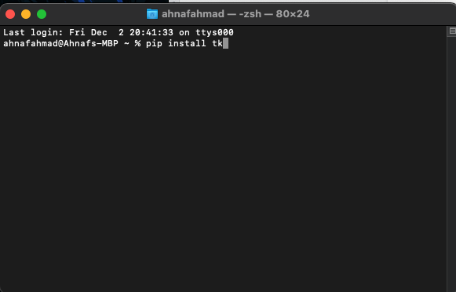

To install mysql connector, open your terminal on mac or windows command shell on windows, and type the command: “pip install mysql-connector-python”

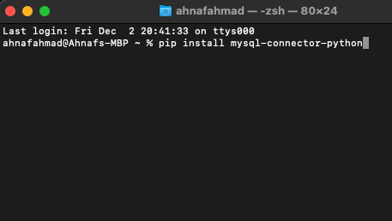

Once that is done, to run the GUI program for the car rental database, first you need to modify minor details in the python file, projectGui.py.

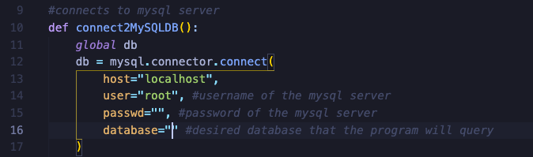

In the function in line 10, you would need to change three things. Change the user value to the username of your MYSQL server. You would need to edit inside the quotes. Then similarly, enter password in the passwd field, and for database, enter the name of the car rental database that is stored inside your MySQL server on your localhost.

Once the above instruction is done, save the field then exit. Then open a terminal where the projectGui.py file is located and run the python compiler command. In this case it would be “python3 projectGui.py”. This should successfully open the project gui window to the following screen.

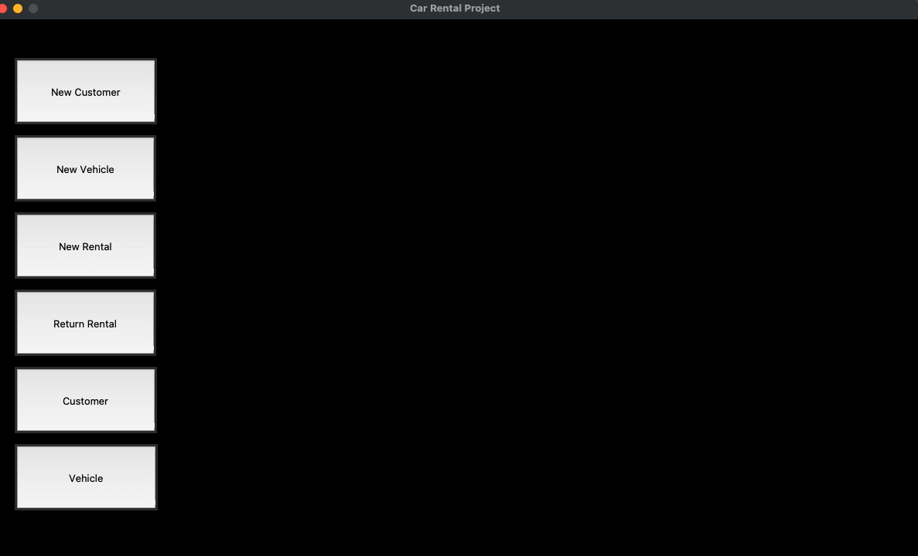

Now the program is ready to be used. If all the naming convention and structure matches, the program should run smoothly. If There is a problem, there is a backup sql file containing all the queries from creating tables to some database modification queries. It should help recreate the ideal car rental database.

Instructions to set up and import the backup database

To set up the backup database, you would need to open CarRental2019.sql file, and run some queries in a mysql server.

First, you would need to create the database, by running the following query:

CREATE DATABASE CarRentalDatabase;

Then run USE CarRentalDatabase; to start creating tables. Run the following 4 queries to create the tables.

CREATE TABLE CUSTOMER ( CustID INT NOT NULL PRIMARY KEY AUTO_INCREMENT , Name VARCHAR(100) , Phone VARCHAR(100) );

CREATE TABLE RATE ( Type INT NOT NULL , Category INT NOT NULL , Weekly INT NOT NULL , Daily INT NOT NULL, CONSTRAINT VehicleType PRIMARY KEY(Type , Category) );

CREATE TABLE VEHICLE ( VehicleID VARCHAR(30) NOT NULL PRIMARY KEY , Description VARCHAR(100) NOT NULL , Year INT NOT NULL , Type INT NOT NULL , Category INT NOT NULL , FOREIGN KEY (Type , Category) REFERENCES RATE(Type , Category) ON DELETE NO ACTION ON UPDATE CASCADE );

CREATE TABLE RENTAL (

CustID INT NOT NULL ,

VehicleID VARCHAR(30) NOT NULL ,

StartDate VARCHAR(30) ,

OrderDate VARCHAR(30) ,

RentalType INT ,

Qty INT ,

ReturnDate VARCHAR(30) ,

TotalAmount INT ,

PaymentDate VARCHAR(30) ,

FOREIGN KEY (CustID) REFERENCES CUSTOMER(CustID) ON DELETE NO ACTION ON UPDATE CASCADE , FOREIGN KEY (VehicleID) REFERENCES VEHICLE(VehicleID) ON DELETE NO ACTION ON UPDATE CASCADE

);

Next, to import data from the CSV files, you need to use the mysql data import wizard. There is a specific order you would need to import data in. The order is as follows:

1. Customer
2. Rate
3. Vehicle
4. Rental

When importing data, match the following screenshots

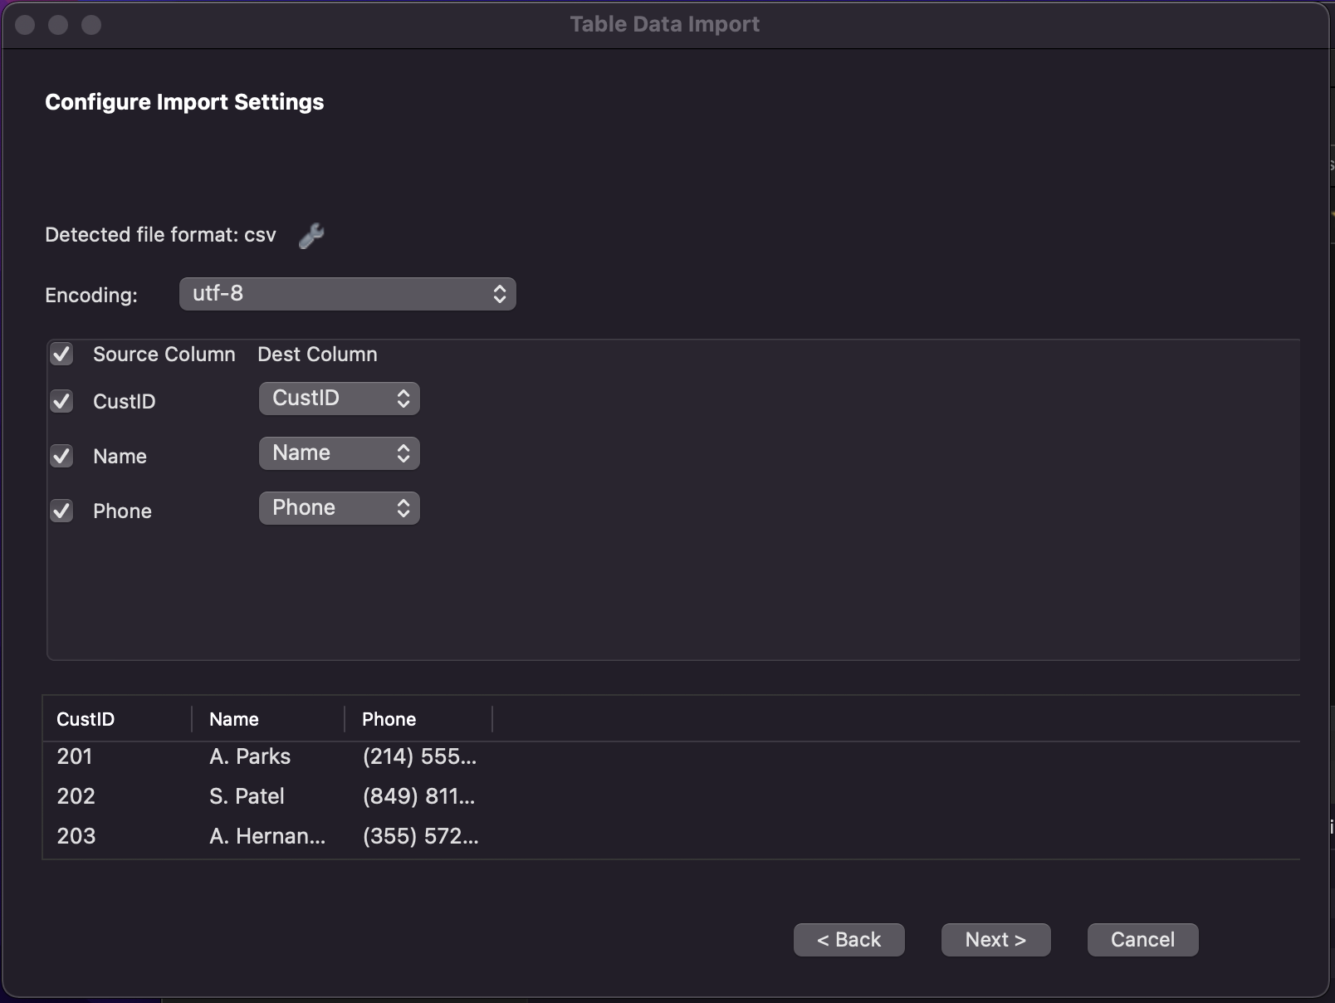

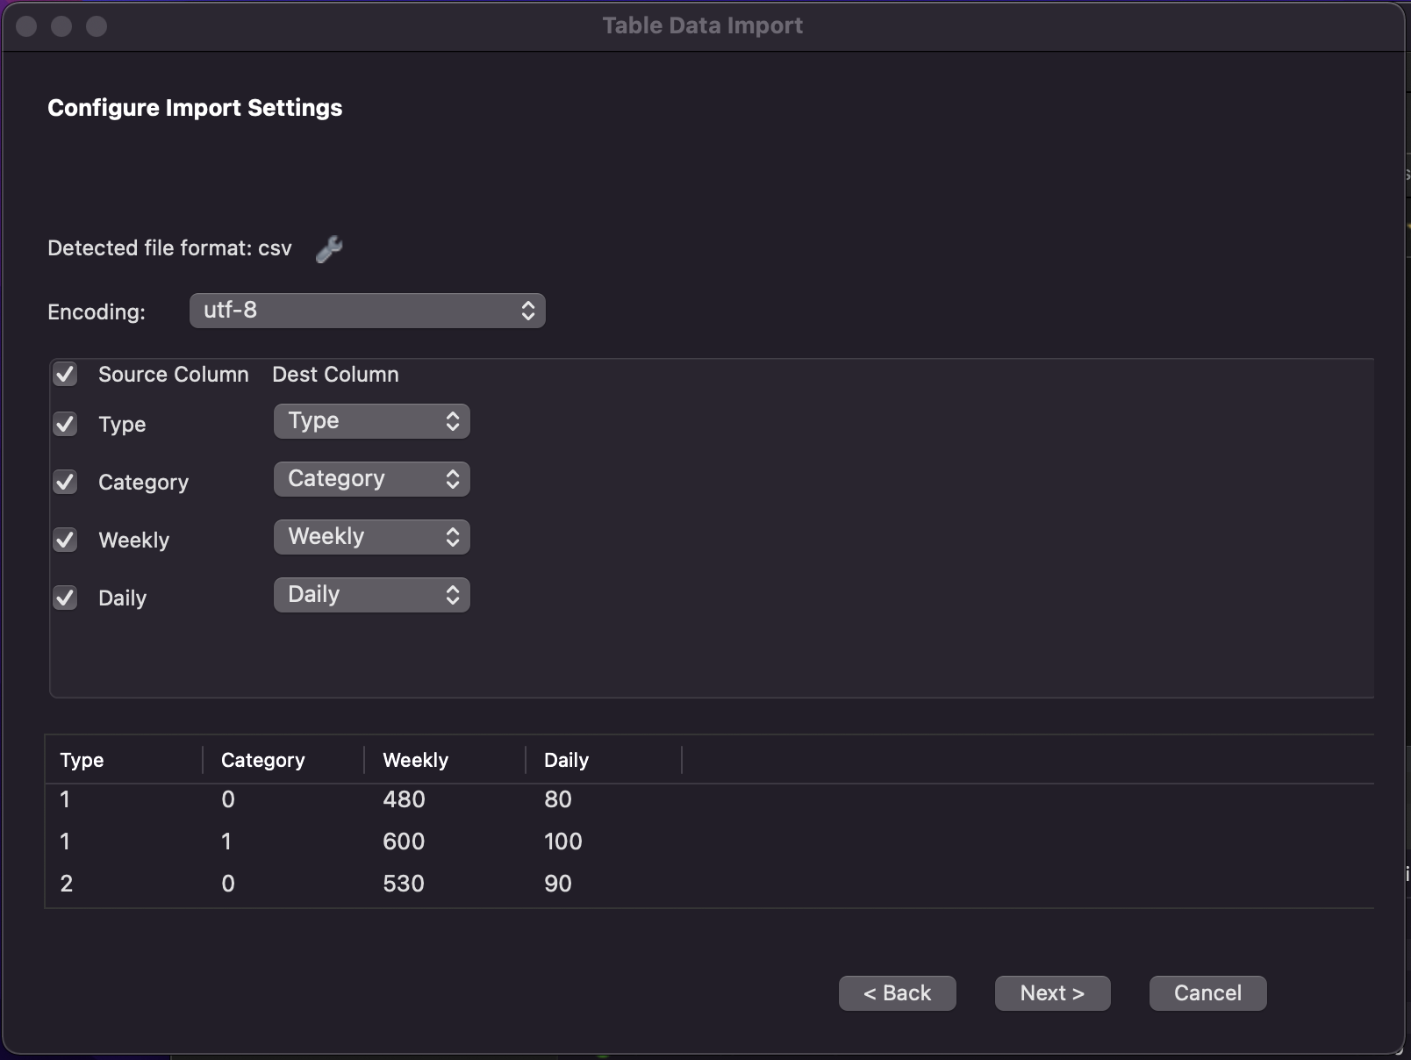

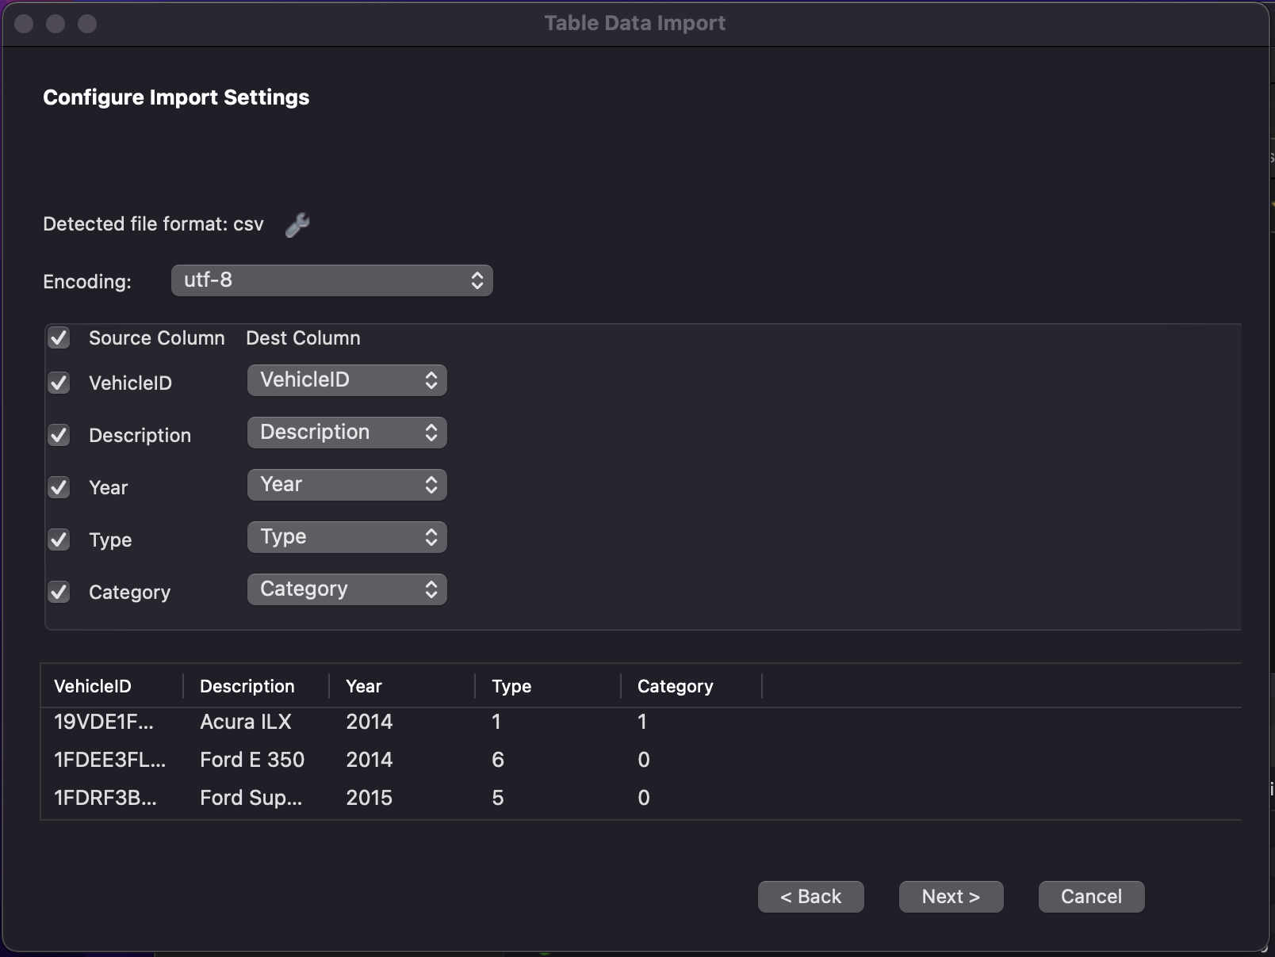

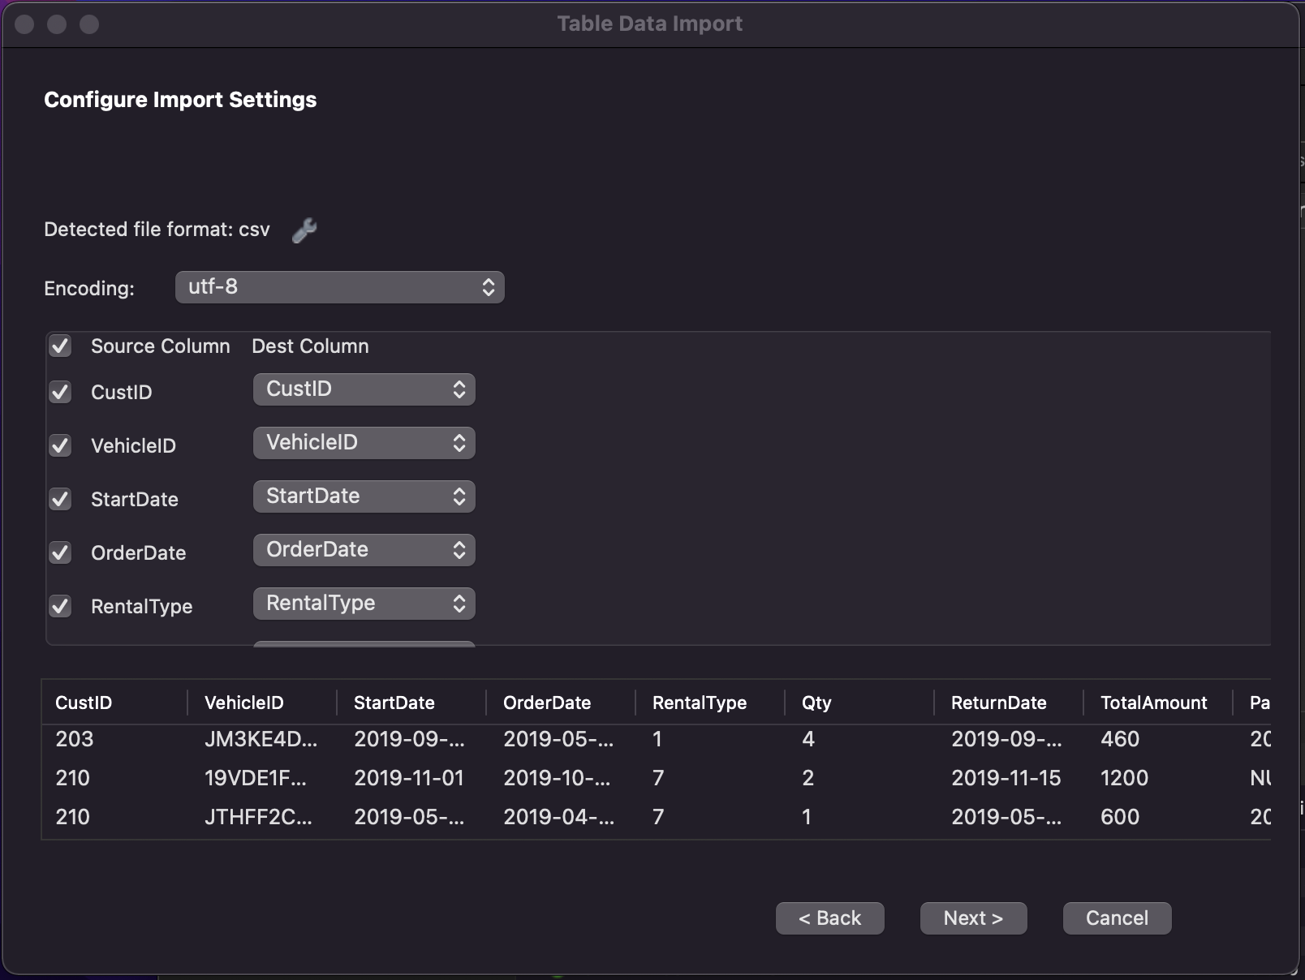

Once this is done, you need to run some queries to finish setting up. But first run the query

SET SQL_SAFE_UPDATES = 0; so that the next queries will work.

From the section labeled “part 2 queries” run query 1, 2, 3, 4b, 4a in the exact order.

Then go to the section labeled part 3 task 1 queries, run query 1 and 2.

Now your backup database is setup and ready to be used. Don’t forget if you’re using the backup database, make sure you go back to the pythonGui.py file, and change the database field to “CarRentalDatabase”

