**Manual**

1. Run Application

* ***{AppPath}*/index.html**

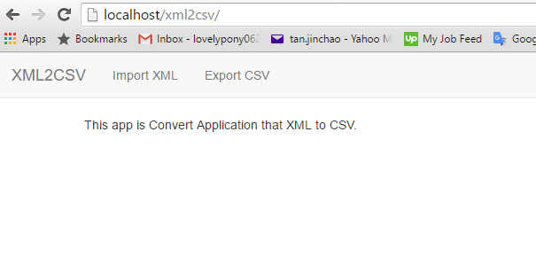

1. Read XML File

* Click import XML tab

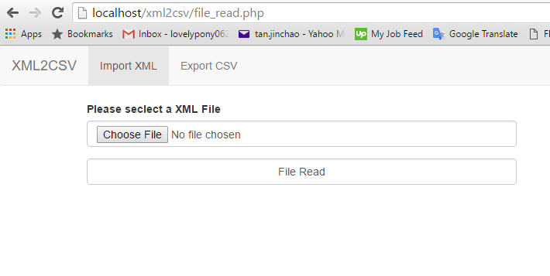

* Click choose file button and choose XML file

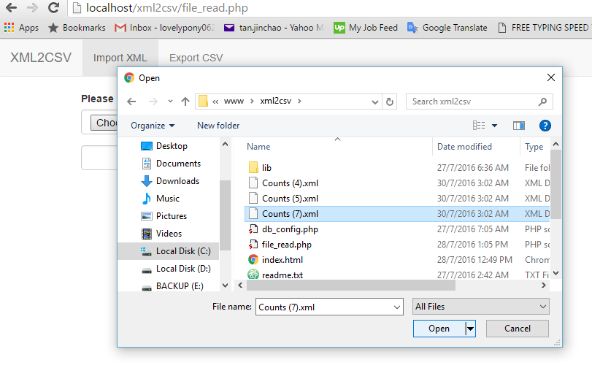

* Click file read button

At this moment this app will read and store xml file in database.

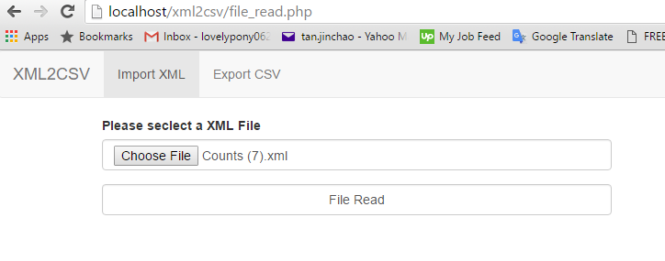

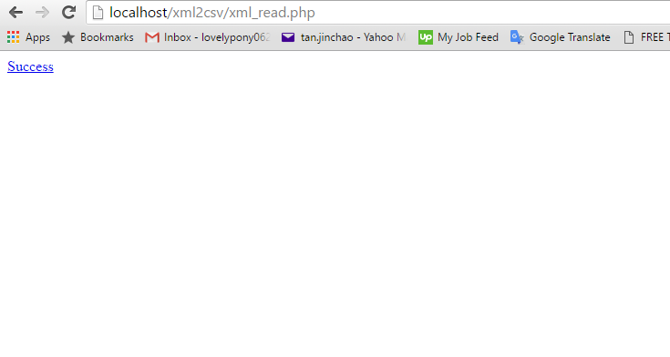

1. Write CSV file

* Click export CSV tab

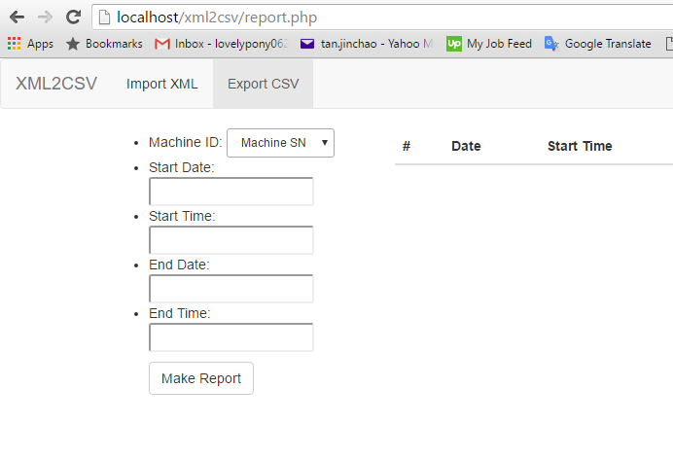

* Select Machine ID and select Date and Time range
* Click Make Report button

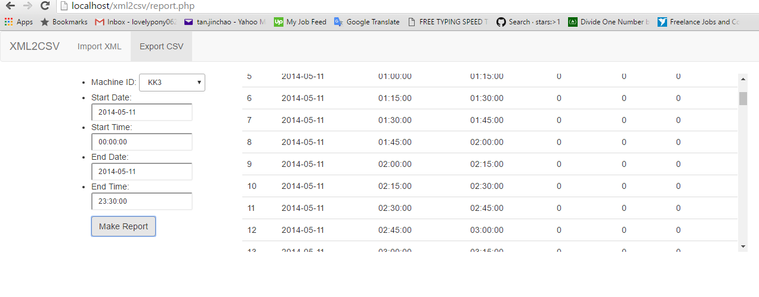

At this moment this app will write relevant information in **{*AppPath*}/report.csv** file after it is read from database.

s