THE MONTHLY RENDER
Company Newsletter · Issue 14 · July 2026

User Growth Hits a New High
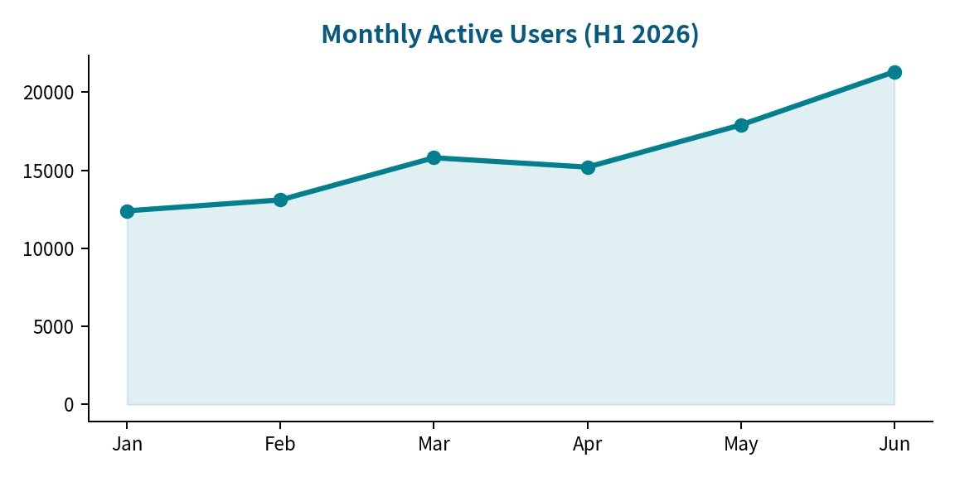
Monthly active users crossed 21,300 in June, up 72% since January. The growth team credits the new self-serve onboarding flow and the template gallery launch.

Shout-outs
- Kudos to the infra team for a zero-downtime database migration.
- Welcome aboard: 4 new engineers joined the rendering squad this month.
- Reminder: submit summer offsite topic proposals by July 25.

Upcoming
Date | Event
Aug 3 | v0.7 feature freeze
Aug 12 | Customer advisory board (virtual)
Aug 21 | v0.7 release + team celebration

