**On control server**

**Login as ansible user and create playbook directory**

su - ansible

mkdir -p /home/ansible/playbooks

cd /home/ansible/playbooks

**Create a new playbook by name apache2.yml**

vim apache2.yml

**Copy and paste below code :**

---

- hosts: ubuntu.iselglobe.com

sudo: yes

tasks:

- name: install apache2

apt: name=apache2 update_cache=yes state=latest

# ansible-playbook apache2.yml

Login to Ubuntu node

# which apache2

**Service management**

vim apache2.yml

- name: restart apache2 service

service: name=apache2 state=started

After editing your file should look like this

On Ubuntu node

service apache2 status

On control server – Push files to nodes

# su - ansible

# cd /home/ansible/playbooks

# sudo wget <https://s3.amazonaws.com/anilchef/index.html>

# sudo wget <https://s3.amazonaws.com/anilchef/logo.png>

# sudo wget <https://s3.amazonaws.com/anilchef/style.css>

# vim apache2.yml

- name: copy index.html

template: src=index.html dest=/var/www/html/index.html

- name: copy logo.png

template: src=logo.png dest=/var/www/html/logo.png

- name: copy style.css

template: src=style.css dest=/var/www/html/style.css

# ansible-playbook apache2.yml

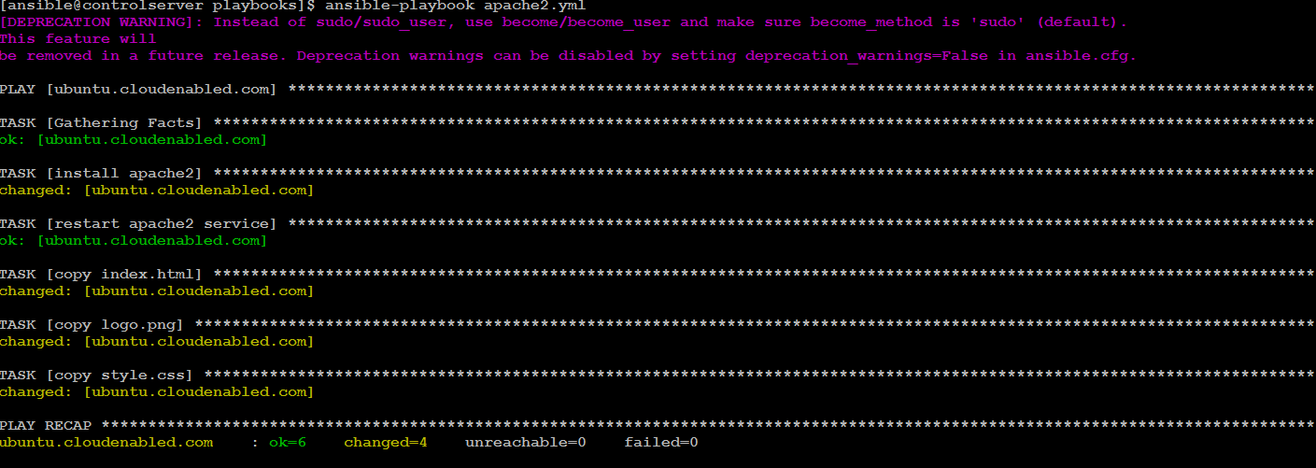

Validate on web browser of Ubuntu node

