**Kubectl cli**

**Get nodes and status of nodes**

# kubectl get nodes

**Print the supported API versions on the server, in the form of "group/version"**

# kubectl api-versions

Start a single instance of nginx.

kubectl run nginx --image=nginx

kubectl get deployments

kubectl expose deployment nginx --port=80 --target-port=8000

kubectl get pods

Start a single instance of anil-ngnix and set labels "app=anil-ngnix" and "env=prod" in the container.

kubectl run kedar-ngnix --image=nginx --labels="app=kedar-ngnix,env=prod"

Start a single instance of hazelcast and let the container expose port 5701 .

kubectl run hazelcast --image=hazelcast --port=5701

Start a replicated instance of nginx.

kubectl run kedar-replica-5-nginx --image=nginx --replicas=5

Start a replicated instance of nginx.

kubectl get pods

Delete a pod with minimal delay

kubectl delete pods --all

Re run belwo command and you can notice how kuberentes has got the pods recvered back

kubectl get pods

Start a pod of of Jenkins images

kubectl run -i -t kedar-jenkins --image=kedarkulkarni/jenkins:1.0 --restart=Always

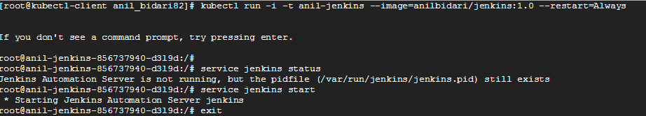

Connect to your instance

kubectl attach kedar-jenkins-856737940-d3l9d -c kedar-jenkins -i -t

Delete your deployment

kubectl delete deployment kedar-jenkins

Create a new clusterIP service named my-cs

kubectl create service clusterip my-cs --tcp=5678:8080

Create a new clusterIP service named my-cs (in headless mode)

kubectl create service clusterip my-cs --clusterip="None"

Create a new LoadBalancer service named my-lbs

kubectl create service loadbalancer my-lbs --tcp=5678:8080

Delete a pod using the type and name specified in pod.json.

kubectl delete -f ./pod.json

Delete a pod based on the type and name in the JSON passed into stdin.

cat pod.json | kubectl delete -f -

Delete pods and services with same names "baz" and "foo"

kubectl delete pod,service baz foo

Delete pods and services with label name=myLabel.

kubectl delete pods,services -l name=myLabel

Force delete a pod on a dead node

kubectl delete pod foo --grace-period=0 --force

Delete all pods

kubectl delete pods --all