AN EMPIRICAL STUDY ABOUT SOCIAL MEDIA IMPACT ON THE RECRUITMENT & SELECTION PROCESS IN INFORMATION TECHNOLOGY COMPANIES IN THE UK

Table of Contents
Assignment 1: Proposal 4
A. Introduction 4
Background 4
Context 4
Aim and Objectives 5
B. Literature Review 5
Concept of requirement and selection process through social media platform 5
Factors of Requirement and Selection Process through social media platform 6
Challenges of Requirement and Selection Process through social media Platforms 6
Gaps 7
C. Research Methodology 7
Philosophy 7
Approaches 7
Data Collection 7
Data Analysis 8
Ethical Consideration 8
D. Conclusion 8
Recommendations 8
Conclusion 9
Assignment 2: Poster presentation 10
A. Introduction 10
B. Literature Review 10
Methodology 11
Philosophy 11
Approaches 11
Data Collection process 12
Data Analysis 13
Ethical Consideration 13
D. Conclusion 13
References 14
Journals 14
Website 16
Appendix: Poster 17

Assignment 1: Proposal

A. Introduction

Background
Social media is a significant platform for spreading important information related to job openings and the organisation of the information technology sector. 57.1 million people are active on social media in the UK in 2023 and approximately 91% of employers are using social media to find jobs (Gov.uk, 2023). Social Media can help to improve the efficiency and effectiveness of the selection process of job seekers in IT industries. This scenario highlights an influential insight into the uses of social media in IT’s recruitment process. Nowadays, job candidates are active on social media to search for suitable job options in the IT sector in the UK. Hence, the UK’s IT organisations should utilise this social media platform for their effective recruitment process. With the help of this platform, organisations can easily connect with candidates and it will be easier to hire employees. As per the research on this case, 86% of job candidates follow social media platforms to search for jobs (Gov.uk, 2023). This research analysis discusses social media's impact on the selection and recruitment process in the UK’s IT sector.

Context
Social media failed to provide a user-friendly pathway to the application process, which is a significant issue of social media requirements in the IT sector. Approximately 29% of active users have no knowledge about the application process for jobs in the IT sector in the UK (Gov.uk, 2023). The main reason behind this issue is that this job-finding process is easy but the application process is way more difficult for a lot of job seekers. This is an issue now because there are a lot of cyber criminals who promote fake jobs on social media platforms and demand money for providing jobs. 39% of businesses in the UK are negatively affected by cybercrime in 2022 and 65,000 attempts of cyber hacks were identified in the IT sector of the UK in 2022 (Gov.uk, 2023). Therefore, this research analysis should identify effective strategies to overcome these issues.
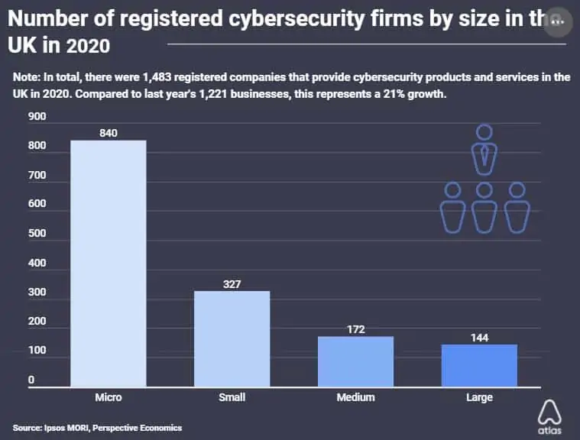
Figure: Cyber Crime rates in the UK
(Source: comparitech.com,2023)

Aim and Objectives
Aims
The aim of this research proposal will be to identify and analyse the effective impacts of the social media platform for the purpose of the requirement process of the UK’s “Information Technology” sector.
Objectives
- To identify the impacts of social media on the UK’s IT sector’s requirement process
- To analyse the different types of challenges related to the uses of social media in the selection process
- To evaluate how social media affect both applicants and recruiters
- To find a few types of recommendations to mitigate the issues

B. Literature Review

Concept of requirement and selection process through social media platform
Social media-based recruitment has been assisting companies in creating job openings for candidates enhancing the rate of employment. Platforms like Face book and LinkedIn have been playing a significant role in attracting and recruiting candidates. The employment process via social media is more cost-effective and less time-consuming. As stated by Duffy and Hund, (2019), social media also helps the organisation to create an easy pathway for job seekers to communicate with the company’s HR which improves the selection process. On the other hand, there are presently more than 57.1 million people active on social media, and 86% of those following social media for job searching in the UK in 2022. According to Ruparel et al. (2020), uses of technology are the main base of the IT sector, hence, it can be stated that uses of social media positively impact the employment process in the UK’s IT industries. In recent days, this hiring process via social media faces a lot of challenges, which can decrease the effectiveness of the uses of social media in the hiring process.

Factors of Requirement and Selection Process through social media platform
The social media requirement process needs to focus on different types of effective factors and the most important factor social media requirement process in the IT sector is the knowledge of the proper uses of technological processes. It can be stated that, without suitable knowledge of technology, no one can properly use social media for the IT requirement process. Secondly, as mentioned by Dwivedi et al. (2021) cyber security is an important factor in the social media requirement process because many cybercriminals use this platform for negative use. The IT industry's provide basic guidance as the job details; hence job seekers cannot face any kind of confusion about the job. Moreover, as stated by Pitafi et al. (2020), social media provides easy access where common individuals can get access to find jobs, to which they are eligible to apply for the job. On the other hand, there is a need for an easy pathway to move from the job information to the application process. There is a need for effective skills for job access in the IT sector. Hence, the job requirement pages need to create a space where the IT companies provide which kind of skills they need from job seekers. This might be helpful for job seekers because it maintains clarity in these requirement pages.

Challenges of Requirement and Selection Process through social media Platforms
The process of selection and requirements of IT employers in the UK via social media is an effective way. Nevertheless, there are identified different types of issues related to this social media requirement process in the IT sector in the UK.
Cyber Crime: The most crucial issue in recent days related to the social media requirement process is security and cybercrime. As stated by Hmoud and Laszlo (2019), approximately 39% of companies were negatively affected by cybercrime in the UK in 2022. Cybercriminals spread fake job openings and demand money for the selection process and nearly 4500 cyber criminals are successful at their job (Al-Rahmi et al. 2021). Hence, many IT employers lost their confidence to use the social media requirement process.
Complicated pathway: The process of finding jobs on social media is easy but via social media, the job application process is way more complicated. As mentioned by Abdalla et al. (2021), this is difficult for the common people to apply for jobs via social media. Hence, a lot of job seekers ignore social media in the job searching process.

Gaps
The researcher can identify and evaluate the effective impact, and important factors related to the social media platform for the IT job requirement process in the UK. This also finds issues according to the factors related to this requirement process in the UK’s IT industries. Nevertheless, there is a research gap to identify the effective mitigation strategies which can help to overcome the identified issues.

C. Research Methodology

Philosophy
Research Philosophy helps to identify which kind of data needs to be collected, analysed, and used in the exact proposal. There are mainly three different types of research philosophy, such as interpretivism, realism, and positivism. As mentioned by Alharahsheh and Pius (2020), positivism is appropriate for this research proposal. Positivism holds all the authentic data which are trustworthy and positive for the proposal. This research philosophy depends on effective quantifiable observation based on statistical analysis. This positivist research philosophy is way more significant than the other research philosophies because it is connected with the science-related information which is essential for the research outcomes.

Approaches
A research approach is used to collect, interpret and analyse the proper data. According to Pearse, (2019), there is present abductive, deductive, and inductive research. The deductive research approach helps the researcher to think with proper logic and helps to make the proper decision for the research. Moreover, it helps to explain the connection between variables and concepts of the research. On the contrary, the other approach failed to analyse the data logically. This research approach helps to create specific ideas for the betterment of the research proposal. Hence, a deductive research approach will be applied in this research analysis.

Data Collection
The data collection method is a procedure and technique used to collect data for the development of a study. As stated by Ruggiano and Perry (2019), there are mainly two types of data collection methods such as primary and secondary data collection. The secondary data collection method is way easier to access, time-saving, and low-cost which is effective for this research proposal. According to Xu, and Zammit (2020), the common sources of secondary data collection methods are organisational documents and government agencies. Hence, it can be stated that this data collection method is more effective to use for this study because the other primary data collection method is time-consuming and difficult to access. Therefore, the secondary data collection method will be used in this research proposal to collect the proper information for this research.

Data Analysis
Data analysis process is mentioned as a process to describe, summarise, illustrate, and evaluate the collected data with the help of logical and statistical techniques. As stated by Braun and Clarke (2019), the data analysis process has two different types of techniques to analyse data, such as statistical and thematic. The thematic data analysis method does not need detailed technical knowledge to access. Hence, it is easy to utilise for the data analysis method. Moreover, it is a qualitative research proposal; hence, there is no need for statistical analysis. As mentioned by Xu and Zammit (2020), the researcher can smoothly analyse the large size of data with a thematic process. Hence, it can be stated that the thematic analysis will be used in this study for the process of research analysis.

Ethical Consideration
Ethical consideration is the set of different types of principles or regulations which can help to guide the research practice and design. According to Braun and Clarke (2019), ethical consideration promotes truth, knowledge, and avoidance of research errors. It helps to minimise the risk of damage to the research process and maintain data confidentiality. This research study will use the Copyright, Designs, and Patents Act 1988 as ethical consideration. Under 1988 c. 48 Copyright, Designs, and Patents Act 1988 is helpful to maintain security in the data collection method (Legislation.gov.uk, 2023). Every social media platform needs to follow this regulation for the selection process in the UK’s IT organisation.

D. Conclusion

Recommendations
Social Media is a significant platform for the requirement and selection process of the UK’s IT industries. Nevertheless, this social media platform has different types of issues, such as security issues, complicated pathways, and weak requirement marketing strategies. These issues need to be mitigated with the help of some effective recommendations, such as the use of security tools, choosing the right social networks, and improving recruitment strategies. As stated by Hermanda et al. (2019), social media needs to apply technical security tools, which can help to decrease the cybercrime issue in the requirement process. Hence, job seekers can depend on social media for the requirement process. Moreover, IT organisations need to choose the proper and genuine social networks because the world of social media is continuously transforming and it is difficult to recognise the suitable network for the requirement of IT industries (Lim et al. 2019). On the other hand, the most important strategy for the social media requirement process is to make easy access to the job application process, hence, a lot of common individuals can utilise social media for jobs. IT organisations need to provide proper job descriptions as any kind of confusion will not happen during the job-finding process.

Conclusion
It can be concluded this research study identifies different types of effective impacts of social media on the requirement process of the IT industries in the UK. Nevertheless, this study has identified some challenges related to this scenario such as security issues and complicated pathways. This study has also identified different types of mitigation processes of strategies. The identified recommendations are the use of security tools and choosing an appropriate social network. This research study will apply positivism research philosophy, deductive research approach, thematic data analysis, secondary data collection method, and Copyright, Designs, and Patents Act 1988.

Assignment 2: Poster presentation
[Refer to Appendix: Poster]

A. Introduction
Social media is used as the job requirement and selection platform in the IT organisation in the UK. This social media platform is less time-consuming and less cost-effecting. Common people can easily use this plan to find the proper IT job and also apply for the jobs. Nevertheless, in recent days, many IT organisations and job seekers face different types of challenges related to this requirement process. This study will recognize those issues and analyse them. Moreover, this study will identify a few types of recommendations which can help to mitigate those identified issues. This research study also helps to identify the proper research analysis, research approaches, data collection process, and ethical considerations.

B. Literature Review
Social media platforms help to enhance employment in the UK with the help of IT job opening access for job seekers. As mentioned by Abdalla et al. (2021), the important factor of the social media requirement platform is the presence of suitable knowledge on technological application uses. On the other hand, the proper job description is also needed on the requirement page of social media. It might be more helpful for the candidates to find out the proper jobs. As stated by Ruparel et al. (2020), these social media need to follow the proper policies and rules to maintain the security factor. The chatting facility can help the candidates to communicate with the HR of the IT organisations to collect genuine information regarding the job. Approximately, 86% of candidates in the UK, use social media to find the proper job openings in the IT sectors of the UK (Gov.uk, 2023) According to Hmoud and Laszlo (2019), nevertheless, nowadays a lot of IT organisations and job seekers face different types of challenges. The most commonly identified challenge is the security issue in social media requirement platforms and 39% of companies in the UK are affected by cybercrime in 2022. Cyber-criminals utilise this social media platform and spread fake job openings. They demand money against the offer of IT jobs. A lot of candidates suffer from this issue and ignore this social media to identify IT jobs. On the other hand, as opined by Dwivedi et al. (2021), the process of identifying job openings is easy to use for common candidates, but the application process is way more difficult to use. Hence, many candidates ignore this platform because of this reason. Job seekers need an easy pathway to apply for jobs via a social media platform, but in some cases, it has been difficult to access these job application pathways.
This research study can identify various types of effective factors related to the use of social media platforms for the IT job selection and recruitment process. This study has identified the impacts of the social media platform on the job requirement process in the UK’s IT industries. The IT organisation and candidates face security issues and complicated pathway-related issues, which have also been discussed by the researcher. Nevertheless, there is a research gap in this scenario. The gap in this study is that this study cannot recognise the effective mitigation process which can help to overcome the identified issues related to the social media requirement platform in the UK’s IT organisation.

Methodology

Philosophy
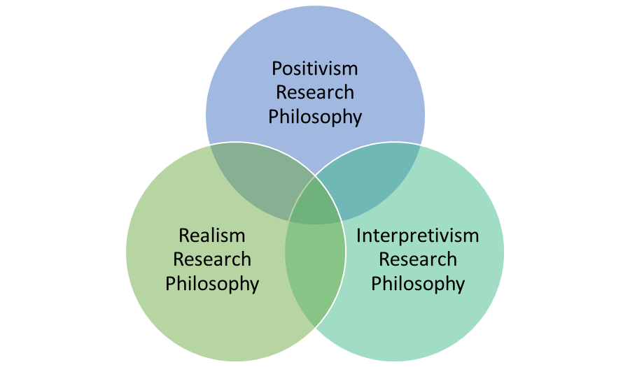
(Source: Influenced by Muhaise et al. 2020)
The research philosophy refers to the appropriate direction of the research that is effective to attribute the research findings. As mentioned by HR and Aithal (2022), the research philosophy has three variants such as positivism, realism and interpretivism. The research will be conducted by using a positivism approach as it is helpful to gain factual knowledge regarding the subject of the research. The factual knowledge is helpful to include trustworthy measurements for the research that are effective to enhance the research outcome. The positivism research philosophy is more effective than the other philosophies as it helps to make interpretation of science that is essential to enhance the research outcome.

Approaches
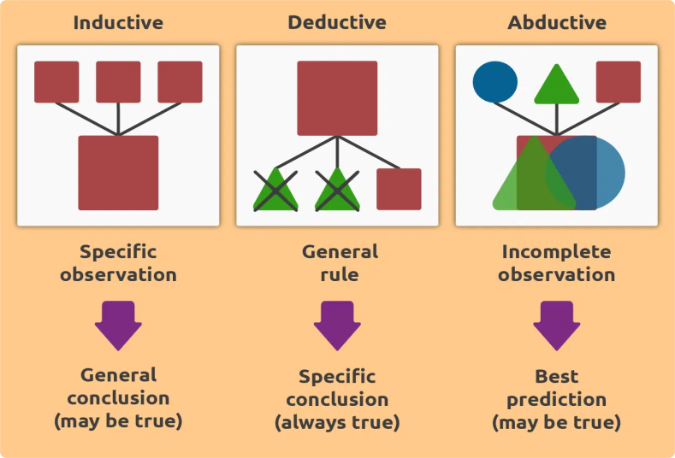
(Source: Influenced by Hall et al. 2021)
The research approach is helpful to interpret, collect and analyse the data that is helpful to provide effective legitimacy for the research. As per the view of Chang (2023), the research approach has three variants such as deductive, inductive and adductive. This research will be conducted by using deductive approach as it will be helpful for logical thinking and enhance the decision making process. Besides, the deductive approach is more appropriate than other approaches as it helps to turn the general assumptions into specific ideas.

Data Collection process
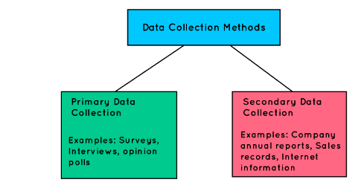
(Source: Influenced by Beierle et al. 2020)
The data collection process in a research process is helpful for problem solving and understanding. In the views of O'Cathain et al. (2019), the data collection process has two approaches such as primary and secondary. This research will be conducted by using a secondary qualitative process as it is helpful to assess the information regarding the research that have been collected and analysed previously. The secondary qualitative data collection process is helpful to maintain the time effectiveness and cost effectiveness of the research. Therefore, the secondary data collection process makes the research more effective than the primary data collection process by enhancing the cost effectiveness due to easy sources of relevant data for the research.

Data Analysis
The data analysis for a research is essential to enhance the future aspects of the research by providing accurate information regarding the research. As commented by Kuckartz (2019), the data analysis process has two variants such as thematic and statistical. This research will be conducted by using thematic data analysis as it is helpful to address the research data that is helpful to enhance the research outcome.

Ethical Consideration
This research will follow legislation of The Copyright, Designs and Patents Act 1988 that is helpful to maintain the security of the secondary data (Copyright Service.co.uk, 2023). Besides, this research will be conducted by using proper texting and referencing for the taken articles and journals.

D. Conclusion
It can be concluded that social media has a significant impact on the recruitment & selection process in information technology companies in the UK. This research proposal summarises that the research will be conducted by using secondary qualitative data to identify the impact of social media in the It sector of the UK. Furthermore, this research will be highlighting the analysis regarding the challenges associated with social media implementation. Hence, this research will provide relevant recommendations for the future usage of social media.

References

Journals
Abdalla Hamza, P., Jabbar Othman, B., Gardi, B., Sorguli, S., Mahmood Aziz, H., Ali Ahmed, S., Sabir, B.Y., Burhan Ismael, N., Ali, B.J. and Anwar, G., 2021. Recruitment and selection: The relationship between recruitment and selection with organizational performance. Hamza, PA, Othman, BJ, Gardi, B., Sorguli, S., Aziz, HM, Ahmed, SA, Sabir, BY, Ismael, NB, Ali, BJ, Anwar, G.(2021). Recruitment and Selection: The Relationship between Recruitment and Selection with Organizational Performance.
Alharahsheh, H.H. and Pius, A., 2020. A review of key paradigms: Positivism VS interpretivism. Global Academic Journal of Humanities and Social Sciences, 2(3), pp.39-43.
Al-Rahmi, A.M., Shamsuddin, A., Alturki, U., Aldraiweesh, A., Yusof, F.M., Al-Rahmi, W.M. and Aljeraiwi, A.A., 2021. The influence of information system success and technology acceptance model on social media factors in education. Sustainability, 13(14), p.7770.
Beierle, F., Tran, V.T., Allemand, M., Neff, P., Schlee, W., Probst, T., Zimmermann, J. and Pryss, R., (2020). What data are smartphone users willing to share with researchers? Designing and evaluating a privacy model for mobile data collection apps. Journal of Ambient Intelligence and Humanized Computing, 11, pp.2277-2289.
Braun, V. and Clarke, V., 2019. Reflecting on reflexive thematic analysis. Qualitative research in sport, exercise and health, 11(4), pp.589-597.
Chang, E.Y., (2023). Prompting large language models with the socratic method. arXiv preprint arXiv:2303.08769.
Copyright Service.co.uk, (2023). UK copyright law: An introduction Available at: https://copyrightservice.co.uk/copyright/uk_law_summary [Accessed on: 10.04.2023]
Duffy, B.E. and Hund, E., 2019. Gendered visibility on social media: Navigating Instagram’s authenticity bind. International Journal of Communication, 13, p.20.
Dwivedi, Y.K., Ismagilova, E., Rana, N.P. and Raman, R., 2021. Social media adoption, usage and impact in business-to-business (B2B) context: A state-of-the-art literature review. Information Systems Frontiers, pp.1-23.
Hall, J., Gaved, M. and Sargent, J., (2021). Participatory research approaches in times of Covid-19: a narrative literature review. International Journal of Qualitative Methods, 20, p.16094069211010087.
Hermanda, A., Sumarwan, U. and Tinaprillia, N., 2019. The effect of social media influencer on brand image, self-concept, and purchase intention. Journal of Consumer Sciences, 4(2), pp.76-89.
Hmoud, B. and Laszlo, V., 2019. Will artificial intelligence take over human resources recruitment and selection. Network Intelligence Studies, 7(13), pp.21-30.
HR, G. and Aithal, P.S., (2022). Why is it Called Doctor of Philosophy and Why Choosing Appropriate Research Philosophical Paradigm is Indispensable During Ph. D. Program in India?. International Journal of Philosophy and Languages (IJPL), 1(1), pp.42-58.
Kuckartz, U., (2019). Qualitative text analysis: A systematic approach. Compendium for early career researchers in mathematics education, pp.181-197.
Lim, K.H., Chan, J., Karunasekera, S. and Leckie, C., 2019. Tour recommendation and trip planning using location-based social media: A survey. Knowledge and Information Systems, 60, pp.1247
Muhaise, H., Ejiri, A.H., Muwanga-Zake, J.W.F. and Kareyo, M., (2020). The Research Philosophy Dilemma for Postgraduate Student Researchers. International Journal of Research and Scientific Innovation (IJRSI)|, VII, pp.202-204.
O'Cathain, A., Croot, L., Duncan, E., Rousseau, N., Sworn, K., Turner, K.M., Yardley, L. and Hoddinott, P., (2019). Guidance on how to develop complex interventions to improve health and healthcare. BMJ open, 9(8), p.e029954.
Pearse, N., 2019, June. An illustration of deductive analysis in qualitative research. In 18th European conference on research methodology for business and management studies (p. 264).
Pearse, N., 2019. An illustration of a deductive pattern matching procedure in qualitative leadership research. Electronic Journal of Business Research Methods, 17(3), pp.pp143-154.
Pitafi, A.H., Khan, A.N., Khan, N.A. and Ren, M., 2020. Using enterprise social media to investigate the effect of workplace conflict on employee creativity. Telematics and Informatics, 55, p.101451.
Ruggiano, N. and Perry, T.E., 2019. Conducting secondary analysis of qualitative data: Should we, can we, and how?. Qualitative Social Work, 18(1), pp.81-97.
Ruparel, N., Dhir, A., Tandon, A., Kaur, P. and Islam, J.U., 2020. The influence of online professional social media in human resource management: A systematic literature review. Technology in Society, 63, p.101335.
Saunders, M.N., Lewis, P., Thornhill, A. and Bristow, A., 2015. Understanding research philosophy and approaches to theory development.
Torous, J., Bucci, S., Bell, I.H., Kessing, L.V., Faurholt‐Jepsen, M., Whelan, P., Carvalho, A.F., Keshavan, M., Linardon, J. and Firth, J., 2021. The growing field of digital psychiatry: current evidence and the future of apps, social media, chatbots, and virtual reality. World Psychiatry, 20(3), pp.318-335.
Xu, W. and Zammit, K., 2020. Applying thematic analysis to education: A hybrid approach to interpreting data in practitioner research. International Journal of Qualitative Methods, 19, p.1609406920918810.

Website
Gov.uk, 2023, Welcome to GOV.UK, Available at: https://www.gov.uk/, [Accessed on: 10 April, 2023]
Legislation.gov.uk, 2023, Copyright, Designs and Patents Act 1988. Available at: https://www.legislation.gov.uk/ukpga/1988/48/contents, [Accessed on: 10 April, 2023]

Appendix: Poster

