**BPP Business School**

**Coursework Cover Sheet**

Please use this document as the cover sheet of for the 1st page of your assessment.

Please complete the below table – the grey columns

|  |  |
| --- | --- |
| Programme | MSc Management |
| Module Name | Business Project |
| Schedule Term | 3rd Term |
| Student Reference Number (SRN) | BP0258013 |
| Assignment Title | Marks and Spencer Facing Profit Decline for Gathering Storm of Cost of Crisis in UK |
| Date of Submission | 30/04/2023 |

Please complete the yellow sections in the below declaration:

|  |
| --- |
| DeclarationofOriginalWork:  I hereby declare that I have read and understood BPP regulations on plagiarism and that this is my original work, researched, undertaken, completed and submitted in accordance with the requirement of school Business and Technology.  The word count, excluding contents table, bibliography and appendices, is 5000 words.  Student Reference Number: BP0258013 Date: 30/04/2023 |

By submitting this coursework you agree to all rules and regulations of BPP regarding assessments and awards for programmes.

Please note that by submitting this assessment you are declaring that you are fit to sit this assessment.

BPP University reserves the right to use all submitted work for educational purposes and may request that work be published for a wider audience.

|  |
| --- |
|  |

# Executive Summary

Marks & Spencer is one of the most recognized and reputed multinational companies based in the UK operating for 139 years. It specializes in the retail of clothing, beauty food and home products. It had been serving the people of the UK as a leading clothing and beauty store. The company has had a flourishing business from 1884 as one of the leading garment stores in the UK. However, the economic crisis which arose due to various issues both in the national and global scale had impacted multinational as well as national companies. The economic downfall proved detrimental to most recognized companies including Marks & spencer. In the recent years,Marks and Spencer was found to suffer from a severe decline in the profit earned. This was one of the chief issues faced by the company. Several issues faced by the company apart from the decline in the profit are decline in the revenue from the Ocado Retain, a joint venture of the Ocado Group and Marks & Spencer, rise in the cost of energy and labour, the strengthening of dollars which affects the prices of goods and products making them exceedingly expensive and unavailable to the customers. Other issues faced by the company are the reduction of disposable income of the customers caused due to various reasons caused by the difficult economic condition (Jiang, 2022). This has resulted in another issue that is of increased inflation. Customers as a result of a decreased disposable income had to focus their spending more on the necessary items than the luxury items. This can be highly detrimental to the business of Marks & Spencer.

This report incorporates an introduction discussing the company’s profit and provides an overview of the company and the issues and challenges it has faced as a result of the economic crisis. The report proceeds to discuss the challenges and the problems faced by the company in the recent years in detail. The challenges and problems had been discussed along with their causes and their impact on the business of the company. It then presents the purpose of the report clearly defining the aim and the purpose of writing this report followed by contention of who the stakeholders of the company are and how they will be impacted by the situation of facing a severe decline in the profit of the company. It discusses who the internal and external stakeholders along with using Mendelow’s Matrix. The report proceeds to present an evaluation with the secondary data with the help of PESTLE analysis. The PESTLE analysis of the company has helped to navigate and figure out the various areas it needs to focus on for smooth functioning and operation of its business. It is followed by the recommendation which has been made with the help of the Porter Generic strategy. It is followed by the conclusion consisting of the points discussed in the report in a nutshell.

Contents

Executive Summary 1

1: Introduction 4

2: Challenges or problems being faced 5

3: Purpose for report 7

4: Stakeholder analysis and impact 8

5: Evaluation with secondary data 10

6: Recommendation and Conclusion 14

Reference 18

# 1: Introduction

Marks & Spencer is one of the most renowned multinational companies based in the UK. It chiefly deals in clothing, beauty, home and food products (Faseluka, 2022). Being a multinational company based in the UK, it has its headquarters in London. The multinational company is named after the founders Michael Marks, and Thomas Spencer in 1884 (Halan, and Singh, 2023). It had its original store in Leeds before turning into one of the most sought-after clothing brands in the world. The company mainly emphasizes on the quality of the products it specializes in, especially the food products such Swiss rolls. However, due to these issues almost 100 stores had been closed down and almost 7000 jobs were cut down (Joshi,et al., 2022).

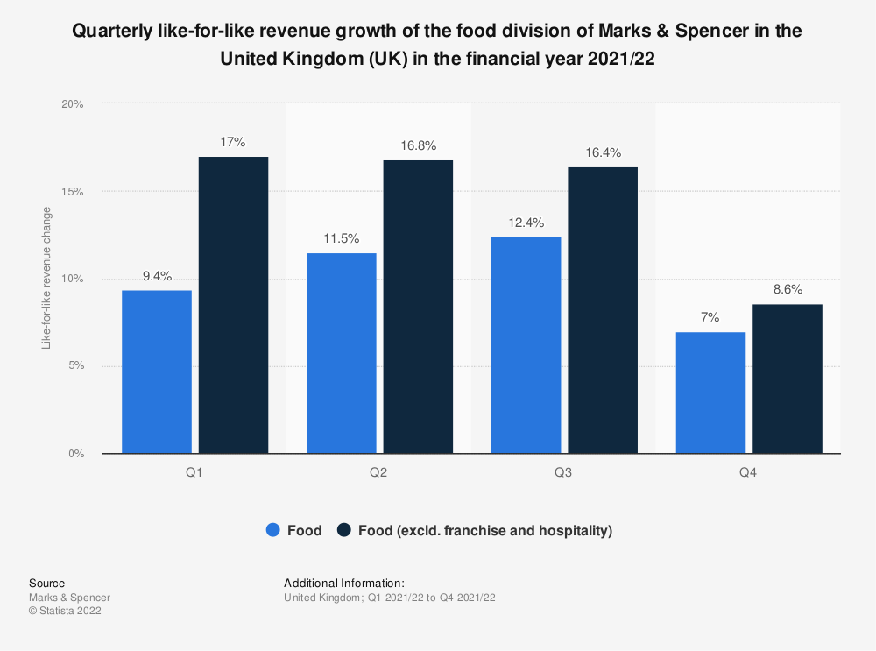

***Fig:M&S revenue growth in the year 2021-2022((Wattel, 2022)***

The economic crisis caused a severe impact on various multinational companies with Marks & Spencer being one of them. Several stores had suffered in the period of crisis. In the recent years, Marks & Spencer has been found to suffer a decline in the profit posing as a big challenge in the recent time (Pinto Nogueira,et al, 2022) . This decline in the profit has been found to pose an issue due to various reasons. One of the chief reasons is the rise in the cost of living of the customers which can be seen as a result of the economic crisis that emerged with the crisis (Joshi,*et al.,* 2022). Due to increase in inflation and alleviation of disposable income, customers had to focus on purchasing the necessary items compared to the luxury items (Halan, and Singh, 2023). Several other issues such as lack of profit from Russia as a result of the joint venture with Ocado group, high labour and energy costs, fall in the disposable income of the customers, high purchasing costs, less spending are some of the issues Marks & Spencer is facing as an insurmountable challenge (Hill, 2022).

# 2: Challenges or problems being faced

Many multinational companies have witnessed a fall in their profits, Marks and Spencer are one of them. The fall in their profits is a result of several Economic crises like high costs and weak customers.Despite an 8.5% rise in revenue, the profile fell because of higher costs.Analysts found that the average forecast of profit before tax and adjusted items was 397 million pounds for the year 2022-2023 reduced from 523 million pounds in the fiscal year 2021-2022(Chen, and Petersen, 2022). The company claimed a 24% fall in the profits prior tax and other adjustments to around 205.5 million pounds (Wattel, 2022).  However, there has been a strong performance of the company’s food department leading to 0.9% rise in the sales margin due fall in prices and availability of new range of food products (Ovezmyradov, and Kurata, 2022). Not only that the company is also facing more substantial dollars that increase their cost of purchase while the disposable income of customers is falling. The continuous decline in the sale of clothes also results in a company's profit reduction. In addition, profits also reduce in the company because higher property cost taxes after the end of the relief of business rate are also excluded from Russia (Bello, and Zango, 2022). Another issue that has seemed to emerge and cause a decline in the profit margin of the company has been missing out on the profit contributions from the joint venture with Ocado Group reporting a 3.8% decrease in yearly revenue compared to the previous year (Ovezmyradov, and Kurata, 2022). However, it believes in the strength of the customers building up a strong customer base for future growths. The Group plans to strengthen its customer base to invest more in value in order to aid the customers dealing with the cost of living pressure. It is difficult to demonstrate that an organization making in excess of £550 million annually is broken, but shareholders are undoubtedly concerned about the squeeze on margins in the food industry, and M&S must take care to prevent flat profits from turning into a gradual decline that eventually becomes an unexpected, rapid decline (Conway, 2021).

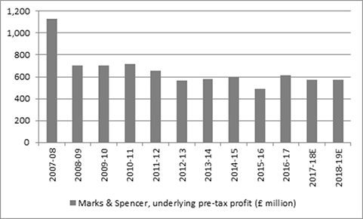

***Fig:M&Spre tax profit (***Conway, 2021***)***

In Spite of the increasing cost of energy and labour, they had to purchase them which left the customers with a low disposable income. This caused strengthening of dollars which gave a rise to the prices of goods and products. Strong dollars and better economic state of the US has caused an aggravation of the prices of goods making it difficult for the consumers to purchase these items (Brayson, 2022). This brought down the sales margin and profits.

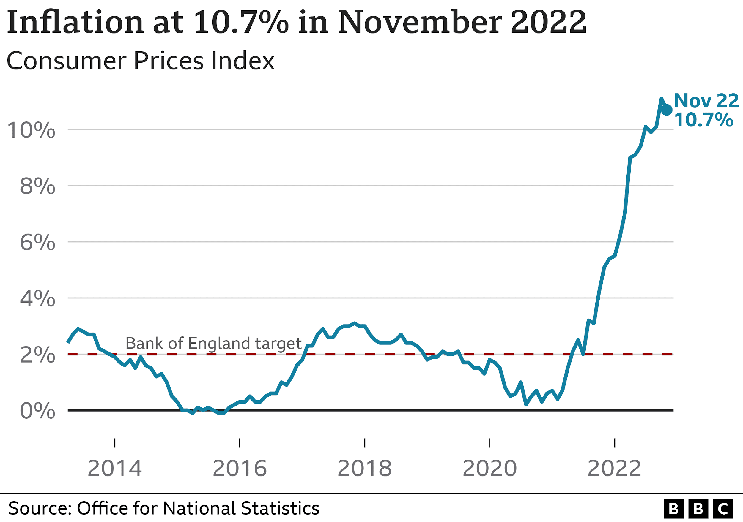

***Fig: High inflation in UK (Chen, et al 2022)***

Another unavoidable issue that has caused declining profit is the reduced disposable income of the customers. Customers having to spend on more important items such as energy and labour are left with a meagre amount to spend on luxury clothing and other items (Chen, and Petersen, 2022). This situation makes it extremely difficult for the customers to maintain their standard of living. Besides, inflation in the UK, especially due to the economic crisis has been found at a 40-year high of 10.1% causing the rising prices of items impacting the reduced disposable income of the customers(Joshi, et al, 2022).

# 3: Purpose of the report

The purpose of the report is to assess the challenges faced by the multinational company Marks & Spencer which is leading to an acute decline in the profit.  It aims to focus on the chief issue for the fall in the profit margin of the multinational company that is the dwindled cost of living of customers causing a weak customer base for the consumption of their products. The other issues faced by the company are fall in the revenue from the Ocado Retail, rise in the cost of energy and labour, stronger dollar causing rise in the prices, fall in the disposable income, inflation, and customer planning on less spending.

# 4: Stakeholder analysis and impact

Stakeholders are crucial to a company’s success. Stakeholders empower the company and get the business to soar high. The support of the stakeholders aids in the decision making process of the company and boosts the confidence of the managers (Sooriyage, 2022). Therefore the significance of stakeholders makes it essential for the study of their impact in a business organization. Marks & Spencer possesses its share of stakeholders who are highly impacted by the growing decline in the profit of the company in the period of economic crisis (Kofler, 2022). For Marks & Spencer the fall in the profit has been impactful to the both internal and external stakeholders of the company illustrated below.

|  |  |
| --- | --- |
| Internal Stakeholder | External Stakeholders |
| Employees working in the organization to earn a source of livelihood | Customers are the consumers of the products manufactured by the company |
| Managers are the stakeholders who are involved in the decision making processes of the company(Susanti,andKartikawati, 2022). | The local and national government set regulations for the company to follow and also charge tax for  its business. |
| Investors can be anticipated as internal shareholders who are accountable to the profit making sequence of the firm. | Suppliers are the group of individuals who provide the company with raw materials. |
|  | Shareholders are the group of individuals who invest in the company to share their profits |

The impact of stakeholders can be evaluated through Mendelow’s Matrix as it will aid to identify the chief and priority stakeholders who can cause rise in the business of Marks &Spencer’s which makes it necessary to manage communications with them.

As per Mendelow’s Matrix, the four quadrants represent the priority stakeholders who are supposed to be highly affected by the decline in the profit of the company.

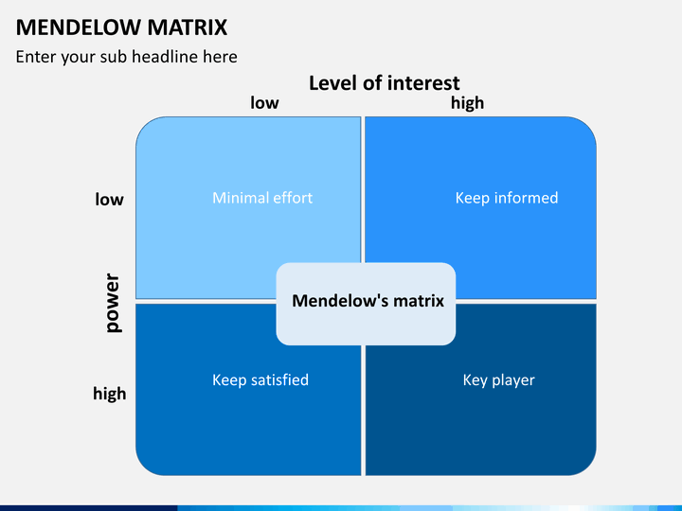

***Fig: Mendelow’s Matrix (Joshi, et al., 2022).***

**High interest-high power**

The stakeholders falling under the category of stakeholders with high interest and high power are the investors and shareholders. The investors and shareholders are the group of individuals who bear the cost and invest the money into the business hoping for possible returns.Therefore, the investors and shareholders will be less likely to invest their money into the business and fear taking risks (Ahmed,*et al*, 2022). This attitude of the investors and shareholders will alleviate managers’confidence and impact their decisions.

**High interest- low power**

The stakeholders of Marks &Spencer such as the employees and suppliers can be seen to be impacted by the fall in the profit of the company. It can be seen that the employees devoting their time and energy to earn a means of livelihood will be affected by the unequal distribution of income as a result of declining profit (Bello and Zango,2022). This will impact their functioning and affect their confidence in the company. As for suppliers, the decline in the profit of the company can result in the delayed payments hampering the swiftness and smooth working of the supply chains.

**Low interest-high power**

The stakeholders like the government and the customers having low interest and high power in the company can also be highly impacted by the declining profit of the company. The fall in profit will impact taxes paid to the government resulting in the low income of the government as tax received from Marks & Spencer (Testa, *et al* , 2022) . Due to the disrupted supply chain caused due to declining profit will shift to other brands.

**Low interest-low power**

The stakeholders of Marks & Spencer having low interest and low power are mainly the managers and employees working in the company. This group of stakeholders are affected by the decline of the profit affecting the functioning of both the managers and the employees of the company. (Lindblom, *et al*, 2022). However, it can be identified that they incur upon low interest about the investment ratio or profit making, rather they play administrative toi increase revenue for firm.

# 5: Evaluation with secondary data

Marks & Spencer one of the biggest names in the British Business has reported a 24% decline in its profit, the profits have fallen 8.5% despite the rise in revenues due to the higher costs of products and production (Williams, 2022).Marks & Spencer known for its fast fashion clothing and low price clothing is finding it hard to ensure continuous sales of its products for the long term. It is mainly because of the recent uncertain situation which has led to higher CPI index and lesser consumer spending power over the period.

**PESTLE analysis**

Political factors- although the political stability of UK is one of the best in the world, with its providing full term prime ministers this has helped in ensuring that the country operates its full businesses and ensures foreign companies to have stable businesses in the country as well. After coming of Rishi Sunak the government of the UK has stabilized and has provided with due diligence to all the businesses. With the Russia-Ukraine war this has led to rise in energy costs as well as costly raw materials as well (Yasmeen, *et al.,* 2022). This has led to Marks & Spencer and several other fashion brands focus on increasing the prices of the clothes (Grigoli, &Pugacheva, 2022). With high inflation in the rise, Consumers are not buying as much as they would do when the prices were low. However, the countries that Marks & Spencer stores in, it also needs to have better political stability in order to have better business opportunities. Furthermore, the UK Government should have, business friendly laws and taxation policies, which will help the fashion companies in the time of crisis.

The expansion of free commerce between nations is one of the best features of contemporary politics. This will help M&S quite a bit as it is mostly a UK-based company with some international activities. Open commerce helps Marks & Spencer to import products from other nations at reduced rates for sale in its retail locations since it has a high profitability margin. The ability to trade has long existed, especially among firms in Europe, but it may be impacted by the choice made by the UK to leave the EU (Nyame-Asiamah, and Ghulam, 2020).

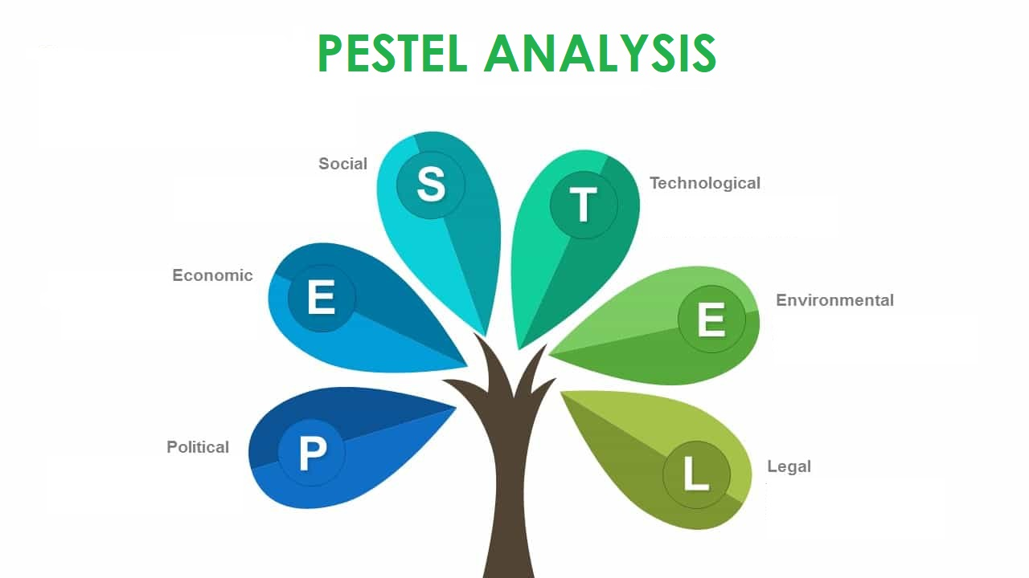

(Fig: PESTLE analysis, Source: Zhang, 2022)

Economic factors- Like any other major economic factors, inflation is also a large problem in the current generation. With the 40 year high inflation rate in the UK, this has led to companies increasing their prices, thus affecting the customers (King, 2022).The relevance to this is that companies such as Marks & Spencer are cutting down on operational costs in order to keep going in the current uncertain condition. Similar to this, many companies have also started laying off their employees in bulk in order to reduce their operational income.

Although price is still a key factor in the retail industry, there are now many low-cost retailers operating in the UK. These new competitors, which vary from discount grocery shops to discount clothes chains, are taking market share away from more costly companies by encouraging customers to buy equivalent items at significantly lower prices (Yasmeen, *et al.,* 2022).

Social factors- UK is known for their fast fashion brands and for the people who were fast fashion clothes as well. The fast fashion clothes are cheap in cost, therefore buying in large numbers is easier for the consumers. M&S is a well-known brand in the UK. Young people, elders, and everyone in between are now familiar with the retail industry, which has existed since the 1800s. Customers are starting to associate M&S with earlier generations, which is a tragic outcome of this company's long-standing reputation. As fresh and fashionable stores open each year, M&S's reputation as a chic brand for consumers—particularly younger ones—may suffer. There are several fast fashion brands in UK such as Zara, Marks & Spencer, Primark and more. The fast fashion clothes are low in quality which explains the low cost of these products. However, the present situation of the market and the rising inflation has led consumers to think on their priorities and focus less on fast fashion clothes (Mann, & Brandt, 2022). However, this will still not be enough and the company is facing losses in terms of sales in spite of the rising revenue. With the rising costs of energy and labour charge, the pricing has been increased which has led to consumers focusing on other brands with better quality clothes.

Technological factors- With the rising technology, the cost of producing fast fashion clothes has reduced to a large extent. This has led to companies selling clothes in cheap prices. Furthermore, with the rise in online technology, online shopping has gained popularity in the past 3 to 4 years. UK being a services country, the growth of online shopping has increased many folds. Companies are cutting back on their brick, brick and mortar stores and opening and focusing on online shopping experience (Tusher, 2022). Being one of the leaders in the clothing industry, Marks & Spencer, has seen its market grow with the use of new technological factors. Marks & Spencer has opened up stores for consumers to experience such technology and focus on the engagement and experience of the consumers.

Legal factors- Similar like the other industries, the fashion industry too has to follow the guidelines of the UK Government. However, since Marks & Spencer &M does not use manufacture the clothes in UK, the rules of the UK Government does not apply in the international boundaries or other countries. With the UK getting out of the European Union due to the Brexit, of several materials and its prices have increased considerably. Brexit is also one of the main reasons for the rising prices in the UK, along with the Russia, Ukraine War in Europe (Ali, *et al.,* 2022).

Environmental factors- Fashion also impacts the environment in many ways, such as the use of harmful chemicals in making the clothes and the type of fabric used for making fast fashion clothing. Is the demand of fast fashion clothing reducing due to the inflation? Companies will have to focus on making better quality clothes. Fairtrade is a strategy for paying producers abroad more fairly, but it also has an impact on the environment. This is done in order for smaller firms, who gain the most through fair trade, to operate more environmentally friendly than their more seasoned competitors. For that reason, the company M&S decided to offer fair trade goods benefits the environment as well (Lea, 2022).

**Porter’s Generic Strategy**

Porter’s generic strategy showcases the competitive strategies which can be used by companies. These strategies can be used in a way which will help the company, to move ahead of the competition and ensure better growth in the business.

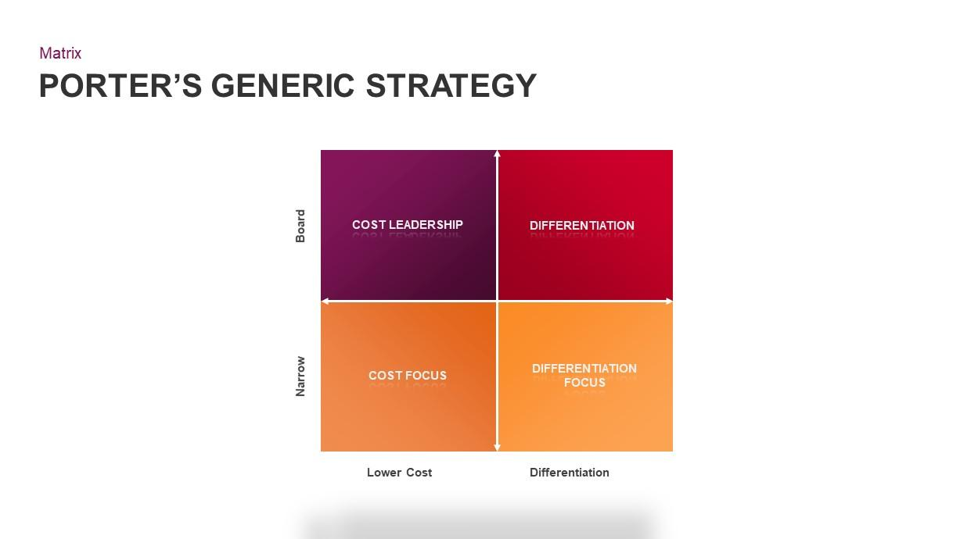

(Fig: Porter’s Generic Strategy, Source: Rogoff, 2022)

Cost leadership- this focuses on the pricing side of the business. The target for the companies are often the price conscious consumers. In this the company will be providing better quality products in low prices which will be on par with the competition (Asif, *et al.,* 2022). This is one of the best strategies in order to attract high consumer footfall and ensure that the market share increases significantly. The strategy of cost leadership determines to reduce expenses for the purpose and intention to gain the advantage of competitiveness. Cost leadership is the main strategy that Marks Spencer uses across a range of customer groups. The company M&S develop a strategy to concentrate on the middle class, which makes up the greatest section of the worldwide market of consumers in most nations, Marks Spencer may increase its market share. Cost management is the finest strategy to meet middle-class consumers' requirements since they typically pay a lot of attention to the pricing issue. Great brand awareness, quick sales growth, and a strong basis for competitive advantage are the benefits of Marks Spencer's concentration on the affordability and availability of its goods worldwide.

Differentiation strategy- this focuses on the difference of the products between the company and its competitors. There are consumers who do not think of the pricing and are ready to pay high prices for better quality products. Companies are ready to provide the best features that their product has and also showcase qualities which the competitor’s product do not have. Differentiation is a highly used strategy when there is need to increase variation in products and ensure that the consumer’s demands are met in the right direction. M&S may grow its customer base by emphasizing the unique features of its products and employing variety as a secondary fundamental strategy. The goal of Marks Spencer's use of this tactic is to stand out from the competition by embracing innovation and addressing the rising health concerns of consumers. For instance, M&S has broadened its product assortment in response to a study of consumers' changing tastes in an effort to set the company different from their market competitors and develop different options available in the market. Marks Spencer has amassed a sizable and devoted consumer base as a result of its originality and effective cost management. They need to be effective and be unique in nature.Marks Spencer advertises their product lines as being unique from alternatives available in the market. Being a seasoned, widely recognized brand, the company uses distinction as a strategy to lessen competition from competitors (Nyame-Asiamah, and Ghulam, 2020).

Focus Strategy- this strategy is for companies who attracts specific customers. This strategy is not meant for large companies or multi-nationals. In this strategy companies often try to focus on providing specific products which will be catering to the needs of the specific group of consumers. Therefore this strategy is for highly selective group of consumers who aim for providing unique and exclusive products for the businesses with lesser competition. This strategy can be used by multinationals on top of cost leadership or differentiation strategy (NGOZI, 2022). In order to deliver the highest level of value and lowest pricing, the company employ the focus strategy. The price-effective focus strategy is used to satisfy a certain market segment's needs at the lowest possible cost. The material, size, and look of the item that can best satisfy the consumers' requirements and preferences are highlighted by the most successful value-focused strategy. By focusing on its product characteristics, M&S continually refines its marketing approach and makes changes to its item appearance and packaging in order to satisfy consumers' psychological demands and maximize value for money.

All the above discussed strategies are used by companies in order to get ahead of the competition or ensure that its market share does not get dwindled with time. However in the present scenario where companies are unable to understand the needs of the consumer as the consumers have reduced their buying in order to set focus on priorities this has led to lesser sales for companies in the fashion industry such as Marks & Spencer. Therefore cost leadership is one of the best ways for the company to go about. First and foremost it is important for Marks &Spencerto close down the line of brands which are not generating revenue for the company which will help in reducing the operational costs of the company. Since consumers are looking for quality clothing in less prices, With the fears of recession the situation may get worse for companies and they may have to lay-off even more employees than planned. Reducing the operational costs will help in decreasing in the losses and with the popular brands in the frontline consumers will be back to stock on their inventory of clothes. Secondly it is also important for the company to close down on its brick and mortar stores and focus on online market. Upgrading the present website or app along with focusing on increasing its footfall and differentiation prospects this will help Marks &Spencerto ensure its online presence is increased during this period. Shifting most of the business to online marketplace will ensure the company for online sales with minimum operational costs (Youssef, *et al.,* 2022). Thirdly with the different rate of inflation for the different products, the company can consider substituting one material for the other. In manufacturing of the clothes, use of different material of low cost can become a better substitute than the already used raw material. The key is to look for substitutes which is away from the high inflation products. The rise in inflation leads the distraction from the fundamental business practices of serving the consumers in the most productive manner possible. Managing inflation has been added to the long list of the company to-do list which is of higher importance than before.

# 6: Recommendation and Conclusion

Marks & Spencer's apparel and home division sales almost quadrupled in the 19 weeks to August 14 over a year prior to was down only 2.6 on prior to the 2019 pandemic. This was due to a determination to improve the high-quality items and significant investments in technology and online commerce. Food sales increased 10.8% over the previous year and 9.6% over the year prior to, with efforts to reduce costs helping to counterbalance inflation and disruptions to the supply chain brought on by labor shortages. improving effectiveness as To optimize earnings, efficiency must be improved as well (Henderson, 2021). This might entail adopting new technology to cut expenses, streamline procedures, and increasing overall operational effectiveness. Investment in new goods and services is something that Marks & Spencer should do in order to stay competitive. (Blake, *et al*., 2021). The foundations of fashion are correct. Today, it can be emphasized how M&S remains a leading provider in subcategories like lingerie and denim. M&S can keep bringing in customers who could subsequently make additional purchases once they come to the stores by succeeding in these as well as additional categories, such as schoolwear. Choose fashion over style. Despite the ups and downs of fashion, true style always remains in vogue. The prints M&S now uses are just too overt and may act as both an attraction and a barrier to customers. A more conventional approach would be significantly more suited for M&S's target demographic. Prioritize quality over cost (Conway,2021). M&S should resist the urge to be competitive in price and concentrate on offering better value. This may result in margin pressure, however it can be a price to pay for bringing growth back to the highest line. However, because earlier attempts to use external brands to achieve this goal failed, M&S need to instead achieve this goal using its own owned goods or classifications, like Rosie. (Brayson, A., 2022). Implement a pricing plan that accounts for the dollar's strength. This can entail putting a foreign currency premium in place or establishing pricing in foreign currencies. Consider raising pricing to pass along the expense of the stronger currency to buyers. This can assist in absorbing some of the extra expenses brought on by a higher currency. Think about exporting production to nations with weaker currencies (Spencer, *et al*., 2020). This can help reduce the cost of production and help absorb the extra costs associated with a stronger dollar. Re-evaluate the sourcing strategy. Consider hedging currency exposure. This involves entering into a forward contract to buy or sell a specific currency at a pre-determined exchange rate. Invest in technology to help streamline operations and reduce costs (Atherton, J., 2019). Radical thought is required, The home goods industry is where M&S has trouble. M&S won't provide sales or margin details, and demands for projections of the company split from top analysts were rebuffed, indicating that they are unsure of the details. The consensus opinion is that the "home" segment represents far under fifty percent of the overall home market, and the apparel division's sales, profitability, and the same as-for-likes are significantly lower than the rest of the fashion industry. Automation and digitization can help reduce the cost of operations, including labour costs. Review the inventory management strategy. Keeping inventory levels low can help reduce the costs associated with storage and warehousing (Walker, *et al*., 2019). These changes should help the company to improve its profitability and increase its market share in the future. The shop's size should be decreased. The decision by Mr. Rowe to forgo plans to open further Just Food locations and approve a further £48 million in costs for closing or depreciating certain sites is noteworthy. Work has to be done. Action needs to be made everywhere as some of the big out-of-city areas initiate the risk of becoming a burden (Hart, *et al*., 2021). It can be recommended to do away with home sales completely and concentrate on footwear, a segment where the company's offering is lacking and needs to be strengthened. They would even go so far as to propose that M&S buy Clarks, a company in the midst of restructuring its business, closing several of its 550 UK locations, and shifting its attention to the Far East. We believe that combining the reputable Clarks brand with M&S's food and apparel selection would be a strong proposition. In addition to giving shoppers another incentive to go to M&S stores, we think that adding footwear will boost apparel division profits (EmmenQuirós, 2019). Additionally, the company should explore ways to reduce its cost of labour, such as providing more flexible working hours, offering employee benefits, and providing training and development opportunities (Rust, E., 2022). Moreover, they should look at ways to reduce their costs by increasing efficiency and productivity. M&S acknowledges that it is lagging behind in the digital sector. The 11 million customers of the website of M&S have seen improvements in page load times on average, and the company has experimented with social media "piloting" by creating a shoppable Instagram feed. Internet-based sales of homes and apparel made up 22% of total sales in the 2018–19 fiscal year, with clothing sales outpacing the market as a whole. Next up will include later clicking and collecting cutoff times, trials of delivery on the same day, quicker payment processing times, and an Android-based M&S app aimed at over 1 million customers. The goal is for one-third of house and clothes transactions to be completed online. Businesses utilize market expansion as a tactic to sell their present products in new areas. New market sectors, uses for the company's products and services, or geographical areas may need to be investigated in order to draw in customers. This strategy may be put into action in a variety of ways, including: different international market fields, such as shipping goods to a new country. The company Marks & Spencer announced the inauguration of its largest store outside of the UK (Esoimeme, 2020).

Due to an impending storm of costs and a crisis in the UK, The M&S Group is now experiencing a challenging time. To lessen the effects of the storm, the corporation has put in place a variety of cost-cutting initiatives and is concentrating on cost effectiveness. However, it is clear that the company is in an untenable circumstance, and further cost reductions and strategic changes will be needed to ensure the enterprise's kept going viability. It will be fascinating to see how the company adjusts to this changing environment and maintains its competitiveness in the UK market. To boost its success, the firm has implemented a variety of strategic adjustments, including enhanced supply chain oversight, cost reduction, and concentrate on digital marketing (Walker, *et al*., 2019). By taking these steps, Marks and Spencer can ensure the long-term success of their business project. Using a variety of models to develop their business project (Hart, *et al*., 2021). These models will help them create an effective and sustainable business project that will help them thrive in the modern market. Marks and Spencer should consider implementing energy and labour efficiency measures to reduce their costs (EmmenQuirós, 2019). As a result of entering areas where it possesses little to no knowledge and potentially risky application scenarios, diversification might be inherently riskier than other strategies. A corporation must have a clear understanding of what it expects from the strategy and an honest assessment of the risks before considering a diversification plan. In addition, the completely novel markets that the corporation has successfully achieved as it has grown its amount for 40 nations. Although the decline in menswear sales has not stopped, the clothing industry still struggles with slow stock replenishment, occasional depth of buy, and selling out of common lines prematurely, although our impression is that compared to a performance is going to improve. Margin improvement is also being aided by a decrease in the stock kept for sales. These measures could include investing in energy-efficient equipment, implementing energy-efficient operations, and utilizing renewable energy sources. Additionally, the company should look into utilizing automation technologies to reduce labour costs and improve productivity. Additionally, the company should explore ways to reduce its cost of labour, such as providing more flexible working hours, offering employee benefits, and providing training and development opportunities. Reducing the amount of real estate it owns. M&S would shut 32 full-line outlets, up from 68 stores that sold just their products. M&S has closed in recent years. An additional 30 full-line sites will close over the course of the subsequent nine years. A total of 130 full-line retailers have been laid off. Marks & Spencer, however, has announced ideas to create 15 brand-new full-line shops and 40 brand-new restaurant over the course in coming three years as it shifts its focus from clothing to food. Finally, the company should explore ways to reduce its energy costs, such as utilizing energy-efficient lighting, utilizing renewable energy sources, and investing in energy-efficient equipment.

# 

# Reference:

Ahmed, I., Mehta, S.S., Ganeshkumar, C. and Natarajan, V., 2022. Learning from failure to enhance performance: a systematic literature review of retail failure. *Benchmarking: An International Journal*, (ahead-of-print).

Ali, M., Ateik, A.H., Zainol, S.B., Azizzadeh, F., Aljounaidi, A., Subhan, M. and Islam, M.S., 2022. Current Political Crisis Impacts on Pakistan’s Public Life: An Economic Case Study Regarding the Present Situations in Pakistan. *Sarc. Jr. Eco. Bus. Man*, *1*.

Asif, R., Fiaz, M. and Zulfiqar, Z., 2022. The Impact of Sustainable Energy on Liquidity and Financial Performance of the Textile Industry. *SAGE Open*, *12*(4), p.21582440221141704.

Atherton, J., 2019. *Social media strategy: A practical guide to social media marketing and customer engagement*. Kogan Page Publishers.

Bello, B. and Zango, T.N., 2022. Organisational Failure and Turnaround: An Empirical Analysis of the Defunct Nigerian Telecommunications Limited (NITEL). Ife Social Sciences Review, 30(1), pp.27-43.

Blake, D. and Cairns, A.J., 2021. Longevity risk and capital markets: The 2019-20 update. *Insurance: Mathematics and Economics*, *99*, pp.395-439.

Brayson, A., 2022. Fiscal Theory and Practice in Yorkist England: The Regression from a “Tax” to a “Domain” State. *StudiaHistorica. Historia Medieval*, *40*(2), pp.11-34.

Chen, N. and Petersen, F.E., 2022. Consumers’ Cooperation with Sustainability Programs: The Role of Luxury Branding and Profit Motive Attribution. *Journal of Macromarketing*, *42*(4), pp.655-672.

Chen, N. and Petersen, F.E., 2022. Consumers’ Cooperation with Sustainability Programs: The Role of Luxury Branding and Profit Motive Attribution. *Journal of Macromarketing*, *42*(4), pp.655-672.

Conway, I. (2020) M&amp;S should choose revolution over evolution in order to grow, Shares Magazine. Available at: https://www.sharesmagazine.co.uk/article/ms-should-choose-revolution-over-evolution-in-order-to-grow (Accessed: 02 May 2023).

Dobos, E., 2022. Changing Landscapes but Ingrained Power Relations? The Green Promise of the COVID-19 Pandemic, the (Un) sustainability of the Fashion Industry, and the Central-Eastern European Production Background. *Acta Universitatis Sapientiae, Social Analysis*, *12*(1), pp.1-27.

EmmenQuirós, D.I., 2019. *The impact of fast fashion on the environment: Perspectives from Consumers and Retailers in Ireland* (Doctoral dissertation, Dublin, National College of Ireland).

Esoimeme, E.E., 2020. Using the risk-based approach to curb modern slavery in the supply chain: The Anglo American and Marks and Spencer example. Journal of Financial Crime, 27(2), pp.313-322.

Faseluka, J.T., 2022. *A critical analysis of the effectiveness of corporate rescue in retail sector insolvency cases* (Doctoral dissertation, University of Leeds).

Grigoli, F. and Pugacheva, E., 2022. Updating Inflation Weights in the UK and Germany during COVID-19.

Halan, D. and Singh, E.P., 2023. Enemies to frenemies: coopetition between online and offline retailers amidst crises. *International Journal of Retail & Distribution Management*, (ahead-of-print).

Hart, A.F., 2021. *Irish women in business, 1850-1922: navigating the credit economy* (Doctoral dissertation, Trinity College Dublin. School of Histories & Humanities. Discipline of History).

Henderson, R., 2021. *Reimagining Capitalism in a World on Fire: Shortlisted for the FT & McKinsey Business Book of the Year Award 2020*. Penguin UK.

Hill, J., 2022. How I helped kill the high street. *British Journalism Review*, *33*(4), pp.41-45.

Jiang, B., 2022. Momentum Investing. In *Investment Strategies: A Practical Approach to Enhancing Investor Returns* (pp. 133-146). Cham: Springer International Publishing.

Joshi, N., Gabhane, D. and Somashekhar, C., 2022. How Social Media Marketing is Helping in Customer Retention and Customer Engagement: A Case of Marks and Spencer. *ECS Transactions*, *107*(1), p.17027.

Joshi, N., Gabhane, D. and Somashekhar, C., 2022. How Social Media Marketing is Helping in Customer Retention and Customer Engagement: A Case of Marks and Spencer. *ECS Transactions*, *107*(1), p.17027.

King, M., 2022. Monetary policy in a world of radical uncertainty. *Economic Affairs*, *42*(1), pp.2-12.

Kofler, G., 2022. Should We Cut ‘Final’Losses?.*EC Tax Review*, *31*(3).

Lea, R., 2022. CPI inflation hit 7.0% in March–and higher inflation to come. *Arbuthnot Banking Group*, *19*.

Lindblom, A., Nadayama, N., Asakawa, K. and Cuthbertson, R., 2022. De-internationalization of transactional platforms: an exploratory case study. *The International Review of Retail, Distribution and Consumer Research*, *32*(1), pp.3-24.

Mann, C.L. and Brandt, L., 2022. On Returning Inflation to Target.

NGOZI, E.A., 2022. LOCALIZATION OF TEXTILE INDUSTRY IN NIGERIA.

Nyame-Asiamah, F. and Ghulam, S., 2020. The relationship between CSR activity and sales growth in the UK retailing sector. Social Responsibility Journal, 16(3), pp.387-401.

Ovezmyradov, B. and Kurata, H., 2022. Omnichannel fulfillment and item-level RFID tracking in fashion retailing. *Computers & Industrial Engineering*, *168*, p.108108.

Pinto Nogueira, J.F., Garcia Prats, F.A., Haslehner, W.C., Heydt, V., Kemmeren, E., Kofler, G., Lang, M., HJI Panayi, C., Raingeard de la Blétière, E., Raventos-Calvo, S. and Richelle, I., 2022. Opinion Statement ECJ-TF 4/2022 on the ECJ Decision of 22 September 2022 in Case C-538/20, W AG, on theDeductibility of Foreign Final Losses. *CFE Tax Advisors Europe*.

Roberts, C., 2022. New Developments and Technological Change: The Business of Mass Manufacturing Fashion. In *Consuming Mass Fashion in 1930s England: Design, Manufacture and Retailing for Young Working-Class Women* (pp. 137-196). Cham: Springer International Publishing.

Rogoff, K.S., 2022. The Age of Inflation: Easy Money, Hard Choices. *Foreign Aff.*, *101*, p.120.

Rust, E., 2022. Unravelling the Complex Nature of Events-Focused Policy: A Framework to Aid Understanding. *Festivals and the City*, p.211.

Sooriyage, J., 2022. A Comprehensive Literature of Marketing Strategies Used by Different Industries in Local and Global Context during COVID-19 Impact. *Available at SSRN 4306929*.

Spencer, G. and Handwerker, C., 2020. The use of decision support tools to accelerate the development of circular economic business models for hard disk drives and rare-earth magnets.

Susanti, S.S. and Kartikawati, D., 2022. Fashion From Home Sebagai Customer Relationship Management Toko Marks & Spencer Mall Kasablanka di MasaPandemi Covid-19. *Populis: JurnalSosialdanHumaniora*, *7*(1), pp.98-110.

Testa, D.S., Slaton, K. and Karpova, E., 2022. A Mixed Methods Exploration of Economic Factors Role in Fashion Specialty Retailers' International Expansion and Performance. *Journal of Marketing Development & Competitiveness*, *16*(1).

Tusher, N.U.H., 2022. Bangladesh RMG Supply Chain Vulnerabilities To Disruption Beyond Covid-19. *International Research Journal of Business Studies*, *14*(3), pp.199-214.

Walker, D. and Rowlinson, S. eds., 2019. *Routledge handbook of integrated project delivery*. Routledge.

Wattel, P.J., 2022. Tax In History: Thirty Years of Fiscal (In) coherence. *Intertax*, *50*(10).

Williams, K., 2022. Cutting the cost of living.

Yasmeen, R., Shah, W.U.H., Ivascu, L., Tao, R. and Sarfraz, M., 2022. Energy Crisis, Firm Productivity, Political Crisis, and Sustainable Growth of the Textile Industry: An Emerging Economy Perspective. *Sustainability*, *14*(22), p.15112.

Yasmeen, R., Shah, W.U.H., Ivascu, L., Tao, R. and Sarfraz, M., 2022. Energy Crisis, Firm Productivity, Political Crisis, and Sustainable Growth of the Textile Industry: An Emerging Economy Perspective. *Sustainability*, *14*(22), p.15112.

Youssef, I.S., Salloum, C. and Al Sayah, M., 2022. The determinants of profitability in non-financial UK SMEs. *European Business Review*, (ahead-of-print).

Zhang, Y., 2022. Evaluating the Effectiveness of Loyalty Programmes in the Fashion Industry: A Case Study of ASOS UK.