Consumer Trend Canvas



**Analyze**

**Apply**

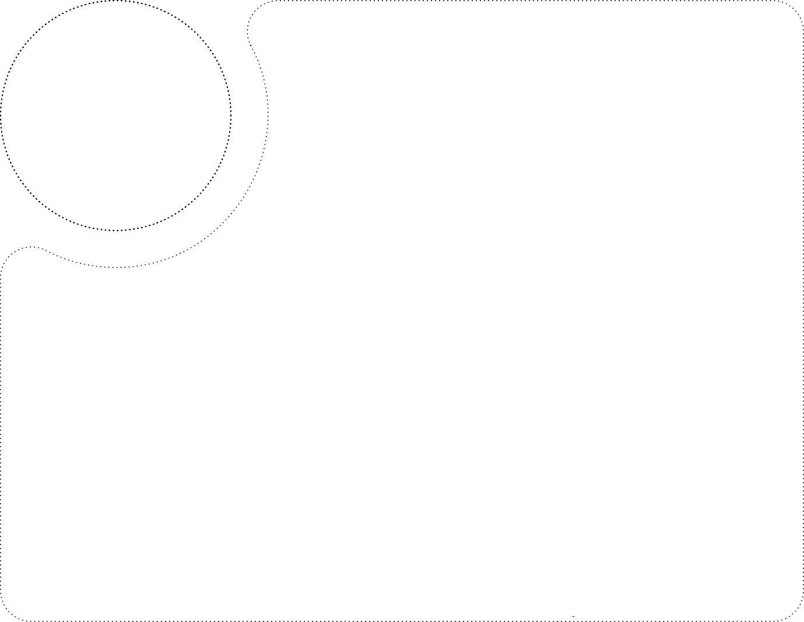

**Inspiration**

**Emerging Expectations**

**Basic Needs**

**Drivers of Change**

Shifts (Long-term)

Triggers (Short-term)

The business is applying the trends by introducing innovative technologies. Introducing diverse products into the market to attract the customers.

The trends are applied into the customer group of the business. The new products developed are required to be advertised and communicated to the market to reach to its customers.

The new customers are expecting development of the product that will bring new features into the product. That will allow it to work in an efficient manner.

The consumers who are aware of the technological advancement and follows the lifestyle of the celebrity are more attracted towards the trending products.

The growing demand of the customers are emerging. They are focused towards providing all the features that can be of requirement to the customer. This will enhance the productivity in the office work by providing access to the MS office and Google Workspace.

The trend is emerging due to its unique features. A wide range of products is being introduced for customer satisfaction.

The trend is applied to the middle aged group of person who are updated with emerging technological advancement. The customers who is technology freak will be attracted by the products. The products are also useful for various office purpose work.



**Innovation Type**

**Who**

**n**

**o**

**v**

**d**

**a**

**t**

**i**

**o**

**n**

**Y**

**o**

**u**

**r**

**T**

**I**

**n**

**r**

**e**

**n**