CREATIVE BUSINESS DOCUMENTTEMPLATE

**PROJECT PLANNING FOR OPENING A NEW SHISHA BAR & CAFÉ**

Student Name

L4091234

Group 1 Weekday June 22

**Final Major Project**

* Please Delete This **Text**/ **Text Box**
* Please Edit This **Text**/ **Text Box**

**KEY**- PLEASE FOLLOW THIS KEY TO UNDERSTAND WHICH SECTIONS TO KEEP, CHANGE, OR DELETE.

**NOTE:** THIS IS A TEMPLATE. YOU’RE ABLE TO CHANGE THIS TO A DESIGN WHICH BEST SUITS YOUR AESTHETIC. PLEASE FOLLOW THE ORDER IN WHICH THE PROJECT IS DELIVERED.

**CONTENTS PAGE**

PROJECT PROPOSAL 3

INTRODUCTION 5

CUSTOMER RESEARCH 6

MARKET RESEARCH 7

MARKET RESEARCH 8

SUSTAINABILITY RESEARCH 9

BRAND DEVELOPMENT 10

STORE FRONT 13

BIBLIOGRAPHY 14

# PROJECT PROPOSAL

Section 1: Review(approx. 150 words)

| The business plan will involve the operation facilities of Shish Bar and Cafe through this I can involve the promotion of connectedness in this planning. The foundation journey will help to figure out hookah is a rooted cultural tradition in the world.  The experience of opening a shop helped me to begin finding locations, setting out initial investment in designing materials, cost implementation, and client entertainment places.  I have learned about setting out goals, market analysis, communication, setting preferences of work with employees, company description, filling out management planning, etc for doing any business.  I would prefer to include management team distribution Strategy, Positioning Statement  Of brands, pricing strategy, and goal implementation with time as it will help to gain market audiences more. For this business, setting milestones to build awareness to the public about newly opening cafes and bars. Menu listing would bring more connection for food lovers to come and attend their presence too.  Strength:   * Pricing strategy in traction of customers in the market.   Weakness :   * Would not give me proper time to present during planning.   I have experienced that without market trends investigation this business planning is not possible. |
| --- |

Section 2: Project Concept (approx. 250 Words)

| The project will involve designing a sustainable shisha bar and cafe that centers on sustainability in its practice. The interior design will focus on incorporating eco-friendly materials, energy-efficient systems, and natural elements to create a welcoming and calming environment for customers (Alexander *et al.* 2020). The use of 'Reversible' by Marco Campardo and Andy Stagg and 'Washington Skeleton Side Chair' by David Adjaye will add a modern and unique touch to the design, while 'Elle' by Campardo will serve as a centerpiece that combines functionality and sustainability.  **Techniques**  Energy-efficient lighting and cooling systems will be installed to reduce energy consumption. Eco-friendly materials such as bamboo, recycled metal, and FSC-certified wood will be used in furniture and decor. Natural elements such as plants and green walls will be incorporated to improve indoor air quality and provide a calming atmosphere.  **Primary Research**  Surveys will be conducted to design elements that customers value and prioritize.  **Secondary Research**  Relevant literature on sustainable design principles and practices will be reviewed to provide a solid foundation for the project (Asfar *et al.* 2019). The environmental impact of materials commonly used in interior design and their alternatives will also be examined to identify sustainable options.  **Final Outcome**  The outcome of the project will be a sustainable shisha bar and cafe that centers on sustainability in its practice. The sustainable techniques used in the project will minimize the carbon footprint of the establishment and the research conducted will ensure that customer preferences and opinions are taken into account. The outcome will be a shisha bar and cafe that is both aesthetically pleasing and environmentally conscious. |
| --- |

Section 3: Evaluation (approx. 100 Words)

| Feedback from customers can be obtained by presenting the project concept to classmates or colleagues and requesting their input on the proposed techniques, research methods, and outcomes. Teachers can also provide feedback and guidance on the project by ensuring that it meets academic standards and requirements (Damiano, 2019). Communication will ensure project success with regular updates provided to academic mentors and any stakeholders involved in the project. This will allow for timely feedback and adjustments to be made. It also confirms that the project stays on track and meets its objectives. It will be important to stay committed to the principles of sustainability. |
| --- |

# INTRODUCTION

The main motive of this shisha bar and cafe is to create a comfortable and inviting space where customers can enjoy hookah, food, and drinks with friends (Kasl, 2021). The business might focus on offering unique flavors of shisha, healthy food options, or sustainable design practices to attract customers and differentiate itself from competitors. The ultimate goal of any business idea is to create a profitable venture that provides value to customers and meets the needs of the market.

**PERSONAL SKILLS**

WHAT SKILLS WILL YOU DEVLOP?

**MISSION**

WHAT IS YOUR COMPANY’S AIMS?

**BUSINESS GOALS**

HOW WILL YOU REACH YOUR GOALS?

**INCOME**

HOW WILL YOU EARN MONEY?

Interior design skills

Project management skills

Creative thinking

Knowledge o Interior design skills

Project management skills

Creative thinking

Knowledge of sustainable materials

Knowledge of product design

Marketing skills

Communication skills

f sustainable materials

Knowledge of product design

The main motive of this shisha bar and cafe is to create a comfortable and inviting space where customers can enjoy hookah, food, and drinks with friends. The business might focus on offering unique flavors of shisha, healthy food options, or sustainable design practices to attract customers and differentiate itself from competitors (Khamidovich, 2021). The ultimate goal of any business idea is to create a profitable venture that provides value to customers and meets the needs of the market.

Conduct market research

Develop a strategic plan

Implement effective management practices

Invest in technology, equipment, and infrastructure

Continuously innovate and improve

Selling products or services

By Advertising

Doing Subscriptions

Via Licensing

Via Sponsorship

# CUSTOMER RESEARCH

PRIMARY RESEARCH: CREATE A SURVEY/QUESTIONNAIRE AIMED AT YOUR TARGET CUSTOMER TO FIND OUT INFORMATION ABOUT THIS CUSTOMER. WHAT ARE YOU TRYING TO FIND OUT FROM YOUR CUSTOMER?

**Example: What is your field of practice?**

QUESTION 2

Which of the following themes would you like to see incorporated into a shisha bar and cafe?

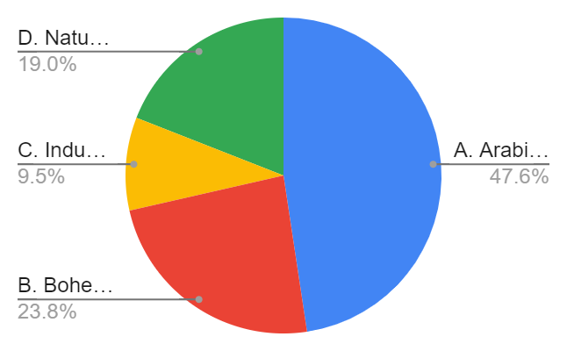

Which of the following factors do you consider when choosing a cafe/bar?

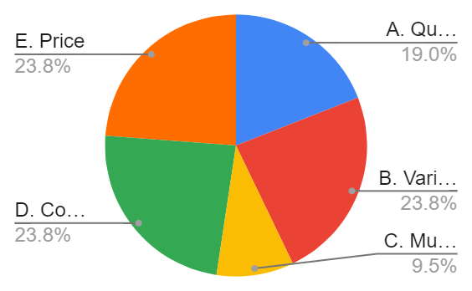

Have you ever smoked shisha before?

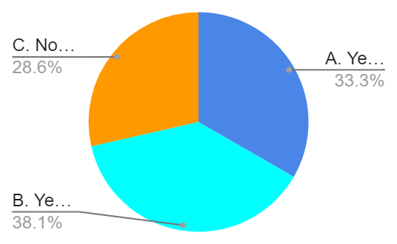

QUESTION 3

QUESTION 4

QUESTION 5

Which of the following seating options do you prefer at a shisha bar and cafe?

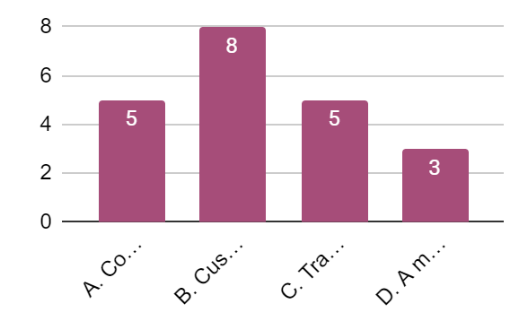

What I have learned in the foundation year?

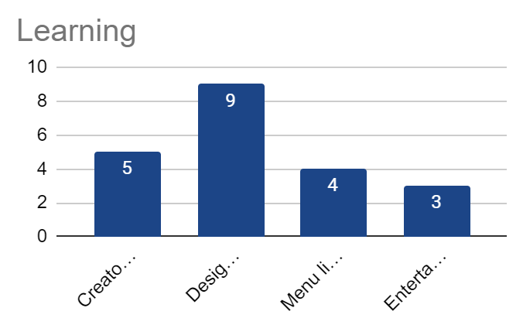

QUESTION 6

The above survey results help to gather knowledge about the new business.

# MARKET RESEARCH

PRIMARY RESEARCH:

PRIMARY RESEARCH IMAGES

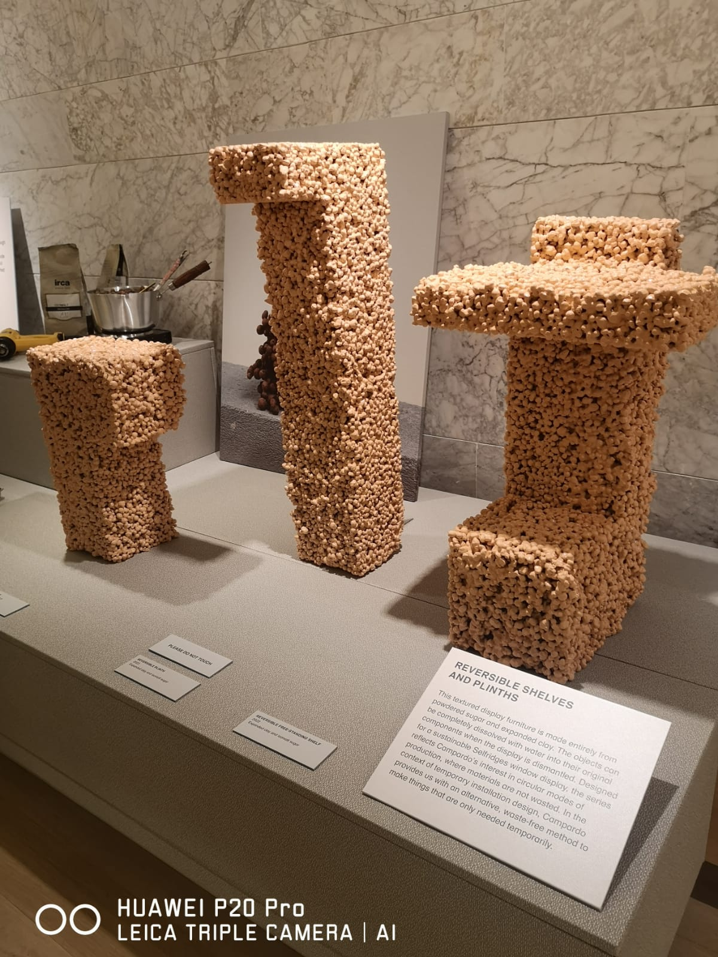 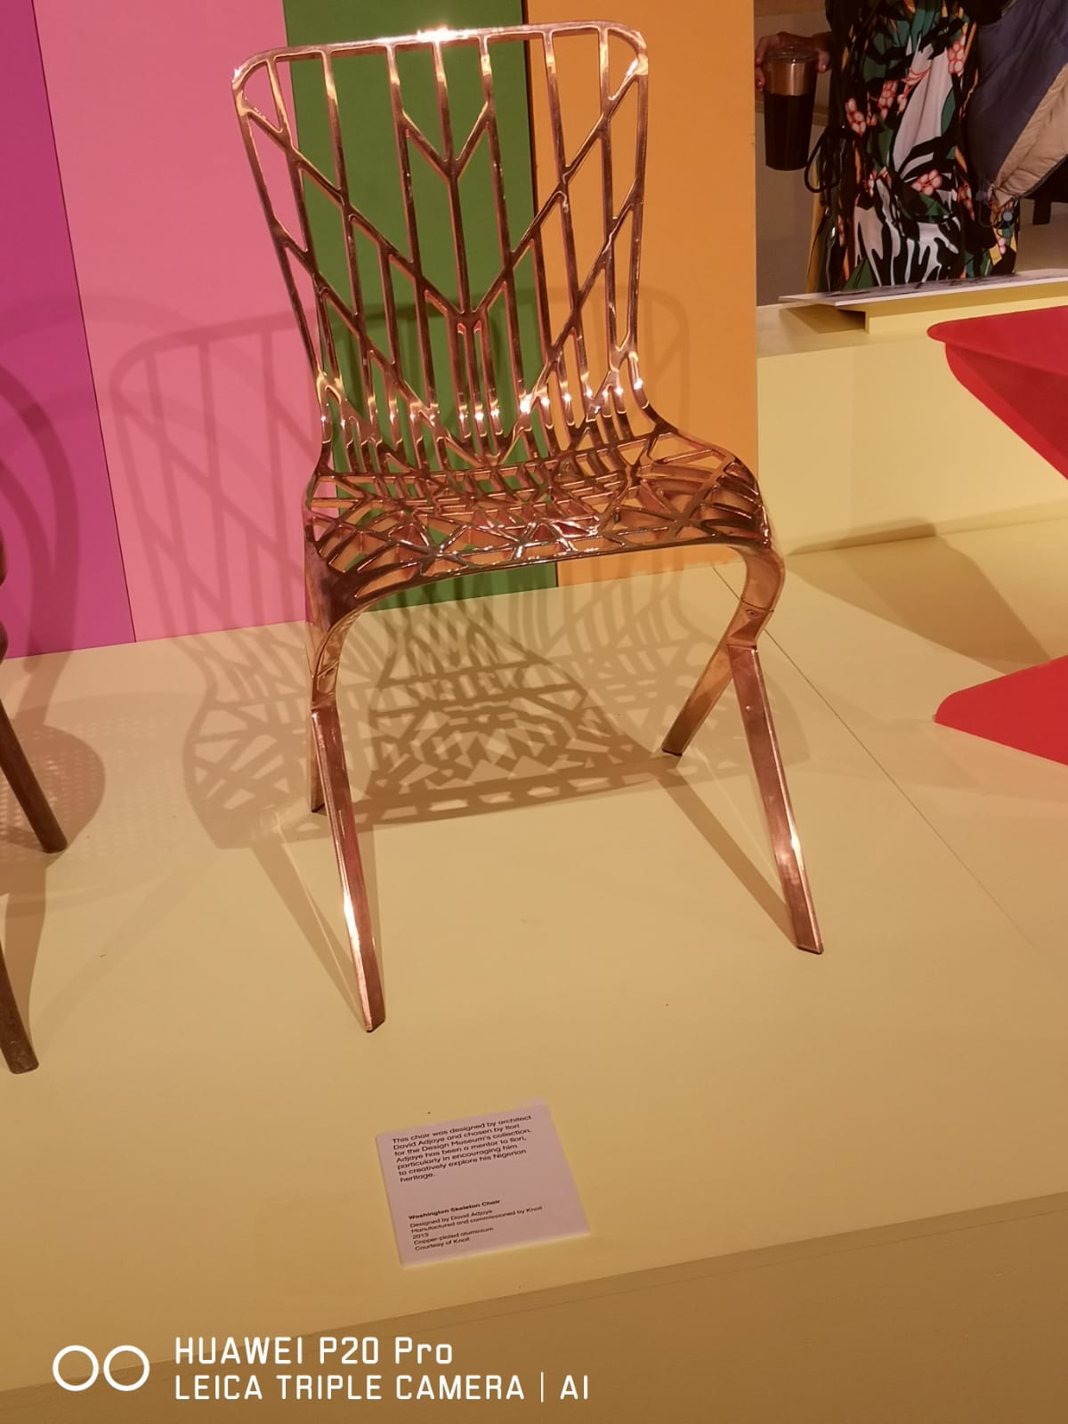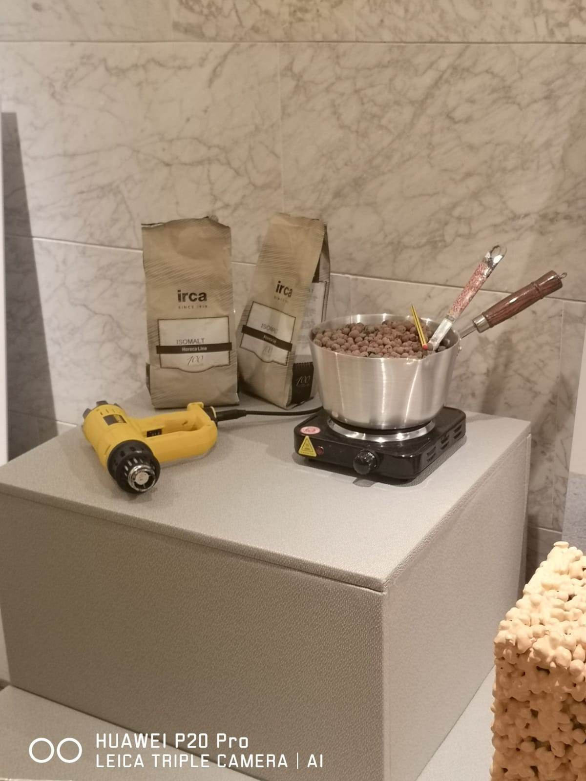 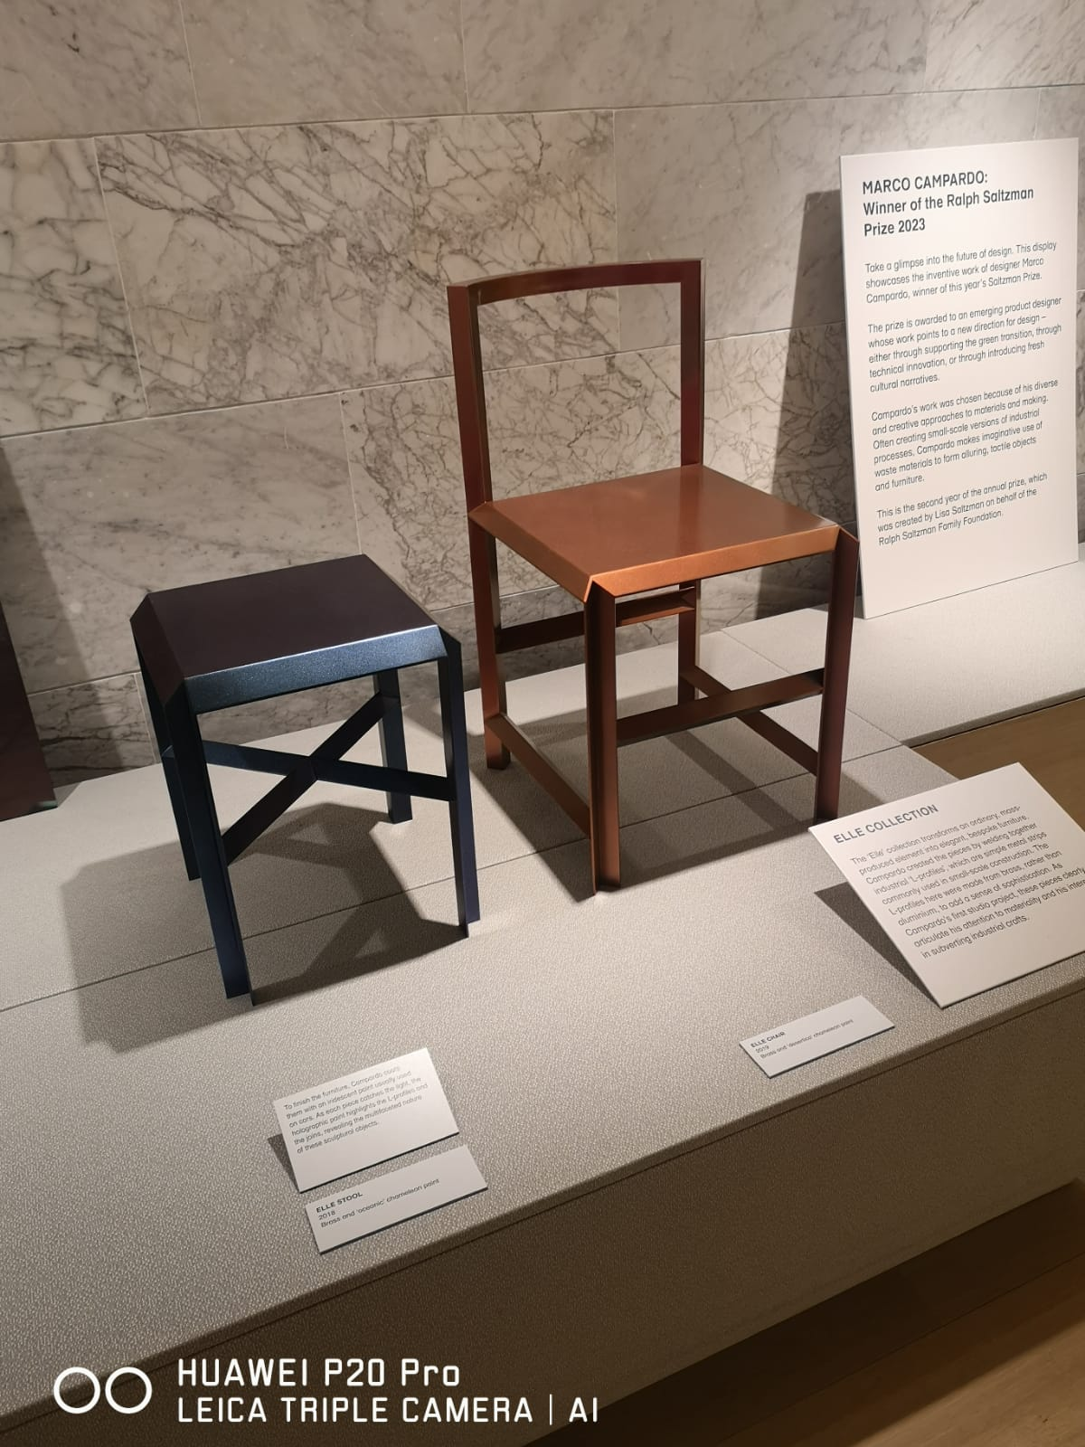

**COLOUR**

The color scheme of 'Reversible' is likely to incorporate bold and contrasting colors to create a striking visual effect. The color of the "Washington Skeleton Side Chair" may be black or dark brown, muted color, reflecting its minimalist and modern design (Kryukova *et al.* 2019). The color of 'Elle' may be light and airy & reflecting its soft and delicate design. Irca Isomalt itself may be colorless but it can be colored using food coloring to create a variety of shades.

**AUDIENCE**

The audience of 'Reversible' will be individuals, especially youngsters (students & job holders) looking for a sustainable and versatile interior design in a Bar & Cafe. The audience for "Washington Skeleton Side Chair" may be individuals or businesses looking for a stylish and practical seating solution. The audience of 'Elle' may be individuals or businesses looking for an elegant and feminine lighting solution. The audience of "Irca Isomalt" may be people inside a bar & cafe looking for versatile and high-quality ingredients.

**PACKAGING**

The packaging of 'Reversible' may be simple and eco-friendly & reflecting its sustainable ethos. The packaging for the "Washington Skeleton Side Chair" may be simple and functional & it protects the product during transportation (Mishra and Mishra, 2020). The packaging of 'Elle' may be sleek and stylish & emphasizing its high-end design. The packaging of “Irca Isomalt” may be airtight and resealable, ensuring freshness and preventing moisture.

**THOUGHTS**

The 'Reversible' is a sustainable and versatile interior design solution that offers bold and striking design possibilities. The Washington Skeleton Side Chair is a stylish and practical seating solution that offers a minimalist and modern design. Its simple packaging emphasizes its functionality (Pardue, 2022). 'Elle' by Campardo is an elegant and feminine lighting solution that offers a soft and delicate design. Its sleek and stylish packaging reflects its high-end design. Irca Isomalt is a versatile and high-quality sugar substitute used in baking and confectionery. Its airtight and resealable packaging ensures freshness and quality.

# MARKET RESEARCH

SECONDARY RESEARCH:

SECONDARY RESEARCH IMAGES:

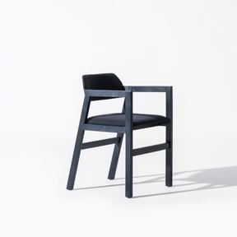

PRICE

The price of oakwood cafe is competitive and reasonable, given its high-quality materials and stylish design. The Illey chair is expensive due to its unique design but it can be unbreakable and it won't keep up with the loss of outside money. In our business, a side chair is relatively affordable as it is cost friendly and reasonable.

PRODUCT

The black-stained chair is a stylish and modern chair made of high-quality oakwood with a black-stained finish. It has a comfortable seat and backrest, making it suitable for extended periods of use (Sergeevna, 2021). The Illey chair is made of metal and wood with a modern and sleek design. The side chair can be simple in design and made of wood.

PROMOTION

The black stain and illey chair can also be promoted through similar channels but with a focus on its unique design, the side chair may rely more on word-of-mouth and traditional advertising.

PLACE

However, when it comes to pricing cost-effective planning for a customer and owner, it would be preferable to choose Illey and side chairs over the black stained oakwood chair (Sighaldeh *et al.* 2020). These chairs are more affordable, have a modern design, and are durable, making them a practical choice for a busy and cost-conscious business.

# SUSTAINABILITY RESEARCH

The UN's Sustainable Development Goals (SDGs) can provide a useful framework to guide your sustainability research. This sustainability research aims to identify opportunities to minimize your business's environmental impact, promote social responsibility as well as support economic sustainability. This will depend on the nature of the shisha Bar & Café business and the areas where it can make the most significant impact.

No poverty is the main motive of this business.

It has been used sustainable products to bring sustainability

Zero hunger is another motive

# BRAND DEVELOPMENT

**TEAM**



interior designer marketing specialist financial analyst

**ABOUT**

An interior designer (4 years experience), a marketing specialist (knowing customer attractive marketing strategy), and a financial analyst (making a financial budget plan) would be the three most important team members.

**SWOT ANALYSIS**

|  |  |
| --- | --- |
| **STRENGHTS**  Begin positioning in location through expanding on the world will help to gain social connection. | **WEEKNESSES**  Conflict among team members and shortage of investment fund lies on low depreciation of interior designing |
| **OPPURTUNITIES**  It would be helpful to know the specific techniques and methods used to create the interior design  It would be helpful to know the specific techniques and methods used to create the interior design | **THREATS**  A lack of members' seriousness and hard work can lengthen the whole business process**.** |

**GLOBAL PRESENCE**

**Nottingham:** Nottingham is known for university students, which would provide a steady stream of potential customers.

**Leicester:** Leicester has a vibrant nightlife scene, making it a popular destination for people looking to socialize and have a good time.

**London, Ontario:** The city has a diverse population and a growing young adult population.

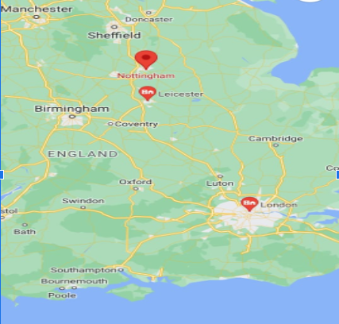

**BRAND DEVELOPMENT**

**PROJECT DEVELOPMENT**

The financial analyst will analyze market trends, forecast revenue and expenses, develop a budget, and create financial reports that provide insights into the business's performance (Siniakova, 2020). Interior designers would be responsible for creating and implementing a marketing strategy that attracts customers. Marketing specialists can develop and design promotional materials and plan events that generate buzz and interest in the business.

Their role is crucial in ensuring that the business is visible to the target audience, creates a welcoming atmosphere or not, and generates revenue and profits as projected.

**BRAND DEVELOPMENT**

**FINANCIAL PERFORMANCE**

INCLUDE SOME VISUAL CHARTS REGARDING WHAT YOUR TARGETS ARE FOR WHAT THE COMPANY WILL BE MAKING OVER THE NEXT 4 YEARS.

**LOGO DESCRIPTION**

The above logo involves brainstorming, and sketching the design. From the outside, it can give information about the company's values, target audience, competitors, and industry trends to ensure that the logo effectively communicates the business's unique identity and resonates with its intended audience. Regarding hidden meanings in logos, there are often intentional elements like lovers of coffee, tea, and drinkers, incorporated into designs that represent a company's values, history & products, or services.

**COMPANY LOGO**



**YEAR 1**

**YEAR 2**

**YEAR 3**

**YEAR 4**

# STORE FRONT



The concept of creating a sustainable interior for a shisha bar and cafe using "The 'Reversible' by Marco Campardo_Andy Stagg", "Washington Skeleton Side Chair By David Adjaye", "'Elle' by Campardo", and "circa isomalt" is an interesting and ambitious project. The selection of sustainable materials and designs is a commendable effort to promote eco-friendly practices in the design industry. The use of "The 'Reversible' by Marco Campardo_Andy Stagg" and "Washington Skeleton Side Chair By David Adjaye" indicates a preference for durable and long-lasting furniture pieces that can withstand the wear and tear of high-traffic areas. However, the use of "'Elle' by Campardo" is not explicitly explained, and its relevance to the project is not apparent. A more detailed explanation of its purpose and how it contributes to the overall sustainable interior would be beneficial.

The inclusion of "circa isomalt" in the project is an innovative way to incorporate sustainability in the interior design. However, it is important to ensure that the material is used responsibly and that its production and disposal do not harm the environment. In terms of the technical processes used, there is limited information provided, which makes it challenging to evaluate. The idea development is well-thought-out, and the focus on sustainability aligns with the current global trend toward environmentally conscious practices. However, there could be further exploration and research on how to incorporate sustainable practices beyond material selection and furniture design, such as energy-efficient lighting and water-saving technologies. The project concept shows potential, but it requires more clarity and detail to fully evaluate its effectiveness in achieving a sustainable interior for a shisha bar and cafe.

# BIBLIOGRAPHY

**References**

**Journals**

Alexander, C., Carey, S., Hall, S., King, J. and Lidher, S., 2020. Beyond Banglatown: continuity, change and new urban economies in Brick Lane.

Asfar, T., Ben Taleb, Z., Osibogun, O., Ruano-Herreria, E.C., Sierra, D., Ward, K.D., Salloum, R.G. and Maziak, W., 2019. How do waterpipe smoking establishments attract smokers? implications for policy. *Substance use & misuse*, *54*(4), pp.560-571.

Damiano, E., 2019. An explorative ethnography in the super-diverse Wilmslow Road.

Diab, J., Jacques, M., Vandervord, J. and Holland, A.J., Burns Open.

Kasl, M., 2021. A Business Plan for a Shisha Club.

Khamidovich, Z.K., 2021. Pandemic and trends in the restaurant business in 2021. *Central Asian Journal of Innovations on Tourism Management and Finance*, *2*(6), pp.54-61.

Kryukova, E., Bodneva, N., Sribnaya, T., Filimonova, N. and Vershinina, O., 2019. The development of the restaurant business in Russia. *Journal of Environmental Management & Tourism*, *10*(3 (34)), pp.412-419.

Mishra, G.P. and Mishra, K.L., 2020. Testing a Model of Business Leader's Inclination toward a Promising Prospective Endeavor–A Study. *Indian Journal of Commerce and Management Studies*, *11*(1), pp.20-31.

Pardue, D., 2022. Are you in the club? The contested role of the night for Muslim immigrant youth in Aarhus, Denmark. *Journal of Ethnic and Migration Studies*, pp.1-17.

Sergeevna, G.V., 2021. SMEs Stakeholder Management during COVID-19 Pandemic Crisis: the Case of Russian Catering Industry.

Sighaldeh, S.S., Zarghami, F., Charkazi, A. and Negarandeh, R., 2020. A qualitative study of factors influencing the onset of hookah smoking among Iranian men with Turkmen ethnicity. *Journal of epidemiology and global health*, *10*(2), p.135.

Siniakova, A.M., 2020. Marketing plan for a “Tangiers Lounge” Hookah Lounge in the US, California.