# 

# FINANCIAL ANALYSIS OF WORKERS LIFESTYLE

TABLE OF CONTENTS

Introduction 2

Chapter 1: Descriptive Analysis 2

1.1 Numerical variables 3

1.2 Category variables 4

Chapter 2: Regression Analytics 4

2.1 Correlation between variables 4

2.2 Stepwise regression model 5

2.3 Testing for Outliers 6

2.4 Interaction test 7

2.5 Distribution of errors 7

2.6 Multicollinetary test 8

2.7 Regression analysis conclusion 9

Chapter 3: Managerial Interpretation and Implication 10

Conclusion 12

Reference List 14

Appendices 17

# Introduction

In this project, the discussion about labor plays a vital role and is one of the important sectors of economics to run the country. The level of labor earnings increases by giving them the right amount at the correct time. Workers' bargaining power increases by acquiring knowledge from authentic websites and not taking help from brokers as they earn commissions and do not pay the proper amount to the workers. Salaries are influenced by experience and seniority as got much knowledge and have much experience in that sector which has a great influence on their salary. Education is very important with respect to work as many people take advantage to have less knowledge. Gender plays a great role in farming because both males and females work together from day to night not only working but supplying grains to other manufacturing industries where converted raw to finished and supply to the country. This is the overall knowledge about the labor work and also, discussing the research and development process and sales that many employees engaged by the different backgrounds like life science, medical, and other sectors. The job role is distinct in accordance with the employee's educational field as it is easy to work with or research that works. Males and females participated in the research and development and sales and monthly income is also defined on that basis.

# Chapter 1: Descriptive Analysis

This analysis describes the previous years’ experience of the salary which is important to the laborers. A worker has full knowledge of the farming sector and problem arises regarding the issues. It is not important that a worker know everything but the government's responsibility to guide them and give them a pathway to reach the right destination and know the actual reason for backwardness and challenges that arises at the time of working. Using proper technology to increase the work and use the proper amount of pesticides and insecticides for the fertilizers that help in growing the crops and maize and also with the help of technology supply the crops and also care the crops in the climatic changes in the environment. It is necessary to have knowledge in all these subjects as it is a matter of the science of technology that uses in the farming sector (Kafle, 2019). It is not about just working hard day and night for the growth of grains with all care means but it is also necessary to have smart work that occurs in less time in an efficient and effective manner. This is the need for the agriculture farm sector also it is the responsibility of the government to take necessary steps regarding this and educate them in the correct way that is going on one generation to another, This is the motive and responsibility of every resident to educate the worker on time to time. Sometimes, the worker cannot understand the actual reason behind the changes and does not much focus on the result which is a very big deal for the government to face with them in this challenge (Pal *et al* 2019). Therefore, the government takes some small and relevant steps for the worker so that it is easy to understand the problem and loopholes and tries to fill out the gap with efficient knowledge. Thus, the discussion is going to the next level to develop the country with the development of mentality towards those basic things which are important for the workers and for the public of a country.

This section is the described form of the introduction part that those employees are in life science or medical background the job has to be allocated in that way. Some people travel frequently and some people travel rarely and some are non-travel for business purposes (Nizam *et al* 2020). Everyone is working eight hours a day but salary or monthly income is different from each other as it depends on one’s experience and hard work and also discharging of work in an efficient manner. Most of the employees working in the different sectors of the specialization field are more than one year and everyone is over 18, also training time last year is a minimum allocation of two months and a maximum is six months as per the subject matter (Hamutoğlu *et al* 2020). Those persons who have equal to or less than one year have no promotion but whereas other employees are being promoted, however, there are few employees who are working for more than two or three years but have not been promoted due to their work and experience gaining in that field of working. Every employee has a different distance from home that it takes a lot of time to reach and every one holds a different unique identifier in the company.

## 1.1 Numerical variables

DS7 contains the various variables one dependent and other independent variables, which means dependent variables have flexibility changes that depend on the changes and outcomes of the independent variables. The dependent variable is salary whereas the independent variable contains four elements: education, job role, marital status, and monthly income. The numerical variables are based on the numbers along with the charts and graphs to clarify the presentation of the work (Montgomery *et al* 2021). These variables have so many outcomes that are interesting for the work and maintain the efficiency level of the worker or employees.

## 1.2 Category variables

The categorial variables are divided into two categories male and female and have to be visualized by the charts or graphs to analyze the situation well (Ali *et al* 2021). It is also called the qualitative variable that takes numbers or values and it is defined by the different types or forms or other categories. Thus, the numerical variables are inter-connected with the category variables to define the situation of the work that has to visualize in the right manner in this regard. Variables refer to the changes in position and categories including sex, age, and educational field separated with the help of different columns to show the reader in the correct way.

# Chapter 2: Regression Analytics

Regression analysis is an analysis of a method that is a statistical model that is important to control the form of the variables in different regression methods such as linear and multiple. 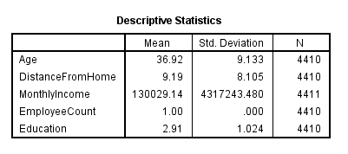

**Figure 1: Descriptive statistics**

(Source: Self-created in SPSS)

The table above shows the descriptive statics pf the regression analytics that analyzes the age, distance from home, monthly income, employee count, and education.

## 2.1 Correlation between variables

The correlation variables signify the establishment of strength between two variables whether it's symmetric form, asymmetric form, or normal (Griffith *et al* 2019). It also defines that the changes of one variable have an effect on the average changes on the other side.

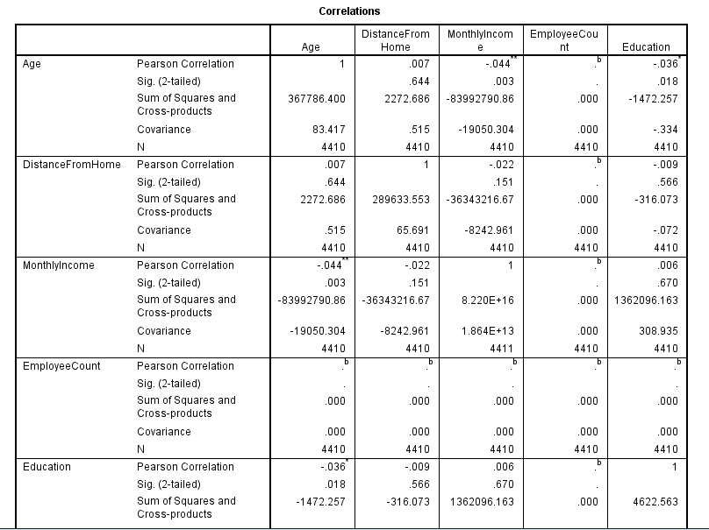

**Figure 2: Correlation matrix**

(Source: Self-created in SPSS)

Correlation is one of the statistical methods that have continuous variables and it is easy to calculate and understand by the graph or charts.

## 2.2 Stepwise regression model

The stepwise regression model is to increase the potency of the statistical model by introducing the relevant regression model in the project to achieve a target in the minimum time.

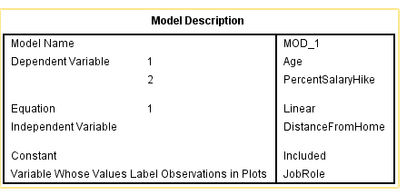

**Figure 3: Model description**

(Source: Self-created in SPSS)

The regression model also contains unnecessary regression variables through which the process is more complex and difficult to manage the work (Knoblach *et al* 2020). The stepwise regression model also defines the step-by-step method for the selection of the independent variables that may be used in the final presentation of the model. It put the direction to the variables that may be changed in the changes of the succession variables after each repetition.

## 2.3 Testing for Outliers

Outliers are also an important or essential part of the statistical model by applying this one can recognize all values.

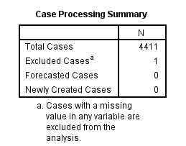

**Figure 4: Case processing summary**

(Source: Self-created in SPSS)

The two main methods to detect the outliers are using the density and distance of the relevant data and building a model that estimates the distribution of data points along with the high point not to meet with any user who is defined in the threshold (Wang *et al* 2021). The outliers should be tested and show the numerical values of the data to meet such requirements.

## 2.4 Interaction test

This is a statistical test that is used for interaction purposes and is generally defined as the sub-group analysis. The interaction between the two or more variables that interact with the third variable is affected in a supplementary way (Kim *et al* 2019). There are multiple regressions that can be used in the interaction test as the variables are continuous in nature.

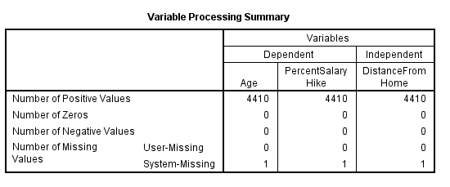

**Figure 5: Variable processing summary**

(Source: Self-created in SPSS)

Interaction is present in the different categories of variables that are necessary to analyze the variance and when it is significant the interaction must follow the relevant tests with the help of informative data.

## 2.5 Distribution of errors

An error should be incurred in the distribution or estimation of each point as it is important to discuss every estimated point by showing it in the delta format. The opportunities and the expected return are of the same nature but the presentation is shown in a different manner.

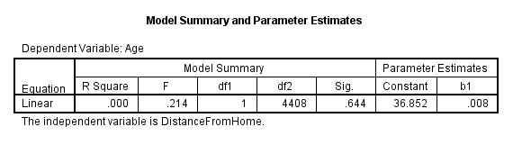

**Figure 6: Model summary and parameter estimates**

(Source: Self-created in SPSS)

There are different types of distribution errors that are random and normal that has statistical method used to analyze the data as random data is also drawn from the normal distribution error. A company must distribute the work in such a way that causes fewer errors to occur in the work and run fluently in an efficient manner (Liu *et al* 2020). Human error or mistakes also less occur when there is the right use of the statistical methods in the right way to achieve the target very soonly.

## 2.6 Multicollinetary test

The multicollinearity test is another important part of the statistical method that establishes a relationship between the variables that are correlated to the data but it creates issues as it is not a dependent variable (Shrestha *et al* 2020). Though it produces the regression model but less reliable the obtaining the results as it has different confidence intervals which are wider and reduces the significance of the statistical method in the coefficients of a regression model.

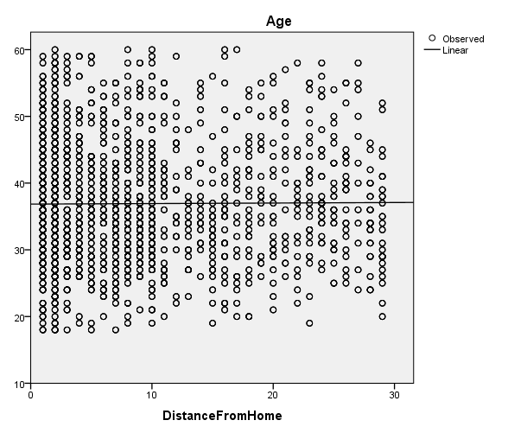

**Figure 7: Age**

(Source: Self-created in SPSS)

There is one method to determine the multicollinearity test through the calculation of variances inflation factor (VIF) for those variables which are independent. Also, define the percent salary hike with the help of a statistical model to give a clear view. ***[Referred to Appendix 1]***

## 2.7 Regression analysis conclusion

In this concluded part, regression analysis is discussed with the various models by evaluating each of them such as the correlation model, stepwise regression model, testing of outliers, interaction tests, distribution of errors, and multicollinearity test. These are all the essential parts of the statistical model that helps in defining each test and outliers with the help of figures and graphs. It is useful for the collection of data and measuring the performance of the company by using or analyzing a regression model. Each company uses different types of models to evaluate the work and the whole scenario is shown in a detailed manner as this is the raw form of data through assembling by using the graph for understanding and then it comes to the final result. A business includes accounting techniques and other software techniques for running the business as it is the basic part of the collection of data.

# Chapter 3: Managerial Interpretation and Implication

Managerial interpretation is to conduct the managerial activities and also increase the efficiency level of the managers in the work or in any field or in the organization (Boldosova *et al* 2020). The interpretation is necessary to understand the problem in those works which is important to complete the work. Different backgrounds of the people doing the different work as some people are in life science and medical some are related to other backgrounds so allocation of the job in accordance with. However, different sectors of employees are specialists in different types of fields such as health representation, sales executive, human resources, and laboratory technician, and some are posted in the manager role. The interpretation of this work is the managerial interpretation which means choosing the right people for the right job to take the right decision-making.

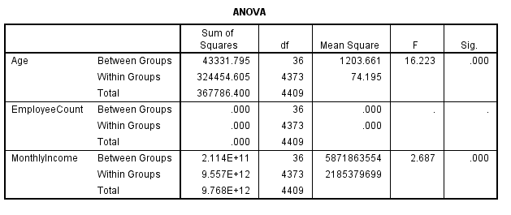

**Figure 8: ANOVA**

(Source: Self-created in SPSS)

Everyone has a different monthly income and marital status which is some are single, some are unmarried, and some are married (Bratianu *et al* 2020). The use of analyzing the managerial process or jobs as it includes the common method of interviews, noticing the activities, using the specialization method, creating questions, and many more. The analysis is important in the managerial implication to solve the arising issues and come to a conclusion. Strengthen and weaknesses are the two most important types of managerial activities in the implications that include the survey by analyzing the proper situation to select a sample size out of the population (Ye *et al* 2021). Managerial implication signifies practical decision-making in the business by collecting the relevant information and data that uses in the project for efficient work. It helps in analyzing the research in the right direction or path to achieve better results and complete the target on time. Department of Sales and Research and Development explains the situation that most of the employees are in the Research and Development process whereas few employees are engaged in sales. Monthly income has given a good or bad impact on employees as everyone is working hard in their field but it depends on the post and experience of each employee that relies on in a different manner (Tang *et al* 2019). Managerial implication changes the behavior of the employees as it depends on the behavior of managing the activities and a good leading role should be done by the managers or leaders. Thus, it can give a good impact on the work and obtain a vibrant result with the organizational behavior in the business (Huffman, 2022). The adoption of new technology and innovation brings new features to give more energy to their work by adding innovative features. As technology rapidly changes in the turbulent environment and it must be understood that managers update the system regularly to maintain the growing nature of the business without losing the customers. The ultimate meaning of regression analysis, managerial interpretation, and the managerial implication is to serve the best quality of goods and services to the customers and also expand the business as much as possible (Farias *et al* 2019). The objectives should be managed as designed by the special needs and framework to grow the business environment daily and compete with the other competitors in the market. There are four managerial duties or responsibilities by following this one can achieve goals namely, planning, staffing, controlling, and organizing (Karhade, 2021). As these are the basic rules to follow, planning is the initial stage or a strategy to execute the program at the very beginning of the stage by using collective and informative data. On the other side, staffing means allocating the job to the right person at the right time through the analysis of one’s expertise and not on a random basis. Also, managers or a leader have to discuss with the employees and take their opinion in regard to the job before allocation (Sato *et al* 2020). Controlling refers to the control in the system and overlooking the employee's work at a fixed interval basis as sometimes, the employees are not taking the job seriously and completed the projects in the wrong way, therefore, has to be well-managed. Organizing the system in such a way that does not hinder any problem or issue in the path of the work (Winkler *et al* 2020). A company considers many things at the time of execution of the plan and the results are very important as the projects go through various tests before launching in the market. Therefore, make the right policies and procedures to follow on the right path and not do any work in an unauthentic way or break the policies as some companies run their business by following the old tradition that one has to follow that steps. Fast-growing business is made by fast thinking in relation to the product with the generation and studying the market by a survey to the people about its needs and wants. Thus, one can research the implication of the product and develop the project by passing many tests, expenditure on research are falling down on the profit and loss statement whereas expenditure on development should be capitalized (Castillo *et al* 2021). It means research on the new product incurs expenses and invests too much money to make a prototype whereas the development of the product is help in to capitalize on the amount at the time of launching the product in the market. MBO means managerial by Objectives and focuses on the achievement of goals by taking feedback from the employees and the customers as well (Leonelli *et al* 2019). It mainly focuses on the need for the work that the actual demand of the customers along with the challenges faced by the company for growth in the business in a large sector. The government also promoted improving the existing and start-up companies generating revenue for the country. Laborers also play a vital role in increasing the economic sector of the countries as work hard day and night to maintain the supply of the food chain. Therefore, there is a need to guide or educate them regarding improving the potency of the laborer work and it should be effective as it holds the major portion and a great responsibility towards a country. The managerial implementation plays a great role to interact with the employees from the base and increase the level of confidence within them (Cetindamar Kozanoglu *et al* 2021). Every employee has a right to an opinion in regard to the project because the involvement of employees in the project shows interest and also managers have an idea with the team to have some knowledge in respect to those projects which have a great impact on the market. Failures of team management are the failure of the company, therefore, the managers should be very alert about the active participants in the project to achieve the target.

# Conclusion

In order to conclude that the regression analysis describes various models which define the matter in a descriptive analysis and the company uses different strategies to achieve the target. Here, also analyzes the T-test series factor and different statistical models that signifies the important model which is mandatory to describe those factors. Also, doing the data analysis by giving the proper amount in the proper way has to be expanded and discussed in the managerial implication. Thus, concluding all points of managerial interpretation and implication included the overall result in the process and the company must have to take the right decision regarding its business by using various analyses.

# Reference List

**Journal**

Shrestha, N., 2020. Detecting multicollinearity in regression analysis. *American Journal of Applied Mathematics and Statistics*, *8*(2), pp.39-42.

Montgomery, D.C., Peck, E.A. and Vining, G.G., 2021. *Introduction to linear regression analysis*. John Wiley & Sons.

Ali, P. and Younas, A., 2021. Understanding and interpreting regression analysis. *Evidence-Based Nursing*, *24*(4), pp.116-118.

Kafle, S.C., 2019. Correlation and regression analysis using SPSS. *Management, Technology & Social Sciences*, *126*.

Pal, M., Bharati, P., Pal, M. and Bharati, P., 2019. Introduction to correlation and linear regression analysis. *Applications of Regression Techniques*, pp.1-18.

Nizam, R., Karim, Z.A., Rahman, A.A. and Sarmidi, T., 2020. Financial inclusiveness and economic growth: New evidence using a threshold regression analysis. *Economic research-Ekonomska istraživanja*, *33*(1), pp.1465-1484.

Hamutoğlu, N.B. and Başarmak, U., 2020. External and internal barriers in technology integration: A structural regression analysis.

Griffith, D., Chun, Y. and Li, B., 2019. *Spatial regression analysis using eigenvector spatial filtering*. Academic Press.

Knoblach, M., Roessler, M. and Zwerschke, P., 2020. The elasticity of substitution between capital and labour in the US economy: A meta‐regression analysis. *Oxford Bulletin of Economics and Statistics*, *82*(1), pp.62-82.

Wang, Q. and Wang, L., 2021. The nonlinear effects of population aging, industrial structure, and urbanization on carbon emissions: A panel threshold regression analysis of 137 countries. *Journal of Cleaner Production*, *287*, p.125381.

Kim, S.Y. and Bottema-Beutel, K., 2019. A meta regression analysis of quality of life correlates in adults with ASD. *Research in Autism Spectrum Disorders*, *63*, pp.23-33.

Liu, S. and Papanikolaou, A., 2020. Regression analysis of experimental data for added resistance in waves of arbitrary heading and development of a semi-empirical formula. *Ocean Engineering*, *206*, p.107357.

Boldosova, V. and Luoto, S., 2020. Storytelling, business analytics and big data interpretation: Literature review and theoretical propositions. *Management Research Review*, *43*(2), pp.204-222.

Hanelt, A., Bohnsack, R., Marz, D. and Antunes Marante, C., 2021. A systematic review of the literature on digital transformation: Insights and implications for strategy and organizational change. *Journal of Management Studies*, *58*(5), pp.1159-1197.

Brownscombe, J.W., Lédée, E.J., Raby, G.D., Struthers, D.P., Gutowsky, L.F., Nguyen, V.M., Young, N., Stokesbury, M.J., Holbrook, C.M., Brenden, T.O. and Vandergoot, C.S., 2019. Conducting and interpreting fish telemetry studies: considerations for researchers and resource managers. *Reviews in Fish Biology and Fisheries*, *29*, pp.369-400.

Bratianu, C. and Bejinaru, R., 2020. Knowledge dynamics: a thermodynamics approach. *Kybernetes*, *49*(1), pp.6-21.

Alvarez-Torres, F.J., Lopez-Torres, G.C. and Schiuma, G., 2019. Linking entrepreneurial orientation to SMEs’ performance: Implications for entrepreneurship universities. *Management Decision*.

Ye, G., Hudders, L., De Jans, S. and De Veirman, M., 2021. The value of influencer marketing for business: A bibliometric analysis and managerial implications. *Journal of Advertising*, *50*(2), pp.160-178.

Tang, A.K., 2019. A systematic literature review and analysis on mobile apps in m-commerce: Implications for future research. *Electronic Commerce Research and Applications*, *37*, p.100885.

Huffman, D., Raymond, C. and Shvets, J., 2022. Persistent overconfidence and biased memory: Evidence from managers. *American Economic Review*, *112*(10), pp.3141-75.

Farias, F., Szatmari, P., Bahniuk, A. and Franca, A.B., 2019. Evaporitic carbonates in the pre-salt of Santos Basin–Genesis and tectonic implications. *Marine and Petroleum Geology*, *105*, pp.251-272.

Karhade, P. and Dong, J.Q., 2021. Innovation outcomes of digitally enabled collaborative problemistic search capability. *MIS Quarterly*, *45*(2), pp.693-718.

Sato, Y., Tse, Y.K. and Tan, K.H., 2020. Managers' risk perception of supply chain uncertainties. *Industrial Management & Data Systems*, *120*(9), pp.1617-1634.

Winkler, P., Etter, M. and Castelló, I., 2020. Vicious and virtuous circles of aspirational talk: From self-persuasive to agonistic CSR rhetoric. *Business & Society*, *59*(1), pp.98-128.

Castillo, D., Canhoto, A.I. and Said, E., 2021. The dark side of AI-powered service interactions: Exploring the process of co-destruction from the customer perspective. *The Service Industries Journal*, *41*(13-14), pp.900-925.

Leonelli, S., 2019. Data governance is key to interpretation: Reconceptualizing data in data science. *Harvard Data Science Review*, *1*(1), pp.10-1162.

Cetindamar Kozanoglu, D. and Abedin, B., 2021. Understanding the role of employees in digital transformation: conceptualization of digital literacy of employees as a multi-dimensional organizational affordance. *Journal of Enterprise Information Management*, *34*(6), pp.1649-1672.

# Appendices

Appendix 1:

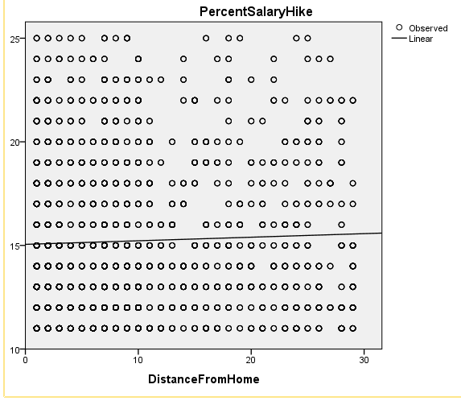

(Source: Self-created in SPSS)