**BIM IMPLEMENTATION PROCESS**

**TABLE OF CONTENTS**

1.0 Introduction 3

2.0 Discussion 3

Section 1: Building Information Modeling 3

1.0 BIM & its importance in construction industry 3

2.0 Requirement for interoperability of BIM 3

Section 2: Supporting BIM 4

3.0 BIM dimension 4

4.0 BIM Execution Plan 5

Section 3: BIM Process 8

5.0 Main difference between modern and traditional process of management 8

6.0 Positive outcomes 8

7.0 Process of BIM implementation 9

8.0 Detailed appraisal of responsibilities as Information Manager 9

3.0 Conclusion 10

Reference List 11

Appendices 13

# 1.0 Introduction

BIM (“Building Information Modelling”) is the process which is supported by different technologies, tools and the contracts that involves management and generation of the functional and physical characteristics of different places. This is the process of workflow used for design, planning, management and construction of the building and its infrastructure. The model of BIM is the virtual form of the project outcome generated from the concept to the completion in its entire lifecycle. With the use of BIM that allows the completion of the project in an economical and efficient manner causing less impact to the environment.

# 2.0 Discussion

## Section 1: Building Information Modeling

### 1.0 BIM & its importance in construction industry

BIM is a technological method for the management of information. With the use of a BIM model that allows collaboration of different members of the team, information sharing and monitoring the cost of the project. The application of digital tools have made management of the project easy in a streamlined manner and silos are avoided. The potential hazards that can be caused can be predicted using this software and thus necessary adjustments are made using the software.

The management of construction is a complex process which requires open communication between the construction and design teams (Dakhil *et al.* 2019). On occurrence of miscommunication, delays and errors, that can highly impact the overall cost of the project. This issue is solved using the BIM software. This has helped to make better decisions of design and improve the performance of the building. Digitization of the construction site and the information are connected through handover. This also helps in the improvement in predictability, workflow profitability and enhanced productivity. It supports successful delivery of the project by improving the design quality and collaboration (Neves *et al.* 2019). In this way adopting BIM for the operational and capital phase of the auditorium project will be beneficial. Revit is the single application for BIM with different features like architectural design, structural engineering and MEP.

### 2.0 Requirement for interoperability of BIM

BIM interoperability is the capacity to data exchange among different applications, allows standard workflows and the automation process is simplified. BIM interoperability that allows working of two systems together and allows information exchange. Interoperability in the computing that enables working and interaction of one software with the other that have made the process simpler. Different organizations and teams are able to share the required data of a project to all the stakeholders. This has only become possible due to BIM interoperability. Thus, the required information of the project is stored in the single place and accessed by different disciplines using different tools. It indicates data exchanging ability with different systems by introducing major modifications (Besné *et al*. 2021). BIM allows the techniques for visualization like augmented reality to fulfill different targets like management of defects, previewing of built environment and facility management.

**BIM Modeling**: BIM modeling is the digital representation of the functional and physical characteristics of the facilities.

**Field Analysis**: A process in which the tools of BIM are utilized for the property evaluation in the area given for determining the most suitable site location for future project purpose.

**Visualization**: It helps to better understand the design solution and helps to make proper modification as per the requirements.

**Collaboration**: The 3D model allows better understanding of the project. Effective communication with the project stakeholders which ensures alignment of the construction process requirements.

**Planning**: The interoperability approach enables working together of the persons having the same software and the similar information can be accessed by all. Different stakeholders involved with the project require data access (Abbasnejad *et al.* 2021). BIM allows information exchange across different ranges of software thus the interoperability is provided.

**Operation**: Interoperability is necessary at the initial stage of the project.

## Section 2: Supporting BIM

### 3.0 BIM dimension

The dimension of the BIM influences the outcome of the project. There are different dimensions like 3D, 4D, 6D, 5D and 7D dimensions of the model of BIM. These dimensions help in the improvement of the data related to the model, which will enhance the transparency and comprehension level regarding the building project (Biancardo *et al*. 2020). BIM basically helps in reducing the building materials wastage that helps to assess the project risk. It helps in clash detection which ensures that there is no mistake over the site.

**2D Dimension of BIM**: It is the past model of construction. This mainly comprises the Y- axis and X- axis. These types are mostly made using the hand or using CAD drawings.

**3D dimension of BIM**: It is the popular dimension of BIM which is widely used. The classroom auditorium was designed on a 3D model (Olanrewaju *et al.* 2022). 3D structure represents the geographical structure in 3 dimensions, which includes X- axis, Z- axis and Y- axis. 3D BIM involves creating non- graphical and graphical building information which can be shared into the “common data environment (CDE)”.

**4D dimension of BIM**: The BIM model of 4D that provides dimensional information additionally like the time or data element (Habte and Guyo, 2021). This model initiates with 3D BIM that includes a time element. It is basically 3D BIM and schedule.

**5D dimension of BIM**: It is basically 4D BIM and cost estimation. The main function of 5D modeling is integration of the schedule, cost and the design in a 3D output. This predicts the finance flow and the progress is visualized.

**6D dimension of BIM**: 6D BIM involves the addition of other information supporting operations and present information.

**7D dimension of BIM**: The 7D BIM which mainly consists of 3D, time schedule, cost intelligence and sustainability. 7D BIM is utilized for the operation and maintenance of the project in its whole life cycle.

### 4.0 BIM Execution Plan

BIM Execution Plan is helpful in the management of the auditorium classroom project. For the successful implementation of BIM, the execution plan is required. The plan defines building of the construction project form designing, facility management construction also collaboration process for BIM execution. It helps in management and quality control of the deliverables of BIM. Pre contract BEP are created by the prospective vendors that provide details about the competency, strategy, competence and capacity for satisfaction to the information requirements of the employees (Viana and Carvalho, 2021). The BIM execution plan that helps in timely delivery of the project and within the budget, ensures proper communication and collaboration, transparency. The execution plan consists of the team's responsibilities and roles, project milestones, “Project Information Plan (PIP)”, work process and many more. [***Referred to Appendix 1]***

**Table 1: Project Stakeholder**

|  |  |  |  |  |
| --- | --- | --- | --- | --- |
| **Discipline** | **Role Code** | **Organization** | **Originator code** | **Key Contact** |
| Architect | A | ABC Company | XYZ | Shyam Prasad |
| Civil Engineer | B | ABC Company | XYZ | S. Singh |
| Building Surveyor | C | ABC Company | XYZ | K. Yadav |
| Facility Manager | D | ABC Company | XYZ | M. Singh |
| Structural Engineer | E | ABC Company | XYZ | B. Yadav |
| Interior designer | F | ABC Company | XYZ | K. Singh |

(Source: Self- created)

**Table 2: Project Milestones**

|  |  |  |  |
| --- | --- | --- | --- |
| **RIBA Plan of Work** | **Period** | **Project Milestone** | **BIM Deliverable** |
| Strategic Definition | 5 | Understanding the project requirement. | The requirement of the project is understood clearly. |
| Brief Preparation | 8 | Project plan is prepared. | Proper planning of the project is performed. |
| Concept Design | 9 | Design of the auditorium classroom. | Auditorium classroom is designed in the Autodesk Revit software. |
| Developed Design | 10 | Proper modification of the developed design. | Developed design is modified properly. |
| Technical Design | 20 | The chairs of the classroom auditorium is designed to accommodate maximum number of peoples. | The chairs are aligned properly after design development. |
| Construction | 25 | After the planning stage, the auditorium is constructed. | Auditorium is constructed finally. |
| Handover & Closeout | 5 | Project is delivered finally. | Project is delivered finally. |

(Source: Self- created)

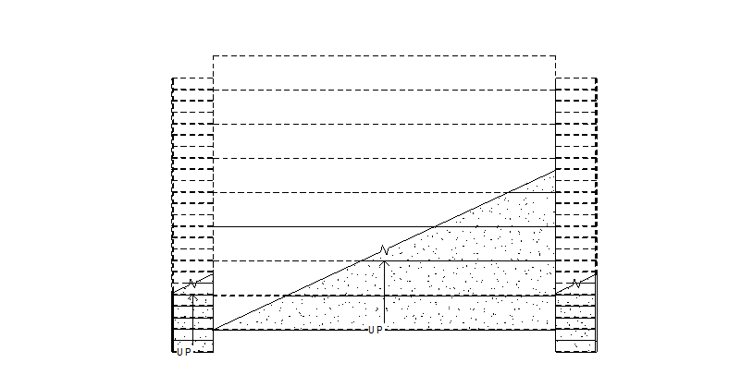

**Figure 1: Classroom Auditorium Plan**

(Source: Self- created in Autodesk Revit)

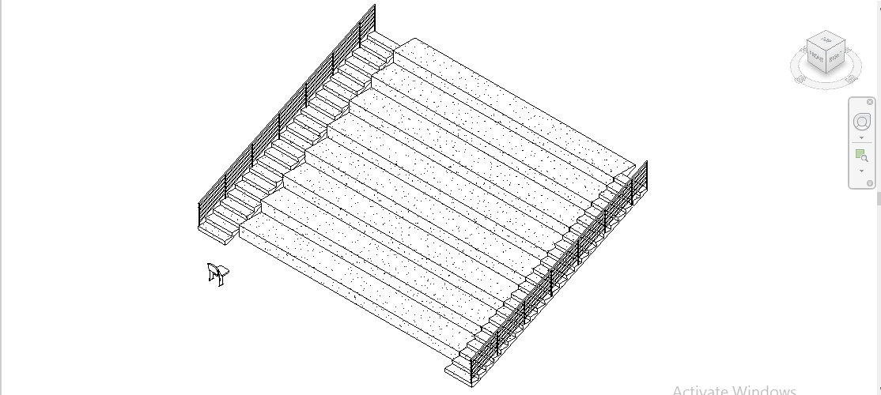

**Figure 2: 3D View of Classroom Auditorium**

(Source: Self- created in Autodesk Revit)

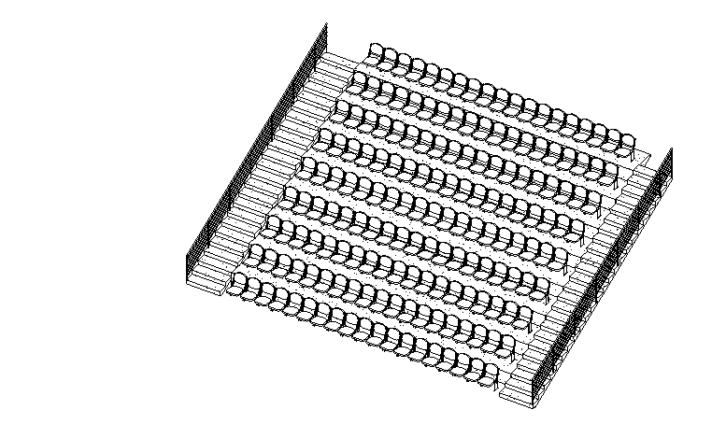

**Figure 3: Classroom Auditorium**

(Source: Self- created in Autodesk Revit)

## Section 3: BIM Process

### 5.0 Main difference between modern and traditional process of management

* Traditional management of design that follows the process of massive batching with the use of schematic design, construction documentation and design development.
* The information that results from the batching leads to the formation of different assumptions on the basis of the outdated knowledge.
* In the construction and design industry, misunderstandings are primarily a contributor in waste generation.
* The outcome obtained from the traditional management process will result in delays and inaccurate design.
* Traditional process of management affects the performance and cost of the project.

### 6.0 Positive outcomes

The different events of BIM offer positive outcomes to the design team. The significant benefits achieved in the construction process are resource and cost savings, great efficiency and short life cycle of the project, improved coordination and communication process, opportunities for modular construction and prefabrication and also helps in obtaining quality results (Siebelink *et al*. 2021).

* **Resource and cost saving**: It provides reliable estimation of the cost of construction. Tools like BIM 360 Docs are used for cost estimation of the materials, prefabricated shipping, material shipping and labor cost.
* **Great efficiency and short lifecycle of project**: Fast the completion of construction process that involves less cost of the project.
* **Improved communication**: The communication is improved among the contractors, architects and other parties associated with the project. BIM relies on a single information source that includes estimates and models to be stored and shared in the single palace.
* **Modular construction & Prefabrication**: The BIM software is used for creating detailed models of production to be prefabricated later on off- site.
* **High quality result**: BIM have also helped to improve the quality of building by making accurate and detailed calculations.

### 7.0 Process of BIM implementation

The process of creation, management and sharing of the information due to BIM implementation of the classroom auditorium. This are as follows:

**Pre- design phase**: This phase involves considering different decisions related to the project. The classroom auditorium plan is developed considering the design requirements.

**Design Phase**: In the design phase which involves additional parts of the BIM like estimation and scheduling (5D and 4D). Scheduling ensures timely delivery of the classroom auditorium and estimation which ensures that the project is aligned within the predetermined budget. Collaboration plays a crucial role in the delivery of the design process (Jasiński, 2021).

**Construction Phase**: The designed plan is then constructed as per the design. Simulation that allows accurate estimation of the project. ***Referred to Appendix 2]***

### 8.0 Detailed appraisal of responsibilities as Information Manager

* The protocol of BIM suggests selection of an information manager by the client who is responsible for management and setting up of the environment of shared data.
* The main responsibility of the information manager is acting as the gatekeepers for the process, monitoring the environment of shared data in order to check if it is adhered to the existing protocols and ensures safe keeping of the data.
* However, Information Managers are not the BIM coordinator as it is not responsible for the clash detection, model coordination or design (Hochscheid and Halin, 2019). They are also not responsible for designing purposes.

**Detailed responsibilities of the Information Manager are as follows**:

* Creating an environment of shared data with integrity, workflows and security.
* Establishing standards, model structure, conformance and output format of the information.
* Establishing different information and detailed responsibility in every stage of the project in accordance with the requirements of the employer's information (Özorhon and Karaciğan, 2020).
* Allowing integration of the project team and coordination of the leading designer.
* Supports sharing of project information.
* Keeping of records, change control are the services performed by the Information Manager. They are involved to host the environment of shared data.

# 3.0 Conclusion

From the study it can be concluded that the entire project is focused on the implementation of BIM in the design process. BIM, or "Building Information Modeling," is a process that manages and generates the functional and physical characteristics of various locations. It is supported by a variety of technologies, tools, and contracts. This workflow procedure is used for the infrastructure of the building as well as its design, planning, and management. The project outcome developed from conception to completion over the course of a project's complete lifecycle is represented virtually by the BIM model. With BIM, the project may be completed more cheaply and effectively while having a smaller environmental impact.

# Reference List

**Journals**

Abbasnejad, B., Nepal, M.P., Ahankoob, A., Nasirian, A. and Drogemuller, R., 2021. Building Information Modelling (BIM) adoption and implementation enablers in AEC firms: a systematic literature review. *Architectural Engineering and design management*, *17*(5-6), pp.411-433.

Besné, A., Pérez, M.Á., Necchi, S., Peña, E., Fonseca, D., Navarro, I. and Redondo, E., 2021. A systematic review of current strategies and methods for BIM implementation in the academic field. *Applied Sciences*, *11*(12), p.5530.

Biancardo, S.A., Viscione, N., Cerbone, A. and Dessì Jr, E., 2020. BIM-based design for road infrastructure: a critical focus on modeling guardrails and retaining walls. *Infrastructures*, *5*(7), p.59.

Dakhil, A.J., Underwood, J. and Alshawi, M., 2019. Critical success competencies for the BIM implementation process: UK construction clients. *Journal of information technology in construction (ITcon)*, *24*, pp.80-94.

Domingues, L.F. and Santos, E.T., 2021. Improving the design process quality using BIM: A case study. In *Proceedings of the 18th International Conference on Computing in Civil and Building Engineering: ICCCBE 2020* (pp. 466-482). Springer International Publishing.

Habte, B. and Guyo, E., 2021. Application of BIM for structural engineering: a case study using Revit and customary structural analysis and design software. *J. Inf. Technol. Constr.*, *26*, pp.1009-1022.

Hochscheid, É. and Halin, G., 2019. Micro BIM adoption in design firms: Guidelines for doing a BIM implementation plan. In *Creative Construction Conference 2019* (pp. 864-871). Budapest University of Technology and Economics.

Jasiński, A., 2021. Impact of BIM implementation on architectural practice. *Architectural Engineering and Design Management*, *17*(5-6), pp.447-457.

Neves, J., Sampaio, Z. and Vilela, M., 2019. A case study of BIM implementation in rail track rehabilitation. *Infrastructures*, *4*(1), p.8.

Olanrewaju, O.I., Kineber, A.F., Chileshe, N. and Edwards, D.J., 2022. Modelling the relationship between Building Information Modelling (BIM) implementation barriers, usage and awareness on building project lifecycle. *Building and Environment*, *207*, p.108556.

Özorhon, B. and Karaciğan, A., 2020. Drivers of BIM implementation in a high rise building project. In *Advances in Building Information Modeling: First Eurasian BIM Forum, EBF 2019, Istanbul, Turkey, May 31, 2019, Revised Selected Papers 1* (pp. 28-39). Springer International Publishing.

Pinti, L. and Bonelli, S., 2022. A Methodological Framework to Optimize Data Management Costs and the Hand-Over Phase in Cultural Heritage Projects. *Buildings*, *12*(9), p.1360.

Siebelink, S., Voordijk, H., Endedijk, M. and Adriaanse, A., 2021. Understanding barriers to BIM implementation: Their impact across organizational levels in relation to BIM maturity. *Frontiers of Engineering Management*, *8*, pp.236-257.

Viana, V.L.B. and Carvalho, M.T.M., 2021. Prioritization of risks related to BIM implementation in brazilian public agencies using fuzzy logic. *Journal of Building Engineering*, *36*, p.102104.

Vijayan, V. and Johnson, J., 2020. A study on the analysis and modeling of multipurpose concert center by the integration of Building information modeling (BIM). *Mukt Shabd Journal, Forthcoming*.

# Appendices

**Appendix 1: BIM Execution Plan**

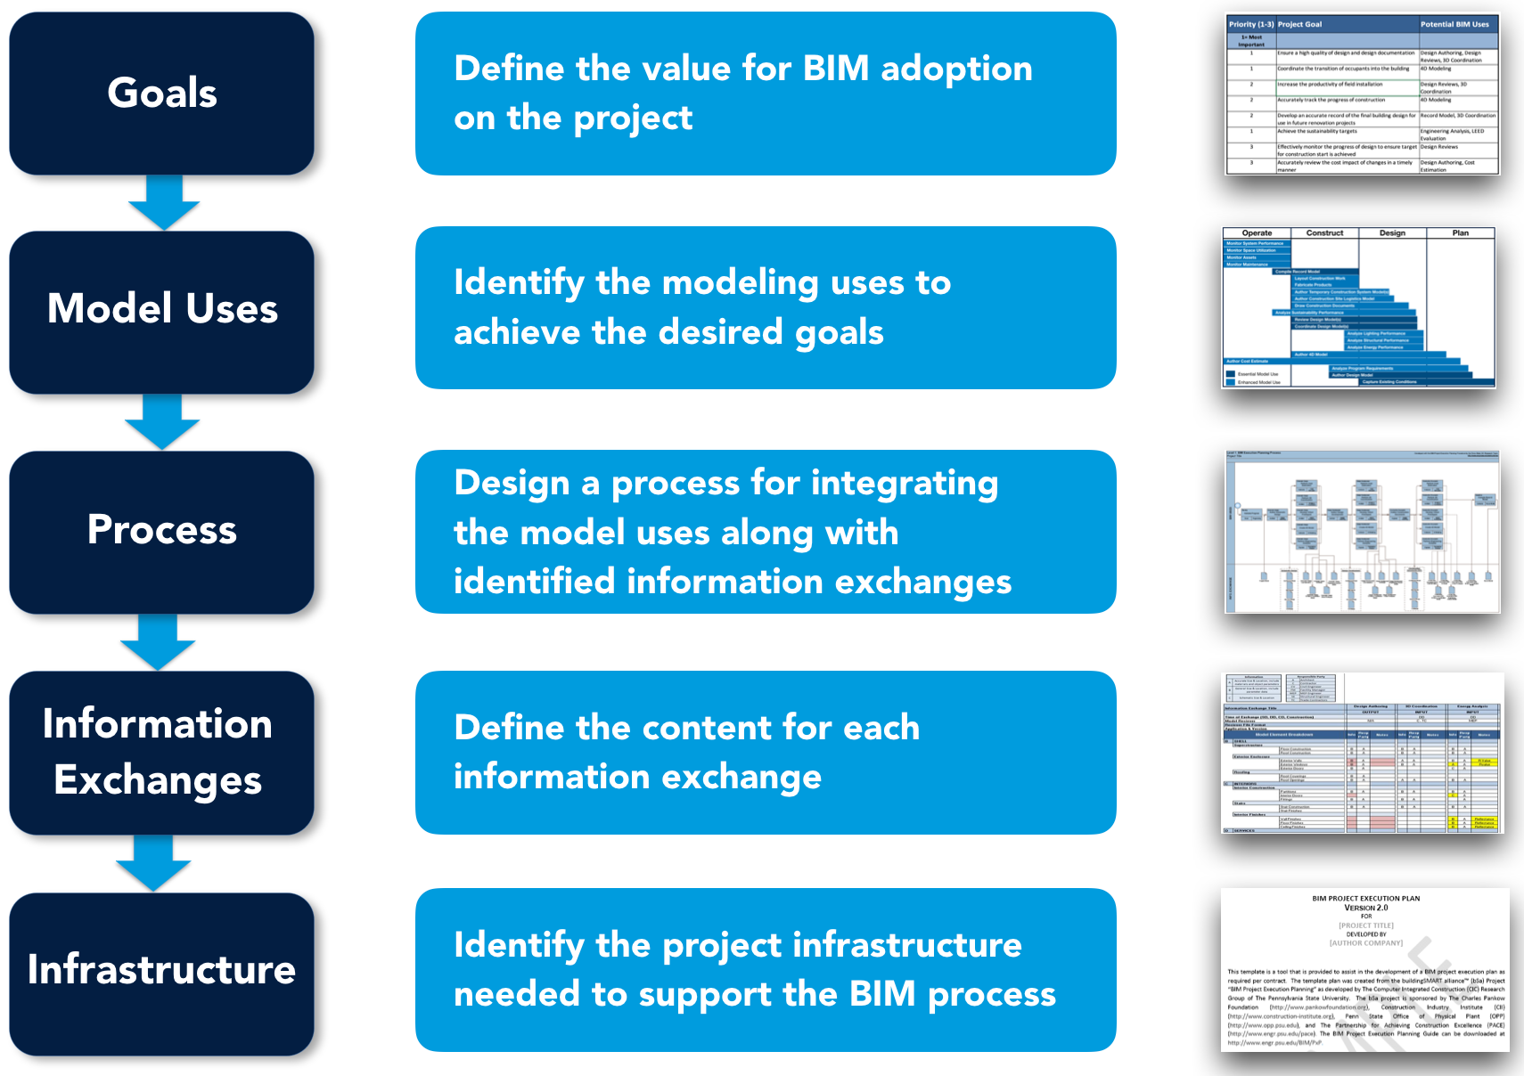

(Source: https://psu.pb.unizin.org)

**Appendix 2: Process of BIM Implementation**

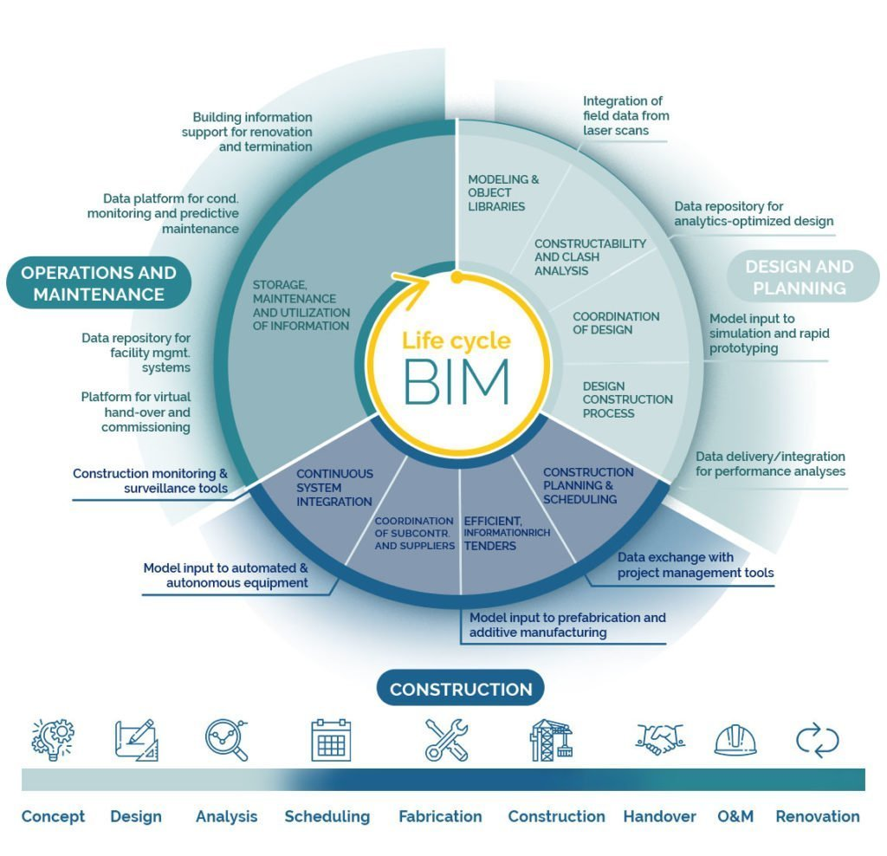

(Source: https://cemexventures.com)