**IMPORTANCE OF SMART DATA MANAGEMENT IN HEALTHCARE RECORD KEEPING**

**TABLE OF CONTENTS**

Introduction 3

Research Background 3

Objectives 3

Literature Review 4

Resources 7

Deliverables 7

Research Approach, Methodology, and Methods 7

Research Approach 7

Methodology 8

Method 8

Academic challenge 9

Ethical Issue 9

Project Plan 10

Reference List 11

Appendices 12

# Introduction

Data management seems essential to maintaining medical records because it makes it possible to store and retrieve patient information effectively. By facilitating quick and safe access to patient records, effective data administration can contribute to better medical results. In addition to enhancing communication amongst healthcare professionals, effective data administration helps guarantee that the appropriate information is retrieved promptly and properly. Smart data handling makes it possible for treatment professionals to store alongside retrieve knowledge more effectively, which may assist in lower the overall expense of medical. Finally, it needs to be emphasized how important proper handling of data is to maintain medical records.

# Research Background

Smart data management additionally helps in ensuring adherence to pertinent laws like HIPAA. PHP-based computer languages as well as database servers like MySQL are capable of making it possible to gather, store, and retrieve health information in a safe manner. The framework may be developed and tested before to implementation with the assistance of such integrating programming surroundings, which might include Visual Studio Code or XAMPP (Madushika *et al.* 2021). By making it possible to quickly retrieve patient documentation, the enactment of advanced data storage technologies for medical purposes may enhance patient care. Additionally, technology can aid in reducing mistakes, enhancing care comprehension in general, and enhancing the reliability of such health records. The danger of data breaches may also be decreased and adherence to pertinent rules can be increased through the use of intelligent solutions for handling data

**Aim**

The purpose of this proposal intends to develop an effective data management software for maintaining medical documentation utilizing a MySQL database, PHP programming in Visual Studio Code, or XAMPP, with the objective to increase the precision and effectiveness of individual patient documents.

# Objectives

There are several goals that need to be archived, those are;

* To use MySQL along with PHP, create a safe and effective medical keeping documents software.
* To use clever data processing, raise the standard of patient treatment.
* To boost the precision and dependability of such patient records.
* To set confidentiality but also data security guidelines.
* To expose of the current, comprehensive patient information should be improved.
* To enhance the effectiveness of medical services while lowering costs.

# Literature Review

According to Palantei (2019), Researchers can use emerging innovations to enhance health care. Telecommunication has become one instance of how technology is advancing in the medical field. For the present scenario, online payment transactions were made using a single debit card while patient information monitoring was connected. The final endeavor uses a card identification chip technology which is connected to the Unhas Hospital webpage to do. Investigators employ International Intelligent Card Indonesian iRFC v1.0-based smart card technology, and their website was created using the PHP computer language (Palantei *et al.* 2019). A program named XAMPP combines the functions of such enabling web internet run by Apache, which handles HTTP requests alongside responses, with the construction of MySQL. The following creates a sophisticated card-based system.

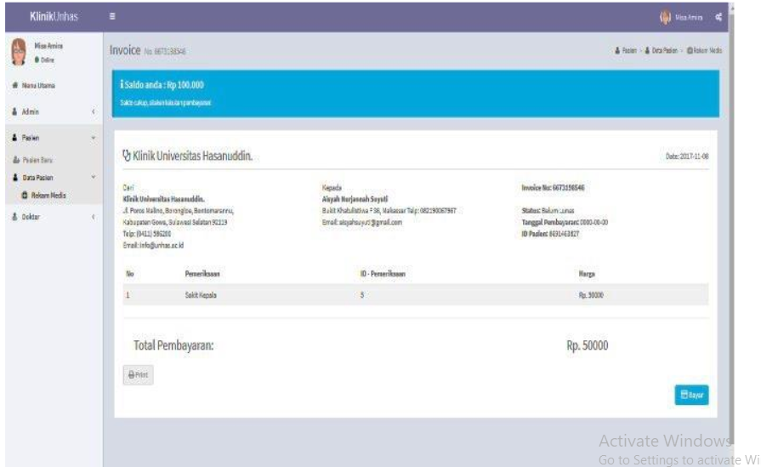

**Figure 1: Invoice Page**

(Source: Palantei *et al.* 2019) ***[Referred to Appendix 1]***

Which might carry out transactions involving electronic payments and retain patient health information. Ten individuals have signed up as sufferers on the online platform. Two of the individuals are insured patients along with have effectively utilized their Unhas Hospital program to accomplish the test. Additionally, the verification procedure during Unhas Both short-distance as well as long-distance clinics may be conducted utilizing Linux is the operating system for the Wireless Fidelity (Wi-Fi) connection, mobile networks like Supplier 1 along with Provider 2 with quick bandwidth.

According to Ismail (2022), Technology advancement has increased accessibility and sped up processes relating to the healthcare industry. In order to manage and supply healthy blood in an emergency, technologies like the Internet of Things (IoT) might be used in conjunction with blood bank operations. Nevertheless, there are several issues with managing blood banks and keeping track of inventories, particularly in underdeveloped nations as opposed to industrialized ones. One of the main obstacles to providing quality healthcare in poor nations is the absence of a sufficient and secure source of such blood. The employment of manual processes, particularly characterized by labor and financial fatigue as well as human errors, adds to organizational issues.

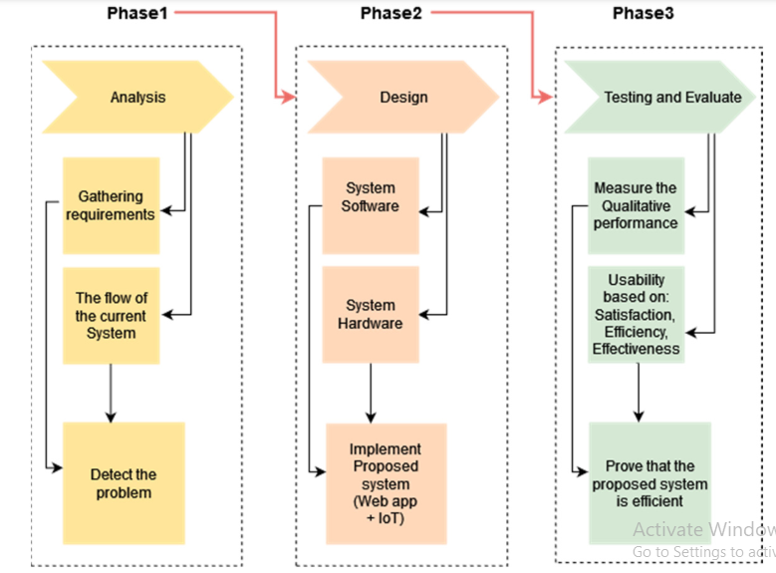

**Figure 2: Methodology**

(Source: Ismail *et al.* 2022)

The unstable electric supply in underdeveloped nations may cause a thermal deviation from the optimum level for maintaining blood inventories. With the help of a dependable, useful implementation, the blood center will be handled while organized, donor data will be controlled, inventories will be monitored, and compatible kinds of blood will be found as soon as feasible (Ismail *et al.* 2022). The suggested system was created and put into operation in two distinct phases: Utilizing web technologies to improve data administration and using connected devices from the Internet of Things to continuously check the ambient temperature of a blood supply. Everyone was able to assess the Internet implementation's performance using sensors thanks to the initial test phase because the findings were promising. The use of the black box approach for functionality testing makes it simpler to acquire and analyze collection banking information in a contemporaneous fashion. Utilizing an interview technique with three criteria—satisfaction, performance, alongside efficiency—the assessment stage was carried out.

# Resources

For the implementation of a sophisticated data management platform for medical keeping records, MySQL, PHP, but also Visual Studio Code all seem to be useful tools. Although XAMPP might offer a foundation for evaluating but also deploying the systems, Google Scholar would give a multitude of academic literature on the significance of this kind of framework (Ajagbe & Adesina, 2020). By employing these technologies, a reliable and comprehensive platform for maintaining medical records may be designed and put into place.

# Deliverables

The construction of such a MySQL database utilizing PHP but also Visual Studio Code or XAMPP constitutes one of such the proposed deliverables that will help with smart information systems in medical documentation keeping. The technology will enhance patient satisfaction, information security, and overall precision.

# Research Approach, Methodology, and Methods

## Research Approach

That study will have to use combined inductive and deductive investigative methods. Researchers may detect connections but also trends in that information using the inductive technique. Designers will indeed be able to conclude these findings and create hypotheses that may be put to further examination (Nizamuddin *et al.* 2019). Utilizing pre-existing ideas but also frameworks to analyze the data but also generate inferences is referred to because of the deductive method. Combined quantitative and qualitative methodologies can be employed to study the information, gathering and evaluating both textual as well as numerical data.

**Figure 3: Research Approach**

(Source: Self-Create in MS-Word)

## Methodology

This initiative's technique will employ an adaptive process. This entails examining the data, formulating speculation, doing an analysis utilizing the information, and subsequently revising the proposed theories as necessary. The information will be gathered from a variety of sources, such as wellness inquiries, healthcare records, and additional resources. Both descriptive and inferential analytics are going to be used to examine this information.

## Method

Database administration in MySQL, system layout throughout VS Code or XAMPP, along with statistical evaluation will all be employed in the current endeavor. The information will be processed, stored, and arranged using the MySQL database. Using VS Code as well as XAMPP, a layout for the system is going to be made using this data. The aforementioned layout will enable the processing and analysis of the data (Oruche *et al.* 2022). Descriptive and inferential statistics are going to be used in the statistical examination, which will enable us to anticipate outcomes and derive meaning compared to the information at hand.

**Figure 4: Methods**

(Source: Self-Create in MS-Word) ***[Referred to Appendix 2]***

# Academic challenge

For the provision of high-quality medical care, intelligent data management in medical bookkeeping is essential. It guarantees that every single piece of data is structured and kept securely. To collect, organize, but also evaluate medical records, the efficient data company utilizes databases including MySQL, XAMPP, but also VS Code. One such aid in giving current knowledge and perspectives on medical problems, cures, and care strategies. Moreover, it assists in guaranteeing certain medical institutions follow data privacy laws. Also, it increases productivity and lowers expenses by minimizing the bureaucracy related to medical records. To deliver the greatest treatment and guarantee patient safety, healthcare professionals must handle data intelligently.

# Ethical Issue

Patient confidentiality represents one of such moral questions raised by the necessity of intelligent information management in medical documentation keeping. This database should always be appropriately protected by utilizing encryption, identity management, and also an adequate authorization mechanism in order to safeguard patient information (Khan *et al.* 2020). This information should also only be available to authorized individuals, and adequate security precautions must be made to prevent unauthorized personnel from getting hold of it. Moreover, the database shall be properly created to guard against security breaches but also destruction. Last but not least, the process must always be built to guarantee that perhaps the data is maintained current and that any modifications or adjustments are duly noted and safely saved.

# Project Plan

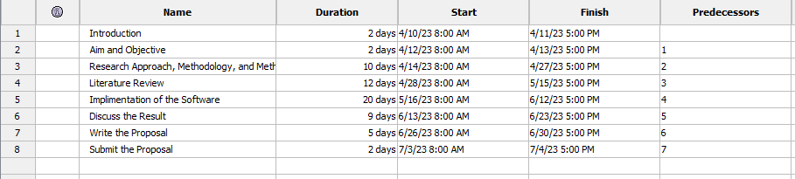

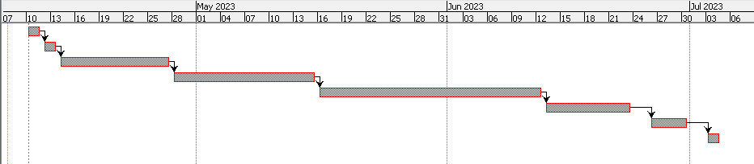

**Figure 5: Project Plan**

(Source: Self-Created in Project Libre) ***[Referred to Appendix 3]***

# Reference List

**Journals**

Ajagbe, S.A. and Adesina, A.O., 2020. Design and development of an access control based electronic medical record (EMR). *CPJ*, *2020008*, p.26108.

Avinash, M.K., Mohan, M.S., Rakesh, V., Harish, C. and Pujitha, C., REMOTE PATIENT HEALTH MONITORING SYSTEM USING IOT AND EMBEDDED SYSTEM.

Ismail, R.D., Hussein, H.A., Salih, M.M., Ahmed, M.A., Hameed, Q.A. and Omar, M.B., 2022. The Use of Web Technology and IoT to Contribute to the Management of Blood Banks in Developing Countries. *Applied System Innovation*, *5*(5), p.90.

Khan, Z., Abbasi, A.G. and Pervez, Z., 2020. Blockchain and edge computing–based architecture for participatory smart city applications. *Concurrency and Computation: Practice and Experience*, *32*(12), p.e5566.

Madushika, M.A.D.L., Uwanthika, G.A.I. and Premarathna, W.P.J., 2021. Smart Hospital Diabetic Clinic Patient Management System.

Nizamuddin, N., Salah, K., Azad, M.A., Arshad, J. and Rehman, M.H., 2019. Decentralized document version control using ethereum blockchain and IPFS. *Computers & Electrical Engineering*, *76*, pp.183-197.

Oruche, R., Milman, E., Lemus Alarcon, M., Cheng, X., Pandey, A., Wang, S., Calyam, P. and Kee, K., 2022. Science gateway adoption using plug‐in middleware for evidence‐based healthcare data management. *Concurrency and Computation: Practice and Experience*, p.e7195.

Palantei, E., Azwar, M.A. and Artini, S.W., 2019, October. Transactions of Real-Time Medical Services Using Smart Card to Support the Role of Smart Campus. In *IOP Conference Series: Materials Science and Engineering* (Vol. 619, No. 1, p. 012001). IOP Publishing.

# Appendices

**Appendix 1: Invoice Page**



(Source: Palantei *et al.* 2019)

**Appendix 2: Methods**

(Source: Self-Created in MS-Word)

**Appendix 3: Gantt chart**





(Source: Self-Created in Project Libre)