**INVESTIGATING THE EFFECT OF PHYSICAL ACTIVITY ON COGNITION**

**TABLE OF CONTENTS**

1.0 Introduction 3

1.1 Introduction 3

1.2 Rationale 3

1.3 Physical Activities 4

1.4 Research question 4

2.0 Methodology 4

2.1 Participants 4

2.2 Design 5

2.3 Procedure 6

2.4 Data Analysis 7

3.0 Results 8

4.0 Ethics 16

5.0 Discussion and Conclusion 16

Reference List 18

# 1.0 Introduction

## 1.1 Introduction

Physical activity for children provides effective opportunities for them to interact and meditate in playful activities with other children. Various physical activities like running, playing games will help to improve physiological fitness along with mental health. Indeed various research activities indicated that fixed quantities of physical activities allowed for children each day will help to improve muscular functions along with cardiovascular effects of the children taken for the study. Physical activities mediated during the daytime will also help in the improvement of the motor skills, which will aid these children to become particular over the basic movements necessary for their everyday life (Diamond and Ling, 2019). Interaction with other children, that are involved while performing physical activities outdoors which will also aid in building and developing social and communication skills like that of teamwork, and vocabulary, which will play important role in mediating their development. Apart from the aforesaid developmental skills, research from many international centers like the “National Institute of Health (NIH)”, indicated important links between the mediation of physical activities and the cognitive skills and brain functions associated with children (Donnelly *et al.* 2016). Thus the study focuses on the positive linkage between physical activities and cognitive development that will aid proper understanding of the surroundings with active problem solving skills.

## 1.2 Rationale

The meditation of the investigation regarding finding the linkage between physical activities and cognitive actions of the children was performed to discover the positive impacts that physical activities mediated over the cognitive development of the children as evident from a wide number of studies that were mediated with this research topic (Hillman *et al.* 2009). Research indicated that physical activities particularly focussed on children will help to increase their brain function that will allow these children to respond with improved responses and decision solving skills. Moreover, these researches indicated a positive correlation between the two components with the improved overall mental health of the children. Therefore in accordance with the results obtained, the study aims in finding a correlation between the physical activities and cognitive actions that will aid in shaping the decision making skills of the students.

## 1.3 Physical Activities

Research indicated that various types of physical or aerobic exercise activities are involved which will aid in the development of the cognitive skills associated with children. These physical activities include walking, running, and swimming which will help in building neural and brain development which will help in building the various skills that are important like logical reasoning, that will aid in the effective development of cognitive skills.

## 1.4 Research question

Focusing on the main objectives of the research, some research questions were proposed that will aid in the effective mediation of the research. The research questions are defined as follows -

1. Do you think walking is involved in the cognitive development of children?
2. What will be the relationship between the various physical activities and cognitive development among the children?

# 2.0 Methodology

## 2.1 Participants

**Qualitative (focus group)**

In this research, five participants are presented in the focus group and they are involved in various physical activities for the children’s cognitive development. The researcher makes questionaries with the help of various important questions for effective assessment regarding the effects of physical developments over cognitive skills.

**Quantitative**

This means that the researcher used various numerical values for this research and analysis in Excel. This analysis is called quantitative analysis.

|  |  |
| --- | --- |
| Male/female | 60% Male and 40 % Female |
| Age | 24-38 years |
| Employment | 3 are full-time, 1 are part-time and 1 participant are unemployed |
| “Number of children” | 6 |

## 2.2 Design

Every research has its own research design which is always followed by the researcher to make it perfect. In this research, the researcher used two analyses such as quantitative and qualitative analysis for better understanding. Qualitative analysis is always based on perception-based information with the help of questions. To get the results, the researcher used mixed methods such as quantitative and qualitative analysis both. These results help to get information “on cognitive development”.

The advantage of this mixed method is that it is qualified of delivering the perfect outcomes. With the help of qualitative analysis. The researcher gets the themes and patterns of the research. The deep investigation process is helped by qualitative analysis. The qualitative analysis provided various and perfect resources for the research to get perfect outcomes. This method is very easy to use and provided the various information as per the requirements. Quantitative analysis is always based on the numerical and statistical values of the research.

## 2.3 Procedure

Using the focus groups for the mediation of the study is seen as a useful procedure for the mediation of the collection of the data along with results analysis. The focus group consists of five participants, whose thoughts, and opinions were used for the research purpose. Initially, the group members are informed regarding the procedures undertaken for the investigations. Informing the focus groups regarding the investigation can be mediated using information documents that consist of details and guidelines regarding performing the investigation. This step is then followed by the second step of the investigation which involves a pilot study that was predetermined using a group member which was taken to design a questionnaire to check regarding its working (Oppici *et al.* 2020). Once it was determined, the participants were informed about the interview procedures in accordance with the questionnaire, by fixing a particular time with that of the participants. Finally, the results that were obtained using the interview method were effectively analyzed using Microsoft Excel, to find the intended results that were aimed for the investigation.

|  |  |  |
| --- | --- | --- |
| Serial number | Questions | Response |
| 1. | Do you think walking is involved in the cognitive development of children? | 1. 4 Female 2. 1 Male |
| 2. | What will be the relationship between the various physical activities and cognitive development among the children? | 1. 3 Feamle 2. 2 male |

## 2.4 Data Analysis

**Thematic analysis and its importance**

The thematic analysis mainly describes the process of analysis of the qualitative data. It is mainly used in research where the data has been collected via interviews or surveys using questionnaires. Through the thematic analysis, the researcher usually wants to identify the main topic, theme, text, ideas, and summary of the interaction between the interviewer and the participants. Thematic analysis performs an important function within the qualitative analysis of the data so that important themes regarding the data sets can be identified to mediate important research questions that were set for the investigations.

**Correlation analysis and its importance**

“A statistical technique” used in investigations to assess the connection between two factors and evaluate the intensity of "their linear relationship" is known as correlation analysis. The magnitude of a variation in one parameter as a result of the variation in the other is determined using correlation analysis. Using the correlation coefficient provides us with a number of advantages that includes helping in measuring the relationship among variables, helps in identification of the important factors within a variable upon which another is dependable, and reducing the chances of any uncertainties within the decision making process.

# 3.0 Results

**Section 1**

**Thematic Analysis: Question no 1**

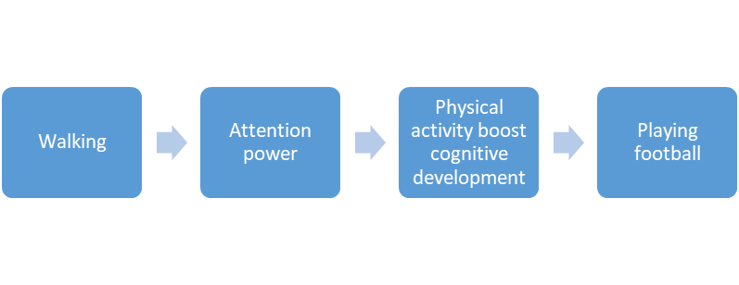

**Figure 1: Thematic Analysis of Participant 1**

(Source: Self-created)

The 1st participant thinks walking is one of the physical activities and attention power is an example of cognitive power. She thinks physical activity boosts cognitive development, and football playing is the best example of children’s physical activity.

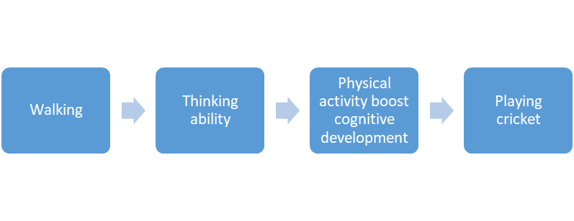

**Figure 2: Thematic Analysis of Participant 2**

(Source: Self-created)

The 2nd participant thinks walking is one of the physical activities and thinking ability is an example of cognitive power. She thinks physical activity boosts cognitive development, and cricket playing is the best example of children’s physical activity.

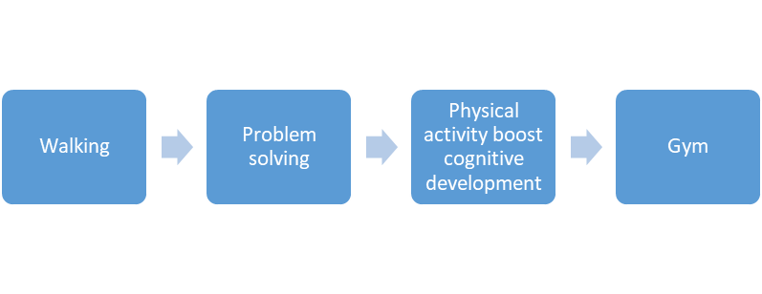

**Figure 3: Thematic Analysis of Participant 3**

(Source: Self-created)

The 3rd participant thinks walking is one of the physical activities and problem-solving is an example of cognitive power. She thinks physical activity boosts cognitive development, and gym is the best example of children’s physical activity.

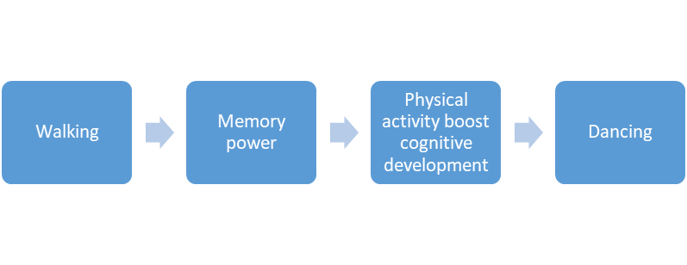

**Figure 4: Thematic Analysis of Participant 4**

(Source: Self-created)

The 4th participant thinks walking is one of the physical activities and memory power is an example of cognitive power. She thinks physical activity boosts cognitive development, and dancing is the best example of children’s physical activity.

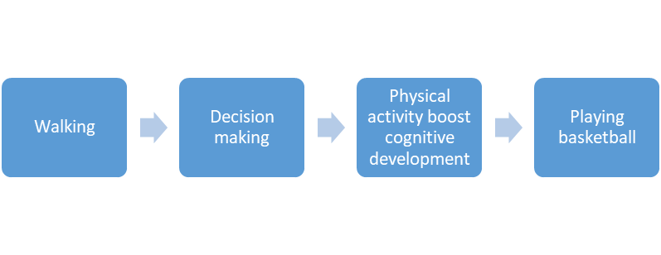

**Figure 5: Thematic Analysis of Participant 5**

(Source: Self-created)

The 5th participant thinks walking is one of the physical activities and attention power is an example of cognitive power. She thinks physical activity boosts cognitive development, and basketball playing is the best example of children’s physical activity.

**Thematic Analysis: Question no 2**

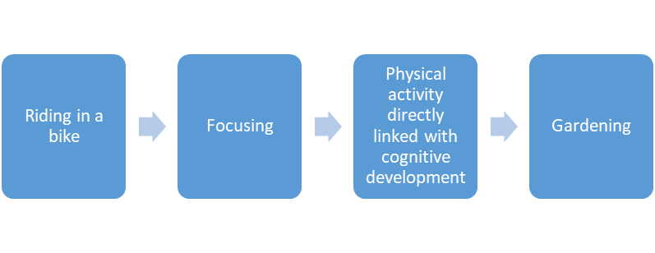

**Figure 6: Thematic Analysis of Participant 1**

(Source: Self-created)

The 1st participant have chosen an example of a physical activity that has been recognized is “Riding in a bike”. The cognitive function introduced here is “Focusing”. There is a relation between cognitive function and physical activity. The best physical activity is considered to be “gardening”.

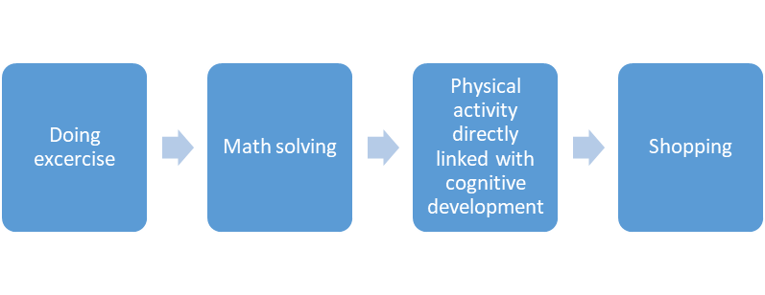

**Figure 7: Thematic Analysis of Participant 2**

(Source: Self-created)

The 2nd participant have chosen an example of a physical activity that has been recognized is “doing exercise”. The cognitive function introduced here is “Math Solving”. There is a relation between the cognitive function and physical activity. The best physical activity is considered to be “shopping”.

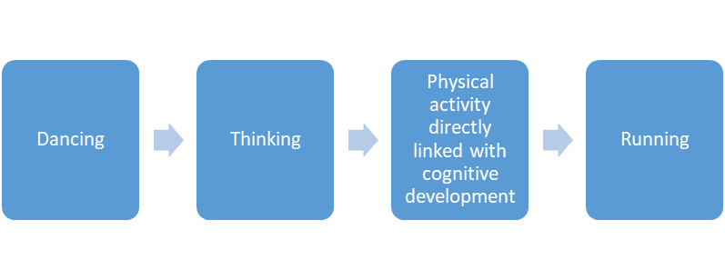

**Figure 8: Thematic Analysis of Participant 3**

(Source: Self-created)

The 3rd participant have chosen an example of a physical activity that has been recognized is “Dancing”. The cognitive function introduced here is “Thinking”. There is a relation between the cognitive function and physical activity. The best physical activity is considered to be “running”.

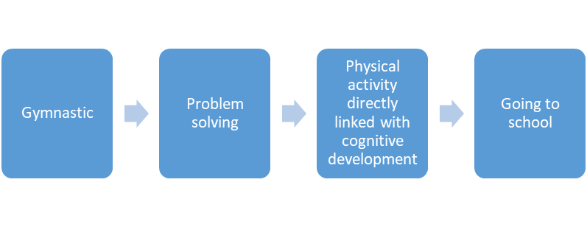

**Figure 9: Thematic Analysis of Participant 4**

(Source: Self-created)

The 4th participant has chosen an example of a physical activity that has been recognized is “Gymnastic”. The cognitive function introduced here is “Problem-Solving”. There is a relation between the cognitive function and physical activity. The best physical activity is considered to be “Going to school”.

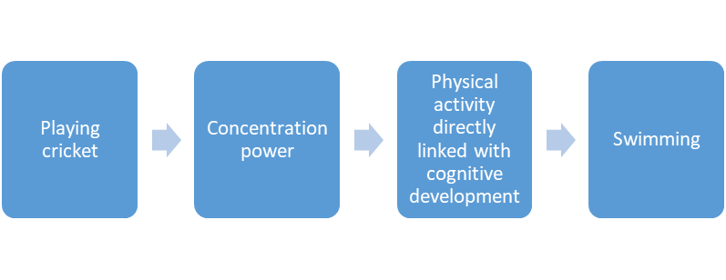

**Figure 10: Thematic Analysis of Participant 5**

(Source: Self-created)

The 5th participant have chosen an example of a physical activity that has been recognized is “Playing Cricket”. The cognitive function introduced here is “Concentration Power”. There is a relationship between cognitive function and physical activity. The best physical activity is considered to be “Swimming”.

**Section 2**

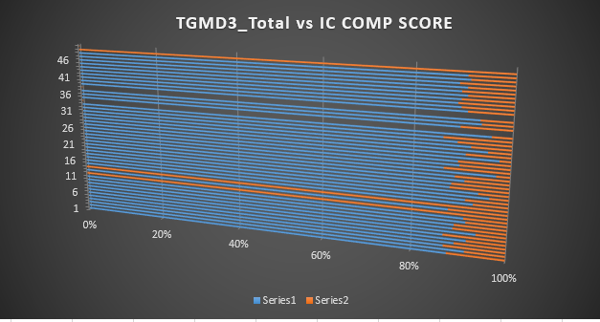

**Figure 11: “Graph of TGMD Total vs IC Comp Score”**

(Source: Self-created)

The above graph represents the three dimensional bar graph that has been generated using the Microsoft Excel platform. The three-dimensional graph that has been generated represents the relationship among the “TGMD3 Total” against “IC Comp Score”. The above graph has been which has been generated using Microsoft Excel includes fifty values from each of the variables that were chosen for the study.

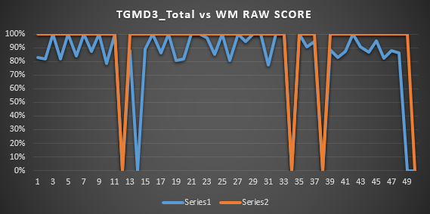

**Figure 12: Graph of TGMD Total vs WM Raw Score**

(Source: Self-created)

The graph shows the **TGMD Total vs WM Raw Score.** The graph is created according to the “TGMD3 Total” and “WM Raw Score”. The X-axis values go up to 49 and the yAxis value goes up to full 100 percent.

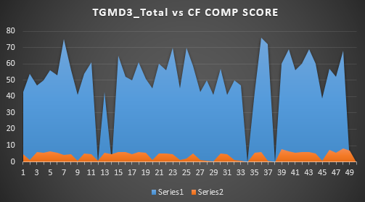

**Figure 13: Graph of TGMD Total vs CF Comp Score**

**(Source: Self-created)**

The graph shows the **TGMD Total vs CF Comp Score.** The graph is created according to the “TGMD3 Total” and “**CF Comp Score**”. The X-axis values go up to 49 and the yAxis value goes up to full 100 percent.



**Figure 14: R-value**

(“Source: Self-created using Microsoft Excel”)

With the help of the R square value the variance within the data sets among the dependent and the independent variable can be assessed. The R square value that has been obtained using the given data sets is shown in the above figure.



**Figure 15: Correlation Analysis**

(Source: Self-created using Microsoft Excel)

The above figure represents the correlation data of the three cognitive function that has been considered within the study. The three correlation includes “inhibitory control – cognitive function 1, working memory – cognitive function 2, and CF - cognitive flexibility”. The values of the correlation show an important relationship between these cognitive functions and physical activity. The values indicated that these positive outcomes are associated with a positive correlation between cognitive function and physical activities.

# 4.0 Ethics

There are various ethics that must be followed for the mediation of the results. This includes -

1. All the procedures involved in the investigation are mediated with full consent of the participants.
2. The information gathered from the participants must be kept in accordance with the standards of data protection so that this information must not fall into the hands of intruders.
3. It must be also ensured that no forms of discrimination were mediated over the participants and no manipulation of data was mediated.

# 5.0 Discussion and Conclusion

The investigation were mediated to find the importance of physical activities, and how it affects the growth and development of children. Particularly within this investigation, the effects of physical activities on cognitive development were studied. Accordingly, research questions were framed to find the relationship between physical activities and cognitive development, and to study the effects of walking on cognitive development. Using the thematic analysis and Excel study, it can be seen that there is “a positive correlation” among the various “physical activities and Cognitive development” within the children. While using the thematic analysis, it shows that walking and other physical activities like riding a bicycle have prominent positive effects on the cognitive function, the EXCEL-mediated analysis using the correlation coefficient and R square values also indicated positive association among the three given cognitive functions and the given physical activities.

Therefore schools must play an important role in increasing the period of physical activities for children and must include proper guidelines to ensure that each child can get adequate amounts of physical activities that will lead in their cognitive as well as overall development.

**Future Implication**

The recognition of the relationship between the various physical activities with the cognitive development of children will allow for effective knowledge regarding the child’s growth and development.

**Research Limitation**

In addition to relying on self-reported and parental surveys, which are subject “to bias, as well as” qualitative research which lacks randomization along with control groups, the studies frequently focus on short-term effects, which limits their ability to address long-term implications.

# Reference List

**Journals**

Donnelly, J.E., Hillman, C.H., Castelli, D., Etnier, J.L., Lee, S., Tomporowski, P., Lambourne, K. and Szabo-Reed, A.N., 2016. Physical activity, fitness, cognitive function, and academic achievement in children: a systematic review. *Medicine and science in sports and exercise*, *48*(6), p.1197.

Hillman, C.H., Pontifex, M.B., Raine, L.B., Castelli, D.M., Hall, E.E. and Kramer, A.F., 2009. The effect of acute treadmill walking on cognitive control and academic achievement in preadolescent children. *Neuroscience*, *159*(3), pp.1044-1054.

Diamond, A. and Ling, D.S., 2019. Aerobic-Exercise and resistance-training interventions have been among the least effective ways to improve executive functions of any method tried thus far.

Oppici, L., Rudd, J.R., Buszard, T. and Spittle, S., 2020. Efficacy of a 7-week dance (RCT) PE curriculum with different teaching pedagogies and levels of cognitive challenge to improve working memory capacity and motor competence in 8–10 years old children. Psychology of Sport and Exercise, 50, p.101675.