**DATA ANALYTICS PORTFOLIO OF CAPGEMINI**

**TABLE OF CONTENTS**

Introduction: 3

1. Task 1: The Company and Business Processes 3

1.1 Business Process Map / Flow Chart 4

1.2 Main/Key Business Decisions 5

1.3 Business Digital Transformation 5

2. Task 2: Data Management Systems 6

2.1 Information/Data Management Systems 6

2.2 Database Management Systems 8

2.3 Big Data for Business 10

3. Task 3: Business Intelligent (BI) Tools 11

3.1 Opportunities for Intelligent Tools and Systems 11

3.2 Business Intelligent (BI) Support 13

3.3 Reflect on the BI tools 13

Conclusion 14

Reference list 15

Appendices 17

# Introduction:

This project is about suggesting many business processes for the considered company “Capgemini” which include key ideas of the business process. Several modern technologies are also discussed which can be implemented into the business process and mitigate the possible obstructions that might occur during the execution of the planning. The goal is to achieve three tasks that is mentioned for this particular project.

# 1. Task 1: The Company and Business Processes

The name of the chosen company for this project is Capgemini. Capgemini is a multinational retail organization that operates a chain of hypermarkets and provides discounts to departmental stores and grocery stores. The retail industry operated by Capgemini is based on providing low prices for the services and products provided by the company. There are several numbers of strategies that consist of Capgemini regarding its business model. The key attributes of its business model of Capgemini are to provide services and products for low prices. This strategy is named the “Avant-Grade” strategy that supports the handcraft of the Business process. During the recruitment of employees, many strategies are maintained such as the scale of economies, price leadership, expansion of the business worldwide, and improvement in information technology. Apart from that the outlet plans of Capgemini ensure that multiple stores exist in every city, as their customer can easily access to their products on daily basis.

Another important business process of Capgemini is the buying strategy of products and raw materials which provides much profit to their business. The company always tries to buy the products directly from the manufacturing companies to get the product at the lowest price in the market as there is no middleman existing within the deal. Another tactic used is ordering the products in bulk in volume, this phenomenon helps them get their products at the best possible condition.

## 1.1 Business Process Map / Flow Chart

This section holds information about the flow chart regarding the business model of the e-commerce company Capgemini. Through this flow chart, all of the attributes of the business model can be understood specifically and guidance on the business process can be get.

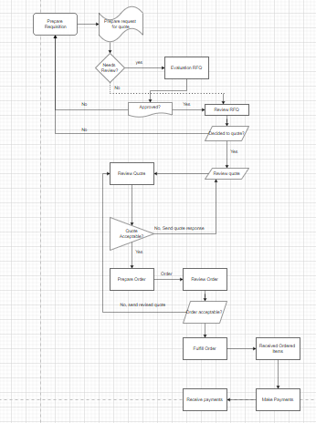

**Figure 1: Flow chart of business process**

(Source: https://www.capgemini.com)

Through the flow chart, it can clearly be understood that there are several key sections connected with the primary object of the business (Kliestik, T. *et al*, 2021). The major objects that are directly connected to the main business process are the suppliers of the products, the customers, and their orders. After an order is placed by the customer, the information about the ordered material goes to the sales department.

## 1.2 Main/Key Business Decisions

One of the key business decisions made by Capgemini to increase the business is enabling the findability. It needs to be ensured that all the data are labeled and there are enough key attributes for users to identify every data (Majerova, J. *et al*, 2020). The consumers of the company may need to access all the related data that was stored in the past years. In this scenario, the format of the data collection is need to be applied.

Another key decision that Capgemini made about enabling Accessibility is determining the right data available for the right users. The data access of this company is restricted as the consumers can only access the information which is enabled to them. Due to this attribute, the risks of the security of information and leakage of data are much reduced and the consumers can access their data without any hesitance.

The next key decision made by Capgemini is enabling the interoperability of data. It is the ability to exchange information within the computer systems and with people who are accessing the dataset (Novak, A. *et al*, 2021). The management has the responsibility to decide the amount and the context of the data that is to be shared between the software and the consumer. Most business information is shared in this process which does not have much risk for security purposes. Semantic interoperability is the system exchanging the full information by understanding the origin of the data.

The final business process is enabling reusability which is very efficient for the organization. The original context of the data needs to be understood by the user as it can achieve the goals of data reusability (Macek, J. *et al*, 2021). The processing methods of the transformation are performed to achieve the current data which is the key feature for reusability.

## 1.3 Business Digital Transformation

Digital transformation for business is very crucial as modern technologies are already getting digitalized all most of the work is done online basis. From the considered process for the business model, it can be said that all of the mentioned processes can be utilized for the digitalization purpose. In order to achieve better outcomes for security purposes and decrease the operational cost, digitalization of the business model is very necessary (Ghanem, E. *et al*, 2022). Processes like findability and data accessibility are denoted by the digitalization process as all the related data is accessed by the user online basis which is a prime example of digital transformation. The interoperability of data can be fully digitized and it can be benefited from digital transformation. From this attribute, the users can create their accounts on the online portal and check their credentials through the big dataset stored by the portal organization.

# 2. Task 2: Data Management Systems

## 2.1 Information/Data Management Systems

The data management systems are generally built over the platforms of the data management which include several processes and components which work together to extract the main value from the data. This system consists of several attributes like data lakes and data warehouses, database management, and tools for data integration (Nica, E. *et al*, 2019). There are several components of the database management systems exits that are important forte the whole process of data storage and data transfer.

**Relational database management system (RDBMS):** The database management system related to the RDBMS includes the function of the data definitions which helps retrieval systems and programs for understanding the references of the data by proper name. Without these components, the references of the data have to be identified by describing the structure and the exact location of the data each tie it has to be accessed. This feature is also used for maintaining the relationship between the data items which can enhance access and helps avoid the duplication of the data based on the relational model (Hawkins, M. *et al*, 2021). The basic characteristics and definitions of any item can be stored and linked to the details of the customer order and pricing of the products.

**Information system about sales and human resources:**

The information system bout the sales can provide an overview of the stored data and process this in sales and distribution. The logistic data is sent from the decentral sales and the distribution system to the central cells of the distribution cells. The structure of the information system needs to be updated for this scenario.

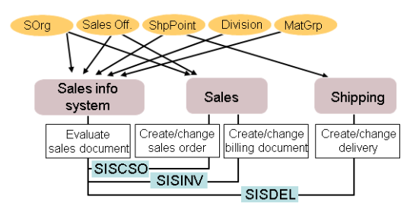

**Figure 2: Information system about sales**

(Source: https://help.sap.com)

The given figure is showing the model of the reference model regarding the information system about sales. The major segment of this model is the sales of the system which are connected to almost every entity of the model. There are three key components of this model such as sales information system, data on sales, and data on shipping (Cunningham, E. *et al*, 2021). The main components of this model are evaluating the sales documents, creating or changing the sales order, creating the billing documents, and also creating the information dataset of deliveries. The major core master of the dataset has to be distributed to the related components which are the material master and records of the customer master.

The information system regarding the human resources used to collect and gather the data and store the information about the employees of the particular organization. The basic functionality of the information system of human resources lies at the end-to-end of the management of the human resources. It can run on the technical infrastructure of any organization or the cloud-based technology which is implied by most modern companies (Porter, K. *et al*, 2021). Several new techniques are implied by Capgemini as boosting the experience of the employees and introducing exciting platforms that increase the productivity and satisfaction of the employees. The newly introduced human resources platform can retain the current elements of the operations and re-engineer the higher levels of efficiency which is part of the new model.

## 2.2 Database Management Systems

**Object-oriented database management system (OODBMS):** Object-oriented is a different approach from the previous one in terms of data definition and data storage.This is mainly developed and used in the sector of object-oriented programming systems (Blackburn, E. and Pera, A. *et al*, 2021).

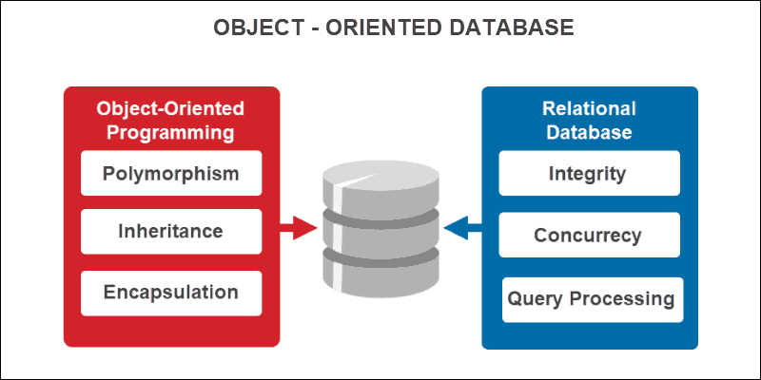

**Figure 3: Object-oriented database management**

(Source: https://phoenixnap.com/kb/object-oriented-database)

In this process, the data is stored as an object and the entities regarding the data are self-described and self-contained and the table format for data storage like the RDBMS is not used.

**In-memory database:** The process of IMDB or in-memory database can store the data and information in the core memory of the computer which is RAM. The disk drive is not used here for the data storage system.

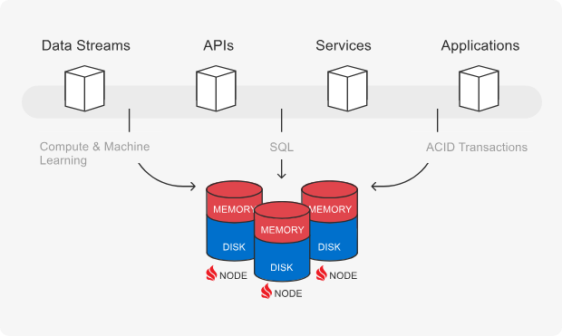

**Figure 4: In-memory database management**

(Source: https://ignite.apache.org)

The reason behind the storage of data in the main memory is that the retrieval of data from RAM is quicker and easier than retrieval from the disk drive (Mijoska, M.et al, 2019). Applications that are required rapid response times for many attributes, use this in-memory database system for its speed of data retrieval. The reports or the tasks that needed a day to e completed now can be done within minutes due to this database management system.

**Columnar database:** The columnar database system stores the groups of data together in one place to access quickie in the time of emergency. This feature is used in modern application which is based on the in-memory system (Rowland, Z. *et al*, 2019). Several applications use the data warehouse system to quickly access the data and reduce the data retrieval time uses this data management system.

**Importance of the storage of crucial data:**

The crucial data refers for this project is information about the records of products, planning of production, and information about the customer which are required to be stored. By looking at these forms of data it can be said that without this information no dataset can be established. Record of the products helps to find the exact product which the customers are seeking. A good production plan can increase efficiency and reduce the total cost of the project (Kalinova, E. *et al*, 2021). The information about the customer is very important data to make the products according to the requirements and target the potential customers.

## 2.3 Big Data for Business

Big data for business purposes is very important as it holds much information about the products and the customers. By processing the big data many attributes can be accessed which are related to the business. Big data means a dataset with a huge size and volume which contains many data and information about several entities.

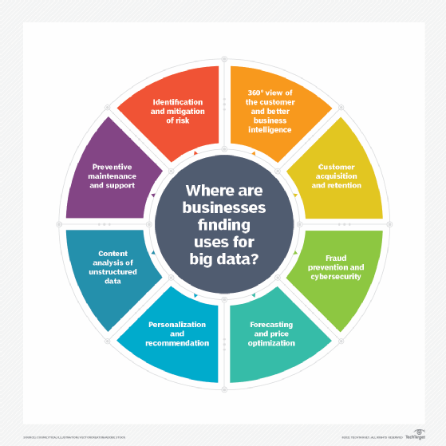

**Figure 5:** **Big Data for Business**

(Source: https://www.techtarget.com)

The entities about the product and the customers are recorded in big data (Mijoska, M.  *et al*, 2019). Business knowledge (BI) devices are programming applications that are utilized to examine, cycle, and present information in a way that can be effortlessly perceived by business clients. It has many benefits in the business purpose as through this the desired product of the customers can be understood. Along with that, the hidden pattern of the sales can be observed which also refers to the products that are most sought by the market. The potential customer can be identified by analyzing the big data with artificial intelligence technology.

# 3. Task 3: Business Intelligent (BI) Tools

## 3.1 Opportunities for Intelligent Tools and Systems

There are plenty of intelligent tools are available which can be implemented in the business model that is considered for this project.

**SAP business object:** The first tool is the SAP business object which is software that offers a comprehensive analysis of the dataset, reporting, and visualization of the dataset. This platform mainly focuses on some critical categories such as customer experience and digital supply chain which is much needed for the business model considered by Capgemini (Clarke, G. *et al*, 2020). Data discovery, reporting, and visualization are all features of SAP BusinessObjects, a collection of business intelligence (BI) tools. As the business model of Capgemini holds a big dataset to record the details of their products and customers, this software is very useful as it is very efficient and can do a comprehensive analysis within a very short time.

**Data pine:** This software is very useful for business processes acquired by Capgemini as it is a complete solution for business intelligence. The complex process of data analysis can be done very quickly. This software consists of a critical attribute as self-service analytics which is an important approach that must be operated by this particular business model. Can be expected from this tool can ease the possess of analyzing big data. Capgemini is a huge organization with plenty of employees and clients of their business (Lăzăroiu, G. *et al*, 2021). For this reason, the dataset regarding this organization gets huge in size and volume which consists of all the data of employees and clients. Ranging from simple tools for visualizing data to more complicated platforms with features. That is why many obstructions could come at the time of handling the dataset. The handling of data includes the access of personal information of the employees and the clients and transferring the data from the main storage to another storage. This software can solve the issues that occur during the transformation of the data.

**Microstrategy:** This is a very important tool that can offer very powerful dash boarding and data analytics and cloud solutions for management. It is a cloud-based platform that lets users use a variety of data sources to create interactive dashboards and reports. Insights into their operations and market trends, these tools are intended to assist organizations in making better decisions. This feature can identify the trends and identify new opportunities that improve productivity and increase efficiency. Multiple parties can involve in this attribute for this reason the involvement of different users is made easy. This feature can also filter a huge amount of data to detect and present the actual data that is needed by the client or the employees for personal purposes. It supports a variety of visualizations, including maps, charts, and graphs (Michalikova, K.F. *et al*, 2021). This feature can also connect to numerous data sources which are essential for the transfer of information purpose.

**Microsoft Power BI:** This is one of the useful intelligent tools that can e implemented in the business process of the organization. It is basically a business analysis tool that supports the excel for data visualization. It has advanced analytics capabilities like predictive modeling and machine learning. It can allow the identification process for real-time trends which are the new connections made within the big data server.

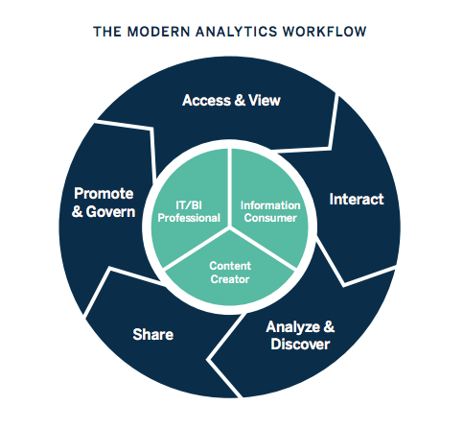

**Figure 6: Business Intelligent (BI) Support**

(Source: https://encrypted-tbn0.gstatic.com)

Reporting, analysis, and dashboarding are all features of analysis which is a BI platform. The integration of the applications can be delivered by the main server which is directly connected to the big data storage. It works well with other Microsoft products. Delivering the needed report in real time without any hesitancy is the primary task of this process. It is expected that from this feature the estimated business process which is discussed earlier can be benefited from these modern technologies.

## 3.2 Business Intelligent (BI) Support

The tools that are suggested can support the business process in many aspects such as for its consumers and for its stakeholders. All of the business processes are very modern and hi-tech technology oriented which can be very useful for the business process. The SAP business object suggested incorporating progressed investigation abilities. For example, prescient demonstrating and information mining, and can coordinate with other SAP items. The considered business process needs to be flawless and very quick as plenty of users are trying to access their accounts to look at their personal credentials. It can connect to a variety of data resources and has advanced analytics capabilities which are very essential for database technology like predictive modeling and data mining.

## 3.3 Reflect on the BI tools

This section holds information about the reflection of the tools of business intelligence and the impact on the improvement of the services. As it is directed there are two major issues that need to be considered for this project. The most widely used BI tools are as follows using a drag-and-drop interface. The impact of business tools is huge on the intelligent process of business.

**Security issues:** The dataset regarding records for the employees of Capgemini is huge in size and shape. The personal information of each employee and client is recorded in the primary dataset of this company. Due to the size of the database, there are several issues related to the serenity database. The security of the database could be branched during the access of the information of employees and clients. Another incident for security purposes could occur during the transfer of the information from the main server to the branch servers. It is essential to take into account factors like ease of use, and data integration capabilities.

# Conclusion

This section holds a brief discussion of the activities that are performed throughout this report. The primary task of this project is to suggest several business processes that are implemented by the company Capgemini. After Suggesting the key process the information about the database management system is also discussed. For the final task, new intelligent tools are discussed which can improve the considered business processes and mitigate the problems of those business processes. All the information about this project is given in this report for the studies that will be performed in the coming future.

# Reference list

**Journals**

Novak, A., Bennett, D. and Kliestik, T., 2021. Product decision-making information systems, real-time sensor networks, and artificial intelligence-driven big data analytics in sustainable Industry 4.0. *Economics, Management and Financial Markets*, *16*(2), pp.62-72.

Popescu, G.H., Valaskova, K. and Majerova, J., 2020. Real-time sensor networks, advanced robotics, and product decision-making information systems in data-driven sustainable smart manufacturing. *Economics, Management and Financial Markets*, *15*(4), pp.29-38.

Lăzăroiu, G., Kliestik, T. and Novak, A., 2021. Internet of things smart devices, industrial artificial intelligence, and real-time sensor networks in sustainable cyber-physical production systems. *Journal of Self-Governance and Management Economics*, *9*(1), pp.20-30.

Cohen, S. and Macek, J., 2021. Cyber-physical process monitoring systems, real-time big data analytics, and industrial artificial intelligence in sustainable smart manufacturing. *Economics, Management and Financial Markets*, *16*(3), pp.55-67.

Ghanem, E., 2022. Assessing ESG from a Position of Wealth. In *Sustainability, Technology, and Finance* (pp. 235-250). Routledge.

Nica, E., 2019. Cyber-physical production networks and advanced digitalization in Industry 4.0 manufacturing systems: Sustainable supply chain management, organizational resilience, and data-driven innovation. *Journal of Self-Governance and Management Economics*, *7*(3), pp.27-33.

Hawkins, M., 2021. Cyber-physical production networks, internet of things-enabled sustainability, and smart factory performance in industry 4.0-based manufacturing systems. *Economics, Management, and Financial Markets*, *16*(2), pp.73-83.

Cunningham, E., 2021. Artificial intelligence-based decision-making algorithms, sustainable organizational performance, and automated production systems in big data-driven smart urban economy. *Journal of Self-Governance and Management Economics*, *9*(1), pp.31-41.

Rowland, Z. and Porter, K., 2021. Autonomous vehicle driving algorithms, deep learning-based sensing technologies, and big geospatial data analytics in smart sustainable intelligent transportation systems. *Contemporary Readings in Law and Social Justice*, *13*(2), pp.23-36.

Blackburn, E. and Pera, A., 2021. Autonomous vehicle interaction control software, big geospatial data analytics, and networked driverless technologies in smart sustainable urban transport systems. *Contemporary Readings in Law and Social Justice*, *13*(2), pp.121-134.

Mijoska, M., 2019. Assessing Organisational Maturity in Predictive Analytics of Telecommunications Companies in the Republic of Macedonia. *Economic Analysis Journal: Applied Research in Emerging Markets, Vol 52 No 1 (2019)*.

Whittle, T., Gregova, E., Podhorska, I. and Rowland, Z., 2019. Smart manufacturing technologies: Data-driven algorithms in production planning, sustainable value creation, and operational performance improvement. *Economics, Management and Financial Markets*, *14*(2), pp.52-57.

Rogers, S. and Kalinova, E., 2021. Big data-driven decision-making processes, real-time advanced analytics, and cyber-physical production networks in industry 4.0-based manufacturing systems. *Economics, Management and Financial Markets*, *16*(4), pp.84-97.

Blagoeva, K.T. and Mijoska, M., 2019. Assessing Organizational Maturity in Predictive Analytics of Telecommunications Companies in the Republic of Macedonia. *Economic Analysis*, *52*(1), pp.48-55.

Clarke, G., 2020. Sensing, smart, and sustainable technologies in big data-driven manufacturing. *Journal of Self-Governance and Management Economics*, *8*(3), pp.23-29.

Watch, C.M., 2020. 2020. *Above and Beyond Carbon Offsetting: Alternatives to Compensation for Climate Action and Sustainable Development*.

Kovacova, M. and Lăzăroiu, G., 2021. Sustainable organizational performance, cyber-physical production networks, and deep learning-assisted smart process planning in Industry 4.0-based manufacturing systems. *Economics, Management and Financial Markets*, *16*(3), pp.41-54.

Goodman, C. and Michalikova, K.F., 2021. Autonomous vehicle decision-making algorithms, interconnected sensor networks, and big geospatial data analytics in smart urban mobility systems. *Contemporary Readings in Law and Social Justice*, *13*(2), pp.93-106.

# Appendices

**Appendix 1: Business Intelligent (BI) Support**

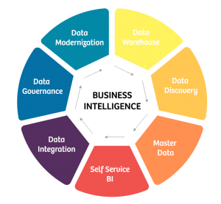

(Source: https://ezdatamunch.com)