**CLASSICAL DISH PORTFOLIO OF CHICKEN BREAST WITH GRAPES**

**Table of Contents**

Introduction 3

Discussion 3

The detailed appraisal of classical food production 3

Quality evaluation of Chicken Breast with Gapes 7

Specific modifications and relevant kitchen management 9

The future direction of culinary artistry and classical technique in a range of contemporary commercial settings 10

The relationship of classical cuisine and modern kitchen management within the wider gastronomic landscape 12

Conclusion 13

Reference List 14

Appendices 16

# Introduction

This assignment is based on “Classical Dish Portfolio of Chicken Breast with Gapes”. Through this assignment, a detailed appraisal of classical food production will be covered. Relevant information regarding specific modifications and relevant kitchen management will be provided in this assignment. Classical dishes are a “staple of traditional cuisine”. It shows a timeless quality that is both comforting and familiar. With a collection of textures and flavors, these dishes have been appreciated for centuries and persist to stay popular nowadays. This dish portfolio is a collection of recipes highlighting classic dishes that have been handed down via generations and stay beloved choices. From savory stews to decadent desserts, these dishes are certain to tease the taste buds and add a sense of nostalgia to the meal.

Whether anyone is a seasoned cook or a beginner in the kitchen, these recipes are very convenient to follow and filled with flavor. This dish can be made simply and quickly, and it allows one to stay focused on the pleasure of the meal instead of the preparation process. With ingredients, the dishes can change the taste or be adjusted to utilize whatever is available on hand. These dishes are ideal for impressing guests and convenient for a quick-made weekend meal that everyone prefers to eat.

# Discussion

## The detailed appraisal of classical food production

The classical combination of chicken breast with grapes is a timeless choice among many food lovers. This dish provides light, lean protein with sugary, juicy fruit, making a perfect balance of tastes that can be appreciated in any season. This dish is also convenient to make and can be represented as a starter, or side dish.

**Ingredients**

* 2 large boneless, skinless pieces of chicken breasts
* 1/2 cup white grapes, cut in half
* 1/2 cup red grapes, cut in half
* 1/4 cup dry white wine
* 1/4 cup freshly pressed lemon juice
* 2 cloves garlic, minced
* 1 teaspoon dried thyme
* One spoon of dried oregano
* 1/2 spoon of sea salt
* 1 spoon of dried rosemary
* 1 spoon of olive oil
* 2 spoons of butter

**Preparation**

To make this dish, start by cleaning and drying the pieces of chicken breasts. After that, it is required to cut the breasts in half, so that one can be easily cooked then a combination of herbs and spices including garlic powder, salt, rosemary, pepper, and thyme. After that put oil into a baking dish so that the pieces of chicken breasts can be placed into it. In a preheated oven the pieces of chicken are baked at 350 degrees Fahrenheit for a time period of 20 minutes. In the meantime, the grapes need to wash and dry. After that the grapes are cut in half portion and exclude the seeds. After that, the grapes are placed into a bowl and seasoned the pieces of grapes with sugar, a pinch of salt, and lemon juice (Erdogan, *et al.* 2020). Once the baking of the chicken is done, a generous amount of grapes are garnished on top of each piece of chicken breast. After that, the baking dish returns to the oven for baking the pieces of chicken for an extra 10 minutes. Once the chicken and grapes both are cooked via baking, clear the baking dish from the oven for cooling it for a few minutes. This dish can be served with a side dish including salad, rice, and with potatoes. **[*Referred to******Appendix 1*]**

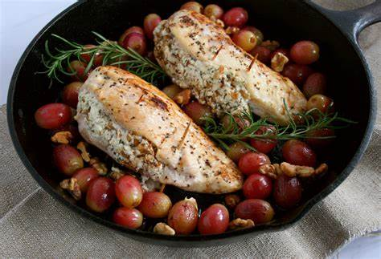

**Figure 1: Chicken Breast with Gapes**

(Source: https://i0.wp.com/chelsealeblancrdn.org)

The combination of this dish like juicy, sweet grapes with the light, skinny chicken is recognized as a classic food pairing that enhances the taste bud. The balance of flavors makes a satisfying and delicious meal that leads to the enjoyment of the food. The ease of preparation makes this dish a significant option for when entertaining guests or on busy weeknights. The plus point of this food is the leftovers can be utilized to prepare a delicious sandwich the next day. Nevertheless, on the occasion, the mixture of chicken breast with grapes is confident to be a hit. This dish can be enjoyed as a starter, or side dish, and encounter the flavor mixture that has been a choice for generations.

**Serving methods**

When it reaches to serving a classical dish like chicken breast with grapes, there are various ways that can be done it. The considerable prevalent methods contain roasting, baking, sauteing, and grilling. All of these methods will produce a flavorful and delicious dish that is convinced to pleasure.

* **Roasting method**

For this method, a piece of chicken breasts, needs to be preheated in the oven to 375 degrees Fahrenheit and put the pieces of chicken breasts within a roasting pan. After that add a tablespoon of oil to the pan and salt and pepper added on the pieces of chicken breasts (Joanis, 2020). After roasting the chicken pieces for fifteen minutes then the grapes are added to the pan. The pieces of chicken need to be roasted for an extra ten minutes so that the chicken is properly prepared by this method.

* **Grilling** **method**

It is another famous method for cooking pieces of chicken breasts with the addition of grapes. After that preheat a gas or grill of charcoal to moderate-high heat. Brush the pieces of chicken breasts with oil and season with salt and pepper. Place the chicken on the grill and add the grapes to the side. Cook for 7-8 minutes, flipping the chicken over halfway through.

**Figure 2: Serving Methods**

(Source: Self-created in MS Word)

* **Baking** **method**

Baking chicken breasts in the oven is another easy and delicious way to make this dish. Preheat oven to 350 degrees Fahrenheit and place chicken breasts in a casserole dish. Sprinkle with salt, pepper, and sesame oil. Place the grapes on a plate and bake for 15 to 20 minutes until the chicken is done.

* **Sauteing** **method**

Finally, baking the chicken breast with grapes makes this dish even easier to prepare. After adding one spoon of oil and over medium heat required to prepare the chicken. Sprinkle the chicken breast with salt and pepper and place it in the pot. Cook for 7-8 minutes, flipping the chicken halfway through. Add grapes and simmer for an additional 2-3 minutes so that the chicken is properly prepared by this method.

No matter which method has been chosen, this classic dish of pieces of chicken breasts with grapes is sure to be delicious and healthy food (Khodamoradi, *et al.* 2020). This classical dish can be served with a side of green salad or roasted potatoes for a complete meal.

## Quality evaluation of Chicken Breast with Gapes

To increase the quality of this dish it takes care of the ingredients which are required for preparing the dishes from the initial stage. First of all, make sure that all the required ingredients are organic and used in an accurate way. This helps to maintain the quality of the dish. The chicken which is taken for preparing this dish should be fresh and marinated the ingredients in the proper way.

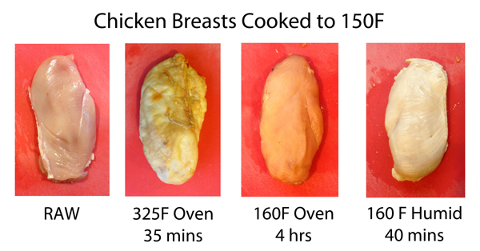

**Figure 3: The cooking process of chicken**

(Source: https://genuineideas.net)

Chicken and grapes are tasty and healthy. The mixture of the sweetness of the grapes and the savoriness of the chicken creates a unique flavor that will delight any palate. Mixing the two ingredients, both poultry and grapes also create a nutritious dish that delivers essential vitamins and minerals. Chicken and grapes are qualitatively easy to prepare and can be prepared in many different ways to suit individual tastes. Chicken can be baked, sautéed, grilled, or boiled, and grapes can be added to dishes in a variety of ways. For example, it can be cooked in the same pan as the chicken or added after the chicken is cooked and ready to serve (Malmberg, and Wellenstam, 2021). The sweetness of the grapes and the savory taste of the chicken are a perfect match, making this a filling dish. The texture of the grapes can also add an interesting element to the dish as the grapes soften a bit when cooked with chicken. Chicken provides protein and essential vitamins and minerals, while grapes are rich in vitamins A and C. The combination of the two ingredients also provides fiber and antioxidants, making this dish perfect for those looking for a nutritious diet. Overall, chicken and grapes are a great choice for those looking for a delicious and healthy meal. The combination of the two ingredients creates a unique flavor, and the food is packed with nutrition.

**Costing Sheet**

|  |  |
| --- | --- |
| **Ingredients name** | **Cost** |
| Chicken breast piece | $140 |
| White grapes | $350 |
| Red grapes | $250 |
| Dry white Wine | $220 |
| Lemon | $18 |
| Garlic | $11 |
| dried thyme | $16 |
| dried oregano | $17 |
| sea salt | $15 |
| dried rosemary | $12 |
| olive oil | $19 |
| butter | $21 |

**Table.1: Cost Table**

(Source: MS Word)

The Ingredients have been separated on the basis of cost allocation. It is significantly dependent on the market value of these ingredients. The successful cost allocation will comfortably handle the kitchen management.

## Specific modifications and relevant kitchen management

A traditional recipe that is easy to make and may be eaten as a starter or as a main course is chicken breast with grapes. Chicken and grapes combine sweet and savory flavors to create an intriguing flavor profile that is sure to impress any palette.

The preparation of the chicken is the first stage in making this dish. The pieces of chicken breasts should first be sliced into tiny strips. Salt and pepper the chicken, then add it to the oil that has been heated in a sizable skillet over medium-high heat. Cook for 7 to 10 minutes, or until the chicken is thoroughly cooked and gently browned.

The grapes need to be cleaned and cut. Wash the grapes first, then chop them into little pieces. In a separate skillet over medium heat, add the grapes and the oil. When the grapes are tender, prepare for 5 minutes, stirring regularly. Combine the cooked chicken and grapes in the skillet along with a small amount of white wine (McAuliffe, 2022). For the sauce to thicken and the flavors to meld, simmer for a few minutes. Overcooked rice or a bed of greens, serve the chicken and grapes. Combine the cooked chicken and grapes in the skillet along with a small amount of white wine. For the sauce to thicken and the flavors to meld, simmer for a few minutes. Overcooked rice or a bed of greens, serve the chicken and grapes. There are a few adjustments that can be done while running a kitchen that serves this traditional cuisine to guarantee a successful dish. Cooks should first be aware of the chicken's cooking time. Keep an eye on the cooking time because overcooking the chicken may result in a harsh, dry texture.

Second, cooks should be aware that the sweetness of the grapes can overwhelm the flavor of the chicken if overcooked. To avoid this, add the grapes to the pot at the end of cooking and warm it just before serving. Third, the cook should be prepared to adjust the spices as needed. The sweetness of the grapes makes it sweeter than expected, so adding a little salt and pepper balances out the taste. Finally, the cook should pay attention to the consistency of the sauce. The sauce should be thick, creamy, and not too thick. If the sauce is too thick, reduce the heat and simmer for a few more minutes to thicken.

These changes will help the kitchen team serve classic dishes that are flavorful and hearty. With just a few taps, the chef can quickly and easily prepare delicious chicken breast and grape plates that everyone will enjoy.

## The future direction of culinary artistry and classical technique in a range of contemporary commercial settings

The future of culinary artistry and technical technique in a range of contemporary settings regarding classical dish portfolios of “chicken breast with grapes” is a compelling and ever-progressing landscape. From the traditional preparation based on the French style of the dish, the chef can modify the classic dish.

One of the most prevalent classic dishes is to utilize a high-quality cut of chicken breast with the accompaniment of exceptional grape. By utilizing a higher-end cut of chicken, such as a “sous-vide chicken breast”, a chef can be able to prepare a more tender and flavorful dish. To complete the chicken, a chef can able to utilize a variety of various grapes to preparing a flavorful and interesting complement (Pawar, and Singh, 2022). As an example, a chef can be able to prepare a “red wine reduction sauce” with a mixture of red, black, and white grapes, with the addition of an extra coating of flavor to the dish.

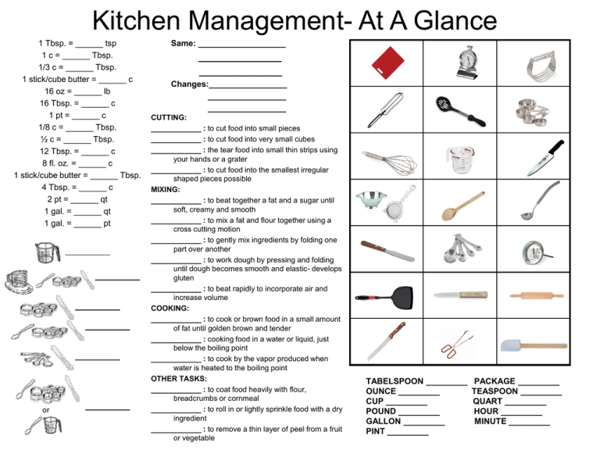

**Figure 4: kitchen management**

(Source: https://s2.studylib.net)

Another prevalent trend in modern cuisine is to utilize innovative cooking methods to prepare an inventive version of the classic dish. By utilizing a “sous-vide or a reverse-sear” mode to cook the chicken breast, chefs can assure that the recipe is cooked perfectly every time, producing a tender and juicy outcome. To prepare the chicken, chefs can prepare a variety of other sauces and glazes, like a “balsamic reduction” or a “honey-mustard glaze”. Further, chefs can also test with various types of vegetables and fruits to prepare an innovative complement to the chicken, such as seasoned potatoes and roasted bell peppers.

Ultimately, chefs can also test with numerous types of cooking oils when presenting classic dishes with a modern twist. Utilizing high-quality cooking fats, such as clarified butter and olive oil, allows cooks to make rich flavor profiles in chicken extra virgin olive oil.

Approximated to the classic portfolio of Grape Chicken Breast, the future of culinary arts and engineering in a combination of contemporary settings is an ever-evolving landscape. From quality chicken cuts to innovative preparations and flavorful side dishes, the chefs have a broad range of options to add a delicious and unique twist to classic dishes. By testing numerous ingredients and cooking methods, chefs can give traditional dishes a modern and innovative twist.

## The relationship of classical cuisine and modern kitchen management within the wider gastronomic landscape

The relationship between classical cuisine and the management of modern kitchens has been at the front line of gastronomic discourse for centuries. Both approaches have their potencies and drawbacks, with classical cuisine often being assumed more strict and conservative, while management of modern kitchen is noticed as more versatile and progressive.

Classical cuisine is repeatedly noticed as the foundation and base from which the management of modern kitchens has developed. The traditional method of cooking depends upon a set of core regulations and procedures which have been generated over centuries and are even rehearsed in current times. This contains the applications of seasonal ingredients, managing temperatures, and balancing flavors (Whinston, 2022). As an effect, classical cuisine has made a portfolio of classic dishes that are even very much in demand at the current time, such as chicken breast with grapes.

The traditional making process of chicken breast with grapes concerns marinating the chicken with a mixture of spices, and herbs, and adding oil before frying it in the pan. The grapes are then included and cooked up to lightly caramelize the grapes. The dish is then completed with a sauce which is prepared with onion, garlic, parsley, and wine. This classic dish can be served as a side dish like steamed potatoes, vegetables, and rice. On the other hand, the management of modern kitchens is more concentrated on rate and efficiency (Pietsch, 2021). The method depends upon a sequence of functions and procedures that are developed to streamline the generation of food. This contains the usage of pre-ready ingredients, by applying standard measures and ingredients and employing technology including automated systems and kitchen robots.

The management of modern kitchens has permitted the development of a much broader range of dishes in comparison with classical cuisine. This contains dishes like chicken breast with grapes, which currently can be made in a mixture of various ways. As an example, the chicken can be grilled, or roasted. The grapes can be prepared in a variety of various ways, from the process of sauteing to roasting and to caramelizing. The use of sauce can also be changed to serve various tastes and requirements of dietary.

The mixture of classical cuisine and the management of modern kitchens have shown in a much broader and more diversified gastronomic landscape. While the classical system is still very much in demand, the management of modern kitchens has permitted the development of new dishes that are both innovative and delicious (Rout, *et al.* 2020). This has permitted chefs to find out further flavors and textures, while yet possessing the core regulations of classical cuisine. Eventually, the connection between classical cuisine and the management of modern kitchens is a vital part of the broader gastronomic landscape. Both procedures have benefits and drawbacks, but the mixture of the two has represented a much broader mixture of classic dishes like chicken breast with grapes. By adopting both directions, chefs are able to make compelling and innovative dishes that are still embedded in the traditional methods and tastes of classical cuisine.

# Conclusion

The Classic Food Portfolio Chicken Breast with Grapes is a lasting classic that is still loved by generations. This dish is the ideal mixture of textures and flavors that carries out the best of both grapes and chicken. Most people love the sour and sweet flavor of the grapes and the juicy taste of chicken. This dish is versatile and can be presented in many various ways. It's a simple dish that can be prepared in a short time, so it's also can be prepared for busy weeknights. This dish is also a great source of protein, vitamins, and minerals to help maintain good health and energy. Classic Food Portfolio Chicken Breast with Grapes is a delicious and nutritious meal for the whole family. This classical dish portfolio encourages chefs to prepare other dishes which can be prepared easily and save longer periods of time. The process of this dish will help others to prepare this delicious and healthy food. This will be healthy for adults and children.

# Reference List

**Journals**

Erdogan, I., Rondi, E. and De Massis, A., 2020. Managing the tradition and innovation paradox in family firms: A family imprinting perspective. *Entrepreneurship theory and practice*, *44*(1), pp.20-54.

HORVÁTH, Z.I., KŐMÍVES, C., Júlia, N.K. and HAPP, É., EXAMINING A MENU ON THE BASIS OF THE KASAVANA-SMITH MODEL IN A HUNGARIAN RESTAURANT. *THE CENTRAL EUROPEAN JOURNAL OF REGIONAL DEVELOPMENT AND TOURISM*, p.111.

IVANCSÓNÉ, Z.H., KŐMÍVES, C., Júlia, N.K. and HAPP, É., EXAMINING A MENU ON THE BASIS OF THE KASAVANA-SMITH MODEL IN A HUNGARIAN RESTAURANT.

Joanis, S.T., 2020. Family meal planning under COVID-19 scarcity constraints: A Linear Programming Approach. *Journal of Food and Nutrition Research*, *8*(9), pp.484-495.

Khodamoradi, T., Salahi, M. and Najafi, A.R., 2020. A note on CCMV portfolio optimization model with short selling and risk-neutral interest rate. *Statistics, Optimization & Information Computing*, *8*(3), pp.740-748.

Malmberg, O. and Wellenstam, J., 2021. Quantum Portfolio Optimization: a Multi-Level Perspective Study of the Swedish Fund Management Industry.

McAuliffe, A.M., 2022. *A Portfolio of Literary Translations* (Doctoral dissertation, Trinity College (Dublin, Ireland). School of Languages, Literature and Cultural Studies).

Pawar, S. and Singh, S.P., 2022. Functional bread fortified with foxnut flour and amaranth flour.

Philpott, T., 2020. *Perilous bounty: The looming collapse of American farming and how we can prevent it*. Bloomsbury Publishing USA.

Pietsch, K., 2021. Ambiguous environmental advertising.

Robert, M. and Sudora, O.S., Fairfield soccer player injured by drunk driver. *Mirror*, *10*, pp.2-2008.

Rout, B., Harichandan, S. and Bebarta, D.L.M., 2020. Portfolio Construction and risk measurement in the Indian Equity market by using Sharpe index model with reference to NSE. *Editorial Board*, *9*(6).

Sorensen, E., Chen, M. and Mussalli, G., 2021. The quantitative approach for sustainable investing. *The Journal of Portfolio Management*, *47*(8), pp.38-49.

van Velzen, E.T., 2020. *Seeking circularity: Finding sustainable packaging solutions for fresh products* (No. 2068). Wageningen Food & Biobased Research.

Whinston, J., 2022. Writing an Existential Novel: An Environmental and Philosophical Exploration.

WOOD, C., Glass ceiling no more. *Mirror*, *2*, pp.28-2002.

Zhong, Z., Zhou, F. and Qiu, G., 2022. Aesthetically Relevant Image Captioning. *arXiv preprint arXiv:2211.15378*.

# Appendices

**Appendix 1: Ingredients**

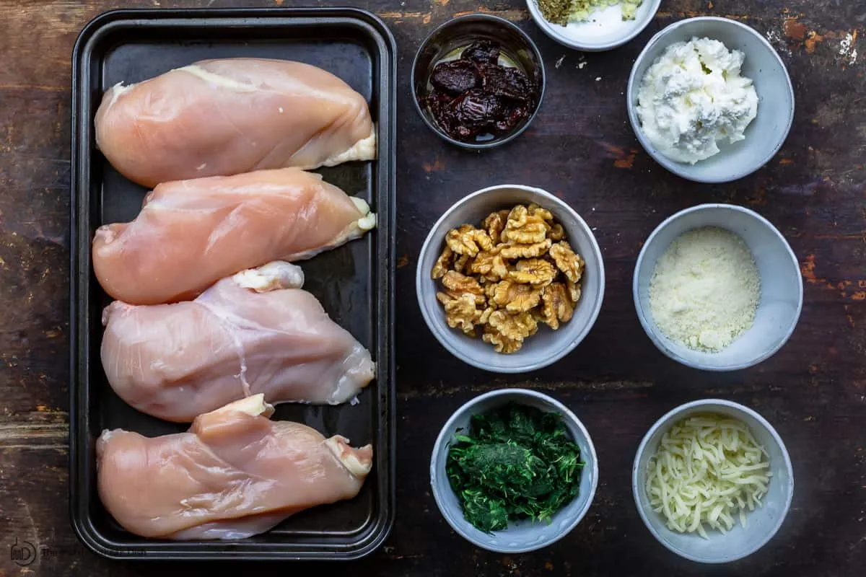

(Source: https://imgs.search.brave.org)