**EBV (Epstein-Barr virus)**

**TABLE OF CONTENTS**

Introduction 3

Background 3

Biology of Virus 3

Replication 4

Life cycle 6

Usage of Beta-cells by EBV Virus 7

Clinical Implications 7

Transformation 7

Causes 7

Consultant 7

Genome Diversity of EBV 8

Genes and different V protein 8

Genetic Nucleus Antigens 8

Classifications of EBV 8

Geographical Determination 9

Genetic factors 9

Clinical Importance Study 9

Vaccine Design 9

Antiviral therapeutics 9

Clinical Impacts on Virology 9

Impact of EBV on B cells and T cells 9

Reference list 11

# Introduction

Epstein-Barr virus (EBV) is one of the popular human viruses which is known as human herpesvirus 4. The virus resides in the family member of the herpes virus. The virus is found almost throughout the world and infects humans at least for ones in the human life cycle. The virus mostly spread through human fluids mainly through human saliva. The virus causes mononucleosis means a fever, swollen lymph glands, and sore throat. However, in this particular research, the replication, life cycle process, and usage of Beta-cells by the EBV will be mentioned in the background section. In addition to that, the clinical implications including the transformation procedure, the causes of the viral infection, and the importance of the consultant will be highlighted in this research. This research also will outline the genome diversity of the virus including its different viral proteins and its genetic antigen. Finally in this study, the classification of EBV and its clinical importance in vaccine designing, and antiviral therapeutics will be discussed.

# Background

## Biology of Virus

Epstein-Barr virus (EBV), the human herpesvirus can infect nearly all people throughout the world mainly the child and it remains for almost the entire life in the body. The virus colonizes the B cells and stays remain inside them for a long time and it also degrades the cytotoxic T cells. When the virus enters the B cell it carries a set of latent genes and is expressed in the resting B cells. In this way, it proliferated quickly and increase the B cell colonization during its primary infection (Damania *et al.* 2022). If the viral cell proliferation cannot be controlled and it persists for a long time, the viral infection may lead to malignancy and it also causes many autoimmune disorders. The life-long latency of EBV causes innate and adaptive immunity in the host cell.

## Replication

The EBV-mediated infection in epithelial cells mainly occurs through the binding of ephrin A2 receptor and αvβ integrins. EBV replicates mainly in two ways, it can be replicated either by vertical B cell proliferation or by lytic virion production. The EBV protein helps to stimulate the proliferation of host cells and thus the DNA of EBV can replicate within the proliferated cells. During the lytic replication cycle, the EBV produces infectious virions, and later they transmit through the host cells. Most of the time, tonsillar B cells carry latent EBV protein-coding genes, which stimulate cell activation, proliferation, & resistance to apoptosis. Eight EBV proteins, two non-translated Epstein-Barr virus EBERs, and 25 pre-miRNAs that mature into at least 44 miRNAs are all encoded by these latent EBV infection genes (Münz, 2019). All of these proteins are present in LCLs, naive tonsillar B cells of healthy virus carriers, and almost all tonsillar B cells of patients with infectious mononucleosis (IMM).

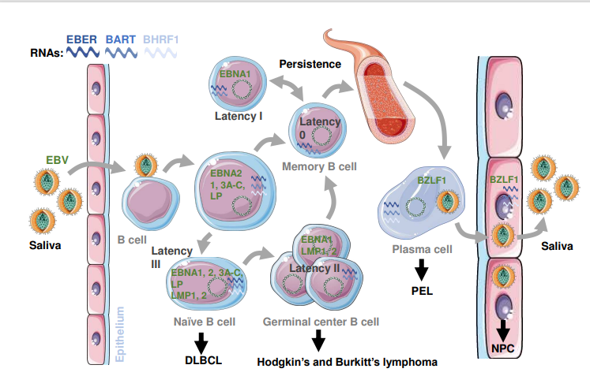

**Figure 1: Models of latent Epstein–Barr virus infection to reach viral persistence**

(Source: https://www.zora.uzh.ch/id/eprint/183065/9/latecny_and_lytic_replication_in_the_oncogenesis_of_the_epstein-barr_virus_final_manuscript.pdf)

Latency III refers to the related viral gene expression program. Just three latent EBV proteins are present in centroblasts and centrocytes, which may indicate the entry of B lymphocytes into the germinal center response after the EBV latency II activation. These three EBV proteins include two latent membrane proteins LMP1 and LMP and Epstein-Barr nuclear antigen 1 (EBNA1).

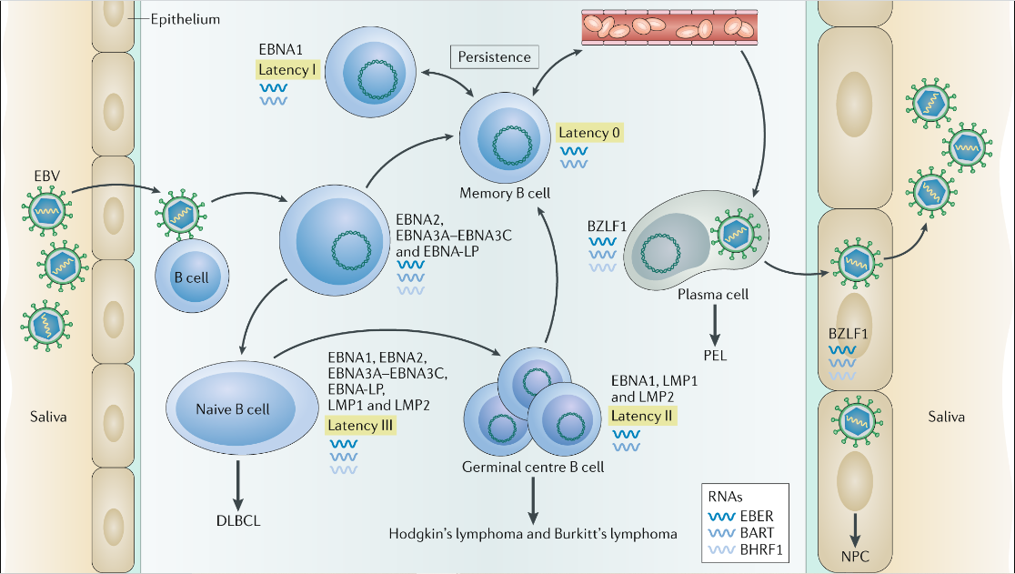

**Figure 2: Latency and Lytic replication of EBV**

(Source: https://media.springernature.com/full/springer-static/image/art%3A10.1038%2Fs41579-019-0249-7/MediaObjects/41579_2019_249_Fig1_HTML.png)

In order to assist infected B cells in passing the germinal center reaction and entering the memory B cell population, it is believed that they are expressed during the latency IIa phase, which enables EBV to live despite the viral protein expression in latency 0. Only in the latency I pattern, the expression of EBNA1 appears in memory B cells during homeostatic proliferation. The premalignant stages of EBV-associated B cell lymphomas are characterized by these latent EBV infection programs in B cells of normal virus carriers. Some but not all transfer big B cell lymphomas, Hodgkin's lymphoma, Burkitt's lymphoma, and Burkitt's lymphoma all display latency II, I, and IIa, respectively. The B cell receptor of EBV-attacked B-cell is stimulated in latency 0 or I phase and called lytic activation and thus the BZLF1 expression can be stimulated by the differentiation of plasma cells with the help of two transcription factors BLIMP, and XBP1. Only in healthy EBV carriers does lytic replication take place in plasma cells. A second replication cycle for more efficient EBV scattering into the saliva may emerge from the virus that was released by the plasma cell infecting mucosal epithelial cells basolaterally.

## Life cycle

One of the most dangerous diseases in the human virus is the Epstein-Barr virus. (EBV). To complete its life cycle, EBV mostly requires B cells and epithelial cells. EBV has a biphasic life cycle with a lytic phase & a latency phase known as the replicative phase (Zhao *et al.* 2019). Like other herpesviruses in the family, EBV doesn't create any virus after the initial infection despite, its preferring to lay latent in the host B cells. However, there are instances in which latency in B cells can be broken, enabling the virus to advance to the viral reproduction phase.

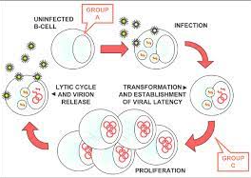

**Figure 3: Life-cycle of EBV**

(Source: data: image/jpeg;base64)

The change from the latent to the lytic reproductive phase in B cells is a critical stage of the viral life cycle that is essential for the persistence & pathogenicity of the virus. The signals that are most important to human physiology are the activation of the B-cell receptor (BCR) and transforming growth factor (TGF). Salivary viruses are created in the mouth cavity of human beings and are spread from one host to another through saliva transmission.

## Usage of Beta-cells by EBV Virus

The Epstein-Barr virus (EBV) enters the human body through two epithelial receptor ephrin A2 receptor and αvβ integrins and infects the B cells of the host. After infecting, the B cell activates the resting B lymphocytes and enhances the proliferation of the infected B cells. In this way, they create a latent infection within the B lymphocytes and express the latent viral genes. After a certain time, the latency period of EBV has broken down and they enter into the lytic cell which is their replicative stage. The B cell where the virus stays in the latent phase act as the pool to maintain its persistence in the human body. Sometimes, the EBV cell likes to replicate within the epithelial cells instead of remaining in the latency period in the B cells. However, the further transmission of the viral cell from the B cell to the epithelial cells is mediated by the viral population of oral epithelial cells.

# Clinical Implications

## Transformation

The EBV spreads mostly through the body fluids mainly through saliva, apart from this the virus also can spread through blood transfusion, organ transplantations, and also through semen during sexual transmission. A person also can spread the virus even before symptoms manifestations.

## Causes

As EBV, is transmitted mainly through the body fluid primarily through saliva, and any other wet objects thus if someone eats the EBV-mediated person’s utensils and shares food with them also may get affected by the Epstein-Barr virus.

## Consultant

Children are mostly affected by EBV, but, all time, the symptoms do not express even after the infection by the EBV. Sometimes the symptoms of EBV infection can not be differentiated from other brief, and childhood illnesses. Usually, children and teenagers become fit after 2-4 weeks but someone needs several weeks or months to become fit. However, if someone shows the symptoms like fever, fatigue, inflamed throat, rashes, etc. must visit the consultants (https://www.cdc.gov/epstein-barr/about-ebv.html).

# Genome Diversity of EBV

## Genes and different V protein

The genome of EBV is primarily linear double-stranded DNA with around 175 kb in length and it remains in the circularized form in the latently infected is circularized in latently infected B cells. It has the terminal direct repeats (TRs) with 0.5 kb and terminal repeat sequences (IRs) (Kanda *et al.* 2019). The genome of EBV has many repetitive sequences spread throughout the genome within the viral latent protein-encoded region which is near the viral replication origin. During the latency period III, EBV expressed many proteins such as EBNA1, EBNA3A-C, EBNA2, LMP1 & LMP2, and EBNA-LP. On the other hand, during latency IIa, LMP1 & LMP2, and EBNA1 are also expressed.

## Genetic Nucleus Antigens

After, the activation of latency III of EBV, the B cell enters into the germinal center reaction where it expresses a total of three proteins, and one of these is Epstein–Barr nuclear antigen 1 (EBNA1). It is essential for both the replication process and mitotic segregation of EBV episomes,. EBNA1 is needed for the persistence of EBV genomes. Additionally, EBV latency genes required for cell immortalization are also activated by EBNA1.

## Classifications of EBV

There are mainly two types of Epstein-Barr virus that can be detected in human beings. These types are known as Type 1 and Type 2, also called EBV-1 & EBV-2 respectively. These two types of EBV are differed from each other by the sequence of genes that encodes EBV nuclear antigens (Wong *et al.* 2022).

# Geographical Determination

## Genetic factors

EBV is mainly two types, Type 1 and Type 2 where the type- 1 is able to make lymphoblastoid cell lines (LCL) from B cells compared with type 2. In the context of geographical distribution, EBV 1 is mostly predominant throughout the world mainly in Asia, Europe, and South, and North America (Zanella *et al.* 2019).

# Clinical Importance Study

## Vaccine Design

Recombinant viral vector vaccines are most effective against EBV-mediated infections. Firstly, it induces a huge immune response mainly in CD8+ cytotoxic T lymphocyte (CTL) to clear the virally infected tumor cells. Secondly, it expresses pathogen-associated molecular patterns (PAMPs) which helps to induce an inflammatory response within the host (Rühl *et al.* 2020). And, finally, the viral vector vaccine has a high efficiency to transduce genes that can deliver antigens depending on the cell type.

## Antiviral therapeutics

There are no such antiviral therapeutics against of the Epstein-Barr virus (EBV) infectious however, Ganciclovir and Acyclovir can reduce the spreading of EBV.

# Clinical Impacts on Virology

## Impact of EBV on B cells and T cells

It is generally known that the Epstein-Barr virus (EBV) prefers B cells and epithelial cells. EBV type 2 has matured peripheral T cells infected with it. The viral glycoprotein gp350 and the cellular protein CD21 are both used by EBV to enter mature peripheral T cells, and CD21 is also required for EBV infection. EBV-2 activates, multiplies, and modifies the expression of cytokines in T cells by infecting CD8+ T cells and increasing the production of genes linked to latency (Smith *et al.* 2020). On the other hand, the infection of EBV activates the resting B cell in the human body and proliferates it and leading to the establishment of a latent infection within the B cells and expressing many latent viral cells.

# Reference list

**Journals**

Damania, B., Kenney, S.C. and Raab-Traub, N., 2022. Epstein-Barr virus: Biology and clinical disease. Cell.

Münz, C., 2019. Latency and lytic replication in Epstein–Barr virus-associated oncogenesis. Nature Reviews Microbiology, 17(11), pp.691-700.

Zhao, M., Nanbo, A., Sun, L. and Lin, Z., 2019. Extracellular vesicles in Epstein-Barr virus’ life cycle and pathogenesis. Microorganisms, 7(2), p.48.

Kanda, T., Yajima, M. and Ikuta, K., 2019. Epstein‐Barr virus strain variation and cancer. Cancer science, 110(4), pp.1132-1139.

Wong, Y., Meehan, M.T., Burrows, S.R., Doolan, D.L. and Miles, J.J., 2022. Estimating the global burden of Epstein–Barr virus-related cancers. Journal of cancer research and clinical oncology, pp.1-16.

Zanella, L., Riquelme, I., Buchegger, K., Abanto, M., Ili, C. and Brebi, P., 2019. A reliable Epstein-Barr virus classification based on phylogenomic and population analyses. Scientific reports, 9(1), pp.1-11.

Rühl, J., Leung, C.S. and Münz, C., 2020. Vaccination against the Epstein–Barr virus. Cellular and Molecular Life Sciences, 77, pp.4315-4324.

Smith, N.A., Coleman, C.B., Gewurz, B.E. and Rochford, R., 2020. CD21 (Complement Receptor 2) is the receptor for Epstein-Barr virus entry into T cells. Journal of virology, 94(11), pp.e00428-20.

**Websites**

https://www.cdc.gov/epstein-barr/about-ebv.html