**DERIVATIVE INSTRUMENTS**

**TABLE OF CONTENTS**

Task 1 4

Introduction 4

Background 4

Research questions 5

The major themes focusing 5

Methodology & Methods 6

Conclusion 7

Task 2 8

Introduction 8

Literature review 8

Methodology 11

Research design 11

Techniques 12

Inputs 12

Conclusion 13

Reference list 15

# Task 1

## Introduction

The derivative instruments even refer to the financial instrument that is required to complete the financial tasks. It refers to the financial commodity of the stem that offers all the finnan social operations to complete the tasks. This even shows the risks in the process of trading techniques. It even shows the contacts between the two parties that involves in the financial operation. It even defines the value or the prices sections in the method. It even assists to define the underlying assets for the process.

## Background

This even refers to the contract process of the two distinct parties that refers to boost the performance of the financial operation. It even consists of the value of the process that leads to detecting the financial conditions of the process. This even consists of financial assets that lead to developing the progress so the function of the program. All of this stand on the value process that displays the accurate progress of the financial process tro the research. This even defines the assets to complete the process (Gupta *et al.* 2020). This process even shows the security of the process in the financial operation. It even assists to maintain the process of underlying assets. It implies all of the processes that are needed to complete the tasks in the financial process of the system. This even assists in the spot of the process that makes the optimal chances to have in the popper process of the financial assets. The underlying process in the spot section is even called the spot prices in the market. It even brings opportunities that show a tendency to buy the products in a lower price and make it sell at a high price in the market.

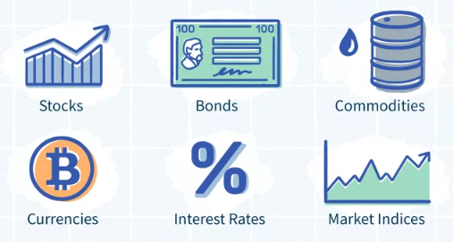

**Figure 1: The derivatives diagram**

(Source: https://www.investopedia.com/terms/d/derivative.asp)

## Research questions

How it detects the financial issues in the market?

What is the proper way to meet the aspects of the financial operations?

What are the chances of detection in the system of the financial process?

According to Larsson, 2020, the derivatives instruments even consist of a fixed amount of aspects to maintain the financial conditions. That even shows the possibility to access the market in a proper way. This process even assists to reduce the chance of the risk regeneration tasks. It even proposes some of the risky factors that are changing the time, holding costs, and the rate of interest. All of this even makes the operation process more difficult. It even offers the market risks that show the main obstacle to performing this. This even shows sty complex process of the operation that makes the difficulties to the understanding process. That makes sensible factors that offer to show the supplying and demanding policy of the products in the markets.

## The major themes focusing

Lock in the prices that maintain the prices and reduce the chances of not to be overflowing in the market. It even makes the chances that assist to reduce the chances of the movement of the rate in unconditional ways (Nafisah *et al.* 2022). This even makes all of the changes that assist o mitigate the risky factors in the financial derivate functions. This even makes them in the lowering the cost in the markets. That makes the chances to sell the energy derivatives in the further future. This even detects the risk in the financial assets that makes all of the possibilities to complete that tasks in the financial markets.

## Methodology & Methods

The research onion even offers a set of the main principles that help to conduct the research. It even defines the path of the research. That makes the best possibilities to complete the research. This even shows the positivism of the method that even necessary to complete the research. This research even follows the path of positivism which refers to the path of the observation of the research outcomes that is very necessary to conduct the research. It also offers the best path for the analysis of the outcomes of the research. It is more scientific and quantitative in nature.

The research approach even refers to the way that assists that the appropriate approach is taken to complete the study (Taipale, 2022). This research even displays the usage of the deductive approach that helps to complete the purposes of the research. It is based on the literature review that assists to makes the process easily understandable to the researcher. It has a tendency to try the hypothesis in the context.

After taking a proper approach the research onion also suggested the appropriate strategy that helps to proceed with the research. It even consists of the various activities taken and the stages that are necessary to complete the research. This is also chosen on the basis of the data collection to complete the research. That even refers to the purpose of the study of the research.

Choices of the methods are very important to the progress of the research. It even defines all of the changes that make the possibility to conduct the research. Here the mixed method is used to complete the research that even shows the best of the possibilities that are needed to complete the research. It even consists of two or then more methods to conduct the research.

The longitudinal data is used to complete the research that assists to conduct research. It even shows the time taken process tro complete the research. It observes a particular time of data that is needed to complete the research.

The data collection and analysis method is one of the most essential parts of the research that is needed to complete the research (Edeki *et al.* 2021). It makes the optimal purpose to conduct the research. It even shows the best of the possibilities that are needed to generate the accurate meaning of the research. It even makes the aspect that is very useful to conduct the research. The data choice meet be proper that offer the best possibilities to conduct the research. It makes the choices of qualitative and quantitative data collection both of these are required to complete this research.

This data collection plays an important role to complete the research.

## Conclusion

It actually consists of the value of the process that directs to detecting the financial conditions of the process. This even consists of financial support that lead to generating the progress so the function of the program. All of this stand on the value procedure that shows the accurate progress of the financial process to the research. This even defines the support to complete the process. This process even shows the protection of the process in the financial operation. It even assists to sustain the process of underlying assets. It implies all of the processes that are needed to conduct the tasks in the financial process of the system. This even helps in the spot of the process that makes the optimal possibilities to have in the popper procedure of the financial assets. All of this is necessary to satisfy the research and submit a conclusion.

# Task 2

## Introduction

The “Black-Scholes-Merton” (BSM) mathematical model is employed to value derivatives such as options. Fischer Black, Myron Scholes, and Robert Merton created the model in 1973. The BSM model is frequently used to assess European-style options, which have an expiration date as their lone point of the exercise. The underlying asset is assumed to have a lognormal distribution, which means that price fluctuations are random and have a normal distribution over time. American-style options, which can be exercised at any time before expiration, can also be priced using BSM.

## Literature review

According to Subalakshmi *et al.* 2021, the development of invariable is based on the financial instrument. That is properly based on the finical market and it is also based on the share market. The researcher covers some important parts about this the first apparent "option" buyer was the Greek mathematician and philosopher. Thales once believed that the amount of "olives" produced will be greater than anticipated and as a result, the researcher was granted the ability to retain ownership of several olive presses throughout the off-season in preparation for the next olive harvesting season. The researcher used his right to choices and gained control of the presses, renting them out for a far greater price than the researcher paid for his "option" since the olive harvest was more abundant than anticipated as the final climax neared. Financial contracts known as derivatives derive their value from underlying securities—another object. Typically speaking, underlying securities might include equities, currencies, commodities, bonds, etc. This study's main aim is to use Greeks to identify the greatest significant correlation between the Black-Scholes Options Pricing Model (BSOPM) and real market pricing. Index Options are very profitable and dangerous derivatives that depend on a number of market factors, including index value, period till expiry, strike price, interest rate, underlying index value, etc. Using the Black Scholes Model, it determined the Call option price, Put option price, and Greeks of the Nifty option for November 2018. They attempted to comprehend and quantify the many dimensions of risk associated with Nifty index option contracts by analyzing the effects of the Greeks Delta, Gamma, Theta, Vega, and Rho on options positions of each strike price. The study's finding is that the option values have no bearing on anything.

According to Halperin *et al.* 2020, one of the most intriguing subfields of machine learning (ML) is reinforcement learning (RL). Even though it is more than 50 years old, ML researchers appear to be becoming more and more interested in this system. Many jobs involving trade or investing choices, in particular, appear well suited for RL techniques. Literature on the subject is currently scarce and dispersed over a variety of financial application fields. This study recommends applying reinforcement learning to a well-known financial scenario that may be compared to the classic inverted pole issue in terms of its financial implications, serving as a genuine test case for previous iterations of reinforcement learning models. Particularly under the well-known RL research platform OpenAI Gym, this setting and other physics-inspired virtual environments are accessible. This study makes a strong connection with the physic. Now the researcher briefly discussed the how-to connected with the physic. The “Arithmetic Brownian Motion” (ABM) model of Bachelier from 1900, the first effective probabilistic model of stock prices, is mathematically similar to Einstein's theory of free diffusion, which was created five years later in 1905. The ABM model is applied to stock price logarithms rather than actual stock prices in the BSM model, which makes use of “Samuelson's Geometric Brownian Motion” (GBM) model. As the dynamics of real stock prices are known to be only very loosely approximated by the GBM model, this results in inaccurate option prices computed using the BSM model. The framework created by the model in this study is based only on the price and trade data.

According to Bieri *et al.* 2021, As the globe gets increasingly linked and technology-driven, large stock price swings and financial crises are becoming more frequent compared to the perception of routine in markets. The subject of risk management, especially tail risk assessment, comes under scrutiny not just by scholars but also by the general public following sharp drops in prices and during disasters. Extreme Value Theory, which was initially developed for the study of weather and climate, recently entered the field of risk management and offered a fresh method for calculating tail risk. This method relied on the data itself rather than distributional assumptions, as most previous methods had done. As the globe gets increasingly linked and technology-driven, large stock price swings and financial crises are becoming more frequent compared to the perception of routine in markets. The subject of risk management, especially tail risk assessment, comes under scrutiny not just by scholars but also by the general public following sharp drops in prices and during disasters. Extreme Value Theory, which was initially developed for the study of weather and climate, recently entered the field of risk management and offered a fresh method for calculating tail risk. This method relied on the data itself rather than distributional assumptions, as most previous methods had done. In this study, the researcher discussed three important things. The three distribution parameters—location, scale, and shape parameter—are obtained by fitting a distribution to the data in the parametric techniques. The location parameter depicts the data's typical position, the scale parameter demonstrates the degree of data dispersion, and the shape parameter serves as a measure of tail fatness. Without initially fitting a distribution to the data, the shape parameter is determined in a non-parametric manner. All of our methods share an underlying, unknowable distribution of random variables, like a series of financial returns.

According to Joseph et al. 2019, in this study, the researcher was the main focus on the risk management system, which is the most important topic for developing the financial market. Options on the underlying average price belong to a type of derivative product that is especially intriguing. Options are those that were first traded on the underlying average price in Tokyo (in Asia). In 1987, Asian options were first made available in the financial markets.Due to the more stable reward nature brought about by the averaging of the underlying market values, the usage of these options by investor’s offers exposure to the underlying market that prevents volatility.

According to Qian *et al.* 2023, the development of invariable is established on the financial instrument. That is appropriately established on the financial market and it is also based on the share market. The researcher covers some important parts about this the first apparent "option" buyer was the Greek mathematician and philosopher. Thales once thought that the amount of "olives" delivered will be greater than anticipated and as a result, the researcher was granted the capacity to maintain ownership of several olive presses throughout the off-season in preparation for the next olive harvesting season. The researcher used his right to choices and gained control of the presses, renting them out for a far greater price than the researcher paid for his "option" since the olive harvest was more abundant than expected as the final climax neared. Monetary contracts known as derivatives derive their value from underlying securities—another object. Typically speaking, underlying securities might include equities, currencies, commodities, bonds, etc. This study's main aim is to use Greeks to identify the most excellent significant correlation between the Black-Scholes Options Pricing Model (BSOPM) and real demand pricing. Index Options are very profitable and dangerous derivatives that depend on a number of market factors, including index value, period till expiry, strike price, interest rate, underlying index value, etc. Using the Black Scholes Model, determined the Call option price, Put option price, and Greeks of the Nifty option for November 2018. They endeavored to comprehend and quantify the many dimensions of risk associated with Nifty index option contracts by analyzing the effects of the Greeks Delta, Gamma, Theta, Vega, and Rho on options opportunities of each strike price. The study's finding is that the option values contain no applicability to anything.

## Methodology

The research onion even suggests a set of the main principles that assist to conduct the research. It even clarifies the path of the research. That makes the best prospects to complete the research. This even shows the positivism of the method that even required to satisfy the research (Larsson *et al.* 2020). This analysis even pursues the path of positivism which refers to the path of the observation of the research developments that is very necessary to conduct the research. It also proposes the best path for the analysis of the outcomes of the research. It is more scientific and quantitative in nature.

Choices of the methods are very important to the progress of the research. It even represents all of the changes that make the possibility to conduct the research. Here the mixed approach is operated to satisfy the research that even shows the best of the possibilities that are needed to complete the research. It even consists of two or then more methods to conduct the research.

## Research design

The research approach even directs to the way that assists that the appropriate procedure is accepted to conclude the study. This research even displays the usage of the deductive approach that helps to achieve the purposes of the research. It is based on the literature review that assists to makes the procedure easily understandable to the researcher. It has a propensity to try the hypothesis in the context (Wong *et al.* 2022). After assuming a proper approach the analysis onion also suggested the appropriate strategy that benefits to proceed with the research. It even consists of the various movements taken and the stages that are necessary to achieve the research. This is also chosen on the basis of the data collection to complete the research. That even refers to the purpose of the study of the research.

## Techniques

The longitudinal data is utilized to complete the research that assists to conduct research. It even displays the time taken process tro to complete the research. It observes a precise period of data that is needed to conduct the research. The data collection and analysis method is one of the most elementary parts of the research that is needed to complete the research. It makes the optimal purpose to conduct the research (Obthong *et al.* 2022). It even shows the best of the prospects that are required to generate the accurate meaning of the research. It even makes the element that is very useful to conduct the research. The data choice meet be reasonable that offer the best possibilities to conduct the research. It makes the choices of qualitative and quantitative data collection both of these are demanded to complete this research. This data collection plays a substantial role to conclude the research.

## Inputs

The researcher provided the financial data for this job like income, expenditure, profit, etc. With the help of various financial values, the researcher made the graph with proper way. Perfect input always gives the accurate graph that helps to understand the accuracy level of the research.

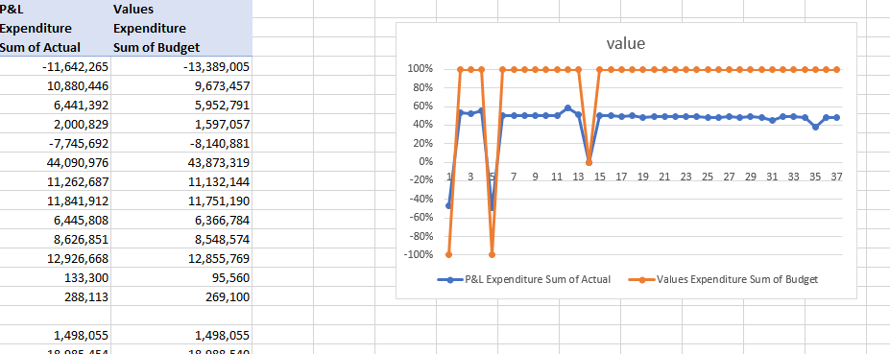

**Figure 2: Graph of expenditure sum of actual and values expenditure sum of budget**

(Source: Self-created in Excel)

The figure shows the Graph of expenditure sum of actual and values expenditure sum of budget with proper values.

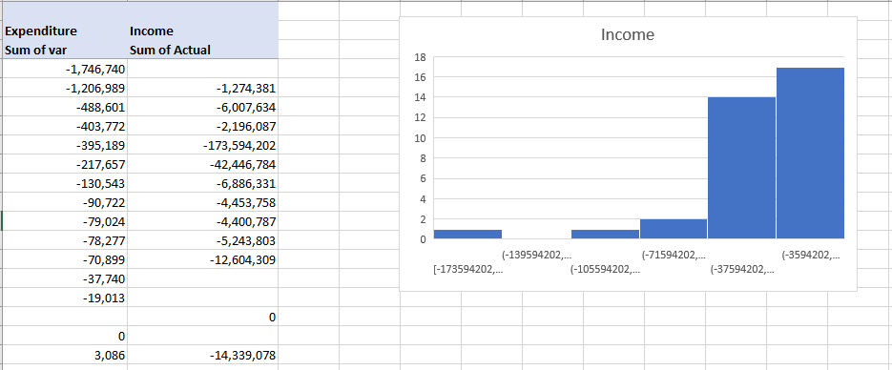

**Figure 3: Graph of expenditure sum of actual and values expenditure sum of budget**

(Source: Self-created in Excel)

## Conclusion

Asian opportunities suggest a nice level of investor protection from the unanticipated whims of the underlying markets precisely because of the averaging that takes place with these options. “Numerous researchers have made approximations of the value of Asian options due to the inability to directly use the BSM closed-form option solution to price and hedge Asian options, particularly arithmetic average Asian options Reynaerts, et al. Because there is very little scholarly literature on the valuation of Asian options, where both the strike and spot prices are arithmetically averaged, the danger of a poor option price assessment is much more pronounced.” The application of a specific differential equation that affects only one state variable is the main topic of the next section..All of this is necessary to complete the proper conclusion of this research.

# Reference list

**Journal**

**Task 1**

Gao, M. and Yu, Y., 2021, December. Simple Chooser Option Evaluation. In *2021 3rd International Conference on Economic Management and Cultural Industry (ICEMCI 2021)* (pp. 2892-2900). Atlantis Press.

Mulliez, M., DYNAMIC HEDGING IN THE PRESENCE OF BASIS RISK: A REINFORCEMENT LEARNING APPROACH.

Pohjonen, T., 2022. Pricing and hedging options with neural networks: a case of FTSE 100 index options.

Konopek, A. and Vrins, F., " Implied volatility modelling and non-linear machine learning estimation of payoff replication performances in the Black-Scholes framework.

Taipale, T., 2022. Does hedging affect firm value? Evidence from Finland.

**Task 2**

Gupta, P., 2020. Trading and Technical Analysis.

Nafisah, L., Halimah, E. and Iskandar, Y., 2022. Botanical and Chemical Overview, Traditional Uses and Potential of Anticancer Activity from Several Costus Plants: A Narrative Review. *Bioscientia Medicina: Journal of Biomedicine and Translational Research*, *6*(9), pp.2127-2138.

Larsson, J., 2020. Optimization of option pricing:-Variance reduction and low-discrepancy techniques.

Edeki, S.O., Jena, R.M., Ogundile, O.P. and Chakraverty, S., 2021. PDTM for the solution of a time-fractional barrier option Black-Scholes model. In *Journal of Physics: Conference Series* (Vol. 1734, No. 1, p. 012055). IOP Publishing.

Obthong, M., Tantisantiwong, N., Jeamwatthanachai, W. and Wills, G., 2020. A survey on machine learning for stock price prediction: Algorithms and techniques.

Wong, G.Y., Luttrell, C., Loft, L., Yang, A., Pham, T.T., Naito, D., Assembe-Mvondo, S. and Brockhaus, M., 2019. Narratives in REDD+ benefit sharing: examining evidence within and beyond the forest sector. *Climate Policy*, *19*(8), pp.1038-1051.