**ANALYZING BIG DATA**

TABLE OF CONTENTS

Task 1 3

An Approach to the Improvement in data integrity 4

Task 2 8

Task 3 11

Discussion of business-related information the data set represents 11

Explanation of how the data has been obtained 11

Task 4 13

Data preparation, cleaning, and filtering 13

Descriptive data analysis 13

Task 5 21

Reference List 24

# Task 1

Amazon is one of the world's biggest and best internet-based retailers. Established in 1994 by Jeff Bezos in Seattle, Washington, the organization began as a web-based book shop before quickly venturing into other item classifications like gadgets, dresses, and home products. Today, Amazon is a worldwide innovation combination that offers many administrations, including online business, distributed computing, computerized streaming, and man-made brainpower, from there, the sky is the limit (West, 2019). The organization is most popular for its web-based commercial center, Amazon.com, which has turned into the go-to objective for a large number of clients all over the planet.

Throughout the long term, Amazon has proceeded to improve and upset different businesses, including the distributing and media outlets with the presentation of the Ignite tablet and Amazon Prime real-time feature. Likewise, the organization has additionally taken huge steps in the advancement of voice-controlled menial helper innovation with its well-known Alexa stage.

Starting around 2021, Amazon utilizes over 1.3 million individuals overall and has a market capitalization of more than $1.7 trillion, making it quite possibly the most important organization on the planet. Regardless of its enormous size and achievement, the organization has confronted analysis over issues, for example, work rehearses, antitrust worries, and its effect on private ventures. Financial information that Amazon could utilize includes

**Revenue**

This is how much cash Amazon acquires from the business of its items and administrations.

**Net pay**

This is how much cash Amazon procures in the wake of deducting its costs from its all income.

**Expenses**

Amazon tracks its costs, which incorporate expenses related to tasks, advertising, innovative work, and different regions.

**Figure 1: Financial information**

(Self-created)

**Cash stream**

This alludes to the development of cash all through Amazon's records. Positive income implies that the organization has more cash coming in than going out.

**Debt**

Amazon tracks its obligation levels, including any advances or bonds it has given.

Non-monetary information that Amazon could utilize includes

**Customer information**

Amazon gathers information on its clients, including their buy history, segment data, and inclinations.

**Website traffic**

Amazon tracks site traffic, including the number of guests, time spent on the website, and the pages seen.

**Inventory levels**

Amazon tracks its stock levels to guarantee it has an adequate number of items to fulfill client needs.

**Shipping and conveyance measurements**

Amazon tracks measurements connected with transportation and conveyance times, including the level of bundles followed through on time and consumer loyalty evaluations.

**Social media measurements**

Amazon screens its web-based entertainment presence, including the number of devotees and commitment rates on stages like Twitter and Instagram.

## An Approach to the Improvement in data integrity

**Data Administration**

Amazon ought to lay out a hearty information administration program to guarantee that all information is overseen successfully all through its lifecycle. This includes characterizing information principles, approaches, and strategies, and guaranteeing that these are upheld across the association. This would include setting up a group of information stewards and information proprietors, who are liable for overseeing information across the association.

**Data Quality Administration**

Amazon ought to carry out an information quality administration structure to guarantee that information is exact, finished, and predictable. This includes performing information profiling, information purifying, and information approval to distinguish and address blunders and irregularities in the information. This would include setting up computerized apparatuses and cycles to screen and purify information as it enters the framework.

**Data Security**

Amazon ought to carry out strong information safety efforts to safeguard information from unapproved access, adjustment, or obliteration. This includes carrying out access controls, encryption, and other safety efforts to guarantee that information is safeguarded all through its lifecycle (Rikap, 2022). This would include setting up a group of safety specialists to screen and oversee information security across the association.

**Data Investigation**

Amazon ought to use information examination to acquire experiences into client conduct, patterns, and inclinations. This includes utilizing progressed examination strategies, for example, AI and man-made reasoning to recognize examples and bits of knowledge in the information. This would include setting up a group of information experts and information researchers to dissect information and give experiences to the association.

Further developing information respectability in Amazon requires a comprehensive methodology that includes laying out an information administration program, carrying out information quality administration structures, executing hearty information safety efforts, and utilizing information examination to acquire bits of knowledge into client conduct (Tou *et al.* 2019). By embracing these methodologies, Amazon can guarantee that information is overseen really and precisely, improving client trust and trust in the stage.

**Data protection and ethical assurance**

Amazon is one of the world's biggest online business organizations, and in that capacity, it handles immense measures of individual information from its clients. The organization has set up a few measures to guarantee information security and moral confirmation prerequisites are met. Amazon has carried out a few measures to guarantee information insurance and moral confirmation for its clients and representatives.

Amazon, right off the bat, has executed strong information security measures, for example, encryption, access controls, and interruption discovery frameworks to safeguard client information from unapproved access, change, or revelation. Furthermore, Amazon has laid out strategies and techniques for dealing with client information, including information maintenance and cancellation arrangements. Furthermore, Amazon has executed moral rules for its representatives, which remember a set of principles and strategies for business morals, hostile to debasement, and hostile to payoff (Aloqaily, 2022). These rules advance moral ways of behaving and guarantee that workers act as per the law and Amazon's qualities. Thirdly, Amazon has laid out a protection group liable for observing and implementing the organization's security strategies and methods. The group is additionally answerable for answering client requests in regard to their own data.

Amazon has acquired different confirmations and consistency certificates, for example, the Installment Card Industry Information Security Standard (PCI DSS) and the Overall Information Security Guideline (GDPR), exhibiting its obligation to information assurance and moral affirmation.

**Data protection**

Amazon is focused on guaranteeing the protection and security of its client information. The organization has set up different measures to defend individual information from unapproved access, use, or exposure. A portion of these actions includes

**Encryption**

Amazon scrambles all client information on the way and is very still. This guarantees that regardless of whether the information is caught, it can't be perused or adjusted by unapproved parties.

**Access controls**

Amazon has severe access controls set up to restrict who can get to client information. Workers and workers for hire are just conceded admittance to information that is important to play out their work capabilities.

**Data maintenance approaches**

Amazon has laid out information maintenance arrangements to guarantee that client information is just held however long and important. After the maintenance period has terminated, information is safely erased.

**Regular security reviews**

Amazon conducts ordinary security reviews to guarantee that its frameworks and cycles fulfill industry guidelines.

**Ethical assurance**

Notwithstanding information insurance measures, Amazon is additionally dedicated to moral affirmation. The organization has set up different measures to guarantee that it conducts business morally and consistently with significant regulations and guidelines. A portion of these actions includes

**Code of lead**

Amazon has a governing set of principles that frames the moral and lawful norms that representatives and project workers should comply with. The governing set of principles covers points like an enemy of payoff, hostile to defilement, and against separation.

**Training**

Amazon gives customary preparation to workers and project workers on moral and legitimate principles. The preparation covers subjects like information protection, hostility to paying off, and debasement.

**Whistleblower program**

Amazon has an informant program that permits workers and project workers to report any dishonest or unlawful way of behaving. The program guarantees that reports are dealt with secretly and that there are no counters against informants.

**Compliance reviews**

Amazon conducts consistency reviews to guarantee that its activities are consistence with important regulations and guidelines (Pierleoni *et al.* 2019). The reviews cover points like information protection, hostile to pay off, and against debasement.

In general, Amazon has set up a few measures to guarantee information security and moral confirmation necessities are met. The organization is focused on protecting client information and leading business morally and in consistence with pertinent regulations and guidelines.

# Task 2

Amazon is a worldwide internet business goliath that offers a great many items and administrations to clients around the world. The organization has encountered huge development throughout the long term, extending its activities and broadening its plan of action to incorporate distributed computing and real-time features, and that's just the beginning (Delfanti, 2021). As Amazon proceeds to develop and advance, it faces a few key questions that require the utilization of both monetary and non-monetary information in direction.

One significant strategic question that Amazon faces is the manner by which to keep extending its business while keeping up with productivity. The organization has customarily reinvested a lot of its income into extending its tasks, however as it keeps on developing, it should adjust the requirement for development with the requirement for productivity. Monetary information like income, total compensation, and income are basic in surveying the monetary soundness of the organization and deciding the best strategy (Zamri *et al.* 2020). Another strategic question that Amazon faces is the way to remain in front of its rivals. The online business industry is profoundly aggressive, with numerous players competing for a piece of the pie. Amazon should persistently develop and work on its items and administrations to remain in front of the opposition. Non-monetary information, for example, consumer loyalty evaluations, item audits, and site traffic are significant in figuring out client inclinations and recognizing regions where Amazon can get to the next level.

Moreover, Amazon should think about the effect of its procedure on the climate and society. The organization has confronted analysis in the past for its carbon impression and work practices, and it should keep on resolving these issues to keep up with its standing and appeal to socially cognizant purchasers. Non-monetary information, for example, fossil fuel byproducts, worker turnover rates, and social obligation appraisals are significant in surveying the effect of Amazon's procedure on the climate and society (Oberdorff *et al.* 2019). Generally speaking, monetary and non-monetary information assume basic parts in Amazon's dynamic cycles. Monetary information assists the organization with evaluating its monetary well-being and deciding the best game plan to keep up with benefits and development, while non-monetary information gives experiences into client inclinations, contests, and social and natural effects. By taking into account the two kinds of information, Amazon can go with educated choices that balance the requirements regarding the organization, its clients, and society all in all.

One of the most basic business questions that Amazon needs to deal with any consequences regarding upper hand and execution improvement is: "What elements impact client dedication and maintenance on the Amazon stage?"

Client dependability and maintenance are fundamental for the outcome of any web-based business, and Amazon is no special case. Amazon's prosperity is generally subject to its capacity to hold its current clients and draw in new ones. Amazon's plan of action depends on clients over and over purchasing from the stage, as Amazon produces a huge piece of its income through recurrent buys (Shrestha and Nasoz, 2019). Breaking down client conduct and understanding the elements that influence client dependability and maintenance can assist Amazon with growing better procedures to hold clients and increment their lifetime esteem. By recognizing and addressing the elements that lead to client beat, Amazon can further develop consumer loyalty, increment client devotion, and improve its market position.

A few factors that might impact client steadfastness and maintenance on Amazon's foundation could be valuing, item quality, conveyance speed, client assistance, and general client experience. By dissecting information connected with client conduct, buy history, audits, and input, Amazon can distinguish examples and patterns that impact client faithfulness and maintenance (Talha *et al.* 2020). Amazon can utilize this examination to further develop its valuing procedures, improve the nature of its items and administrations, enhance conveyance speeds, and give better client care. This will assist Amazon in withholding its current clients and drawing in new ones, which thusly, will work on its income, piece of the pie, and productivity. Taking everything into account, understanding the variables that influence client dedication and maintenance is basic for Amazon's prosperity. By dissecting information connected with client conduct, Amazon can foster methodologies to further develop consumer loyalty and faithfulness, which will give an upper hand and work on its presentation in the long haul.

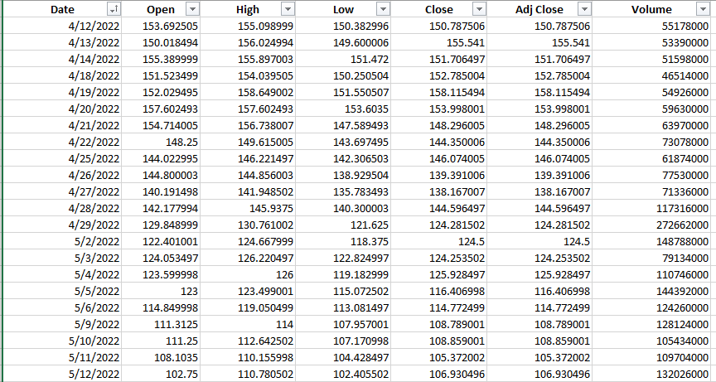

**Figure 2: Dataset for the Analysis**

(Source: Kaggle)

Information on the multinational corporation Amazon is included in the selected dataset. For Amazon, historical data have been chosen. Using the filter feature in the Excel platform, the data have been filtered. According to the dates that were filtered in ascending order, the data has been filtered. The historical data was downloaded from the "Kaggle" website's online data sources. The dataset contains 250 data for all the variables and is considered large enough for the analysis.

# Task 3

## Discussion of business-related information the data set represents

The historical data of Amazon addresses the organization's monetary exhibition and development after some time. It incorporates data like income, benefits, and pieces of the pie, as well as patterns in client conduct and changes in the cutthroat scene. Investigating this information can give significant experiences into the organization's past and future possibilities.

For instance, Amazon's historical financial data shows a consistent expansion in income and benefits throughout the last ten years, driven by the organization's effective venture into new business sectors and item classifications (Bullock *et al.* 2020). The information additionally features the effect of key vital choices, for example, the obtaining of Entire Food varieties and the advancement of Amazon Web Services. Notwithstanding financial data, Amazon's authentic information remembers data for client conduct, for example, buy examples and inclinations. This can assist the organization with bettering comprehending its clients and designing its items and administrations to their requirements.

## Explanation of how the data has been obtained

The dataset of Amazon's historical data is collected from Kaggle since the website allows a variety of datasets to choose from. At first, an account was created through Google account to get access to all the datasets included in Kaggle. The search bar was used to search for the required dataset. The Historical dataset of Amazon was searched for and many results have been put forward. The most suitable dataset was chosen. Information was also given about the contents of the dataset that has been chosen and also a brief description of the dataset. The website allows the user to download any format of the dataset. The file includes a .json file. .sql file, and .csv file. The .csv file was downloaded for analysis from Kaggle. The chosen data has been implemented for the analysis.

Amazon's historical dataset is a huge assortment of information that incorporates item data, client conduct, and conditional information from the online business monster. While this dataset is thorough and covers a large number of items and client socioeconomics, there are potential limits related to its representativeness.

One constraint is that the dataset principally reflects internet shopping conduct, which may not be delegated to disconnect shopping conduct. This restriction could be especially applicable for specific items and classifications, like food, where online deals might be more uncommon than in-store buys. Hence, it is fundamental to consider the particular item or classification of interest while utilizing this dataset.

One more constraint is connected with the example inclination of the dataset. Amazon's client base isn't illustrative of the general populace, and it might over represent certain socioeconomics and underrepresent others. For instance, the dataset might be slanted towards more youthful and more well-informed clients who are bound to shop on the web. This inclination could be especially important for specific items or classifications that are more well-known among explicit segment gatherings.

Also, Amazon's Historical dataset is restricted to information created inside the Amazon stage, which may not mirror the more extensive market patterns. For instance, the dataset may not reflect shopper conduct in actual retail locations or other web-based commercial centers. Thusly, it is fundamental to consider the more extensive market setting while utilizing this dataset.

By and large, Amazon's historical dataset is a significant asset for understanding online business patterns and client conduct. In any case, it is fundamental to know about its expected restrictions and to consider these limits when deciphering the outcomes. Specialists ought to consider the particular item or class of revenue, the potential example inclination, and the more extensive market setting while utilizing this dataset.

# Task 4

## Data preparation, cleaning, and filtering



**Figure 3: Chosen dataset for the Analysis**

(Source: Kaggle)

The chosen dataset contains information about the Multinational Company Amazon. The historical data has been chosen for Amazon. The data have been filtered in the Excel platform using the filter option. The data has been filtered according to the dates filtered in ascending order. The historical data has been downloaded from the online sources of a website named “Kaggle”.

## Descriptive data analysis

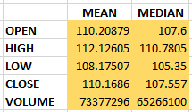

**Figure 4: Descriptive Analysis**

(Source: Self-created using MS Excel)

The mean and the median has been taken out for all the variables which are contained in the historical data of the Amazon company. The mean and the median for the “Open” is calculated to be **110.20** and **107.6**. The mean and the median for the “High” is calculated to be **112.12** and **110.78**. The mean and the median for the “Low” is calculated to be **108.17** and **105.35**. The mean and the median for the “Close” is calculated to be **110.16** and **107.55**. The mean and the median for the “Volume” is calculated to be **73377296** and **65266100**.

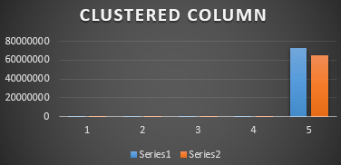

**Figure 5: Clustered column for mean and median**

(Source: Self-created using MS Excel)

The clustered column has been obtained as the graphical representation of the mean and median of the Historical Data of Amazon. The first bar represents the mean of the historical data and is represented by the blue color. The second bar represents the median of the historical data and is represented by the orange color. The mean is slightly higher than the median of the historical data of the Company.

**Correlation**

Whether or whether a statistical link between two random variables or bivariate data is causal, statistics employs the terms correlation or dependency to describe it. In statistics, "connection" is normally used to depict the strength of the linear correlations between's two factors, despite the fact that it can apply to any sort of relationship in the broadest importance. Instances of common dependent phenomena incorporate the connection between a decent's cost and the quantity of units purchasers will purchase, as seen by the demand curve. Correlations are useful because they can show a projected relationship that can be used practically.

For instance, an electrical firm could give less power on a bright day because of the correlation between the weather and the demand for electricity. There is a causal relationship in this situation because during severe weather people consume more energy to heat or cool their houses. In general, neither the presence of a correlation nor its existence does not establish a connection between two occurrences. If random variables fail to meet the formal criteria for probabilistic independence, they are considered to be dependent. The terms correlation and dependency are interchangeable in everyday speech. Oppositely, correlation refers to any of various explicit kinds of numerical tasks between the deliberate factors and their comparing anticipated values when it is utilized from a specialized perspective. Correlation is a valuable device for deciding the connection between at least two factors. The Pearson Correlation coefficient, which exclusively thinks about a direct connection between two factors, is the most notable of them. Expanding the responsiveness of Pearson's Correlation coefficient to nonlinear collaborations as well as Spearman's rank correlation and other relationship coefficients is expected.

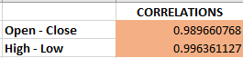

**Figure 6: Correlation of the Historical Data**

(Source: Self-created using MS Excel)

The correlation analysis has been calculated using the MS Excel platform. The first correlation has been done between the variables Open and Close. The value of correlation has been calculated to be 0.98. The correlation value shows that there is a positive correlation between the two mentioned variables. The second correlation has been done between the variables High and Low. The correlation value has been calculated at 0.99. The correlation value shows that there is a positive correlation between the chosen variables. So the correlation is a success.

**Regression Analysis**

A dependent variable (also known as the "outcome" or "response" variable or a "label" in “machine learning algorithm”) and one or more independent variables (also known as "predictors," "covariates," "explanatory variables," or "features") are compared using “regression analysis”, a group of statistical techniques used in statistical modeling. “In linear regression, the most popular type of regression analysis, the line (or more complicated linear combination) that most closely matches the data in terms of a given mathematical criterion is found”. For instance, it is feasible to pinpoint the exact line that minimizes the sum of squared differences between the line and the real data when using ordinary least squares. The researcher can therefore calculate the dependent anticipation(“or population average value”) of “the dependent variable” when the “independent variables” take on a provided set of weights for precise “mathematical reasons” (see linear regression). Less popular versions of “regression” such as “quantile regression and necessary condition analysis” use somewhat different methodologies to evaluate alternative “location parameters” or to calculate the “conditional expectation” over a larger “collection of non-linear models” (such as nonparametric regression). Most commonly, “regression analysis” is employed for two very distinct objectives.

First off, when it comes to prediction and forecasting, regression analysis and machine learning have a lot in common. Second, regression analysis may be utilized in specific circumstances to demonstrate a causal link between the independent and dependent variables. Regressions by themselves only show associations “between a dependent variable and a group of independent variables in a particular dataset”, it should be emphasized. “Researchers must carefully explain why prior correlations have predictive value in a new context or why a relationship between two variables has a causal meaning before using regressions for prediction or to infer causal links. The latter is crucial when scientists want to infer causal correlations from observational data”.

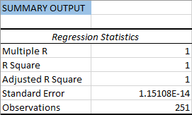

**Figure 7: Statistics of Regression**

(Source: Self-created using MS Excel)

The statistics for the Regression Analysis of Amazon’s Historical dataset have been provided in the above snip. The Regression Statistics include the multiple R values which are calculated to 1. The R square value is also calculated to 1 along with the adjusted R square value. The standard error has been computed to 1.15108E-14. The total number of observations is taken as 251.

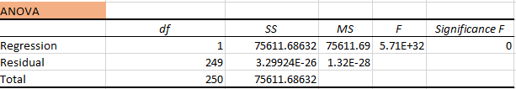

**Figure 8: Anova Test**

(Source: Self-created using MS Excel)

The Anova Test has been done using the MS Excel platform. The ANOVA test includes the Regression statistics and the Significance has been computed to zero (Ahmed *et al.* 2021). The total residues have also been calculated. The total number of observations taken is 250. The observation for regression is observed as 1 and the residual observations are taken as 249 making it a total of 250.



**Figure 9: Intercept Value and Statistics**

(Source: Self-created using MS Excel)

The intercept value and its statistics have been provided in the overhead picture. The coefficients have been computed for the intercept. The standard error for the intercept and variable is also computed using the Data Analysis of MS Excel. The P value and the t stat have been calculated using the MS Excel platform for both the Intercept and X variable.

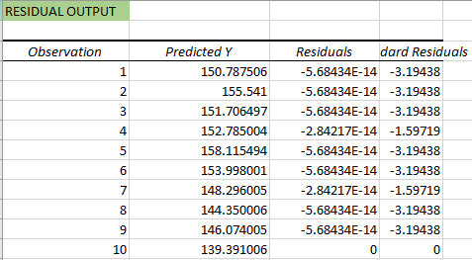

**Figure 10: Residual Output**

(Source: Self-created using MS Excel)

The residual output for the Regression is computed using the MS Excel platform. The Predicted values of Y have been computed along with the residuals. The dard Residuals are also calculated up to a certain observation.

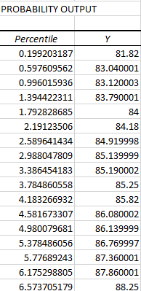

**Figure 11: Probability Output for Regression**

(Source: Self-created using MS Excel)

The probability output for the Regression of the dataset of Amazon’s Historical Data has been calculated using the MS Excel platform. The percentile of probability along with the Y values have been computed in MS Excel for the Regression Analysis of the chosen dataset.

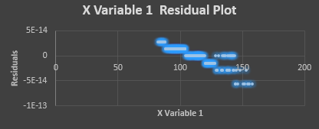

**Figure 12: Variable 1 Residual Plot**

(Source: Self-created using MS Excel)

The Residual plot for the X variable 1 has been provided. The plot has been observed and obtained in MS Excel. The y-axis contains the Residuals and the x-axis contains Variable 1. The plot is in the form of scatters. The scatter plots have been significantly marked with the color blue.

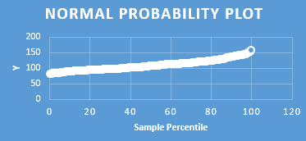

**Figure 13: Normal Probability Plot**

(Source: Self-created using MS Excel)

The Normal Probability plot for the Probability Output has been provided. The plot has been observed and obtained in MS Excel. The y-axis contains the Y values and the x-axis contains the Sample percentile. The plot is in the form of a straight line and is a linear plot. The linear plot has been significantly marked with the color white.

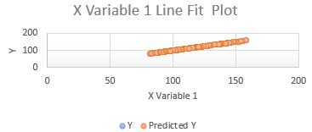

**Figure 14: Variable 1 Line plot**

(Source: Self-created using MS Excel)

The Line Fit plot for the X variable 1 has been provided. The plot has been observed and obtained in MS Excel. The y-axis contains the Y values and the x-axis contains the x variable 1. The plot is in the form of a straight line and is a scatter plot. The scatter plots have been significantly marked with the color orange.

# Task 5

Amazon has been fruitful in broadening its business over the course of the years by embracing different techniques that have assisted the organization with keeping up with its efficiency. Here are a few different ways Amazon can continue broadening its business while staying aware of the efficiency

**Innovation**

Amazon has forever been at the front line of advancement and innovation. It constantly puts resources into innovation to work on its items, administrations, and tasks. For example, the organization has put vigorously in its satisfaction habitats to expand proficiency and efficiency (Gomes *et al.* 2020). Amazon has likewise utilized innovation to send off new items and administrations, for example, Amazon Prime, Amazon New, and Amazon Web Services (AWS). By persistently developing and utilizing innovation, Amazon can continue broadening its business while keeping up with elevated degrees of efficiency.

**Scalable framework**

Amazon has fabricated a versatile foundation that can deal with the rising interest in its items and administrations. The organization has put resources into server farms, satisfaction focuses, and coordinated operations organizations to guarantee that it can address client issues proficiently. The versatility of Amazon's framework has empowered the organization to enter new business sectors and grow its business lines without compromising efficiency.

**Continuous improvement**

Amazon is focused on persistent improvement in all parts of its tasks. The organization utilizes information examination to recognize areas of progress and executes changes to build proficiency and efficiency. By consistently working on its tasks, Amazon can continue expanding its business while keeping up with elevated degrees of efficiency.

**Automation**

Amazon has utilized mechanization to further develop efficiency and proficiency in its activities. The organization has put resources into mechanical technology and man-made brainpower to mechanize its satisfaction communities, lessening the requirement for physical work. Via robotizing its tasks, Amazon can increment efficiency and lessen costs, which empowers the organization to extend its business lines.

**Customer concentration**

Amazon has forever been client-centered. The organization's main goal is to be the most client-driven organization on the planet. By zeroing in on client requirements and inclinations, Amazon can foster new items and administrations that address client issues and broaden its business lines (Zheng *et al.* 2020). This concentration likewise assists the organization with keeping up with elevated degrees of efficiency since it empowers Amazon to recognize and wipe out shortcomings in activities that adversely influence consumer loyalty.

Amazon can continue expanding its business while keeping up with elevated degrees of efficiency by utilizing innovation, fabricating a versatile framework, persistent improvement, robotization, and a client-centered approach. These systems have empowered Amazon to grow its business lines and enter new business sectors while keeping up with its situation as a forerunner in the Internet business industry.

Amazon is quite possibly the biggest organization on the planet, and in that capacity, it fundamentally affects both the environment and society. The organization has previously found a way ways to address these effects, for example, defining an objective to arrive at net-zero fossil fuel byproducts by 2040 and carrying out projects to help nearby networks. Notwithstanding, there is still a lot that Amazon can do to additionally relieve its effect on the world and individuals.

One region where Amazon can zero in is its store network. The organization ought to attempt to guarantee that its providers are utilizing reasonable practices, like decreasing waste and outflows. It can likewise attempt to diminish its dependence on petroleum derivatives by putting resources into environmentally friendly power sources and electric vehicles for its conveyance armada. Another region where Amazon can have a tremendous effect is in its bundling (Ma, 2023). The organization ought to attempt to lessen how much bundling it utilizes and guarantee that it is produced using maintainable materials. It can likewise execute projects to urge clients to reuse their bundling and lessen blowing. Notwithstanding its effect on the climate, Amazon likewise affects society. The organization ought to guarantee that its laborers are dealt with reasonably and that they approach fundamental freedoms like living pay, medical care, and taking care of time. It can likewise attempt to diminish its effect on neighborhood networks by putting resources into programs that help training, medical services, and foundation. Amazon can likewise utilize its huge stage to drive positive change. It can capitalize on its leverage to advance economical practices and items, and it can collaborate with associations that are attempting to resolve social and ecological issues.

Amazon essentially affects both the environment and society, and it has an obligation to address these effects. By zeroing in on its store network, bundling, laborer treatment, local area speculation, and stage, Amazon can have a huge constructive outcome on the world.

# Reference List

**Journal**

West, E., 2019. Amazon: Surveillance as a service. Surveillance & Society, 17(1/2), pp.27-33.

Rikap, C., 2022. Amazon: A story of accumulation through intellectual rentiership and predation. Competition & Change, 26(3-4), pp.436-466.

Tou, Y., Watanabe, C., Moriya, K., Naveed, N., Vurpillat, V. and Neittaanmäki, P., 2019. The transformation of R&D into neo open innovation-a new concept in R&D endeavor triggered by amazon. Technology in Society, 58, p.101141.

Aloqaily, A.N., 2022. The Role of the Human Resources Information Systems in Enhancing the Organizational Creativity Process (A case study in the International Amazon company–Jordan). resmilitaris, 12(2), pp.5441-5458.

Pierleoni, P., Concetti, R., Belli, A. and Palma, L., 2019. Amazon, Google and Microsoft solutions for IoT: Architectures and a performance comparison. IEEE access, 8, pp.5455-5470.

Delfanti, A., 2021. Machinic dispossession and augmented despotism: Digital work in an Amazon warehouse. New Media & Society, 23(1), pp.39-55.

Zamri, N.E., Mansor, M.A., Mohd Kasihmuddin, M.S., Alway, A., Mohd Jamaludin, S.Z. and Alzaeemi, S.A., 2020. Amazon employees resources access data extraction via clonal selection algorithm and logic mining approach. Entropy, 22(6), p.596.

Oberdorff, T., Dias, M.S., Jézéquel, C., Albert, J.S., Arantes, C.C., Bigorne, R., Carvajal-Valleros, F.M., De Wever, A., Frederico, R.G., Hidalgo, M. and Hugueny, B., 2019. Unexpected fish diversity gradients in the Amazon basin. Science advances, 5(9), p.eaav8681.

Shrestha, N. and Nasoz, F., 2019. Deep learning sentiment analysis of amazon. com reviews and ratings. arXiv preprint arXiv:1904.04096.

Talha, M., Sohail, M. and Hajji, H., 2020. Analysis of research on amazon AWS cloud computing seller data security. International Journal of Research in Engineering Innovation, 4(3), pp.131-136.

Bullock, E.L., Woodcock, C.E., Souza Jr, C. and Olofsson, P., 2020. Satellite‐based estimates reveal widespread forest degradation in the Amazon. Global Change Biology, 26(5), pp.2956-2969.

Ahmed, H.M., Javed Awan, M., Khan, N.S., Yasin, A. and Faisal Shehzad, H.M., 2021. Sentiment analysis of online food reviews using big data analytics. Hafiz Muhammad Ahmed, Mazhar Javed Awan, Nabeel Sabir Khan, Awais Yasin, Hafiz Muhammad Faisal Shehzad (2021) Sentiment Analysis of Online Food Reviews using Big Data Analytics. Elementary Education Online, 20(2), pp.827-836.

Gomes, V.C., Queiroz, G.R. and Ferreira, K.R., 2020. An overview of platforms for big earth observation data management and analysis. Remote Sensing, 12(8), p.1253.

Zheng, K., Zhang, Z. and Song, B., 2020. E-commerce logistics distribution mode in big-data context: a case analysis of JD. COM. Industrial Marketing Management, 86(1), pp.154-162.

Ma, X., 2023. Analysis of Amazon Stock Using Simple Linear Regression and Time Series ARIMA Model. Highlights in Science, Engineering and Technology, 38, pp.353-363.