**PMP PROGRAMMING FORMATIVE ASSESSMENT**

**TABLE OF CONTENTS**

Question 1 3

Question 2 6

Question 3 8

Question 4 11

Reference List 12

# Question 1

**a.**

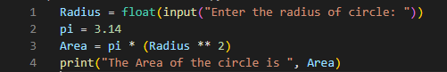

**Figure 1: code for finding the area of the circle**

(Source: Self-created using VS code)

The above code is written for the execution of finding the area of the circle (Heinold, 2021). The radius has been taken as input and the value of pi has been taken as 3.14 and the formula for the area has been provided for the code.



**Figure 2: Output the area of the circle**

(Source: Self-created using VS code)

The output has been provided for the area of the circle. A radius of 4 has been given as input and the area has been computed to 50.24

**b.**

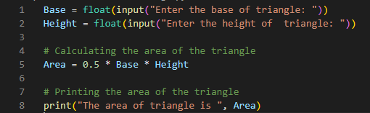

**Figure 3: code for finding the area of the triangle**

(Source: Self-created using VS code)

The above code is written for the execution of finding the area of the triangle (Linge and Langtangen, 2020). The base and the height have been taken as input and the formula for the area has been provided for the code.



**Figure 4: Output for finding the area of the triangle**

(Source: Self-created using VS code)

The output has been provided for the area of the triangle. The base of the triangle is given as input as 10 and the height of the triangle is given as input as 20. The area of the triangle is computed to 100.

**c.**

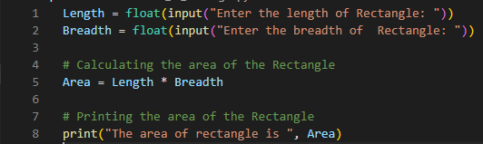

**Figure 5: code for finding the area of the rectangle**

(Source: Self-created using VS code)

The above code is written for the execution of finding the area of the rectangle. The length and the breadth have been taken as input and the formula for the area has been provided for the code.



**Figure 6: Output for finding the area of the rectangle**

(Source: Self-created using VS code)

The output has been provided for the area of the rectangle. The length of the rectangle is given as input as 10 and the breadth of the rectangle is given as input as 50. The area of the rectangle is computed to 500.

.

**d.**

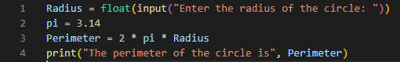

**Figure 6: code for finding the perimeter of the circle**

(Source: Self-created using VS code)

The above code is written for the execution of finding the perimeter of the circle. The radius has been chosen as input and the value of pi is chosen as 3.14 (Becker and Quille, 2019). The formula for the perimeter of the circle is provided.



**Figure 7: Output for finding the perimeter of the circle**

(Source: Self-created using VS code)

The output has been provided for the perimeter of the circle. The radius of the circle is taken as input as 20. The perimeter of the circle is computed to 125.6

# Question 2

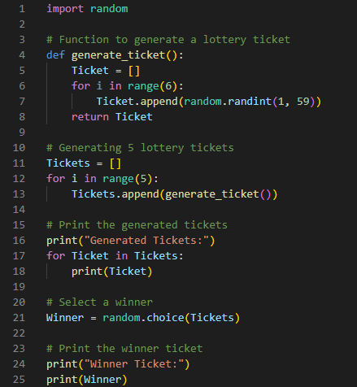

**Figure 8: Function to generate lottery ticket**

(Source: Self-created using VS code)

The above code is written for generating lottery tickets for 6 numbers between 1 to 59. At first, a random list has been generated between the numbers 1 to 59. The generated list of tickets has been appended with another list. The other list will contain a random list of winning tickets that will be taken from the list of generated tickets. The append function has been used to do the entire function.

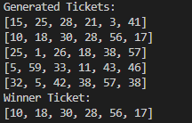

**Figure 9: Output for the generation of lottery ticket**

(Source: Self-created using VS code)

The output shows the list of five generated tickets. Among them, a list has been chosen in random for the winning ticket (Mukhiddinovna, 2022). The output has been generated in the Visual code Studio.

# Question 3

**a.**

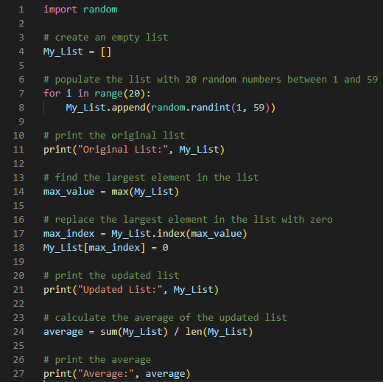

**Figure 10: Creating Array list**

(Source: Self-created using VS code)

The code has been written for creating an empty list and for updating the list while replacing the largest element with zero. The average of all the elements in the updated list has been taken out. The code has been written in Visual Studio code and is written in Python Programming Language.



**Figure 11: Output of the array list**

(Source: Self-created using VS code)

The above figure shows the output of the code that has been written in the Visual Studio code. The output shows the original list that has been generated and also the updated list with the largest value being replaced with zero. In this case, 59 was the largest element which has been replaced by zero in the updated list. The average of the updated list has been computed to 29.4

**b.**

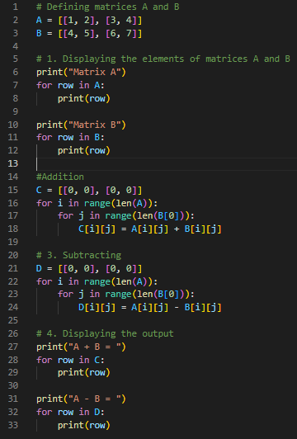

**Figure 12: code for Matrix Functions**

(Source: Self-created using VS code)

The code overhead has been written for generating the given matrices and applying different mathematical functions to them. The code has been written in the Visual Studio code platform in Python Programming Language.

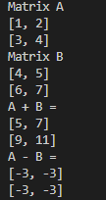

**Figure 13: Output for Matrix Functions**

(Source: Self-created using VS code)

Matrix A and Matrix B have been printed as output. At first, an addition has been done between the two matrices and the output matrix has been printed. Secondly, a subtraction has been done between the two given matrices and the output matrix has been printed.

# Question 4

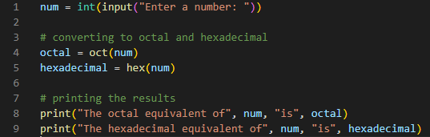

**Figure 14: code for conversion to Octal and Hexadecimal**

(Source: Self-created using VS code)

The code has been written for the conversion of a number to octal and hexadecimal. A number has been taken as input which can be in either binary or decimal or any other form of the number except octal and hexadecimal (Tan *et al.* 2020). The code has been written in the Visual Studio code platform in Python Programming Language.



**Figure 15: Output for conversion to Octal and Hexadecimal**

(Source: Self-created using VS code)

The output of the above code has been provided. In the output, the input has been taken as 59. The equivalent octal conversion of the input is computed as 73 and the equivalent hexadecimal conversion of the input is computed as 3B which is the actual output of the number that has been taken as input.

# Reference List

**Journal**

Heinold, B., 2021. A practical introduction to Python programming.

Linge, S. and Langtangen, H.P., 2020. Programming for Computations-Python: A Gentle Introduction to Numerical Simulations with Python 3.6 (p. 332). Springer Nature.

Becker, B.A. and Quille, K., 2019, February. 50 years of cs1 at sigcse: A review of the evolution of introductory programming education research. In Proceedings of the 50th acm technical symposium on computer science education (pp. 338-344).

Van Rossum, G., 2007, June. Python Programming Language. In USENIX annual technical conference (Vol. 41, No. 1, pp. 1-36).

Srinath, K.R., 2017. Python–the fastest growing programming language. International Research Journal of Engineering and Technology, 4(12), pp.354-357.