**ANALYSING BIG DATA**

**TABLE OF CONTENTS**

Task 1 3

Task 2 6

Task 3 9

Task 4 12

Task 5 20

Reference List 24

# Task 1

The chosen contextual analysis organization is Nintendo Organization, a global leader in the production, distribution, and sale of consumer electronics. Among Nintendo Corporation's many offerings are gaming systems, home audio solutions, home appliances, and other consumer electronics. Nintendo Enterprise right now utilizes different monetary and non-monetary information to illuminate its independent direction. Nintendo Partnership supplies labor and products to business sectors everywhere, taking care of both homegrown and global clients. Customer preferences, purchasing habits, and other demographic data, for instance, are all collected, processed, and stored by the company (Pramanik *et al.* 2022). In addition, Nintendo Corporation gathers and stores information regarding product sales, market trends, and product performance. When making decisions, financial data like budgets, costs, and profits are also taken into account. An enhanced analytics framework is necessary for Nintendo Corporation's decision-making process to improve. Making ensuring the data is accurate and of the highest integrity is a crucial part of this approach. Nintendo Corporation should put in place a data governance plan to accomplish this. A data quality audit, which would involve data profiling, data cleaning, and data validation, might be part of this. This would make it possible to guarantee the greatest level of accuracy and quality for the data. Nintendo Corporation ought to think about putting in place a strategy for data protection and ethical assurance in addition to the data quality audit. Implementing measures like data anonymization, access control, and encryption could be part of this. The company's compliance with data protection laws and the security of the data would benefit from these measures.

If Nintendo Corporation wants to make better decisions, it should think about collecting and storing more kinds of data. This could incorporate client feeling information, statistical surveying information, and serious insight information. Nintendo Corporation would gain valuable insights into customer preferences and market trends from this additional data, which could assist the company in making decisions. If Nintendo Corporation wants to make better decisions, it should think about putting in place a better analytics framework. A data quality audit, data protection, an ethical assurance strategy, and the collection and storage of additional types of data should all be part of this framework. This would assist in ensuring the company's compliance with data protection laws and the highest quality and accuracy of the data.

These statistics comprise both financial and non-financial information. Nintendo relies heavily on financial data when making decisions. The company's sales, profits, costs, expenses, cash flow, investments, and other financial metrics are included in this data. Nintendo utilizes this information to evaluate its ongoing monetary position, break down its past execution and plan for what's in store. Nintendo also collects and analyzes non-financial data in addition to financial data Additionally, the company makes use of financial data to decide on pricing and product development, measure the efficacy of its marketing campaigns, and monitor the performance of its products and services.. This information can incorporate client input, statistical surveying, examination, and client conduct.

The company is able to better comprehend the requirements and preferences of its customers, keep track of industry trends, identify potential growth opportunities, and create new products and services with the assistance of this data (Kim and Wang, 2019). Additionally, Nintendo analyzes and collects data concerning its operations and supply chain. The company's suppliers, production costs, inventory levels, delivery times, and other operational metrics might be included in this data. The company is better able to comprehend the performance of its supply chain and identify areas for improvement thanks to this data. Nintendo stores and collects employee-related data. This includes information about job satisfaction, employee performance, qualifications, and skills. The company is able to develop training programs, assess employee performance, and identify potential areas for improvement with the assistance of this data. The notion of data integrity encompasses data accuracy, completeness, validity, and consistency. It is fundamental for any association, including Nintendo, to guarantee information trustworthiness to settle on informed choices and remain serious on the lookout. A data analytics framework's data integrity can be improved in a number of ways, but this paper will focus on three main strategies: information administration, information quality administration, and information security.

**Data Governance**

The integrity of data depends on good data governance. It involves the procedures and rules that an organization establishes to guarantee the efficient management and utilization of data. This includes putting in place guidelines and standards for the collection, storage, processing, and analysis of data. Defining roles and responsibilities for data stewards and other personnel accountable for the data is also part of this process. Data accuracy, relevance, and timeliness are all aided by data governance. Additionally, it aids in lowering the likelihood of data corruption or improper use.

**Data Quality Management**

Another crucial component of data integrity is the management of data quality. To ensure that the data meets the necessary quality standards, this entails monitoring and evaluating the data. Quality principles can incorporate precision, culmination, practicality, and consistency. Information quality administration additionally includes making and carrying out cycles to guarantee the information is stayed up with the latest and exact (Sheng *et al.* 2021). These cycles might incorporate information approval, information purifying, information advancement, and information planning. Because it aids in ensuring that data is trustworthy and useful, data quality management is essential for maintaining data integrity.

**Data Security**

The integrity of data is dependent on data security. It includes the execution of arrangements, techniques, and advancements to safeguard information from unapproved access, alteration, or misfortune. Encryption, access control, authorization, authentication, and data backup are all ways to protect data. Any data analytics framework needs to have data security because it helps keep data confidential and protects it from bad actors.

Nintendo can make its suggested data analytics framework's data integrity better. Data quality management helps to guarantee that data is trustworthy and usable, while data governance helps to ensure that data is managed and used properly (Cabrera-Sánchez and Villarejo-Ramos, 2020). Data security also aids in preventing data loss and unauthorized access, alteration, and deletion. Nintendo can guarantee the accuracy and completeness of its data by using these strategies.

# Task 2

Nintendo is a global computer game organization situated in Japan, and like any organization, it utilizes financial and non-financial data to decide. Financial data is utilized by Nintendo to survey the organization's presentation and financial well-being. This data incorporates income, costs, benefits, and income (Muniswamaiah *et al.* 2019). Financial data is urgent for dynamically connected with ventures, development plans, evaluating techniques, and cost-cutting drives. In 2021, Nintendo's financial reports demonstrated that the organization's deals and benefits were supported by the outcome of the Switch console and the arrival of well-known games like Creature Crossing: New Skylines.

Non-financial data incorporates data that can't be communicated in money-related terms. This data can be utilized by Nintendo to assess consumer loyalty, market patterns, and brand notoriety. Non-financial data is especially helpful for dynamic connected with item advancement, showcasing procedures, and client service. In 2021, Nintendo utilized non-financial data to evaluate the prevalence of its games and control center, the effect of the Coronavirus pandemic on the gaming business, and shopper inclinations for web-based gaming and social cooperation.

One strategic question Nintendo faces is the way to use areas of strength for its property (IP) portfolio, which incorporates cherished establishments like Super Mario, Legend of Zelda, and Pokémon. Nintendo should adjust the need to constantly invigorate and advance these establishments while likewise remaining consistent with their center fanbase's assumptions. Moreover, they should decide how to adapt these IPs really, whether through conventional game deals, membership administrations, or other income streams. In general, resolving the strategic question of how to stay cutthroat in the computer game industry is urgent for Nintendo's drawn-out progress and the authoritative upper hand. One critical strategic question that Nintendo faces is the manner by which to stay cutthroat in the quickly developing computer game industry (Ferraris *et al.* 2019). As innovation keeps on progressing, Nintendo should decide how to remain on the ball and proposition creative encounters to customers. Moreover, they should adjust the necessities of their main fans, who frequently esteem Nintendo's exceptional image and IP, with the craving to arrive at a more extensive segment.

The above question is fundamentally significant for Nintendo's hierarchical upper hand in light of the fact that the computer game industry is exceptionally aggressive and continually advancing. To keep an upper hand, Nintendo should proceed to develop and separate itself from contenders while likewise utilizing its center assets. By focusing on development and separation over crude handling power, Nintendo has had the option to cut out a remarkable specialty in the market with the Nintendo Switch and creative games like Ring Fit Experience (Shamim *et al.* 2020). This approach has permitted Nintendo to speak to a wide crowd, including both bad-to-the-bone gamers and easygoing players. One approach Nintendo has taken is to focus on advancement and separation over crude handling power. This has prompted interesting equipment, for example, the Nintendo Switch and creative games like Ring Fit Experience. Nonetheless, this approach additionally presents chances, as contenders might outperform Nintendo regarding crude power and graphical capacities.

Besides, utilizing areas of strength for its portfolio is basic for Nintendo's upper hand, as these establishments have a reliable fanbase that anticipates great and creative encounters. By ceaselessly reviving and developing these establishments while likewise remaining consistent with their center fanbase's assumptions, Nintendo can keep an upper hand on the lookout.

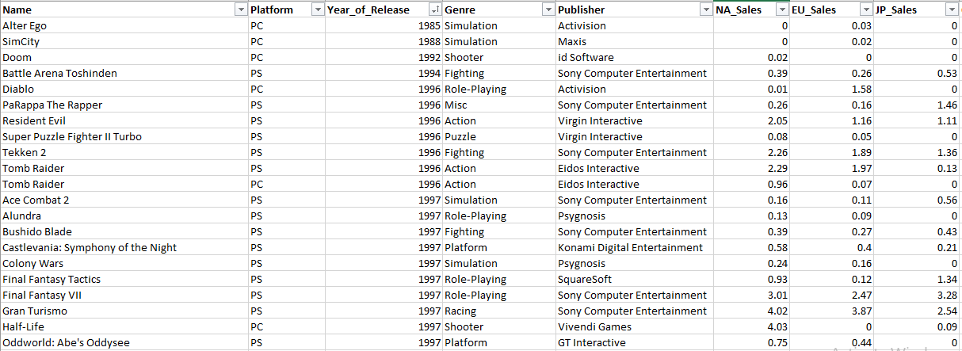

**Figure 1: Data Cleaning and Filtering**

(Source: Self-created using MS Excel)

The dataset has been chosen for the different types of analysis. The dataset contains the different types of games and their manufacturers. The different year of release of each game is also provided on the dataset. The dataset also contains the different kinds of sales for each individual game. The critics and users count and scores are also provided in the provided dataset.

# Task 3

**Business-related information the data set represents**

In this assignment, the data set is related to the gaming industry. Thus, a gaming data set can provide various information and also can analyze different aspects of the gaming industry.

1. **Customer analysis**

Technologies for data analytics are crucial for analyzing client behavior and turning it into possibilities. Analytics and data science tools have shown that subscription-based services can increase revenue for gaming companies (ur Rehman *et al.* 2019). For their gaming environments, many gaming businesses provide subscription-based gaming models. Big data analysis in game production aids businesses in creating marketing strategies that may help them keep current players and draw in new ones.

1. **Capturing the essence of fun**

Games are what fun is all about. Game development companies may increase revenue, attract new players, and maintain user engagement with the use of data analytics solutions. Data analytics tools produce information that businesses use to develop more exciting trends and game-related technology. For it to work well, the science service provider company's facts, nevertheless, must pay close attention.

1. **Customer engagement and user experience**

Any video game design starts with a compelling narrative, stunning visuals, and epic performance. However, given that we work in the most cutthroat sector of the economy, this is insufficient. To retain clients, a business must go above and above by offering a superb user experience. Data science and AI techniques and technologies can be used to better understand user behavior, how they engage with the system, what they like about it, and other factors.

**4) Gaming analytics AI**

In order to learn more about its users, including who they are, whether or not they love the product, how long they spend on the website, and other details, a game development company uses data analytics approaches. They use this information to create smart business decisions that could boost profits and enhance user experience. The usage of "artificial intelligence" and "machine learning techniques" can instantly provide insightful data that can be used to enhance user experience and address problems that lead users to leave a platform

“(https://www.hdatasystems.com/blog/7-roles-of-data-analytics-in-video-games-develoment)”.

**Dataset collection**

In this study, the data set is all about video games. And the data set has been provided and used for the different analyses. Thus, in this case, the secondary data set has been used to do the primary analysis. The analysis includes a descriptive analysis for sales, a descriptive analysis for critics, a descriptive analysis for users, a correlation analysis, a regression analysis, an ANOVA test for regression analysis, and for the regression analysis, two types of output can be obtained such as output for residual output for regression analysis, probability output for regression analysis (Bellet and Frijters, 2019). Apart from these, residual plots, line plots, and normal probability plots also have been done in Excel. The video game dataset has different information like the name of the game, the platform used for this, releasing year, the genre of the game, publishers of the game, NA Sales, EU Sales, JP Sales, Other Sales, Global Sales, critic score, critic count, user score, user count, developer, and rating.

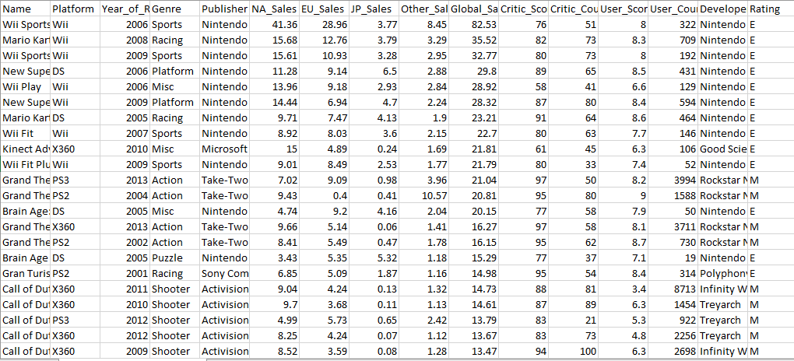

**Figure 2: Dataset of video game**

(Source: Provided)

**Potential limitations and application of the video game dataset**

**Limitation**

The video game dataset helps to develop the game. However, this dataset can be grouped mainly into five categories such as pre-production problems, internal problems, external problems, technology-related problems, and finally schedule-based problems. Video game datasets may be uneven toward specific sorts of games or players. For example, if the dataset simply integrates notable games, it may not be representative of the entire video game industry. Basically, if the dataset relies upon data assembled from a particular region or section, it may not be representative of the overall video game market. It might bar extremely significant information of interest, similar to player economics or game execution estimations. This can make it try to arrive at precise conclusions about the data and it moreover may become outdated quickly, particularly as new games are conveyed and players direct changes (Garcia-Arroyo *et al.* 2021). This can limit the comfort of the dataset for expecting future examples or separating current player lead. Another issue is associated with tricky individual information about players, similar to their age, direction, and region. It is vital to ensure that this data is assembled and taken care of in a strong and moral manner to defend players' security. This dataset can be confounded and difficult to translate, particularly for those without an establishment in video game assessment or data science. This can confine the worth of the dataset to a greater group “(https://arxiv.org/pdf/2001.00491.pdf)”.

**Application**

A video game has various applications as it can provide different information and also can help to analyze the sales pattern of several features. By using the dataset, someone can investigate various features and use approaches (Liu *et al.* 2020). However, a gaming data set helps to answer several answers as it can say the best-performing palace, the most rated gaming names operated in the world, which publishers impact the regional sales area, and many more. Apart from these, the gaming dataset also helps to provide information like gaming rank, gaming name, its platform, genre, publishers, etc.

# Task 4



**Figure 3: Data Cleaning and Filtering**

(Source: Self-created using MS Excel)

The method which involved rectifying or eliminating bad, mistaken, or extra information from the information collected and gathered datasets preceding the information examination is called "information cleaning," "information scouring," or "information purifying." As a result, the results will be more precise because only relevant information will be examined by this data cleaning and data filtering process.

The data has been cleaned and filtered using the filter option in MS Excel. The data has been sorted in accordance with the year of release of the games. The data has been filtered according to the ascending order of the year of release. In the data cleaning and filtering process, only the required information has been shortlisted and stored to get better outcomes of the results and the analysis which will help to meet the research purpose.

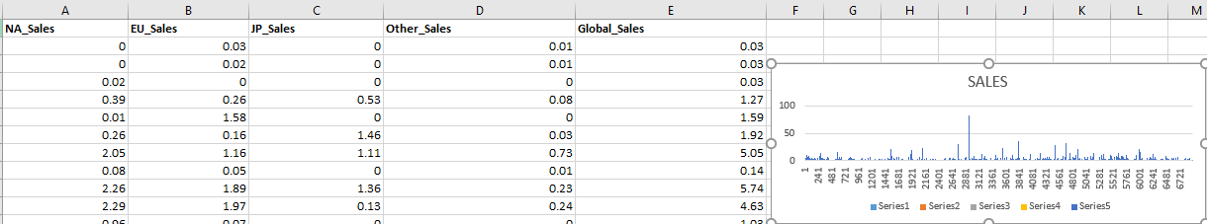

**Figure 4: Descriptive Analysis for Sales**

(Source: Self-created using MS Excel)

Descriptive analysis is the type of analysis that will help to answer special types of questions like what happened in a particular operation. The descriptive analysis also helps to undertake the historical data to analyze the changes that can be happened in the operational case. This type of analysis helps the companies to compare with other companies and the reporting periods with the reporting periods of other companies (Goes *et al.* 2021). Thus, the descriptive analysis helps to compare between two companies.

The descriptive analysis has been done using the MS Excel platform. The graph has been obtained for the different kinds of sales in the video game industry in accordance with the significant companies of video games. The outcome of the descriptive analysis helps the Nintendo video game company to compare its sales report with other companies.

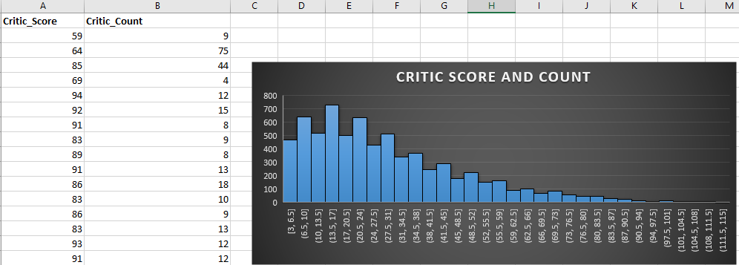

**Figure 5: Descriptive Analysis of Critics**

(Source: Self-created using MS Excel)

The descriptive analysis for the critics helps to demonstrate the supportive materials which can be utilized in any lesson and its function. This analysis also helps to consider the way how the supporting materials are connected to the purpose, tone, and structure of the overall operation.

The graph was taken out for the different critic scores and counts. The bar graph has been obtained using the MS Excel platform. In the above bar graph, the X-axis represents the critic score, and the Y-axis represents the critic count. According to the above critic score and critic count is inversely proportional where the critic count decreases with increasing critic count.

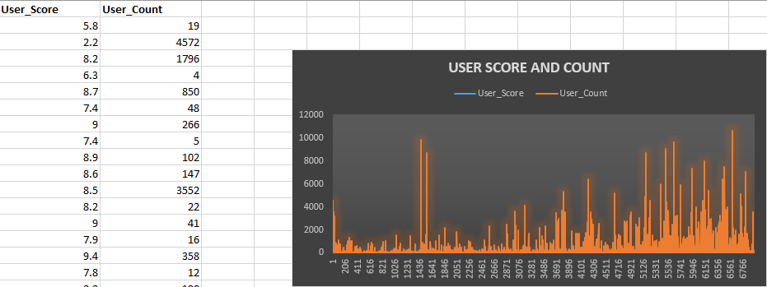

**Figure 6: Descriptive Analysis for User**

(Source: Self-created using MS Excel)

The descriptive analysis for the user is the procedure that uses historical and as well as current data to find out the connectivity and the trends in the users. As this analysis provides only the relationship and trends, but can not analysis in depth thus it is sometimes known as the simplest type of data analysis.

The graph has been taken out for the different user scores and critic counts. The bar graph has been obtained using the MS Excel platform (von Bloh *et al.* 2020). In the above bar graph, the X-axis represents the user score and the Y-axis represents the user count. In this case, the user score and user count are directly proportional as the value of the user count gradually increases with increasing the value of the user score. However, in the middle of the graph, the sudden increase in the user count has been observed.

**Results**

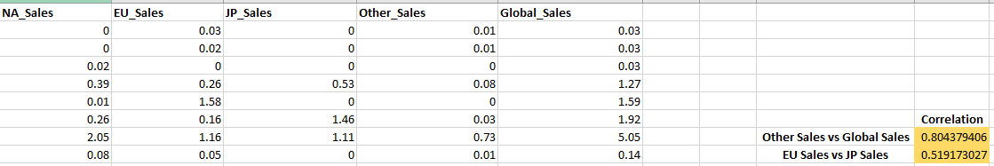

**Figure 7: Correlation Analysis**

(Source: Self-created using MS Excel)

A correlation relationship is also called a bivariate. The primary aim of the correlation analysis is to figure out the connectivity between the variables of the dataset and it most particularly identifies the existing relationship among the variables of the dataset. The correlation analysis not only figures out the relationship between the variables but also helps to determine the magnitude, and the relationship action among the variables.

The correlation analysis has been done using the MS Excel platform. The chart has been obtained to identify the relationship between different kinds of sales in the video game industry such as NA Sales, EU Sales, JP Sales, Other Sales, and Global Sales (Kumari *et al.* 2019). However, in this particular correlation analysis, two types of relationships were mainly identified, one of these is the relationship between the other sales and the global sales where the correlation is 0.8043…and the second one is the relationship between the EU sales and the JP sales where the correlation is 0.5191…

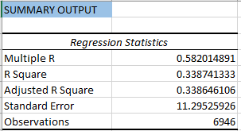

**Figure 8: Summary of Regression Analysis**

(Source: Self-created using MS Excel)

The regression analysis has been done mainly for two purposes, one is to determine the dependent variable’s value mainly for the data and some information concerning the availability of the explanatory variables. And another one is to determine the impact of explanatory variables upon the dependent variables.

The regression analysis has been done using the MS Excel platform. The chart presents an overall summary of regression analysis such as multiple R, R Square, Adjusted R square, Standard Error, and the number of observations. The value of regression R is 0.5820…, the value of R Square is 0.33874…, the value of adjusted R Square is 0.33864…, and the value of standard error is 11.295…, and finally the total number of observations is 6946.

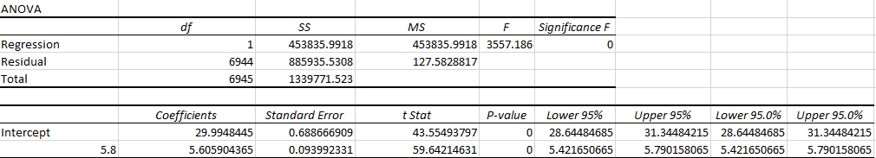

**Figure 9: ANOVA Test for Regression Analysis**

(Source: Self-created using MS Excel)

The ANOVA Test for Regression Analysis has been done using the MS Excel platform. The analysis has been done to get information about the variability levels among the regression model and it also creates a basis for the significance test. In this ANOVA test, it can be said that the previously obtained regression model or the regression R-value is significantly valid. And it can be said as significantly valid as the significance value is 0.

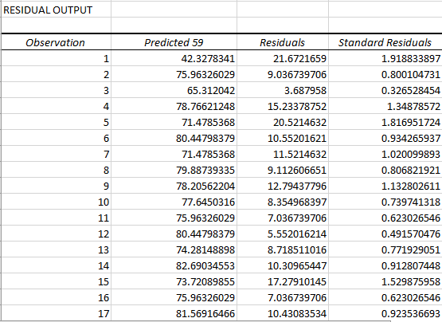

**Figure 10: Residual Output for Regression Analysis**

(Source: Self-created using MS Excel)

The Residual Output for Regression Analysis has been gotten by using the MS Excel platform. In the above chart, the residual values are represented. The residual value indicates the values which have not been used in the overall analysis and it can not provide any outcomes for this study. The above chart represents the total four columns such as observation, predicted 59, residuals, and standard residuals.

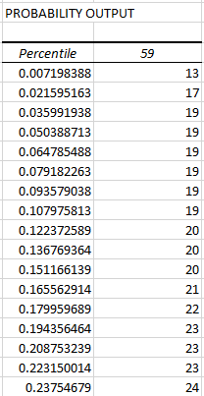

**Figure 11: Probability Output for Regression Analysis**

(Source: Self-created using MS Excel)

The Probability Output for Regression Analysis has been gotten by using the MS Excel platform. The analysis has been done to get information about the probability of the regression analysis. In the above table, a total number of probabilities is 59, and the total number of columns is two where the probability is represented by percentile.

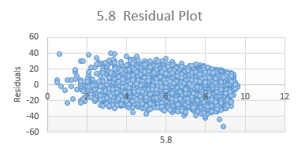

**Figure 12: Residual Plot**

(Source: Self-created using MS Excel)

The Residual Plot has been done using the MS Excel platform. The residual plot provides the information for the difference between the “fitted response values”, and the observed response. The above residual plot or the null residual plot represents the random scatteredness of some values that can form the constant band with specific width about the individual line. In the above residual plot, the length of the plot is arranged almost from 0 to 10, and the width of the plot ranged from 40 to - 40.

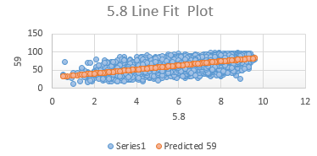

**Figure 13: Line Plot**

(Source: Self-created using MS Excel)

The Line Plot has been done using the MS Excel platform. The line plot represents the process of displaying the data through the number line. The above line plot or the dot plot represents the regression analysis where the orange dots represent the values of the regression plot and the scattered blue dots represent the residual values.

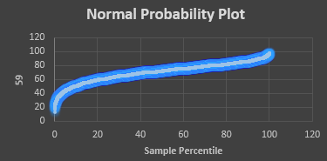

**Figure 14: Normal Probability plot**

(Source: Self-created using MS Excel)

The Normal Probability plot has been done using the MS Excel platform. The normal probability plot represents the outputs of the probability values of the regression analysis where the total number of probability is 59 and which is represented in the Y-axis and the percentile values of the sample represents in the X-axis.

# Task 5

* **Staying cutthroat in the quickly developing computer game industry**

There are different ways that can be applied to stay cutthroat in the quickly developing gaming industry.

**Posting the work in the decision boards**

If someone is a confident game planner, they could contribute a lot of energy sneaking around discussion blocks and soaking however much data as could be expected.

That is the explanation it's an optimal technique for getting the work seen by game studios, which can help people with building industry affiliations and could provoke a suggestion for business.

**Gaming vlog**

If someone gunning for an undertaking elucidating games or running a gaming neighborhood, the most ideal method for getting all that going might be to just start a gaming video blog. Through the gaming video blog, the vlogger can amass their experiences from the clients. In the uncommonly ferocious universe of gaming, the client experience is the big cheese (Wüest *et al.* 2020). Gamers are constantly looking for particularly captivating experiences, so keeping this at the actual front of game improvement is key. This suggests placing assets into client assessment and testing to get a handle on the necessities and tendencies of the vested party and incorporating their analysis into your strategy.

**Building of own games**

There is something different, better, free game-making mechanical assemblies available now than at some other time. With all that is open for someone to download and start making PC games today, they are definitively out of reason.

**Getting a relationship in a video game studio**

If someone has a skill that can be used in-game improvement like programming, workmanship, or well thought out plan, then, at that point, they might actually find another profession at a game studio whether or not they've never manufactured a certified game. Just a single out of each and every odd studio has an "official" game designer section level position program, but most are accessible to the chance of a part-time, fleeting, sensible, or free expert that could turn out to be helpful to them finish their game (Shamim *et al.* 2019). Developing areas of fortitude for gamers around the brand can help with making a reliable fan base that will remain with someone through different difficulties. This can be achieved by attracting the neighborhood electronic diversion, conversations, and other online channels, and by setting out open entryways for them to help out your picture and each other “(https://www.gameindustrycareerguide.com/how-to-break-into-video-game-industry/)”.

* **Recommendation**

Data assessment can generally additionally promote the unique method of a gaming association like Nintendo. By separating data on client direct, tendencies, Nintendo can secure parts of information that can help them with seeking after-educated decisions on game turn regarding occasions, publicizing, and business framework. One way data assessment can additionally foster Nintendo's bearing is by helping them with perceiving the most notable game sorts, stages, and components among their ideal vested party. By analyzing client data, Nintendo can perceive which sorts of games are for the most part notable among different ages social affairs, sexual directions, and geographic regions (Ajayi *et al.* 2019). This information can help Nintendo with focusing its game improvement attempts on making games that are most likely going to resonate with their vested party.

Data analytics can moreover help Nintendo with perceiving areas where they can additionally foster the client experience. By looking at client analysis and lead, Nintendo can gain pieces of information into which components and functionalities clients consider commonly confounding or testing to use. This information can help Nintendo with zeroing in on upgrades and updates to their ongoing games, as well as teach the improvement in regards to future games (Chehbi-Gamoura *et al.* 2020). Moreover, data assessment can help Nintendo with improving its displaying strategy by giving encounters into which promoting channels and missions are best in driving client responsibility and arrangements. By following estimations, for instance, exploring rates, change rates, and client getting costs, Nintendo can perceive which publicizing channels and missions are for the most part useful and change it's exhibiting spending plan as necessary. Data assessment can help Nintendo with choosing more taught and data-driven decisions across all areas of their business, from game progression to promoting and business methods. By using the power of data assessment, Nintendo can get an advantage in the extraordinarily serious gaming industry and continue to convey first-class gaming experiences that reverberate with its principal vested party. According to PwC, the target of proactive assessment in the gaming industry is to cause genuine models that ingest certain and current data to calculate scores, risks, and assumptions considering an outcome. For instance, judicious models can help gaming associations by influencing in-game purchases, preventing shaking, and smoothing out lifetime regard. Things can be spread out according to the goals and vision for the proactive models which is the name of the estimations and KPIs that legitimacy expects, to help variation for the question of Nintendo. Different data of the Nintendo gaming association similarly can be directed by data assessment. Creating long-stretch data collection and data stockroom establishment helps with supporting the detached information absorption of the association. Quantitative model improvement furthermore ought to be reasonable by using data examination. Besides this, the proper quantifiable strategies still hanging out there to set up the perceptive models of the Nintendo gaming association. Planning of any models moreover can be ensured so much that they are performing as a matter of fact. Material changes ought to be possible by data examination “(https://www.indicative.com/resource/gaming-analytics/#:~:text=With%20this%20context%20in%20mind,%2C%20monetization%2C%20and%20business%20impact.)”

.

* **Usage of Big Data to manage the big data analytics framework**

Big data is a major piece of managing the big data assessment arrangement of the gaming industry, and Nintendo is no exception. The gaming business produces colossal proportions of data, including client data, game execution data, and various kinds of data that can be used to additionally foster the gaming experience. While the in vogue articulation "big data in the gaming industry" is likewise new out of the plastic new, the movement of moving together and taking care of tremendous proportions of data for conceivable evaluation is age-old. The contemporary applications could great and sizzle. Google screens our chases and besides the practices in various different applications like Gmail, Docs, drive, translate, maps, and YouTube, and works with the got data to make client profiles of their clients and further deal with these clients' profiles to their clients. Facebook isn't behind in the task, it takes the posts and gains data about the clients and offers this data to these sought-after and willing people, and awards the automation region to put pertinent and precise promotions on our pages. Both of them use the data given to them by their endorsers to make more altered expertise. Nintendo can manage its assessment structure, for instance, Nintendo can use big data to gain encounters with client lead. This data can be used to encourage new games or work on existing games. By separating client data, Nintendo can perceive areas where the gaming experience can be moved along (O’Halloran *et al.* 2019). For example, Nintendo can examine client data to sort out which components are by and large popular and use this data to deal with future games. Nintendo can use big data to expect future examples in the gaming industry. This data can be used to cultivate new games or work on existing games to meet the changing necessities of gamers. Nintendo can obtain continuous encounters in-game execution. This data can be used to perceive and determine gives that impact the gaming experience quickly. Big data can moreover be used to additionally create displaying and bargain attempts. Nintendo can use big data to look at client lead and target publicizing endeavors to express groups

“(https://www.datatrained.com/post/the-use-of-big-data-in-the-video-game-industry/)”

# Reference List

**Journal**

Pramanik, P.K.D., Pal, S. and Mukhopadhyay, M., 2022. Healthcare big data: A comprehensive overview. *Research anthology on big data analytics, architectures, and applications*, pp.119-147.

Kim, J.K. and Wang, Z., 2019. Sampling techniques for big data analysis. *International Statistical Review*, *87*, pp.S177-S191.

Sheng, J., Amankwah‐Amoah, J., Khan, Z. and Wang, X., 2021. COVID‐19 pandemic in the new era of big data analytics: Methodological innovations and future research directions. *British Journal of Management*, *32*(4), pp.1164-1183.

Cabrera-Sánchez, J.P. and Villarejo-Ramos, Á.F., 2020. Acceptance and use of big data techniques in services companies. *Journal of Retailing and Consumer Services*, *52*, p.101888.

Muniswamaiah, M., Agerwala, T. and Tappert, C., 2019. Big data in cloud computing review and opportunities. *arXiv preprint arXiv:1912.10821*.

Ferraris, A., Mazzoleni, A., Devalle, A. and Couturier, J., 2019. Big data analytics capabilities and knowledge management: impact on firm performance. *Management Decision*, *57*(8), pp.1923-1936.

Shamim, S., Zeng, J., Choksy, U.S. and Shariq, S.M., 2020. Connecting big data management capabilities with employee ambidexterity in Chinese multinational enterprises through the mediation of big data value creation at the employee level. *International Business Review*, *29*(6), p.101604.

ur Rehman, M.H., Yaqoob, I., Salah, K., Imran, M., Jayaraman, P.P. and Perera, C., 2019. The role of big data analytics in industrial Internet of Things. *Future Generation Computer Systems*, *99*, pp.247-259.

Bellet, C. and Frijters, P., 2019. Big data and well-being. *World Happiness Report 2019*, pp.97-122.

Garcia-Arroyo, J. and Osca, A., 2021. Big data contributions to human resource management: a systematic review. *The International Journal of Human Resource Management*, *32*(20), pp.4337-4362..

Liu, Y., Soroka, A., Han, L., Jian, J. and Tang, M., 2020. Cloud-based big data analytics for customer insight-driven design innovation in SMEs. *International Journal of Information Management*, *51*, p.102034.

|  |  |
| --- | --- |
|  |  |
| Nuccio, M. and Guerzoni, M., 2019. Big data: Hell or heaven? Digital platforms and market power in the data-driven economy. *Competition & Change*, *23*(3), pp.312-328. |  |
|  |  |

Goes, F.R., Meerhoff, L.A., Bueno, M.J.O., Rodrigues, D.M., Moura, F.A., Brink, M.S., Elferink-Gemser, M.T., Knobbe, A.J., Cunha, S.A., Torres, R.S. and Lemmink, K.A.P.M., 2021. Unlocking the potential of big data to support tactical performance analysis in professional soccer: A systematic review. *European Journal of Sport Science*, *21*(4), pp.481-496.

von Bloh, J., Broekel, T., Özgun, B. and Sternberg, R., 2020. New (s) data for entrepreneurship research? An innovative approach to use Big Data on media coverage. *Small Business Economics*, *55*, pp.673-694.

Kumari, A., Tanwar, S., Tyagi, S. and Kumar, N., 2019. Verification and validation techniques for streaming big data analytics in internet of things environment. *IET Networks*, *8*(3), pp.155-163.

Wüest, R.O., Zimmermann, N.E., Zurell, D., Alexander, J.M., Fritz, S.A., Hof, C., Kreft, H., Normand, S., Cabral, J.S., Szekely, E. and Thuiller, W., 2020. Macroecology in the age of Big Data–Where to go from here?. *Journal of Biogeography*, *47*(1), pp.1-12.

Shamim, S., Zeng, J., Shariq, S.M. and Khan, Z., 2019. Role of big data management in enhancing big data decision-making capability and quality among Chinese firms: A dynamic capabilities view. *Information & Management*, *56*(6), p.103135.

Ajayi, A., Oyedele, L., Davila Delgado, J.M., Akanbi, L., Bilal, M., Akinade, O. and Olawale, O., 2019. Big data platform for health and safety accident prediction. *World Journal of Science, Technology and Sustainable Development*, *16*(1), pp.2-21.

Chehbi-Gamoura, S., Derrouiche, R., Damand, D. and Barth, M., 2020. Insights from big Data Analytics in supply chain management: an all-inclusive literature review using the SCOR model. *Production Planning & Control*, *31*(5), pp.355-382.

O’Halloran, K.L., Tan, S., Wignell, P., Bateman, J.A., Pham, D.S., Grossman, M. and Moere, A.V., 2019. Interpreting text and image relations in violent extremist discourse: A mixed methods approach for big data analytics. *Terrorism and Political Violence*, *31*(3), pp.454-474.

.