DETAILS OF VEG KABAB

**Table of Contents**

Introduction 3

Current culinary trends 3

Market development 4

Development as a commercial product 4

Information of a Technical Kind: 6

Sensory Assessment: 6

Information on Nutrition: 6

Food Security: 6

Allergens: 6

Packaging Methodology 6

Preparation of Veg kabab 8

Preparation of BBQ sauce 10

Conclusion 12

Reference list 13

Appendices 15

# Introduction

Veg Kabab is a tasty and sound starter that is delighted by many individuals from one side of the planet to the other. It is a vegetarian take on the well-known meat kabab that is made with a variety of spices and vegetables. In this article, we will examine the arrangement cycle of Veg Kabab exhaustively. They are a magnificent strategy for acquiring the flavors and surfaces of barbecued food without the utilization of meat. In place of meat drippings or stock, vegetarian and vegan barbecue sauces can be made with vegetable broth or other non-animal ingredients in the traditional recipe. The market for vegetarian kababs is expanding, particularly in nations like India and the United States with a large vegetarian and vegan population. Because of the low amount of fat and calorie, it is beneficial to health. Figuring out how to make veg kababs can be a tomfoolery and remunerating experience. One can make delicious kababs for family and improve skills with practice. Road food has turned into a well-known pattern in numerous nations, and veg kababs are a famous road food choice because of their transportability and reasonableness. Veg kababs are likewise a well-known road food choice and have turned into a combination dish in numerous nations.

# Current culinary trends

Due to the rising demand for plant-based foods, veg kababs, also known as vegetarian kebabs, have become a popular dish in many countries (Alam, *et al*. 2019). In this reaction, we will investigate the ongoing culinary patterns and pertinent market improvements in light of veg kabab.

**Foods based on plants:** The interest in plant-put-together food sources has been with respect to ascent lately because of the rising consciousness of the medical advantages of a plant-based diet. A popular plant-based option for consumers is veg kababs, which are made with a variety of spices and vegetables.

**Fusion Foods:** In the food industry, combining different culinary traditions has become a popular trend. Veg kababs have been adjusted to various foods, for example, Indian, Center Eastern, and Mediterranean, and have turned into a famous combination dish in numerous nations.

**Road Food:** Road food has turned into a well-known pattern in numerous nations, and veg kababs are a famous road food choice because of their transportability and reasonableness.

Wellness and health: The well-being and health pattern has been filling in the food business, and veg kababs are viewed as a solid and nutritious choice because of their high fiber and protein content.

Ethnic Dishes: In recent years, ethnic cuisine, particularly Indian and Middle Eastern cuisine, has grown in popularity, and vegetarian kababs have emerged as a popular ethnic food option in many nations.

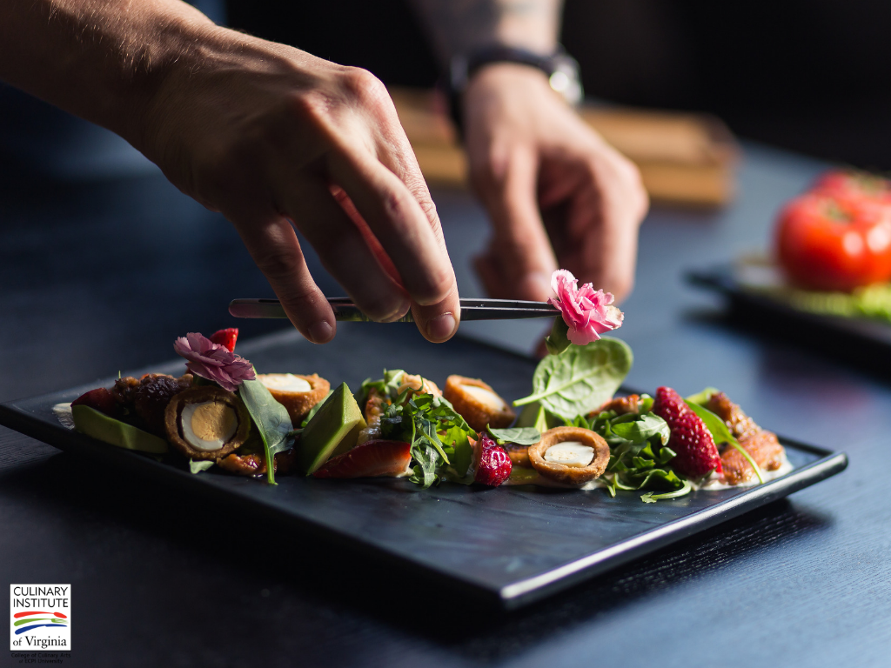

**Figure 1: Culinary Skills**

(Source: Ecpi.edu)

# Market development

Increasing Inquiry: Vegetarian and vegan diets are becoming increasingly popular, which has led to an increase in demand for vegetarian kababs.

Expanding Market: The market for vegetarian kababs is expanding, particularly in nations like India and the United States with a large vegetarian and vegan population.

New Product Creation: To meet the rising demand for vegetarian kababs, businesses are making investments in the creation of new products (Al-Amiri, *et al*. 2019). This includes creating new flavors, packaging, and branding to appeal to various customer groups.

Promotion and marketing: In order to attract new customers and raise awareness of veg kababs, businesses are investing in marketing and promotion. This includes partnerships with restaurants and food bloggers, influencer marketing, and campaigns on social media.

Channels of distribution: Companies selling their products through traditional retail channels, online platforms, and food delivery services are expanding the distribution channels for veg kababs.

All in all, veg kababs are a well-known plant-based dish that is filling in ubiquity because of the rising interest in plant-based food varieties and the ascent of veggie lovers and vegetarians eating less (AL-HASSAWI, *et al*. 2019). The market for veg kababs is extending, with organizations putting resources into new item advancement, promotion, and dispersion channels to satisfy the developing need. Veg kababs are likewise a well-known road food choice and have turned into a combination dish in numerous nations. To meet the rising demand for vegetarian kababs, businesses are making investments in the creation of new products.

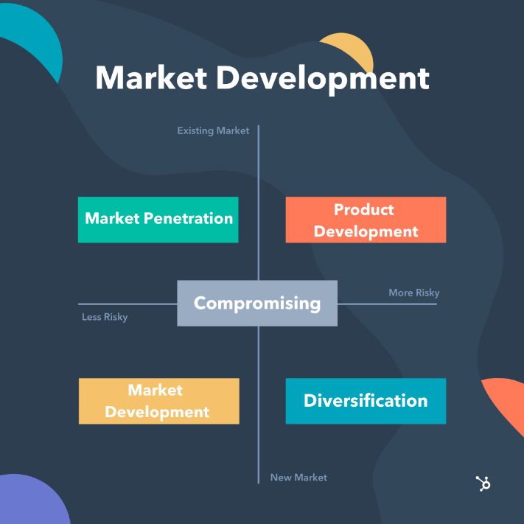

**Figure 2: Market development Process**

(Source: Blog.hubspot.com)

# Development as a commercial product

Homemade veg kabab can be used and launched as a commercial product by creating a new line of the market (Angellin, *et al*. 2019). This innovation process can be achieved in various ways. That are listed below.

**Innovative ingredients:** Unique ingredients can be added to make the product more attractive and flavorful. For instance, one could add yams, beets, or mushrooms to the kabab blend to make another flavor profile.

**Innovation in texture:** To make the mouthfeel of the kababs more interesting, one can experiment with their texture (Hussain, *et al*. 2019). To give the kababs a chewier texture, one could, for instance, incorporate bulgur wheat or quinoa into the mixture.

**Innovation in packaging:** One could bundle the kababs such that makes they are simple to cook and serve (Asha, 2019). For instance, one could offer pre-cooked kababs that can be warmed in the broiler or microwave.

**Marketing innovation:** The group of people who are concerned about their health can be targeted by making veg kabab their choice or the group of people who like spicy food as well as being conscious about their health can choose spicy veg kabab.

**Organization advancement:** One could cooperate with a café or provide food administration to offer kababs as a component of their menu (Dua, and Gandhi, 2019). One would be able to expand the audience and increase product exposure as a result of this.

In general, the way to foster a fruitful business item founded on natively constructed veg kababs is to be imaginative and creative in methodology. One can make a product that tastes good and can be sold commercially by experimenting with different ingredients, textures, packaging, marketing, partnerships, and other aspects. Because of the low amount of fat and calorie, it is beneficial to health. Figuring out how to make veg kababs can be a tomfoolery and remunerating experience.

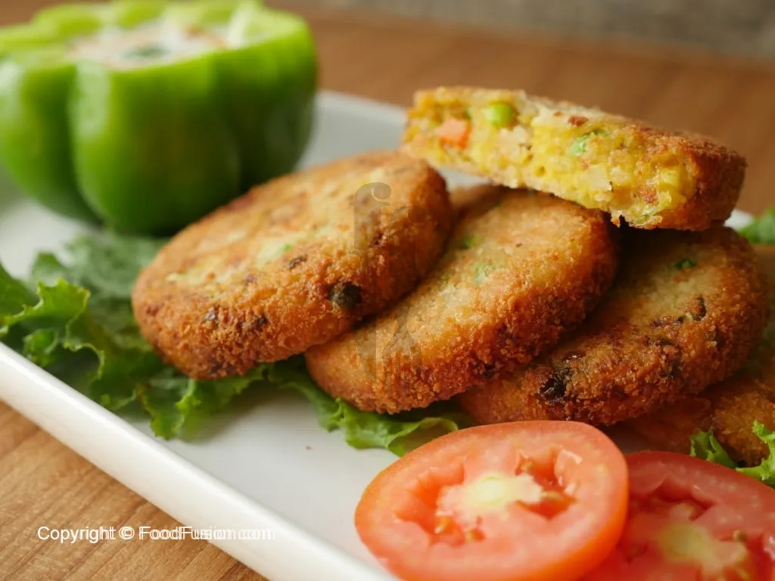

**Figure 3: Development as a commercial product of veg kabab**

(Source: https://www.foodfusion.com)

# Information of a Technical Kind:

Veg kabab is a well-known veggie lover bite or canapé that is produced using different vegetables and flavors (Kumar, *et al*. 2019). The fixings used to make veg kabab may differ relying upon the recipe, yet ordinarily incorporate vegetables like potatoes, carrots, peas, onions, and chime peppers. Coriander, cumin, and gram masala are used to add flavor to the veg kabab.

# Sensory Assessment:

Kababs are generally soft on the inside and crispy on the outside due to frying (Damle, 2019). The fragrance of the kabab is additionally extremely alluring, on account of the mix of flavors utilized in its readiness.

# Information on Nutrition:

Depending on the recipe and the ingredients used, vegetarian kabab may have different nutritional information (Bose, 2019). Be that as it may, by and large, veg kabab is a decent wellspring of starches, dietary fiber, and protein. Because of the low amount of fat and calorie, it is beneficial to health. 100 gm of veg kabab contains around 10gm protein, 2-3 gm of fat, 7-8 gm of fiber, 100-125 gm of calorie, and 200-230 gm of sugar ***[Referred to Appendix 2].***

# Food Security:

While preparing the kabab it is necessary to maintain the internal temperature at around 165°F (74°C) (Kumar, *et al*. 2019). It helps to reduce foodborne diseases and keep the food safe.

# Allergens:

Veg kabab contains some allergens such as nuts, cheese, and white sauce. So it is necessary to list the allergens products by the manufacturer. So that before consuming the product a person should be aware of the ingredients.

# Packaging Methodology

Bundling is a significant part of any item as it guarantees that the item arrives at the client in great shape (Kumar, *et al*. 2019). On account of home-made veg kabab, the bundling ought to be finished such that jelly its newness and taste. When packaging homemade veg kabab, the following steps should be taken:

**Step 1:** **Get the packaging materials ready:** Make certain that One has all of the necessary packaging materials before beginning the process of packaging. One needs containers with lids, aluminum foil, or food-grade plastic wrap.

**Step 2: Cover the kebabs:** Take the kebabs and envelop them with saran wrap or aluminum foil. Guarantee that the wrap is tight so that the kababs don’t get presented to the air. One can likewise utilize impermeable holders to store the kababs.

**Step 3:** **Labelling:** It is essential to mention the expiry date, packaging date, list of ingredients, and product name while labeling the product.

**Step 4: Storing:** After completing the packaging it is necessary to store them below 3 degrees Celsius temperature to keep them safe and hygienic.

**Naming Method:**

Marking is a significant part of the bundling system. Customers receive the necessary product information from it. When putting labels on homemade veg kabab, follow these steps:

**Step 1:** **Select a label:** Select a label that matches the packaging material (Namdev, 2019). One can use a tag or sticker label.

**Step 2:** **Inscribe the product’s name:** Compose the name of the item plainly on the mark. “Homemade veg kabab” will be the one in this instance.

**Step 3:** **Identify the components:** List every one of the fixings utilized in making the kabab. Customers who have dietary restrictions or allergies will benefit from this.

**Step 4:** **Notice the date of planning:** Include the date that the kabab was made (People, and Planet, 2019). Customers will be able to gauge the product's freshness from this.

**Step 5:** **Mention the date it expires:** Notice the expiry date of the item. Customers will be able to tell when the product is no longer safe to consume thanks to this.

**Process of Promotion:** Any business needs to do a lot of promotion. It aids in promoting the product and attracting customers. When promoting homemade veg kabab, the following steps should be taken:

**Step 1:** **Establish a brand:** Make a name for homemade veg kabab as a brand (SHAHISAVANDI, 2019). This helps the customers to recognize the product easily among the various types of available products.

**Step 2:** **Design a logo:** Designing of logo is necessary to make the product identifiable and rememberable.

**Step 3:** **Offer:** Discounts or offers are able to attract a huge section of customers. So, it is necessary to give discounts every now and then to attract customers.

# Preparation of Veg kabab

**Ingredients:**

To plan Veg Kabab, we will require the accompanying fixings:

* boiled mashed potatoes
* garlic paste
* coriander leaves
* green chilies
* ginger paste
* garam masala powder
* coriander powder
* onion powder
* Garlic gloves
* Salt
* onions
* chili flakes
* Olive Oil
* Egg
* Cornflour
* Quorn mince
* Yogurt

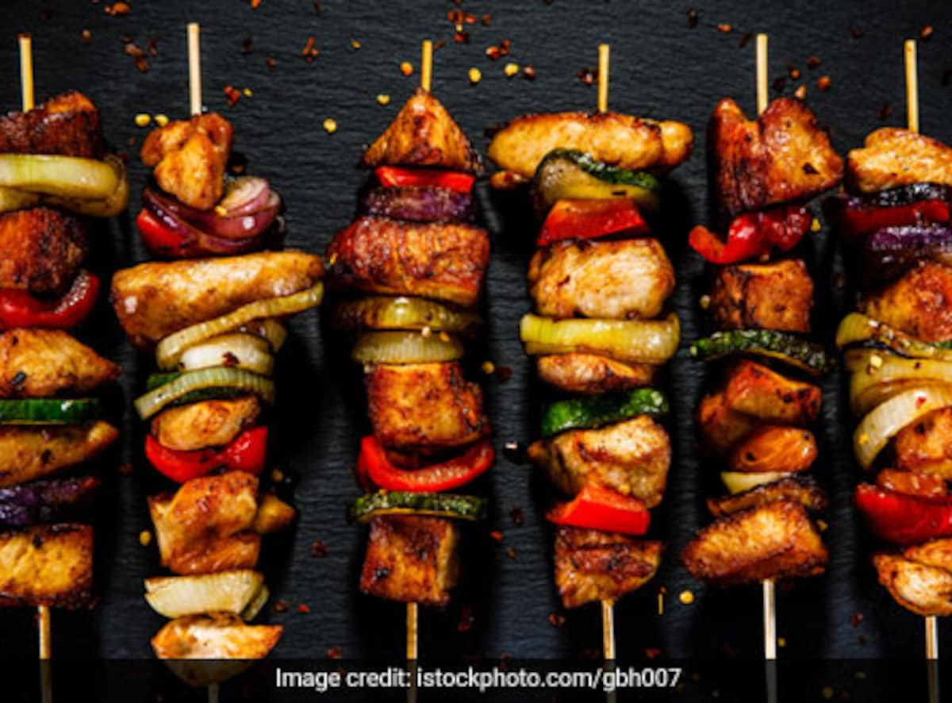

**Figure 4: Veg Kabab**

(Source: Food.ndtv.com)

**Procedure:**

**Step 1:** The vegetables that are used in this recipe are cleaned in warm water and cut into small pieces. Coriander leaves, onion, and green chilies are chopped finely ***[Referred to Appendix 1].***

**Step 2:** Channel the water and crush the vegetables utilizing a potato masher.

**Step 3:** Mix thoroughly the boiled and mashed potatoes into the vegetables.

**Step 4:** To the mixture of the vegetables 1 tablespoon of finely chopped coriander leaves, 1 tablespoon of finely chopped onion, 1g of onion powder, 320 gm of Quorn mince, 1 gm of chili flakes, and ½ tablespoon of finely chopped green chilies are added and mixed thoroughly.

**Step 5:** Then 1 egg is added to the mixture

**Step 5:** After that 1 tablespoon of garam masala powder, 10 gm of Cornflour, salt (as required), 1 tablespoon of garlic paste, and 1 tablespoon of ginger paste are added, and mixed properly. This mixture is done for frying purposes.

**Step 6:** Then yogurt is added to the mixture

**Step 7:** Make kababs by dividing the mixture into equal portions and shaping them.

**Step 8:** Then 10g Olive oil is taken for the frying purpose. In the pan, olive oil is heated at 4 degree Celsius temperature and start to pour the pieces of kabab in the oil. Fry the kababs until all sides are golden brown.

**Step 9:** After frying the kabab, it is placed on tissue paper. The process is done by keeping the tissue papers on the plate. Tissue is used for removing the excess oil from the kabab.

**Serving Thoughts:**

One can serve Veg Kabab as an appetizer or a side dish. It pairs well with tamarind or mint chutney or homemade BBQ sauce. It can likewise be presented with salad and cut onions.

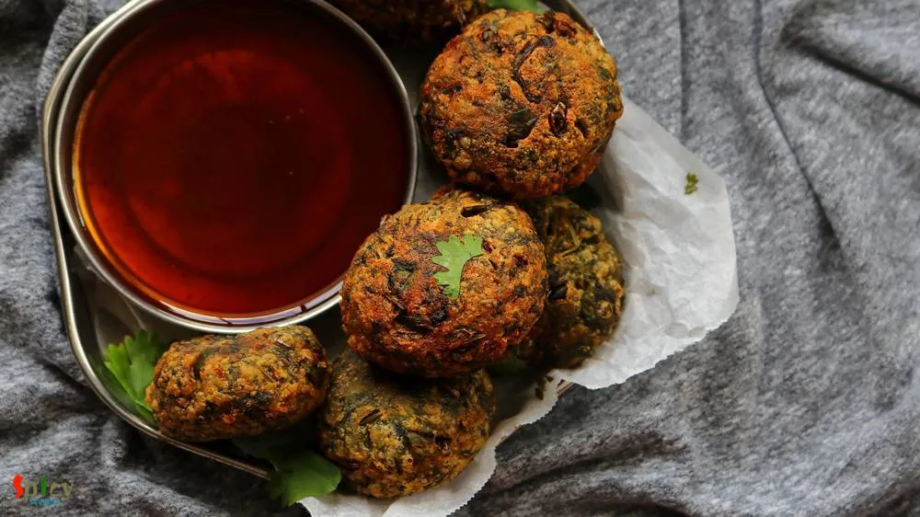

**Figure 5: Serving thoughts of Veg kabab**

(Source: http://spicyworld.in)

**Learning Experience**

If one wants to learn how to make vegetarian kababs, one can start by looking up recipes online or in cookbooks (Sri, and Akash, 2019). Wash and cut any new trimmings, similar to onions or garlic, and measure out the dry trimmings overall. In a pan or skillet, join each of the fixings as per the recipe. Look for recipes that use trimmings and that are inside the cooking skill level. Gather all of the necessary equipment and ingredients after finding a recipe. Pay attention to the cooking times and temperatures because they can affect the texture and flavor of the kababs. Make a rundown of any changes one needs to make for the following time while making the kababs. For instance, alter the cooking time or the seasoning to suit preferences. To wrap things up, taste completed kababs to decide how well it was made. Give careful consideration of what worked out positively and what one could improve the following time. Figuring out how to make veg kababs can be a tomfoolery and remunerating experience. One can make delicious kababs for family and improve skills with practice.

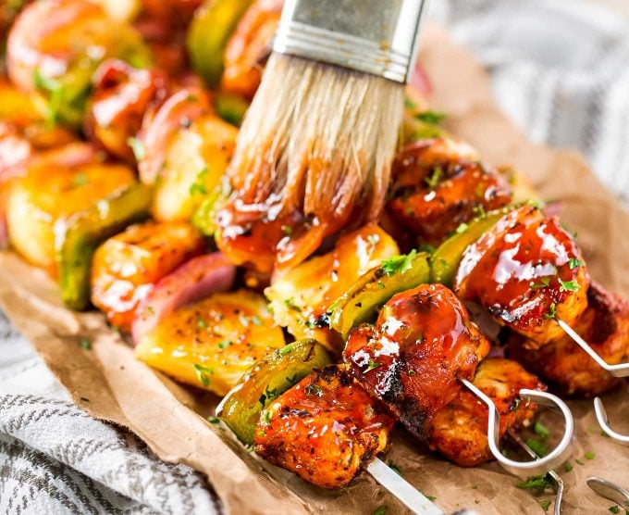

**Figure 6: Veg kabab with BBQ sauce**

(Source: Thechunkychef.com)

# Preparation of BBQ sauce

A delightful fix that is regularly used to improve the kind of barbecued or smoked meat is grill sauce, otherwise called bar-b-que sauce.

Ingredients:

* Ketchup
* brown sugar
* Apple cider vinegar
* Worcestershire sauce
* yellow mustard
* Chili powder
* garlic powder
* Onion powder
* cayenne pepper
* salt
* black pepper,

**Step 1:** In a saucepan, all the mixture is added. Mix well.

**Step 2:** Add 1g of cayenne pepper, 1g of onion powder, 3g of garlic powder, 1 tablespoon of bean stew powder, salt, and black pepper. Combine thoroughly by mixing.

**Step 3:** In the saucepan, it is heated at medium temperature. Diminish the power to low and permit the sauce to stew for 10-15 minutes, blending on occasion.

**Step 4:** Permit the sauce to cool to room temperature subsequent to taking it off the intensity.

**Step 5:** After preparing the sauce it is cooled and stored in below 2 degree Celsius temperature. It can be stored for three to four weeks.

**Tips:**

The sauce can be made smoky by adding fluid smoke to it. Begin with half a teaspoon and increase according to preference.

One can similarly investigate various roads with respect to different sorts of vinegar, similar to red wine vinegar or balsamic vinegar, to add different flavors to the sauce.

Making barbecue sauce is a fantastic way to personalize smoked or barbecued meat. To make the ideal grill sauce, one can begin with this fundamental recipe, however, go ahead and mess with various flavors and fixings (Srivastav, *et al*. 2019). One will soon have a mark sauce that everyone will adore with a little bit of experimentation.

**Serving Thoughts:**

One can serve Veg Kabab as an appetizer or a side dish. It pairs well with homemade BBQ sauce.

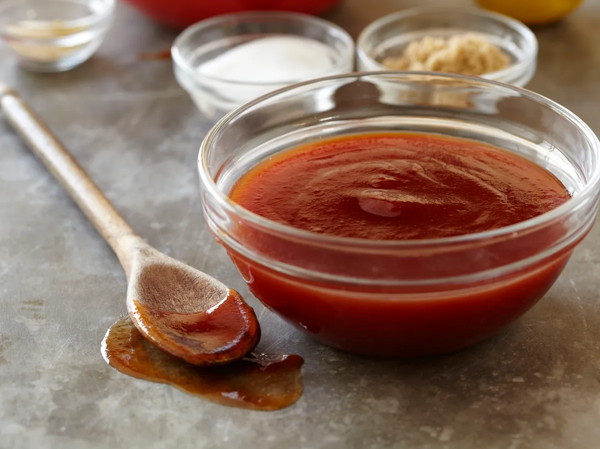

**Figure 7: Preparation of BBQ Sauce**

(Source: http://milestogo.squarespace.com)

**Learning experience**

Figuring out how to make bar-b-que sauce without any preparation can be tomfoolery. Turn upward different bar-b-que sauce recipes on the web or in cookbooks. Peruse a few recipes to find out about the most widely recognized fixings and techniques. Pick a recipe that sounds great or make it by joining components from a few recipes. Go out to shop for each of the fixings one requires for a recipe subsequent to making a rundown of them. A portion of the more uncommon fixings could require an excursion to a specialty store. Wash and cut any new trimmings, similar to onions or garlic, and measure out the dry trimmings overall. In a pan or skillet, join each of the fixings as per the recipe. Stew the sauce over low force, mixing occasionally, until it thickens and the flavors consolidate. Taste the sauce after it has completed the process of cooking and change the flavors if important (Yasmeen, *et al*. 2019). To accomplish the ideal flavor balance, one might have to add extra corrosive, sugar, or salt. Move the sauce to a holder or other airtight fixed compartment and let it cool to room temperature preceding taking care of it in the refrigerator. In the fridge, the sauce will save for a long time. Make a rundown of the things one like and could do without about the recipe as one makes bar-b-que sauce. One should ponder making changes to the recipe in the future to improve it to fit inclinations. One could try and have the option to make unmistakable grill sauce that One can be glad for with enough practice.

# Conclusion

Bar-b-que sauce is a versatile fix that can be utilized to work it up in dishes, from barbecued vegetables to stewed meats. With a little practice and trial and error, you can make bar-b-que sauce and hand-crafted vegetable kababs that will impress your loved ones. In place of meat drippings or stock, vegetarian and vegan barbecue sauces can be made with vegetable broth or other non-animal ingredients in the traditional recipe. In recent years, ethnic cuisine, particularly Indian and Middle Eastern cuisine, has grown in popularity, and vegetarian kababs have emerged as a popular ethnic food option in many nations. To accomplish the ideal flavor balance, one might have to add extra corrosive, sugar, or salt. Move the sauce to a holder or other airtight fixed compartment and let it cool to room temperature preceding taking care of it in the refrigerator. In the fridge, the sauce will save for a long time. In general, the way to foster a fruitful business item founded on natively constructed veg kababs is to be imaginative and creative in methodology. One can make a product that tastes good and can be sold commercially by experimenting with different ingredients, textures, packaging, marketing, partnerships, and other aspects.

# Reference list

**Journal**

Alam, M.S., Shahriar, S.H.B. and Biswas, K., 2021. Deriving Some Marketing Insights from the Kachhi Biryani Market in New Dhaka. *Developing Resilience in Disruptive Times: Insights from Strategic Management*.

Al-Amiri, H.A., Ahmed, N. and Al-Sharrah, T., 2020. Fatty acid profiles, cholesterol composition, and nutritional quality indices of 37 commonly consumed local foods in Kuwait in relation to cardiovascular health. *medRxiv*, pp.2020-11.

AL-HASSAWI, F.A.T.I.M.A., GOSAL, M.S., AGGARWAL, P. and SIDHU, J.S., Studies on the Development of Processed Products from Buffalo Veal.

Angellin, M.E., Tarugu, J., John, M.S., Silpa, M.C., Rajeswari, M. and Beulah, M., Inspire zone.

Asha, S.R., 2019. Branding Practices of Kazi Food Industries Limited: A Case Study on Bellissimo and Za'n Zee Brands.

Bose, I., Culinary Chroniclers of Bengal: Pioneering Bengali Women’s Cookbooks. In *Proceeding of*.

Damle, I.K., *Submitted to* (Doctoral dissertation, Rashtrasant Tukadoji Maharaj Nagpur University).

Dua, S. and Gandhi, M., 2019. Sindhi Cuisine: A Study Of Evolution And Eating Habits. *PUSA Journal of Hospitality and Applied Sciences*, *5*, pp.71-78.

Hussain, Z., Naz, H., Naz, M.Y., Gulab, H., Sulaiman, S.A., Khan, K.M. and Shukrullah, S., 2019. Catalytic and noncatalytic conversion of spent fat oil into combustible gases and liquids. *Journal of Renewable and Sustainable Energy*, *11*(2), p.023102.

Kumar, K., Patil, R., Chinnappa, B. and Manjunatha, G.R., 2019. Economic analysis of value chain management in broiler chicken. *Indian Journal of Poultry Science*, *54*(2), pp.169-174.

Kumar, M., Parimita, P.A. and Agarwal, S., 2023. Market Survey On Consumption Pattern Of Street Food Products In Prayagraj District. *Journal of Pharmaceutical Negative Results*, pp.155-162.

Kumar, N. and Pandey, P.C., Food Tourism: An Important Component for Marketing of Destination in India. *Local Food and Community Empowerment through Tourism*, p.285.

Namdev, M.K.A., 2019. Growth Of Tourism And Food Industry. *Think India Journal*, *22*(38), pp.189-195.

People, H. and Planet, A.H., 2021. Novel Plant-Based Meat Analogues.

SHAHISAVANDI, M., 2023. DISCOVER THE JEWELS IN IRANIAN FOOD. *International Journal of Intellectual Cultural Heritage*, *3*(2), pp.1-14.

Sri, V.A. and Akash, S., 2022. A Study On Immigrant Experiences Of Mrs. Sen And Ashima Ganguly In Jhumpa Lahiri’s Interpreter Of Maladies And The Namesake. *Journal of Language and Linguistic Studies*, *17*(4).

Srivastav, D., Goel, M.G.J. and Tripathi, M.S., 2021. Examining the Potentiality of Growth of Fusion Cuisine in Meerut.

Yasmeen, I.K.F., Ahmad, J., Abdullah, A., ud Din, Z., Iqbal, Z. and Iqbal, M., Developing a meal-planning exchange list for commonly consumed Pakistani dishes.

# Appendices

**Appendix 1: Ingredients used in the recipe**

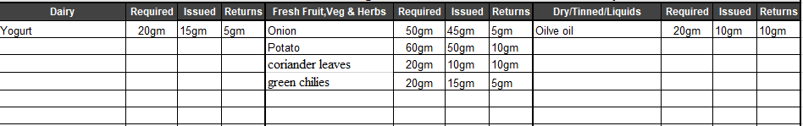

(Source: Self-created)

**Appendix 2: Nutritional list**

|  |  |
| --- | --- |
| **Nutrients** | **Quantity** |
| Fat | 2-3gm |
| Protein | 10gm |
| Fiber | 7-8gm |
| Calorie | 100-125gm |
| Sugar | 200-230gm |

(Source: Self-created)