**PYTHON IMPLEMENTATION FOR CALCULATION**

**TABLE OF CONTENTS**

Calculating Mean 3

Calculating Median 3

Calculating Mode 4

Taking User Input 4

Calling the Function 5

Results 5

Reference List 6

# Calculating Mean

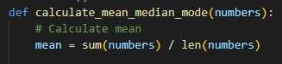

**Figure 1: Function for defining the mean**

(Source: Self-created using VS code)

The function has been created for calculating the mean for a particular sequence of numbers. The code has been written in the Visual Code Studio and has been written in Python Programming Language.

# Calculating Median

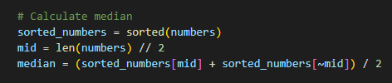

**Figure 2:** **Function for defining the median**

(Source: Self-created using VS code)

The function has been created for calculating the median for a particular sequence of numbers (Sahoo *et al.* 2019). The code has been written in the Visual Code Studio and has been written in Python Programming Language.

# Calculating Mode

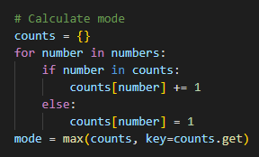

**Figure 3:** **Function for defining the mode**

(Source: Self-created using VS code)

The function has been created for calculating the mode for a particular sequence of numbers. The code has been written in the Visual Code Studio and has been written in Python Programming Language.

# Taking User Input

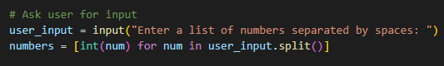

**Figure 4: Asking for User Input**

(Source: Self-created using VS code)

The code has been written in Python Programming Language using VS code. The code has been written for taking user inputs for the calculation of mean, median, and mode.

# Calling the Function

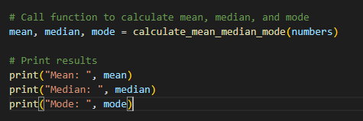

**Figure 5: Calling the functions and printing**

(Source: Self-created using VS code)

The code has been written for finding the mean, median, and mode for a particular sequence of numbers. The results for mean, median, and mode have been printed individually. The code has been written in the Python Programming Language using VS code.

# Results

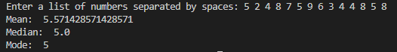

**Figure 6: Output of the function**

(Source: Self-created using VS code)

The output for the function has been provided in the above snip. A certain list of numbers has been given input at random (Subasi, 2020). The mean has been calculated to be 5.57, the median has been calculated to be 5.0, and the mode has been calculated to be 5.

# Reference List

**Journal**

Sahoo, K., Samal, A.K., Pramanik, J. and Pani, S.K., 2019. Exploratory data analysis using Python. International Journal of Innovative Technology and Exploring Engineering (IJITEE), 8(12), p.2019.

Subasi, A., 2020. Practical machine learning for data analysis using python. Academic Press.