**UNDERSTANDING TRENDS & FORECASTING**

**TABLE OF CONTENTS**

Task 1: Brand and Trend Research & analysis 3

Task 2: Contextual awareness 4

Task 3: Peer Review of Tasks 1 6

Task 4: Trend Ideas 8

Reference List 9

# Task 1: Brand and Trend Research & analysis

**SLIDE 1: TITLE PAGE**

**SLIDE 2: SAMSUNG COMPANY**

* Samsung is leading in chip making.
* The chips are sustainable, fast processing, and consume less power.
* The company is focused on customer-oriented innovations.

**SN:** The selected brand is Samsung. The company is leading in chip making. The company is ahead of its competitors in the performance of Smartphones (Haizar *et al.* 2020). The generation of new chips, allows fast processing, reduced consumption of power, and also the sustainable type of performance over a long time period. The company is successful due to its innovations that are mostly oriented toward the customers. Huge investments are made by the company in the R&D sector.

**SLIDE 3: TRENDS OF SAMSUNG**

* The company has trending Galaxy devices that have multitasking capability.
* The expansive and leverage crisp screen that provides options for using multiple apps.
* Office productivity is enhanced as it allows easy access to MS Office and Google Workspace.

**SN:** The Company has the capability of multitasking as it has preferred Galaxy devices. The Galaxy devices leverage crisp and expansive screens that provide users with a wide variety of options to work with multiple apps (Han *et al.* 2022). There are different features of Samsung smartphones, such as Galaxy Note II. This has allowed for multitasking experiences. It has a wider range of ecosystems of apps on the Android device. This also enhances office productivity by provisioning easy access to Google Workspace and MS Office.

**SLIDE 4: TARGET CUSTOMER**

* The target audience of Samsung varies from the 15- 45 age group.
* The audience follows the latest technologies and trends.
* The mobile has unique features that attract customers.

**SN:** The target audience of Samsung varies from the age group of 15 - 45 who is following the latest trends in technology. The lifestyle of the customers is based on huge consumption of TV and other digital media as they are engaged with local series of TV along with celebrities and other aspirational lifestyles. Mobile phones have power sharing and a battery that is long-lasting.

**SLIDE 5: STRATEGY OF SAMSUNG COMPANY**

* The company adopt dynamic changes and produce a diverse range of product for customer satisfaction.
* The competitive advantage of the company is innovative research, cost-effectiveness, and unparalleled features.
* A wide range of electronic product is produced like smart TV, watch, monitor, memory storage, etc.

**SN:** The strategy of the Samsung Company is the development of the marketing trends by adapting the dynamic changes and different products are produced to satisfy the target demands. The company is a brand that is customer-centric that offers a diversified product to its customers (Abdelshafie *et al*. 2021). The product range of the company varies from smartphones and other related accessories like watch, smart TV, memory storage, and monitor.

**SLIDE 6: FUTURE TECHNOLOGY**

* The company is focused on introducing foldable phones.
* Different technological innovations are adopted to bring new products to its customers.
* A wide range of mobile phones are manufactured by the company with different features.

**SN**: The Company is focused on the new technology of foldable phones. The company is popular for the wide range of products that the company has manufactured (Siriram, 2022). This includes Galaxy S23 Ultra, Galaxy Tab S8, etc. The competitive advantage of the company is technology cutting edge, innovative research, cost-effectiveness, and also unparalleled features of the product.

**SLIDE 7: REFERENCE LIST**

**SLIDE 8: THANK YOU**

# Task 2: Contextual awareness

The PESTEL Analysis of Samsung Company is as follows:

|  |  |
| --- | --- |
| **Political**   * The company operates in a market with benign marketing factors. * The company has faced headwinds politically in South Korea. * An unstable political environment exists in some parts of America. | **Economic**   * The company has expanded its global footprint due to the existence of its markets worldwide. * Samsung operates in a macroeconomic environment that is unstable in nature. |
| **Socio-Cultural**   * In spite of being a multinational company, its main core is a Korean company. This causes difficulty in adapting to the local condition. * The company is required to adopt local strategies in the emerging market (Haizar *et al.* 2020). It has tailored the products according to the preference of the consumer. | **Technological**   * It is the leader of innovative companies throughout the world. The company harnesses the power of technology and adapting innovation for the purpose of sustainable business. * The company successfully beat its competitors and rivals to be the first to reach customers with innovative products. |
| **Legal**   * Samsung has faced various penalties due to its limitation on iPhone and Apple’s iPad. * The company has faced issues related to getting approval from consumers and public perceptions while considering its strategies. | **Environmental**   * The growth of ethical consumer that wants to choose a brand whose products are made in an environmentally and socially responsible manner. * The company is to be concerned not to compromise with the working condition or wage payment to laborers who are involved with the making of the final product (Han *et al*. 2022). |

**Trend Mapping of Samsung**: The Company is focused on Technological Development. The company has changed its image from high- a quality, stylish brand that is attractive to customers. The company is focused on making products that are reliable. The technique of education is used for building awareness among the customers. This has revealed that products of Samsung cut the technological edge and are worth for money.

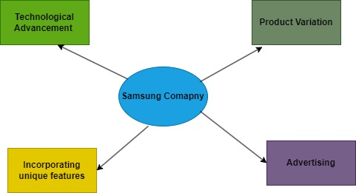

**Figure 1: Trend Mapping**

(Source: Self- created in draw.io)

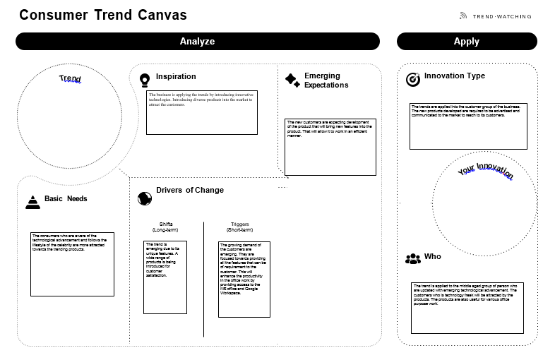

**Figure 2: Customer Trend Canvas**

(Source: Self- created)

# Task 3: Peer Review of Tasks 1

Task 1 is focused on the Samsung Company and its different trends. The process of trend clustering is used to review the task. The task is focused on the trends that the company has developed which is helpful in generating sales. A diverse product range is produced that will attract the customer to use the unique products. The company is focused on producing products that are customer-oriented. The Samsung Company's strategy is the creation of marketing trends by reacting to dynamic changes and the production of various products to meet target demands. The business is a consumer-focused brand that provides a wide range of products to its clients. Cutting-edge technology, creative research, cost-effectiveness, and unmatched product characteristics are the company's competitive advantages. The company offers a variety of products, including smartphones and related peripherals like watches, smart TVs, memory storage, and monitors.

The corporation is able to multitask because it favors Galaxy smartphones. The Galaxy devices make use of clear, generous screens that give consumers several possibilities for interacting with numerous programs. Samsung smartphones have a variety of features, including the Galaxy Note II. This has made it possible to multitask. The Android device has a greater variety of app ecosystems. Allowing simple access to Microsoft Office and Google Workspace also improves office productivity. The different features of the mobile phone that the company provides are helpful in different sectors of life. Samsung's target market is made up of people who are interested in the newest technological developments and range in age from 15 to 45. In order to keep up with local TV programs, celebrities, and other aspirational lifestyles, the customers' lifestyle is centered on heavy TV and other digital media consumption. Power sharing and a long-lasting battery are features of mobile phones. This is the reason why the customer prefers to use Samsung mobile phones.

# Task 4: Trend Ideas

The communication and marketing of Samsung are as follows. Marketing communication of Samsung Company utilizes different communication channels of marketing like media advertising and prints, sale promotion, experiences, and events, and thus helps in building public relations. These channels are used in an integrated manner.

**Advertising**:

Media and print advertising is the main element of the marketing mix. The main feature of its advertising strategy of Samsung Company is that the multinational company advertises only the specific type of products like Note Smartphones and Galaxy S, but is not focused on advertising the brand of the company (Nguyen and Kravets, 2023). The print advertising of the company in popular magazines, newspapers, and also journals includes direct attacks from major rivals like Apple. The company also uses viral marketing which is the most effective type of advertising method.

**Sales Promotion**:

Sale promotion is used by the company as a tool for marketing in comparison to other competitors. The various promotion techniques used by the company are as follows:

**Reward program of Samsung**: It is a system that is point based where certain points are awarded for qualified types of purchases. The points allow choosing rewards from the catalog that is featuring everything from the latest products of Samsung to gift cards.

**Point for the supply of sales**: Aesthetic display stands and effective product presentation are features of Samsung Retail Store designs.

**Presentations that are free**: When clients buy another product from Samsung, occasionally they get a free product. For instance, the business provided complimentary Gear 360 cameras, 128GB memory cards, and “Quick Wireless Charging Convertibles” to the persons who have purchased a “Samsung Galaxy Note 8” device (Nguyen and Kravets, 2023). This is a selling strategy that is adapted to draw the attention of the customer towards a certain product and make them believe that they are making huge profits. In this way, marketing and communication have helped to reach a wider number of customers and thus increase sales. Presenting unique products in such a form will acquire customer attraction to buy the product.

# Reference List

**Journals**

Abdelshafie, A., Fatouh, T. and Rashid, M., 2021. Trends and Practices of Reverse Logistics in Electronic Industry: A Case Study of Samsung Company. *Global Business & Management Research*, *13*(3).

Chumnumpan, P. and Shi, X., 2019. Understanding new products’ market performance using Google Trends. *Australasian marketing journal*, *27*(2), pp.91-103.

de Medeiros, A.H.G., 2020. *Equity Research-Samsung Electronics Co., LTD* (Doctoral dissertation, Universidade de Lisboa (Portugal)).

Haizar, N.F.B.M., Kee, D.M.H., Chong, L.M. and Chong, J.H., 2020. The impact of innovation strategy on organizational success: A study of Samsung. *Asia Pacific Journal of Management and Education (APJME)*, *3*(2), pp.93-104.

Han, F., Yoon, S., Raghavan, N. and Park, H., 2022. Investigating Company’s Technical Development Directions Based on Internal Knowledge Inheritance and Inventor Capabilities: The Case of Samsung Electronics. *Sustainability*, *14*(5), p.3117.

Li, X., Fan, M., Zhou, Y., Fu, J., Yuan, F. and Huang, L., 2020. Monitoring and forecasting the development trends of nanogenerator technology using citation analysis and text mining. *Nano Energy*, *71*, p.104636.

Liu, L.L. and Chiang, C.H., Patent Trend Analysis: Extended Reality (XR) and Future Virtual Adventure.

Nguyen, T.V. and Kravets, A., 2023. A Novel Method for Predicting Technology Trends Based on Processing Multiple Data Sources. *Advances in Systems Science and Applications*, *23*(01), pp.69-90.

Singhal, S., Anand, A. and Singh, O., 2020. Studying dynamic market size-based adoption modeling & product diffusion under stochastic environment. *Technological Forecasting and Social Change*, *161*, p.120285.

Siriram, R., 2022. Forecasting new product growth. International Journal of Foresight and Innovation Policy, 16(1), pp.33-65.