**MOLECULAR PHARMACOLOGY & TOXICOLOGY**

**TABLE OF CONTENTS**

Section A 3

Question 1 3

Question 2 4

Question 3 4

Question 4 7

Question 5 8

Question 6 9

Question 7 10

Question 8 12

Section B 14

Question 9 14

Reference list 15

# Section A

## Question 1

**Agonism -** Agonism is defined as a process in which a drug or substance can bind the receptor which may present either on the cell surface or inside the cell. The drug may show the same efficacy as the natural substance that generally binds to the natural receptor. In other words, agonism can act in both the function that is it can bind to the target receptor and also can increase the efficacy of the target receptor molecule at its specific function.

**Inverse agonism -** Inverse agonism is the process played by the inverse agonists. An inverse agonist can bind to the same receptor binding site as the agonist. But the inverse agonist not only antagonizes the effect of agonists, it also shows the inverse effect of the agonist thus it suppresses the regular activity of the receptor molecule. Therefore the normal receptor-ligand signaling pathway becomes downregulated. The inverse agonist decreases the basal activity of the regular receptor-ligand signaling activity.

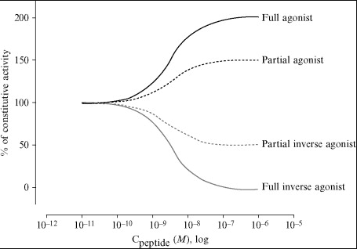

**Figure 1: Dose responsive curve for agonist and inverse agonists**

(Source: https://ars.els-cdn.com/content/image/1-s2.0-B9780123812964000063-f06-02-9780123812964.jpg)

However, the main difference between agonism and inverse agonism relied on the efficacy of the agonist and the inverse agonist. According to the above dosage responsive curve, it can be said that the agonist exerts the full efficacy on its receptor-ligand binding signaling pathway that is 100 percent or above 100 percent. On the other hand, the inverse agonist shows an efficacy below 100 percent and sometimes tends to 0 in case of the presence of a full inverse agonist which means the negative activity on the target molecule. As the function agonist and inverse agonist has an opposite function, thus, it can be said that the agonists show intrinsic efficacy which means they can increase the activity of the receptor molecule whereas the inverse agonist exits the negative intrinsic efficacy which means it lower the receptor activity.

## Question 2

The main aim of the written by Wisler *et al.*,2007, is to find out one adrenergic receptors (AR) antagonist among 16 AR antagonists which can show unique activity in signaling pathways where their main hypothesizes that carvedilol displays a unique profile in vitro signaling characteristics mainly for the treatment of cardiovascular disease mainly in heat disease, and as the new therapeutics of beta-2AR ligands. Here, carvedilol displays unique efficacy in arrestin-dependent and Gs-dependent cellular signaling pathways whereas carvedilol shows negative efficacy in Gs-dependent AC activation and positive effectiveness in arrestin-dependent ERK 1/2 activation.

## Question 3

#### **G Protein Independent Signaling of the B2- adrenergic receptor**

The heart, skeletal muscles, and the lungs contain a specific class of protein known as the beta-2 adrenergic receptor on the cell surfaces of the mentioned tissues. As one of the numerous adrenergic receptors, it answers to the chemical, adrenaline (epinephrine) as well as to norepinephrine. Various physiological reactions are set off when the beta-2 adrenergic receptor is initiated by adrenaline or related agonists. These responses incorporate a relaxing of smooth aviation route muscles, an expansion in pulse and circulatory strain, and an expansion in the degradation of glycogen in skeletal muscles. Thus, beta-2 agonists are periodically utilized by specialists as reasonability redesigning drugs and as bronchodilators for treating diseases such as asthma and other respiratory issues. Beta-blockers, then again, are utilized to treat coronary illness, angina, and hypertension. They prevent beta receptors from working.

#### 

#### **Figure 2: G Protein Independent Signaling**

(Source: Self-Created)

It has been proven that beta-arrestins increase the heart's and cardiomyocytes' capacity to contract. The study demonstrated that AT R-β-arrestin-dependent signaling improves contractility in isolated adult mouse cardiomyocytes by using AT R agonists directed against arrestin that does not activate Gq/11 protein. Recent studies using a particular -arrestin-biased AT1R ligand have confirmed the necessity of β-arrestin 2 in mediating the Gq/11-protein-independent force of contraction in response to AT1R activation. Furthermore, unbiased AT R stimulation with Ang II caused cardiomyocytes lacking -arrestin 2 to respond less vigorously in terms of contractility, indicating that -arrestin 2-mediated effects overexcitability might not be replicated in relation to Gq/11 protein-dependent signaling. Synthetic AT R peptide ligands with a preference for arrestin improve cardiac contractility when present. In contrast to traditional AT R blockers, these AT R ligands targeted to arrestin did not alter stroke volume despite increasing cardiac contractility and reducing blood pressure (https://www.ahajournals.org/doi/10.1161/CIRCRESAHA.110.231225).

G Protein Dependent Signaling of the B2- adrenergic receptor

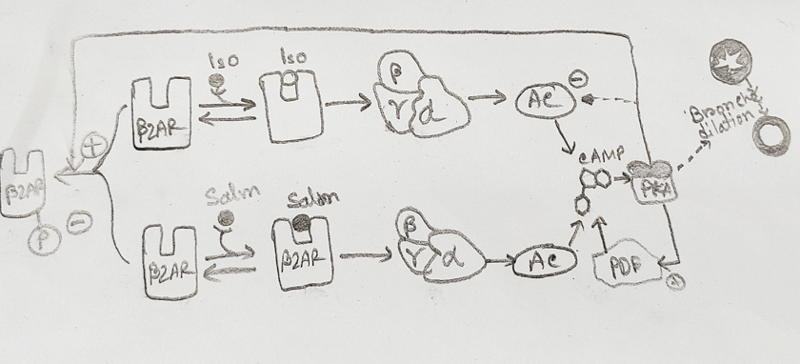

**Figure 3: G Protein Dependent Signaling**

(Source:Self-created)

G proteins are seen to belong to a family of proteins, that are seen to be transmitting signals upon the interaction of a number of stimuli that are interacting with particular receptor types. They are seen to be associated with the abilities to effectively bind with the guanine nucleotides, like that of GDP (guanosine triphosphate) along with GDP (guanosine diphosphate). The alpha (α), beta (β), and gamma (γ) are seen as the three subunits that are associated with the G proteins. A binding site for GTP is seen to be associated with that of the alpha subunit of G protein which on being activated, mediates the exchange of GDP with that of GTP. Such actions lead to conformation changes within the structure of the protein which allows the protein to effectively interact with that of the downstream effectors. Such downstream effectors within the physiological system include the several ion channels, along with the enzymes that will aid in the generation of the signaling cascades. G proteins are seen to consist of two major classes, the Gs protein which is seen to activate adenylate cyclase in order to increase the intracellular levels of cyclic AMP (cAMP). Apart from the Gs protein another class is the Gi protein, that are seen to associate with the inhibition of the adenylate cyclase which mediates the decrease in the levels of cAMP levels. Various types of G proteins, for instance, Gq and G12/13, drive downstream effectors through different pathways. G protein-coupled receptors (GPCRs) are a colossal gathering of transmembrane receptors that start G proteins subsequent to confining extracellular ligands. They accept critical parts in various physiological cycles, similar to vision, taste, olfaction, compound emanation, and neurotransmission. The degradation of G proteins or GPCRs can provoke different ailments, including sickness, cardiovascular issues, and neurological issues.

β-AR signaling raises heart rate and contractility is supplied by Gs protein activity. The adenylyl cyclase (AC) enzyme generates cAMP in response to β-AR stimulation, which then activates protein kinase A (PKA). The L-type calcium channel (LTCC), phospholamban (PLB), ryanodine receptor, cardiac myosin-binding protein C, and the cardiac troponin I (cTnI), are just a few of the substrates that PKA signaling phosphorylates to enhance contractile function, as persuasively discussed elsewhere. The phosphorylation of the ryanodine receptor, LTCC, TnI, and cardiac myosin-binding protein C by PKA, as well as the release of PLB's inhibitory impact on the SR calcium ATPase and promotion of Ca2+ SR storage, all contribute to the addition of much-needed creativity and lusitropic effects of adrenergic stimulation. Furthermore, PKA-mediated phosphorylation of Ca2+ handling proteins like ryanodine receptor and PLB as well as membrane ion channels and tightens control of Ca2+ cycling and heart rhythm in pacemaker cells (https://www.ahajournals.org/doi/10.1161/CIRCRESAHA.110.231225).

## Question 4

HEK-293 is a human cell line that has been used in the study of Carvedilol stimulates -arrestin signaling. The cell line has 64 chromosomes that can stably express β-2 adrenergic receptors and thus it was selected for the experiments in the Wisler *et al*. study. The HEK-293 cell is very important for this study because it can successfully express β-2 adrenergic receptors which is a cell surface receptor that shows various physiological functions in the human body in the cardiovascular and pulmonary systems. As this study is related to the cardiovascular system, which is related to beta blockers that release different stress hormones like non-epinephrine, and epinephrine helps to prevent heart failure, and heart rate-related problems, and also to control blood pressure.

## Question 5

**Isoproterenol**

Isoproterenol is an agonist of beta 1 and beta 2 adrenergic receptors and increases heart contractility and thereby increasing heart rate and leading to a heart attack. On the other hand, beta-blockers help to treat cardiovascular disease such as it helps to regulate the systemic heart rate and blood flow, preventing heart failure, etc. However, the agonists of the beta blocker mean it does the opposite action of beta 1 and beta 2 AR. Beta 2 adrenergic receptor has a low affinity towards the beta-arrestin in the plasma membrane after internalization. However, the class B receptor, vasopressin V2 shows more affinity towards the beta-arrestin. Thus, to increase the affinity of beta-arrestin towards the Beta 2 adrenergic receptor, a chimera has been produced that is a beta 2AR-V2R receptor chimera where isoproterenol induces the internalization of beta-arrestin with GFP tagged but in this study, it has been proved that isoproterenol stimulates around 38 percent internalization with compare to the Carvedilol.

**Propranolol**

Propranolol is act as the inverse agonist of GS-dependent adrenergic receptors activation which can weakly activate Extracellular signal-regulated kinase (ERK) which helps in the treatment of hypertension by doing active vasocontraction. In this study, HEK-293 cells stably express beta 2 adrenergic receptors that help in the activation of ERK ½ but the activation response of this can be checked by different antagonists where propranolol is one of them in this study. The researcher, used different partial agonists which showed weak agonism for GS-dependent adrenergic receptors activation, however, these partial agonists did not show enough efficacy for the generation of cyclic AMP. Therefore, propranolol, along with other inverse agonists used in the accumulation of cyclic AMP. Thus, propranolol is considered the only agonist which can function as the inverse agonist in GS-dependent adrenergic receptors activation but it cannot efficient in beta 2AR phosphorylation.

## Question 6

Beta-2ARTYY mutant can not bind with G protein but it can maintain the MAP kinase stimulation. As this experiment has been done based on both the presence and absence of G protein thus such anadrenergic receptor requires which must be uncoupled with the G protein therefore, this mutant adrenergic receptor has been used.

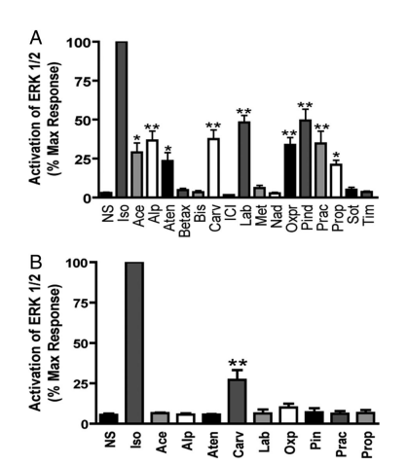

**Figure 4: ERK activation in beta-2AR and beta-2ARTYY stable cells**

(Source: www.pnas.org)

The above diagram describes the ERK 1/2 Activation in presence of beta-2AR and beta-2ARTYY which can stably be expressed by HEK-293 cells. Where figure 2(A) describes the ERK 1/2 activation in beta-2AR and figure 2(B) describes ERK 1/2 Activation in beta-2ARTYY. In figure 2A, It has been documented that beta-arrestins can operate as scaffolding to activate signaling networks like ERK 1/2 without the need for the activity of G protein. Despite none of the beta-AR antagonists they investigated activating ERK1/2 in untransfected HEK-293 cells, we found that different beta-AR antagonists can produce a variety of ERK 1/2 activation responses in HEK-293 cells that are stable in producing 2 pmol/mg beta-2AR. ERK is activated in variable degrees by acebutolol, atenolol, alprenolol, carvedilol, labetalol, oxprenolol, pindolol, practolol, and propranolol. They employed a mutant beta-2AR called beta-2ARTYY, which does not bind to G proteins but still has the capacity to activate MAP kinases, to ascertain the function of G protein stimulation in these ERK1/2 events.

In Figure 2B, In cells that were consistently expressing the deletion mutation beta-2ARTYY, only carvedilol significantly triggered an ERK1/2 response. Gi-coupled has no role in carvedilol-stimulated pERK because it is insensitive to pertussis toxin from before administration through either receptor. Additionally, beta-2AR specificity was confirmed by the complete inhibition of carvedilol-stimulated pERK following injection of the beta-2AR antagonist.

## Question 7

In this study, the beta-arrestin2 siRNA is used for the maintenance of the activation of extracellular regulated kinase 1/2 (ERK 1/2). Here, siRNA is used to reduce the cellular level of beta-arrestin 2 by. The siRNA here shows the silencing effect to express the beta-arrestin 2 level.

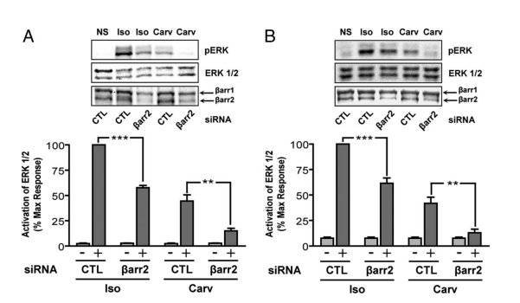

**Figure 5: Carvedilol-stimulated ERK 1/2 phosphorylation is abolished by siRNA targeting beta-arrestin2**

(Source: https://www.pnas.org/doi/abs/10.1073/pnas.0707936104)

ERK activation is mediated by beta-arrestin2. By observing the activation of ERK ½ in HEK-293 cells that consistently express beta-2AR when beta-arrestin2 was knocked down by siRNA, we looked into the potential role of -arrestin in carvedilol-stimulated cell signaling. Figure 5A shows that at 5 minutes, pERK decreased for both carvedilol and isoproterenol by 71.0 4.5% and 42.3 2.2%, respectively. After 5 min of beta-arrestin2 silencing, pERK for isoproterenol decreased by 38.5 5.2% in HEK-293 cells that were persistently expressing beta-2ARTYY, whereas pERK for carvedilol decreased by 70.1 4.4% shown in Figure 5B.

Both of these results were in line with the siRNA's general ability to reduce beta-arrestin2 quantities in cells by 70%. The silencing effect's precision was demonstrated by the similar results that were achieved when a second siRNA targeting -arrestin2 was utilized. It should be noted that the isoproterenol-stimulated ERK activation seen in cells expressing beta-2ARTYY after siRNA silencing of -arrestin2 was triggered by G peptides, not the mutant receptors, and occurred in HEK-293.

## Question 8

In this study, carvedilol is used as the non-subtype selective beta-adrenergic receptor helps in the treatment of heart failure. In this study, carvedilol shows the unique function i9n the inverse efficacy in the enhancing of GS-dependent adenylyl cyclase but it cannot phosphorylate the cytoplasmic tail of the receptor-kinase site of G protein-coupled receptor, attachment of beta-adrenergic receptors to the beta-arrestin, the internalization of the receptor, extracellular regulated kinase 1/2 (ERK 1/2) activation maintaining by G protein-uncoupled mutant beta-2ARTYY. In this study, carvedilol is used in the accumulation of cyclic AMP as the inverse agonist. It also helps in the activation of ERK ½ along with the stimulation of

ERK1/2 response significantly. Carvedilol stimulates the phosphorylation of ERK. In this study, carvedilol was used only beta-AR antagonists can act as inverse agonists in AC activation in the presence of G protein. On the other hand, carvedilol, can effectively, stimulate the phosphorylation of beta-2 AR. With an evidence, it acn be said that, carvedilol stimulated around 2 fold phosphorylation in the receptor at the site of GRK at 255 and 266 serine residue.

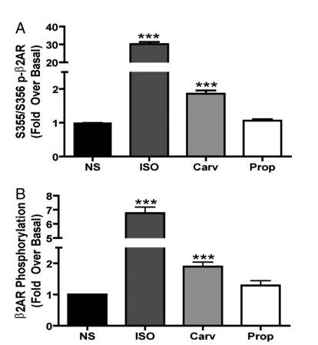

**Figure 6: Beta-2AR phosphorylation stimulated by carvedilol**

(Source: https://www.pnas.org/doi/abs/10.1073/pnas.0707936104)

By functioning as an agonist of beta 1 and beta 2 adrenergic receptors, isoproterenol increases heart contractility and heart rate, which might cause a heart attack. Contrarily, beta-blockers help treat cardiovascular disease by, among other things, controlling blood flow and heart rate throughout the body, preventing heart failure, etc. But because of its agonists, the beta blocker works against beta 1 and beta 2 AR. The beta-arrestin in the plasma membrane has a poor affinity for the beta-2 adrenergic receptor after internalization. Vasopressin V2, a class B receptor, has a stronger affinity for beta-arrestin, though. Therefore, a beta 2AR-V2R receptor chimera, which is where isoproterenol causes the internalization of beta-arrestin with GFP tagged, has been created to increase the attraction of beta-arrestin for the beta 2 adrenergic receptor. However, in this study, it has been proven that isoproterenol induces around 38 percent internalization with comparison to the drug carvedilol. In addition to that, carvedilol stimulates the recruitment of beta-arrestin which is blocked by pre-administration of ICI(551,118) or propranolol.

# Section B

## Question 9

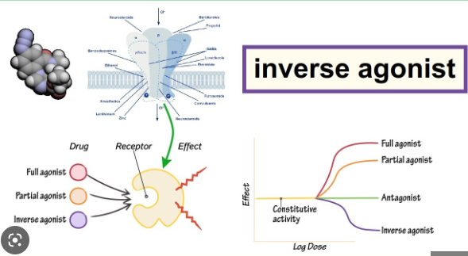

**Figure 7: Inverse agonist drug**

(Source: https://i.ytimg.com/vi/f6J34xqO1FQ/maxresdefault.jpg)

The agonist is something that induce the opposite activity of any ligand. In the treatment of any disesae it helps as reduce the negative impact of any receptor. The role that the inverse agonists play is called inverse agonism. The same receptor binding site that an agonist uses can also bind an inverse agonist. However, the inverse agonist not only counteracts the effects of agonists, it also exhibits the opposite function of the agonist, which decreases the receptor molecule's normal activity. As a result, the typical receptor-ligand signalling cascade is suppressed. The inverse agonist reduces the regular receptor-ligand signalling activity's baseline activity.

# Reference list

**Journals**

Wisler, J.W., DeWire, S.M., Whalen, E.J., Violin, J.D., Drake, M.T., Ahn, S., Shenoy, S.K. and Lefkowitz, R.J., 2007. A unique mechanism of β-blocker action: carvedilol stimulates β-arrestin signaling. *Proceedings of the National Academy of Sciences*, *104*(42), pp.16657-16662.