**PREVENTION AND TREATMENT STRATEGIES FOR PROSTHETIC JOINT INFECTIONS**

**TABLE OF CONTENTS**

Lay description 3

Objectives 5

Technical summary 6

Data handling 8

Reference List 9

# Lay description

Prosthetic Joint Infections (PJI) is a medical complication that is seen to be associated with the hip and knee following a surgical procedure also known as the arthroplasty. Within the joints following the surgical procedures, the development of such infection mediates which results in a number of complications that include swelling, pain, and fever. The hematogenous infections within the prosthesis and within the joints are seen to be increasing with the increasing number of implanted prosthetic joints particularly among the senior aged persons. Although a large percentage of patients don't experience any negative side effects, periprosthetic joint infection (PJI), can occur in 0.5%–1.4% of original surgery patients as well as 30% of revision arthroplasty patients. The number of PJI patients is anticipated to be over 70,000 annually within the United States that can expense around $2 billion. Additionally, PJI poses a significant healthcare burden due to its 26% 5-year death rate, which is comparable to many prevalent malignancies.

Looking at the pathogenesis it can be seen that in most of the cases, inoculation of microorganisms is caused at the intra-operative stages. In contrast to the free living microorganisms, most of the organisms are seen to exist in the form of biofilms. Manifestation of the infection at the early stages is caused due to high-virulent pathogens like that of the Staphylococcus aureus, streptococci, enterococci, etc (Indelli *et al.* 2021). *Staphylococcus aureus* stands out as one of the prominent infectious agents that are seen associated at the site of the infection.

The Current strategies available for PJI treatment include combinations of antibiotic treatment, mechanical disruption, irrigation and debridement (I&D), and removal of the infected prosthesis in either single‐stage or two‐stage procedure. Though several methods are available, the use of the traditional treatment methods for the irradiation of joint infection possess many difficulties, among which the multi-drug resistance of the microorganisms stands out as a prominent drawback. The minimum inhibitory concentration (MIC) for antibiotics can increase by up to a thousand times as a consequence of this matrix, rendering biofilm-based illnesses particularly challenging to treat without removing the contaminated device. This emphasizes the need for the development of novel strategies for irradiation of the infection that is affecting human lives.

Within this proposal, the use of specific bacteriophages is suggested to fight against the dominant pathogens coming from the group of *Staphylococcus* that are responsible for the infection within the joints (Lamret *et al.* 2020). Treatment procedures using the Anti-staphylococcal phages were projected to use for the effective lysis of the bacterial strains after repetitive cycles of treatment at the site of infection.

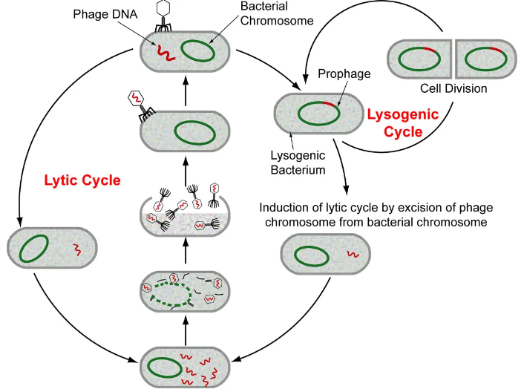

**Figure 1: Bacteriophage Life Cycle**

(Source: https://globalfoodsafetyresource.com/)

Bacteriophages are seen as bacterial viruses that contain a head where DNA or RNA is surrounded by a capsid consisting of protein called the lipoprotein, and a tail. In accordance with the lytic activity of the virus, it is differentiated into two forms called the lytic and lysogenic bacteriophages. As bacteriophages invade their host organism, they multiply, and this procedure is completed when the bacteria are lysed and viral offspring are released (Esteban *et al.* 2021). The lytic cycle refers to this process. They are referred to as temperate phages and proliferate via a lysogenic cycle whenever the bacteriophages have the ability to incorporate their genomes into the genome of a bacterium and thereafter replicate for numerous generations alongside the genome of their hosts. With the help of the phage protein, called endolysins the lysis of the bacterial cells was mediated while it is inside the bacterial hosts thereby helping to destroy the bacterial cells that are mediating the biofilm formation. Apart from the projected treatment methods effective prevention methods must also be undertaken that will focus on the patient-specific optimization that will aid in the effective prevention of prosthetic joint infections.

# Objectives

The mediation of the prosthetic joint infections are seen to be increasing in recent years with the increase in the cases of joint surgery particularly among the senior aged individuals. Several classes of microorganisms are seen as the causative agents for the infection like that of the *Staphylococcus aureus, streptococci, and enterococci*, whose irradiation is seen as the most challenging task in the effective treatment of the infections. Though several methods are available for the effective treatment for the infection that are recommended by several medical institutions, the growing concern for treating the disease is focused on the emergence of severe antibacterial resistance forms of the bacterial strains (Gallo *et al.* 2020). The emergence of high resistance strains of the micro bacterial species resulted in the treatment procedures with the help of combinations of different antibiotics and at varied concentrations that will have altered physiological consequences within the physiological systems apart from the eradication of the bacterial strains from the infection site. The several physiological consequences that result from the treatment with antibiotic mixtures include increased risks leading to ill effects, the possibility of antagonism as well as superinfection. In addition the level of irradiation of the bacterial strains is not at its full potential which mediates the requirement of the alternative strategies for the effective treatment of the infections across the globe.

The mediation of effective treatment using the bacteriophage is seen to stand out as an effective procedure for the mediation of infections. Several literatures point out the effectiveness of the treatment mediated by bacteriophages, where several bacterial diseases are seen to be treated efficiently with the help of the bacteriophages. Therefore within this proposal treatment of the infections was mediated using the bacteriophages that are specific for the bacterial strains that are seen dominating within the biofilm that is formed at the site of infection.

Accordingly, the research aims in proposing a novel strategy for the effective treatment of the multi drug-resistant bacterial strains that are forming biofilms and resulting in the formation of prosthetic joint infections. Again the research also aims in the projection of Patient‐specific prevention methods for the efficient prevention of the bacterial infections over a wider population. Therefore in accordance with the aim of the research that has been set for the investigation the set of objectives that has been set for the investigation are as follows -

1. To isolate the bacterial isolates from specimens of hospital samples, followed by a screening of the isolates to identify and multiply the bacterial isolates within agar plates.
2. To successfully treat the bacterial isolates within the agar plate with titers of bacteriophage at an appropriate concentration so that such concentration can be applied to the patients at the site of the infection.
3. Mediating risk factors that are patient specific and that would allow for the effective prevention of the infection within the prosthetic joints.

# Technical summary

Prosthetic Joint Infections (PJI) is characterized by the disturbance in the joint of knee and hip joint in one or more quarters of the udder accompanied by leukocyte creation, predominantly monocytes and blood serum proteins like cytokines, chemokines, and interleukins. It is caused generally by infectious pathogens like *S. aureus* and *Streptococcus spp.* furthermore, environmental pathogens like *E. coli*. Staphylococcus aureus is one of the organisms that cause variety of diseases, and it is regarded as a causal agent of major concern due to its propensity to remain in a herd as undiagnosed subclinical infections and the low cure rate of S. aureus infections with hostile to microbiological treatment. (Iannotti  *et al.* 2020). Vaccines for the treatment of Prosthetic Joint Infections (PJI) have limited efficacy. Cure rates for infection therapy are usually lower than 15%. This is caused by the unfortunate penetration of the organ by infection agents permitting *S. aureus* to survive inside the epithelial or phagocytic cells. Hostile microbial resistance in *S. aureus* is likewise a developing concern, with overall rates of antimicrobial resistance in bovine *S. aureus* isolates differing widely by region. The continued emergence of MRSA strains in people and creatures focuses on the need to develop new antimicrobial agents or therapies treatment for this pathogen. The treatment of bacterial infections with bacteriophages and their derivatives is such a choice.

**Experiments**

**Isolation of *S. aureus* from sample**

*S. aureus* can be isolated from patients who are suffering from Prosthetic Joint Infections (PJI). Protection by *S. aureus* from a lethal bacterial infection occurred in a dose-dependent manner. Immediate phage injection can provide a much better safeguard than delayed administration. The collected bacteria are cultured in a growth medium such as BHI and Tryptic soy broth (TS are the optimum growth temperature is 37 degrees Celsius.

**Administration of the bacteriophage in the culture medium**

After the successful growth of the bacteria such as *S. aureus,* the bacteriophage can be introduced to the bacterial plate. Bacteriophages specific to *S. aureus* have been isolated and studied for their normal healing use. The administration of bacteriophage in an *S. aureus* culture plate involves the use of the phage on the surface of the plate containing the bacterial culture. The phage particles will then, spoil the *S. aureus* microorganisms and repeat inside them, finally provoking the lysis or passing of the bacterial cells. The feasibility of the phage treatment can be assessed by observing the opportunity of the bacterial colonies on the lifestyle plate in the wake of agonizing.

Nonetheless, the success of bacteriophage treatment depends on several factors, including the suitable selection of phage, the dosage, the preparation of administration, and the course of movement. In this manner, further research is supposed to propel the administration of bacteriophage in S. aureus culture plates for their convincing use as a logical treatment for S. aureus infections.

**Checking the growth rate of the bacteria within the plate**

After the successful inoculation of the bacteriophages within the bacterial colony, the formation of plagues was determined as the rate at which the bacterial colony was destructed. In this method, a layer of supplement agar is first filled a petri dish and allowed to solidify. Then, a suspension of *S. aureus* is spread fairly on top of this agar layer. Subsequent to agonizing, a second layer of agar containing a pH indicator is poured over the basic layer of agar and allowed to solidify (Walter *et al.* 2021). The pH indicator in the second layer changes tone as *S. aureus* grows and produces corrosive, demonstrating the improved speed of the microbes. The size of the zone of assortment change can be measured and used to choose the speed of improvement of S. aureus in the culture plate.

**Administration of the bacteriophage in the mice model**

The administration of bacteriophages in an *S. aureus* mouse model normally involves several steps. First, a suitable bacteriophage that targets the specific strain of S. aureus is distinguished and isolated. The phage is then refined and prepared for infusion. Then, the corrupted mice are treated with a single dose or a series of doses of the bacteriophage, either by infusion or oral administration. The sufficiency of the treatment is then assessed by observing the decrease in bacterial weight and any improvements in the prosperity and survival of the mice. This process could vacillate depending on the specific preliminary design and the objectives of the study.

**Use of Bacteriophage for the Treatment of *S. aureus* Infections**

A suitable PFU amount of phage K can be used as a control along with saline. This can be administered one time per day and must be continued for up to 5 days. However, the cure rate by this experiment can be established by using four -five samples serially (Buchalter  *et al.* 2022). It can be observed from the previous experiment where that phage K can be used to treat the infection caused by the *S. aureus*, the cure rate is around 15-16 percent and it also can be seen that the control that is the saline water has been used for the control shows very low reduction rate of the infection.

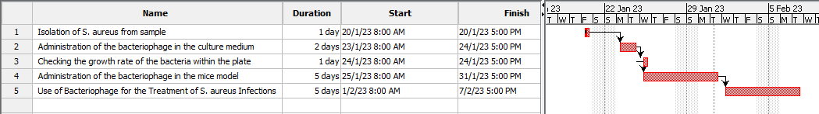

**Figure 2: Gantt chart**

(Source: Self-created in Project Libre)

# Data handling

The data regarding the mediation of the experiments with the bacteriophages are seen to involve dependent as well as independent variables. The dependent variable for the experiment includes the twitter of the bacteriophages that will lead to the recovery rate of the patients, while the independent variables include the serum neutralization assays, the levels of plaque formation, and the types of phages used in the experiment. The data that will be generated includes the data related to the colony of the bacterial cells, and data regarding the titre value of the phage that are effective in the creation of the plagues within the agar plates. Data regarding the changes in the number of blood cell counts are also seen both for the mouse models as well as for the human models.

# Reference List

**Journal**

Indelli, P.F., Ghirardelli, S., Iannotti, F., Indelli, A.M. and Pipino, G., 2021. Nanotechnology as an anti-infection strategy in Periprosthetic Joint Infections (PJI). *Tropical Medicine and Infectious Disease*, *6*(2), p.91.

Lamret, F., Colin, M., Mongaret, C., Gangloff, S.C. and Reffuveille, F., 2020. Antibiotic tolerance of Staphylococcus aureus biofilm in periprosthetic joint infections and antibiofilm strategies. *Antibiotics*, *9*(9), p.547.

Esteban, J., Vallet-Regí, M. and Aguilera-Correa, J.J., 2021. Antibiotics-and heavy metals-based titanium alloy surface modifications for local prosthetic joint infections. *Antibiotics*, *10*(10), p.1270.

Gallo, J. and Nieslanikova, E., 2020. Prevention of prosthetic joint infection: from traditional approaches towards quality improvement and data mining. *Journal of Clinical Medicine*, *9*(7), p.2190.

Iannotti, F., Prati, P., Fidanza, A., Iorio, R., Ferretti, A., Pèrez Prieto, D., Kort, N., Violante, B., Pipino, G., Schiavone Panni, A. and Hirschmann, M., 2020. Prevention of Periprosthetic Joint Infection (PJI): a clinical practice protocol in high-risk patients. *Tropical medicine and infectious disease*, *5*(4), p.186.

Walter, N., Rupp, M., Hierl, K., Koch, M., Kerschbaum, M., Worlicek, M. and Alt, V., 2021. Long-term patient-related quality of life after knee periprosthetic joint infection. *Journal of Clinical Medicine*, *10*(5), p.907.

Buchalter, D.B., Nduaguba, A., Teo, G.M., Kugelman, D., Aggarwal, V.K. and Long, W.J., 2022. Cefazolin remains the linchpin for preventing acute periprosthetic joint infection following primary total knee arthroplasty. *Bone & Joint Open*, *3*(1), pp.35-41.

Costa-Pinto, A.R., Lemos, A.L., Tavaria, F.K. and Pintado, M., 2021. Chitosan and hydroxyapatite based biomaterials to circumvent periprosthetic joint infections. *Materials*, *14*(4), p.804.

Hu, L., Fu, J., Zhou, Y., Chai, W., Zhang, G., Hao, L. and Chen, J., 2021. Trends in microbiological profiles and antibiotic resistance in periprosthetic joint infections. *Journal of International Medical Research*, *49*(3), p.03000605211002784.