# 

**SUSTAINABLE CITIES – ASSESSMENT DOCUMENT**

**Table of Contents**

Part B 3

Introduction 3

Analysis 3

A. Urbanization Pattern 3

B. Smart City 5

C. Environmental issues 7

Conclusion 8

Reference List 9

# Part B

## Introduction

The development of sustainable cities is a form of proceeding with technological advancement, innovation, and improvement of the lifestyle of citizens. In this particular essay, the chosen city is ***ADDIS ABABA (ETHIOPIA)*** which is the capital of Ethiopia. The urbanization planning of the city *ADDIS ABABA* is going to develop in this essay in collaboration with the process of growth in city planning and required improvement. The development of smart cities, whether it can be possible in *ADDIS ABABA* or not, is going to be illustrated in this essay. The key environmental issues and policies of this city are going to be addressed in this essay.

## Analysis

## A. Urbanization Pattern

Urbanization has increased to 15% in the recent years of globalization. As per Weldegebriel *et al.* (2023), rapid growth and mobility have been witnessed as key priorities for developing urbanization. Urbanization has been developed as a pillar for providing people with increased capacity, public health and safety, and mobilization to improve the quality of living. Urbanization in Ethiopia has been associated with a high level of economic growth.

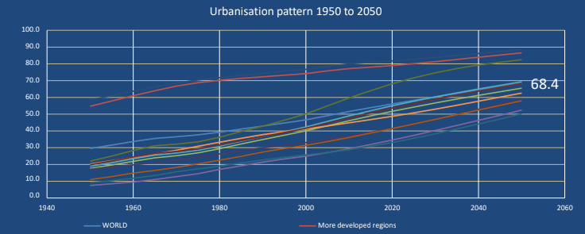

Figure 1: Urbanisation pattern of the World

(Source- Kundu and Pandey, 2020)

The average growth of the economy and urbanization scope in Ethiopia has improved by 10.4% from 2003 to 2013 (Data.worldbank.org, 2022). Natural population increase and rural-to-urban migration are the common trends of urbanization in recent years. Migration from rural to urban areas is the main trend and reason behind the increasing rate of urbanization in Ethiopia.

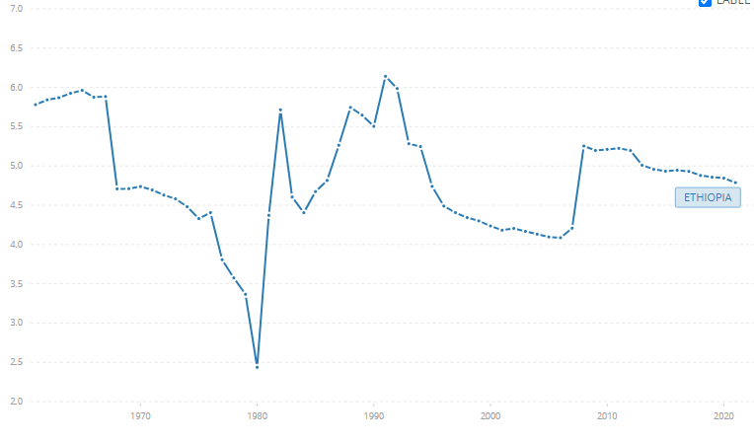

**Figure 2: Urban Population Growth in Ethiopia**

(Source- Data.worldbank.org, 2022)

Employment opportunities, population growth, roads and railway infrastructure, and policy framework are the determinants to develop urbanization in Ethiopia.

There are three stages of urbanization such as the initial stage, the celerity stage, and the terminal stage. Ethiopia is at the ***initial stage*** of belongingness of urbanization (21.9%) in the developing process. The low level of urban growth in Ethiopia has been observed lower in 2019 due to a lack of policy framework by the Ethiopian government and less economic growth in the pandemic period across the world. Economic and social transformation, unemployment, and poverty are the issues faced by Ethiopian cities that hindered economic development and the growth of urbanization. Urbanization in Ethiopia is increasing at a rate of 4.5% to the statistics of World Development Indicators (Data.worldbank.org, 2022).

As per Li *et al.* (2022), ***a primate city*** is the largest in the country, region, or province and disproportionately larger than any other city in the urbanized area. A primate city has several characteristics that cover the largest population growth of the country belonging to that city with facilities to develop urbanization growth and lifestyle. 'A*DDIS ABABA’* is the capital of Ethiopia which is one of the largest cities in the country with eleven times greater population than the second largest city. As one of the oldest and largest cities in Africa, ADDIS *ABABA* hasdeveloped as the centre of urbanization with the mobility of people from rural to urban places. The city has been exercising a kind of self-rule in Africa to provide facilities and infrastructure to the inhabitants.

**Urban growth of *ADDIS ABABA***

*Urban profiling* has been accelerating in ADDIS ABABA due to central governance and the development of urban growth. In this city, rapid urban growth was witnessed till 2019 hence the rate of unemployment, and poverty increased during the pandemic period. The urban growth of ADDIS ABABA will increase by 4.5% in 2023 which is a sign of developing significance in the rapid migration of rural people into cities (Grasham and Neville, 2021). This city has hosted 30% of the urban population of Africa. Slum dwellings, poor housing, sanitization, and infrastructure development are the required areas that ADDIS ABABA needs to be taken care of to improve the urban growth of 12 million in 2024. The second-order city growth is not distorted by the urban growth of ADDIS ABABA as each city has its own scope of development and characteristics to grow.

## B. Smart City

As per Ongel (2019), ***a Smart city*** is a kind of city structure that has a reflection of its citizens and behaves as an innovative ecosystem. The development of a 'smart city' depends on the requirement of technological innovation implementation in social construction. According to CISCO smart cities are scalable solutions that adopt (Anand, 2021). the advantage of Information Technology (IoT) to improve resources, and efficiencies and reduce the cost of living. In *ADDIS ABABA* smart city projects are already developing. After the process of permission and administrative requirement development, the much-awaited smart city project of *ADDIS ABABA* has started in 2022. Smart city projects are pursued to provide people with technology-oriented living and reduce the cost-of-living infrastructure and save time.

The smart city project of *ADDIS ABABA* will provide citizens living in the capital with the development of reliable facilities in collaboration with governance and technology. The use of AI-driven technologies will provide the inhabitants of the city with better opportunities for living and make the city attractive for living. As per Crijns (2021), the development of smart and sustainable cities is effective to improve data-led management and planning for the people, efficient community-based infrastructure and services, and localized innovation adoption.

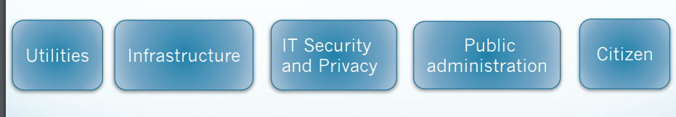

**Figure 3: Smart city planning**

(Source- Ongel 2019)

In Ethiopia, the development of smart cities has been initiated by the government to provide people with IT security and services, well-being and education, and better infrastructure for living. ADDIS ABABA being a primate city in the country has taken strategic planning to launch smart city projects for the people.

The classification of a Smart City can be developed according to its characteristics such as- ***virtual cities, knowledge-based cities, Broadband metropolis and digital cities.*** The facilities that can be found in these classified cities are mainly dealing with the facility provided for people living in those cities such as digital technologies, virtual space for living, and local needs of the transaction. Broadband city approach to provide internet connection and knowledge regarding the government policies and facilities of the people to make it attractive for a living (Mohamed *et al.* 2020).

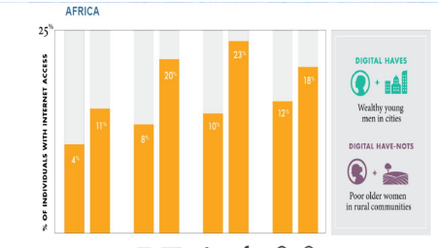

**Figure 4: Digital divide in Africa**

(Source- Mohamed *et al.* 2020)

The core challenges of *ADDIS ABABA* can be identified as the most significant that has to be improved to provide people with a healthy infrastructure of living. Poverty, unemployment, and lack of economic growth are the core challenges of ADDIS ABABA which can be addressed with the development of launching smart city projects. The new smart city project will definitely bring employment opportunities for local people, and increase migration for working opportunities and the need for city space. Employability can reduce poverty and develop the quality of living. On the other hand, the development of economic improvement can be initiated with the new smart city project in the city.

## C. Environmental issues

Environmental degradation and climate change have been regarded as one of the main challenges in the globalized world to maintain environmental protection. The increase of the global population across the world and the rate of pollution development in the air has reduced the scope of improving health and hygiene. In *ADDIS ABABA* the core environmental challenges are

***Increasing soil erosion-*** The rapid population growth of the city has put extreme pressure on the environmental balance. As per Bayu (2020), environmental degradation has been found in the city due to a lack of awareness among people to protect the environment and fewer administrative measures to handle human activities. River and soil pollution has occurred as a result of industrial waste. Around 35% of the industrial waste has not been collected from the industrial areas which led to mixing up the waste with soil and water.

***Deforestation and forest degradation*** have been found as another way of environmental pollution in ADDIS ABABA. Increasing population in the city due to migration leads to their livelihood by cutting trees for wood, sap, wax, and fuel to lice their livelihood. As per Gelan (2021), in this way forest degradation occurred in the city that reduced the amount of fresh oxygen in the air and increasing carbonated gas. The purification of air cannot be executed by human activities in the city. The uncontrolled population growth of ADDIS ABABA causes deforestation and environmental damage.

***Water scarcity and loss of biodiversity-*** Environmental obstacles have been perceived in Ethiopia especially in ADDIS ABABA in terms of developing water scarcity and loss of biodiversity. Water scarcity has been witnessed by the people of the city due to lack of adequate rain the whole year and less water supply facility development by the government. On the other hand, biodiversity of wild animals and species has been lost due to deforestation, mixing of solid waste on river water.

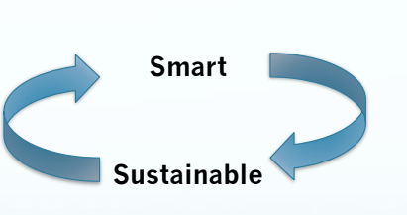

**Figure 5: Smart city with sustainability**

(Source- Azagew and Worku 2020)

The tangible income growth in the city such as higher standard of living and employment opportunities have to be developed to make sustainability in the cities

The Environmental Policy of Ethiopia has a specific goal to develop sustainable ways of protecting the environment and improve quality of living in a healthy manner. The *Ethiopian Environmental Policy 1997* has been developed to provide environmental protection and this cat has been modified in 2010 to incorporate new requirements of improving sustainability on environment. The scope of this policy is to develop environmental awareness among people of ADDIS ABABA to make them more environmentally conscious to save the environment, control human activities such as deforestation, and the storing of industrial waste without disposal.

The renewable energy resources such as water energy, solar energy will have to be used in the industrial process to reduce the emission of carbonated gas in the environment. The people of this city have to be more environmentally protected to maintain the soil and water protection from mixing of industrial waste. As per Azagew and Worku (2020), the government has to be stricter and monitoring to oversee the system of waste collection infrastructure and maintain prohibition to increase deforestation.

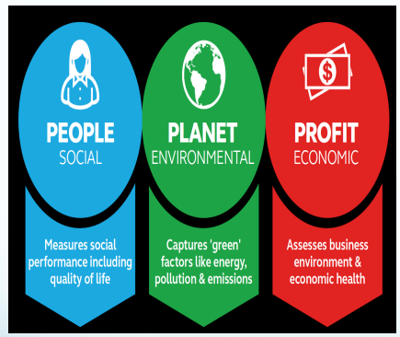

**Figure 6: Principles of sustainable cities**

(Source- Sodiq *et al*. 2019)

The principles of sustainable cities have to be maintained to save social, economic and environmental issues in the society by developing smart living and awareness.

The innovative policy of Ethiopia environment protection development in ADDIS ABABA has no use in the present context as the rate of waste storage, garbage at the city and less maintenance of sanitization has been witnessed. The people living in this city are not aware about the development of bringing knowledge to improve environment protection. In this context, the government will have to be stricter to prevail on environmental policy to develop a sustainable way of improving infrastructure for the inhabitants of the city. Environmental Policy will have to be unique to attract people to develop awareness in improving the quality of life by maintaining health and hygiene in the city, controlled human activities to keep the balance of biodiversity of nature.

## Conclusion

In this essay the Ethiopian city ADDIS ABABA has been taken into consideration to analyse its urbanization growth, the rate of population development to become more urbanized in Ethiopia. The smart city development plan has been analysed in this essay along with the requirements of developing better opportunities for the urban people to become more facilitated. The technological advancement and scope of urbanization has been illustrated. The environmental challenges of the city have been evaluated. The policy of the country and required measures to improve the policies have been analysed in this essay.

# Reference List

Azagew, S. and Worku, H., 2020. Accessibility of urban green infrastructure in Addis-Ababa city, Ethiopia: current status and future challenge. *Environmental Systems Research*, *9*(1), pp.1-20.

Bayu, T.B., 2020. Smart leadership for smart cities. *ORAȘE INTELIGENTE ȘI DEZVOLTARE REGIONALĂ*, *4*(02), pp.41-62.

Crijns, F., 2021. Inclusive neighbourhoods across urban waters: A spatial design for intensifying socio-ecological resilience in communities in Addis Ababa positioned between tradition and transition.

Data.worldbank.org, 2022. Accessed at:https://data.worldbank.org/indicator/SP.URB.GROW?locations=ET

Gelan, E., 2021. Municipal solid waste management practices for achieving green architecture concepts in Addis Ababa, Ethiopia. *Technologies*,*9*(3), p.48.

Grasham, C.F. and Neville, G., 2021. Socio-political processes must be emphasised alongside climate change and urbanisation as key drivers of urban water insecurity. *Water Policy*, *23*(1), pp.36-57

Li, X., Stringer, L.C. and Dallimer, M., 2022. The Impacts of Urbanisation and Climate Change on the Urban Thermal Environment in Africa. *Climate*, *10*(11), p.164.

Mohamed, A., Worku, H. and Lika, T., 2020. Urban and regional planning approaches for sustainable governance: The case of Addis Ababa and the surrounding area changing landscape. *City and Environment Interactions*, *8*, p.100050.

Ongel, G., 2019. The urban poor at a crossroads: exploring speculative urbanisation dynamics in Addis Ababa’s social housing programme.

Weldegebriel, A.T., Tekalign, M. and Van Rompaey, A., 2023. Socio-spatial analysis of regime shifts in Addis Ababa's urbanisation. *Applied Geography*, *154*, p.102918.

Sodiq, A., Baloch, A.A., Khan, S.A., Sezer, N., Mahmoud, S., Jama, M. and Abdelaal, A., 2019. Towards modern sustainable cities: Review of sustainability principles and trends. *Journal of Cleaner Production*, *227*, pp.972-1001.

Kundu, D. and Pandey, A.K., 2020. World urbanisation: trends and patterns. *Developing National Urban Policies: Ways Forward to Green and Smart Cities*, pp.13-49.

Anand, P.B., 2021. Assessing smart city projects and their implications for public policy in the Global South. *Contemporary Social Science*, *16*(2), pp.199-212.