**CHALLENGES FACED BY SARACENS RUGBY CLUB TO HOST EVENTS**

**Executive summary**

In this report, the challenges faced by the Saracens rugby club in terms of the operating cost of club will be discussed briefly. The effect of Brexit on the club in terms of operational costs will also be discussed in this report.

**Table of Contents**

Introduction 4

Literature review 4

Introduction 4

Description Of the sector 4

Financial Performance and Competition 5

Key issues in the sector and its impact 5

5 E's of Event Planning 6

Research gap 6

Conclusion 6

Methodology 7

Introduction 7

Research Onion 7

Research Philosophy 8

Research Design 8

Data collection method 8

Data Analysis 9

Inclusion and exclusions 9

Discussion 9

Challenges faced by the club 9

Effect of Brexit on the Club 10

Recommendation 10

Conclusion 10

References 11

# Introduction

The Saracens Rugby Club is a professional rugby club based in the UK. The club participates in Premiership rugby. The club was established in 1876. The club has won 10 major trophies. The annual revenue of the club is 68.2 million USD. The club participates in the Heineken championship cup, Allianz Cup rugby and many other rugby championships. In this study, the challenges faced by the club will be discussed in terms of the operational costs of the club events. The effect of different political issues on the club will also be discussed in this report.

# Literature review

## Introduction

The Saracens Rugby Club is a professional Rugby club that is based in North London. The club is sponsored by the City Index company. The club participates in events such as the English Premiership, and the European Rugby Champions Cup. Lucy Wray is the CEO of the club and Neil Golding is the Chairman of the Club (Saracens.com, 2023).

## Description Of the sector

Rugby is a professional sport that is popular in the UK (Mackreth and Bond, 2021). The Rugby Football Union governs sports in England. The Premiership Cup is the most popular event for Rugby in the UK. The sport of Rugby is very popular in the Northern parts of the UK. In recent years sports and clubs such as the Saracen are facing financial issues to organize events due to various underlying issues. This has also increased the cost for the viewers and fans following the sport of Rugby. According to Gregson, and Huggins (2021) the Rugby Union have faced many issues such as government regulations which have affect the Rugby clubs and their revenues. To sustain the challenges of operational costs the clubs of Rugby are trying to cut the cost of their operations. Moreover, on the other hand Saracens Club is also finding new investors who which will help the club to face the challenges of increasing operation costs.

## Financial Performance and Competition

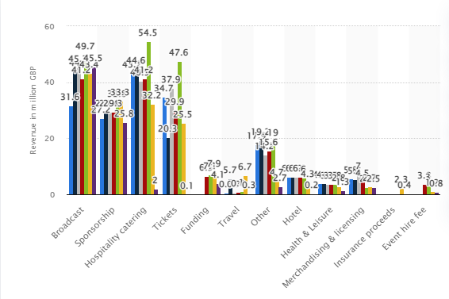

**Figure 1 - Financial income of Rugby Football Union from 2015 to 2022 In GBP**

(Source - statista.com)

The Saracens Rugby Club is getting income from different sources which are helping the club to manage its operational costs and generate revenue. The club is earning from the broadcast, sponsorships, tickets and merchandising of its products. The Club has gained sponsorship from the City Index for its Gallagher premiership match. Version 2 is a company that has agreed with the firm as an official lighting partner of the club. Still, the club made a loss of 3.89 million GBP in the year 2018 followed by a loss of 2.69 million GBP in the year 2017. The competitors of the club are Tottenham Hotspur Ltd, Arsenal, Everton football club and Cambridge city council.

## Key issues in the sector and its impact

As per the club, it is facing issues to manage its community responsibilities and commercial targets. The onset of Covid-19 has affected the revenues and operating costs of the club (Skinner and Smith, 2021). The club is trying to find a way to manage the risks and uncertainties it is facing from the challenges of Brexit. The Russia and Ukraine war also impacted the inflation of the country which has further increased the operation cost of the Club. The Club is experiencing a rise in debts to manage the cost of the operations of the club and its events. The Club is satisfied that the investors of the Club are supporting the Club in the testing times.

**Trends in the company**

Firstly the biggest trend the club and the sports of Rugby are experiencing in recent times is that the club is underperforming in its broadcast income which is also contributing to the losses of the club. Secondly the club is experiencing is the decline in sponsorship by 6%. With the decrease in the sponsorship, the apparel and kit costs of the player are increasing with the increase in the inflation rate which is affecting the operational costs of the firm.However this has not affected the popularity of the game in UK. According to Hind*et al.,* (2020) Rugby is very popular in the UK. The overall cost of the events in the sport of Rugby has increased which has also impacted the operational cost of the club. To manage this increase in the operational cost the Saracens club is finding new investors and sponsors which will help to fight the challenges of the increasing costs.

## 5 E's of Event Planning

In this section, the event planning of the Saracens Rugby Club will be discussed with the help of the 5 E's of Event planning and management.

Firstly the elements are the things that help in the organization of the event by the club. The elements will be food and drinks, decoration and lighting, the administration of the game by the officials and the audio-visual equipment for broadcasting. Secondly the essential things required for the events are the seating facilities and the venue of the sports. Thirdly proper environment has to be selected in which a proper venue is selected which will be feasible for the spectators to reach and enjoy the game.Fourthly the energy of the game which should be planned in such a way that spectators do not feel distracted and bored. Lastly the event of the club should be organized in such a way that it will give rise to emotion in the spectators (Jeong*et al.,* 2020).

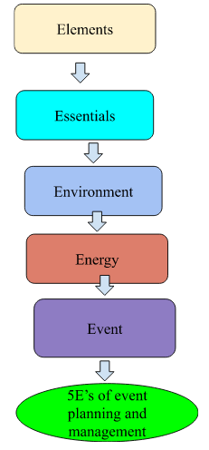

**Figure 2 – 5E’s of event planning and management**

(Source – Self-Made)

## Research gap

The researcher has tried to study the operational cost challenges faced by Saracens Rugby Club but the literature gap existed to find out the long-term implications of the Covid - 19 on the operational cost of the club. The data and findings made in this report cannot be showcased in the form of statistics is a gap identified in this report.

## Conclusion

In this report, it was found the Saracens Club is facing issues such as the increase in the cost of the kits and apparel used by the players. The Brexit-related Visa issues are also faced by the club in organizing events and the inflation related to Covid 19 and the war between Russia and Ukraine has also increased the cost of the events of the club.

# Methodology

## Introduction

The challenges faced by the Saracens Rugby Club to organize events have been discussed in this report. The appropriate research methodology tools and procedures have been applied to make findings about this research topic in this research. The systematic research procedures applied in this research to reach the data analysis stage in this research have been discussed extensively in this chapter. The research methodology in this research has utilized a logical path to make findings and recommendations in this research.

## Research Onion

The research onion has laid out all the decisions and procedures that have been applied by the researcher to the data analysis stage in this research. The research onion represents the structure of the procedures and the tools that have been applied in this research to reach the end goals of this research. The research onion in this research included the research philosophy, the research design, the data collection methods and the central part of the structure is the data analysis in this research. The research onion in this research has guided the research to follow a systematic path to research to the data analysis stage in this research and make proper findings in this research.

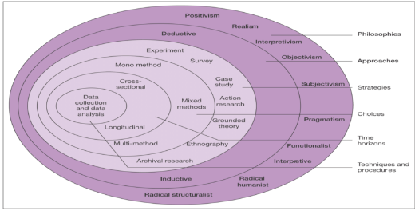

**Figure 3 – Research Onion**

(Source – Saunders, Lewis, Thornhill& Bristow, 2015)

## Research Philosophy

In this research, the researcher has used the research philosophy of interpretivism. The interpretivism research philosophy has helped the researcher to collect the data related to the research issues from different perspectives and viewpoints. This has helped the researcher to make the findings on the research from a broader perspective. The research philosophy of positivism is not used by the researcher to make findings in this research as positivism research philosophy has generalized the findings about the research issues, with the use of the positivism research philosophy the researcher will not be able to make specific findings on the issue (Alharahsheh and Pius, 2020).

## Research Design

In this research, the explanatory research design is selected by the research in the data analysis stage. The explanatory research design has helped the research to find in-depth answers to the research issue by finding the answers to the 'why' and 'how' related questions to the research issue. The descriptive research design is not used in this research as the use of the descriptive research design can lead to bias of the researcher influencing the findings made in this research. To keep the findings of the research free from personal bias and make an in-depth analysis of the research issue the research design of explanatory research is used by the researcher in this research (Asenahabi 2019).

## Data collection method

The researcher has chosen the secondary data collection methods in this research to collect the data in this research. Secondary data collection is the most economical way to collect quality data related to the research issue. With the help of secondary data collection, the researcher has able to collect data about the research issue which is spread over a wider time zone. This helped the researcher to collect a large amount of data that is available in the secondary data sources. The researcher has not selected the primary data collection in this research as the primary data collection will make the data collection process more time-consuming and costly. The primary data collection in this research would have resulted in making findings that are inaccurate that could not be applied to the research issue. Consequently, secondary data collection was selected in this research.

## Data Analysis

Data collection is the most important part of the research. Consequently, the researcher has carried out the data analysis process in this research with utmost care and diligence. The researcher has chosen qualitative data analysis in the data analysis stage of this research. Qualitative data analysis is chosen in this research as it would help find information that would be non-numeric and conceptual. The qualitative data analysis in this research will be helpful in this research to capture the common themes and patterns visible in the collected data. With the use of the patterns and themes established in data analysis, the researcher has made proper findings in this research (Haven *et al.,* 2019). The use of quantitative data analysis in this research would have made the findings limited to numerical information.

## Inclusion and exclusions

The researcher has employed high ethical morals in every step of this research report to make findings that will be able to address the problems faced in this research. The articles, journals and reports used in this research to make the findings in this research are taken from reliable sources such as Google Scholar. The articles from 2019 to 2023 were included in this research. The articles which were older than 2019 were not included in this research.

# Discussion

## Challenges faced by the club

Recent years have been a turbulent year for the club as it has seen a dip in its revenues due to covid 19 and Brexit (Cisneros 2022). The club is experiencing a shortage or gap in investors' funding into the club which is affecting the growth of the club. The club is experiencing high maintenance costs for its infrastructure which have also increased the operational costs of the club and its events. This has caused the club to increase the price of its tickets for the people who come to watch its games. The club is experiencing a gap in investment and on the other hand, the sport equipment costs are also increasing due to an increase in the inflation rate of the country which has increased the operational costs of the clubs for its events. The cost of the professional working with the club has also increased in recent years which has severely impacted the operational costs of the club.

## Effect of Brexit on the Club

The cost of the visas for the players and the professional association increased post-Brexit which is putting an extra burden on the financial resources of the club which is increasing the operational costs of the club and decreasing the revenue of the club in the post-Brexit period similar to other sports clubs in the UK (Goodlad 2021). The club has a large number of players and professionals from a non-EU background which will make the club make extra-expense on those staff's Visa which is increasing the operational cost of the club. This extra cost will pass on to the spectators and the followers of the club which will make the fans pay more to avail of the ticket to watch the events of the Club. The post-Brexit tourist industry is severely impacted which will discourage people to visit the UK and this will also have an effect on the clubs as fewer fans will visit to watch the matches due to increased Visa prices. Brexit is also having an effect on the GBP which means the operation costs of the Saracens Rugby Club will increase as the club has to make more spending to organize an event post-Brexit.

## Recommendation

With the help of findings made in this research, it is recommended that the club should try to increase its sponsors and investors who can fund the events. The Club with the Application of the 5E model of the event should increase the emotions of the spectators about the events which will pull more spectators and increase the revenue for the club (Read *et al.,* 2021). The Club can also try to pool the resources of the other club which will help the club to manage the cost associated with the resources. The club while organizing events should take the help of the Government and the tourism department to sponsor the events.

# Conclusion

In this report, it was found that Club has various issues which are increasing the operational costs of the club. To name a few a high infrastructure maintenance cost, increasing the inflation rate of the country will increase the operation cost of the club. Brexit is also having an adverse effect on the operational costs of the club and its events as the visa costs of the players increased post-Brexit. Various recommendations are made with the help of the data collected in this research by which the club can increase the revenue from the events. The recommendations can also help the club to manage its cost of operations.

# References

Alharahsheh, H.H. and Pius, A., 2020. A review of key paradigms: Positivism VS interpretivism. *Global Academic Journal of Humanities and Social Sciences*, *2*(3), pp.39-43.

Asenahabi, B.M., 2019. Basics of research design: A guide to selecting appropriate research design. *International Journal of Contemporary Applied Researches*, *6*(5), pp.76-89.

Cisneros, B., 2022. Premiership Rugby’s Response to COVID-19: A Competition Law Analysis. *Entertainment and Sports Law Journal*, *20*(1).

Goodlad, F., 2021. Why the United Kingdom Should Look to Switzerland's Immigration System to Protect the English Premier League After Brexit. *Emory Int'l L. Rev.*, *35*, p.671.

Gregson, K. and Huggins, M., 2021. Principles, pragmatism, and pressure: the rugby union clubs of North-East England 1895–1914. *Northern History*, *58*(1), pp.109-128.

Jeong, Y., Kim, E. and Kim, S.K., 2020. Understanding active sport tourist behaviors in small-scale sports events: stimulus-organism-response approach. *Sustainability*, *12*(19), p.8192.

L. Haven, T. and Van Grootel, D.L., 2019. Preregistering qualitative research.*Accountability in research*, *26*(3), pp.229-244.

Mackreth, K. and Bond, A.J., 2021. Changing the sport product: marketing implications for championship rugby league clubs in the United Kingdom.*Managing Sport and Leisure*, *26*(6), pp.559-574.

Read, D., Smith, A.C. and Skinner, J., 2021. A comparative analysis of competitive balance between a closed and an open league in Rugby League.*Journal of Sports Economics*, *22*(8), pp.871-892.

Saracens.com, 2023 Available at <https://saracens.com/>

Skinner, J. and Smith, A.C., 2021. Introduction: Sport and COVID-19: Impacts and challenges for the future (Volume 1). *European Sport Management Quarterly*, *21*(3), pp.323-332.

Statista.com,2023 Available at <https://www.statista.com/statistics/463918/rfu-income-breakdown-england-uk/>