**BM7013 FINANCIAL AND ACCOUNTING MANAGEMENT**

# Executive Summary

This assignment has two parts. The first part is the ratio analysis is a method of evaluating financial performance by comparing various financial ratios to assess the liquidity, profitability, efficiency, and stability of a company. It is a useful tool for understanding a company’s financial situation and assessing its potential for growth and profitability. In this report, the financial analysis will be conducted of Vodafone group PLC in the three years of performance which is 2022, 2021 and 2020 with another company in the same industry which is the BT Group PLC focusing on the telecommunications industry and analyzing performance within the same industry for the two companies. The second part includes an analysis of costing using by comparing Modern and Traditional costing systems such as Absorption costing and ABC Costing.

**Table of Contents**

Part A 4

Introduction 4

Ratio Analysis 5

-Profitability Ratios 5

-Liquidity Ratios 6

-Inventory Turnover (Efficiency) 7

-Gearing Ratio 8

Investment Ratios 8

Performance Evaluation 9

Conclusion 13

Recommendations 14

Part B 15

Introduction 15

Discussion 15

Similarities and differences in the impacts of traditional and modern costing systems such as absorption costing and ABC on production 15

Influence of the sizes and types of organisations and products and costing systems on the choice(s) of costing system 16

Relationship between production costs and production planning 17

Conclusion 18

References 19

Appendices: 21

# Part A

# Introduction

**-Company Specific**

With operations in more than 30 countries, Vodafone Group plc is one of the biggest telecommunications businesses in the world. It offers a wide range of services, including internet, digital television, fixed-line and mobile phone service, and more. Incorporated in 1991, Vodafone has its main office in the UK (Vodafone Plc, 2023). It is present throughout America, Asia Pacific, Europe, the Middle East, and Africa. Vodafone is a member of the FTSE 100 Index and is listed on the London Stock Exchange. BT Group plc, a global provider of telecommunications services with headquarters in London, the United Kingdom, will be contrasted with Vodafone. It is one of the top providers of communications services worldwide, operating in more than 180 nations (BT Plc, 2023). The 1984-formed BT Group plc is a part of the FTSE 100 Index. In addition to networked IT services, BT provides mobile, fixed-line, internet, and television services. Additionally, it offers managed network and IT services to business and government clients. This report is therefore a financial comparison of Vodafone Plc with BT group and assessing which company has better performance in the Telecom sector.

**-Industry Specific**

The communication and telecom industry is diverse and the overall average revenue has increased from the previous year’s considering the impact of the pandemic. To guarantee that customers obtain fair services and rates, Ofcom, the UK's communications regulator, intensively regulates the telecom sector (Statista, 2023). To safeguard consumers, Ofcom has put in place a number of laws and regulations, such as a code of conduct for telecom providers, guidelines for how they can market their services, and standards for how clients are charged for their services. Companies invest substantially in R&D to keep ahead of the competition, and the sector is also very dependent on technology. To guarantee that their consumers have access to the most recent services and technology, businesses are also making investments in new technologies, such as 5G networks (Sana *et al*., 2022). The telecommunications industry has enabled the almost 68 million residents of the UK to stay in touch with one another and the rest of the world. Despite significant declines, the industry generated over 31 billion British pound sterling in sales in 2021.

# Ratio Analysis

## -Profitability Ratios

|  |  | **Vodafone Group** | | | **BT Group** | | |
| --- | --- | --- | --- | --- | --- | --- | --- |
| **Ratios** | **Formula** | **2022** | **2021** | **2020** | **2022** | **2021** | **2020** |
| **Profitability Ratios** | | | | | | | |
| **ROCE** | PBIT/(Total Assets-Total Current Liabilities) | **4.71%** | **4.03%** | **3.02%** | **7.08%** | **6.18%** | **7.80%** |
| **Operating Margin** | PBIT /Revenues*100 | **12.43%** | **11.63%** | **9.11%** | **13.84%** | **12.13%** | **14.33%** |
| **Gross Margin** | Gross Profit/Revenues*100 | **32.92%** | **31.32%** | **31.78%** | NA | NA | NA |

**Table 1: Profitability Ratio**

(Source: Self-developed)

Profitability ratios measure a company’s ability to generate income relative to its revenue, operating costs, balance sheet assets, or shareholders’ equity (Kamaluddin *et al*., 2019). They provide insight into a company’s ability to generate income from its operations and ultimately show how well a company is performing financially.

From the above profitability ratio, it can be seen that the company Vodafone group has a return on capital employed of 4.71% in 2022 4.03% in 2021 and 3.02% in 2020 which shows an increase in the return on capital employed. This means that there is a good performance of the company in terms of return on capital employed. BT group can also be seen to have a good return on capital employed of 7.08% in 2022, 6.18% in 2021 and 7.80% in 2022.

The operating margin ratio has experienced growth for the Vodafone group from 9.11% in 2020 to 11.63% in 2021 and 12.43% in 2022 which shows that the company has experienced growth in the revenues as well as operating profits. This shows that the company has been able to develop its potential for future growth in the telecom industry. However the same cannot be set for BT group as the operating profit ratio seems to be declining for the company from 14.3% in 2020 to 12.13% in 2021 and 13.84% in 2022. This shows that the business experienced a decline in the operating margin in the year 2021.

The gross margin ratio has only been evaluated for the Vodafone Group as the gross margin was not available for the BT group. Hence, can be seen as the gross margin ratio has also experienced an increase from 31.78% in 2020 to 32.9% in 2022 which shows an approximate 1% increase in the gross margin due to an increase in sales performance.

## -Liquidity Ratios

| **Liquidity Ratios** | | | | | | | |
| --- | --- | --- | --- | --- | --- | --- | --- |
|  |  | **Vodafone Group** | | | **BT Group** | | |
|  |  | **2022** | **2021** | **2020** | **2022** | **2021** | **2020** |
| **Current Ratio** | Current Assets/Current Liabilities | **0.8** | **0.94** | **1.01** | **0.98** | **1.15** | **1.09** |
|  |  |  |  |  |  |  |  |
| **Acid Test Ratio** | Current Assets-Inventories/Current Liabilities | **0.79** | **0.9** | **0.99** | **0.95** | **1.1** | **1.06** |
|  |  |  |  |  |  |  |  |
| **Working capital** | Current Assets-current liabilities | -6069.00 | -1698.00 | 188 | -138 | 1394 | 1006 |

**Table 2: Liquidity Ratio**

(Source: Self-developed)

The computation of the liquidity for BT group shows that the company has weak liquidity as in 2020 the company had liquidity of 1.01 by calculating the current assets by the current liabilities which declines to 0.94 in 2021 and 0.8 in 2020. The acid test ratio also shows a decline in the ratio performance from 0.99 in 2020.79 to 2022 which shows that the company is unable to manage its working capital and has not been able to keep the ideal ratio which is 1 in order to manage the liquidity and balance between the current assets and current liabilities. It also means that the obligations of the business are more than that of its assets in hand. This is important for financial performance because it allows investors and creditors to assess the company's ability to meet its obligations without having to resort to selling long-term assets or borrowing additional funds (Kamaluddin *et al*., 2019).

The analysis of liquidity of BT Group PLC also shows a decline from 1.09 in 2020 to 0.98 in 2022 and the acid ratio also shows 1.06 in 2022 which means that this company is also unable to meet the liquidity requirements as the company is incurring higher expenses that of the income. The working capital ratio has also negative working capital for the Vodafone group in the year 2022 which is -6069 and in 2021 is -1698. In the year 2020 the company had a positive working capital. Additionally, in the year 2022 the working capital is is -138 which is higher in the previous years at 1394 in 2021 and 1006 in 2020.

## -Inventory Turnover (Efficiency)

| **Efficiency Ratios** | | | | | | | |
| --- | --- | --- | --- | --- | --- | --- | --- |
|  |  | **Vodafone Group** | | | **BT Group** | | |
| **Ratios** | **Formula** | **2022** | **2021** | **2020** | **2022** | **2021** | **2020** |
| **Average inventories turnover period** | Cost of Goods Sold/Average Inventory | **40.44** | **47.72** | **47.24** | NA | NA | NA |
|  |  |  |  |  |  |  |
| **Receivables turnover ratio** | Net Sales/Average Receivables | 0.30 | 0.27 | 0.29 | 0.33 | 0.26 | 0.35 |
| **Fixed Assets Turnover Ratio** | Net Sales/ Average fixed assets | 0.55 | 0.65 | 0.77 | 0.33 | 0.21 | 0.33 |

**Table 3: Efficiency Ratio**

(Source: Self-developed)

From the above table, it can be seen that the efficiency ratio has been gathered for Vodafone group showing that the efficiency of the company has increased over the years and terms of average inventory turnover period showing that the company has more inventory period 2020 at 47 days as compared to 2022 at 40 days. This means that the inventory turnover has increased the efficiency performance of the Vodafone group. Inventory turnover ratios not applicable for BT group as the company does not have any effective cost of goods sold identified from the income statement which districts the calculation of the average inventory turnover period for the company. The Receivable turnover ratio has also been calculated for Vodafone and BT group which shows that the ratios were 0.30, 0.27 and 0.29 in 2022, 2021 and 2022 respectively.

In comparison to BT Group, the ratios are 0.33, 0.26 and 0.35. Also, the fixed assets to turnover ratio has been calculated that shows 0.55, 0.65 and 0.77 for Vodafone as compared to BT Group which are having ratios of 0.33, 0.32 and 0.33 in 2022, 2021 and 2020. Hence, these ratios are highly important as it indicates financial performance in terms of utilization of resources to generate more sales.

## -Gearing Ratio

| **Gearing Ratios** | | | | | | | |
| --- | --- | --- | --- | --- | --- | --- | --- |
|  |  | **Vodafone Group** | | | **BT Group** | | |
| **Ratios** | **Formula** | **2022** | **2021** | **2020** | **2022** | **2021** | **2020** |
| **Debt-To-Total Assets Ratio** | Long Term Debt/Total Assets | **0.38** | **0.39** | **0.37** | **0.31** | **0.31** | **0.31** |

**Table 4: Gearing Ratio**

(Source: Self-developed)

The gearing ratio has been computed for both Vodafone Group PLC as well as BT group showing that Vodafone group has increasing long term debts due to the companies increase in the debts from the year 2020. The gearing of the Vodafone group has been seen at 0.37 in 2020 as compared to 0.38 in 2022.The Vodafone group has recorded a gearing ratio of 0.39 in the year 2021. However, BT group is seen to have a constant debt to total assets ratio at 0.31 due to not much difference between the long-term borrowings of the company Long-term debt to assets indicates the number of an organization's assets that are financed with debt. It is an important indicator of a company's financial health and can be used to assess the company's ability to repay its debts (Rashid, 2018). A high ratio might indicate that the company may be over-leveraged and could be at risk of defaulting on its debt payments.

## Investment Ratios

|  |  | **Vodafone Group** | | | **BT Group** | | |
| --- | --- | --- | --- | --- | --- | --- | --- |
| **Ratios** | **Formula** | **2022** | **2021** | **2020** | **2022** | **2021** | **2020** |
| **Dividend Per Share** | Annualized dividend/ weighted average shares | **9** | **9** | **9** | **5.39** | **7.7** | **0** |
|  |  |  |  |  |  |  |  |
|  |  |  |  |  |  |  |  |
| **EPS** | Net Income/Outstanding shares | **11.03** | **8.08** | **5.6** | **12.9** | **14.8** | **17.5** |
|  |  |  |  |  |  |  |  |
| **P/E Ratio** | Share Price/Earnings per share | **10.4** | **15.0** | **26.4** | **13.65** | **9.67** | **10.98** |
|  |  |  |  |  |  |  |  |

**Table 5: Investment Ratios**

(Source: Self-developed)

From the above table it can be seen that the dividend per share available for Vodafone group has a constant dividend of 9 pence for share for each of its shareholders in each of the years 2020-2022. However, it can be seen that BT group has a fluctuating dividend per share which is 5.39 in 2022 and 7.7 in 2021. The entity did not pay dividends in the year 2020 due to the Covid-19 pandemic and its effects on the financial performance of the company which led to losses to the company in the year. These ratios are important indicators of returns to the investors of the company and indicate the capability of the company to provide adequate returns to the shareholders in each of financial period.

# Performance Evaluation

***Profitability Comparison***

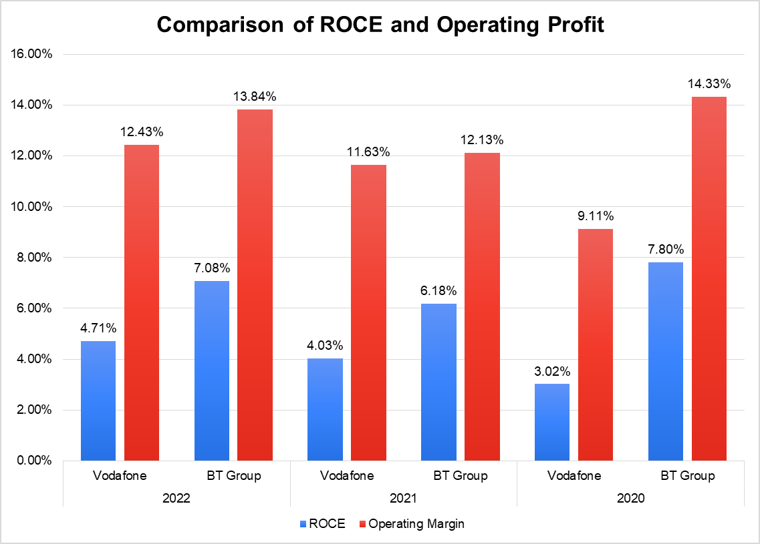

**Figure 1: Comparison of Profitability of Vodafone and BT Group**

(Source: Self-developed)

The comparison of Vodafone Group and BT Group is shown in the column chart above. The operating margin ratio has shown a rise for the Vodafone group from 9.11% in 2020 to 11.63% in 2021 and 12.43% in 2022 which shows that the business has faced a growth in revenues as well as operating income. However the same cannot be set for BT group as the operating profit ratio seems to be declining for the company from 14.3% in 2020 to 12.13% in 2021 and 13.84% in 2022. This shows that the business of Vodafone Plc has experienced a decline in the operating margin in the year 2021. Overall, Vodafone Group's profitability is significantly higher than that of BT Group. Vodafone Group reported higher total revenues as compared to BT group and showed a higher profitability trend than that of Vodafone where the return on capital employed has been shown in blue bars and the operating margin has been shown in the red bar. It shows that BT group has a better performance as compared to Vodafone in terms of operating profit as well as return on capital employed as seen from the trends. This is due to the high amount of loans and expenditures that have been borne by the company in various segments that have affected the performance of Vodafone Group PLC.

The firm, which boasts the second-most valuable brand in Europe, is a major participant in the telecom sector. In the upcoming years, the industry's overall spending is anticipated to increase at a CAGR of 1%, rising demand. Operators have difficulties, nevertheless, as a result of intense competition (Rodrigues, 2019). One of the biggest issues with the business's present strategy is whether it will be able to keep raising dividends in the future because profits could not be high enough to do so.

***Liquidity Comparison***

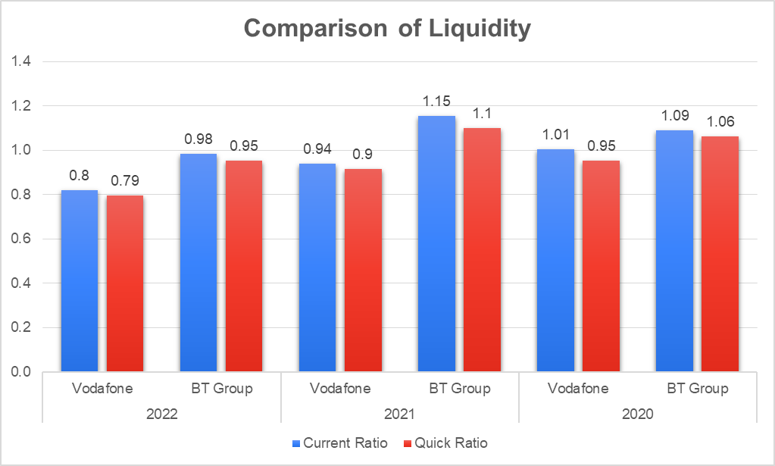

**Figure 2: Comparison of Liquidity of Vodafone and BT Group**

(Source: Self-developed)

The above liquidity ratio comparison has been conducted in terms of the current ratio in the blue bars and the quick ratio in the red bar showing that BT group has the highest liquidity as compared to Vodafone in terms of liquidity in 2021 as well as in 2022. In both these years BT group has outperformed the Vodafone group the company has maintained a ratio of more than 1 in ratio as well as in the quick ratio in the years 2020 and 2021 as well as 2022 both companies experiences a decline in performance as both ratios are less than 1 which can be seen from the column chart above.

***Gearing Comparison***

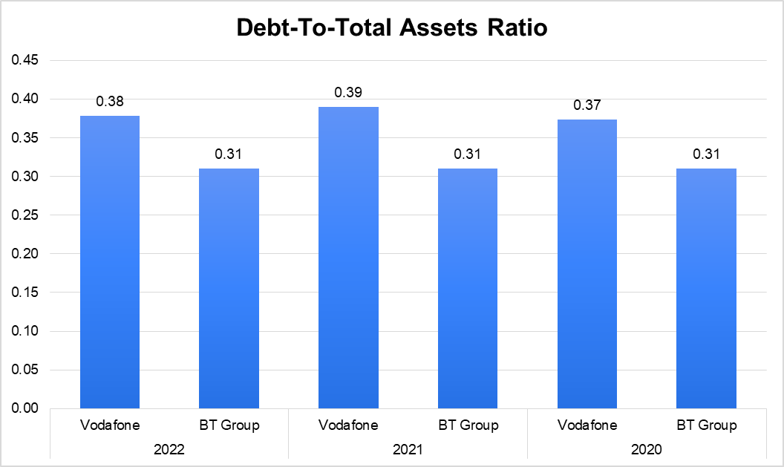

**Figure 3: Comparison of Gearing of Vodafone and BT Group**

(Source: Self-developed)

The comparison of gearing ratio has been done for Vodafone Group and BT group for three different years which shows that Vodafone has the highest gearing which means that the company is leveraging its assets in order to get more debts for the company to meet the obligations for the company. In this case, also BT group has outperformed Vodafone group PLC as BT group has a constant debt-to-assets ratio of 0.31 in all three years so you know fluctuation or addition in terms of long-term debts. This means that Vodafone Group needs to consider its performance in terms of managing its borrowing in terms of assets. The year-over-year service revenue growth for the Vodafone Business sector was offset in part by roaming limitations. Although advantages have been arising from the vertical integration of financial and automotive services, enterprise represents 29% of the Group's service revenue, with the Internet of Things being one of the fundamental points of differentiation in this sector (Rodrigues, 2019).

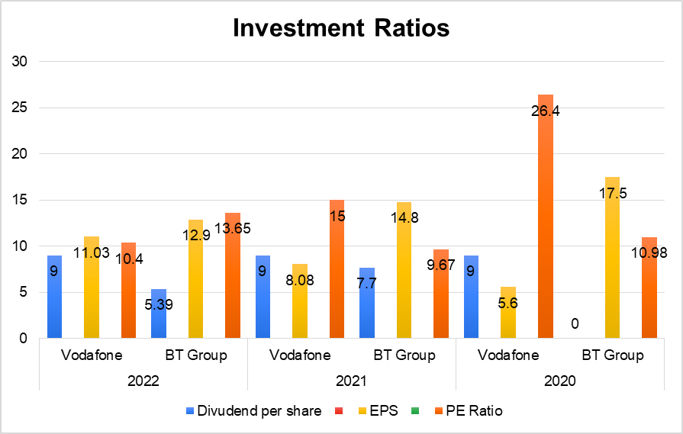

**Figure 4: Comparison of Investment of Vodafone and BT Group**

(Source: Self-developed)

On the above graphical representation it can be identified that the earnings per share of Vodafone is higher in each of the years as compared to BT group. Vodafone PLC pays a constant dividend to its shareholders with respect to the financial performance which means that the company is feasible and investors can consider it for future financial investments. Vodafone also has a good P/E ratio as compared to BT group as the company has high earnings per share and higher profitability that impacts the PE ratio performance.

# Conclusion

In conclusion it must be stated that the financial performance of BT group is much better in comparison to Vodafone group as Vodafone group has a high amount of borrowings which affects the growth of the assets of the company. This has been indicated by the gearing ratio. The liquidity of Vodafone PLC has also declined over the years as compared to BT group which means that the company has not given much attention towards increasing the capacity of its current assets to meet the current obligations. From that, the business profitability is also at risk which must be taken into consideration by the management and the board of directors. The financial viability of BT group is high as the company despite its low revenues as compared to Vodafone PLC has enabled a good percentage of ratios in terms of liquidity as well as gearing.

# Recommendations

From the present report the only issue that has been identified for the business organisation of Vodafone Plc is the high debt-to-equity ratio which indicates the increased dependence on debt financing for conducting business operations and asset utilisation of the firm. Considering the above statement, it can be advisable that the company of Vodafone Plc should be engaging toward the decrease of financial leverage of the firm for reducing the liability risk of the firm. In order to reduce the leverage of the firm, it can be recommended to Vodafone plc engage in other methods of financing its cooperation such as equity financing and retained earnings. The equity financing includes the company of Vodafone Plc engaging in the issuance of the equity share. The retained earnings on the other hand is financing the business operations from the maximisation of the profits.

From the investor’s standpoint, it is recommended that the investors should be considering the business organisation of Vodafone plc as it exhibits a promising return on investment due to high profitability.

# Part B

# Introduction

Cost is generally related to the amount that was paid for a product or service and the cost object is a thing that is to be determined using the cost. Costing systems are used to track the cause that is associated with the production of goods and services and the goal is to provide a comprehensive understanding of the product or service production (Hansen *et al*., 2021). For this purpose, this report will include a discussion regarding the similarities in differences of the impacts of modern and traditional costing systems such as ABC costing and absorption costing as well as the influence of the sizes and types of organizations' products and costing systems on the choice of a particular costing method.

# Discussion

## Similarities and differences in the impacts of traditional and modern costing systems such as absorption costing and ABC on production

***Similarities:***

Both traditional and modern costing systems provide an accurate picture of the costs of producing a product or service. Both are also used to identify areas of inefficiency and optimize processes to reduce costs and improve profits.

The similarities between absorption costing and ABC costing systems are that both systems provide a means for valuing inventory and assigning costs to products for pricing and financial reporting. Both systems allocate overhead costs to products and services. Both systems divide up administrative expenses between goods and services. Both offer a foundation for figuring out the cost of products sold (Jiambalvo, 2019). The distribution of overhead expenses to goods and services forms the foundation of both systems. The profitability of a business and its goods and services is assessed using both the ABC and absorption costing methodologies. Both systems, are intended to accurately depict the cost of goods and services, depending on cost drivers to assign costs to items and services. Management uses the ABC and absorption costing techniques to assist in making defensible choices on price and product mix.

***Differences***

Modern costing systems employ computerized systems and software as opposed to traditional costing methods, which rely on human spreadsheets and paper-based data (Mowen *et al*., 2022). Modern systems are automated, but traditional methods need a lot of labour. Modern costing systems are more precise and have a wider range of data analysis capabilities than traditional costing systems. Modern costing systems also offer more thorough information and analysis, which may be utilized to advice decisions.

Absorption costing is a traditional accounting practice used to assign all of a product's manufacturing costs to the product. Activity-based costing identifies all of the specific overhead

Operations related to the production of each product as well as the manufacturing-related indirect expenses like administrative costs (Quesado and Silva, 2021). The true cost of the actions involved in creating the product is not taken into account by this accounting approach. Activity-based costing, often known as ABC costing, is a technique for allocating costs to goods, services, and clients. It accounts for the true cost of processes like product development, manufacturing, and marketing that go into its creation (Alsayegh, 2020). When analyzing a company's expenses, ABC costing enables more precise cost allocation and improved decision-making. ABC costing also enables businesses to comprehend the cost of individual customer accounts and product costs well.

## Influence of the sizes and types of organisations and products and costing systems on the choice(s) of costing system

The way absorption costing is used may be significantly influenced by an organisation's size, nature, and the kinds of goods and services it provides. Due to the fact that they must take into account a greater number of goods and services, large organisations often require more complicated costing systems than smaller ones (Labro, 2019). This implies that in order to effectively distribute expenses, companies require more thorough and precise absorption costing methods. Additionally, various products and services call for various absorption costing schemes. For instance, a distinct absorption costing approach is often needed for services compared to commodities or products (Weygandt *et al*., 2020). The allocation of indirect expenses, such as overhead and human costs, is frequently higher for services. Finally, the use of absorption costing may be impacted by the type of costing system selected. Businesses can decide whether to utilize more conventional methods like throughput costing or goal costing, or more contemporary ones like process costing, task costing, or activity-based costing. Each of these systems will have an impact on the application of absorption costing.

Similarly, systems for ABC Costing are significantly influenced by the sizes and types of businesses. For instance, larger companies frequently have more intricate cost structures than smaller ones, necessitating the use of ABC Costing systems that are more sophisticated in order to effectively capture the expenses related to their operations (Making, 2020). To suit their unique demands, various organisational types may also require various pricing methods. A manufacturing company, for instance, could need a different costing methodology than a service company. ABC Costing additionally includes product size and kind. Depending on how complex their manufacturing process is, various items may require various costing methods (Quesado and Silva, 2021). For instance, a manufacturing company could need a different costing system than a service company. A product that needs more effort and resources to create, for instance, would necessitate a more intricate costing structure than a product that uses less labour and resources.

## Relationship between production costs and production planning

Planning for production and costs are strongly interrelated due to the process of deciding how much of a product or service should be produced and when is known as production planning (Weygandt *et al*., 2020). It is employed to ascertain the most effective and economical method of producing a good or service. The expenses incurred during the production of a good or service are referred to as production costs. Because the production plan has a direct influence on the cost of providing a good or service, production planning and production expenses are closely related. The cost of manufacturing a product is influenced by the production plan, which also impacts the amount of labour, raw materials, and other resources required (Jiambalvo, 2019). Higher production costs may result from inefficient production plans that ignore the most economical methods of manufacturing a given good.

Production planning is also employed to reduce expenses associated with production. To determine the most economical method of manufacturing a good or service, production planners employ a variety of methodologies, such as total cost analysis. To assess if the advantages of manufacturing a product exceed the disadvantages, they also utilize cost-benefit analysis. Thereby, production planners can contribute to lowering total costs and raising profit by maximizing production costs. The production plan must also include a timeline for the completion of the project. This timeline must be realistic and achievable. It must also be flexible enough to accommodate any changes in the production process or unexpected costs. To ensure that the production plan is successful, the planner must constantly monitor the production costs and compare them to the expected final price of the product or service. This will help to ensure that the production plan is on track and that any unexpected costs can be taken into account.

# Conclusion

In conclusion, it must be stated that both absorption and ABC costing are widely relevant and have certain differences and similarities. It is similar in its nature, but different in its actions. The size and type of an organization, as well as the types of products and services they offer, can have a significant impact on the way absorption costing is implemented. Companies should carefully consider which costing system is best suited to their particular needs and understand the relationship between marginal and absorption costing for a better understanding of costing techniques. In summary, production costs and production planning are closely related. Production planning is used to determine how much of a product or service should be produced and when, and it affects production costs.

# References

Alsayegh, M.F., 2020. Activity based costing around the world: Adoption, implementation, outcomes and criticism. Journal of Accounting and Finance in Emerging Economies, 6(1), pp.251-262.

BT Plc, 2023. *Home |.* Available at: https://www.bt.com/about (Accessed: 12 April 2023).

Davis, C.E. and Davis, E., 2019. Managerial accounting. John Wiley & Sons.

Hansen, D.R., Mowen, M.M. and Heitger, D.L., 2021. Cost management. Cengage Learning.

Jiambalvo, J., 2019. Managerial accounting. John Wiley & Sons.

Kamaluddin, A., Ishak, N. and Mohammed, N.F., 2019. Financial distress prediction through cash flow ratios analysis. International Journal of Financial Research, 10(3), pp.63-76.

Labro, E., 2019. Costing systems. Foundations and Trends® in Accounting, 13(3-4), pp.267-404.

Making, I.R.I.D., 2020. Activity based costing system and its role in decision making. A case study of cement companies in Kurdistan region of Iraq. International Journal of Psychosocial Rehabilitation, 24(06), pp.5915-5929.

Mowen, M.M., Hansen, D.R. and Heitger, D.L., 2022. Managerial accounting: The cornerstone of business decision-making. Cengage learning.

Quesado, P. and Silva, R., 2021. Activity-based costing (ABC) and its implication for open innovation. Journal of Open Innovation: Technology, Market, and Complexity, 7(1), p.41.

Rashid, C.A., 2018. Efficiency of financial ratios analysis for evaluating companies’ liquidity. International Journal of Social Sciences & Educational Studies, 4(4), p.110.

Rodrigues, M., 2019. Vodafone group Plc-telecommunications: a transforming Industry (Doctoral dissertation).

Sana, J.K., Abedin, M.Z., Rahman, M.S. and Rahman, M.S., 2022. A novel customer churn prediction model for the telecommunication industry using data transformation methods and feature selection. Plops one, 17(12), p.e0278095.

Statista, 2023. *Topic: Telecommunications industry in the UK* (2023). Available at: https://www.statista.com/topics/7198/telecommunications-industry-in-the-united-kingdom/#topicOverview (Accessed: 12 April 2023).

Vodafone Plc, 2023. Home. <https://www.vodafone.com/> (Accessed: 12 April 2023).

Weygandt, J.J., Kimmel, P.D. and Aly, I.M., 2020. Managerial Accounting: Tools for Business Decision-Making. John Wiley & Sons.

# Appendices:

Excel Sheet

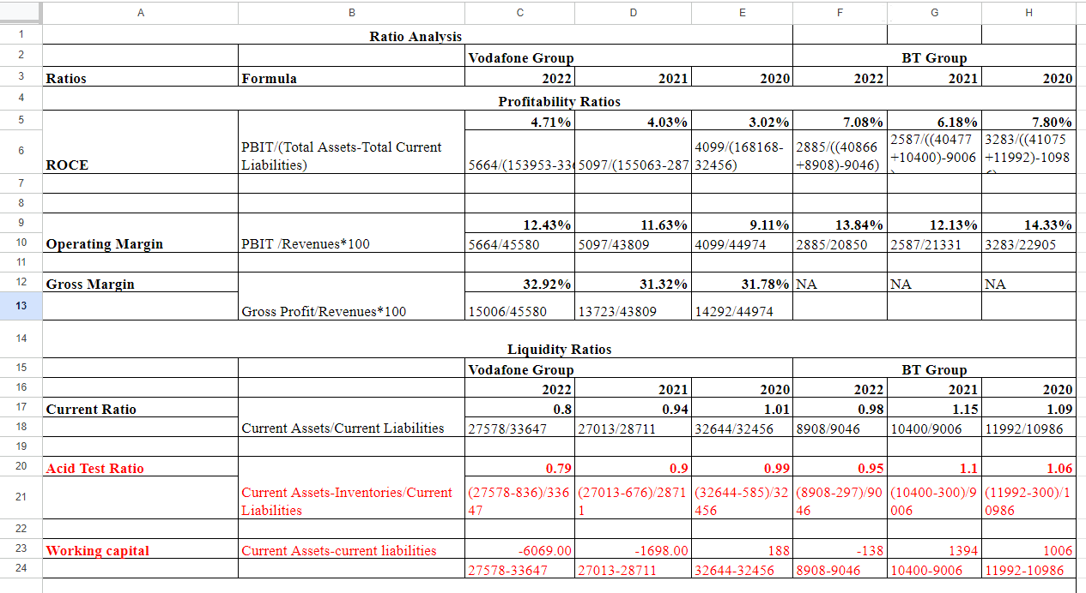

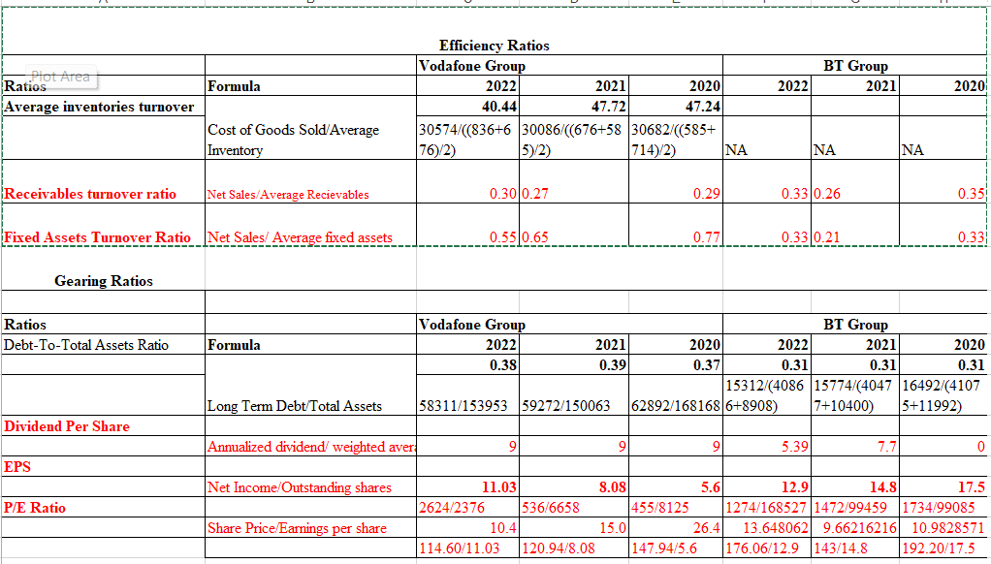

Link: https://docs.google.com/spreadsheets/d/12NWjMr_gm9bC1Wh1nwqQKnxPZfCC2lf9/edit#gid=1254174447

**Financial Statements:**

**BT Group**

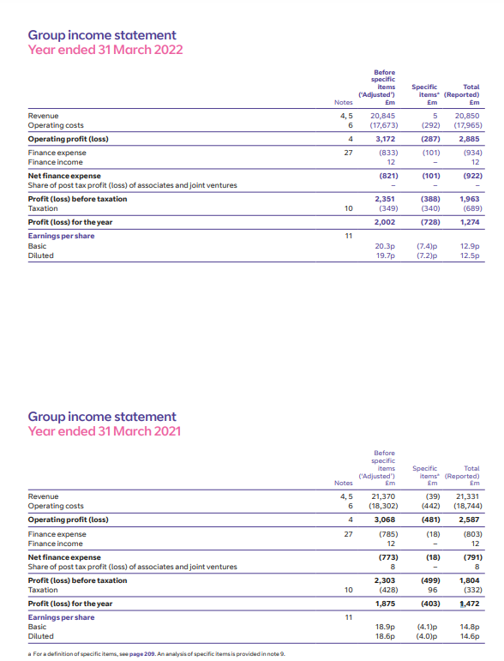

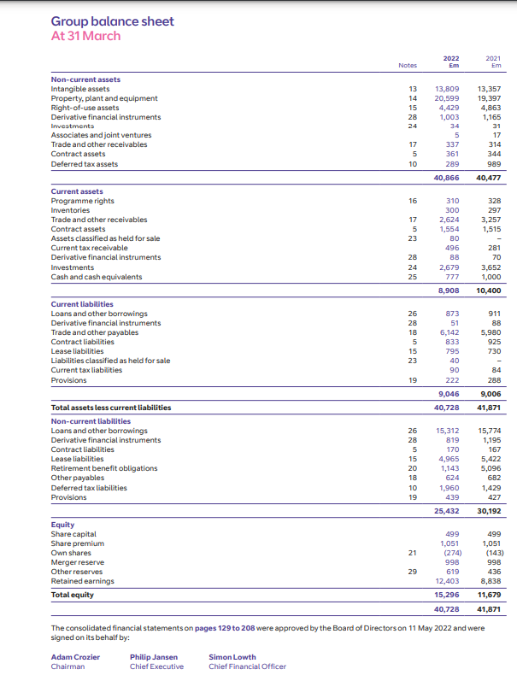

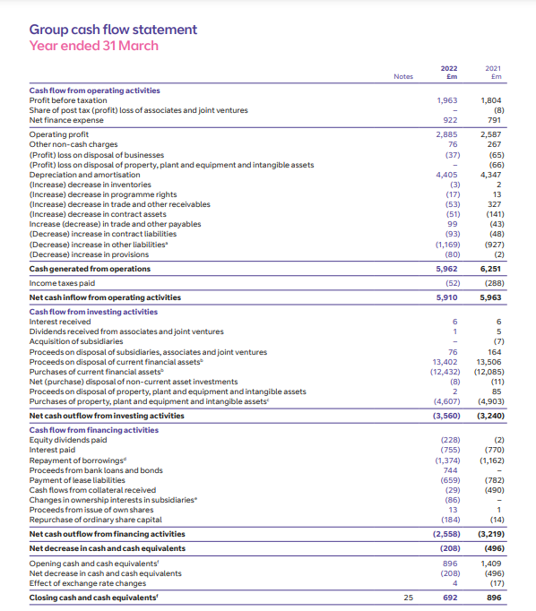

**Vodafone Group**

