**ASSESSMENT: IMPACT OF TRADE LIBERALISATION ON EMPLOYMENT OF INDIAN MANUFACTURING INDUSTRY**

**Table of Contents**

Chapter 1: Introduction 3

1.1 Introduction 3

1.2 Research Background 3

1.3 Problem Statement 4

1.4 Research Rationale 4

1.5 Research Aims 5

1.6 Research Objectives 6

1.7 Research Questions 6

1.8 Research Significance 6

1.9 Research Structure 7

1.10 Conclusion 8

Chapter 2: Literature Review 9

2.1 Introduction 9

2.2Empirical Studies 9

2.2.1 Identification of the situational changes in employment in the Indian manufacturing sector before and after trade liberation 9

2.2.2 The opportunities faced by the manufacturing sector due to trade liberalisation 11

2.2.3 The probable obstacles faced by the manufacturing sector 12

2.2.4 Intervening policies regarding the improvement process of trade liberalisation on employment in manufacturing sectors 14

2.2.5 Discussion on the benefits of outward-oriented trade policies in Manufacturing Industry 16

2.3 Past Literature 17

2.4 Theoretical Framework 18

2.5 Conceptual Framework 21

2.6 Research Gap 22

2.7 Conclusion 22

Chapter 3: Methodology 23

3.1 Introduction 23

3.2 Research onion 23

3.3 Research philosophy 24

3.4 Research approach 25

3.5 Research design 26

3.6 Data collection 27

3.7 Sampling and sample size 28

3.8 Data analysis 29

3.9 Ethical consideration 30

3.10 Gantt chart 30

3.11 Summary 32

References 33

# Chapter 1: Introduction

## 1.1 Introduction

In this chapter of the research study, it has been noted that the research is being started from this chapter based on the specific topic of the impact of trade liberalisation on employment of the Indian manufacturing industry. Trade liberalisation mainly refers to removing barriers or restrictions based on the free exchange of goods and products between nations. These barriers may involve tariffs such as surcharges, and duties and also non tariff barriers such as quotas and licensing rules. The present research has included research background to have certain history and the rationale of the study to discuss the challenges and issues that occurred in the research. The aims and objectives of the research will be covered in order to maintain the significance and structure of the research study. The missing part of the past literature has also been included in the research study to identify and understand the particular topic efficiently.

## 1.2 Research Background

In the present research study, the impact of trade liberalisation for removing the restriction and reducing accordingly in order to make a free exchange of services and goods between the nations. This has made a high change to the employment level in the Indian manufacturing sectors. Rapidly increasing the flow of products and services over the nations has been the most visible aspect in order to increase the integration of the global economy in recent years. However, this has also been one of the most controversial aspects of globalisation. The level of employment is known as the key determinant of overall economic welfare (Nasim *et al*., 2022). It helps in developing and improving countries which have weak social protection systems. It has been observed that the Indian economy has been shown to have outperformed in the context of the rate of its annual growth. It has been obtained that the impact of the economic liberalisation in the Indian economy in the early years has led the economic growth to a high level in the Indian industry. The research study has mainly focused on the employment determination to a large extent which also impacts on poverty, income distribution, wage and the quality of employment.

## 1.3 Problem Statement

In the present section of the research study, the problem statement of the particular research has been discussed. There are different ways that can have both positive and negative impacts on the employment rate in India. The research section has helped in identifying some of the areas in a specific way for making possible solutions. Relying on the announced changes in the policies involving the reduction in tariffs or the removal of the restriction in the country. It has been observed that trade liberalisation has begun in the year of 1991 in India, and at that time the growth of the manufacturing industries, compared with other countries, was lagging to provide proper employment and generate revenue (Beak *et al*., 2022). The main issue with the new trade liberalisation in changing the policies has made it difficult for the workers working in the manufacturing industry. The unemployment rate has increased in the past few decades and the industry also faced challenges regarding the economic growth in the nation.

It has been obtained that, in India, there is a disconnection between the employment level and its output. It highly indicates that the larger firms in the country have more impact rather than the small ones. This has become a crucial issue after globalisation, in the competitive world all industries are maintaining a position to achieve their targets. The change in the policies of trade liberalisation has made it difficult for the workers in the industry to gain more opportunities and benefits. It is also necessary to note that the use of multiple criteria including tariff changes and changes in the prices may also impact on aggregation. The separation process of the impact of trade liberalisation of other macroeconomic crises, policy shifts and others can also occur at the same time.

## 1.4 Research Rationale

***What is the issue?***

The issue of trade liberalisation on employment has become a major issue which is raising the unemployment rate day by day. The unemployment rate and wage inequality in the Indian manufacturing industries increased the exploitation of the workers in developing the economic factors along with employment conditions and the standard of labour. The issues regarding the effective policies in the country must be optimised in order to improve the employment level.

***Why is the issue?***

After globalisation, it has been observed that the policies and rules have changed and the trade liberalisation has impacted on the employment rate in the Indian manufacturing sectors very much. As a result, the unemployment rate has been raised massively and job opportunities have become insufficient for them. The Indian manufacturing industry has been suffering through this particular problem which needs to be resolved for providing better opportunities regarding employment.

***Why is the issue in the present time?***

In recent years, the unemployment rate has increased gradually due to the impact of trade liberalisation (Abosede and Tolulope, 2022). Globalisation made a competitive economy between different nations and by reducing the employment rate, employees have faced many challenges and issues in the Indian manufacturing industry. Trade liberalisation has the ability to pose a threat to the development of the nation and its economy as they are forced to compete in the same market.

***What does the research shed light on the issue?***

The present research study shed light on the issue as the research is mainly on the impact of trade liberalisation on the employment of the Indian manufacturing industries. The number of research held for the particular research mainly deals with the purpose of unemployment which has become an issue in the Indian manufacturing industry and the reason is the trade liberalisation in changing the policies and economy of the nation.

## 1.5 Research Aims

The aim of the research mainly deals with Trade liberalisation and its impact on the employment of the Indian manufacturing industry. The research study will help in understanding the base of the positive and negative impact on this premise and also determine whether trade liberalisation increases the elasticity of demand for the labourers and reduces the bargaining position of workers and wages. It has brought the unemployment situation in the nation and faced many issues regarding it.

## 1.6 Research Objectives

* To identify the situational changes in employment in the Indian manufacturing sector before and after trade liberation
* To identify the opportunities and barriers faced by the manufacturing sector
* To figure out the policy intervention that can improve the employment effects of trade liberalisation in the Indian manufacturing sector
* To identify the advantages of outward-oriented trade policies and the possible outcomes achieved by trade liberalisation

## 1.7 Research Questions

* Why is it necessary to identify the situational changes in employment in the Indian manufacturing sector before and after trade liberation?
* What are the opportunities and barriers faced by the manufacturing sector?
* How will policy intervention improve the employment effects of trade liberalisation of the Indian manufacturing sector?
* What are the advantages of outward-oriented trade policies and the possible outcomes achieved by trade liberalisation?

## 1.8 Research Significance

The significance of the present research study is to control the certain limitation which has been obtained from the limited knowledge of the impact of trade liberalisation on employment of the Indian manufacturing industry. The main focus of the research is to increase the employment rate and improve their efficiency level and create more opportunities for the employees in the manufacturing sectors. Reducing tariffs and non-tariff barriers can help in the short run and the economic crisis has led to the significance of involuntary unemployment through the reduction of costs. It has been observed that trade liberalisation has a high impact on the employment level of the Indian manufacturing industry as well as the economy of the country (Elryah and Siddeg, 2023). Trade and employment are highly related to the development process in several ways such as creating job opportunities. It highly impacts the economy and helps increase the income rate and expand the demand. The particular focus of the research is on improving the unemployment rate in the Indian manufacturing industry and reducing tariffs and non-tariff efficiently. Thus the present research study has mainly focused on bringing the efficiency level in trade liberalisation and making it effective in the manufacturing industry in order to generate more opportunities and increase the employment rate.

## 1.9 Research Structure

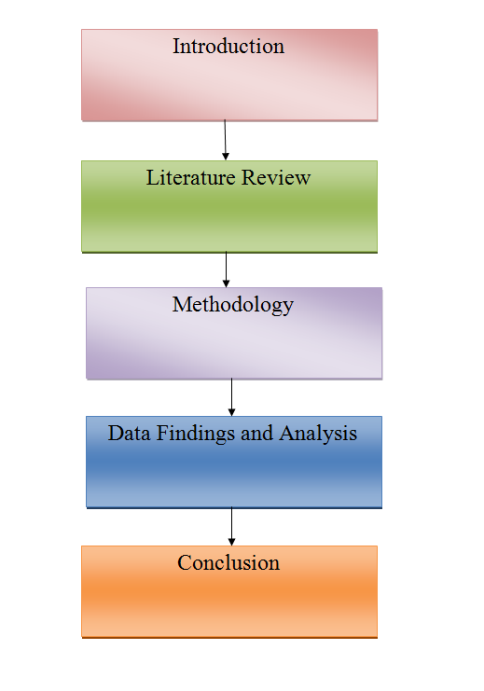

**Figure 1: Research Structure**

(Source: Self-developed)

## 1.10 Conclusion

From the above research study, it can be concluded as the effect of trade liberalisation on the employment of the Indian manufacturing sectors. The research background made it easy to know the past history and the background of the particular study. The research rationale has been in providing the challenges and issues of the research available. The present research has also provided the aims and objectives with research questions. The significance of the research has focused on the significance to be made for the sake of the particular research.

# Chapter 2: Literature Review

## 2.1 Introduction

In this present section of the research study, a proper analysis of the context of the study has been provided by observing different opinions from different authors and researchers. This present chapter of the research has included an overview of the existing research study in the particular field in which the research can be made. The research has involved several data and information from the authors on the impact of trade liberalisation on employment in the Indian manufacturing industry. The relevant theories and models are also provided for a better understanding of the particular research topic. A conceptual framework has also been developed in order to identify the dependent and independent variables efficiently.

## 2.2Empirical Studies

### 2.2.1 Identification of the situational changes in employment in the Indian manufacturing sector before and after trade liberation

According to the statement by Rijesh, (2021), since early liberalisation at the beginning of the 1990s, the Indian manufacturing sector has experienced significant changes over the years. Economic liberalisation began with trade liberalisation policies that basically focused on increasing international trade prospects, reducing taxes on imported products and services and opening up spaces in the domestic market for foreign competitors. The manufacturing industry of India plays a major role in contributing to the national economy. The employees and the employment opportunities of the manufacturing industry endure significant effects of any change in the manufacturing industry. As a result of this, they had to experience the effects of trade liberalisation as well.

Before the introduction of trade liberalisation in India, most of the industries operating in the market including the manufacturing sector were exempt from high import tariffs and government-induced regulations. As a result of this, the competition between companies operating in the manufacturing sector was relatively low. In addition to that, the product in the market offered by these manufacturing industries was of poor quality. Due to the Limited focus on the quality of the products, the sector was especially characterised by low-level productivity of operations, decreased efficiency as well as lesser adoption of new technologies in order to facilitate operations and in corporate upgradation in products and services. Additionally, the sector was dominated by a few big companies due to which the bargaining power of the workers was low. As a result of this, the employees were bound to work at low wages. It had limited employment opportunities in the industry. The sector basically relied upon labour-intensive industries such as apparel and textiles with limited career growth and skill development. The lack of competitiveness among the companies operating in the industry limits the growth potential (Kumar and Dhar, 2020). As a result of this, the sector was unable to create enough opportunities to keep up with the growing worker population.

As per the observation by Jha and Talathi, (2023), on the other side of trade liberalisation that is after its introduction in India, the manufacturing industry experiences significant changes in terms of employment. With the incoming Foreign industries, Global competition was introduced in the Indian market. As a result of this, the competitiveness went up significantly in the industry. Companies begin competing with international companies as well as domestic companies and emphasise the quality improvement of products. This had a direct impact on the improvement of productivity of companies operating in the manufacturing sector. The trade liberalisation policies had both positive and negative effects on the employment of workers in the sector. Some industries including textiles and apparel came across challenges due to the increasing competition of its production with those of foreign companies. This led to job losses of workers due to the increased demand for skilful workers. On the other hand, the new policies created job opportunities for workers in logistics, warehousing and transportation. This is due to the integration of the manufacturing industry with the global market. The company started adopting new technologies which also led to employment opportunities for individuals.

The economy has grown more than 6 percent after the liberalisation on average between the period of 1990 to 2004. The overall employment growth of India has also increased from 1 percent to 3 percent. However, the fact is that the employment rate has risen mostly in the unorganised sectors, particularly after 1995 but there is a decline in the employment rate in the organised sector. The process of liberalisation begins in 1980 in India when efforts has been made to remove the controls on the imports and exports that were built for a long period The shift in the trade liberalisation policy came in 1991 when there is a discussion on reducing the tariff in various sector and to promote the export was introduced and a new initiative of the foreign direct investment has been adopted (Francis, 2020). The fundamental changes effectively bring an end to the import industrialization strategy and strengthen the role of trade in the process of the growth of the economy, substantially it helps to strengthen the economy and integration into the global economy. After the stagnation of employment in the manufacturing industries in 1980 there is steady growth in 1990 and the growth is based on export-oriented industries which played a pivotal role in employment growth.

### 2.2.2 The opportunities faced by the manufacturing sector due to trade liberalisation

According to Francis (2020), trade liberalisation has an impact on the development of reducing the barriers in terms of quotas and licensing. The manufacturing industry has found benefits in the development of trade liberalisation. The reserved items in the manufacturing industry have been curtained due to liberalisation. Due to the reduction of tariff barriers in the trade exchange and liberalisation of free trade many small-scale industries have been opened that branched out as the process of a new beginning in the manufacturing sector. The small-scale industry has been regarded as the backbone of the manufacturing industry with the developing process of investment ventures. . The development of small-scale industries in the manufacturing sector has brought opportunities to export their products to other countries with the help of reducing trade barriers. The supply chain management can be facilitated with the trade opportunities such as shifting working schedule development. After 1990 the annual increase of trade registration has developed 10%. In the early 1990s’ the Indian economy faced 13% growth in the business industry after trade liberalisation.

According to Dewi *et al.* (2020), by improving trade liberalisation by making exchange free and fewer tariff barriers in the export process, small-scale industries have provided opportunities to develop large-scale exports and employment in the private sector which leads to an increase in economic stability. Tariff liberalisation led to a decline in labour share in capital-intensive sectors and technology. The economy of the manufacturing industry has seen a significant growth rate due to the liberalisation of trade. The nature and strategy of tariff liberalisation have been reviewed in the process of managing the growth rate of the manufacturing industry. The exchange rate of export has been reduced to 5.6% which facilitated the small-scale manufacturing companies gaining the courage to export their products to the international market. Before 1991 the trade market was less profitable in India as fewer Foreign companies showed interest in developing trade with the Indian economy. After 1991 the liberalisation policy of trade has shown the enhancement of import and export and trade economy has developed to 30% along with the rate of employment in the manufacturing industry.

The global trade trend of the manufacturing industry has changed. The liberalised access to imported input in business has brought benefits for the companies to develop the market share. The reset of global trade trends has been improved in the liberalisation of trade opportunities. Large foreign capital enforcement and currency appreciation have been developed in the process of improving trade liberalisation. The traditional labour-intensive and resource-based sectors such as cotton, apparel, coffee, tea, and spices were the dominating sectors in the export process of business. Since the export facilities have been revitalised and free trade opportunities have grown, other sectors of manufacturing such as handicraft products, art, and craft, and jute products have been a strategic stepping place in the export market (Ho Dinh *et al.* 2020).

The non-oil manufacturing export has developed momentum in the process of building profitability and inclusion in the export market. Organic, chemical, electric, and non-electric machinery articles have significantly brought in the trending pattern of trade in recent years. The development of business relations has been improved as a matter of developing opportunities due to trade liberalisation and reducing the licensing barriers. The elimination of quotas and reducing the barriers to licensing small and medium size industries have developed significant growth in the textile-producing sector. The largest business opportunities have emerged in textile and electric materials for export in the highly competitive market. Many rural industries producing materials using bamboo and soil have got the opportunity to develop the business by exporting goods to other countries. As per Kyander (2020), on the other hand, female employment in the manufacturing sector has increased due to the increase of export in business.

### 2.2.3 The probable obstacles faced by the manufacturing sector

According toMukherjee and Chanda (2019), the impact of tariff and non-tariff reduction in the factory level of Gross Value of Output (GVO) and the rate of the declining productivity of different manufacturing sectors. Labour productivity in the case of the manufacturing industry has been found as a significant barrier to generating employment opportunities. It has been found that the trade barrier occurs due to trade war and US-Iran tensions across the world in the path of developing business export. Less availability of adequate skilled and equipped labour in the economic infrastructure has been found as another obstacle to improving trade in the manufacturing sector. Due to trade tension between the U.S-Iran availability of proper quality labour has not been found to grow the manufacturing sector.

As per Li *et al*. (2019), on the other hand, the pandemic impact across the world has been found a matter of great concern in the path of developing the manufacturing industry. Lack of adequate human resources and financial security have emerged as potential barriers against the path of developing future growth of trade in the manufacturing sector. Joblessness has been found prominent in the pandemic period in the manufacturing sector and a void has been created for a skilled workforce. High investment requirements have been developed as another barrier in the manufacturing industry. In most cases, high investment is required in the manufacturing industry of textiles, electronic goods, and appliances, the non-oil materials that were not generated due to the economic crisis that happened in the pandemic period. The uncertain economic stability of the post-pandemic period has created uncertainty among the minds of investors to invest money in the scope of business.

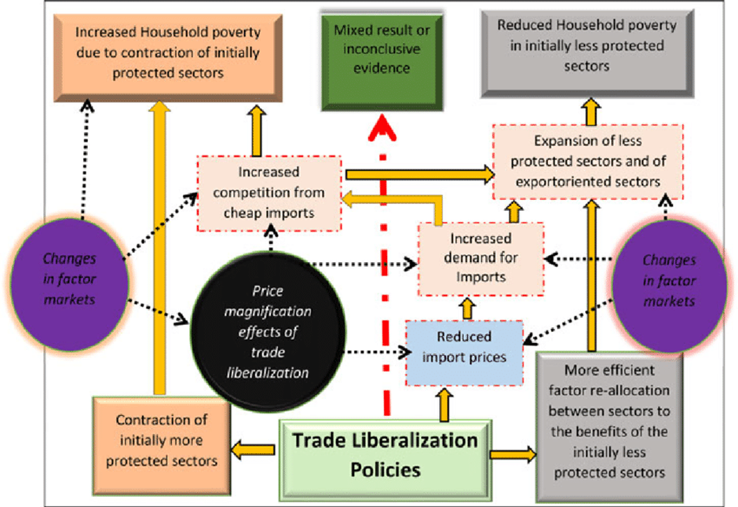

**Figure 2: Trade Liberalisation on Poverty**

(Source- Briggs and Sheehan 2019)

As per Briggs and Sheehan (2019), trade liberalisation has caused barriers to reducing product quality. It has been found that by reducing the tariff barriers and developing foreign investment in business trade, the quality of the product has been decreased to meet the demand for export in huge quantities. Trade liberalisation has impacted the poverty scale of developing countries. Capital accumulation and the process of developing earnings in the household business have been found less profitable due to trade liberalisation. The demand for low-skilled labour has increased in the business market. A higher dropout rate has been observed in developing countries like India in terms of improving capital formation in business opportunities for low-skilled labour. On the contrary, the cross-cultural barrier has been found in the process of trade liberalisation. The challenges faced by the business companies before 1991 were mainly dealt with less opportunity to develop import and export in the business market especially by the small scale industries. The cross-cultural barrier such as the negative impact of trade potential has affected the business opportunities. Individual labour market performance in capital formation has emerged as a barrier to trade liberalisation. The reduction of workers' wages in the labour market has come out as a barrier to flourishing quality businesses.

### 2.2.4 Intervening policies regarding the improvement process of trade liberalisation on employment in manufacturing sectors

According to Laiprakobsup (2019), the wage differentiation between skilled and unskilled workers has been found to have an impact on trade liberalisation in the manufacturing industry. The tariff barriers have been reduced to 10% which improved the demand for low-skilled workers in the manufacturing sector. The low-skilled workers are in demand in terms of gathering opportunities for the manufacturing, supply chain, and collection of raw materials. Trade liberalisation policies such as duties of surcharges and non-tariff barriers such as licensing and quotas have been established in the manufacturing sector. A higher growth rate has been found in the corporation of investment ventures in the business economy. The higher cost of capital has been found effective on the employment level due to trade liberalisation policies have been improved.

Foreign exchange reforms and tax reforms have been found as the intervening policies in the trade liberalisation process that help business productivity growth and effective opportunity for improving employment in the supply chain, production, networking, and private sectors. Trade liberalisation leads to the lowering of wage inequality in the manufacturing sector of developing countries as the difference between skilled and unskilled workers has decreased. Freer trade improves labour-intensive manufacturing products and the aggregate development of the manufacturing industry. As to Le (2020), on the other hand, industrial policies have been effectively developed to provide labourers with an appropriate way of improving wage differences and innovative skill-gathering processes. The Unitary Trade Association has focused on the process of maintaining trade regulations and policies to improve employment opportunities and facilitates the way of managing labour-incentive growth of rural manufacturing industries. The policy framework has been improved in the context of the manufacturing industry to deal with the process of managing the wage gap and inequality. The outward-oriented trade policy in the manufacturing industry provides the opportunity of developing capacity, productivity, and industrialisation.

According to Baldwin Asada (2022), the different stages and development processes of the economy and others in order to adopt the different policies and approaches might give an advantage to the industry and help in reducing the unemployment rate in the nation. In the early stages, the policies related to the sector are observed as a crucial part in order to define the current comparative advantages in the trade liberalisation process and develop the sector with new ideas and innovative ways (Ramzan *et al*., 2019). Trade liberalisation is known for the microeconomic policy which helps in making it possible in order to achieve advantages as well as preventing the overtaking process by the competitors in the global world. On the other hand, as per Agenor *et al.* (2018), the policies regarding the improvement of the trade liberalisation process can help in creating new opportunities for the employees and increasing the growth of the economy. This highly follows the government's effectiveness and openness which can help in leading the economic growth and associate trade and financial openness. The process of boosting the economic growth when the economy is more financially open allows more advantages to the industry and makes the increase in the financial source. Financial openness helps in investigating the positive relationship between the trade openness and the government sectors. Through boosting the economical factors the employment rate will gradually increase and the efficiency level of the industry will grow positively (Liu *et al.*, 2022).

### 2.2.5 Discussion on the benefits of outward-oriented trade policies in Manufacturing Industry

In the context of the trade liberalisation on employment needs the strategy of outward-oriented trade policies could help in building the trade and industrial policies efficiently. It has been obtained that it does not determine between the production and exports, nor between the foreign production and purchasing of the domestic production. According to Guinigundo (2018), trade is involved in opening the foreign portfolio flows which help in the growth of the nation through following the liberalisation of trade and foreign exchanges (Le, 2020). The outward-oriented trade policy in the manufacturing industry has the capability in improving productivity and efficiency levels with exposure to the competition level globally. It has been observed that the adaptation of foreign innovative technologies in the procedure of the manufacturing industries can help in making effective results in the end. Through outward-oriented trade policies in the nation, can bring positive outcomes such as an increment in the investment process and helps in encouraging inward investment and developing domestic productivity. Liberalisation policies have increased the size of the market through integrating with the global market which have increased in recent days and made the competition tough. The outward trade policies are the free trades gain from the tariff removal which helps in increasing the competition and the efficiency.

On the other hand, Brun and Gnangnon argued in this specific matter stating that trade policies may help in opening and accelerating the development process of the country and the technical process is incorporated into the new material, manufacturing products and other equipment. It can be said the technical changes through liberalisation help in promoting the investment procedure and reduce the cost rate of the additional exports. The possible outcomes have a greater capacity level and it helps in utilising the process for fast growth in the industry. Before 1991, the employment rate in the Indian manufacturing industry remained virtually stagnant and the manufacturing rate was about 0.53%. After 1991 the rate highly grew at a 4.03%.

As per the opinion of Henry and al (2019), outward-oriented trade policies highly focus on growth which helps in developing growth and generating more opportunities via the ideas and knowledge obtained through imports (Momenta, 2022). It can be said that the import of new technologies is defined as an important source of growth factor in developing the nation and its economy. However, the impact of growth is highly dependent on the efficiency by which the technology transfers are engaged. On the other hand, as per Mahembe and Odhiambo (2019), trade openness and the growth of the economy can be boosted by some significant development in the context of the new growth theory. With the help of endogenous changes in technology, the unemployment rate of the nation will be reduced and the industry will obtain new ideas and processes that can be involved in the present method. It has been obtained that after 1990, the outward oriented trade policies were changed and the manufacturing industry has faced some difficulties (Le and Tomasi, 2023).

According to Balisacan and Pernia (2019), the impact of trade liberalisation on the growth of productivity also impacts on the economy and on the employment of the industry. In recent days, trade has been gaining a competitive advantage in almost every country and the impact of trade policies on the exports of the agricultural component has been observed the most. It has been highly seen that the GDP has a high impact on agricultural exports and the outward-oriented trading strategy creates a clear improvement in terms of the price incentives for exports (Tan *et al*., 2022). In this way the real GDP will be increased in an efficient way as well as the income distribution will also be improved. Through this improvement, the employment rate in the industry will have the opportunity to grow and make the industry sustainable in the long term process. On the other hand, as per Rayes and Tabuga (2019), the employment situation from the past years has been unchanged in the service sectors and despite the impact of trade liberalisation some of the countries have gained improved and developed skills, ideas and knowledge effectively. The improvement in the skill and knowledge will gradually help in building the industry more effectively and generate economic growth efficiently. If the economic growth becomes efficient and brings more opportunities to the industry the employment rate will grow gradually and it will make an improvement to the nation. Employment highly depends on economic growth and it gradually engages the industry in making more advantages globally in order to build their goals effectively. The new implementation of the policies and techniques in the manufacturing industry can help in building new strategies for the industry and increase the employment rate efficiently. It will also highly support in making the economic growth increase of the nation.

## 2.3 Past Literature

In the research paper, the past literature has immense importance as it supports the development of the proper understanding of the area of focus on research. In the process of the research various literature works of eminent authors, and journals have been considered which helps to identify the areas of research and to bridge any gaps which are present in certain areas of the research. To understand the focus area of research this section of the study has targeted to analyse the various previous research work and helps to determine how significant the importance of changes in employment opportunities in the Indian manufacturing sector is before and after the trade liberalisation. Post-liberalization has helped the Indian economy to integrate with the global economy with the adoption of foreign direct investment which helps India to evolve in the global market thus increasing the number of foreign tourists in India (Mishra and Palit., 2020). After the liberalisation, there is increasing international competition in various sectors like automobile, telecommunication, technology, software, development, and research. One of the biggest beneficiaries in the economic development of India is the expansion of the sectors like telecommunication. This sector now has various competitive service providers which were once heavily controlled by the regulation and monopoly of the government. The establishment of the National Telecom Policy in 1994 opened the doors for all the private sectors to expand their business in the telecommunication industry. Apart from telecommunication, there is an evolution in the insurance and banking sector which attracts the FDI and helps to create employment opportunities post-liberalization. The highest job opportunities are generated through the integration of the global market into the Indian economy. The workforce has increased in the manufacturing industry, agriculture, and various service sectors over the period. Thus it can be said that the Indian Government should take some measures to capture the generation of employment in the organised sector.

## 2.4 Theoretical Framework

***The New Trade Theory*** has emerged as a collection of different dynamics to associate the link between international trade opportunities and explanation of developing productivity among trading companies.

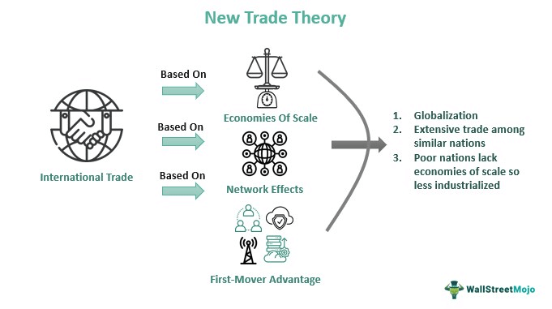

**Figure 3: The New Trade Theory**

(Source- Ahmed, 2012)

The development of business opportunities in the international trade market can be influenced according to the theory of new trade. The elements of new trade theory have been surrounded by globalisation, extensive trade opportunities, and the good effect of network scale to expand international business. In this context, the development of international trade opportunities can be enlarged with the growth of globalisation and new trade trend-setting (Ahmed, 2012). The impact of globalisation and networking on trade productivity has been found with the increasing number of developing small-scale industries in developing countries. An industry's ability to realise economies of scale is very important to measure growth and efficiency. The new Trade Theory can be implemented in the context of improving productivity and quality in the manufacturing industry after identifying the process of managing network effect and connectivity.

The manufacturing industries of artefacts and automobiles have an extra advantage in the business world to deal with profitability. The companies that come with these products in the manufacturing industry always are in a position of profitability. The development of employment opportunities in the manufacturing industry can be improved with the trade liberalisation impact on the manufacturing industry. The skilled workforce and financial investment in capital formation have to be regained in the process of managing employees in the trade market. As per Gaspar (2020), the barriers are there in the trade market to develop improvement in gaining benefits are mainly an inefficient labour force and a lack of investment ventures. Internationalisation of trade can be improved with the establishment of global channels and economies. Companies with first-mover advantages can reach the high-performance development process in business. employment can be increased by adopting the advantageous position of using.

Another trade theory that can be applied in this context is According to **The Heckscher-Ohlin trade theorem** trade theory, the strategy, structure, and rivalry among the companies in the market have been effective to provide opportunities for trade and profitability management.

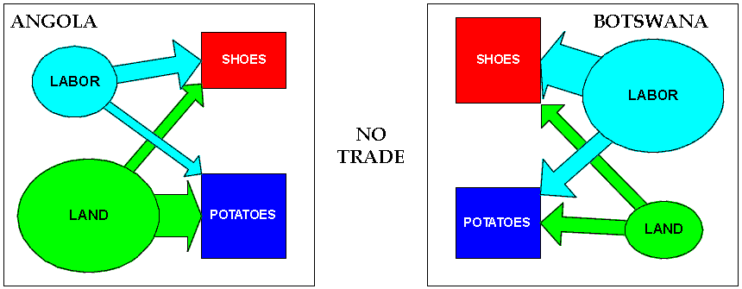

**Figure 4: The Heckscher-Ohlin trade theorem**

(Source- Kuik *et al.* 2019)

The factor conditions such as economic factors, industrial factors, and financial factors are there to indicate the process of maintaining trade opportunities in the international market. The process of trade liberalisation has been focused on the improvement of flourishing trade opportunities for small-scale industries. As per Kuik *et al.* (2019), developing countries such as the Indian manufacturing industry have faced opportunities of improving international trade with the help of trade liberalisation. The impact of trade liberalisation on the manufacturing industry can be developed and measured with the implementation of the competitive advantage theory. It can be stated that supporting industries such as small-scale industries can develop the positionality of business in export trade by using non-tariff barriers and reducing quotas in export trade. According to this theory the countries producing goods requiring more labour are cheaper in cost structure.

The factors such as human resources, financial stability, and investment opportunities of business ventures have to be taken into consideration to maintain international trade opportunities by the manufacturing industries. The existing rivalry among the companies of other sectors has to be considered while developing the competitive environment. Trade facilities can be utilised with the development of potential benefits and challenges of the liberalisation process. The trade liberalisation policies have to be maintained by the existing private companies in the manufacturing industry to deal with the process of managing economic and financial mobility. ***The Heckscher-Ohlin trade theorem*** can be useful to develop employment in the manufacturing industry to gain competitive advantage.

## 2.5 Conceptual Framework

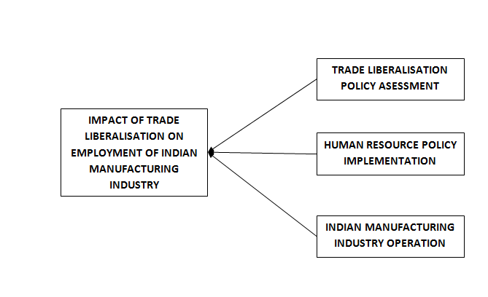

**Figure 5: Conceptual framework**

(Source: As created by researcher)

The conceptual framework has provided the dependent and independent variables of the main context of the research study. It has been obtained that the dependent variable is dependent on the independent variable with the relevant finding of the research topic. It has been observed that the independent variable of the research topic is the impact of trade liberalisation on employment in the Indian manufacturing industry and the dependent variables are such as trade liberalisation policy assessment, human resource policy implementation and Indian manufacturing industry operation.

## 2.6 Research Gap

In this particular research, the analysis of trade liberalisation opportunities and employment structure in the manufacturing industry has been discussed. Hence the article has been lacking the research to analyse the opportunities and identification of challenges associated with trade liberalisation in the manufacturing industry. As per Li *et al*. (2019), on the other hand, a lack of evidence has been found in this research to compare the growth of manufacturing businesses due to trade liberalisation.

Less graphical representation and use of data have been presented in this paper to evaluate the role of trade liberalisation on the employment of the Indian manufacturing industry (Briggs and Sheehan 2019). In the analysis of the research articles, the weakness of the research has not been highlighted which can help to improve the scope of this particular research. A knowledge gap has been found in the research paper in terms of presenting fewer data on the economical growth of the business. The future scope of improving the research has not been explored in this particular research paper to evaluate the opportunities and development related to the manufacturing industry.

## 2.7 Conclusion

In this chapter, the development of trade liberalisation in the Indian trade economy and employment opportunities has been focused on. Various research journals and articles have been studied and evaluated in this chapter to evaluate the impact of trade liberalisation on the manufacturing sector. The opportunities and barriers of trade liberalisation in the manufacturing sector have been discussed. The research gap in this chapter has been mentioned for further development. The conceptual framework of the research paper has been presented. Theoretical analysis of the understanding of developing trade liberalisation in business has been analysed. The analysis of the past literature has been explained in this chapter.

# Chapter 3: Methodology

## 3.1 Introduction

This section of the present research has helped in identifying the relevant tools and techniques for gathering the right data of the provided research topic. This part of the research has provided detailed information on the methodological directions and generated effective results at the end. This section of the research is divided into various categories such as “research approach”, “research philosophy”, “research design” and others. It has also provided a short note on the research onion in order to understand the vital parts of the research work. The data collection and analysis process has also been discussed thoroughly for better understanding. Also, it has been observed that ethical consideration has been included in order to maintain all the ethics and originality of the data that has been collected and a proper timeline has been given.

## 3.2 Research onion

“Research onion” is highly important for the research work to be completed successfully as it helps in covering almost all the elements of the methodological section. It has helped in guiding the researchers to conduct an effective research design. Each part or layer of the research onion helps in describing a more detailed structure of the present research process. According to Schwichow, (2022), the research onion basically deals with the various data and the process of data collection efficiently. The main concept of the onion is to give a conceptual framework which can be used in the research work for getting effective outputs. The research onion starts with the outermost layer of the onion. This section has provided the philosophical paradigm for the overall process of the present research. This has helped in identifying and highlighting the data collection process and the overall process of the research work.

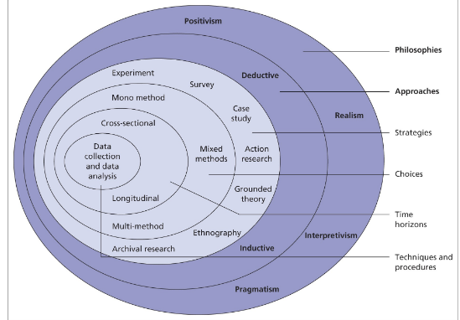

**Figure 6: Research onion**

(Source: Saunders, 2007)

## 3.3 Research philosophy

The research philosophy is the belief about the way in which the data of the situation should be gathered, analysed effectively and used in the future. In this section of the research, the research philosophy is important to make the research efficient and develop within the time scale. As per Marshal, (2018), the section philosophy of the research helps in dealing with the different sources and the data collecting process in order to develop the knowledge effectively. It has been obtained that there are mainly four types of research philosophy such as positivism, interpretivism, realistic and pragmatic research philosophy. With the help of these philosophies, the research procedure becomes easier for the researcher and more positive outcomes can be developed at the end of the research. The present study is about the impact of trade liberalisation on the employees of Indian manufacturing companies, which has increased the demand for the labourers and reduced the bargaining position of the employees and other workers. For making the research effective the interpretivism research philosophy has been chosen and conducted properly in the research study. It has made it easy for the researchers in the investigation process of the research and gathers the relevant data for the present research topic efficiently.

***Justification of selecting interpretivism research philosophy***

The main reason to select this philosophy is to obtain the data and information related to the research topic and implement it properly. It helps in attaching the opinions that have been gained through the individuals efficiently and makes it easy. Also, it has helped in focusing on human behaviours more and understanding them properly for obtaining effective results in the end. This particular research philosophy has provided high validity data and helped in to make a concern and focus on the motivation level (Burns *et al.*, 2022). This specific philosophy in the research has helped in obtaining and collecting satisfactory answers to the particular research questions accurately. Therefore, the interpretivism research philosophy has managed to play a key role in terms of the investigation process of the research and its variables. In the context of the impact of trade liberalisation on the employment rate is a key determinant of economic welfare. Developing the countries where the protection system is weak will high;y hamper on society and to the people as well. The impact on the employees, on poverty, the wage for their most abundant resources and the unskilled labour rate are some of the situations which need special attention.

For the particular research, the positivism research philosophy has not been taken for the insufficient in-depth analysis of the data that has been gathered. Positivism philosophy cannot help in solving the issues of the research work efficiently.

## 3.4 Research approach

“Research approach” is known as the collection of various processes and plans which helps in deciding the overall process of the present research study. The research approach helps in deciding the methods of the data collection process, analysis and also interpretation. The main concept of the research approach has been followed throughout the entire research work to make a positive outcome. It can be said there are many factors that help in selecting the research approach such as research experience, objectives of the research and the number of audiences in the present research study. For the particular study, the deductive approach has been selected in order to make the research procedure effective. The deductive approach is known as the logical approach that helps in the progressing process from the general ideas and information to specific and logical conclusions. It is also known as top-down logic and defines the ability in order to make an interference based on various hypotheses. The deductive approach in this research method has played a significant role in explaining the impact of the trade liberalisation on employees of the Indian manufacturing industry. It has also helped in identifying different variables in the research method efficiently.

***Justification of deductive approach in the research***

In order to make the research study more effective and accurate the implementation of the deductive approach has been done properly. As per Pearse, (2019), with the help of the deductive approach, the several theoretical propositions are generally derived from the chapter of the literature review and always serve as a point of departure. Therefore, the deductive approach is crucial in generalising the findings of the present research process. The importance of the trade liberalisation on the employees of the Indian manufacturing industry has been identified easily through this specific research approach. The main reason to choose this approach is to help in understanding the causal relationship between the variables and the concepts of the particular research (Sharifi Khajedehi *et al.*, 2022). The possibility of measuring the concepts and different aspects quantitatively becomes easy for the researchers. Also, it helps in exploring the relevant theories efficiently and examining whether the theories are relevant in the provided situation. It can be said the deductive approach follows the logical path very closely for generating effective solutions.

In the present research, the inductive research approach has not been involved in the specific research as this research has the subjective nature and room for bias on the behalf of the researchers or the academicians. The data and information generated by the interpretivism approach cannot be generalised as the data is impacted highly by the personal point of view and values of the people.

## 3.5 Research design

“Research design” is known as the blueprint of the research study which includes the relevant tools and techniques in order to conduct the research easily. It has a huge role in identifying and addressing the possible issues that may arise at the time of the research process. It is the overall strategy and the analytical approach for integrating the data in a logical way and ensuring the research study will be investigated properly. For the specific research, the descriptive design has been chosen and implemented efficiently. Descriptive research design is known as a powerful tool that highly helps in gathering data and information on the relevant topic or about a particular group or a situation. It provides relevant and accurate images of the specific characteristics or behaviours of the people. This research design provides the researcher in order to learn and describe the distribution of one or more variables in the research method. This research design is highly focused on different activities and different situations.

***Justification of descriptive research design in research***

For generating effective outputs from the current research, the descriptive research design has been selected. The primary reason behind selecting this research design is to observe and help in determining the relationship between the different characteristics of the people as well as the community. This research design helps the researcher to learn and go through the described procedure in order to gain more knowledge on the present research by identifying the variables of the research efficiently (Taherdoost, 2022). The present research has stated the impact of the trade liberalisation in employees of the Indian manufacturing industry which has increased. The trade liberalisation has reduced the tariff and other barriers after the globalisation process. This design can be implemented easily by the researchers and it is considered very fast. Therefore, the research design has helped in saving time for the individuals present in the research method.

The explanatory research design has not been involved in the current study. The explanatory design helps in solidifying and supporting the theories used in a particular research, however, this design lacks conclusive results. Also, ethics approval can be difficult in order to obtain in the research procedure, it can be time-consuming and the selection of the data can be subjective. For these reasons, the explanatory design has not been implemented in the research.

## 3.6 Data collection

In connection to the development of the research process, this would require the application of the data collection which through the data can be gathered. Based on the data collection process, this can be possible to make development of the research process more effective and specific. Connecting to the characteristics of the research process, there are two types such as primary and secondary. Primary research connects to the process of making collection of the information through the direct source. Therefore, the possible development of the research process can be identified. On the other hand, the process of making collection of the secondary data can be undertaken by focusing on the indirect sources as well. Therefore, the possible development of the secondary research regarding values can be assessed. Linking to the secondary data collection process, this would keep the requirement of dynamic secondary information based on which the proceeding of the research process can be done such as e-book, journal and newspaper articles. This can upgrade the standard of quality regarding the research value assessment and operation. With the support of the data collection segmentation process, the probability of upgrading the operation standard can be ensured (Park, 2021). Based on the characteristics, there are two certain types such as quantitative and qualitative types of data collection. Regarding the quantitative data collection process, the numeric data has to be collected which through the feasible development of the research process can be determined. Herein, the application of survey would be effective which through the numeric data collection can be determined. Therefore, the application of the likert scale would help to present the survey based information as well.

On the other hand, the application of the qualitative data collection would also identify the possible area based development aligning to the subjective types of data collection and assessment. Herein, the subjective type of research process would help to keep development of the frame with the help of the thematic type of data analysis process (Ruggiano and Perry, 2019). In this research secondary research has been taken considering the qualitative based data collection process development. Qualitative data collection would ensure the feasibility of the data presentation with the support of the subjective dimension. Herein, the authenticated subjective type of data would be considered which through the probability of risk can be arrested. This would consider the development of the better understanding of the research regarding development and providing proper direction of the research value generation.

## 3.7 Sampling and sample size

Regarding the development of the research process, this would require to keep following the application of the sampling and sample size process. The support of the sampling would provide the evidence of the research output and frame the research value identification (Ames *et al.* 2019). This would be beneficial for the process of making assessment of the journal selection process and delivering the output. In this research, the application of the inclusion and exclusion sampling process have been identified which through the probability of deriving data can be ensured. This would be beneficial for the research value development regarding the selection of the sources based on quality. Herein, the specification of the exclusion and inclusion criteria can be identified based on the year specification and database. For this particular research, information regarding the journals has been selected based on the selection of the google scholar database. This would provide a certain authenticity concern for the research quality and standard maintenance process. Secondly, the data collection process has been done from the year 2018. Therefore, the probability of old information usage can be avoided regarding the development of this research process. Therefore, the strategic planning regarding the collection of the secondary data can be ensured and the research quality can be maintained.

## 3.8 Data analysis

In order to make the data collection process effective and the development of the present research improved, data analysis is important in this section. In order to finalise the research work, it is very much crucial for analysing the collected data properly and optimising the understanding process. The analysis of the data highly depends on the data that has been gathered through the academicians. The present research has included a secondary quantitative data collection process and it has been considered in having the thematic analysis for the particular research study. The research has helped in analysing the objectives of the present research by comparing different scholarly journals and articles as well as gathering different views of the authors and researchers effectively. The present topic of the research which is on the impact of trade liberalisation on the employees of the Indian manufacturing industry. Trade liberalisation has reduced the tariff and other barriers and has also helped in increasing the flow of services and goods over national borders. The relevant data helps in identifying different aspects of trade liberalisation and makes an effective solution that can be implemented easily. However, it has been blamed for raising different issues such as unemployment in the manufacturing industry and wage inequality as well as the exploitation of the workers working in the industry. The impact of the trade liberalisation has had on the research with the result that there has been an 8% decline in the net manufacturing of employment between 1979 and 1986. This has been strongly used and depreciated in the impact of liberalisation with the procedure for the bargaining position that the workers can be implied on the indian manufacturing industry. The government of India has made an effort with the small-scale industry that is thus used for preserving the goods that are solely used for manufacturing the list of companies impacted on the trade liberation of employment. In the advent of liberalisation of 1992, the industrial relations can be considered as the new beginning for change in the employment of the Indian market. Trade liberalisation has impacted with the policies that thus have voluntary retirement of the schemes and flexibility to be worked for the work-palce that is required. Herein, the possible dimensions can be incurred regarding the process of structuring the information. In addition, the possibilities of deriving data can be raised. Trade liberalisation policy assessment can be undertaken which through the risk reduction concern can be determined.

## 3.9 Ethical consideration

In connection to the development of the research process, this would require maintaining a certain ethical consideration based on which the quality of the research can be ascertained. Herein, the ethical concern can be maintained regarding the protection of the information. Therefore, implementation of the Data Protection Act 2018 would be effective which through the protection of the information can be determined. On the other hand, the possible manipulation of the data can be denied which can ensure the quality of the information as well. In addition to that the feasibility of the risk mitigation is considered regarding the matter of not accessing the commercial application of the gathered data. This would provide a certain level of feasibility based on which the operational acceleration can be confirmed. This can be effective for the research quality development and determining the risk management concern. With the help of ethical value maintenance, the possible growth of research study can be maintained.

## 3.10 Gantt chart

| Main functions of the research | Apr 1- Apr 10, 2023 | Apr 11-  Apr 20 | Apr 21- Apr 30 | May 01 – May 08 | May 09- May 15 | May 16-  May 22 | May 23-  May 31, 2023 |
| --- | --- | --- | --- | --- | --- | --- | --- |
| Topic specification |  |  |  |  |  |  |  |
| Submitting the proposal |  |  |  |  |  |  |  |
| Research structuring process |  |  |  |  |  |  |  |
| Developing the secondary research collection |  |  |  |  |  |  |  |
| Research assessment plan |  |  |  |  |  |  |  |
| Technique identification |  |  |  |  |  |  |  |
| Secondary data collection |  |  |  |  |  |  |  |
| Data assessment |  |  |  |  |  |  |  |
| Documentation process data findings |  |  |  |  |  |  |  |
| Conclusion |  |  |  |  |  |  |  |
| Making Overdraft |  |  |  |  |  |  |  |
| Submission |  |  |  |  |  |  |  |

**Table 1: Gantt chart**

(Source: As created by researcher)

## 3.11 Summary

The methodology chapter is the third chapter of the research with the understanding of the proper methods that have been used in the research. The interpretivism philosophy of the research is used with proper justification for the reason for using research philosophy. Deductive approach and descriptive research design have been made for the research to proceed with the research. Justification of using deductive approach and usage of descriptive research design thus have been made for the research. Secondary data collection methods have been used with a qualitative approach for the research as thus the data was gathered from various journals and online articles about the impact of liberalisation on the Indian manufacturing industries. Ethical considerations for the research have been made to understand the data protection policies to protect the data and any such copying is restricted. A gantt chart is used to understand the research timeline in completing the research within that time.

# References

Abosede, A.O. and Tolulope, G., 2022. Manufacturing Sector Growth and Trade Policy in Nigeria.

Ahmed, G., 2012. Krugman trade theory and developing economies. *China-USA Business Review*, *11*(12).

Ames, H., Glenton, C. and Lewin, S., 2019. Purposive sampling in a qualitative evidence synthesis: A worked example from a synthesis on parental perceptions of vaccination communication. *BMC medical research methodology*, *19*(1), pp.1-9.

Beak, Y.H., Bae, K.H. and Lee, H.W., 2022. Industrial policy reforms for political risk management? Understanding the evolution of automotive industrial policies in Vietnam. *Globalizations*, *19*(8), pp.1225-1240.

Briggs, K. and Sheehan, K.M., 2019. Service trade liberalisation and economic growth. *The Journal of Developing Areas*, *53*(4).

Burns, M., Bally, J., Burles, M., Holtslander, L. and Peacock, S., 2022. Constructivist grounded theory or interpretive phenomenology? Methodological choices within specific study contexts. *International Journal of Qualitative Methods*, *21*, p.16094069221077758.

Dewi, M.U., Mekaniwati, A., Nurendah, Y., Cakranegara, P. and Arief, A.S., 2020. Globalisation challenges of micro small and medium enterprises. *Eur. J. Mol. Clin. Med*, *7*(11), pp.1909-1915.

Elrah, Y. and Siddeg, A., 2023. Trade Policy and Productivity Growth: Why Do Sudanese Manufacturing Firms Eport Less.

Francis, S., 2020. Impact of preferential trade liberalisation on India's manufacturing sector trade performance: An analysis of India's major trade agreements. New Delhi, India: Institute for Studies in Industrial Development.

Francis, S., 2020. *Impact of preferential trade liberalisation on India's manufacturing sector trade performance: An analysis of India's major trade agreements*. New Delhi, India: Institute for Studies in Industrial Development.

Gaspar, J.M., 2020. Paul Krugman: Contributions to geography and trade. *Letters in Spatial and Resource Sciences*, *13*(1), pp.99-115.

Ho Dinh, B., Nguyen Phuc, H., Bui, T. and Nguyen, H., 2020. Declining protection for Vietnamese agriculture under trade liberalisation: evidence from an input–output analysis. *Economies*, *8*(2), p.43.

Jha, P. and Talathi, K., 2023. Trade liberalisation and local development in India: evidence from nighttime lights. Indian Economic Review, pp.1-25.

Jha, P. and Talathi, K., 2023. Trade liberalisation and local development in India: evidence from nighttime lights. Indian Economic Review, pp.1-25.

Kuik, O., Branger, F. and Quirion, P., 2019. Competitive advantage in the renewable energy industry: Evidence from a gravity model. *Renewable energy*, *131*, pp.472-481.

Kumar, R.A. and Dhar, B., 2020. Trade Liberalisation and Export Competitiveness of Indian Manufacturing Industries.

Kumar, R.A. and Dhar, B., 2020. Trade Liberalisation and Export Competitiveness of Indian Manufacturing Industries.

Kyander, E., 2020. Trade liberalisation and female employment in manufacturing: Evidence from India.

Laparakobs, T., 2019. The policy effect of government assistance on rice production in Southeast Asia: Comparative case studies of Thailand, Vietnam, and the Philippines. *Development Studies Research*, *6*(1), pp.1-12.

Le, H.P., 2020. The energy-growth nexus revisited: the role of financial development, institutions, government expenditure and trade openness. *Heliyon*, *6*(7), p.e04369.

Le, H.P., 2020. The energy-growth nexus revisited: the role of financial development, institutions, government expenditure and trade openness. *Heliyon*, *6*(7), p.e04369.

Le, Q.T. and Tomasi, C., 2023. Trade liberalisation and firms’ productivity in Vietnam: the role of the local business environment. *Regional Studies*, pp.1-33.

Li, J., Lu, Y., Song, H. and Xie, H., 2019. Long-term impact of trade liberalisation on human capital formation. *Journal of Comparative Economics*, *47*(4), pp.946-961.

Liu, J., Lai, M.Y. and Liu, Z.S., 2022. Trade liberalisation, domestic reforms, and income inequality: Evidence from Taiwan. *Review of Development Economics*, *26*(3), pp.1286-1309.

Mishra, R. and Palit, S., 2020. Role of FDI on employment scenario in India. International Journal of Recent Technology and Engineering, 8(6), pp.1481-1489.

Momenta, D.S., 2022. Impact of Trade Liberalisation in the ASEAN-China Free Trade Agreement on Indonesia's Economic Growth Post Covid-19 Pandemic. *Jurnal Sosial Politik Integratif*, *2*(5), pp.273-78.

Mukherjee, S. and Chanda, R., 2019. Trade liberalisation and Indian manufacturing MSMEs: Role of firm characteristics and channel of liberalisation. *The European Journal of Development Research*, *31*(4), pp.984-1062.

Nasim, I., Chaudhry, I.S. and Bashir, F., 2022. Effects of Trade, Environment Quality and Human Capital on Industrial Sector Output in Developing Countries: A Panel Data Analysis. *iRASD Journal of Economics*, *4*(1), pp.107-116.

Park, S., 2021. Data collection. In *Encyclopedia of Sport Management* (pp. 129-131). Edward Elgar Publishing.

Ramzan, M., Sheng, B., Shahbaz, M., Song, J. and Jiao, Z., 2019. Impact of trade openness on GDP growth: Does TFP matter?. *The Journal of International Trade & Economic Development*, *28*(8), pp.960-995.

Rijesh, R., 2021. Liberalisation, import of capital goods, and industrial exports: Evidence from Indian manufacturing sectors. Global Journal of Emerging Market Economies, 13(1), pp.81-103.

Rijesh, R., 2021. Liberalisation, import of capital goods, and industrial exports: Evidence from Indian manufacturing sectors. Global Journal of Emerging Market Economies, 13(1), pp.81-103.

Ruggiano, N. and Perry, T.E., 2019. Conducting secondary analysis of qualitative data: Should we, can we, and how?. *Qualitative Social Work*, *18*(1), pp.81-97.

Schwichow, M., Brandenburger, M. and Wilbers, J., 2022. Analysis of experimental design errors in elementary school: how do students identify, interpret, and justify controlled and confounded experiments?. *International Journal of Science Education*, *44*(1), pp.91-114.

Sharifi Khajedehi, S., Namvar, M., Pool, J. and Akhlaghpour, S., 2022. On Justification: Legislating a Digital First Artefact.

Taherdoost, H., 2022. Different types of data analysis; data analysis methods and techniques in research projects. *International Journal of Academic Research in Management*, *9*(1), pp.1-9.

Tan, X., Xiao, Z., Liu, Y., Taghizadeh-Hesary, F., Wang, B. and Dong, H., 2022. The effect of green credit policy on energy efficiency: Evidence from China. *Technological Forecasting and Social Change*, *183*, p.121924.