**ESSAY**

Table of Contents

Part: A 2

Introduction 2

Discussion 2

Conclusion 8

Part-B 9

Introduction 9

Main Body 9

Conclusion 15

References 16

Appendices 18

# Part: A

## Introduction

Homicide is simply associated with the murder of a person either intentionally or non-intentionally. In this respect, murders are committed by an individual either intentionally or unintentionally. Considering this, the aim of the essay is to discuss the reduction rate of Homicide cases within a particular city in Latin America. In this context, first of all, the background of the city is to be provided in terms of providing statistical data for the same. Moreover, the reasons and the attempts will also be specified here in terms of the Homicide rates within the chosen city of Latin America. Further, the last achievements of the goals and objectives will also be specified here.

## Discussion

**Determination of the City and the homicide rate over there**

The city chosen here is Mexico which is one of the most prominent countries in Latin America. Mexico is considered to be the second-largest economically strong economic city in Latin America. The total population level of Mexico is about 130 million at the present time along with having a huge diversity of natural resources. In the recent few years, the economy of the country has grown by 3.1% within the year 2022. The macroeconomic framework of Mexico acts as a solid base of manufacturing for the development of the economic structure of the city at the present time (*Mexico overview,* 2023). Despite having such a huge increment within the city, there is a huge increment in homicide cases over there. In Mexico, firearms are the major reason behind the death rates among both the male and female gender groups of homicides. From the year 2015 to 2021 the death rates observed in male homicides have increased from 16.9% to 71.3%. Whereas, in case of the female homicides it has been observed that the percentage of cases has increased from 37.8% to 56.8% subsequently. With respect to this, it can be stated that the in the recent seven years guns have been becoming the major or say common means of homicides in the male and female gender groups of Mexico.

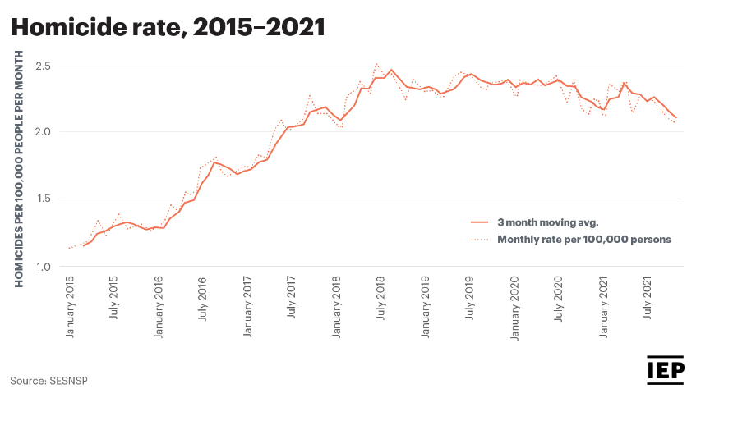

**Figure No 1: Homicide rate in Mexico from 2015-2021**

(Source: *Mexico peace index,* 2023)

The figure presented above that is figure number one determines the graphical representation of the aggregate level of homicide read within the entire city of Mexico. The statistical figure that has been drawn above is indicating the data from the years 2015 to 2021. In this context, it can clearly be observed over here that in the year 2015, there was a limited number of homicide cases within Mexico. In simple words, it can be stated here that the number of incidents in terms of homicide cases, there was limited during the year 2015 within the various parts of Mexico. Apparently, the city has observed a huge increment in terms of their homicide cases right from the Year 2017 which can clearly be ascertained over here. The graphical presentation indicates that nearly one and a half years before the Outbreak of the global pandemic employment has been observed in terms of homicide cases over here. Whereas on the other hand, a small positive relief can also be observed over here that there was a decline in homicide cases right after the year 2020. In other words, that can be stated that after the year 2020, Mexico has observed a decline in the rate of homicide cases, which were relatively increasing in the past few years.

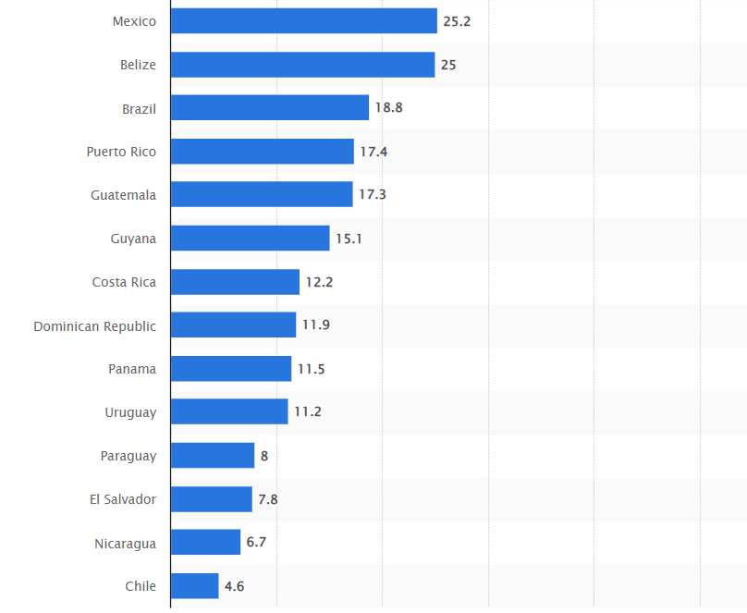

**Figure No 1: Aggregate rate of Homicide cases within the various cities of Mexico**

(Source: Statista Research Department, 2023)

From the above figure, the graphical representation of the homicide cases can be observed in terms of the comparison of the various cities of Latin America. Among all the five cities of Latin America, it can clearly be observed over here that Mexico is having the highest percentage in terms of the aggregate level of homicide cases. As compared to the overall comparison Mexico is having 25.2% of the total homicide cases in terms of both male and female gender groups.

**Analysis of the reasons for the higher murder rate**

There is various reasons behind the increment in the number of Homicide cases in Mexico. These reasons have been explained in detail below:

* Corruption- Mexico is having a higher level of corruption within their judiciary system which has promoted the rise in the crime rate over there. According to the survey of (*Transparency.org,* 2023). Mexico is considered to be the 138th least corrupt country in the entire globe at the present time.
* Violence against journalists- The country is also observed to have a higher level of violence towards journalists (). In this respect, it is quite problematic for the citizens as well as the journalists to make any complaint about the violence that is done against them. This indicates that there is a lack of opportunity for journalists in terms of taking any strong actions action against the culprits.
* Slavery- A wide population of Mexico as well as the foreigners that are coming over here are observed to be on the way to slavery as well as human trafficking within the country. In a broader sense, it can be stated that the citizens along with the foreigners that are coming to Mexico fall under the track of slavery. This aspect has also led towards an increment in the murder rate within various parts of Mexico.
* Violence against women- Violence towards the women's gender group is another cause towards the increase in murder cases within Mexico. Moreover, Mexico is considered to be the 16th country in terms of human trafficking against women in the entire globe. The rate has increased since the year 2007 a result of which the country has observed a vivid increment in terms of the murder rate there. Apparently this reflects that a wide population of the women gender group are under human trafficking and are not able to achieve an adequate level of support from the higher authority.

**Analysis of the attempts taken by the authority of the city**

* Move towards gun companies- The government of Mexico has taken strict action in terms of a comprehensive strategy in order to reduce the trafficking within the various parts of the territory. Mexico has taken a strict ball in terms of lawsuits against the manufacturers and distributors of the USA Who are associated with the felicitating trafficking of arms within the territory (*Arms control Today,* 2023). A huge restriction has been imposed toward the seasons in terms of having a licence for guns in their homes. The main reason behind taking such strict action against the US territories is just that most of the guns are being brought from there making it easier to be smuggled. In another word, it can be stated that the countries are having enough opportunity to smuggle print varieties of guns for their own profit of the business. This action taken by the government is strictly against the restriction of the smuggling of guns from the US territories. Moreover, the step was taken to ensure that the rate of crime is observed to be decreasing within there and the citizens are able to live a standard living standard without any obstacles. In this context, the various boundaries were strictly searched out to ensure that there were no chances of any smuggling from that particular place.
* Joining Bolivia- Mexico is majorly associated with not providing an adequate level of support towards the women population of the country. A wide range of women population living in Mexico is observed to have an issue in terms of gender inequality and human life trafficking. As a result of this, it has been observed that the human population of the country and not have a better level of living standard as compared to the male gender group over there. In terms of this issue, Mexico has joined Bolivia in order to provide a better service to women's gender groups (*UN Women – Headquarters,* 2023). The major purpose of the joining of the countries is to the violence against women in the field of politics and create a significant Workspace for each and every woman. In this respect, the women's groups will be provided with adequate support in terms of having a better facility within various office premises. Apart from this, it will ensure that no one will be liable for violent action against the woman group. This decision has been taken by the means of considering the various issues that the woman are facing in terms of violence and big indigenous towards their culture. This indicates that apart from the major issue of violence the manager of the countries with delivering a better empath over women belonging from different cultures also.
* Evolving response of the government towards crime- The government of Mexico and the USA has launched a bond namely the United Nations-Canada Agreement (USMCA) in terms of mitigating the various crime that is faced by the same (Ellis, 2023). The main motive of the bond is the maintenance of the safety and security of the people of all these countries. The bond ensures that none of these countries are having any issues in terms of crime. In a broader sense, it can be stated that the bond species that the concerned countries will not be participating in any of the criminal activities.
* Anti-Crime security policy- The anti-crime security policy was enforced in the year 2020 in Mexico during the time of the outbreak of the global pandemic (Felbab-Brown, 2023). During the initial stage of the pandemic, Mexico has observed a wide range of death cases all across the country. Moreover, the crime rate also increased during that time leading towards the loss of life and property for many of the citizens. As a result of this, the government of Mexico introduced an anti-crime security policy to save the public from this particular issue at the time. The main motive of the policy was to provide better living space to the citizens in terms of the pandemic as well as the crime that has been occurring in the surrounding. In a broader sense, it can be stated that the government was trying to maintain an adequate level of safety and security for all the citizens at that time period. According to the policy, it was ensured that people were able to have an adequate level of medical support and none of the crimes conducted in that particular field. In addition to this strict supervision was being done over the various activities that we are happening all around the country to ensure that not even a small crime was occurring over there.

**Assessment of the achievement of the goals along with justification**

Mexico has observed a huge decline in terms of the crime rate within the past few years. The main reason behind this aspect is just because of the strict law and orders that were being enforced by the higher officials of the country.

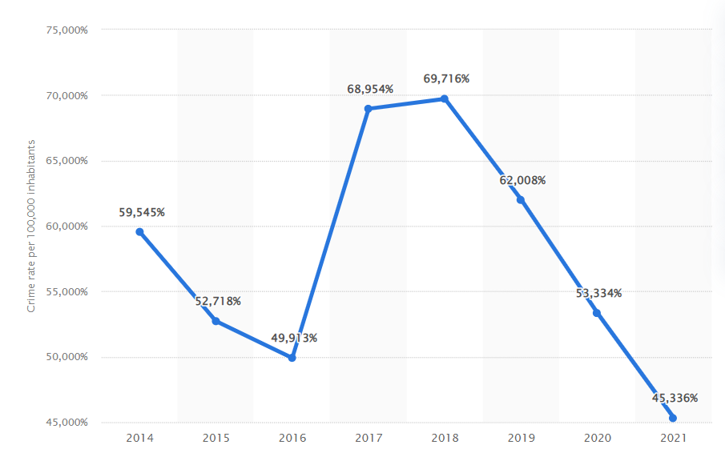

**Figure No 3: Decline in the crime rate within Mexico**

(Source: *Crime rate mexico city,* 2023)

The figure presented above that is figure no 3 determines the graphical indication of the crime rate within the overall territories of Mexico. The figure indicates the data from the year 2014 to 2021 over here. Apparently, it has been observed that by the year 2021, the country has observed a huge decline in terms of various criminal activities along with violence against human beings at that time period. In other words, it can be stated that the goals and objectives are adequately achieved by the country,

## Conclusion

The essay has covered all the necessary pieces of information that were associated with the crime and homicide cases within Mexico. Apparently, it has been observed that there were various reasons behind the increment in criminal and homicide cases within Mexico. For this purpose, the government has taken various legal actions in terms of mitigating the same. Further, these low orders were also observed to be successful in terms of achieving the goal and objectives of the same. In a broader sense, it can be stated that the enforcement of the law and orders was observed to be successful for Mexico as it has provided a better result for the citizens.

# Part-B

## Introduction

The population grows in exponential patterns and with the rise of the population the habitants, scarcity of foods, and living patterns vary from place to place. The city chosen for this report is Asmara, the capital of Eritrea in the Horn of Africa. The urbanisation pattern, livelihood, and living pattern of the citizens are discussed in this report. The data is extracted from the world development indicator database.

## Main Body

* **About the city**

The city named Asmara is the capital of Eritrea in the Horn of Africa. The total population of the city is 9,63000 for the whole area. The geographical area of the city is 45 sq/km. The area is situated at an elevation of 2,325 meters from sea level.

* **Urbanisation pattern**

There are some data about Asmara, the capital of Eritrea extracted from the World Development Indicator. The data is given below which may help to analyse (data. world bank. org,2023).

|  |  |
| --- | --- |
| **Description** | **Statistical Data** |
| Poverty Headcount ratio | $2.15 a day (2017 PPA) |
| Life expectancy at birth and total(years) | 67 (2020) |
| Population growth Rate (annual %) | 1.8 (2021) |
| Net Migration | -14,988 (2021) |
| GDP | $2.07 billion (2021) |
| GDP growth rate (annual %) | 8.7 (2011) |
| Unemployment (total % of the labour force) | 6.8 (2021) |
| Carbon Emmison (metric ton per capita) | 0.3 (2019) |
| Forest Area (% of land area) | 8.7 (2020) |
| Access to electricity (% of the population) | 52.2 (2020) |
| Annual Freshwater withdrawals (% of internal Resources) | 21 (2019) |
| Individuals using the Internet (% of the population) | 1 (2017) |
| Foreign Direct Investment (FDI,% GDP) | 1.9 (2011) |

the development of Asmara City.

It is seen from the above table that the poverty headcount of Asmara is $2.15 a day (2017 PPA) which states that the city is in the middle stage of urbanization. There are still many developments that need to do for the city of Asmara. The GDP of the country is about $2.07 billion for the year 2021which helps to evaluate that the country still needs many developments in the various sectors. The country has an old heritage of cultural groups and there is development in the field of technology, agriculture, and tourism. There are many tourists from all around the world who come to Asmara to have views of the old cultural heritage.

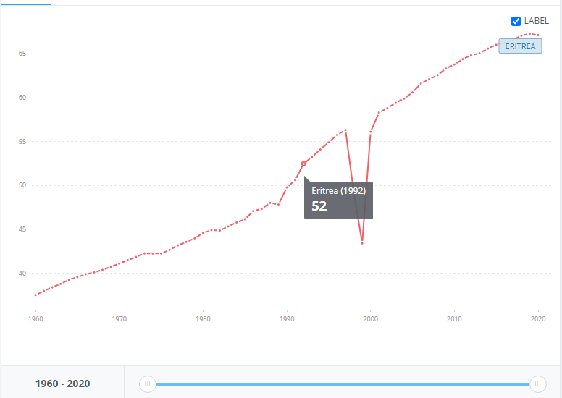

**Figure 4: Life Expectancy rate**

**Source: data. world bank. org,2023**

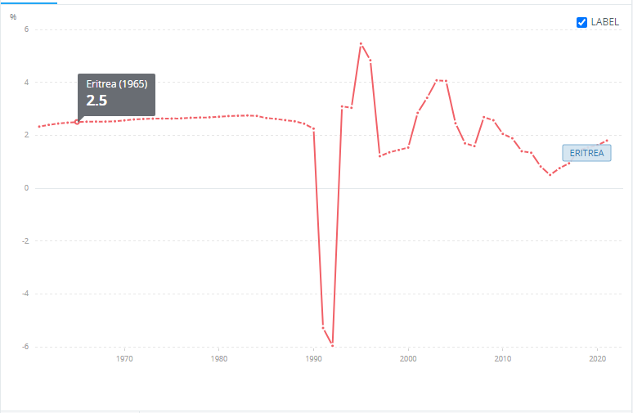

**Figure 5: Population Growth Rate**

**(Source: data. world bank. org,2023)**

The population growth rate for the city is 1.8 (2021) which is a moderate growth rate. The carbon emission for the city from the various industrial and commercial applications is 0.3 metric tons per capita. It means there is a significant level of carbon dioxide in the environment. It may help to show the environmental sustainability of the city and due to environmental pollution, the life expectancy (Denison, 2019) in the city is quite low 67 (2017). The city needs improvement in the environmental factors and land, water, and air pollution must be reduced in order to better life expectancy.

The access to electricity for the people of Asmara is about 52.2 % (2020) and it shows more than half of the total population does not have the access to electricity. The power shortage in the country shows that it is still in the development phase and people there still need to live without the aid of electricity. The digital connectivity and access to the internet for the people of Asmara is quite low and it is estimated by the world development Index that the using of the internet with respect to the percentage of the population is 1 (2017). The rate of the annual freshwater withdrawals with respect to the percentage of internal resources is 21 (2019) which means people have inadequate access to drinking water and somehow, people in the village need to compromise with the usable water and drinking water. The percentage of an emulsion of the foreign particles mixed in the drinking water must be calculated too in PPM (Perce per million) in order to estimate the people’s health and hygiene.

As the city has an old cultural heritage and the tourism industry has catastrophic value for the city named Asmara (Mohammad, 2021). The Foreign Direct Investment for the year 2011 is calculated as 1.9 with respect to the percentage of the GDP. It shows there is a positive effect of the FDI investment for this city.

A primate city means it is the largest region or province in the given area and Asmara is not a primate city. *Asmara is the primate city* of Eritrea having a total population of 9,63000 and being the capital of Eritrea, this region has a more stable economic structure compared to the other province of Eritrea.

* **Alonso Model**

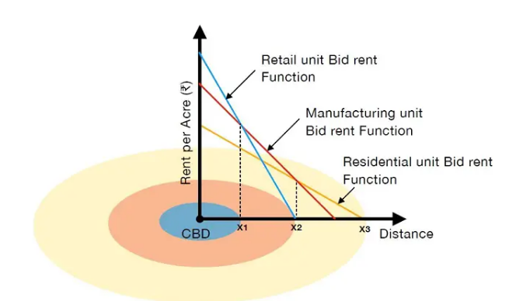

**Figure 6: Alonso Model**

**Source ( planningtank.com)**

In the Alonso Model, the main parameter to consider is Central Business District (CBD) and the land price decreases as the distance from the CBD increases. In the above diagram the blue circle shows the commercial land, the orange circle shows the manufacturing land and the yellow circle shows the residential apartment land for a given city. In the above graph, it is shown that the rent of commercial land is the highest compared (Nuissl and Siedentop, 2021) to the other land in the category. The point of the intersection between the commercial line and the manufacturing line is the line of equilibrium where the manufacturing unit cannot pay more than the commercial land. The point of intersection between the manufacturing line and the residential line shows the point of equilibrium where residential people need to pay for their living inhabitants. The people need access to manufacturing and commercial land for their livelihoods. The prices of the lands decrease as it is moved further from the CBD.

It is seen from the above data that the total number of migrants for Asmara is -14,988 for the year 2021. The negative migration indicates that there are more people moving out than the total number of people moving in. People need to find a more effective place for their habitats and livelihoods and Asmara shows negative feedback (Massa, 2021) from the migration point of view. The GDP of the country, poverty rate, and rate of unemployment is the major key factors for the development (Cameron, 2022) of the overall country. Being the primate city, Asmara is always the focal point of Eritrea and the (Tsegay, 2020) land prices for commercial, manufacturing, and residential quite vary depending on the place.

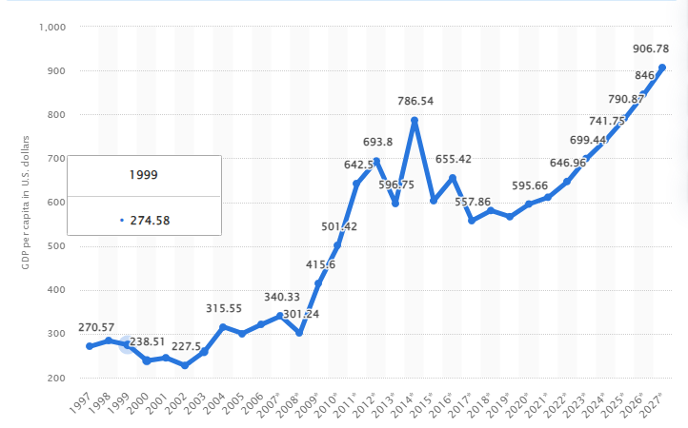

**Figure 7: GDP per capita of Asmara, Eritrea**

**Source ( statista.com)**

In the above diagram it is shown that the GDP of Eritrea is increasing in nature and there are potential for commercial, manufacturing, and residential land and their price may also increase in the upcoming years. The Asmara satisfies the Ansol Model and it is seen as per the increasing GDP per capita that there may be demands for the commercial, manufacturing, and residential lands and as it is moved away from the CBD the price of the land decreases according to the demands and usage of the land.

* **Slums and housing**

The total population in Asmara is 9,63,000 and the total population of Eritrea is 36,20,312. Asmara significantly develops urbanization strategies over the past few years. The GDP growth rate, Rate of inflation and value of lands are some of the major criteria in determining the social hierarchy and living property of the people. The living standards are divided in three major segments in Asmara and are social urbanization, health, and education for the people of Asmara. Different governmental bodies are formed in order to monitor the urbanization of the city. The Department of urban development in the sector of public work plays a major role in monitoring the city well–being. Gender discrimination is not very high and there are 27% of women work in the different government sectors and public health departments (Achila *et al*., 2022). The people’s health is also another significant point in order to monitor their health status. The HIV/AIDS infection is significantly low in the past few years. The rate decreased by the value 2.7% per year and it shows that the health department works actively for the citizens of Asmara.

The current policies are taken by the government authority along with some NGOs and ENCC(European Network of Cultural Central) there are some provisions and guidelines for small and medium enterprises and people can improve their livelihoods by engaging them with the respective professions.

The engagement of children in education also increases over the past few years. The enrollment rate of male candidates in the year 1995 to 2002 is

59.2 and 71.4 % respectively. It clearly shows that more children now engage with education and significantly decreasing the rate of child labour in the city. The rate of enrollment for girls in education is 9.6% to 11.8% from the year 1995 to 2022. Although, the engagement of girls in education is lesser than the number of boys and moreover, the number is significantly increasing in the past years.

The Ministry of Land, water, and Environment (MoLWE) especially take major initiatives in order to protect the environment and ecology. It is seen the total carbon emission rate per metric ton per year is 0.3 and there are more services in the city than agricultural work. The government takes good initiatives in order to prevent carbon pollution however this rate is somehow higher for increasing the global temperature.

## Conclusion

The overall development of Asmara is as per the world development index and is seen that the city is in the middle stage of development. The local ministry still needs various phases for the overall development and must adopt sustainability goals for the betterment of the citizens and environment. There are more people moving out of the country than moving in and livelihoods and habitats are the most basic needs for people. The future vision of urban development may show effective plans in the near future for overall development.

# 

# References

(/unhabitat.org,2023) available at

(data.worldbank.org.2023) Available at

2022 corruption perceptions index: Explore the results (2023) Transparency.org. Available at: https://www.transparency.org/en/cpi/2022 (Accessed: April 10, 2023).

Achila, O.O., Araya, M., Berhe, A.B., Haile, N.H., Tsige, L.K., Shifare, B.Y., Bitew, T.A., Berhe, I.E., Abraham, I.A. and Yohaness, E.G., 2022. Metabolic syndrome, associated factors and optimal waist circumference cut points: findings from a cross-sectional community-based study in the elderly population in Asmara, Eritrea. BMJ open, 12(2), p.e052296.

Arms control Today (2023) Mexico's Bold Move Against Gun Companies | Arms Control Association. Available at: https://www.armscontrol.org/act/2022-09/features/mexicos-bold-move-against-gun-companies (Accessed: April 10, 2023).

Cameron, G., 2022. Village Projects Observed in Eritrea: Post-Conflict Pathways towards Democratic Rural Development. Modern Africa: Politics, History and Society, 10(1), pp.61-88.

Denison, E., 2019. Beyond Africa's Modernist City. A magazine, (9), pp.32-35.

Ellis, E. (2022) Organized crime in Mexico and the evolving government response, Global Americans. Available at: https://theglobalamericans.org/2022/08/organized-crime-in-mexico-and-the-evolving-government-response/ (Accessed: April 10, 2023).

Felbab-Brown, V. (2022) Crime and anti-crime security policy in Mexico in 2020, Brookings. Brookings. Available at: https://www.brookings.edu/blog/order-from-chaos/2021/01/04/crime-and-anti-crime-security-policy-in-mexico-in-2020/ (Accessed: April 10, 2023).

https://data.worldbank.org/country/ER

https://unhabitat.org/sites/default/files/2020/10/eritrea_-_national_and_cities.pdf

Massa, S., 2021. Eritrean heritage: ancient routes and settlements. E Motion: Eritrean Mobility and Cultural Heritage. New frontiers in the Horn of Africa, 17, p.47.

Mexico joins Bolivia in efforts to stop violence against women in Politics (2023) UN Women – Headquarters. Available at: https://www.unwomen.org/en/news/stories/2021/3/feature-mexico-joins-bolivia-in-efforts-to-stop-violence-against-women-in-politics (Accessed: April 10, 2023).

Mexico overview (2023) World Bank. Available at: https://www.worldbank.org/en/country/mexico/overview (Accessed: April 10, 2023).

Mohammad, A.S., 2021. The resurgence of religious and ethnic identities among Eritrean refugees: A response to the government's nationalist ideology. Africa Spectrum, 56(1), pp.39-58.

Nuissl, H. and Siedentop, S., 2021. Urbanisation and land use change. Sustainable land management in a European context: a co-design approach, pp.75-99.

Pandit, P. (2022) Homicides in mexico - statistics: Mexico peace index, Vision of Humanity. Available at: https://www.visionofhumanity.org/homicides-in-mexico-statistics/#:~:text=Mexico%20homicide%20rate%202015%20to%202021&text=improvement%20since%202014.-,Despite%20recent%20improvements%2C%20Mexico's%20homicide%20rate%20remains%20near%20historical%20highs,day%20on%20average%20in%202021 (Accessed: April 10, 2023).

Published by Statista Research Department and 2, M. (2023) Homicide rate in Latin America by country, Statista. Available at: https://www.statista.com/statistics/947781/homicide-rates-latin-america-caribbean-country/ (Accessed: April 10, 2023).

Published by Teresa Romero and 25, O. (2022) Crime rate mexico city 2021, Statista. Available at: https://www.statista.com/statistics/1288358/crime-rate-mexico-city/ (Accessed: April 10, 2023).

Tsegay, S.M., 2020 SOCIO-CULTURAL INTEGRA ERITREAN MIG.

# Appendices

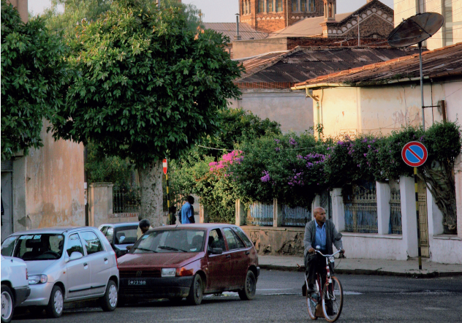

**Figure 5: Asmara main city**

**(Source: unhabitat. org,2023)**

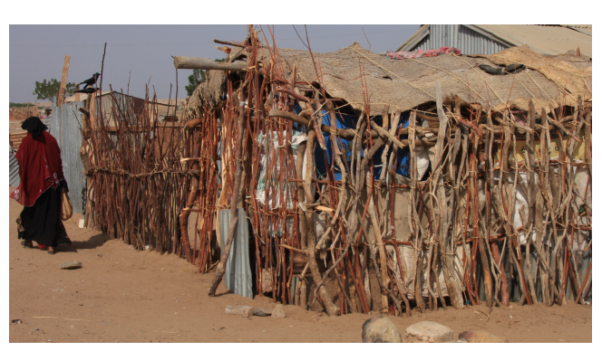

**Figure 6: Asmara slums (Eritrea)**

**(Source: unhabitat. org,2023)**

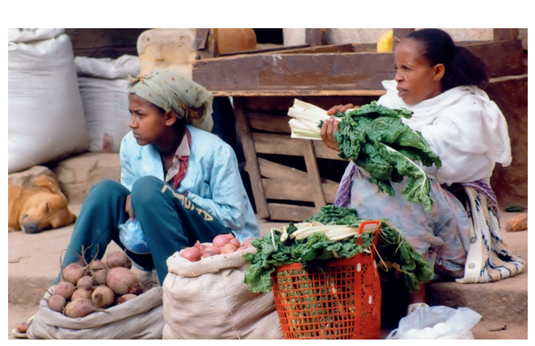

**Figure 6: Asmara urban community (Eritrea)**

**(Source: unhabitat. org,2023)**

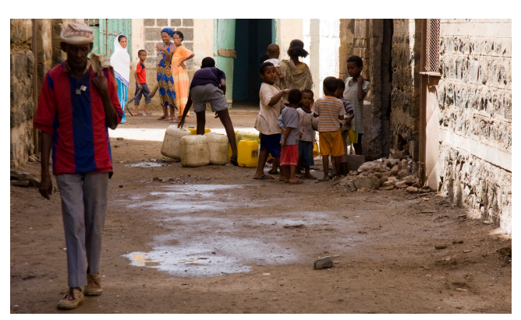

**Figure 7: Asmara environmental sustainability (Eritrea)**

**(Source: unhabitat. org,2023)**