Pandey, P. and Pandey, M.M., 2021. *Research methodology tools and techniques*. Bridge Center.

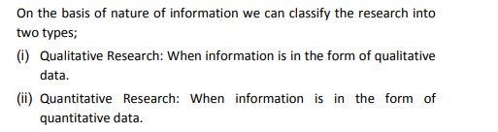

Tajeddini, K., Martin, E. and Ali, A., 2020. Enhancing hospitality business performance: The role of entrepreneurial orientation and networking ties in a dynamic environment. *International Journal of Hospitality Management*, *90*, p.102605.

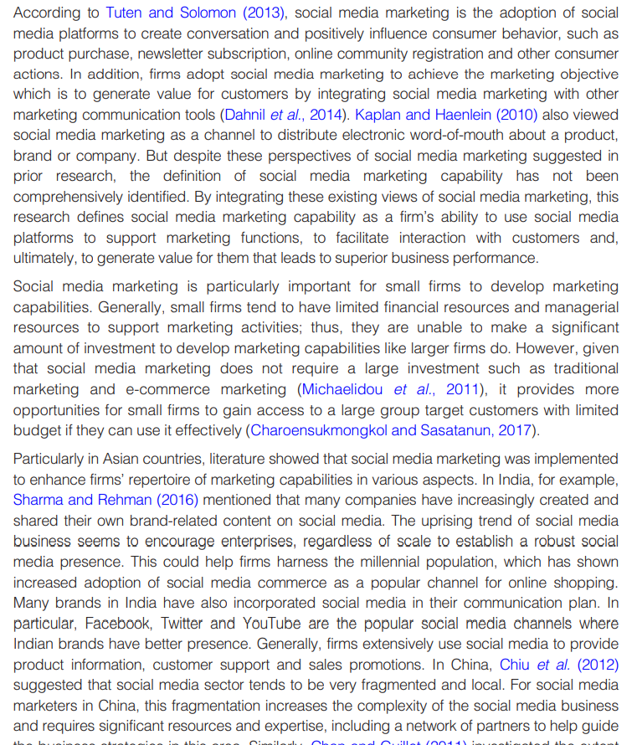

Hameed, W.U., Nisar, Q.A. and Wu, H.C., 2021. Relationships between external knowledge, internal innovation, firms’ open innovation performance, service innovation and business performance in the Pakistani hotel industry. *International Journal of Hospitality Management*, *92*, p.102745.

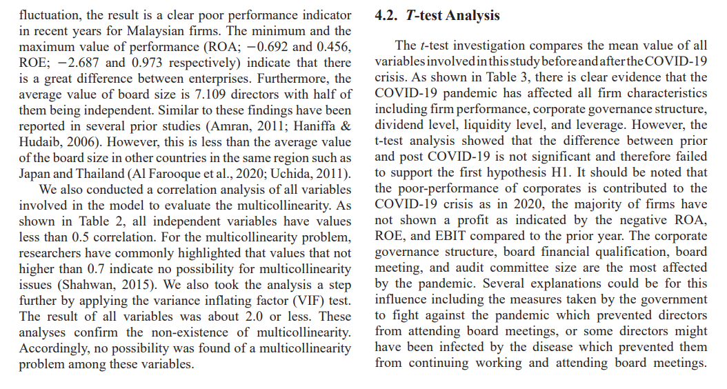

Úbeda-García, M., Claver-Cortés, E., Marco-Lajara, B. and Zaragoza-Sáez, P., 2021. Corporate social responsibility and firm performance in the hotel industry. The mediating role of green human resource management and environmental outcomes. *Journal of Business Research*, *123*, pp.57-69.

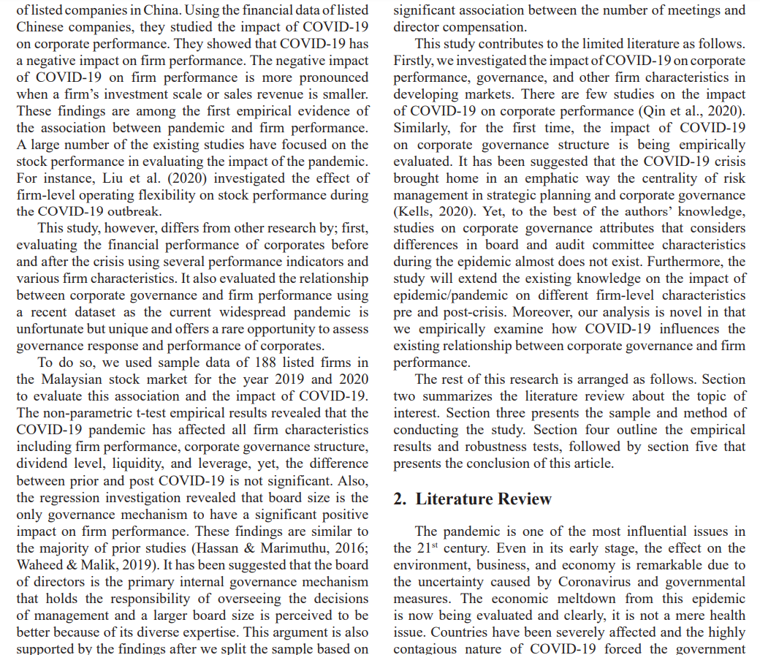

Wilke, E.P., Costa, B.K., Freire, O.B.D.L. and Ferreira, M.P., 2019. Interorganizational cooperation in tourist destination: Building performance in the hotel industry. *Tourism Management*, *72*, pp.340-351.

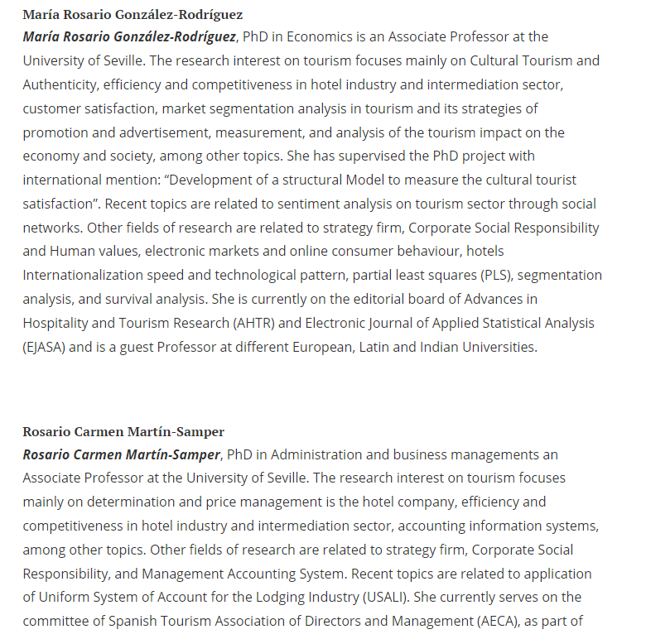

Tarsakoo, P. and Charoensukmongkol, P., 2020. Dimensions of social media marketing capabilities and their contribution to business performance of firms in Thailand. *Journal of Asia Business Studies*, *14*(4), pp.441-461.

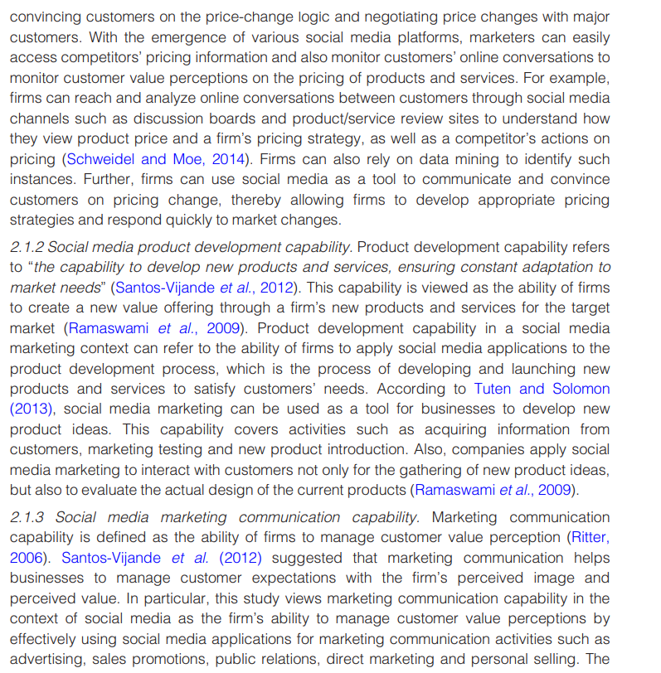

Ribeiro-Navarrete, S., Botella-Carrubi, D., Palacios-Marqués, D. and Orero-Blat, M., 2021. The effect of digitalization on business performance: An applied study of KIBS. *Journal of Business Research*, *126*, pp.319-326.

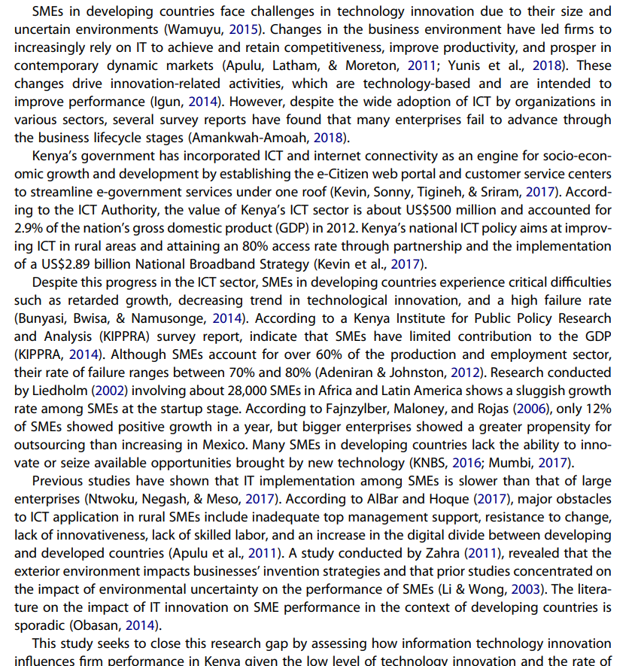

Rhou, Y. and Singal, M., 2020. A review of the business case for CSR in the hospitality industry. *International Journal of Hospitality Management*, *84*, p.102330.