**ASSIGNMENT**

**Table of Contents**

Introduction 2

Discussion 2

Conclusion 10

***‘The principle that banks deal in documents, not goods, is vital to the operation of documentary credits, but causes immense problems for exporters.***

# Introduction

***Letter of Credit*** and ***autonomous guarantees*** have been regarded as the most commonly used methods of finance. They are collectively called ***“documentary credit”***. In the case of trade, the customs have a responsibility to maintain the trade operations and the problems faced by the exporters regarding documentary credit. The International Chamber of Commerce’s (ICC) banking technique to develop the best international practices has been found as important to deal with the challenges faced by the exporters in the documentary credit system of the banks. The *Uniform Customs and Practices* *for documentary credit (UCP) 600* has been enforced by ICC to regulate the issues faced by the exporters and banking suitability to deal with documentary credit since 2007. The identification of the probable challenges will be analysed in this assignment related to the handling of letters of credit or documentary credit operations accepted by the banks for the trade exporters. In this paper, the use of *UCP 700* is going to be analysed in trade transactions.

# Discussion

[1]The banking customs and practices regarding the “Letter of Credit" have been regulated by ICC to bring harmonized control in International Commerce. In order to smooth the running of ***documentary credit*** the banking sectors rely on the principles of document submission and not on the authenticity of goods. The banks rely on straw men to secure payments. The banks are developing the role of providing credit perceiving some of the risks inherent in the international transaction. In the case of banking principles, the reliability of documents such as trade licenses, business documents, transactions with other countries, and annual income statements has to be developed to ask for credit from the banks by the merchants. [2]The regulation of UCP has been considered the key principle to dealing with international banking transactions in trade and commerce. The challenging or problematic part of documentary credit for the banks is the timeframe for banks to increase the validation of the documents submitted by the applicants.

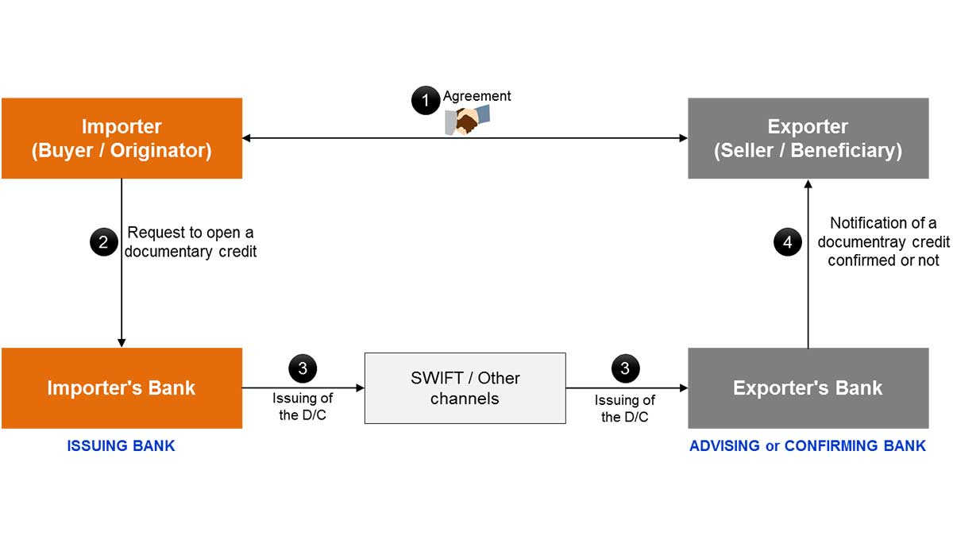

**Figure 1: Process of documentary credit**

(Source- Meral, 2019)

*[3]Documentary credit (D/C)* is a method of payment where the bank of the buyer guarantees the bank of the seller the conditions that the seller has to fulfill while developing trade with the seller. D/C works as a guarantor between both parties involved in the import and export process to maintain transparency in the exchange of goods. The provided statement for this assignment ***‘The principle that banks deal in documents, not goods, is vital to the operation of documentary credits but causes immense problems for exporters’*** can be justified according to the context that the banking system is dependent on documents and proofs. In International Trade the involved parties are not known to the Importer's bank (Issuing bank) and the Exporter’s bank (Advising bank). The document of payment among the parties is the only valid proof to the bank to make the permanent business development. The revocable documentary payment can be modified or canceled by the importer at any time without the agreement of the exporter. The exporter payment agreement is not considered in the process of developing a revocable document of credit. The avoidance of discrepancies among the traders in connection with the banking support document of credit is necessary.

***Letter of Credit*** is another name for "Commercial Credit" and is one of the most reliable or responsible ways of a contract between exporters in international transactions[4]. Letter of credit has been regarded as the substitution alternative for documentary bills. The provision of security through documentary bills to the seller has been prevalent for ages to keep transparency and reliability in the banking transaction with the traders. In the case of banking legal documents such as ***transaction bills, tax clearances, custom approvals, and income statements*** are necessary when an applicant is asking for credit from the bank. The clarity of the documents is needed as authentic documentation for the bank to consider the application of credit for the traders.

In the case of export, the tendency of the buyers can be noticed to receive the goods before making the full payment. On the other hand, the seller always possesses the intention to be fully paid before the shipping of the goods. In such a dichotomy, there should be mutual trust and guarantee between the buyer and the seller before developing the transaction[5]. The guarantee of international trade transactions between the seller and a new buyer has to be developed to make the transaction smooth and running. The development of the international trade transaction between buyer and seller has been modified by the bank with an implementation of the role of a guarantor. While developing the agreement between the buyer and the seller the ***LOC (Letter of Credit)*** conducts an informative role to provide information about the price of the products, and probable date of delivery to make the transaction reliable and trustworthy.

LOC is very important for the development of international transactions between the Importer's Bank and Exporter's Bank to provide clear documentation regarding the international transaction between two countries. The guarantee letter to the credit between both parties is a symbol of a trustworthy agreement to reduce risk and any kind of intentional or unintentional fraud[6]. The *“Letter of Credit”* works as a mediator between the issuing bank and the advising bank of both the importer and the exporter to start the transaction. It can be signified as a very important link between the bank and the buyer before starting the transaction with the seller. The LOC is asked by the buyer to the issuing bank regarding the intended transaction to start. The submission of LOC has been developed by the seller to the advising bank as a valid document of credit for business authentication. The banking officials investigate the LOC properly and when they find it satisfactory including the buyer making the bank charges and other required payments of the shipping requirement, the validity and reliability of the transaction has been maintained by the banks. After the payment is made by the buyer, the bank charges get distributed between the issuing bank and the advising bank[7].

***Banking profitability areas*** in the induction of letters to credit in international trade has been regarded as a money-making process for banks. Letter to the Credit is regarded as a guarantee for the issuing and advising bank in the international trade transaction regarding the method of payment, the pricing agreement between the parties, and maintenance of all shipping regulations. Globalisation is associated with international trade and the advantages are directly linked with the world economy. ***Outside trade*** is a significant feature to develop economic stability in the nations. On the other hand, ***Foreign Trade*** provides opportunities for the global economy to be sustained and increased by the earring of foreign currency.

Banks are supporting the financing of international trade to improve the sustainability and economic market. The ***Foreign Trade payment*** is important to bring sustainability and economic development in the importing country[8]. The importer's bank or Issuing bank can get an opportunity to increase economic stability by bringing foreign payment from international marketers. The capital of international investment to the native companies can increase the earning of capital financing. Foreign trade payments can improve economic globalization in the Importer's bank through currency transactions. The three types of payment techniques in Foreign Trade payment are mainly *letters of credit, payment in cash and sales on account, and export credit.*

***Documentary credit payment*** using a letter of credit is a very usual way of making payment which is being returned by the bank guarantee for the transaction. In this process, payment has been conducted in advance through cash or an open account. A documentary letter of credit is a document that the bank can use against the materials or goods. *World Export Credit Agencies* (ECA) are responsible to develop controlling measures of the international trading process such as receiving payment[9]. The ECA credit facilities are more than 30 days and less than 5 years loan on the scheduled rate of the national bank. By offering LOC international transactions can be transparent and credit growth can be possible for the importing countries.

Banks are effective at producing money. The source of acquiring the loan from the investors and receipt of payment from the buyers in foreign currency is a kind of money-generating process of the banking sector. In order to develop a clear and transparent agreement in the business process between the parties, banks play an important role to make the document signed by the customers and make it a guarantor for taking action against any future discrepancies. The single bank generates credit from the principal money that is being borrowed by the customers.

***The challenges faced by the exporters due to documentary credit*** are the most important part of the discussion.The challenges in international trade transactions are more prominent than the domestic transaction as international exporters have different laws and cultural boundaries associated with trade. The development of a letter to credit is a ***time-consuming process***. It has been found that the process of developing an agreement between a buyer and a seller is a time-consuming process as the buyer has to ask for a letter of credit to the issuing bank, and the request is then transferred to the advising bank of the seller[10]. The seller has to submit all the necessary documents regarding the price of goods, method of payment, and contract agreement of shipping. In this whole process of the banking system being covered the trade opportunity sometimes gets missed. Export and import businesses in terms of exchanging goods and services often get convoluted due to the maintenance of LOC for banks.

The general agreement conducted between the parties involved in the trade is not accepted by the banks while required to maintain the agreed principles of LOC which can decrease the interest of the probable buyer in developing trade transactions. Though the modification of UCP 500 has been implemented in the process of L/C in business transactions, the challenges faced by the exporters in the trade is ***not verification of the physical goods or their quality***. L/C is operated on the basis of documentation which has been suggested in UCP 600. Hence without the verification of physical goods or their qualities, it can affect the payment of the beneficiary. The parties under the letter of credit do not have any permission to physically check the goods. So, if the buyer wants to check the quality of goods, he is buying he can seek help from an inspector agency of international repute and provide instructions to the exporter to mention a condition in the letter of credit. In these terms and regulations of banking principles the buyers have to face difficulties in managing the quality check of the goods.

***If the buyer wants to stop the export order, he cannot do so*** due to the clause of the *Letter of Credit.* Sometimes due to the fluctuation of business product prices the importer/buyer wants to stop the export. Hence it cannot be possible for him due to the signing agreement in LOC. The selling price variation is a very common phenomenon in export and import. The exporters can face problems due to the fluctuation of the selling price in the process of import. ***Currency fluctuation*** can be regarded as another challenge faced by the exporters in the business due to LOC or documentary credit processes by the banks. Any loss due to fluctuation of foreign currency found under the Letter of Credit has to be borne by the buyer. This can be regarded as another major disadvantage that exporters and importers face in international trade. Currency fluctuation may impact the price variation in the local market as well. The demand for imported goods may reduce due to the fluctuation of foreign currency. Under the letter of credit currency fluctuation has a grave impact on the exporters.

The ***commercial reality of today’s market*** has not been presented by signing L/C in a business perspective. Without understanding the risk assessment or cost implementation of business the sales managers often accepted L/Cs from the buyers. L/C is often seen as a revocable instrument. The poor drafting and law clauses implemented in UCP 500 and 600 have made the validity of the document of credit less trustworthy. It has been seen that for a buyer developing a relationship with a bank which is completely unknown is less reliable for the buyer. In case of trade and export finance development the letter of credit cannot be the only means of guarantee.

***The* *Uniform Customs and Practices* *for documentary credit (UCP)***has been provided the responsibility to follow the process of maintaining Letter of Credit in the development of International Trade transactions[11]. From years *UCP 400, 500 and 600* have been used in monitoring the business scope and transparency developing process between both the parties involved in import and export. UCP 400 was introduced as a set of regulations for International Trade Transaction. UCP helped in reducing risk of the agreement and business transaction to be developed.

In 1993 revision UCP 500 tried to develop modified versions of regulations in International Trade. UCP 500 and 600 could not clarify what the banking day is wanting in revocable and irrevocable agreement. On the other hand, UCP 600 focused on developing how to reduce the time frame for the submission and investigation of the validity of the documents[12]. The development of ***reasonable time*** within 5 banking service days was the main aim of UCP 600 regulation to reduce the time-consuming process of the document investigation of Letter of Credit. In different periods the development of changes has been conducted in the UCP rules to highlight the problem of time frame regarding the banking verification of documents. From “reasonable time” of UCP 400, to “seven banking days” to UCP 500 and “five banking days” in UCP 600 the final alteration has been found to be developed in UCP 700.

Hence the parties involved in business are still not happy and satisfied with the “five days limit” prescribed in UCP 600. The development of business in the international market needs to be flourished to enhance the economy of the domestic country. The foreign investment and development of earning foreign currency is required to increase the business economy. In this context, the timeframe of examining the document papers by the bank has been suggested to be reduced to the ***“three days limit”*** under UCP 700[13]. The implementation of ***Blockchain smart letter of credit contract*** can be useful to reduce the timeframe of document verification to 3 days limit by the banks. The International Chamber of Commerce Tradeflow has been suggested to develop and implement blockchain smart letter of credit contracts to reduce the gap between international financing.

In the blockchain contract the document verification of Letter of Credit can take less time as both the parties involved in business agreement can establish a smart contract with the importing bank. The principles of banking regulations have been found most important to verify the documents before starting the international Trade between two parties. The regulation of UCP 700 can be effective to make the timeframe of documentation and examining the documents by the banks little rapid to enhance the business effectiveness. The development of the business transaction can be implemented with the modification of UCP regulations and authentic documentation.

# Conclusion

In this assignment the analysis has been conducted according to the importance of *Letter of Credit* for banks in the development of import and export. The concept of documentary credit and letter of credit has been explained in this research paper. The way the banking sector can find it profitable to deal with International Trade and using the payment method of Letter of Credit. The analysis of the banking principles while undertaking a letter of credit has been discussed in this paper. The challenges faced by the exporters in the way of managing Letter of credit as business guarantee has been analysed. The suggestion of the use of UCP 700 to make the development of documentary credit has been mentioned in this paper. The modern business market and its implication with the provision of banking opportunities for the buyers and sellers have been discussed in this paper.

1. Hussain, S., Ahmed, A.A.A., Kurniullah, A.Z., Ramirez-Asis, E., Al-Awawdeh, N., Al-Shamayleh, N.J.M. and Julca-Guerrero, F., 2021. Protection against Letters of Credit Fraud. *Journal of Legal, Ethical and Regulatory Issues*, *24*, pp.1-11.
2. Warnasuriya, C., 2021. Fraud Unravels All; Do Fraudulent Documents Invalidate A Letter of Credit?. *KDU LJ*, *1*, p.17.
3. Meral, Y., 2019. Strategic Management of Finance and Role of Documentary Credit. In *Handbook of Research on Global Issues in Financial Communication and Investment Decision Making* (pp. 395-416). IGI Global.
4. Chang, S.E., Chen, Y.C. and Wu, T.C., 2019. Exploring blockchain technology in international trade: Business process re-engineering for letter of credit. *Industrial Management & Data Systems*, *119*(8), pp.1712-1733.
5. Bastan, M., Akbarpour, S., Ahmadvand, A. and Shakouri, G.H., 2019. Making the profitability paradox of bad banks: a system dynamics approach. In *The international conference on industrial engineering and operations management, Pilsen, Czech Republic*.
6. Al-Amaren, E.M., Ismail, C.T.B.M. and Nor, M.Z.B.M., 2020. The blockchain revolution: A gamechanging in letter of credit (L/C). *International Journal of Advanced Science and Technology*, *29*(3), pp.6052-6058.
7. Barnes, J.G., 2019. Letters of Credit. *The Business Lawyer*, *74*(4), pp.1267-1276.
8. Chang, S.E., Chen, Y.C. and Wu, T.C., 2019. Exploring blockchain technology in international trade: Business process re-engineering for letter of credit. *Industrial Management & Data Systems*, *119*(8), pp.1712-1733.
9. Garg, R., 2022, November. Ethereum based Smart Contracts for Trade and Finance. In *International Conference on Blockchain and Smart Contracts, Bangkok Thailand. International Journal of Economics and Management Engineering* (Vol. 16, No. 11, pp. 619-629).
10. Kim, D.C., 2020. A Study on the Problems and Countermeasures Relative to Negotiation Clause under L/C Transactions in the UCP 600. *C Transactions in the UCP*, *600*, pp.49-70.
11. Zhang, J., 2019. Sea transport documents in bank's hands—bridging the UCP with commercial shipping law. In *Codification of Maritime Law* (pp. 121-133). Informa Law from Routledge.
12. Kowalski, M., Lee, Z.W. and Chan, T.K., 2021. Blockchain technology and trust relationships in trade finance. *Technological Forecasting and Social Change*, *166*, p.120641.
13. Trade finance. training, 2022. Accessed at: https://www.tradefinance.training/blog/articles/ucp-700/