Hussain, S., Ahmed, A.A.A., Kurniullah, A.Z., Ramirez-Asis, E., Al-Awawdeh, N., Al-Shamayleh, N.J.M. and Julca-Guerrero, F., 2021. Protection against Letters of Credit Fraud. *Journal of Legal, Ethical and Regulatory Issues*, *24*, pp.1-11.

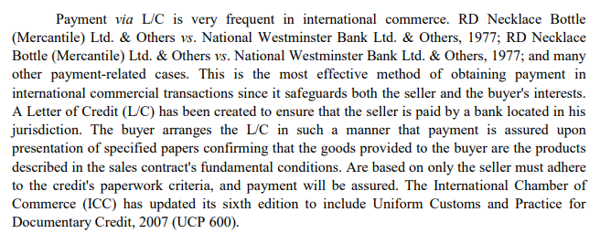

Warnasuriya, C., 2021. Fraud Unravels All; Do Fraudulent Documents Invalidate A Letter of Credit?. *KDU LJ*, *1*, p.17.

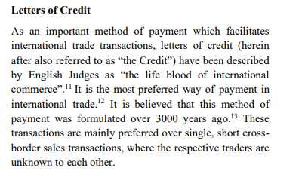

Meral, Y., 2019. Strategic Management of Finance and Role of Documentary Credit. In *Handbook of Research on Global Issues in Financial Communication and Investment Decision Making* (pp. 395-416). IGI Global.

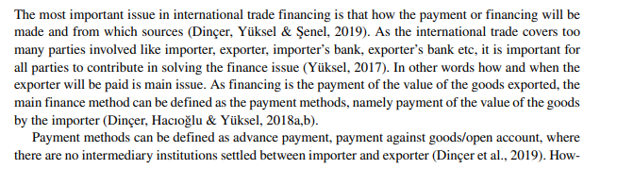

Chang, S.E., Chen, Y.C. and Wu, T.C., 2019. Exploring blockchain technology in international trade: Business process re-engineering for letter of credit. *Industrial Management & Data Systems*, *119*(8), pp.1712-1733.

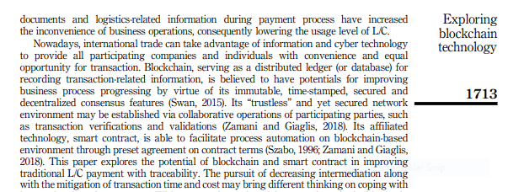

Bastan, M., Akbarpour, S., Ahmadvand, A. and Shakouri, G.H., 2019. Making the profitability paradox of bad banks: a system dynamics approach. In *The international conference on industrial engineering and operations management, Pilsen, Czech Republic*.

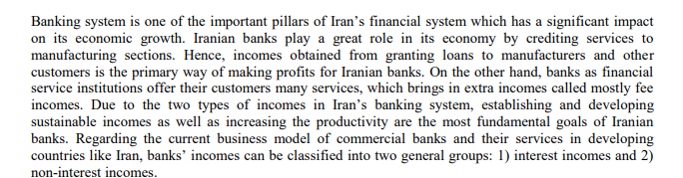

Hussain, S., Ahmed, A.A.A., Kurniullah, A.Z., Ramirez-Asis, E., Al-Awawdeh, N., Al-Shamayleh, N.J.M. and Julca-Guerrero, F., 2021. Protection against Letters of Credit Fraud. *Journal of Legal, Ethical and Regulatory Issues*, *24*, pp.1-11.

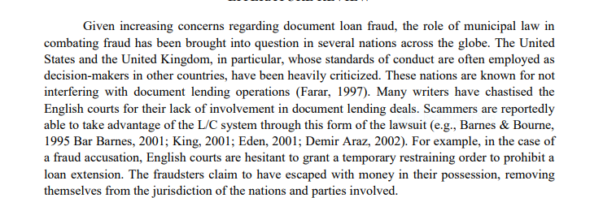

Al-Amaren, E.M., Ismail, C.T.B.M. and Nor, M.Z.B.M., 2020. The blockchain revolution: A gamechanging in letter of credit (L/C). *International Journal of Advanced Science and Technology*, *29*(3), pp.6052-6058.

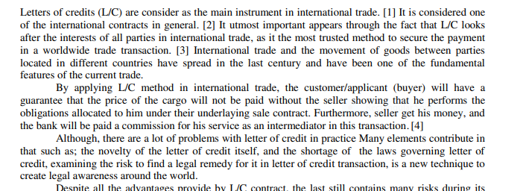

Barnes, J.G., 2019. Letters of Credit. *The Business Lawyer*, *74*(4), pp.1267-1276.

Chang, S.E., Chen, Y.C. and Wu, T.C., 2019. Exploring blockchain technology in international trade: Business process re-engineering for letter of credit. *Industrial Management & Data Systems*, *119*(8), pp.1712-1733.

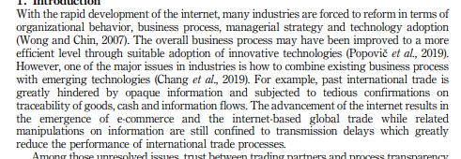

Garg, R., 2022, November. Ethereum based Smart Contracts for Trade and Finance. In *International Conference on Blockchain and Smart Contracts, Bangkok Thailand. International Journal of Economics and Management Engineering* (Vol. 16, No. 11, pp. 619-629).

Kim, D.C., 2020. A Study on the Problems and Countermeasures Relative to Negotiation Clause under L/C Transactions in the UCP 600. *C Transactions in the UCP*, *600*, pp.49-70.

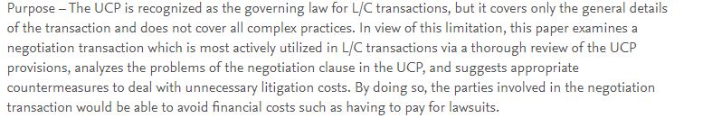

Zhang, J., 2019. Sea transport documents in bank's hands—bridging the UCP with commercial shipping law. In *Codification of Maritime Law* (pp. 121-133). Informa Law from Routledge.

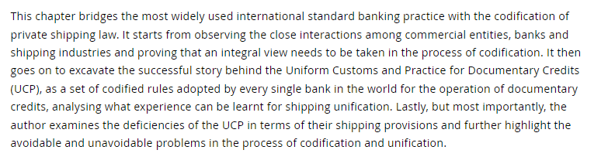

<https://www.tradefinance.training/blog/articles/ucp-700/>

Kowalski, M., Lee, Z.W. and Chan, T.K., 2021. Blockchain technology and trust relationships in trade finance. *Technological Forecasting and Social Change*, *166*, p.120641.

