**RESEARCHING EXPERIENCE DESIGN AND CONSUMER EXPERIENCE: ASSESSMENT 2 WORKSHOP**

**INDIVIDUAL PORTFOLIO**

**Table of Contents**

Introduction 2

Design and experience management theories related to Qatar World Cup 2022 2

Analysis and discussion of supporting documentation of the event 8

Research Approach with Self-reflection 10

Conclusion and Recommendation 11

References 13

Appendix 15

# Introduction

The chosen event for this assignment is ***Qatar World Cup 2022.*** The FIFA World Cup 2022 was organized in Qatar from 20th November to 18th December. The event was celebrated across the world by all football lovers. Millions of people have visited Qatar to watch the most important matches of the world cup. The event experience associated with Qatar World Cup is dynamic in terms of arranging hospitality development for all the visitors, their suitability, and affordability to stay in the hotels and enjoy the game physically. 64 matches were played in the total world cup series across 8 venues in Qatar. Qatar promoted the hosting of the tournament as it represented the Arab world. More than 1.4 million fans have visited the Fifa World Cup in 2022 in Qatar. The stadiums of Qatar accommodate almost 60,000 to 80,000 visitors in each match.

*The Match Hospitality sales Team* and the *Official Hospitality Program* of Qatar World Cup have ensured the Fifa World Cup experience of visitors is memorable. The event and hospitality management group associated with the tournament has developed the responsibility to manage the visitors. They provide them with adequate facilities in Qatar in terms of accommodation, fooding, and traveling to the match grounds, and confirmed the ticket availability, safety, and security in the cities of Qatar to gain personalised experience of the travel. In this assignment, the use of design and experience management process for the consumers adopted by event groups of the Qatar World Cup will be going to be presented. The critical evaluation of the customer hospitality management in the world cup will be assessed in this assignment to develop an understanding of the number of facilities provided by the event and hospitality management group to the customers. The accommodation pricing for the tourists and ticket rates will be discussed along with the service facilities.

# Design and experience management theories related to Qatar World Cup 2022

**Design**

The design of Qatar World Cup 2022 has been analysed in this discussion as a great event for celebration.

***Ball design***

The design of Qatar World Cup 2022 has been analysed in this discussion as a great event for celebration. ***Al Rihla*** is the official name of the football used in the World Cup 2022. The name suggests "the journey" in Arabic and the design of the ball refers to the cultural transcendence and relationship development with other countries. Al Hilm was the official producer of the ball in the Fifa World Cup 2022 with the technological facility of capturing even the small moves of the game in each second (Fifa.com, 2022).



**Figure 1: Ball design**

(Source- Fifa.com, 2022)

***Theme***

The quadrennial world championship for national football was organised in Qatar in 2022. The “official soundtrack” ***The Calling*** was released to encourage all football lovers to jump in the mega event. The opening ceremony of the mega event was fascinating. As per Elias et al. (2022), the event management group of Fifa developed planning and strategies to bring eminent signers and world-famous artists to make the event the most attractive access to the world. The ***grand opening ceremony*** with the international celebrities’ performance has been organised by the event management team to make the opening successful.

***Logo***

The Logo design of the FIFA World Cup 2022 was a symbol of regional Arab culture. The logo symbolises the attraction of any event to make people interested in it. In the case of Fifa World Cup 2022, the primary design elements of the logo were ***the shawl, the swooping curves, the infinity symbol, and the number eight***. The nicely flowing emblem has been recognised as a cultural aspect of Arab countries.

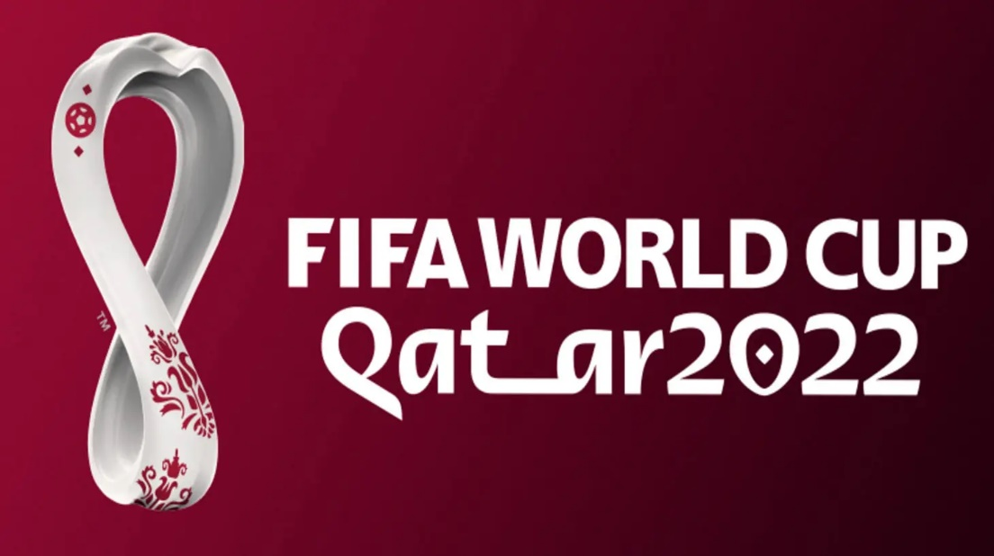

**Figure 2: Logo of FIFA World Cup 2022**

(Source- Fifa.com, 2022)

***Stadium design***

The stadium decoration of the FIFA World Cup matches have been conducted by the event management team to make the matches successful in terms of availability of proper lighting, space in the ground, sitting arrangement for the spectators, and medical facilities with other safety arrangements (Al-Emadi et al. 2022). All the stadiums used for the matches in the world cup were extensively beautiful and the transport facility has been made available by the Qatar government to provide spectators easy accessibility to come to the stadiums. As per Kukreti et al. (2023), ***a new green stadium design*** has been developed by Qatar World Cup planners for the stadium decor idea. Lazar light arrangement across the stadium has been organised by the world cup team management.

The event management group working with FIFA World Cup 2022 has ensured customer journey is satisfactory in the matches.

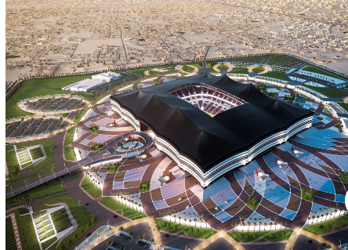

**Figure 3: Stadium decor**

(Source- Fifa.com, 2022)

**Application of theories**

***Consumer satisfaction theory***

Customer satisfaction is most important to make an event successful and satisfactory. The ***Consumer Satisfaction Theory*** can be analysed in this context to assess the requirement of making customers satisfied. The expectation of the consumers has to be identified by the host to provide the service. In the changing market of digitalised world customer needs have changed especially in the post-pandemic era. The maintenance of the safety and health security of the consumers has to be developed in the customer satisfaction planning process. In the Qatar World Cup 2022 event, the event managers have taken responsibility to understand the needs of guests while providing them with accommodation.

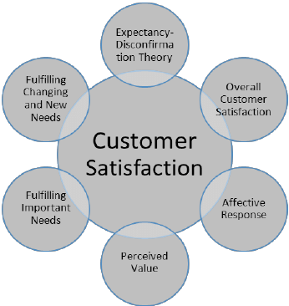

**Figure 4: Customer satisfaction management theory**

(Source- Khan et al. 2022)

The development of customer satisfaction can make an event satisfactory. In the Qatar world cup 2022 almost 1.4 million people gathered within 1 month of the continuation of the game. In this period the availability of rooms in the hotels, and proper room service facility (***food, wi-fi, digital assistance in the payment option, and match streaming opportunity from the hotel***) development can be monitored by the consumer satisfaction theory implementation. The analysis of real-time data for customer demand can be best executed by implementing the perceived value and feedback of service management in hospitality service planning for visitors in Qatar.

***Consumer experience hierarchy model***

***Gartner’s CX Pyramid*** has been developed to analyse the customer experience hierarchy according to need. The hierarchy of needs depends on the requirement and varies among different people (Bouwer et al. 2022). Customer experience and behavior management have to be improved to provide customers with proper facilities along with resolving queries. In the hierarchy pyramid of Gartner, it has been shown that customers want adequate information for the service, resolve the queries by the service providers, take care of the customers without asking, and make the environment safer, better, and trustworthy.

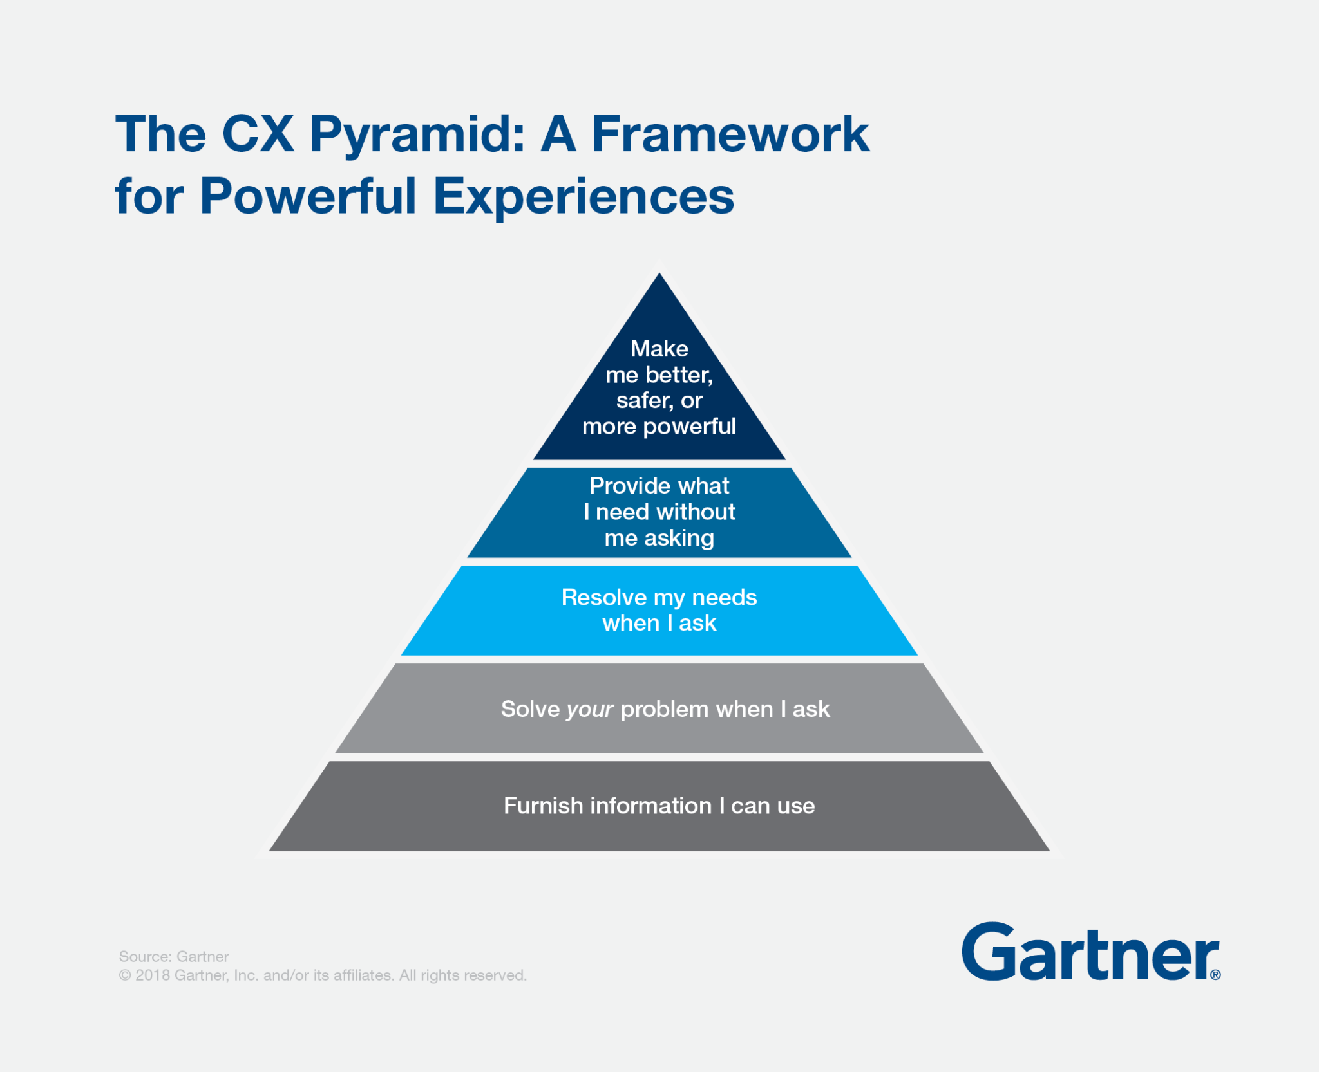

**Figure 5: Gartner’s CX Pyramid**

(Source- Bouwer et al. 2022)

The hospitality and tourism development surrounding Qatar World Cup 2022 has flourished in Qatar. Visitors across different countries have visited Qatar to watch the matches. The hierarchy of needs to assess customer requirements could be used by the event management team to understand the requirements of the guests. The most attended matches between famous teams were the source of huge gatherings in Qatar. In this context, the management of guests could be better organised by assuming the needs and requirements of the customers.

**Consumer experience**

Customer service management is the most important responsibility of event planners in any event. As per Charfeddine & Dawd (2022), in Qatar World Cup 2022, the management of customer service has been organised by mainly ***LCC Event Group*** to provide customers adequate facilities in terms of ***hotel booking, room availability, room charges along with food services, digital technology inclusion (wi-fi and data management).*** The handling of hotel reservations, inventory, and rooming list, managing ticket booking for the matches, and sitting availability have been supervised by the event managers. Transport, logistics, and assessment with tour operators and ticketing have been managed by the event managers to provide confirmation about the booking. In the hotels of Qatar, a minimum of 40,000 to 1 lakh guests have gathered for special matches which created discrepancies for the event managers to arrange hotels and rooms according to the customer's preference due to increasing demand.

The live streaming of the matches has been organised by the event management group and visitors would enjoy the match without going to the stadium from the hotel as well. Problems have been witnessed by many tourists during the world cup matches regarding the nonavailability of client travel documents at the proper time. During the world cup in Qatar, hotel and hospitality management has not been found satisfactory among 45% of customers. Discrimination in terms of caste, religion, and gender has been witnessed in Qatar by hotel providers over LGBTQ+. Some of the official's list of recommended accommodation hotels in the list of FIFA have denied the accommodation of same-sex couples. Almost 69 hotels on the recommended list of FIFA have denied the accommodation of same-sex (Theguardian.com, 2022).

Hotel guests have faced discrimination in getting service from hotels as homosexuality is illegal in Qatar. Any discrimination by the hotel management team while providing service to the guests has terminated the contract with the FIFA world cup team (Chopra et al. 2023). The local communities along with LGBTQ+ were not permitted in the hotels of Qatar and they have experienced discriminatory behavior from them. The accommodation worries for football fans have been witnessed in Qatar during the matches. It has been found that 39% of the visitors have not managed to book any accommodation in Qatar. Prices of food products and room charges have increased by 25% usual in Qatar during the world cup making it impossible for any local community to enjoy the game (Simkhad et al. 2022).

# Analysis and discussion of supporting documentation of the event

The event of FIFA World Cup 2022 can be analysed by presenting evidence of research documentation such as website links, images, and brochures. The analysis of the customer data which can be found from the market research after the Qatar world cup has ended can be presented as research evidence of this portfolio to assess the customer experience in the matches and hospitality management process. As per Diop et al. (2022), hotel rooms were in great demand in the Qatar World Cup 2022, especially in the semi-final and final matches. It has been found that the LCC Event Group has taken responsibility for the hospitality development of the customers coming to Qatar for enjoying matches. Almost 1.4 million people have gathered in the mega tournament of football across the world.

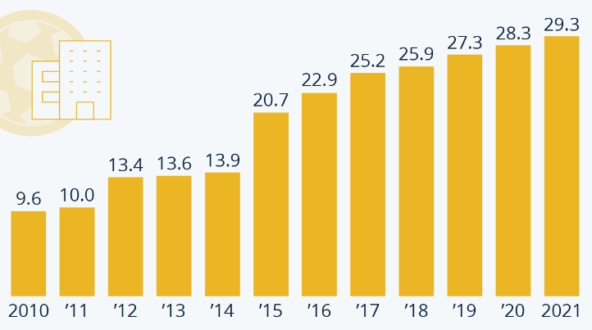

**Figure 6: Hotel rooms demand in Qatar World Cup 2022**

(Source- Statista.com, 2022)

From the above statistics, it can be said that the popularity of the FIFA World Cup increases with each passing year. The gradual demand has increased for the availability of rooms for the time of world cup matches. In 2022 in Qatar, the demand for hotel rooms increased by 29.3%. The customers have faced difficulties in managing ticket booking and packages offered by the event management team of Qatar during the World Cup. It has been found that the online link of the website for ticket booking of the matches and hotels collapsed due to the rush of visitors in Qatar. The World Tourism Organization (UNWTO) has stated that 29,000 rooms were available in Qatar for visitors in 2022 which was 20% more from 2010 (Statista.com, 2022).

The organizers have asserted that rooms could be available from ***budget fan villages to luxury five-star resorts***. The availability of ***traditional tenting in the desert and room sharing*** was available for the visitors according to the affordability. ***Two cruise ships*** docked at Doha Port with 70,000 availabilities of rooms were offered for accommodation during the world cup period. The controversy has developed in Qatar due to its stance on LGBTQ+. The rigidity of Qatar in terms of homosexuality and acceptance of same-sex room sharing was so prominent in the period of the world cup in 2022 (Theguardian.com, 2022). It has been found that almost 69 hotels contracted with the world cup team have refused to provide accommodation to the LGBTQ+ community. The grievance has been focused on the development of customer experience facing such discrimination from the hotel organizers of Qatar. Almost 39% of the visitors were unable to manage to book any type of accommodation for visiting Qatar in the world cup (Bbc.com, 2022).

The official link of the website of FIFA World Cup 2022 was the source for buying tickets for the match. The website link collapsed at a time while a huge number of people were trying to book reservations for the matches. The hospitality management and service of tourism development were not satisfactory according to the reviews of the visitors in Qatar as they have not provided peer documentation of the match schedule, sitting arrangement and logistics facilities in Qatar.

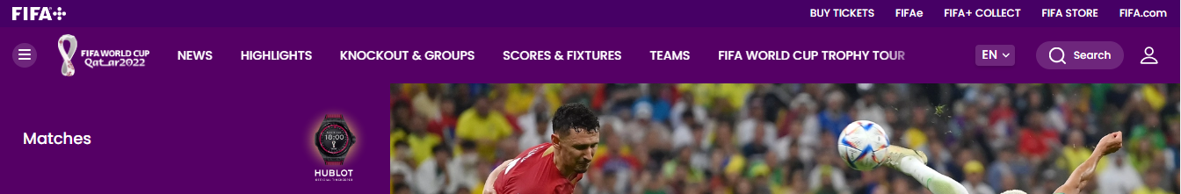

**Figure 7: Official website of FIFA**

(Source- Fifa.com, 2022)

The non cooperation and mismanagement has been witnessed in the Qatar World Cup 2022 in terms of discriminatory behaviour with a particular people community, providing less information and location details to the guests regarding the match and arrangement of transport facilities (Fifa.com, 2022). The event management group arranged accommodation and other digital facilities for the guests to provide them luxury and comfort hence the lack of market research and assumption regarding the probable gathering in the cities of Qatar in the important matches, faltered the hospitality management facilities. On the other hand, the expenditure in Qatar for staying was increased for common people to afford.

# Research Approach with Self reflection

***Research approach***

Research approach of the portfolio to develop the significant understanding of analysing FIFA world cup as a grand event and the experience of the customer journey has to be evaluated. In this assignment the development of *semiotic analysis* has been undertaken to assess the customer experience and customer journey during the world cup in Qatar. The responses of the customers regarding the discrimination faced by them in the Arad country has been analysed in this portfolio using the experiences and thematic content of the observers. The news reporters have captured the various instances of customer experience in the Qatar world cup that can be used in this analysis to assess the customer data.

***Self-reflection***

Being a current and future manager I think the working process of event managers in the hospitality management development for visitors coming to Qatar will be a matter of significant study in this field. According to me, the relationship management and communication development with the customers would be effective to understand the queries and requirements of them in an unknown place. I think the service management of the customer service has to be developed to arrange a grand event in any place. The analysis of proper customer data I think is required to provide customers adequate service in terms of accommodation and digital assistance service. Being a manager I have learned that managing differentiated customers is quite difficult for the event managers in a mega event preparation. I will develop a market research of probable estimation in future before taking any responsibility of any mega event to monitor. I think the analysis of the hierarchy of needs of the customers can be effective for the event manager to provide them service and hospitality management development process.

# Conclusion and Recommendation

In this portfolio assignment the concerned topic was the consideration of Qatar World Cup 2022 as a mega event and the customer experience associated with it. The design of the event organised in Qatar has been described in this portfolio by assessing the design of the ball, logo of the world cup, stadium decoration and hospitality management services provided to the customers. The theoretical analysis has been developed in this portfolio to assess the customer service management and customer experiences in Qatar. The discrepancies faced by the customers in Qatar in getting accessibility of rooms and ticket availability in matches has been discussed in this assignment.

***Recommendations***

1. As per Talavera et al. (2019), the customer service management can be developed by using technical tools for data management and market survey. The event managers have to be more responsible to maintain trust and reliability with the customers. The confirmation of event booking, customer data collection can be organised in authentic manner by using digital optimisation tools.
2. The focus should be developed on live streaming and virtual accommodation in gathering audiences for any event. The post pandemic period has come out as a remarkable transition for emphasizing health and hygiene. The development of the arrangement of accommodation for any mega event has to maintain security and customer preferences. Skilled workforce and management team has to be recruited for the event management to communicate with the customers effectively to understand their preference and meet the requirement.

# References

Al-Emadi, A., Sellami, A. L., & Fadlalla, A. M. (2022). The perceived impacts of staging the 2022 FIFA world cup in qatar. *Journal of Sport & Tourism*, *26*(1), 1-20. <https://doi.org/10.1080/14775085.2021.2017327>

Bbc.com, 2022. Retrieved from: https://www.bbc.com/news/world-middle-east-62995496

Bouwer, Louis, Strategic CX Innovation (August 1, 2022). Available at SSRN: <https://ssrn.com/abstract=4179831> or [http://dx.doi.org/10.2139/ssrn.4179831](https://dx.doi.org/10.2139/ssrn.4179831)

Charfeddine, L., & Dawd, I. (2022). Innovations and Hotel Performance in the Aftermath announcement of Qatar Hosting FIFA 2022 World Cup. *Event Management*, *26*(2), 253-273. **DOI:** <https://doi.org/10.3727/152599521X16192004803728>

Chopra, H., Islam, M. A., Chandran, D., Emran, T. B., Nahed, A., Al-Tawfiq, J. A., & Dhama, K. (2023). MERS-CoV recently re-emerged in Qatar, Saudi Arabia, its feasible global health risks amid FIFA world cup 2022 and salient counteracting strategies–an update. *International Journal of Surgery*, *109*(2), 153-155. *DOI:* 10.1097/JS9.0000000000000056

Diop, A., Jatić, Š., Holmes, J. L., Le Trung, K., El Maghraby, E., & Al Naimi, M. (2022). Interest in volunteering for the FIFA 2022 World Cup in Qatar: a nationally representative study of motivations. *Journal of Policy Research in Tourism, Leisure and Events*, 1-20. <https://doi.org/10.1080/19407963.2022.2125521>

Elias, J., Mobarak, M., & Rosenthal, J. (2022). Qatar FIFA World Cup 2022. In *SAGE Business Cases*. Yale School of Management. DOI: https://doi.org/10.4135/9781529796407

Fifa.com, 2022. Retrieved from: https://www.fifa.com/fifaplus/en/tournaments/mens/worldcup/qatar2022

Khan, R. U., Salamzadeh, Y., Iqbal, Q., & Yang, S. (2022). The impact of customer relationship management and company reputation on customer loyalty: The mediating role of customer satisfaction. *Journal of Relationship Marketing*, *21*(1), 1-26. <https://doi.org/10.1080/15332667.2020.1840904>

Kukreti, M., Mishra, A., Dangwal, A., Jain, V., & Tewari, V. (2023). Destination Branding and Mega Events: A Case of FIFA World Cup 2022 and Sultanate of Oman. In *Managing Festivals for Destination Marketing and Branding* (pp. 285-302). IGI Global. DOI: 10.4018/978-1-6684-6356-7.ch018

Simkhada, P., van Teijlingen, E., & Regmi, P. (2022). Migrant Workers in Qatar: Not just an important topic during the FIFA World Cup 2022. *Health Prospect: Journal of Public Health*, *21*(3). DOI: 10.3126/hprospect. V21i3.49835

Statista.com, 2022. Retrieved from: https://www.statista.com/chart/28707/rooms-in-qatar-for-world-cup/

Talavera, A. M., Al-Ghamdi, S. G., & Koç, M. (2019). Sustainability in mega-events: Beyond Qatar 2022. *Sustainability*, *11*(22), 6407. [**https://doi.org/10.3390/su11226407**](https://doi.org/10.3390/su11226407)

Theguardian.com, 2022. Retrieved from: https://www.theguardian.com/football/2022/may/13/fifa-issues-warning-to-qatar-2022-hotels-over-lgbtq-discrimination

# Appendix

**Ticket price table**

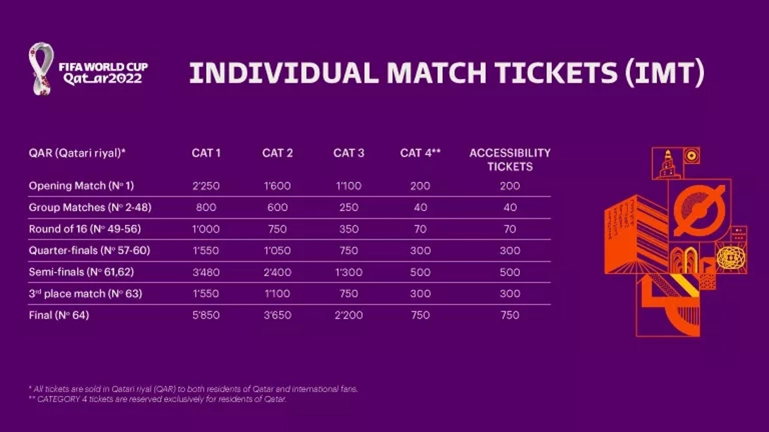

**Promotional leaflet**

