**ASSESSMENT: LEAN PRODUCT MANAGEMENT**

Table of Contents

Introduction 3

Research Background 3

Research Aim and Objectives 3

Research Objectives 3

Research questions 3

Research rationale 4

Literature review 4

Discussion on the several values in lean product management for increasing customer satisfaction 4

Theoretical framework 4

Literature gap 5

Methodology 5

Research Philosophy 5

Research approach and design 6

Data collection and analysis 6

Conclusion and Recommendation 6

References 7

# Introduction

The present study has focused on lean product management which is known as a strategy to help product managers in eliminating waste and developing deliver value for customers. It helps in providing the product development process and reduces the cost of building the product and increases customer satisfaction.

## Research Background

Lean product management is designed in order to help organisations and help in bringing products into the market in a fast way (Asha *et al.*, 2023). Providing a structure for the product development process it also helps in decreasing the time, reduces the cost of building products and maintains its focus.

## Research Aim and Objectives

The main aim of the research is to improve the overall process and design the product with the least wastage for increasing customer satisfaction.

## Research Objectives

* To identify the different values of lean product management to increase the customer satisfaction level
* To eliminate waste from the business procedure through lean product management
* To assess effective strategies in lean product management for improving the work process

## Research questions

* How to identify the different values of lean product management to increase the customer satisfaction level?
* Why is it necessary to eliminate waste from the business procedure through lean product management?
* What are the strategies in lean product management for improving the work process?

## Research rationale

The main issues can be said as after globalization many changes have been made in product management and customer demand has increased. The major issues related to understanding customer demand and satisfaction level over internal requirements.

# Literature review

## Discussion on the several values in lean product management for increasing customer satisfaction

According to Schwaber (2018), product management has increased rapidly by the impact of innovative technology and business procedures. The implementation of lean management has shed light on the customer's needs and expectations by eliminating errors and delays (Ahmed *et al.*, 2023). It has managed to increase the customer satisfaction level. On the other hand, Davis (2019) stated that the process of lean product management has made the competition level increased in the global market by reducing errors and making the business level smoother. The customer may move to another organization for mote better products at affordable prices.

## Theoretical framework

***Six sigma model***

For making the business procedure effective and eliminating the major errors the implementation of the six sigma model can help in achieving a positive outcome. This tool is highly used for improving the business procedure by reducing defects, minimizing variation as well as increasing quality and efficiency. This model consists of six different stages such as define, measure, analyze, improve and control procedure. All these stages can be involved in the lean product management and make the business procedure efficient by eliminating errors. It will highly improve the existing product and service and also will help in increasing the customer satisfaction level (Tampubolon and Purba, 2021). Removing variations and communicating clearly with the customer will help in increasing the understanding process.

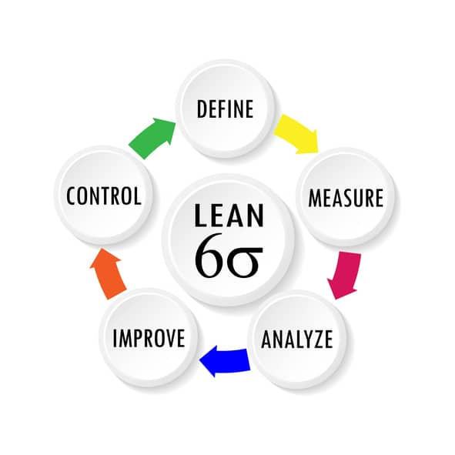

**Figure 1: Six Sigma model**

(Source: Tampubolon and Purba, 2021)

## Literature gap

In the present research, it has been observed there were many scholarly articles and journals which were lacking the sequences. The different viewpoints of the author were not relevant to the present research topic.

# Methodology

## Research Philosophy

The research will include the positivism research philosophy for covering the entire situation of the present research topic. This particular research philosophy will help in generating valid resources and increase the knowledge of the researchers.

## Research approach and design

In the context of the research topic of lean product management, the inductive research approach will be selected. It will help in exploring new theories and will provide support to get effective results. It will help in understanding the theories and provide new ideas and measure them properly in the research process.

The descriptive design will be chosen for the particular research. It will help in identifying several variables without hypotheses.

## Data collection and analysis

In this section, the research will include a secondary qualitative data collection method and will help in gathering relevant information on lean product management (Debnath *et al.*, 2023). The analysis of the data is important to gain knowledge of the different relevant themes as well as to define variables and techniques efficiently.

## Conclusion and Recommendation

The process of lean product management is essential for making the business grow and sustain in the global market. With the help of lean management the obstacles and errors in the business will become reduced. This may lead to an increase the customer satisfaction level and meet their expectation efficiently.

# References

Ahmed, S., Hawarna, S., Alqasmi, I., Ashrafi, D.M. and Rahman, M.K., 2023. Mediating role of lean management on the effects of workforce management and value-added time in private hospitals. *International Journal of Lean Six Sigma*.

Asha, A.A., Dulal, M. and Habib, A., 2023. The Influence of Sustainable Supply Chain Management, Technology Orientation, and Organizational Culture on the Delivery Product Quality-Customer Satisfaction Nexus. *Cleaner Logistics and Supply Chain*, p.100107.

Debnath, B., Shakur, M.S., Bari, A.M. and Karmaker, C.L., 2023. A Bayesian Best–Worst approach for assessing the critical success factors in sustainable lean manufacturing. *Decision Analytics Journal*, *6*, p.100157.

Tampubolon, S. and Purba, H.H., 2021. Lean six sigma implementation, a systematic literature review. *International Journal of Production Management and Engineering*, *9*(2), pp.125-139.