**DISSERTATION: THE ROLE OF WOMEN/WOMEN LEADERSHIP IN INTERNATIONAL MANAGEMENT: CHALLENGE AND PRACTICE**

**Table of Contents**

1. Introduction 3

1.1 Introduction 3

1.2 Research background 3

1.3 Research Aim 5

1.3 Research objectives 5

1.4 Research Questions 5

1.5 Research significance 5

1.6 Problem Statement 6

1.6 Research Rationale 6

1.7 Methodology Outline 7

1.8 Research structure 8

Reference List 10

# 1. Introduction

## 1.1 Introduction

This section of the dissertation provides a layout, the study is going to follow. The role of women in the “international management” work process is changing significantly over the years. Increased participation of women in different management-related activities is posing challenges and also bringing change in terms of working style. The role of women as leaders in the workplace brings in different changes such as paying extra care to the personal development of employees. Women leaders also focus on improving communication between different employees and thus add different styles to the overall working process. This section will cover the background of the research and will discuss the rationale of the study as well.

## 1.2 Research background

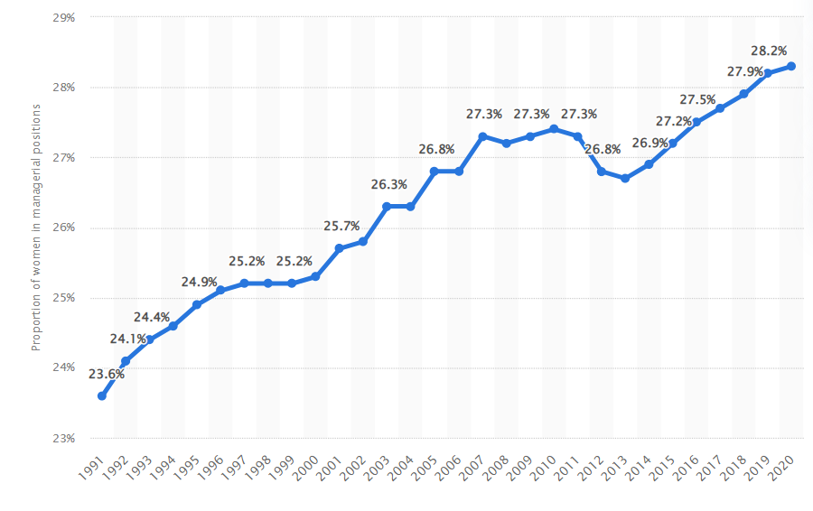

**Figure 1: Women in managerial position**

(Source: Statista, 2021)

On a worldwide basis, the increased advancement of women toward managerial positions is changing the overall perception of work. Towards the end of 2020, around ***28.2%*** of managerial positions are held by women all over the world (Statista, 2021). The introduction of diverse workforce accounting as an important strategy that is playing a crucial role in bringing changes in the working process of different business organisations. The research is targeting to identify different challenges women leaders are facing in order to execute a certain project. Increased participation of women in management-related activities is changing the work process. However, one of the serious issues faced by women managers is related to complexity in terms of migration to another country or region. The study is aiming to highlight different challenges women are facing in the work process.

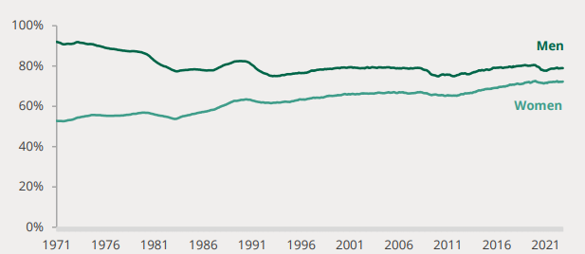

**Figure 2: Changes in the employment rate of women**

(Source:Researchbriefing, 2022)

Increased participation of women in different business activities and managerial roles is posing a change in terms of the trend in the female employment rate. The female employment rate reached “72.3%” at the end of 2022 (Researchbriefing, 2022). Women leaders are bringing creativity as well as new opinions to the work process. Women leaders are adding sophistication to their work approach. However, the biggest challenge in relation to women's leadership is difficulties in relation to having sponsorships and “unequal payment”.

## 1.3 Research Aim

The aim of the research is to assess the role of women leadership in management activities on an international level and assess different challenges. The study is also aiming to assess different changes in management practice observed under women leaders.

## 1.3 Research objectives

Objectives of the study are identified below:

* To identify the role of women as leaders in the international management work process
* To assess change in international management practices observed under women leaders
* To evaluate challenges faced by women leaders and develop the appropriate solution

## 1.4 Research Questions

Research question developed for the study process:

1) What role do women play in the management work process on an international level?

2) How are women leaders responsible for bringing changes in international management practices?

3) What are the challenges faced by women leaders and what are possible solutions?

## 1.5 Research significance

The significance of the research is that it can help to understand the abilities and skills of women as leaders. According to the opinion of Bullough *et al*. (2022), women managers are playing a crucial role in developing creativity in the work process. In order to introduce advancement in leadership by encouraging the recruitment of women leaders, one important initiative is bringing in changes in terms of cultural aspects and beliefs followed by the organisation. The culture of an organisation is an important determinant that influences the success as well as the failure of the organisation. One of the important aspects of women's leadership is the development of “cultural diversity” in companies which ultimately helps in the development of effective solutions for management issues. Hence, the conduction of this research study can help in understanding the ways women leaders help in making work processes better and thus enhancing overall outcomes. A study on the role of women's leadership helps in assessing different challenges faced by women leaders while developing a cooperative working environment.

## 1.6 Problem Statement

***Women leaders face limitations in terms of career advancement opportunities, unequal payment, and poor cooperation demotivates women leaders.***

There are several issues such as lack of cooperation from the end of the hierarchy which poses a serious challenge to the advancement of women leaders in the international management work process. According to the opinion of Brunner (2019), the underrepresentation of women in the business environment poses a serious challenge. Female leaders need to deliver outstanding performance in order to grab the attention of other leaders of the business place. The importance of women leaders in the international management process is emerging owing to the requirements of the rapidly evolving environment of business. However, women leaders are facing critical challenges in terms of leaving a mark in a workplace dominated by men. Despite the development of growth opportunities for women in the workplace, a significant gap in terms of employee management poses a barrier for female leaders to maintain senior leadership positions.

## 1.6 Research Rationale

***What is the issue?***

The issue in the research is related to the estimation of the role of women leaders in the management process of international business. Stereotype gender belief of people results in questioning the capabilities as well as skills of female employees (Merma-Molina *et al.,* 2022). The main issue in this regard is the evaluation of different factors such as unnecessary attention towards the “working style” or “attitude” of female leaders and thus creating an obstruction in the overall work process.

***Why is the issue?***

The role of women leaders and the challenges faced is an issue because it hampers the overall performance of the management. Different “unconscious” biases faced by female employees pose “detrimental” to the leadership sphere for the management process. Lack of trust showcased by associates accounts as an important reason that ultimately results in lowering the confidence of women leaders (Zenger and Folkman, 2019). Another important issue in this regard is the “unfair treatment” faced by women leaders at the workplace.

***Why is the issue in the present time?***

One of the significant barriers for women leaders is a lack of cooperation from subordinates. In the present time, women face obstacles in terms of the advancement of careers. In the present time, the emergence of women leaders is facing issues in terms of a lack of mentors, which ultimately limits career growth.

***Relation to the research topic***

The research shed light on the topic which is about assessing the role of women leaders in different international management activities. Assessment of different challenges faced by women leaders can help in developing an understanding about the emergency of the situation. The research topic is also targeting to assess different changes possible in the work process under the leadership of women.

## 1.7 Methodology Outline

The methodology section of the chapter focuses on different types of tools in use for the research process. The study is focusing on the use of a ***secondary research strategy*** for this research. The study has implemented an ***interpretivism research philosophy*** in this research in order to collect relevant information. According to the opinion of Lê and Schmid (2022), an effective research strategy helps in developing a detailed understanding of the relevant data and information in use for the research process. This research is using a secondary research method in order to collect relevant and appropriate information by using reports of past researchers. An ***inductive research approach*** has been implemented in this research process. It starts from the recognition of a problem and the conduction of testing theories on it. This research approach also helps in working with different probabilities and thus reaching a more appropriate conclusion. It also helps in assessing different past theories studied in past research processes. It helps in generalisation of different observations and reaching a conclusion.

This study is using ***Explanatory Research design*** to investigate different phenomena of the research. In the opinion of Busetto *et al*. (2020), data collected using secondary sources such as “newspaper articles” or “journals” can help in improving the quality of the research process. The incorporation of ***thematic data analysis*** techniques can help in the assessment of different themes developed using research aims and objectives. This specific data analysis technique can help in reaching specific conclusions after analysing data collected for the research process. Incorporation of a secondary research strategy is an effective technique as it helps in saving time as well as the overall budget of the research.

## 1.8 Research structure

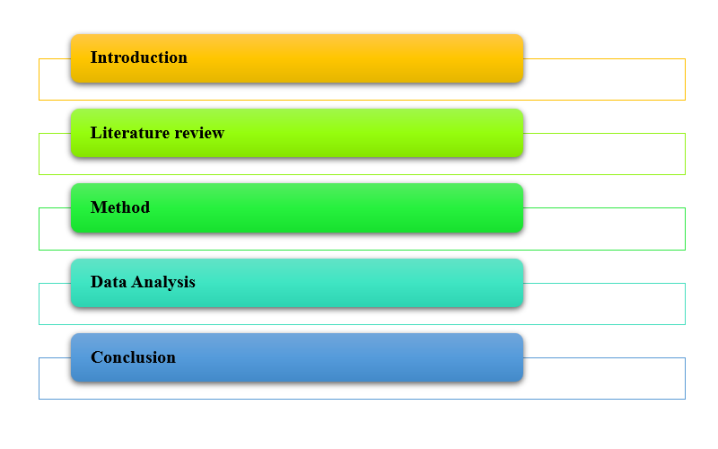

**Figure 3: Research structure**

(Source: Self-generated)

**Chapter 1: Introduction:** This is the first chapter which states the aim and objective of the research. It also includes the development of research questions and staging the significance of the research.

**Chapter 2: Literature review:** This section mainly conducts an empirical study using the aim and objective developed in the first section. It also includes a theoretical perspective on the topic of the research.

**Chapter 3: Methods:** This section discusses the methods selected for the research process. It identifies different tools and techniques to collect relevant data for the study process.

**Chapter 4: Data analysis:** This section includes the identification of different data and the conduction of analysis of the collected information.

**Chapter 5: Conclusion:** This is the final section of the research process.

# Reference List

Brunner, S.S., 2019. *Women in leadership positions: how do female leaders address challenges associated with their role in a male-dominated organizational environment?* (Doctoral dissertation).

Bullough, A., Guelich, U., Manolova, T.S. and Schjoedt, L., 2022. Women’s entrepreneurship and culture: gender role expectations and identities, societal culture, and the entrepreneurial environment. *Small Business Economics*, *58*(2), pp.985-996.

Busetto, L., Wick, W. and Gumbinger, C., 2020. How to use and assess qualitative research methods. *Neurological Research and practice*, *2*, pp.1-10.

Merma-Molina, G., Urrea-Solano, M., Baena-Morales, S. and Gavilán-Martín, D., 2022. The satisfactions, contributions, and opportunities of women academics in the framework of sustainable leadership: a case study. *Sustainability*, *14*(14), p.8937.

Researchbriefing (2022), <https://researchbriefings.files.parliament.uk/documents/SN06838/SN06838.pdf> [accessed on 18th april, 2023]

Statista (2021), <https://www.statista.com/statistics/1259478/women-in-managerial-positions-worldwide/> [accessed on 18th april, 2023]

Zenger, J. and Folkman, J., 2019. Women score higher than men in most leadership skills. *Harvard Business Review*, *92*(10), pp.86-93.