**ASSESSMENT: GLOBAL INNOVATION MANAGEMENT**

**Executive Summary**

Global Innovation Management has been brought as a key concern in this report to assess the working of innovation implementation and digital transformation theme in NextEra Energy. The concerned industry is electronic energy generation. Digital transformation technology used by NextEra Energy has been evaluated in this report. The innovative strategies and green innovation have created more opportunities for the organization and made the business procedure develop. The changes in the infrastructure, financial system, and communication process with the customers are essential for the business to grow. The development in the business involved new innovative techniques and tools in the report. The electric power industry should focus on the investment procedure and clean generation for reducing the pollutant in the air and make the environment healthier.

Table of Contents

Introduction 4

Background of the industry 4

Analysis and Findings 5

Green Innovation 5

Development of sustainability 5

Innovation management 8

Strategic innovation 9

Digital transformation 11

Corporate strategy 12

Current situation of the company 13

Conclusion 15

References 16

# Introduction

The present report has focused on the critical evaluation of the ***NextEra Energy Industry*** and its behaviour and different activities based on digital transformation and the new open innovations. Innovation management in the present era has highly changed the organizational structure and has to build up a long-lasting sustainable business process. The present study has discussed a brief on the organization with the innovations that have been included in it. Green innovation in order to contribute the key product and services to the people by reducing the harm and impact in the existing environment. Also, the corporate strategies have been evaluated in this section for managing the innovative techniques in the business procedure and making the profit rate increase. The delivery process also gets optimised through innovative strategies and makes green innovation grows efficiently.

## Background of the industry

The business world is constantly developing with new technicalities and improvements. Innovation and sustainability along with the development of digital transformation has become the key priority of business development in the present competitive business world. The increase in population and demand for the consumption of electric power has been witnessed in the **electric power industry** operation and energy consumption. The price of residential electric consumption has been increased to 8% in 2022 which can average to 14.9 cents per kilowatt. The consumption rate of electric power has been increased to 23% in the changing standard of living and official workplace (Store.hbr.org, 2022).

Fossil Fuel is the largest source of electricity generation. On the other hand, the burning of fossil fuels indicates an increase in pollution and emission of carbonated gas. The development of green innovation and sustainability has been incorporated into the "electric power industry” as a means of introducing renewable energy resources to produce electric power. The **Business Council for Sustainable Energy** has stated that in the electricity generation process the impact of “clean energy resources” has been found significant. The use of digital transformation and green energy development process has been developed in power energy generation systems to 40.6% (Statista.com, 2022).

# Analysis and Findings

## Green Innovation

The ***NextEra Energy*** industry works towards creating no carbon emissions and reducing the use of fossil fuels. The green innovation of the organization is highly investing in clean energy generation in order to reduce the impact on the environment and on the people. The ***emission-free wind and solar energy, nuclear power, battery storage technology*** and ***low-emission natural gas generation*** have made a great impact on the industry’s growth and reduced the negative impact on the environment effectively (Wang *et al.*, 2022). Green innovation in the organization can help in analysing and improving the reputation of the organisation. It highly enhances the efficiency level of resource utilization and makes the development of sustainable abilities effective.

In order to make the change in the lifestyle and environment grow and develop a healthier environment the minimization of the carbon footprint help the local environment and achieve the goal efficiently.

***Solar batteries in reducing electrical use***

The invention of the solar batteries in the current days has helped in reducing the electricity which is highly required for daily life (Khanra *et al.*, 2022). By switching to solar lights and recharging the solar batteries in the sunlight has highly helped and influenced the people living in this era.

***Sourcing different electricity***

For developing the environment through the NextEra Energy industry, switching to green innovation makes a huge difference in getting a positive result. The investment in emission-free wind and solar generation and innovative battery storage, and other technologies have helped in making the business of NextEra developed and gain more opportunities for the future.

## Development of sustainability

With the rapid development process through the green innovation, the industrial economy and environmental pollution have gradually become an essential part of managing the global economy and people. It is the social goal which highly relates to the ability of people in order to safely co-exist on Earth. Also, it helps in business practice and manages the triple bottom that includes ***Traditional profit/loss***, ***people account*** and ***planet account***.

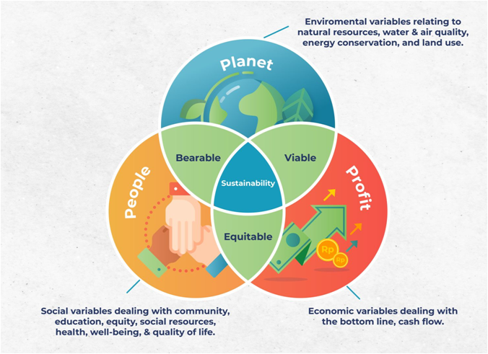

**Figure 1: Sustainability**

(Source: Wheelen *et al.,* 2018)

The development process of the sustainability and its growth in the future for making the organization more efficient. NextEra Energy industry's goal is for ensuring the access process of clean and affordable energy to develop agriculture, business, communication procedure, education, healthcare process, transportation and other services more effectively (Yang et al., 2022). The sustainability of renewable energy is necessary for making the development of the environment and access the affordable energy. Sustainable development goal 7 helps to make the human development process and make the economy of the country increase.

**Standard business models**

The standard business model can be involved in this process for making the business effective and making the strategies and revenue of the company increase. Two general types of business models are identified as ***business-to-business*** and ***business-to-customer*** business models.

The business-to-business model deals between two organizations in order to increase predictability and gain more stability to the business process. In order to make the environment pollutant free and reduce carbon emissions, NextEra can implement this model to the business process and increase the efficiency level (Huang *et al*., 2022) It has the benefit of lowering the cost of the business procedure. Every business needs to purchase products and services from other businesses in order to launch, develop and grow. It helps to increase the brand recognition process efficiently. However, it has also some risks such as it can miss out on individual customer sales and the profit scale can be limited for the of short number of business buyers.

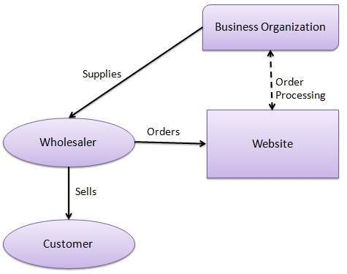

**Figure 2:** **Business-to-business**

(Source: Huang *et al*., 2022)

The business-to-customer business model generally deals with the consumers directly in order to sell their services or products. It makes the demand for the product increases through interacting with the consumers and the business productivity level grows. It highly helps in saving the additional cost, staffing, electricity and others. The benefit of this particular business model is to make the communication process with the customer more efficient which also helps in developing trust (Kari *et al.*, 2023). However, it has some risks in the business procedure such as it faces issues regarding the adjustment of the changing customer behaviours. The competition level in the B2C business is high as other companies also try to get more customers through this process and develop their business.

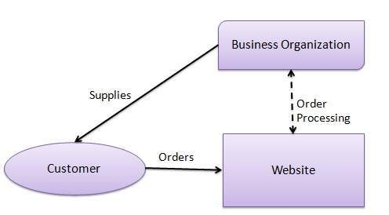

**Figure 3: Business-to-customers**

(Source: Kari *et al.*, 2023)

## Innovation management

Innovation management in the organization involves the specific process of managing the innovation procedure from the initial stage to the final stage of successful implementation. It includes the innovation strategies that have been implemented and made the decision-making process more smoother and increased productivity level. In the context of NextEra Energy, innovation management has helped in discovering the products and services, reducing the cost estimation and enhancing the development process.

***Sources of Innovation***

The innovative ideas and tools, techniques are highly involved in the innovation management in order to bring positive results and more opportunities for the organization efficiently. NextEra Energy has created innovative techniques which have helped the organisation to explore its areas and sustain the business development process in the global world. This innovation can be observed through advertisement process, changing the rules and regulations of the organization, and through unexpected or surprising things offering new directions for the innovation process.

***Stage gate process***

Through the innovative management, the efficiency level of the decision-making procedure has been increased and helped the organization with the relevant tools (Chen *et al*., 2022). The stage gate process is a such kind of tool that innovation management has involved in the NextEra energy industry for guiding the product development process effectively through six steps. These six steps include discovering, scoping, defining the business case, development process, testing and validation and launch.

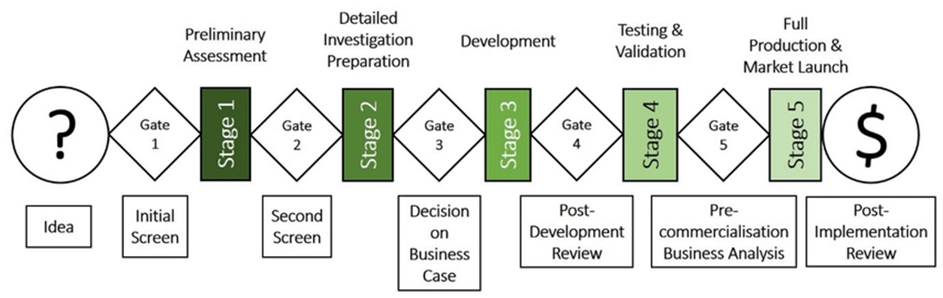

**Figure 4: Stage Gate Process**

(Source: Chen *et al*., 2022)

## Strategic innovation

The strategic innovation helps in creating the value by using the relevant knowledge and information in order to implement new ideas for products and services effectively.

***Value proposition***

The value proposition is known as the tools that help in making sure of innovative product and services are in the right position. It is the easiest way that helps in enabling innovation to flow efficiently in the business process. ***NextEra Energy*** explains its service's relevancy, quantified value and the unique differentiation through a clear statement.

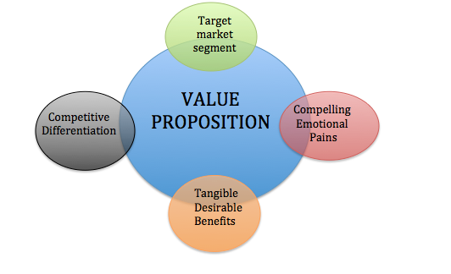

**Figure 5: Value proposition**

(Source: Dall-Orsoletta *et al.*, 2022)

The value chain helps in focusing on the operations of the business procedure and the value proposition is the strategy that looks the outer word at consumers, the demand of the business procedure.

***Infrastructure***

Innovative development often helps in improving the infrastructure of the business process and developing the strategic economy and the social importance. It is important for the business to explore and achieve a position where people will be able to identify and increase the opportunities in the future. Delivering superior value to the consumers is the main aim of the organization. Infrastructure development such as bridges, waste management, environment and telecommunication equipment can help in improving the process and optimizing the transportation channels and other electric systems (Restuputri *et al*., 022). Also, the traditional industry infrastructure involves coal, gas and nuclear plants which help in producing electricity for the entire city. Through regular maintenance procedure, it helps in ensuring the proper and efficient transmit power to a particular location.

***Customers***

With the development of the strategic procedure in the NextEra Energy industry, it helps in adding more value to customer services and making their experience level grow and meet efficiently. The process of making better relationships with customers through the business-to-customer business concept helps in identifying their expectations and demand. It provides help in developing the services and the products as per the customer's demand and improves the organization's business and generates more revenue effectively. The implementation of the new technology made the business procedure more smoother than before and implementing AI and ML made the process efficient. The communication process with the customers will also be developed through the new innovative technologies. It can be said that the development of chatbots in customer services makes the communication process better by answering the customer's queries efficiently and within the time. The customer gets their answers which also satisfy their point of view.

***Finances***

Innovative technologies have made the financial management efficient by creating new investment products, services and processes. These specific changes can be included in the updated technology, risk managing factors, equity generation and other innovations. In the recent days, new technologies have involved mobile banking technology and remittance technology. These have made great advantages in the organization and moved forward in gaining more opportunities. It makes the industry grow efficiently and designs efficient programs for making risk factors reduced.

# Digital transformation

**NextEra** has developed strategies to introduce digital transformational technology in business production, operation, supply chain, and relationship maintenance with consumers. The company has embarked on a whopping $60 billion of capital spending for 2019-2022 to access ***green transformation*** across the company (Nexteraenergy.com, 2022). Digital transformation helps in ***problem identification, risk-taking process, and innovation implementation*** in the workplace. The use of ***next-wave technologies*** (AI, Robotics, Data automation) in business development can be helpful to improve the quality management and unique position gained in the business field. The ESG Goal of NextEra is to achieve ***Real Zero*** within 2045 by developing zero carbon emission, complete clean energy at no incremental cost to the customers (Nexteraenergy.com, 2022).

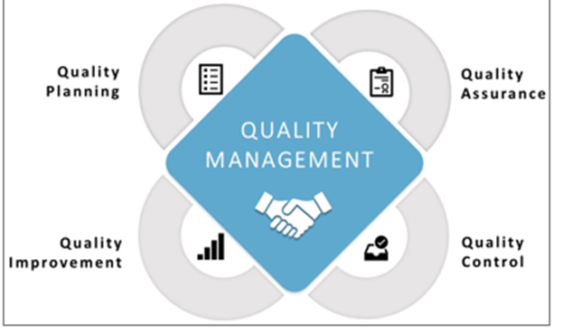

**Figure 6: Quality Management Strategy**

(Source- Stanley and Securities, 2019)

The development of ***quality management*** is very important to measure the probable risk of the organisational operation, the quality planning, improvement, and control development. The use of digital transformation tools such as AI optimisation to reduce time in electric energy generation, and risk identification can be effective to maintain the quality of the production of renewable energy resources. In NextEra Energy, the ***quality assurance program*** (QAP) has been developed to maintain organisational performance and effectiveness of developing organisational freedom in the workplace to reduce time consumption in energy production and supply chain. The use of digital tools such as data optimisation, digital safety, and protection will be applied to the nuclear safety-related structure of NextEra as a QAP process (Stanley and Securities, 2019). The contractor and energy-generating performance activities have been controlled by the use of QAP and QCP processes. The probabilistic safety analysis, and design safety function have been maintained and controlled by developing an effective Quality Control Framework.

Through the quality management process, the organization's services and products will become more developed and effective and it will help in delivering the right services to the customers within the time frame.

## Corporate strategy

Corporate strategies refer to the development of ***a Code of Conduct and Ethics*** in the workplace structure among employees. The incorporation of an ethical code of conduct can develop responsibility, reliability, trust, and collaboration among the team to enhance the relationship development with other employees and customers. ***Next Era Energy*** is very significant to maintain an ethical code of conduct and values among the employees in the workplace. The company maintained CSR policies through day-to-day activities in the workplace ethically with managing integrity and honesty (Ali *et al.* 2020)

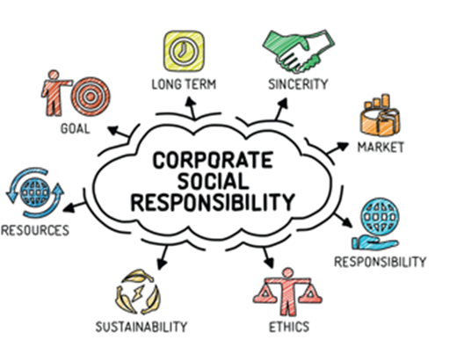

**Figure 7: Corporate Social responsibilities**

(Source- Ali *et al.* 2020)

The core values of Nextera Energy are to prefer ***excellence and commitment*** to improving fact-based decision-making processes, continuous professional development (CPD) for the employees, ***doing the right things*** by maintaining an environment of openness and trust, and ***treating people with respect***. The company promotes diverse and inclusive teamwork to strengthen collaborative energy and engage the employees in working productivity enhancement as the greatest asset of the company. Organizational hierarchy has been maintained in this company by distributing work responsibility in the subordinate team and liability development.

Health safety and protection have been maintained by this company through employing ***Policy Frameworks*** such as ***Nuclear Safety Employee Concerns Hotline and Equal Employment Opportunity Hotline.*** Each hotline is available and active 24 hours and 7 days. The sustainable development approach has been adopted by NextEra Energy by using green innovation and clean energy resources for electricity generation and supply.

## Current situation of the company

***Operation***

Next Era Energy has developed its unique way of maintaining renewable energy resources for electricity generation and improving the process of innovation. In this company currently, ***emission-free solar and wind energy, nuclear energy, and low-emission natural gas generation*** have been incorporated as alternative ways of developing renewable and clean energy resources. In the provision of electric energy power and generation of renewable energy ***NextEra Energy*** company has developed a competitive advantage by maintaining a sustainability approach and innovation.

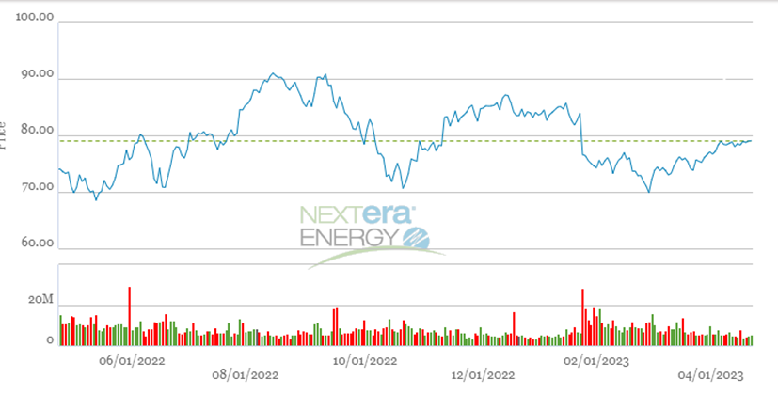

**Figure 8: Stock of NextEra Energy**

(Source- Nexteraenergy.com, 2022)

***Finance***

From the above statistics, it can be said that NextEra Energy has gained the maximum share in 2023 which is almost 87.5% (Nexteraenergy.com, 2022). The business position of the company is sustainable and effective to promote profitability management in the electric energy industry. As per Lapoint and Richardson (2020), the use of digital transformation in business operations has made data collection and keeping a record of supply and production easier using Artificial Intelligence (AI) technology. The cost reduction of the estimated budget has been developed by the use of digital automation technology and machine learning (ML). The development of ***solar thermal technology and wind turbines*** has become the largest resource of the electric generation process through NextEra Energy (Nrc.gov, 2022).

# Conclusion

In this report, the selected sector was the electric energy industry and the company chosen was NextEra Energy. The process of sustainability management and innovation implementation incorporated in this company has been analysed. Moreover, the process of sustainability, social responsibilities and innovation adopted in this company has been described in this report. The importance of digital transformation and quality management has been assessed to develop innovation and environmental sustainability in business. The current situation of the company and new innovations has been discussed. The corporate strategies of NextEra Energy have been mentioned in this report. Green innovation and digital transformation made a huge impact on the business and made the revenue scale grow.

# References

Ali, H.Y., Danish, R.Q. and Asrar‐ul‐Haq, M., 2020. How corporate social responsibility boosts firm financial performance: The mediating role of corporate image and customer satisfaction. *Corporate Social Responsibility and Environmental Management*, *27*(1), pp.166-177

Chen, L., Jiang, M., Jia, F. and Liu, G., 2022. Artificial intelligence adoption in business-to-business marketing: toward a conceptual framework. *Journal of Business & Industrial Marketing*, *37*(5), pp.1025-1044.

Dall-Orsoletta, A., Romero, F. and Ferreira, P., 2022. Open and collaborative innovation for the energy transition: An exploratory study. *Technology in Society*, *69*, p.101955.

Huang, Y., Chen, C., Lei, L. and Zhang, Y., 2022. Impacts of green finance on green innovation: a spatial and nonlinear perspective. *Journal of Cleaner Production*, *365*, p.132548.

Kari, Z.A., Sukri, S.A.M., Rusli, N.D., Mat, K., Mahmud, M.B., Zakaria, N.N.A., Wee, W., Hamid, N.K.A., Kabir, M.A., Ariff, N.S.N.A. and Abidin, S.Z., 2023. Recent advances, challenges, oppoRtunities, pRoduct development and sustainability of main agRicultuRal wastes foR the aquacultuRe feed industRy–a Review. *Annals of Animal Science*, *23*(1), pp.25-38.

Khanra, S., Kaur, P., Joseph, R.P., Malik, A. and Dhir, A., 2022. A resource‐based view of green innovation as a strategic firm resource: Present status and future directions. *Business Strategy and the Environment*, *31*(4), pp.1395-1413.

Lapoint, P.A. and Richardson, C.L., 2020. Implications of the Production Tax Credit on the Tax Liability for Companies in the Wind Energy Sector of the Energy Industry: An Exploratory Study. *The Journal of Applied Business and Economics*, *22*(6), pp.11-17.

Nexteraenergy.com, 2022. Accessed at: https://www.nexteraenergy.com/

Nrc.gov, 2022. Accessed at: https://www.nrc.go[v/docs/ML1617/ML16176A178.pdf](https://www.nrc.gov/docs/ML1617/ML16176A178.pdf)

Restuputri, D.P., Masudin, I. and Damayanti, A., 2022. The role of usability in business-to-customer digital transactions on multiservice platforms of Indonesian e-money providers. *The role of usability in business-to-customer digital transactions on multiservice platforms of Indonesian e-money providers*.

Stanley, M. and Securities, U.I.B.W.F., 2019. NextEra Energy Capital Holdings, Inc.

Statista.com, 2022. Accessed at: https://www.statista.com/statistics/323387/energy-industry-use-of-electricity-in-the-united-kingdom-uk/

Store.hbr.org, 2022. Accessed at: https://store.hbr.org/product/nextera-energy/W92C32

Wang, Q.J., Wang, H.J. and Chang, C.P., 2022. Environmental performance, green finance and green innovation: What's the long-run relationships among variables?. *Energy Economics*, *110*, p.106004.

Yang, H., Li, L. and Liu, Y., 2022. The effect of manufacturing intelligence on green innovation performance in China. *Technological Forecasting and Social Change*, *178*, p.121569.