# 

# OPERATION AND SUPPLY CHAIN MANAGEMENT

Table of Contents

Introduction 3

Contemporary challenges in Supply Chain Management. 3

The forecasting model in the existing supply chain 3

Transportation in the existing Supply Chain Management. 5

Inventory Management 5

Challenges for the Green Supply Chain Management and New Technology 6

Suggested Potential Supply Chain Strategies 7

Supply Chain Strategy (Fisher’s Model) 7

Implementation of the CNH Industrial supply chain with the Fisher’s Model 8

War House Management and Transportation 10

Modern Technology and Green Supply Chain Management 12

Conclusion 13

References 14

# Introduction

CNH International is a capital goods company with specialised equipment and services in agriculture. Headquarters in London, United Kingdom, the company's annual revenue is $23.55 billion for the financial year 2022. The total number of employees in the company is 63,499. Serving over 180 countries around the world, the company has 67 manufacturing plants and 56 research and development units. Inventory management, Logistic Movement, Transportation and warehouse management, and supplier relationship management (SRM) are some of the significant supply chain risks in the company. In this report, supply chain theories, contemporary supply chain risks, and mitigation strategies are discussed.

# Contemporary challenges in Supply Chain Management.



**Figure 1: Industry Business Report**

**Source: (assets.cnhindustrial.com)**

As It is seen from the above diagram the business year 2020 is not responded compared to the year 2021. The global pandemic situation impacts business and their output severely. The average business trends for the company CNH Industrial can be termed as the average output for the targeted regions in this case (assets.cnhindustrial.com). The agro-equipment manufacturing and in the field of construction, the material price increment and suppliers' responses play major roles in this case.

## The forecasting model in the existing supply chain

The general method of the forecasting model for the company is exponential smoothing. This model is quite effective in business forecasting on a general basis. There are some cases where exponential smoothing does not play quite a good role in forecasting the business model. There are many products and contemporary demands on a local basis which need sessional effects of forecasting. In the annual reports for 2021, the company claims that bid price forecasting increases the significance level in the industry trends by about 59.6%, for home building by 77.6%, and for the water infrastructure by 64.4% which are not up to the mark of the company. The company claims that the contemporary challenges and strictly high price in material procurement impact their existing supply chain management (assets.cnhindustrial.com).

|  |  |  |
| --- | --- | --- |
| alpha |  |  |
| 0.2 |  |  |
| **Month** | **%demand** | **Forecasted value** |
| 1 | 6 |  |
| 2 | 3 | 5.4 |
| 3 | 6 | 3.6 |
| 4 | 16 | 8 |
| 5 | 14 | 15.6 |
| 6 | 16 | 14.4 |
| 7 | 13 | 15.4 |
| 8 | 25 | 15.4 |
| 9 |  | 20 |

In the above exponential smoothing forecasting about the company’s sales outlook for the year 2021 and it is seen from the above data that for the 9th month the company must be expecting sales of 20% from the annual sales rate of the product for the construction of households and agriculture equipment, however, the company experienced a decline in the sales rate 13% only for the existing market. This is the reason why then the company does not earn quite a revenue in the financial year with respect to the existing forecasted model.

## Transportation in the existing Supply Chain Management.

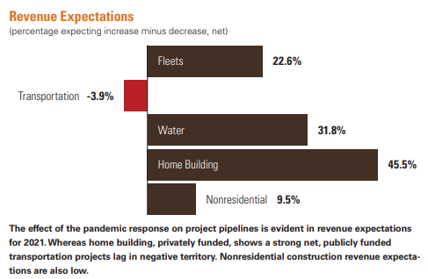

**Figure 2: Revenue Expectation**

**Source: (assets.cnhindustrial.com)**

It is seen from the above diagram there is a negative revenue price expectation in the transportation of the company for the financial year 2021. The company has an existing supply chain on a national and international basis. The transportation cost for carrying the goods from the warehouse to the existing inventory of the company impacts the company drastically and it affects the overall revenue generation for the company in the finical year 2021. The fillets for the machinery and manufacturing equipment required for the process operations in the manufacturing units are about 22.6%. The home building (construction) and the water infrastructure are 45.5% and 31.8% respectively. The percentage of revenue generation for the transportation section is negative (-3.9%).

## Inventory Management

The essential component of inventory management is to estimate the Economic Order Quantity (EOQ) model, Lean Production model (Just-In-Time), and Material Requirement Planning (MRP). The company divides their existing inventory into two different sections part of the inventory is located in its own warehouse and part of the inventory is located in a separate warehouse with an annual inventory holding cost of 23% for the existing inventory.

The revenue generation for the company in terms of inventory decreased -by 46.8% for the year 2021 (Fauziah *et al*., 2022). The inventory carrying cost for a large variation of the products and spare parts in the warehouse makes the company’s existing supply chain complete and revenue generation is unexpected compared to the expected value.

## Challenges for the Green Supply Chain Management and New Technology

The CNH Industrial plans to cut down the carbon emission by 46% in their manufacturing unit by the year 2025. The UK’s government policies in attaining the “Net Zero Emission” imply that all manufacturing company should reduce their carbon emission in the near future for sustainable development of the environment. The manufacturing units of CNH Industrial produce enough amount of Carbon dioxide that is more responsible for raising the global temperature (Green House Effect). The implementation of new technology in the existing supply chain like Big Data Analytics and Artificial Intelligence (AI) may increase the output level by saving cost and time. However, The modification in the existing supply chain and lack of knowledge among the employees and workers are time-consuming. Proper training and new lessons are quite dependent on their cognitive skills development and personal interest among the employees (Abdel *et al*., 2019).

Another challenge for the existing supply chain of the company is to adopt the principles of Green Supply Chain Management (GSCM) and there is a lack of suppliers to whom the bid can be awarded. There are no ample suppliers who can deliver green products for manufacturing on time and unexpected delays can be costly and time-consuming for the company.

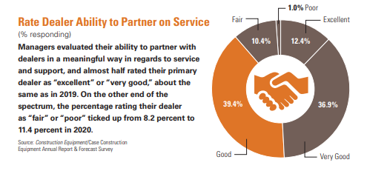

**Figure 3: Supplier Expectation**

**Source: (assets.cnhindustrial.com)**

In the annual report,2021 the company shows the rate dealer's ability to partner and it is seen that the company has a maximum percentage of 39.4% in the “good” remarks (not very good) and which means the company has more expectations from the supplier relation.

# Suggested Potential Supply Chain Strategies

## Supply Chain Strategy (Fisher’s Model)

In Fisher’s Supply Chain Model it is identified there are two types of products and they are primarily functional and primarily innovative. It is required to identify the products in the supply chain model and categorised them as the type of their operations and those products which need the aid of technology and innovation. Fisher also says that there are basically two types of the supply chain strategies such as a supply chain with physical efficiency and another supply chain which is responsive to the market. Physical efficient supply chain management implies the in-house products which are required for manufacturing or operational purposes (Can *et al.*, 2021). There is a portion of the supply chain which is responsive to the market as per the demand criteria of the customer. The marketing forecast, sales forecast, and cost control are some of the key parameters which decide the market response based on the supply chain management.

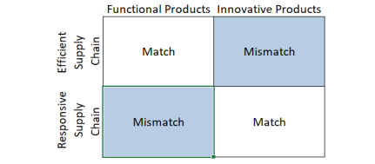

**Figure 4: Fisher Matrix**

**Source: (Can *et al.*, 2021)**

In the above diagram, the Fisher’s Matrix is shown and as it is discussed there are two types of products needed to identify in the supply chain management system of the company. The x-axis represents the type of products which are grouped from a functional and innovative point of view for the operation and the y-axis represents the responsive and efficient parameters in the supply chain. The Mismatch section is coloured in the blue box and the company needs to stay away from such products from the supply chain for better output of the company. The blue-cloured box and if the company keeps those products in their existing supply chain then the company may face a serious drop in the overall output of their existing supply chain management.

## Implementation of the CNH Industrial supply chain with the Fisher’s Model

|  |  |  |
| --- | --- | --- |
| **Demand Aspect** | **Functional Product** | **Innovative Product** |
| Product Life cycle | Average 2 years | Average 4 to 8 months |
| Margin | Average 10% to 30% | Average 20% to 70% |
| Variety in the product | Low | High |
| Marginal error in the forecasting at the time of the manufacturing | 5% | 10% to 30% |
| Rate of stock out | 1% | 10% |
| Lead time requirement | 5 months | 1 to 2 weeks |
| Force end with the sessional effect calculated as market full price | 1% | 10% |

|  |  |  |
| --- | --- | --- |
|  | **Physical Efficiency** | **Marketing Response** |
| Primary aim | Supply demand efficiency at the lowest possible cost | Quick response to the unpredictable demand to the stock-out product and unnecessary inventory |
| Manufacturing | High utilization rate | Deploying the buffer stock |
| Inventory Management | Generation of the high demand with minimum inventory holding cost | Response to the buffer stock |
| Lead time focus | Shorten then lean time and concerning to the cost of production. | Investing in technology to enhance the productivity of the company with the minimum production cost. |
| Supplier Relationship Management | The primary selection criteria are cost and quality. | Speed of the production with flexibility |
| Design of Product | Maximizing the performance and minimising the cost. | The innovative design of the product to meet the customer’s needs. |

In the above two tables, Fisher’s Criteria are shown in the case of the physically efficient products for the supply chain and innovative products. The parameters and criteria in the table are helpful for the company to find out Match and Mismatch products in the existing supply chain and the company can distinguish them effectively.

Just-In-Time Inventory Management: Toyota Corporation adopts the principles of Just-In-Time (JIT) management and lean production strategies in their existing supply chain and Kaeizan’s Waste Management principles for managing the waste in their existing supply chain management. The conception of lean production and JIT is based that the company's need to identify the product demand as per the session and demographic criteria in the locality and produce the exactly same amount of the inventory and products for the operation as per the requirement. Thus, the company may reduce the cost related to the inventory carrying cost and generate a good amount of revenue from their existing inventory in the supply chain.

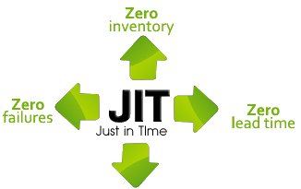

**Figure 5:JIT Inventory Management**

**(Source:Stockarea.io)**

The Break-even analysis for the company may help to estimate the reorder point for the inventory and previously forecasted data may be used in this case. The company CNH Industrial has three major segments named Agro-equipment, Water Infrastructure, and construction area (Smith, 2019). The demand for the forecasted data must be included the exponential smoothing with the seasonal effect in the model to use more precise predictive tools for the analysis.

**Seasonal Forecasting**

|  |  |  |  |  |
| --- | --- | --- | --- | --- |
| **Session Index** | |  |  |  |
|  |  |  |
| **Month** | **%demand** | **Sessional Mean** | **Sessional Index** | **Modified Forecasted Value** |
| 1 | 6 |  |  | 3.07 |
| 2 | 3 |  |  | 1.53 |
| 3 | 6 | 5 | 51.14% | 3.07 |
|  |  |  |  |  |
| 4 | 6 |  |  | 3.07 |
| 5 | 3 |  |  | 1.53 |
| 6 | 6 | 5 | 51.14% | 3.07 |
|  |  |  |  |  |
| 7 | 13 |  |  | 25.70 |
| 8 | 25 |  |  | 49.43 |
| 9 | 20 | 19.33 | 197.73% | 39.55 |
| **Grand Sessional Avaearge** | | | | 9.78 |

It is seen from the above table that by considering the sessional index in the existing forecasted data for the company, the forecast for the month October is 39.55 which is (39.55-20) = 19.55 more from the normal exponential smoothing data for the company and demands are situated in the existing value for the sessional modified exponential smoothing data. The demands may be known and this is essential for JIT inventory management.

The company may adopt Keizan’s model of waste management and encourage the usage of recycled products from the manufacturing units. The calculation for the MRP (1,2) is also essential for inventory management and product life cycle estimation.

## War House Management and Transportation

The Warehouse Management and transportation problem are serious problems for the company as the revenue generation from transportation runs negatively for the company. The goods carrying capacity and carrying cost from the existing warehouse to the manufacturing units, the transportation network may be estimated by the Modified Distribution methods (MODI) or the North West Corner rule.

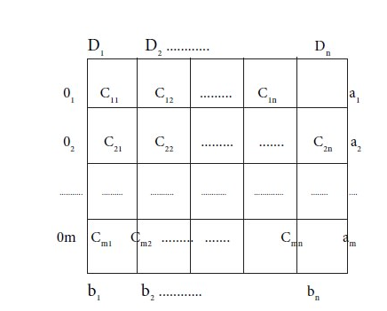

**Figure 6: Transportation Matrix**

**(Source:.brainkart.com)**

In the above figure it is shown the origin (O), the destination (D), the demand (a), and the corresponding cost (b). By solving the linear transportation problem with the North West Corner rules or MODI framework, the company may estimate a good revenue from the transportation for the relative supply chain required for the manufacturing operation.

## Modern Technology and Green Supply Chain Management

Supplier selection is one of the major phases in managing the supply chain. The company may adopt the MCDM framework (Multi-Criteria Decision Making Model) with the AHP model ( Analytical Hierarchy Model) in order to select the suppliers and award them the bid for the respective manufacturing operation. The two major scales that must be taken while taking the decision are cost and Quality. The AHP model is based on the priority of the objective as per the AHP matrix (Shahnazari *et al.*, 2020).

Green Supply Chain Management and such principles are quite challenging for the company to take. The relevant suppliers are very few in this case. The company may use the hybrid model for the power generation in the manufacturing unit (Renewable and conventional)

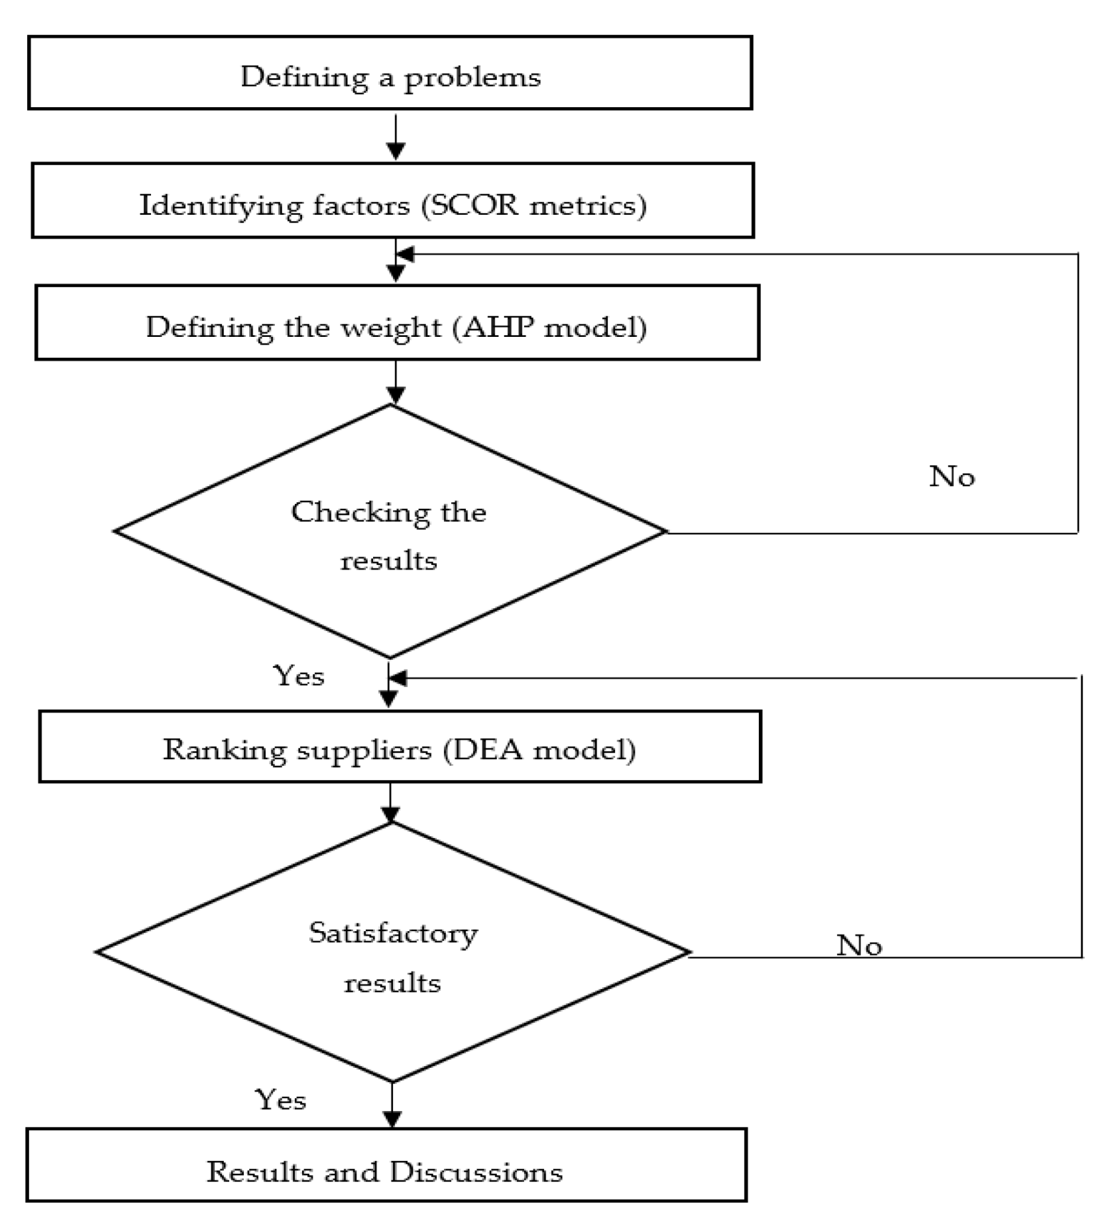

**Figure 7:MCDM Model**

**(Source: Wang *et al*.,2020)**

# Conclusion

The CNH Industrial marks an enormous play role for decades in serving millions of customers throughout the globe. There are possible risks in the existing supply chain management for the company especially in business forecasting, transportation & warehouse management, and GSCM. The company may adopt a more effective model for the overall evaluation of its existing supply chain to get better output from the manufacturing unit. Seasonal forecasting, EOQ inventory management, MODI framework in transportation and the MCDM model for the selection of suppliers are some of the effective models for managing the supply chain.

# References

Abdel-Baset, M., Chang, V. and Gamal, A., 2019. Evaluation of the green supply chain management practices: A novel neutrosophic approach. Computers in Industry, 108(1), pp.210-220.

Can Saglam, Y., Yildiz Çankaya, S. and Sezen, B., 2021. Proactive risk mitigation strategies and supply chain risk management performance: an empirical analysis for manufacturing firms in Turkey. Journal of Manufacturing Technology Management, 32(6), pp.1224-1244.

Fauziah, I., Rizki, M., Hartati, M., Nazaruddin, N., Lubis, F.S. and Nohirza, F.L., 2022. Market Basket Analysis with Equivalence Class Transformation Algorithm (ECLAT) For Inventory Management Using Economic Order Quantity (EOQ).

(cnhindustrial.com,2023) available at

https://assets.cnhindustrial.com/casece/nafta/assets/Resources/News/2021/Q1/Annual%20Report/Annual-Report-Forecast-2021.pdf

Shahnazari, A., Rafiee, M., Rohani, A., Nagar, B.B., Ebrahiminik, M.A. and Aghkhani, M.H., 2020. Identification of effective factors to select energy recovery technologies from municipal solid waste using multi-criteria decision making (MCDM): A review of thermochemical technologies. Sustainable energy technologies and assessments, 40, p.100737.

Smith, A.D., 2019. JIT Inventory Management Strategy. In Handbook of Research on Transdisciplinary Knowledge Generation (pp. 57-74). IGI Global.

Wang, C.-N.; Tsai, H.-T.; Ho, T.-P.; Nguyen, V.-T.; Huang, Y.-F.,2020 Multi-Criteria Decision Making (MCDM) Model for Supplier Evaluation and Selection for Oil Production Projects in Vietnam. Processes 2020, 8, 134. <https://doi.org/10.3390/pr8020134>