**INTERNATIONAL MARKETING**

# 

**Table of Contents**

Part A 2

Introduction 2

Background of the organisation and brief overview of the product 2

Market expansion opportunities in two countries from the domestic one 2

Critical analysis using the Hofstede model 3

Part B: 5

Macro-market analysis 5

Substantive segmentation analysis 8

Challenges and opportunities 9

Critical recommendations 9

Conclusion 10

Reference list 11

# Part A

# Introduction

Global expansion is considered to be a significant growth strategy of an organisation that assists them to expand their business operations outside of the domestic market. The basic importance of international market expansion can be observed in the process of bringing new sources of revenue within an organisation to enhance capitalisation. It is also beneficial to enrich the customer base and at the same time increase profitability. In regard to this, the report is highlighting the factors that can bring significant changes in the market expansion of *Starbucks* in *Italy* and in many more cities in *Africa*. An overall macro analysis is going to be done that can help to know about the environment of the targeted countries.

# Background of the organisation and brief overview of the product

*Starbucks Corporation* is known to be an American multinational coffeehouse chain which is the largest coffeehouse chain in the world. It has been observed that the organisation has 33,833 stores in almost 80 countries internally, among which 15,444 are located in the United States (Starbucks Stories, 2023). In everything they do, the organisation is seen to be dedicated to their mission, where they are working for nurturing the limitless possibilities of human connection, with every cup of coffee and with every conversation.

Taking from farmers to the master rooster who is able to coax the best from each coffee bean, the organisation is really committed to reaching the highest standards of providing quality services. They are seen to embrace their heritage while using innovative ideas that are reflected in their food, drinks and stores to serve new ways to the customers. The attractive menus of the firm are able to attract a wide range of customers into the business along with the introduction of the latest kinds of Starbucks stores that are connecting people throughout the world.

# Market expansion opportunities in two countries from the domestic one

The coffee beverage market in Italy is expected to grow annually by 2.54% by the end of 2025. In addition to this, information also highlights the fact that the overall revenue generated by the coffee market is amounting approximately to US $13.39bn in the year 2023 (*Statista*, 2022). The increased personalisation within the overall coffee industry of the country such as high-quality coffee pods and capsules, ground coffee and many more are adding to the growth. Additionally, Italians have a robust coffee-drinking culture from the coffee shops that are locally situated. It can be quite beneficial for Starbucks to have significant opportunities to position itself with its variety of items in the Italian market.

On the other hand, the beverages market in Africa has reached US$289.90m in the year 2023 and the overall revenue has increased to 19.90% (*Statista*, 2022). This has resulted in a projected market volume of US$599.20m by the end of 2027 and can be regarded as an influencing factor for Starbucks' business. Countries like Ethiopia and Algeria are considered to be the biggest coffee consumers in the African continent where Starbucks can flourish.

# Critical analysis using the Hofstede model

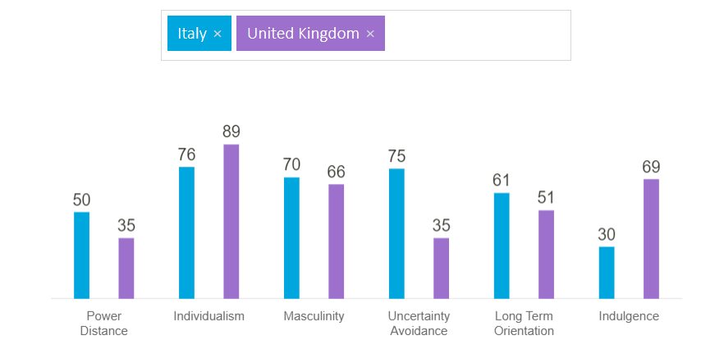

**Figure 1: Hofstede Diagram 1**

(Source: Hofstede Insights, 2023)

The power distance, Between the two countries, shows that the inequalities among the people in the UK are seen to be minimised. On the other hand, Italy tends to prefer decentralisation of power and decision-making. This particular diagram has also been able to find out that the Italian younger generation is disliking control and formal supervision. Starbucks in the process of expanding their business in Italy needs to provide a proper focus on maintaining equality while doing business decision making. In addition to this, in the case of individualism, it has been seen in UK society that the 89 score represents that the British are highly individualistic and private people (Lamb *et al*., 2020). They specifically find happiness in the process of fulfilling personal requirements. A similar pattern can also be observed in Italian society where culture is ‘me’ centred. For the Italian population having their own personal views, and objectives is regarded to be very motivating to achieve success. The mentioned organisation should not have to put that much focus on the process of maintaining individuality as they are already habituated to this. A masculinity score of 66 depicts the fact that UK society is highly success-driven and the people are having a clear performance ambition (Thakur, 2021). The same trend can also be followed in Italian society where success is considered to be a status symbol for the population. They love to flaunt their car, house and their luxurious lifestyles which can be beneficial for Starbucks for their business. The lower score in the UA portrays the fact that the people of the UK are comfortable in an ambiguous situation. The highest score in the UA says that Italian people respect formality. A combination of higher masculinity and higher UA the life of the Italian people is really stressful which can be an issue for the mentioned business. The intermediate score of the LTO dimension represents that it is difficult to determine the preferences of British culture. On the other hand, Italian culture is pragmatic where the people believe that truth depends on particular situations, time and context. They have a tendency of saving and investing tactfully. Additionally, the lower score in the indulgence shows that Italian culture is restrained, that does not put that much emphasis on enjoying leisure time. This in contrast quite opposite from British culture has given a larger focus on Having fun and enjoying life.

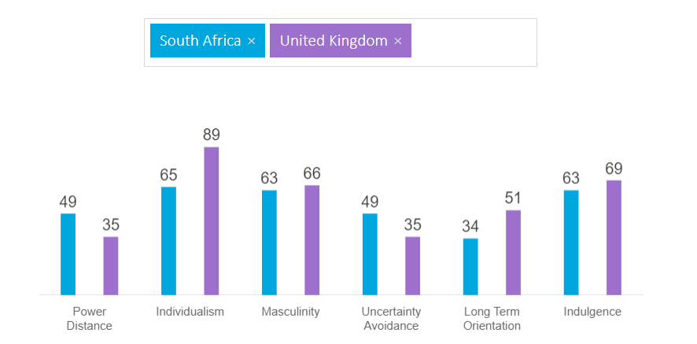

**Figure 1: Hofstede Diagram 2**

(Source: Hofstede Insights, 2023)

PDI score 35 depicts the fact that UK society does not believe in inequalities and the focus has also been given to reducing the inequalities among the people. On the other hand, African society believes in hierarchy in order that can be reflected in creating inequalities and centralisation. Additionally, Africa is also known to be an individual society where higher preferences have been given to individuals which can create issues in employer-employee relationships. A kind of similar approach can be observed in British society as well where individuals get primary importance. Masculinity is preferred in the UK society where people leave and work to be successful. Southern Africa is also known to be a masculine society, where preferences have been given to performance and competition (Bhana *et al.*, 2021. Additionally, SA has lower preferences in avoiding uncertainties and people believe in rules, whereas the British are comfortable with ambiguous situations.

# Part B:

# Macro-market analysis

***PESTLE of Italy***

|  |  |
| --- | --- |
| **Political factors** | * The stable and strong democratic system of Italy. * The alliances with the EU, NTO and many more. * Maintaining good relations with other countries. * Covid 19 has been able to bring threats to the beverage industry. |
| **Economical factors** | * The GDP of the country is 2.01 trillion US dollars which is increasing. * The total revenue of the beverage market has amounted to 22.1 billion euros (Ozbun, 2022). * The inflation rate has fallen to 7.6% in March 2023 (Italy Inflation Rate, 2023). * The tourism industry of the country can be helpful for the mentioned business. |
| **Social factors** | * Younger generations are influenced by the cafe culture. * Racial discrimination can be seen. * The increasing rate of old age people can be an issue. * Italians are seen to be addicted towards coffee (Samoggia *et al.*, 2020). |
| **Technological factors** | * It falls under the top four technologically upgraded countries of Europe. * Innovations are being embraced by businesses. |
| **Legal factors** | * Difficulties can be seen for the foreign business to enter. * Employees can enjoy statutory payment rights. |
| **Environmental factors** | * The scarcity of natural resources and the packaging of products create significant issuers. * Waste management is being done by the government. |

***PESTLE of Africa***

|  |  |
| --- | --- |
| **Political factors** | * The instability of the political environment can be seen in Africa. * These are responsible for the slowdown of economic success. * The pandemic has created disruption in the political environment. |
| **Economical factors** | * The GDP of the country has been estimated at 3.1 trillion US dollars (Etim and Daramola 2020). * The volume of the hot beverage market is expected to amount to 1.78bn by the end of 2025. * Sudan, Zimbabwe and Ethiopia have the highest inflation rate (Archibong *et al.*, 2021). * Well-developed financial system and enhanced FDI. |
| **Social factors** | * The unemployment rate is higher which is 30% (Francis and Webster 2019). * The coffee consumption rate is high in Ethiopia and Algeria. * Although the majority of the population opted for tea for being cheaper. * Some are really wanting freshly brewed coffee. * New generations are loving to socialise outside. |
| **Technological factors** | * The country is rapidly growing in using technology. * Government investment can be seen in technology and innovation. |
| **Legal factors** | * Encouraging Foreign Direct Investments. * The Employment Equity Act of 1998 is promoting equal opportunities in workplaces (Mayer *et al.*, 2019). |
| **Environmental factors** | * Holiday destinations in the country are adding to the economy. * A lack of strategies for waste management and pollution can be noticed. |

# Substantive segmentation analysis

***Segmenting***

The segmentation of this business can be done by a classification of coffee by caffeinated and decaffeinated coffee. In addition to this, the focus is also going to be given to providing coffee in the form of whole beans and ground coffee. The population can be segmented by giving a special focus on the demography and psychographic of the population. In the UK, it has been seen that the segmentation has been done based on the behavioural and psychographic features of the consumers (Liu *et al*., 2019). By giving special emphasis on demography in a better way, it can be easy to reach a greater number of the population.

***Targeting***

For expanding the business the focus can be given on targeting the younger male and female population of the countries starting from the age of 18-30. In addition to this, working professionals with higher incomes are also going to be targeted. Based on the fact that the younger population of both countries are much more interested in socialisation in public places. The focus is also going to be given to utilising online platforms more, to attract the targeted population with the help of attractive content (Leung *et al.*, 2022). It has been observed that the brand has given importance to middle to higher-income employees who are looking for premium quality products. In new countries, giving special focus to the younger population can be helpful to enrich the customer base.

***Positioning***

While doing proper positioning of the product, the focus is going to be given to adding more plant-based food items in their offered items, which can help to attract a health-conscious younger population effectively (Beacom *et al*., 2021). In addition to this, the emphasis is also going to be given to adding organic filter coffee in their used coffee materials in their products. Furthermore, making the price of the product cost-effective is also taken to be another important part of the positioning of the product.

# Challenges and opportunities

The challenges can be seen in meeting the regulatory guidelines of entering into a new country and flourishing business for Starbucks. The higher inflation rate of Italy can be taken to be a significant challenge for Starbucks in the process of getting customers. Besides, the impact of the pandemic on the economic situations of countries is also regarded to be another crucial issue for the firm in order to do business. The organisation is also going to be affected by the foreign exchange rates while doing international trade.

The increasing rate of the GDP of both countries is considered to be an important opportunity for the firm. In addition to this, the fallen rate of inflation in Africa can help businesses to flourish. The upgrading younger generation of both countries can be targeted well by providing healthy beverages which are attractive and delicious at the same time. Apart from that., technological upgradation and the use of innovation can also assist the organisation in a better way.

# Critical recommendations

* The organisation should give focus on enhancing cultural mindfulness that can help them to do business internationally.
* Doing proper market research before expanding into a new market is also needed for the firm which can help them to know about the market scenario.
* Giving more emphasis on using organic food items can also help them to get a competitive advantage and sustainability in a new land.
* Developing partnerships with local beverage organisations can be beneficial for them to enrich their customer base in a new country.
* Maintaining strong brand integrity and developing cost-effective products are also important for them to target a wide range of population.

# Conclusion

Based on the overall information that has been provided, it has been easy to identify significant factors related to the internal market expansion and its advantages. In the process of conducting this study, Starbucks has been taken to expand their market in Italy and Africa. Making the expansion process easy and finding out different factors related to the external environment an overall analysis has been done. In addition to this, the STP model has been used to do proper positioning the business in the target countries. Apart from that, some of the effective recommendations have also been provided to Starbucks for future development.

# 

# Reference list

Archibong, B., Coulibaly, B. and Okonjo-Iweala, N., 2021. Washington consensus reforms and lessons for economic performance in Sub-Saharan Africa. *Journal of Economic Perspectives*, *35*(3), pp.133-156.

Beacom, E., Bogue, J. and Repar, L., 2021. Market-oriented development of plant-based food and beverage products: A usage segmentation approach. *Journal of Food Products Marketing*, *27*(4), pp.204-222.

Bhana, D., Janak, R., Pillay, D. and Ramrathan, L., 2021. Masculinity and violence: Gender, poverty and culture in a rural primary school in South Africa. *International Journal of Educational Development*, *87*, p.102509.

*Coffee - Italy: Statista market forecast* 2022, *Statista*. Available at: <https://www.statista.com/outlook/cmo/hot-drinks/coffee/italy> (Accessed: April 28, 2023).

*Country comparison* 2023, *Hofstede Insights*. Available at: https://www.hofstede-insights.com/country-comparison/south-africa,the-uk/ (Accessed: April 28, 2023).

Etim, E. and Daramola, O., 2020. The informal sector and economic growth of South Africa and Nigeria: A comparative systematic review. *Journal of Open Innovation: Technology, Market, and Complexity*, *6*(4), p.134.

Francis, D. and Webster, E., 2019. Poverty and inequality in South Africa: Critical reflections. *Development Southern Africa*, *36*(6), pp.788-802.

Italy inflation RateMarch 2023 data - 1962-2022 historical - April forecast (no date) Italy Inflation Rate - March 2023 Data - 1962-2022 Historical - April Forecast. Available at: <https://tradingeconomics.com/italy/inflation-cpi> (Accessed: April 28, 2023).

Lamb, Y., Cai, W. and McKenna, B., 2020. Exploring the complexity of the individualistic culture through social exchange in online reviews. *International Journal of Information Management*, *54*, p.102198.

Leung, F.F., Gu, F.F. and Palmatier, R.W., 2022. Online influencer marketing. *Journal of the Academy of Marketing Science*, pp.1-26.

Liu, H., Huang, Y., Wang, Z., Liu, K., Hu, X. and Wang, W., 2019. Personality or value: A comparative study of psychographic segmentation based on an online review enhanced recommender system. *Applied Sciences*, *9*(10), p.1992.

Mayer, C.H., Oosthuizen, R.M. and Tonelli, L., 2019. Subjective experiences of employment equity in South African organisations. *SA Journal of Human Resource Management*, *17*(1), pp.1-12.

Newest Starbucks menu items, Drinks & Food 2023, Starbucks Stories. Available at: <https://stories.starbucks.com/stories/beverages-food> (Accessed: April 28, 2023).

Ozbun, T. 2022 *Italy: Beverage Industry Revenue 2019, by sector*, *Statista*. Available at: <https://www.statista.com/statistics/531633/turnover-of-the-italy-beverage-industry-by-sector/>(Accessed: April 28, 2023).

Samoggia, A., Del Prete, M. and Argenti, C., 2020. Functional needs, emotions, and perceptions of coffee consumers and non-consumers. *Sustainability*, *12*(14), p.5694.

Thakur, A., 2021. Cultural Impact on Global Trade. In *Handbook of Research on the Empirical Aspects of Strategic Trade Negotiations and Management* (pp. 196-210). IGI Global.