**MARKETING & INNOVATION**

**Executive summary**

This respective report revolves around the organization Unilever and discusses the marketing positioning, industry overview, and competitors of the company.

The market segmentation suggests that geographical, demographic and psychographicsegmentation is used by Unilever in order to effectively target its product across different groups of consumers in various markets on a global level.

Unilever uses this segmentation approach to operate over multiple segments which includes home care, personal care and refreshments.

The pestle analysis has been included in this report in order to analyse the market of the UK in which the company Unilever operates.

The key innovative strategies and activities of the company have also been discussed in this particular report. The recommendations and suggestions for the organization to improve the managing process of limited resources have also been evaluated in this report.

**Table of Contents**

Introduction 4

Market analysis 4

Marketing segmentation 7

Innovation in Marketing 9

Strategic marketing 10

Conclusion 12

Reference list 14

# Introduction

A marketing strategy plan is known to be a document that helps in explaining the ways in which a business intends to reach and convert its potential audiences and customers into loyal buyers towards the products or services. An appropriate and effective marketing strategy plan includes the unique core brand message, value proposition, target market data, and other high-level elements of the organization (Ferrell *et al*. 2021). A marketing strategy plan also helps in providing a long-term and effective vision for the overall direction of the marketing efforts, while a marketing plan of the business outlines the ways in which those efforts will be executed within a certain time period or duration. A marketing strategy plays a vital and important role as it helps a business to achieve and communicate a sustainable competitive advantage (SCA) over various rival competitor companies with the help of understanding the wants and needs of its consumers. This respective report shall revolve around the business that has a strong presence in the UK market that is Unilever. The report shall focus on the innovative strengths of the chosen organization, which ultimately results in a sustainable competitive advantage for the business.

# Market analysis

|  |  |
| --- | --- |
| **Political** | **Economic** |
| * Modern parliamentary democracy and constitutional monarchy * Four dominant political parties: Conservative, Labour, Liberal, Democrats, and Scottish Nationalist Party * Brexit has created uncertainties and opportunities for the UK * Good relations with the US and other countries, but criticized for dealing with some authoritarian regimes * Rise in crimes and violence in the country | * World's sixth-largest economy by nominal GDP * An extremely advanced, market-based economy * significant impact on global trade * One of the world's top financial hubs is London. * Impacted by the COVID-19 pandemic-related worldwide lockdowns (Unilever, 2023) * The economy has begun to recover more quickly than anticipated. |
| **Social** | **Technological** |
| * Large customer base * The population is currently above 68.7 million. * By 2039, the population is projected to total 74 million. * Diverse and multicultural society * High social standards and quality of life * Health consciousness and environmental awareness are increasing * Career attitudes and work-life balance are changing | * New technologies are continually emerging, such as robotics and artificial intelligence * The rate of change is increasing * High level of innovation and research * Strong digital infrastructure and e-commerce sector * Government support for technological development and digital transformation * Slow technological development in comparison to the US (Ullah, 2021) |
| **Legal** | **Environmental** |
| * Climate change and the requirement to use sustainable resources * The importance of ethical sourcing and supply chain intelligence * The government's promise to “cut greenhouse gas emissions by 78% by 2035 compared to 1990 levels” poses hazards to the environment and public health as a result of pandemics and other calamities. * utilization of electric cars and alternative energy sources is rising (Christodoulou and Cullinane, 2019) | * Legislative changes that have an effect on import/export restrictions, taxation, and employment * Compliance with EU laws and regulations after Brexit * Protection of intellectual property rights and data privacy * Enforcement of anti-trust and anti-monopoly laws * [Promotion of human rights and social justice](https://www.cipd.co.uk/knowledge/strategy/organisational-development/pestle-analysis-factsheet) |

**Analysis** - Based on the PESTLE analysis. It has been identified that the consumer goods industry of the UK is highly dynamic and competitive, influenced by different types of external factors such as income levels, consumer preferences, environmental concerns, regulatory changes and technological innovations. The chosen organization, Unilever, operates in the consumer goods industry, which mainly covers a wide range of goods and products such as personal care, food and beverages, household care, pet care and many more (Laursen and Andersen, 2023). According to the ONS, the overall value of retail sales in the UK was £446.8 billion in the year 2020, which shows a decrease of 1.3% as compared with the last year's sales of 2019.

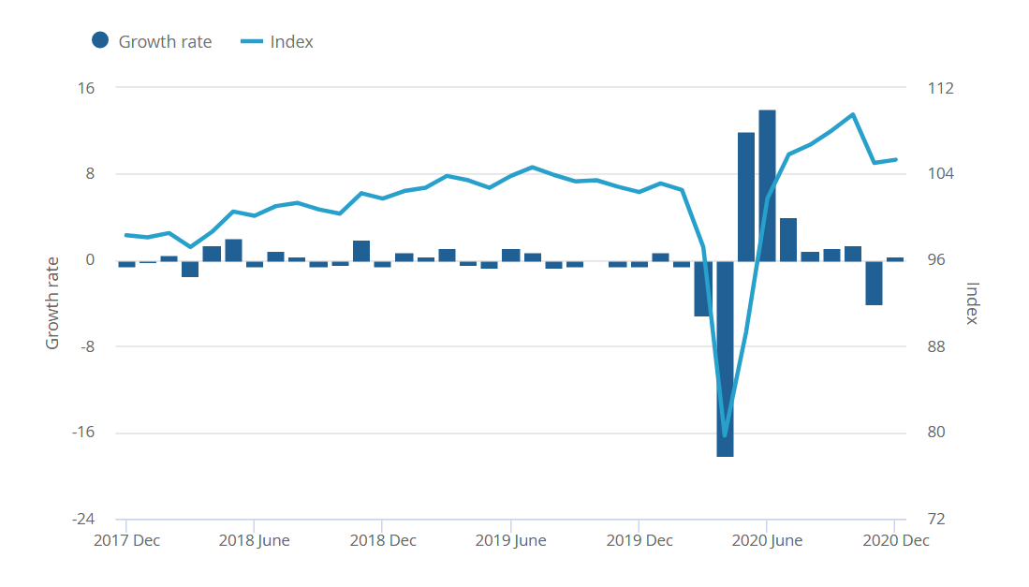

**Figure:** Retail sales in the UK

(Source: Retail sales, 2020)

Unilever is known to be one of the leading players in the global consumer goods industry of the UK, with over 400 brands across various categories such as beauty and personal care, pet care, food and beverages and others. Unilever’s main competitors in the industry include Nestlé, Coca-Cola, Procter & Gamble (P&G), PepsiCo, General Mills, Kraft Heinz, Kellogg’s and many more (Reza, 2020). Each competitor of the business has its own strengths and limitations in terms of market share, product portfolio, innovation capability, geographic presence, and others. It has also been evaluated that the market position of Unilever in the consumer goods industry varies depending on the category as well as on the region. For example, Unilever is known to be the global leader in beauty and personal care products with a 10% market share in the year 2020.

# Marketing segmentation

The global consumer goods company, Unilever, operates over ***multiple segments*** which include home care, personal care and refreshments amongst other categories. The market segmentation of the company depends upon product category and is also variable across the regions that it operates in (Reza, 2020). Hence, the positioning, target and segmentation approach depends upon the range of products and different customers to whom the products appeal to

**Personal Care**

The personal care category of the company has been segmented based on factors like ***Lifestyle, Gender and Age***. Unilever offers a range of products in the context of personal care items under various brands such as Tresemme, Axe, Dove and numerous other brands. An example of segmentation of its personal care range includes the way in which Unilever ensures that the Dove brand is targeted towards female customers of all ages who are in search of nourishing and gentle products for their hair and skin, however, a product like Axe is targeted towards young men who are in search for products that would help them feel more attractive and confident (Tien, 2019).

**Home care**

The company has segmented the market based on home care factors that include product ***usage and geography.*** There is a wide range of products that Unilever offers in terms of home care products such as fabrics softeners, laundry detergents and household cleaners which come under several brands such as Domestos, Comfort, Surf and numerous other brands (Mazikana, 2023). The way in which the markets have been segregated and segmented can be explained through the example where Unilever uses the brand Surf to target consumers who are looking for effective and affordable laundry detergents in emerging market economies, however, the company has targeted the brand Comfort towards consumers who are looking for fabric softeners that are of premium quality and these customers belong to developed market economies.

**Foods**

In the context of market segmentation for food-based markets, there are several factors such as ***lifestyle, age and geography*** which the company considers. Unilever has offered a range of food products such as soups, tea, ice cream and numerous other products under several brands like Lipton, Ben and Jerry, Knorr and numerous others brands (Laursen and Andersen, 2023). The way in which the company has targeted customers can be explained through the example of the brand Ben and Jerry which is targeted at young adults who are in search of indulgent and premium ice cream products. However, the brand Lipton has been targeted by the company towards consumers who are health conscious and are looking for sustainable and natural tea products.

**Refreshments**

The company has used its segmentation approach in the refreshment market based on factors like ***occasion, age and geography.*** There are several different options in the range of refreshments that the company offers such as soft drinks, coffee, tea and more under different brands like Lipton iced tea, PG Tips, Lipton and numerous other brands. The target and segmentation approach can be explained in the way the company has targeted the brand Lipton ice tea towards young adults who are looking for low-calorie and refreshing beverages (Reza, 2020). On the other hand, a product like PG Tips is a brand that targets older customers that are looking for authentic and traditional tea products.

It is observed from the analysis of market segmentation by the company that a combination of ***geographical, demographic and psychographic*** segmentation is used by Unilever in order to effectively target its product across different groups of consumers in various markets on a global level. Unilever uses this segmentation approach to operate over multiple segments which includes home care, personal care and refreshments (Tien, 2019). The market segmentation of the company depends upon product category and is also variable across the regions that it operates in. Hence, the positioning, target and segmentation approach depends upon the range of products and different customers to whom the products appeal.

# Innovation in marketing

Unilever is known to be an organization which mainly strives to innovate for consumers and the planet, with the help of using world-class technology and science in order to create superior products that are kind and effective to the society and environment. Unilever leverages various types of innovation drivers for the purpose of achieving sustainable competitive advantage (SCA) in the consumer goods industry of the UK and other markets. Unilever’s key innovation activities that result in sustainable competitive advantage (SCA) are those that mainly help in creating value for its society, customers, and the planet while differentiating its goods and products from its several competitors (Iglesias *et al.* 2023). Unilever uses various innovation drivers, such as service innovation, product innovation, and business model innovation, in order to achieve its innovation goals effectively and efficiently. Some of these drivers are discussed below:

**Product innovation** - Unilever focuses on developing new products or improving existing ones in order to meet the changing preferences and needs of its consumers. For example, Unilever launched a new brand of hair and skin care products that is Love Beauty and Planet, the products of this brand are cruelty-free, vegan, and made with ethically sourced ingredients. The brand also uses 100% recycled plastic bottles and aims to reduce the overall carbon footprint of the business by 20% by the year 2020. Another example is that the company introduced plant-based meat alternatives, such as De Vegetarische Slager and The Vegetarian Butcher, which offer consumers more choices for healthy and sustainable diets.

**Service innovation** - The organization enhances its services or creates new ones in order to add more value to its products and customers. For example, Unilever partnered with Loop, which is a circular shopping platform that delivers products in reusable packaging and collects them after use for refilling and cleaning. This service helps the company Unilever, in reducing plastic waste and offers an eco-friendly and convenient solution to its various consumers. Another example is Unilever's Shampoo Bar Salon, which is a pop-up store in London that mainly offers customers personalized shampoo bars that are made with natural ingredients and minimal packaging.

**Business model innovation** - Unilever focuses on transforming its business model or creating new ones for the purpose of capturing new markets or increasing overall profitability, efficiency and productivity. For example, Unilever acquired Dollar Shave Club, which is a known to be online subscription service that mainly delivers razors and grooming goods and products to various customers' doors (Lieu *et al.* 2021). This respective acquisition helped the company Unilever, to enter the fast-growing online shaving market and helps in accessing valuable consumer data and insights. Another example is Unilever's AI Hub in Shanghai, in which the company uses real-time data in order to prototype innovations and test with the help of e-commerce in just a matter of days.

These different innovation drivers help the organization Unilever to differentiate itself from its other rivals and competitors and contribute towards creating SCA through the help of delivering superior value to its society, consumers, and the planet. This also helps Unilever in alignment with its purpose of making sustainable living commonplace.

# Strategic marketing

Unilever faces the challenge and issues of managing its limited resources in a dynamic and competitive market while pursuing its vision of making sustainable living commonplace. In order to achieve this, Unilever needs to allocate its various resources strategically to different drivers of innovation, different channels of the business, and different target markets. One possible strategy for Unilever to manage its limited resource allocation is by using the **portfolio approach**, which involves the process of balancing the trade-offs between short-term and long-term goals, risk and return, and core and non-core activities (Ullah, 2021). A portfolio approach would require Unilever to allocate its resources based on the potential impact and value of each innovation activity, as well as the cost and feasibility which can occur while implementing it. During the adaptation of the portfolio approach, Unilever would need to consider various factors such as market trends and opportunities, consumer needs and preferences, competitive advantages and threats, technological developments, environmental and social challenges, and disruptions (Reza, 2020). The effective and appropriate portfolio approach would enable Unilever to align its innovation activities with its various strategic priorities and choices, such as building a high-growth portfolio across the different business groups such as Beauty and well-being, Personal Care and many more. The portfolio approach will also allow Unilever to minimise its risks, maximise its opportunities, and optimize its various returns on investment. Another strategy which the organization can use is a **balanced scorecard.**

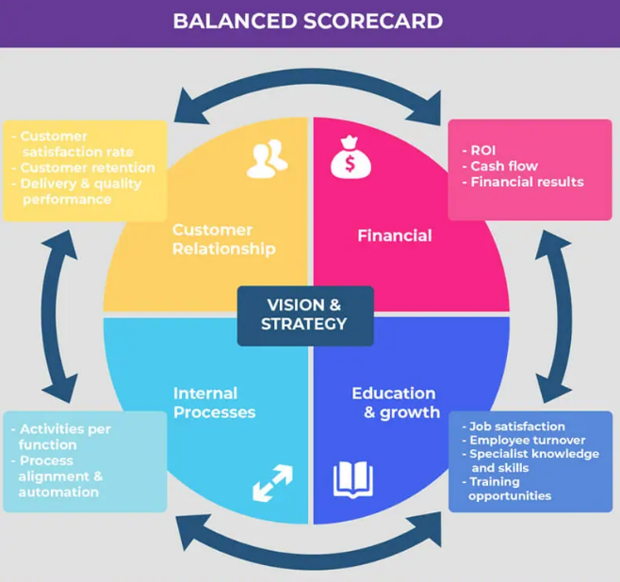

**Figure:** The tool of Balanced scorecard

(Source: Balanced Scorecard, 2018)

A balanced scorecard is known as the tool that helps businesses align their limited resources with their strategic objectives across four different perspectives that is customer, financial, internal process, and learning and growth. The tool of a balanced scorecard can help the organization Unilever in allocating its various limited resources to different channels of the business, different drivers of innovation, and different target markets in a way that helps in maximizing its value creation as well as a competitive advantage (Laursen and Andersen, 2023). Organization Unilever can use the tool of a balanced scorecard in the following ways:

* Allocating more resources to product innovation in emerging markets, where there is a chance and opportunity for higher consumer demand and growth potential for new and affordable products. This can help the company in increasing its overall revenue and market share in these regions.
* Allocating more resources to service innovation in developed markets, where there is a high level of consumer expectation and competition for value-added services. This can help the company in enhancing its customer loyalty and satisfaction in these regions.
* Allocating more and more resources to business model innovation across all markets, where there is a need for adapting to environmental challenges and changing consumer preferences. This can help the business to differentiate itself from its different rivals and competitors and achieve its sustainability goals without facing any kind of challenges or barriers (Ullah, 2021).

By using the balanced scorecard as well as portfolio approach, Unilever can justify its resource allocation decisions based on the expected outcomes, results and impacts on its customer value proposition, financial performance, operational efficiency, and organizational learning and growth.

# Conclusion

According to the information and detail presented in the above section, it has been identified that this respective report focuses on the marketing strategy plan. This report highlights the organization Unilever which is known to be one of the businesses which have a strong presence in the UK market. The report included a market analysis of the UK using pestle analysis and discussed and analyzed in detail the industry overview, market position, and competitors of Unilever. The report helps in understanding a deep knowledge regarding the market segmentation, targeting and positioning strategy of Unilever by including a piece of information on market research and an in-depth understanding of different sub-target markets. The different key innovative strategies and activities followed by Unilever which have helped the company in achieving a sustainable competitive advantage have also been discussed in this respective report. The innovation activities and strategies of the organization have been elaborated using the different innovative drivers such as product, business model, and service innovation. The report also consists of recommendations for the organization such as a portfolio approach as well as a balanced score in order to manage and handle the various limited resources of the company.

# Reference list

Balanced scorecard, 2018. Available at: https://www.founderjar.com/key-performance-indicator-kpi/

Christodoulou, A. and Cullinane, K., 2019. Identifying the main opportunities and challenges from the implementation of a port energy management system: A SWOT/PESTLE analysis. *Sustainability*, *11*(21), p.6046.

Ferrell, O.C., Hartline, M. and Hochstein, B.W., 2021. *Marketing strategy*. Cengage Learning.

https://www.ons.gov.uk/businessindustryandtrade/retailindustry/bulletins/retailsales/december2020

Iglesias, O., Mingione, M., Ind, N. and Markovic, S., 2023. How to build a conscientious corporate brand together with business partners: A case study of Unilever. *Industrial Marketing Management*, *109*, pp.1-13.

Laursen, L.N. and Andersen, P.H., 2023. Resource and supplier interaction in network innovation governance: The case of innovating at Unilever. *Journal of Business Research*, *156*, p.113465.

Laursen, L.N. and Andersen, P.H., 2023. Resource and supplier interaction in network innovation governance: The case of innovating at Unilever. *Journal of Business Research*, *156*, p.113465.

Lieu, P.T.H., Arunjit, N., Buapradabkul, S. and Nathaniel, D., 2021. Unilever Company Strategic Business Analysis.

Mazikana, A.T., 2023. Significance of Social Factors in the Marketing of Fast-Moving Consumer Goods. A Case of Unilever. *A Case of Unilever (March 7, 2023)*.

Retail sales, 2020. Available at:

Reza, M.H., 2020. Marketing Strategy and Sustainable Plan of Unilever.

Reza, M.H., 2020. Marketing Strategy and Sustainable Plan of Unilever.

Tien, N.H., 2019. Comparative Analysis of Multidomestic Strategy of P&G and Unilever Corporation. *International journal of foreign trade and international business*, *1*(1), pp.5-8.

Ullah, N., 2021. A Comparative Analysis between Unilever and Johnson & Johnsons.

Unilever, 2023. Available at: <https://www.unileverusa.com/brands/>