**WORKPLACE HEALTH PORTFOLIO - WORKPLACE STRESS IMPACT ON EMPLOYEE HEALTH AND WORKPLACE PRODUCTIVITY**

Table of Contents

Introduction 3

Workplace health or theme 3

Current approach and management of this theme at the workplace 4

Current management approach and manage the issue in the workplace 4

Strengths and weakness of the current approach with examples and evidence 4

Identification of the relevant workplace policy and workplace stress about the legislation 5

Areas of delivery where the current approach could be improved 5

Identification of challenges of the approach and its improvement 6

Improvement 1: The greater emphasis on workplace wellness 6

Improvement 2: Increase in knowledge and skills of the employees - 7

Improvement 3: The reinvention of the organization's culture and leadership style - 8

Improvement 4: Providing leaves and remote working and flexible hours - 8

Improvement evaluation in the next six months 9

Evaluation plan 1: The greater emphasis on workplace wellness 9

Evaluation plan 2: Increase in knowledge and skills of the employees 9

Evaluation plan 3: The reinvention of the organization's culture and leadership style 10

Evaluation plan 4 : Provide better work-life balance 10

Conclusion 11

References 12

# Introduction

The workplace is the most important part of an organization. Employee health and safety have to be ensured by the organizational culture and the organizational policies framed for the employees. However in real-life circumstances very less is done for ensuring the health and well-being of the employees at the workplace. This leaves a huge gap between the regulations and policies for the organization and its implementation at the ground level. Workplace stress and its impact on employee well-being and employee stress will be discussed in this report. Based on the current approaches of the organization on this burning issue an evaluation plan will be prepared which will help solve the workplace stress and its effects on the employee health and the workplace productivity. The evaluation plan prepared in this report will also be the recommendation of the report after analyzing information about the issue. In the evaluation plan, the existing approaches will be improved to address the health-related issue of the employees due to work-related stress.

# Workplace health or theme

Workplace health is an issue when the employees are not able to match the expectation of the work or when the knowledge and capabilities of the employees are not enough to meet the demands of the workplace. These kinds of situations are common for employees in their day-to-day work lives. But the negativity at the workplace where the employees receive less support and cooperation to do the work the stress levels of the employees are enhanced which affects their mental health and their overall productivity (Rasool *et al.,* 2021). Due to bad work culture and effective leadership, the challenges related to the workplace sometimes convert into stress-generating issues for the employees which makes the employees feel helpless to do a certain challenging task.

In recent times with the advent of the new cutting-edge technology and communication medium the work at the workplace has entirely changed this has added to the stress levels of the employees. Companies are using AI, big data and machine learning at the workplace, however, the organizations are not making efforts to provide in-depth knowledge about the use of technology which segregates the employee completely and affects his efficiency at the workplace and also affects his mental health (Mazzola and Disselhorst 2019).

The insensitive leadership has made the employee give extra effort to achieve deadlines which has resulted in the burnout of the employees at the workplace. This has resulted in high stress on the employee to perform as per expectations (Bakker and de Vri 2021).

# Current approach and management of this theme at the workplace

## Current management approach and manage the issue in the workplace

Employee stress for performance enhancement and increased productivity has affected the employee's health adversely and employee performance (Daniel 2019). This also can be regarded as a big example of employees quitting their job by succumbing to job pressure (Kurniawaty *et al.,* 2019). Most organizations function with less workforce as their work culture and stress associated with them make employees quit the organizations.

The current organization has increasingly become aware of the issue that employee faces while carrying out their daily jobs. Most companies have designed their organizational cultures in such a way that the stress at work can be handled successfully. The organization is also carrying out different programs, and paying the employees necessary perks which will resolve the issues of stress in the employees. Companies in recent times have adopted a ***physiological approach*** to address stress-related issues at the workplace. The organization tries to ***arrange team meetings*** where efforts are made to burst the stress at the workplace. The organization also tries to arrange ***team lunches and outings*** which help in the increase of team relationships which will give rise to a culture based on trust and cooperation.

## Strengths and weakness of the current approach with examples and evidence

***Strengths***

This approach will help increase the trust among the employees and will give rise to a harmonious workplace which will generate less stress. The team meeting and outings will be able to develop cooperation between the employees which will reduce the fear in the minds of the employees about the challenges at the workplace. The organization practising good workplace policy will reduce the burden of work on the employees which will ultimately reduce the stress level of the employee.

***Weakness***

The current approach adopted is the physiological approach that does not understand the importance of employee well-being and its effect on the productivity of the employee at the workplace (de *et al.*, 2023). The current approach ignores the psychological effects that workplace stress can have on an individual employee. The current approach adopted by the organizations will not provide a solution to the issue. The change in the organization policies and the regulations have to be also changed which will address the stress of the employees at the workplace. The current approach of the organization does not focus on increasing the knowledge base of the employees on the issue will make the employees increase their efficiency and feel less stress due to the work assigned to them.

For example - According to Kantor *et al.,* (2019) the company culture of Amazon which is the largest E-commerce company is negative and expects the employees to perform at an extreme level in high-pressure situations which leads to the employees quitting their job.

## Identification of the relevant workplace policy and workplace stress about the legislation

Most companies have formulated policies such as ***care plans***, ***Employee wellness program policies, and safe and healthy workplace policies*** for employees facing stress. This policy provides benefits to the employees and their family members also free of cost. Most of the company promote health and well-being programs such as counselling, Yoga classes for their employees which help them to cope with their work-related stress issues. Companies try to promote and provide work-life balance to their employees which will help the employees to spend more time with their families which will act as a stress buster for the employees.

For example, the company of TCS( Tata consultancy services) framed its policies to provide work-life balance to its employees which has helped its employees to enjoy working from home during the time covid 19 which helped the employee to spread this time safely at home and also work organization at the same times.

Various organizations have framed policies to implement fitness programs which will help the employee to come out of their work and participate in such activities which will help them to get better engaged with the company.

## Areas of delivery where the current approach could be improved

***Area 1 -*** The organizations should try to provide personalized support to each of the employees with the help of counselling. The company should try to identify the challenges that each person is facing. and the stressing factor that is concerning the employees and trying to address the issue in a personalized way. It may be by providing accurate training to the employees or lessening the workload on the employee.

For example, if the organization feels that the stress is due to a lack of knowledge of certain tools for a particular employee, individual support and training can be given to increase his knowledge of the skills and reduce the stress for the individual employee.

***Area 2*** - Identification of the stressors in the organization will be an area in which the current approach of the organization towards stress management can be improved. The entities should try to study the business activity so that they will be able to find the reasons which are leading to stress creation in an organization. It may be due to a lack of workforce or lack of resources etc.

***Area 3*** - Establishing support for the employees facing stress-related health complications. A common point has to be established which will address the stress-related issues of the employees of an organization. The employee can approach the stress point in the organization without any fear of their concerns and queries (Sull *et al.,* 2020).

Area 4 - Establishing relationships and team building is also an area of delivery to which the organization should give more importance. As per the observation, there is a huge lack in the efforts of the organizations to create a workplace based on trust, cooperation and relationship building.

# Identification of challenges of the approach and its improvement

## Improvement 1: The greater emphasis on workplace wellness

Organizations are working for the achievement of the organizational goals and organizational deadlines and ignore the importance of the workplace wellness of the employee. The organization should establish a devoted table and wellness system which will help the organization to understand the stress-related complications each of the employees is facing. The employees should be encouraged to walk every day on the workplace premises, Gym facilities should be provided which will help the employees to indulge in fitness activities which will lead to physical wellness of the employees. Biweekly wellness programs and health checkups have to be implemented. This will help the employee to keep track of their health and also make efforts in the workplace for their physical well-being which will also lead to reduction of stress (Song and Baicker 2019). The organization can also build their regulations in such a way that will reduce the stress of the employees for example increase the leaves of the employees or providing proper maternity and paternity leaves to the employees. The organizations can also wellness webinars for increasing the awareness of the employees.

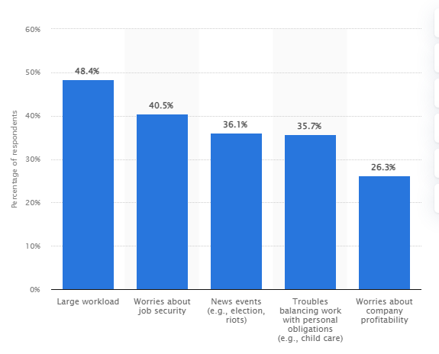

**Figure 1- The survey of U.S employees in 2021 about factors in workplace stress**

(Source - Statista.com)

A good workplace stress management wellness plan will address all the factors shown in the figure above and lead to better health for the employees.

## Improvement 2: Increase in knowledge and skills of the employees -

The organization should make continuous efforts to increase the knowledge and skills of the employees which will help the employees to increase their capabilities at the workplace. Such skills enhancement and knowledge enhancement classes have to be arranged at once every month which will be a big step for the organization to address the issue of workspace stress. This step will decrease the stress of the employees in terms of the work pressures and challenges and also will help increase the productivity and the efficiency of the employee at the workplace. Efforts should be made to provide technical skills which will help the employees to use the technology at the workplace effectively. The organization can also provide stress management classes to the employees which will increase the awareness of the employees and help them to handle the workplace stress in a better way (Kröll and Nües 2019). The company of Unilever conducted the training of the employees to inform them about Covid-19 and its implications on mental health in 10 languages (Unilever.com 2023.

## Improvement 3: The reinvention of the organization's culture and leadership style -

The current wellness plan of the organization regarding stress management has not been able to bear proper results as the companies have not understood in-depth the effects of workplace stress. Workplace stress leads to anxiety and fear and panic attacks in employees due to a negative work environment. Consequently, the organization should introspect about their organizational culture and leadership and find out if the organization's culture and the leadership decision-making have become a cause of serious mental health issues in the employees. After identification of the issue the organizations can try to redesign and reinvention the organization's culture and the leadership in such a way that workplace stress is addressed successfully. For example, the Nokia organizational culture led to employee disengagement and the loss of productivity in the organization (Laitinen and Mainela, 2019). This compelled the organization to complete the reinvention of the organizational structure in Nokia.

## Improvement 4: Providing leaves and remote working and flexible hours -

Organizations which are facing issues of stress at the workplace have to frame their policies and procedures keeping the employees at the central stage. The employee receiving proper care from the organization will put extra effort to accomplish the organization's goals. The organization and the leadership should trust the employees and provide flexible hours to complete a task as and when required. The employee should be provided with the required leaves to complete his duty by providing facilities such as paternity leave and maternity leave. The company should provide the opportunity to work remotely when the employee requires it as it will help the employee to reduce work stress by working from his home's comfort. This will help the employees to maintain their mental well-being and will also increase their efficiency at work. For a person working from home, the work can become a support mechanism instead of generating stress for the employee.

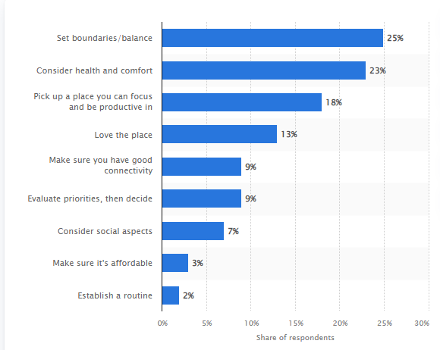

**Figure 2 - Survey for finding advice for employees working from Home**

(Source - Statista.com)

This survey shows that people can take care of their health in a work-from-home scenario.

# Improvement evaluation in the next six months

## Evaluation plan 1: The greater emphasis on workplace wellness

After 6 months, there will be a total difference in the workplace culture. After 6 months the company would have changed its perspective from earning profits to caring for the employees and achieving success with their support. The organization would have identified all the issues which are leading to stress at the workplace and addressed all the issues. A common dedicated Desk would be working which will work individually with all the employees and trying to address their issues and mental health at the workplace. After 6 months the company would have conducted fitness programs and fitness seminars and the employees working for the organization would be fitter and happier at the workplace.

## Evaluation plan 2: Increase in knowledge and skills of the employees

With the implementation of the improvement plan 2 the company would have conducted many classes on skill development and technical knowledge enhancement. The employees working for the organization are more skilled compared to 6 months back. The employees are facing fewer challenges at the workplace due to their increased skill levels. The employees working at the workplace will be more skilled and informed to handle skill-related health issues. The organization's culture will be more engaging for the employees which will be based on cooperation and trust among the employees. The employees would be more aware of the stress-coping activities that they can use. The employees will be aware of the relaxation techniques, stress management theories and time - management at the workplace (Bartlett *et al.*, 2021).

## Evaluation plan 3: The reinvention of the organization's culture and leadership style

This is one of the most important improvements made in this report. After 6 months of the implementation of the improvement plan, the organization will be changed and reinvented. The organization will be able to identify the stressors in the organization successfully and eliminate the stressor. The company would be making policies and regulations in an employee-centric way which will try to provide a safe and healthy work environment for the employees. The organization's culture and leadership will enhance harmony and cooperation in the organization which will result in a harmonious workplace. The organization will try to work to identify the issue faced by the organization and address them so that the employees facing the issue of stress will get the necessary support from the organization. The employees will be more engaged with the organization as their issues and concerns are addressed readily by the organization.

## Evaluation plan 4 : Provide better work-life balance

After the implementation of improvement plan 4, the organization would have employees who are much happier working with the organization as they are getting the leaves to address their issues also. The employees will be having a better work-life balance after the implementation of improvement 4 as the employees will be able to get the option to work from home as and when required. The employees' mental well-being would have increased. There will be a sense of psychological safety for the employees to work in the organization. As the organization takes care of the employees and their mental health by providing flexible working hours, remote working options and leaves for the employees as and when required.

# Conclusion

In this report, the workplace health issue of the employees is studied. Workplace stress and its implication on the employee's mental health are also studied. The mental health implications of workplace stress and its effect are studied in this report. The approach followed by the organizations in terms of stress management is studied and the improvement to the approach is suggested in this report. Based on the improvement plan an evaluation plan is prepared to study the implications of the improvements after some time.

# References

Bakker, A.B. and de Vries, J.D., 2021. Job Demands–Resources theory and self-regulation: New explanations and remedies for job burnout. *Anxiety, Stress, & Coping*, *34*(1), pp.1-21.

Bartlett, M.J., Arslan, F.N., Bankston, A. and Sarabipour, S., 2021. Ten simple rules to improve academic work–life balance. *PLoS Computational Biology*, *17*(7), p.e1009124.

Daniel, C.O., 2019. Effects of job stress on employee’s performance. *International Journal of Business, Management and Social Research*, *6*(2), pp.375-382.

de Oliveira, C., Saka, M., Bone, L. and Jacobs, R., 2023. The Role of Mental Health on Workplace Productivity: A Critical Review of the Literature. *Applied health economics and health policy*, *21*(2), pp.167-193.

Kantor, J., Weise, K. and Ashford, G., 2021. The Amazon that customers don’t see. *The New York Times*, *15*.

Kröll, C. and Nüesch, S., 2019. The effects of flexible work practices on employee attitudes: evidence from a large-scale panel study in Germany. *The International Journal of Human Resource Management*, *30*(9), pp.1505-1525.

Kurniawaty, K., Ramly, M. and Ramlawati, R., 2019. The effect of work environment, stress, and job satisfaction on employee turnover intention. *Management science letters*, *9*(6), pp.877-886.

Laitinen, R. and Mainela, T., 2019. Reemployment after structural change in an entrepreneurial ecosystem: capturing the reengagement experiences of Nokia’s ex-employees within Oulu area.

Mazzola, J.J. and Disselhorst, R., 2019. Should we be “challenging” employees?: A critical review and meta‐analysis of the challenge‐hindrance model of stress. *Journal of Organizational Behavior*, *40*(8), pp.949-961.

Rasool, S.F., Wang, M., Tang, M., Saeed, A. and Iqbal, J., 2021. How toxic workplace environment effects the employee engagement: The mediating role of organizational support and employee wellbeing. *International journal of environmental research and public health*, *18*(5), p.2294.

Song, Z. and Baicker, K., 2019. Effect of a workplace wellness program on employee health and economic outcomes: a randomized clinical trial. *Jama*, *321*(15), pp.1491-1501.

Statista. com,2023 Available at <https://www.statista.com/>

Unilever.com, 2023 Available at <https://www.unilever.com/planet-and-society/responsible-business/employee-wellbeing/>