**ASSESSMENT: EMPLOYABILITY AND PROFESSIONAL DEVELOPMENT**

Table of Contents

Introduction 3

Identifying work-related goals and strategies 3

Description 3

Feelings 3

Evaluation 4

Analysis 4

Conclusion 5

Action plan 5

Conclusion 5

References 6

# Introduction

The present study has focused on the goals planning techniques for achieving them efficiently and by identifying the strength and weaknesses it may become easier. It can help in career growth and achieve a higher position.

## Identifying work-related goals and strategies

Encouraging individuals to think critically about transferable skills and develop the work process smoother will highly make impact their career growth. I have observed that setting goals and making effective strategies may increase my success rate and it will become easy for me to achieve my goals.

## Description

In the beginning step, I have come to know about the different skill sets, knowledge and personal attributes that help in making a student more employable. I realized ***critical thinking, teamwork, collaboration, leadership and maintaining professionalism*** are the major skills.

## Feelings

During this time, I have experienced the essential skills, personal qualities and values that have helped me in enabling thrive in the organization. Employability has helped me to ***identify the barriers*** in the success path as well as overcoming through developing effective strategies and skills. Through employability, I have realised my ***strengths*** as ***adaptability, honesty and integrity*** which can help me to become a dedicated employee. Also, I have identified my ***weakness*** as ***solving a problem*** effectively. I should focus on this particular matter and improve myself.

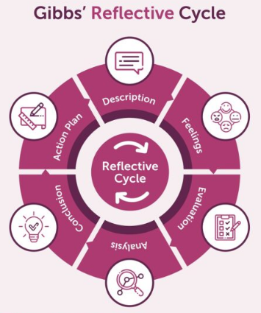

**Figure 1: Gibb’s Reflective Cycle**

(Source: Hwang and Chang, 2022)

## Evaluation

I have obtained being a dedicated employee I must improve my weaknesses and be ***more productive*** in order to achieve my certain goals. Identifying the possible obstacle in the field of professionalism, I should focus on the planning procedure and set my goals properly. ***Using SMART goals*** and ***visualizing my success*** can help in reaching the targets efficiently (Carvalho and Mourão, 2022).

## Analysis

The Situation I experienced has included both good and bad experiences. I have observed there was an issue in the ***communication process*** with my teammates. I should work on it as well as on my problem-solving skill and improve them.

## Conclusion

I lead many things related to ***critical thinking, leadership skills, adaptability*** and ***problem-solving skills*** which are necessary for being a dedicated employee and performing effectively. Improving these skills in my professional life will lead to a positive result and help me to achieve a higher position.

## Action plan

For the purpose of being a dedicated employee, I must ***develop a planning strategy*** that will help me to focus on my ***career goals***. Also, ***time management*** is necessary to reach the objectives efficiently within the time scale.

# Conclusion

From the above study, it can be seen that the skills involved in employability are essential for an individual to identify their strength and weaknesses and make the planning of their career goals more effective. It improves skills and makes a person ready for their professional life.

# References

Carvalho, L. and Mourão, L., 2022. Career adaptability, perceptions of professional development and employability: a mediation analysis. *Psico-USF*, *26*, pp.697-705.

Hwang, G.J. and Chang, C.Y., 2022. A reflective cycle-based virtual reality approach to promoting students’ learning achievement, sense of presence, and higher-order thinking in professional training. *Interactive Learning Environments*, pp.1-16.