**BUSINESS STRATEGY OF AMAZON**

**Abstract**

The present report has stated the change management in Amazon and developed the strategy in order to make the business process improved. The contribution to the regional, national and global trends indicating sustainability, diversity and political changes has helped in gathering the data related to the business process. The global innovations in the business procedure created efficiency in management and made the business more effective. In this report, secondary data was collected from sources such as Google Scholar about the topic. With the use of appropriate research design and research methodology tools and techniques, proper findings were made about the topic. The company overview of Amazon is discussed extensively in this report. Necessary recommendations were made in this report based on the findings made in this research. Proper conclusions are made based on the findings made in this report.

**Table of Contents**

Task 1: Introduction 3

Common business trends and strategies 5

Task 2: Methodology 8

Task 3: Discussion 12

Conclusion 13

Task 4: Reflection 14

References 16

Appendix 18

# Task 1: Introduction

The present report has discussed the current and potential regional, national and global trends including geopolitical changes, sustainability, diversity and strategic changes and the implementation process within Amazon. The help of the secondary data has made possible outcomes that have been reflected in the present study. The study has made it easy to understand the importance of global trends which helps in implementing strategies efficiently. Wipro has contributed to global trends by sharpening the strategy for its business process. Global innovation and secondary data in the study have managed to evaluate the possible outcome and helped in the mini-publication process of the company. Also, the study has also included a discussion of the findings in order to support the emerging trends and strategies for adapting to the business process.

In the present time, social globalization has connected through digital processes and technologies and made effective results for the company. In the context of Amazon, the business needs a strategic formation process for making a positive outcome in the global market. Regional development helps in encouraging the economic factors for improving as well as the communities in their economy, culture, social and professional environmental wellbeing. The strategic formation process of the company uses available knowledge and guidance properly and takes actionable steps in order to achieve the goals efficiently. This procedure may involve resource allocation, alignment, prioritizing and the validation of the business goals. In the modern world business scenario there are different business trends that are being observed to accommodate which the organization try to formulate different strategies. In this report the different trends that are being observed in the modern business scenario are being discussed. The recommendations are made as per the findings made in this report about the company of Amazon.

**Theoretical framework**

**Background of the company**

The company amazon Inc is the American multinational company that provides services such as E-commerce, cloud computing and digital streaming. The company also provides services such as artificial intelligence to its customers. The company is headquartered at Seattle, Washington USA. The company is one of the biggest innovative and customer oriented companies in the world. The founder and the CEO of the company is Jeff Bezos who has led the company to become one of the most valuable companies in the world. Initially the organization started as an online workplace for books that grew into an E-commerce giant. The company offers different range of products as per the different types of the people. The company is known as an innovative company that has aggressively invested in innovation to increase the business and the services offered to the customers. The company has also now started to provide streaming services to the customers where different videos are streamed. The company is also facing challenges in the modern business scenario in different business activities such as sustainability and work culture.

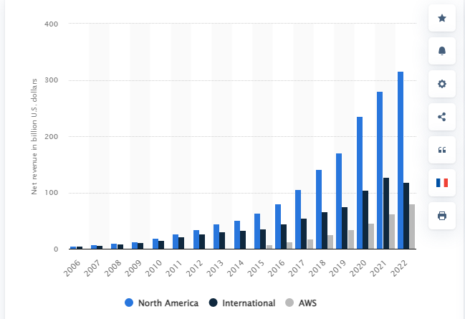

**Figure 1: Total net sales revenue of Amazon from 2006 to 2022**

(Source - statista.com)

**Contribution to regional, national and global trends**

In order to make Amazon grow in the business procedure it needs to obtain some effective strategy that can help in optimizing the different negative aspects. The company should increase the productivity level in the working environment in order to keep the business procedure going smoothly. According to Karimi *et al.* (2018), an organization should follow the recent business procedure and identify the barriers to the business method. By identifying the barriers, the implementation of new innovative ideas and strategies will become easier and make effective outcomes. On the other hand, as per Pratt (2019), the position of the market strength and the competitive advantages are the most essential elements in the business that need to be managed properly. Identifying the position in the global market and making effective ideas in order to make the business more efficient and increase the customer base is the most important part of a company (Liu *et al.*, 2022). Also, the competitive advantages across the customers, scales and diversification make a good impact on the process and help in gathering more advantages and opportunities for the future. In the context of Amazon, the company is focused on servicing its customers with the help of innovative services and excellent services.

**The strategic changes in the company**

In the process of the strategic changes of the company, the company plans and implements the new procedure in order to gain more profit and help people efficiently. It also helps in boosting competitive advantages and achieves a certain objective. Through the contribution process to regional, national and global trends the organization can sharpen the strategies related to restructuring, innovation and managing performances in the organization. Amazon has used the cutting edge technology to serve its customers in new and innovative ways. The strategic changes can be increasing strong digital capabilities, increasing corporate social responsibilities, diversity and flexible price structure. These components can help in changing the strategy of the company to make progress efficiently. On the other hand, as per the opinion of Ahrne *et al.* (2019), digital transformation in the organization has been recently involved in the business process and made a utilization effectively. However, it has some risks according to the implementation and generating output. The risks may be involved in the monitoring process, change in the organization's policies and the new system and procedure for the people (Kiers *et al.*, 2022). Basically, the organization faces challenges in order to adapt the effective change management program and help in developing the business procedure. The issues with the stakeholder's support, lack of funds, inadequate team members, and uncertainty have brought issues to the company as well as it has an impact on the customers.

As per Amazon, strategic development and other challenging factors may come up. In order to make the possible solution the development of the strategies should be implemented in such a way that could help in benefiting the company as well as the people. The company is continuously investing in the research and development for making the company a futuristic company.

**Strategies regarding global innovation and collecting secondary data**

Through the process of strategic change that helps the organization restructure and improve its policies and business processes, innovative techniques and tools have been included efficiently. The implementation of new digital technologies such as AI, ML and IoT made it possible to bring the best result to the organization. The customer demand has been driving the digital adaptation and they are very much influenced by the new technology. This may help in generating effective results by meeting customer demand and expectations and has helped in becoming more innovative.

## Common business trends and strategies

***Strong digital capabilities***

In order to sharpen the strategic change in the organization by contributing to the national, regional and global trends the involvement of the digital technologies can bring effective results. In recent times, customer demand and expectation levels of the people have increased (Jiang and Bai., 2022). The digital adaptation in the business process helped in delivering the right outcome to the customers and satisfying them. Boosting the capabilities in the process such as in online communication, digital payment process and others has facilitated the customers highly.

***Developing corporate social responsibility***

In order to develop and improve environmental sustainability and the operations for managing essential components such as the supply chain management, stakeholders in the organisation and labour practice the improvement of CSR policies help highly to achieve it. Adopting corporate social responsibility highly helps in building a strong brand identity and improves the relationship between customers and employees.

***Diversity***

Workplace diversity helps to develop creativity, innovativeness, increasing profitability, economic growth and performance level in the company (Suwanda and Nugroho, 2022). It also helps in sustaining the business procedure in a more effective way and gaining more opportunities in the future. The company is facing challenges in terms of the work culture as the company has faced issue in terms of the work life balances of its employees and toxic work culture. The company is taking the help of increasing pays and perks to motivate its employee to increase the employee engagement of the employees of the Amazon.

***Artificial intelligence*** - The use of AI is a big trend that is being noticed in the organizations in the current market condition. Amazon has also used AI to develop different products such as its flagship product of Alexa which helps its customers in day to day activities. However the company can also make better use of this trend by implementing in the different business processes and activities to increase their efficiency. The company understands the future the trend of AI has hence the company has also used AI in its websites to provide post-purchase services to its customers (Dash *et al.,* 2019).

***Automation*** - Automation is the use of the machines to decrease the human involvement and increase the efficiency of the process or the business activity. Each and every company is investing in the innovation to streamline its business activities. The company can identify different business processes or the activities for example its distribution network and its fulfilment centres to increase their efficiency (Boysen *et al.,* 2019).

***Sustainability*** - It is the most recent trend that is being observed in the recent times where the organization are taking into account the adverse effects their business activities for the environment and its stake holders and planning out such practices through which the effect on the environment and the planet can be reduced (Escursell *et al.,* 2021). Amazon is also making investment to plan its packing’s in such a way that the sustainable packing can be done for the products. The company is also the biggest investor in renewable energy (Amazon.com, 2023).

Proper pricing - The proper pricing of the products is also a trend which the organization should implement in the products and services which will be helpful for the organization to make the products and services available to its customers in lowest prices. Amazon also follows a fair pricing policy which helps the company to price its products fairly at lower rates to avoid price gouging (Kim 2019).

**McKinsey 7s Model**

For making the business of Amazon more effective and sustainable in the global market the implementation of the McKinsey 7s model can bring positive results. This particular model is highly used for analysing a company's organizational design efficiently. The main goal of the model is to portray the effectiveness of the company which can be achieved by connecting seven different elements.

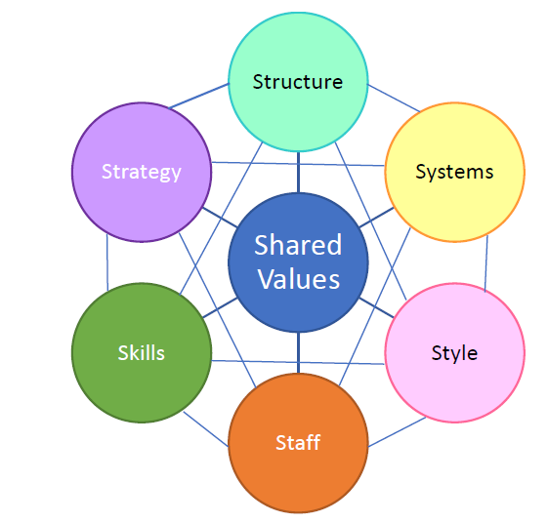

**Figure 2: McKinsey 7s Model**

(Source: Abraham *et al.*, 2022)

***Structure-*** It defines the way the company is organized and the command chain and accountability relationship helps in developing the organizational chart.

***Strategy-*** The strategy in the organization refers to the planning procedure which helps in allowing the organization to make effective plans in order to sustain the business and gain competitive advantages.

***Skill-*** The skills among employees highly provide advantages and capabilities to the organization. The skills in the organization such as effective communication, problem-solving, time management and collaboration can bring efficient results.

***System-*** The business and the technical infrastructure of the company helps to establish the right workflow level and improve the decision-making process (Abraham *et al.*, 2022).

***Shared value-*** The objective, values and mission help in aligning the key elements in order to maintain an effective organizational structure.

***Style-*** Focusing on the attitude and style of the senior employees who help in establishing the code of conduct by interacting with each other and optimizing symbolic decision-making.

***Staff-*** Staff in the company includes the managers, employees and human resources in order to recruit, train and reward systems.

# Task 2: Methodology

**Introduction**

In this report, the researcher has used different research methodology tools that will be helpful for the research to reach the data analysis stage in this research. The research methodology tools employed in this research will help the research to adopt a structure model and logical flow to reach the data analysis stage in this research report. The research methodology in this report lays down all the tools and techniques used in this report to make proper and accurate findings in this research. The research methodology will discuss the research onion, the research design, the research approach, and the data collection and analysis methods (Patel and Patel 2019).

**Research Onion**

The research onion is the most essential part of this research which has laid down the structure that the research methodology will follow in this report. The research onion in this research is the collection of all the decisions taken while doing the research methodology in this report. The preferences made by the researcher about the various tools and techniques that can be used against all the available tools in this research are discussed in the research onion in this report. The structure of the research onion is planned in such a way that it will give the research a logical flow and direction to this research. Each stage in the research onion will lead to the next stage in the research design in this research and ultimately the research will reach the data analysis stage which is the central part of the research onion.

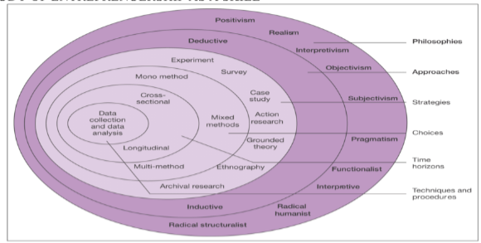

**Figure 3- Research Onion**

(Source - Saunders, Lewis, Thornhill & Bristow, 2015)

**Research Philosophy**

The research philosophy is the most vital part of the research which helps the research to take a particular direction while conducting research. The research philosophy reflects the beliefs and values that the researcher has made the research follow in every activity in this research. The interpretivism research philosophy is chosen in this research as research philosophy. The interpretivism research philosophy considers each human being as a separate entity and has an experience concerning the research issue. Interpretivism takes into account the subjective experience of different articles and tries to collect information for the research issue from different perspectives which helps get an in-depth insight into the research issue (Alharahsheh and Pius, 2020). The positivist research philosophy is quite rigid and scientific which does not stand accurate when taken into account against the social context of the social issues (Majeed 2019).

**Research Design**

The research design is the layout or the road map that the research methodology will follow to make proper and accurate findings in the research. A good research design will help the researcher to understand the research issue properly and then try to establish relationships with the variables in the research. This will help make proper findings in the research which will be able to address the aim for which the research is conducted. The descriptive research design is chosen in this report to analyze the data in this research. The descriptive research design is the simplest of all the research designs and helps to understand the different variables of the research in a better way. The exploratory research is not used in this research as the use of exploratory research is unstructured and flexible which will not be helpful to make conclusive findings in this research (Pandey and Pandey 2021).

**Research Approach**

The research approach is the schemes and procedures that are implemented in research which helps test different hypotheses and theories related to the research issue. The inductive research approach is selected in this report to collect the data in this report and conduct the data analysis in this report. The inductive research approach will help search for different patterns in the data collected and explain the observations with the help of theories. With the help of the inductive research design, the report is free to collect different types of data related to research topics which will be tested only once the observation from the collected data is done. This will help in the collection of in-depth information about the research topic which will help make new findings in this report. The deductive research approach tries to limit the findings in the research to the hypothesis set at the start of the research.

**Data collection**

The data collection is the backbone of a report which helps the researcher to find data which will address the issues and research aims in a report. The data collection will be done to collect data about the trend of sustainability in the organization of Amazon. The different articles, journals and the official website of Amazon will be revived to find relevant information about the sustainability practices and trends in the organization. The data also will be collected about the challenges that the organization is facing in implementation of the sustainability practices. The secondary data collection is selected in this as it has helped the researcher to collect a large amount of data that is spread over a large time frame. The secondary data collection in this research has made the data collection process in this report cost-efficient and simple. With the help of secondary data collection, the report has been able to gather quality data that will help the research to produce proper and relevant findings on this research topic. The secondary data collection in this research has helped to collect the general data that is accepted widely and available in the public domain, consequently, the findings made in this research will also be relevant to the present context of the research issue (Ruggiano and Perry, 2019). The primary data is not collected in this research as this will give specific data which may not be able to provide relevant data in this research (Sileyew 2019). The data is collected from the company's websites and company articles to find relevant information to address the aim of this report.

**Data Analysis**

The data analysis is the process where the raw data that is collected in this research is converted into meaningful information that helps address the research aims of the report. Thematic data analysis of the qualitative data will be done in this report. The data collected in the research will be searched for common points, after identification of the common points the researcher will try to find patterns in the common points in terms of the recurrence in the data collected (Kiger and Varpio 2020). Identification of these patterns will help the researcher to make important findings on the research issue. Qualitative data collected in this research will help in providing in-depth information about the research topic and variables in this report (Rahman 2020). The qualitative data will be helpful for the subjective data that can be generalized to make broad findings at the end of the report. Quantitative data would have made the data provide less detailed information limited to statistics only. The data analysis of the data collected related to the sustainability practices and challenges has helped to understand where the organization of Amazon stands in terms of sustainability and what the plans of the organization in terms sustainability in future.

**Inclusion and Exclusion**

Each activity in the research has been conducted by maintaining high ethical standards which will ensure that the findings in the research do not get affected by the personal bias of the researcher. The researcher has refrained from collecting any sensitive data related to the research topic that will affect the interests of any person, community or religion. The researcher has included the articles, reports and journals which are published between 2019- 2023. The researcher has excluded the articles, reports and journals which are published before 2019. The researcher has included journals, reports and articles only from reliable sources such as Google Scholar. The researcher has excluded the articles which are not from Google Scholar. The researcher has also included information from the official website of Amazon to find proper and accurate information about the sustainability practices of Amazon.

**Limitation and Future Scope**

The biggest limitation of this research is that it has not collected the primary data in this research which would have helped the researcher to gain more specific insight into the research issue. Future reports and research will take into account the findings made in this report and develop future new insight into the issue. Collection of primary data from the employees of Amazon would have provided the accurate information about the sustainability practices adopted by Amazon in the real life business activities.

**Summary**

In this chapter, the research methodology tools that have been used in the report are discussed briefly. The research onion outlines the different tools and techniques adopted in this report are laid out in a structured form. The researcher has used the descriptive research design in this report. The inductive research approach is used in this report, the researcher has collected secondary data to find in-depth information about the research issue. Thematic data analysis is used to analyze the collected data and find meaningful information on the research issue. The findings made in the report will help enhance the knowledge of this research issue. The collection of secondary data has helped the researcher to understand the position of Amazon in terms of sustainability practices.

# Task 3: Discussion

The company understands the importance of the customers consequently it tries to provide customer service that will result in maximum customer retention. Customer centricity has helped the company to become the one of the most valuable companies in the world in a short span of time. The company is aiming at developing a new product, and new payment options to help the customers in new ways which have made the company a customer-centric company. The company has made an investment of worth 42.7 billions USD in its research and development to develop innovative services for its customers. The company is also one of the biggest companies which is continuously investing in R&D to provide new experiences to its customers. The company also understands the changing landscape in society in terms of innovation consequently the company is making investments to increase innovation in its services to the customers. The company is using Big Data to manage the pool of the data of its customers to help itself to take proper and informed decisions regarding its customers. The company is also making use of AI to serve its customers in new and innovative ways. The company is bringing basic changes in its organization to make the company adopt and lead the way in terms of sustainability by bringing changes in terms of the new global, national and trends in the market. The company has also identified the risks and the challenges to change management such as resource shortage, lack of employee involvement etc. These challenges are addressed by the company to bring structural changes in the organization and addressed successfully to help the company to implement the changes successfully.

# Conclusion

***Recommendations*** - As per the report and findings made in this there are some recommendations to be made for the organization of Amazon. The organization should try to identify the business process in the organization where the innovation can be used as per the global trends (Chang and Lee, 2020). This will help the company to serve its customers in a much better way. Being an E-commerce oriented company the company can still try to make investments in research and development which will help the organization to use innovation in its business process. The company should redesign each department in such a way that it adjusted to the globalized business conditions and achieve sustainability (Gharizadeh *et al.,* 2020). The company should also engage with its employees with proper communication to implement the change in the organization without any confusion and eliminate any risk associated with the change. Amazon can try to eliminate the use of plastics in its packing as soon as possible which will help the organization to achieve sustainability in terms of its packing practices. The organization can try to identify the carbon footprints or the emissions in its shipping cycles and try to reduce the carbon footprint of its shipping activity. The organization can also try to build infrastructure which is according to the sustainable business practices which will increase the brand value for the organization in the long run. The company can also try to use single use plastics and focus on use of recyclable materials in its packing’s.

***Conclusion*** - In this report, the strategy of Amazon is discussed based on the global, national and regional trends observed in the market. The report also discussed the strategic changes that are brought in the organization in response to global, national and regional strategic change. The research methodology is conducted to find out information about the trend of sustainability in Amazon. This report studied the modern trends that are being observed in the recent times and the strategies that the organization has adopted to accommodate these business trends in its business practices.

# Task 4: Reflection

**Description**

In the beginning stage of the mini-publication of Amazon, I observed different skills and techniques in the company. I observed the company has implemented different kinds of strategies and techniques in order to make the change management more developed. I have come to know the different situation that has been faced by Amazon in the communication process and tackling issues efficiently.

**Feelings**

During the time of mini-publication, I obtained the different changes that have made some difficulty for the employees as well as for the customers. As per my thoughts, it is necessary to understand the growth of the company and the development process which could facilitate the customers and satisfy them.

**Evaluation**

The learning has provided me with essential knowledge of the company and its business procedure. I have gathered information on the strategic changes that have been made.

**Analysis**

From the learning procedure, I observed there were issues regarding the communication process between team members. However, I managed to tackle the fact by knowing the particular problems.

**Conclusion**

I lead many things in order to make the mini-publication effective and observed different things. The positive and negative facts in the process have helped me to develop knowledge about the company efficiently.

**Action plan**

I should make a plan or create some effective strategy in order to overcome the negative parts that I have observed. It will help me in my future career.

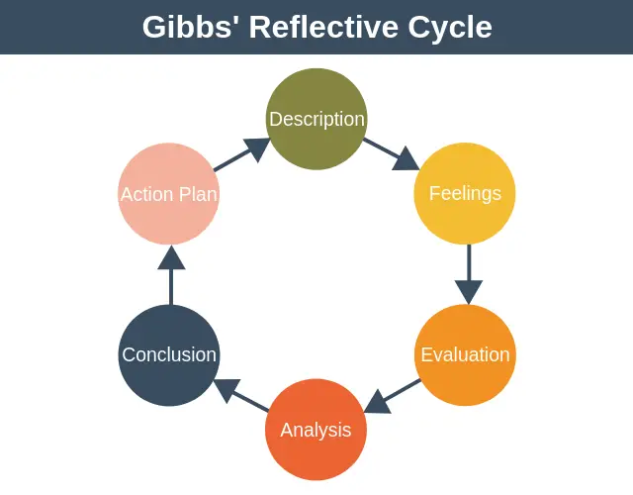

**Figure 4: Gibb’s Reflective Cycle**

(Source: Adeani *et al.*, 2020)

# References

Abraham, J.E., Lantu, D.C. and Ooi, S.K., 2022.ASSESSING THE EFFECTIVENESS OF RELIGIOUS ORGANISATION OFFICE DIVISION USING MCKINSEY 7S MODEL.

Adeani, I.S., Febriani, R.B. and Syafryadin, S., 2020. USING GIBBS’REFLECTIVE CYCLE IN MAKING REFLECTIONS OF LITERARY ANALYSIS. *Indonesian EFL Journal*, *6*(2), pp.139-148.

Alharahsheh, H.H. and Pius, A., 2020. A review of key paradigms: Positivism VS interpretivism. *Global Academic Journal of Humanities and Social Sciences*, *2*(3), pp.39-43.

Amazon.com, 2023 Available at <https://sustainability.aboutamazon.com/>

Boysen, N., De Koster, R. and Weidinger, F., 2019. Warehousing in the e-commerce era: A survey. *European Journal of Operational Research*, *277*(2), pp.396-411.

Chang, J.I. and Lee, C.Y., 2020. The effect of service innovation on customer behavioural intention in the Taiwanese insurance sector: the role of word of mouth and corporate social responsibility. *Journal of Asia Business Studies*, *14*(3), pp.341-360.

Dash, R., McMurtrey, M., Rebman, C. and Kar, U.K., 2019. Application of artificial intelligence in automation of supply chain management. *Journal of Strategic Innovation and Sustainability*, *14*(3), pp.43-53.

Escursell, S., Llorach-Massana, P. and Roncero, M.B., 2021. Sustainability in e-commerce packaging: A review. *Journal of cleaner production*, *280*, p.124314.

Gharizadeh Beiragh, R., Alizadeh, R., Shafiei Kaleibari, S., Cavallaro, F., Zolfani, S.H., Bausys, R. and Mardani, A., 2020. An integrated multi-criteria decision-making model for sustainability performance assessment for insurance companies. *Sustainability*, *12*(3), p.789.

Jiang, L. and Bai, Y., 2022. Strategic or substantive innovation?-The impact of institutional investors' site visits on green innovation evidence from China. *Technology in Society*, *68*, p.101904.

Kiers, J., Seinhorst, J., Zwanenburg, M. and Stek, K., 2022. Which strategies and corresponding competences are needed to improve supply chain resilience: A COVID-19 based review. *Logistics*, *6*(1), p.12.

Kiger, M.E. and Varpio, L., 2020. Thematic analysis of qualitative data: AMEE Guide No. 131. *Medical teacher*, *42*(8), pp.846-854.

Kim, W., 2019. A practical guide for understanding online business models. *International Journal of Web Information Systems*, *15*(1), pp.71-82.

Majeed, I., 2019. Understanding positivism in social research: A research paradigm of inductive logic of inquiry. *International Journal of Research in Social Sciences*, *9*(11), pp.118-125.

Pandey, P. and Pandey, M.M., 2021. *Research methodology tools and techniques*. Bridge Center.

Patel, M. and Patel, N., 2019. Exploring Research Methodology. *International Journal of Research and Review*, *6*(3), pp.48-55.

Rahman, M.S., 2020. The advantages and disadvantages of using qualitative and quantitative approaches and methods in language “testing and assessment” research: A literature review.

Ruggiano, N. and Perry, T.E., 2019. Conducting secondary analysis of qualitative data: Should we, can we, and how?. *Qualitative Social Work*, *18*(1), pp.81-97.

Sileyew, K.J., 2019. *Research design and methodology* (pp. 1-12). Rijeka: IntechOpen.

Statista.com, 2023 Available at <https://www.statista.com/>

Suwanda, S. and Nugroho, B.Y., 2022. Literature reviews: McKinsey 7S model to support organizational performance. *Technium Social Sciences Journal*, *38*, pp.1-9.

# Appendix







