**Contemporary Issues in Festivals and Events (ASSESSMENT B)**

**Executive Summary**

The contemporary issues are connected with a proper planning perspective which provides uncertain legal landscapes, advancement towards the technological approaches and changing the face which helps to increase the market. Contemporary issues highlight the challenges in the festival and event industry, the study is going to provide information regarding the contemporary issues in connection with the international festival and business event the Cannes Lion international festival of Creativity 2022. Necessary fundamentals connected with the contemporary issue are going to educate regarding the necessity of sustainability towards the environment, cultural differences and involvement of social media.

Table of Contents

Introduction 3

Discussion 3

Illustration on the international festival and event Cannes Lion International Festival of Creativity 3

Identification of the key contemporary issues in relation to the festival and event Cannes Lion International Festival of Creativity 2022 4

Identification of the actual influence upon the management of the festival arises from contemporary issues 6

Identification of the future influence on the management of the festival arises from contemporary issues 9

Conclusion and recommendation 10

Conclusion 10

Recommendation 10

References 12

# Introduction

The Contemporary issues related to events and festive necessary to face challenges at the time of contribution towards successful planning, management and marketing process. proper research is necessary to analyse in terms of event and festive to criticize the purpose of the business and corresponding aspects which provide a generous outcome. The respective assignment is going to provide various analyses and discussions over the international festival and business event of the Cannes Lion international festival of Creativity which occurred in 2023. The study is going to provide key awareness and understanding between the inter-relationship and key contemporary issues. The discussion will elaborate where three necessary contemporary issues that are required to highlight and it also helps to approach the impact on the international festival and event business. The study is going to conclude with a proper recommendation which helps in overcoming the challenges of the contemporary issue which is highlighted.

# Discussion

## Illustration on the international festival and event Cannes Lion International Festival of Creativity

The Cannes Lion international festival of Creativity which is also known as the international advertising festival is part of a global festival event where creative communication, proper advertisement and enhancement of relationship feels occurs. It is considered one of the largest gatherings for the advertising and creative communication industry. The Cannes lion international festival of Creativity 2022 has held at Palais des Festivals et des Congres in Cannes, France. It is one of the highlighted international festivals where around 15000 registered delegates from almost 100 countries visited the festival in terms of celebration of best creativity and also enhancement of brand communication (www.canneslions.com, 2023). In fact, this international festival considers various industry issues and network channels that have been discussed to mitigate various communication gaps and create a huge relationship bond with each other. The award function on Canvas Lion has drawn from expertise in every field throughout the globe, where every jury is headed by the Jury president. The judgement submission of the film, art crafts, digital craft, printing and publishing, health and wellness, design, radio, the entertainment world, brand content and many more have participated. The Canvas lion international festival of Creativity which has held in 2021 has highlighted bearing in mind health pandemic prevention in the 2020 edition from being held (Rangel-Pérez and Carretero, 2023). However, the festival of 2022 has targeted maintaining approaches where the lion requires changes. The Cannes Lion function of 2022 includes the launch of Creative Business to Business Lion which is involved with the creative commerce of Lion, where the Global benchmark toward creative excellence and brand communication helps to enhance professionals and businesses. Discussing the Cannes Lion International Festival the program consists of limited agenda, and action inspiration which provokes the enlargement of communication between the people for the rest of the festival. The creative community has reunited and aims to solve various challenges in the industry. Various technology organisation has participated in the festival event where show Cause towards the power of change in the industry and business which provide a potential imagination to the customer and bring technology as well as intelligence which are necessary and important part of the world's enlargement. The Cannes Lion has highlighted the huge reviews on its YouTube page and won the Cannes Lion award (Mabye, 2022). It is a part of business strategy which helps to elaborate the various aspects of the YouTube channel and it also helps in advertising various events which helps the YouTube business to elaborate.

## Identification of the key contemporary issues in relation to the festival and event Cannes Lion International Festival of Creativity 2022

The contemporary issues are relative to the festival event of Cannes Lion international festival of Creativity 2022 aims in highlighting the various contributions which are effective with future planning, management, marketing and various aspects. The Cannes the Lion international festival of Creativity 2022 is a part of the cultural festival. The cultural festival effort with planned to be part of marketing, image branding and civic boost which provide improvement towards the regeneration of urban areas (Van Niekerk, 2017). The key contemporary issues relative to the festival and events are as follows,

***Sustainability changing perspective***

Sustainability is one of the living issues which became important and relevant over various decades and the issue affects all industries and individuals alike. The Cannes Lion International Festival of Creativity focuses towards various creative access which is related to the film industry as well as the technology industry and many more which helps to increase various business connectivity and reduces business issues. However, the heart really tea is a process with a mass which directly impacts the planet and numerals lifestyle. The vast impact on the planet occurs due to the huge gathering of stars, businessmen, influencers and many more as a part of the gathering for the festival event. According to the observations of Ford, (2022), the Cannes lion international festival of Creativity has observed various approaches where the attitude towards social issues has risen. However, it is observed that the values and attitude of the sports brand are approached with TV commercials where communication to convey their messages and evil with various approaches are highlighted which indicates almost 20 commercials of the sports brand campaign led to achieving awards from 2015 to 2017. Social issues are also connected with sustainability where the festival gains the lead position of extreme waste fullness and unsustainability. There are no commercial or responsibility towards approaching the greener festival approaches which end in performing sustainability in the award function.

***Cultural differences***

In the current scenario, one of the best things for the globe is leaving with multi-cultural aspects. following the multicultural aspects, the major sportsman such as the Olympics, FIFA world cup and Commonwealth Games provide a world trade market and various conferences towards the United Nations. The role of the festival event of award function also pleases the same role where multicultural people get connected and provide the world with a message of acceptance of globalisation in the event industry. To sustain the cultural differences, it is necessary to focus on the diverse activities which are necessary to be participated by every individual, however, cultural differences can lead to cause behaviour and personality differences which includes gesture, mindset, communication, body language and various form. The Cannes Lion International Award show it is highlighted the centralised racial disparities towards award choices and various uncomfortable events are been recorded which is part of the business event under cultural Indifference among businessmen, film stars and many more peoples.

***Social Media Involvement***

Cannes Lion International Festival of Creativity which is commonly known as the international advertising film festival launched in Venice, Italy in the year 1954. At that period internet is underdeveloped and the birth of social media sites and not available. Before the birth of social media, this event mainly relied on word of mouth and mass media for attracting the attention of people and businesses. However, the incorporation of social media has become a vital tool for the festival industry which is mainly utilised to reach audiences throughout the globe. The events on social media platform are expensive and the reviews which are posted on the event attributes tend to negative, as due to the rise of the negative comments the target audiences lose their interest in the festival events (Sun *et al*., 2021). Social media provides a huge benefit to getting connected with the festival where people can enjoy the festival, however, it also has a negative impact where connectivity with each other loses. The management of the festival events is unable to target more consumers due to the availability of the various social media interaction where the festival events are shown as a live concert.

## Identification of the actual influence upon the management of the festival arises from contemporary issues

According to the observations of Li *et al*., (2020), The main role of the festival events is to protect the local cultural tradition, maintain sustainability and interact with technology which is necessary for the development and promotion of economic, cultural and social development for the particular destination. However, there is various contemporary issue which is adjusted with the festival event which includes large attraction of crowds, straightening the attractiveness of the particular place, commitment to the community and many more aspects. The actual influences provide positivity which occurs due to the actual performance which is better than that of the expectation of the individual audiences and it is necessary to approach with high satisfaction towards the audiences. However, negative discomfort ness also represents the actual performances which fall under the expectation and create dissatisfaction towards the target audiences.

***Sustainability changing perspective***

From the necessary studies, it is highlighted that sustainability influences the management of the festival event as it provides lower caused, improved efficiency and better productivity. sustainability creates a huge impact where satisfaction to the audience, stakeholders as well as various event activities can enhance.

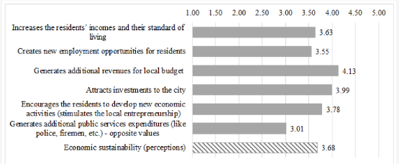

**Figure 1: Sustainability impact on festival event in graphical representation**

(Source: Negruşa *et al*., 2016)

The graphical representation implements various impact that attracts investment to the city 3.99, generating additional revenues for the budgeting which allocates to 4.13. It also provides a huge impact towards the employment opportunity which is enhanced due to the festival events on a large scale. The role of Cannes lion international festival has introduced a campaign which represents all the creative work throughout the world and provides a huge opportunity to build community and engage more content where enhancement of employment is also accessible (Burns, 2021). From the graphical representation, it is analysed that the creation of new employment due to the festival event is almost 3.55%. An article which is established in the UK, “UK festival to clean up their acts”, has provided a huge trading expansion in the business which is connected with the event industries. This act helps to reduce carbon emissions and provide sustainability towards the environment which is an important aspect of encouraging recycling schemes and responsibilities.

***Cultural differences***

It is necessary to understand the cultural differences which are not an important aspect of an event industry however it creates a huge negative impact towards the industry's development (Tan and Zhu, 2022). the part of the management for the festival event, it is one of the necessary aspects to provide awareness which are connected with cultural diversity. It is necessary to understand as well as respect the different cultures which ensures comfort to all the audience is connected with the festival events which helps to encourage the cultural customs and practices and it also encourages to implementation of cultural diversity events and shows in the festivals.

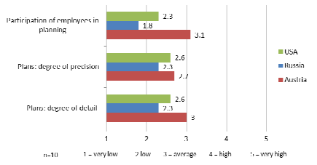

**Figure 2: Impact of the cultural differences in the festival events**

(Source: Keplinger *et al*., 2012)

The cultural differences create an impact towards the planning system of the festival events, in the graphical representation analysis the consequences of the planning, gathering details and degree of precision. The effects of cultural differences create a moderate relationship between travel motivation and even participation. It approaches with a positive socio-cultural impact towards the festival and inter-relationship of the business expansion where the opportunity of cultural exchange, entertainment and self-development are connected.

***Social Media Involvement***

Discussing the impact of the contemporary issue of social media involvement provides a positive experience for festival events. The participation and interaction of festival event via social media helps in gathering festival experience and provide entertainment. However, Media also provide a negative impact towards festival tourism where the negative comments and reviews are unable to attract tourists and there are discontinuations towards the opportunity of elaboration of a new relationship with the country by the tourist (Wu, 2020).

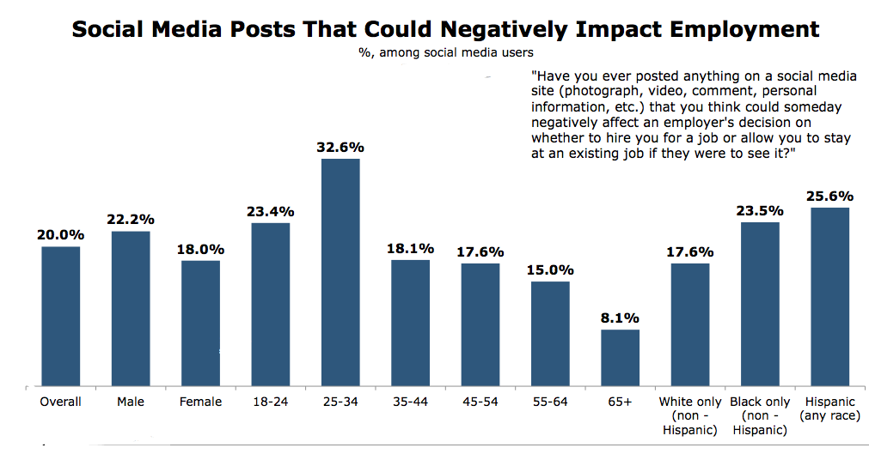

**Figure 3: Impact of social media which impact employment**

(Source: www.marketingcharts.com, 2023)

Social media reviews and post plays a negative impact towards employment, one of the major aspects of enhancing opportunities for festival events through employment. the role of social media reviews provides negativity towards employment. From the graphical representation, the overall achievement in employment in the festival event is 20.0%, which is a decrease due to the review system in social media which creates a contemporary issue. Inter-relationship between the festival and the business through social media interaction helps in proceeding with connectivity through which the brand can expand among the targeted audiences.

## Identification of the future influence on the management of the festival arises from contemporary issues

The future scope for the festival events provides an opportunity to get connected with various people and enhance social belief. Cultivation with the future impact upon the management of the festival event which arises contemporary issues has negative approaches, which include pollution in the environment, an increase of wastage, overcrowding and effects towards the local business and facilities. The large and long-term impact on the future of the festival event industry is access towards downfall due to the huge impact of post-Covid-19 (Davies, 2021).

***Sustainability changing perspective***

Investigation of the reports it is analysed that the environmental sustainability due to the festival events, the Cannes lion international festival of Creativity provide a huge impact. understanding the future impact, it is realised that huge crowdsourcing, pollution and many more aspects are going to hamper environment sustainability which creates more contemporary issues in terms of festival event participation. However, it is necessary to include better enhancement through which the issues in relation to sustainability can be managed. The contemporary challenges will increase such as climatic changes, pollution and many more creating huge shoes towards sustainability which are the future impact of festive events (Duffy and Mair, 2021). There is various respect which is connected with the festive events, which happen due to the instability aspects such as storms outbreak, behaviour approaches, issues with the technology and the kind of risk management in the festive event.

***Cultural differences***

One of the most important approaches managed by the festive events is proposing various cultural customs and practices which creates a huge cultural diversity among the events which is necessary respected and considered. One of the prime instances is the clash Of cultural beliefs which occurred in the 2014 Olympic games creating a huge contemporary issue and it is alertly applied by antigay law. The rejection of homosexual and bisexual relationship and activities create a huge discount for business activities as people throughout the globe create huge disturbances. This activity results in a huge future impact on the culture as it creates differences hence a huge cost needed to pay for the festival event due to discrimination of LGBT members and hurting the community people.

***Social Media Involvement***

The impact of social media towards the festival event is positive as it allows potential attention for interaction with the live environment which enables providing proper feedback, answering questions and showing more connectivity with the audience. However, the future impact of social media involvement creates a huge contemporary issue, as it is highlighted in the current impact where employment is affected due to the review system represented by social media involvement. The opportunity for employment in the festival event is higher however, the labour market is highly focused towards the feedback process which provides knowledge regarding the employment and work environment. negative feedback highlights effective measures towards employment which is a degradation for the future development of the festival's events.

# Conclusion and recommendation

## Conclusion

The study provides information regarding contemporary Issues connected with the festival and events. The complete assessment has highlighted and focused on the Cannes Lion international festival of Creativity 2022, which is one of the largest award function festivals which are connected with the creative and entertainment world and participation in the event is enlarging with various technological organisations. Furthermore, analysing the contemporary issues which highlight the sustainability of the environment, cultural differences and social media involvement. Additionally, the huge current and future impact which entitles the contemporary issues connectivity on the festival events is educated in the study.

## Recommendation

***Sustainability in the Environment***

It is highlighted in the study regarding the approaches of rising contemporary issues due to the impact of the festival events on the environment; hence it is necessary to provide proper sustainability approaches through which the environment can be saved. Approaching with Greener festival helps to reduce various destruction towards the environment which arise due to the festival event approaches. It helps in managing various Strategies for reducing carbon emissions and encourages to use of eco-friendly products. it helps in approaching with recycling scheme for exercising the best behaviour to maintain sustainability in the environment.

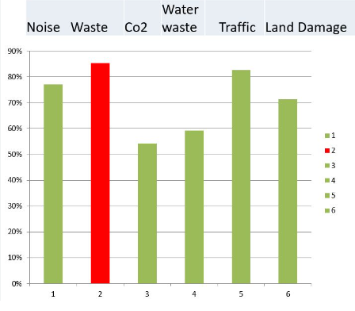

**Figure 4: Output result of the greener festival events on maintaining sustainability**

(Source: www.agreenerfestival.com, 2023)

The graphical representation highlights the categorisation of approaching with the green strategies which are necessary to involve in the festival events through which sustainability can be maintained in the environment.

***Cultural Differences***

The festival events and award functions are the best place to promote the culture and religions which directly helps to reduce the cultural differences and bring the senses to get connected with the community and celebrate the festival event respectively. It is necessary to encourage communication with all the people joining the festival events which create a strong cultural communication style with different community and Nations.

***Social Media Involvement***

The contemporary issues of social media involvement towards the festival events involve a huge disturbance is on employment due to the interaction of negative reviews towards the job section. The festival events propose higher employment opportunity however the use impact of the social media review system create degradation towards achieving employment. it is necessary to implement various Technology involvement rather than social media which is helpful in proposing and analysing the negative reviews and it is necessary to improvise a proper and positive response which helps to mitigate every negative review.

# References

Burns, K.S., 2021. Learning from the best: A review of community building, audience engagement, and influencer campaigns from the 2019 Cannes Lions. Public Relations and Online Engagement, pp.19-26.

Davies, K., 2021. Festivals post COVID-19. Leisure Sciences, 43(1-2), pp.184-189.

Duffy, M. and Mair, J., 2021. Future trajectories of festival research. Tourist Studies, 21(1), pp.9-23.

Ford, S., 2022. Global Challenges Forum 2022 Taking responsibility: The power of figurative communication in sports advertising and its role in tackling social issues of equality and mental health.

Keplinger, K., Feldbauer-Durstmüller, B. and Mitter, C., 2012. Management accounting practices in a multicultural environment: evidence from Austria, Russia and the US. International Journal of Strategic Management, 12(1), pp.37-49.

Li, J., Dai, G., Tang, J. and Chen, Y., 2020. Conceptualizing festival attractiveness and its impact on festival hosting destination loyalty: A mixed method approach. Sustainability, 12(8), p.3082.

Mabye, K., 2022. The Changing Narrative of Stereotypical Portrayals of Women in Advertising (Doctoral dissertation, The IIE).

Negruşa, A.L., Toader, V., Rus, R.V. and Cosma, S.A., 2016. Study of perceptions on cultural events’ sustainability. Sustainability, 8(12), p.1269.

Rangel-Pérez, C. and Carretero, M.J., 2023. How Branded Content is Strategically Transforming the Use of Traditional and Non-Traditional Media in Integrated Campaigns. In Handbook of Research on the Future of Advertising and Brands in the New Entertainment Landscape (pp. 299-318). IGI Global.

Sun, J., Leung, X.Y. and Bai, B., 2021. How social media influencer’s event endorsement changes attitudes of followers: the moderating effect of followers’ gender. International Journal of Contemporary Hospitality Management, 33(7), pp.2337-2351.

Tan, Y. and Zhu, Z., 2022. The effect of ESG rating events on corporate green innovation in China: The mediating role of financial constraints and managers' environmental awareness. Technology in Society, 68, p.101906.

Van Niekerk, M., 2017. Contemporary issues in events, festivals and destination management. International Journal of Contemporary Hospitality Management.

Wu, P.Y., 2020. Using Social Media as A Tool for Promoting Festival Tourism. Available at SSRN 3644862.

www.agreenerfestival.com, 2023. Available at: https://www.agreenerfestival.com/knowledge-base/

www.canneslions.com, 2023. Available at: https://info.canneslions.com/2022-lions-content-guide/the-cannes-lions-international-festival-of-creativity/

www.marketingcharts.com, 2023. Available at: https://www.marketingcharts.com/wp-content/uploads/2013/07/FindLaw-Social-Posts-Negative-Impact-July2013.png