**STRATEGY AND LEADERSHIP IN PRACTICE**

**BUS7B64**

**Table of Contents**

Introduction 2

3.1 Task: Strategic analysis of IKEA 2

1. Business Model of IKEA 2

2. The importance of culture 5

3. Capabilities of sustainable competitive advantage in IKEA 6

4. Key drivers of Macro change in IKEA 8

5. Competitive context of IKEA 9

Reference List 12

Appendix 1: 14

Appendix 2 15

# Introduction

The development of business models and strategies is important to make a company more diverse and structured. In this assignment, the chosen company is IKEA which deals with home furnishing products and furniture. The business model of IKEA along with its value creation and value capturing strategies in the organisation is going to be presented in this report. The impact of culture in IKEA and its importance for a business organisation, the sustainable competitive advantage in IKEA will be shown in this case study analysis report. The macro changes in this company and the competitive context of business will be evaluated to analyse the competitive advantage of the company.

# 3.1 Task: Strategic analysis of IKEA

## 1. Business Model of IKEA

The approach of IKEA is to deliver well-designed and low-cost products that can be affordable and accessible to almost all kinds of purchasers. The ***business model*** of IKEA is to offer a wide range of ***well-designed, functional home furnishing products*** at ***low price***s for customer affordability. IKEA wanted to reach many people without only shipping centers. IKEA operates in 40 shopping centers in 14 countries. These family-friendly shopping centers have IKEA stores to attract shoppers. The worldwide retail sales of the home furnishing market have reached great popularity and the sale exceeds $US600bn in furniture, household textiles, and floor coverings (Burt *et al.* 2021).

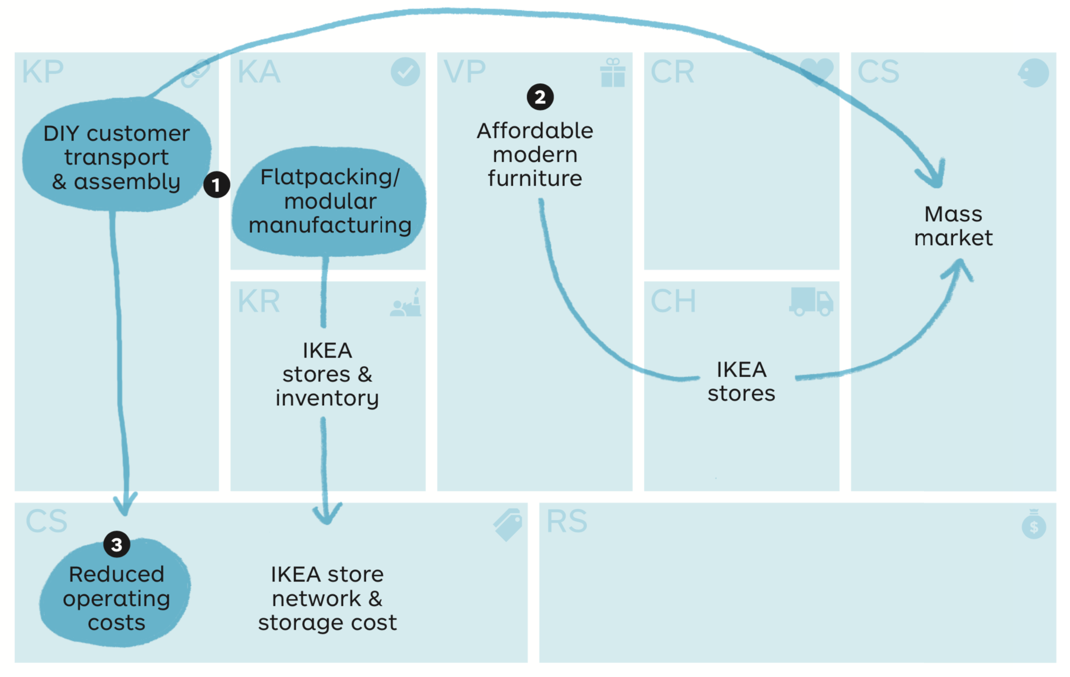

**Figure 1: IKEA business model**

(Source- Burt *et al.* 2021)

The product development and business operation of IKEA have made the signature of business model creation in the home furnishing industry. The customer-oriented business approach of IKEA includes the introduction of ***‘flat packing’*** which allows the customers to buy furniture and other home decor items such as floor covers in pieces in stores. Then the customers can assemble the goods in a DIY fashion at home which helps to reduce the transport cost of product supply for the customers and easy availability of goods at home (Han, 2023). The benefits of flat packing are the avoidance of transport fare for delivery charges, the customers can assemble the products according to their own accord.

***Value creation***

Value creation among the employees is very important to make them responsible and primary assets for a business organisation. IKEA is one of the foremost furniture retailing companies in the UK that makes the management team more responsible to develop value and ethics in the employees by developing effective employee management policies. The ***vertical integration*** of the value chain helps in developing relationships with the line of stakeholders such as suppliers, raw material providers, customers, and employees. Vertical integration of value chain analysis has been incorporated in IKEA which develops effective relationships with the employees and customers.

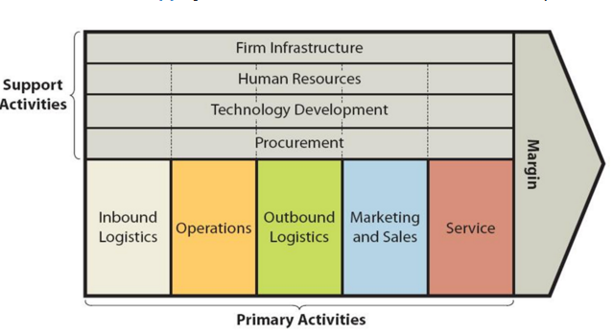

**Figure 2: Value chain of IKEA**

(Source- Catalan, 2022)

***Low cost and differentiation*** have been achieved by IKEA as value creation in the process of value proposition among the target customers.

***Value configuration***

Value configuration has been developed by IKEA by managing the whole value chain from inbound logistics to marketing sales and outbound logistics. The raw material providers to the employees and customers have been controlled and collaborated by maintaining a common goal of developing a competitive advantage in the business field. The ***vertical and backward integration*** system adopted by IKEA while maintaining relationships from the manufacturer, raw material providers to the distributors and customers (Catalan, 2022). This type of integration is helpful to lower cost and improve product distribution. In the process of value configuration IKEA has included the customers by providing them an opportunity to reduce the cost of furniture delivery as they can assemble the furniture at home by themselves.

***Value capture strategies***

The strategies of IKEA are mainly the ***cost-effectiveness of products and product differentiation***. It has been found that IKEA has sold its products at 20% cheaper than the price of its competitors (Mytuitions.files.wordpress.com, 2022). Hence the profitability has been maintained by the company with its diversified product varieties. The profitability is still increasing in the case of IKEA in Europe 72% sales, in Asia 45% sales. IKEA is able to lower the delivery sales of furniture goods by adopting a low-cost and differentiation strategy.

## 2. The importance of culture

***Organisational Culture*** has a great significance in the process of developing a business environment to provide employees with a safe and healthy occupational workplace. ***Unique culture, everyday inspiration, and motivational leadership*** are the key aspects of IKEA culture. A culture of ***entrepreneurship and hard work*** has flourished in IKEA from Sweden that made the employees ***responsible, collaborative***, and develop team spirit to work in a significant manner. IKEA has possessed ***a $15.3 B value*** in the furniture and home furnishing market by developing an effective business model and organisational structure (Mytuitions.files.wordpress.com, 2022). In the ethical and sustainable business process of IKEA, the company has faced poor enforcement and underestimation of cultural differences.

As per Bourny *et al.* (2023), IKEA has developed ***corporate culture*** in the organisation by facilitating shared values, ethics, and relationship management among the employees and customers. ***Corporate moves*** is a set of shared values, norms, and belief systems that sets the path of behaving, feeling, and thinking of an employee in the workplace. In this context, the ***iceberg metaphor of organizational culture model*** developed by ***Edgar Schein in 1984 can*** be contextualised to analyse the behavior management of IKEA. According to this model, three levels of culture can be established in an organisation such as artifacts and creation, basic assumption, and underpinning values.

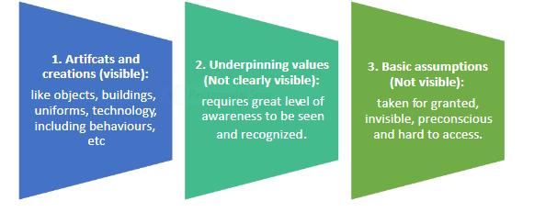

**Figure 3: Schein’s metaphor of organisational culture model**

(Source- MacQueen and MacQueen, 2020)

Schein's model has been regarded as a dynamic model to show the impact of culture in the organisational behavior and employee management process (MacQueen and MacQueen, 2020). The workplace psychological traits and accumulation process of employees have been emphasised in the three levels of this model. In IKEA the development of ***behavior management*** has been emphasised by penetrating the ***reward system*** among the employees. According to the discussed model, IKEA's basic assumption is based on its Swedish origin and the foundation stone of business development. The corporate culture of IKEA possesses extremely ***cost-consciousness, simple, innovation and hard work. Equality, delivering responsibility, and initiative*** have been found among the employees of IKEA in the organisational culture.

As per Genel and IYIGUN (2020), IKEA has possessed informal, caring, and open management in the organisation to provide employees enthusiasm , motivation, and equal space for capturing the innovative mindset. Job security and a caring attitude towards employees have been found in the organisational workplace of IKEA. The company takes the initiative to develop low-cost products and differentiated business models without compromising on quality. In this context, the concept of ***clan culture*** can be associated with the development of corporate culture in business organisations (Fakhri *et al.* 2021).

Clan culture allows equal opportunities for all employees and develops family-like relationships with them to enhance productivity and enthusiasm. In IKEA the employee relationship with the management team and leaders has been found cordial and the caring attitude of the managers towards the employees can suggest the flourishing of clan culture in the organisation. On the other hand, the reward management process for the employees in IKEA motivates them to increase the skill and productivity of the working process.

## 3. Capabilities of sustainable competitive advantage in IKEA

The product differentiation and cost-effectiveness in pricing have provided IKEA with a great advantage in the competitive field of business in the home furnishing market. ***Quality, green technology, and customer service*** are the main competencies that make the company unique and sustainable. The environment-friendly approach for IKEA has been developed to gain a competitive advantage in ***the people, profit, and environment protection*** development process. ***Dynamic capabilities*** are the routines and processes that make companies evolve and transform themselves with time (Alrubah *et al.* 2020). A long-lasting competitive advantage can be gained with the establishment of unique strategic management in business. The bottom end of the furniture market has been captured by IKEA rather than other DIY companies such as B & Q in the UK and Castorama in France.

IKEA has generated more than 50% of sales from furniture stores. The ***multi-brand retail furniture outlets*** in the UK have attracted the attention of customers. The kind of product differentiation and variety that has been achieved by IKEA in ***child care, food departments, and kitchen decoration*** goods has made the company susceptible and a center of attraction for customers of trendy demand. Sustainable development has been achieved by IKEA with the implementation of green technology and supply chain optimisation in business. The ***Dynamic Capabilities View*** (VCD) of an organisation shows its existence competence, learning and effectiveness, and external competencies that can develop emerging space for gaining competitive advantage. The competencies of IKEA such as employee management, value proposition, and cost-effectiveness of pricing have developed ground for adopting sustainability innovation (Nadirah and Aishan, 2020).

IKEA has improved the business approach of customer-centricity to make the development of customer segmentation and increase popularity. IKEA does not sell non-rechargeable alkaline batteries and has replaced them with LADDA rechargeable batteries. This initiative helps customers to reduce waste and save money in the long way of affordability development. Almost 99.5% of wood used in furniture production is either recycled or certified by the Forest Stewardship Council (FSC). recycled wood and raw materials have been used by IKEA in the development of a sustainability approach in business to provide customers long run durability and quality of the product life cycle. Within 2030 IKEA has committed to tackling the issues of climate change, unsustainable consumption, and inequality.

IKEA promotes circular and sustainable consumption by developing renewable sources in production and encourages almost 1 billion people every day to develop sustainable living. IKEA has become climate positive by using regenerative sources of energy such as solar energy in production to reduce the percentage of carbonated gas. Carbon footprint reduction has been the aim of IKEA by developing a net zero process by 2050 (Bernhard, 2021). IKEA has established resource management based on renewable and regenerative sustainable sources. The cotton used in the production of home furnishing products is from renewable sources and recycled which can be good for the planet and people. The circular way of business adopted by IKEA is mainly to develop sustainability through maintaining product recycling, reuse, refurbishing, and remanufacturing. More than 60% of IKEA's products are from renewable materials and 10% are from recycled sources (Ikea.com, 2022).

## 4. Key drivers of Macro change in IKEA

***Political factors***, the political condition in the UK is quite stable which is responsible for improving the business condition of IKEA. As evaluated in the case study, one of the important reasons for the success of IKEA is the provision of high-quality goods to customers. According to the opinion of Zhuravskaya *et al.* (2020), a stable government provides a chance to reach effectively different customers of the business. It also accounts for a significant factor that is responsible for the improvement of IKEA's business position. ***Economic factors***, the current ***GDP of the UK*** is 3.13 trillion (Worldbank, 2023). This is an important factor that highlights the economic position of the country. Countries in a safe and sound economic condition can create chances for successful investment in new product purchases.

***Social factors*** which determine the condition of the labor market are significantly good in the UK. One of the immediate influences of this approach is that it is creating scope to improve the productivity rate in business. However, the introduction of social distancing norms in the post covid hour accounts is responsible for changing the working policy of businesses (Ons, 2022). ***Technological factors*** which include Advancement in technology are helping in developing devices that can further help in improving communication with employees and thus achieving the objectives of the company.

***Kotter's change management theory*** highlights the importance of adapting to the changing business environment. In order to survive in the global competition, it is important for IKEA to create a sense of “urgency” in the business. In the opinion of Kang *et al*. (2022), the inclusion of a change model framework such as ***Kotter's Framework*** helps in bringing necessary change within the business. Management of IKEA needs to identify potential threats to the business. As mentioned in the case study, increased competition is identified as a potential threat in the business. Hence, the management is focusing on bringing changes in the manufacturing process while examining opportunities. The next step identified using this theory is the development of a powerful “coalition” in the business.

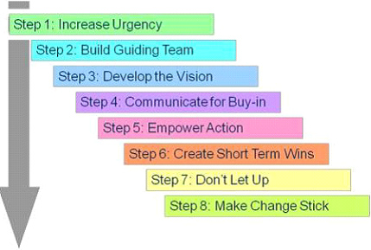

**Figure 4: Kotter's change management theory**

(Source- Harrison *et al*. 2021)

IKEA is also considering changes in terms of leadership style followed in the business. It is also important for businesses to establish an effective vision for change in business. According to the opinion of Harrison *et al*. (2021), globalisation is responsible for the need for rapid change within the business process. As evaluated within the case study, a constant shift in terms of market preference is highlighting IKEA to develop a new range of products. In order to develop products preferred by customers, one important condition is to reach out to customers. It is important to communicate with the new vision of business and thus make decisions accordingly. The next important step for IKEA management is to identify obstacles and thus develop the right and appropriate solution for the same. One of the significant obstacles in this regard is the management of employees. It is important for IKEA management to conduct meetings on a fixed schedule and raise awareness about changes in terms of product development across the business.

## 5. Competitive context of IKEA

The cost focus and differentiation are the main competitive advantage of IKEA. The furniture sold and flat packed can help the lowering down of cost structure of transportation and labor charges. The product variety and differentiation in home furnishing, decor time, floor covers and interior furniture decor have attracted the attention of target audiences due to the low cost of the products. As per Elizaveta (2021), unique Scandinavian design, a day-out shopping experience at one place, low-cost retailing, inspiration, innovation and competitive pricing than the high street retainers are the unique advantageous strategies of IKEA. In this context, ***Porter’s Five Forces model*** can be used to gain an idea of the competitive forces of IKEA.

***Bargaining power of suppliers-*** The bargaining power of the suppliers is ***high*** in the industry of furniture in the case of IKEA. The suppliers have numerous alternatives to sell raw materials and goods to international and regional furniture manufacturers (Hagberg and Jonsson, 2022). The gaining of renewable raw materials such as recycled cotton and Scandinavian wood has been found demanding for IKEA.

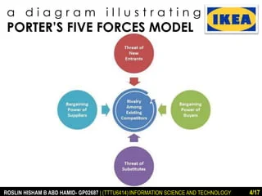

**Figure 5: Porter Five Forces Model**

(Source- Hagberg and Jonsson, 2022)

***Bargaining power of customers-*** On the other hand, the bargaining power of the customers has been found ***high*** in the furniture market. The buyers have different alternatives to buy products from other international and regional companies. The low switching cost refers to the increase of the bargaining power of the customers.

***Existing rivalry among competitors-***  The rivalry among existing competitors in the home furnishing and furniture market is ***high*** in collaboration with IKEA. The competitors of IKEA include B & Q company of the UK and Castorama in France. The unique position of the brand has been maintained by IKEA with the development of innovation, green technologies, sustainability approach and lower price of products.

***The threat of new entries-*** The threat of new entries is ***low*** as a competitive force for IKEA. Analysing the furniture market of the recent demand it has been found that the capital, resources, and skill of developing unique, cost-effective furniture can not sufficiently be flourished by any new company. In this context, the position of IKEA in the furniture market is strong and long-lasting (Mon, 2020).

***The threat of substitution-*** The threat of substitution of the products of IKEA has been found ***low*** in the home furnishing market worldwide. It is not possible for any new companies to create substitute furniture at low prices with the maintenance of sustainability in the competitive business market to attract customers.

**Conclusion**

In this report of case study analysis the development of the business model of IKEA has been described. The value proposition, value generating strategies of the company have been analysed. The importance of culture and IKEA’s cultural aspect in the business field have been discussed in this report. The way dynamic strategies help IKEA to achieve sustainability has been analysed in this report along with the sustainable competitive advantage of the company. The macro environment of IKEA in terms of external environment analysis and competition analysis have been evaluated to show the strong position of IKEA in the home furnishing and furniture market.

# Reference List

Worldbank (2023), <https://data.worldbank.org/indicator/NY.GDP.MKTP.CD?locations=GB> [Accessed on 25th April, 2023]

Zhuravskaya, E., Petrova, M. and Enikolopov, R., 2020. Political effects of the internet and social media. *Annual review of economics*, *12*, pp.415-438.

Ons (2022), <https://www.ons.gov.uk/employmentandlabourmarket/peopleinwork/employmentandemployeetypes/articles/coronavirusandtheeffectsonuklabourmarketstatistics/2020-05-06> [Accessed on 25th April, 2023]

Kang, S.P., Chen, Y., Svihla, V., Gallup, A., Ferris, K. and Datye, A.K., 2022. Guiding change in higher education: An emergent, iterative application of Kotter’s change model. *Studies in Higher Education*, *47*(2), pp.270-289.

Harrison, R., Fischer, S., Walpola, R.L., Chauhan, A., Babalola, T., Mears, S. and Le-Dao, H., 2021. Where do models for change management, improvement and implementation meet? A systematic review of the applications of change management models in healthcare. *Journal of healthcare leadership*, pp.85-108.

Burt, S., Dawson, J., Johansson, U. and Hultman, J., 2021. The changing marketing orientation within the business model of an international retailer–IKEA in China over 10 years. *The International Review of Retail, Distribution and Consumer Research*, *31*(2), pp.229-255.

Han, X., 2023. Analysis and Reflection of IKEA’s Supply Chain Management.

Catalan, M.L.P., 2022. IKEA’s Supply Chain: Growth on Sustainability.

Alrubah, S.A., Alsubaie, L.K., Quttainah, M.A., Pal, M., Pandey, R., Kee, D.M.H., Ling, L.K., Nadirah, N.A. and Aishan, N., 2020. Factors affecting environmental performance: A study of IKEA. *International Journal of Tourism and Hospitality in Asia Pasific (IJTHAP)*, *3*(3), pp.79-89.

Bernhard, M., 2021. The development of scenario analysis tools to help IKEA set and follow up climate footprint goals.

Elizaveta, S., 2021. Sustainable innovations of IKEA company.

Ikea.com, 2022. Accessed at: https://www.ikea.com/ca/en/this-is-ikea/company-information-pubf1695191

Mytuitions.files.wordpress.com, 2022. Accessed at: https://mytuitions.files.wordpress.com/2017/01/the_ikea_case.pdf

Fakhri, M., SYARIFUDDIN, S., WINARNO, A., NURNIDA, I. and HANUM, S., 2021. Democratic leadership practice to construct clan organizational culture in family companies. *The Journal of Asian Finance, Economics and Business*, *8*(1), pp.803-811.

Genel, B. and IYIGUN, N.O., 2020. The role of organizational citizenship behavior on the relationship between organizational culture and organizational deviance. *İstanbul Ticaret Üniversitesi Sosyal Bilimler Dergisi*, *19*(39), pp.1149-1166.

Hagberg, J. and Jonsson, A., 2022. Exploring digitalisation at IKEA. *International Journal of Retail & Distribution Management*.

Bourny, D., Mirza, D. and Turcu, C., 2023. The culture-promotion effect of multinationals on trade: the IKEA case. *Journal of Economic Geography*, p.lbac033.

Mon, C.S., 2020. Predicting VR adoption on e-commerce platforms using TAM and porter five forces. In *Understanding Digital Industry* (pp. 176-179). Routledge.

MacQueen, J. and MacQueen, J., 2020. A Mental Model of Organizational Culture. *The Flow of Organizational Culture: New Thinking and Theory for Better Understanding and Process*, pp.17-39.

Cnbc (2023)<https://www.cnbc.com/2023/04/19/uk-inflation-rate-surprises-again-with-march-figure-holding-above-10percent.html> [Accessed on 25th April, 2023]

# Appendix 1:

# Appendix 2

1. Yes
2. Yes
3. Yes
4. Yes
5. Yes
6. Yes
7. Yes
8. Yes
9. Yes
10. Yes
11. Yes
12. Yes

**PEST analysis**

|  |  |  |
| --- | --- | --- |
| Factors | Analysis | Impact |
| Political | * Stable government * Strong economic hold | Positive |
| Economic | * GDP of UK is 3.13 trillion (Worldbank, 2023) * Inflation rate is 0.8% (Cnbc, 2023) | Positive |
| Social | * Good condition of labor market * Improvement in income level | Positive |
| Technological | * Increase use of digital tools * Advancement in communication approach | Positive |

**Table 1: PEST analysis**

(Source: Self-generated)

**Porter Five Forces Analysis**

|  |  |
| --- | --- |
| **Forces** | **Rate** |
| Bargaining power of the customers | High |
| Bargaining power of suppliers | High |
| Existing rivalry among companies | High |
| Threat of substitution | Low |
| Threat of new entries | Low |

**Table 2: Porter five force analysis**

(Source: Self-generated)